4/9/2020
Views are virtual table derived from other tables.
(1) Define a simple view s19v1 to provide three columns:
- actor_id
- category_id
- film_count: the number of films the actor actor_id appears in the category with category_id.
[A] SELECT statement for the data problem:
Film_actor(film_id, actor_id,..)
Film_category(film_id, category_id)
For example:
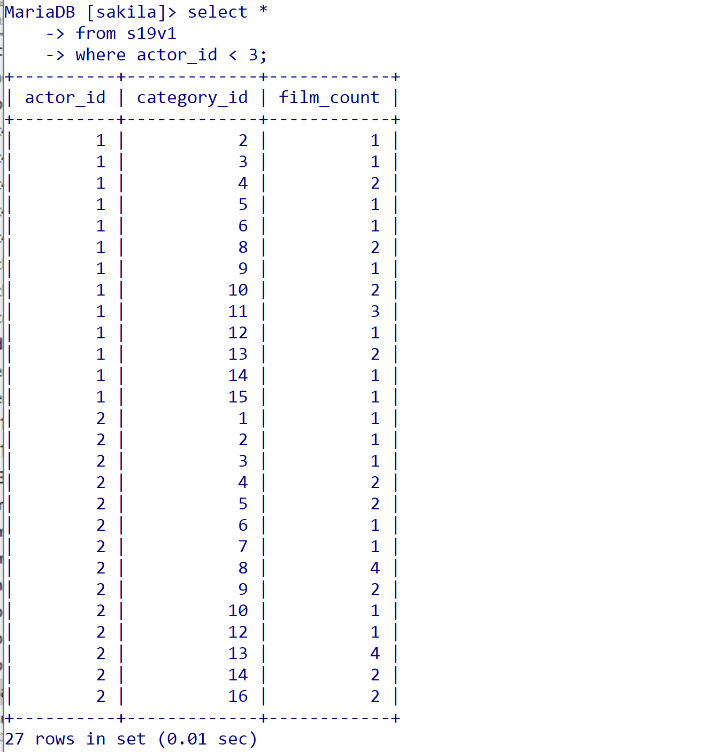
[A] Create View using the standard form. Remove testing code.
(2) Provide the SQL statement to show the actor ids of actors who appear in more than four films in the category with id 13. You must use the view s19v1.
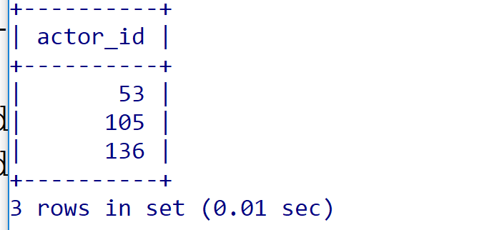

4. Stored Procedures
- Routines stored by the DBMS that can be called.
- Routines can be
  - functions: return a value (but not a table), or
  - procedures: do not return a value.
Functions should in general be preferred over procedures. Yes.

Functions (should) have no side effect.

(6) Write a function
create function s19f1 (
actorId int
) returns int
…

The function returns the number of films that actor appears in. The function must be defined using the view s18v1. For example:
MariaDB [sakila]> select s19f1(1);
+----------+
| s19f1(1) |
+----------+
| 19 |
+----------+
1 row in set (0.01 sec)

