2/13/2020
A2. (basic) For a many to many association between classes CA (class Paper) and CB (class Keyword), create a new relation RAB(RA_Id, RB_Id).
- (RA_Id, RB_Id) is a candidate key (composite)
- RA_Id references RA(RA_Id) as a foreign key.
- RB_Id references RB(RB_Id) as a foreign key.
- An additional surrogate key, such as RAB_Id, can be created.
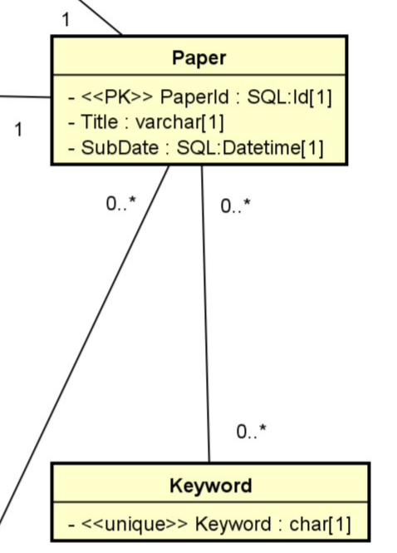
RA: Paper(PaperId, Title, SubDate, …)
PK: PaperId (RA_Id)
PaperId | Title | SubDate | keywordId? No
P1 | How to make ice cream | 1/21/2019 | K1, K2 (not atomic)
P2 | How to eat ice cream | 2/2/2020 | K1, K3, K3 (not atomic)
P3 | How to excel in DB | …

RB: Keyword(keywordId, keyword)
CK: [1] KeywordId, [2] Keyword
PK: [1] KeywordId (RB_Id)
KeywordId | Keyword | PaperId? no
K1 | Ice cream | P1, P2 (not atomic)
K2 | cooking | P1
K3 | Eating | P2
K4 | Good life | P2

PaperKeyword(PaperId, KeywordId): RAB(RA_Id, RB_Id)
PK_Id | PaperId: RA_Id | KeywordId: RB_Id
1 | P1 | K1
2 | P1 | K2
3 | P2 | K1
4 | P2 | K3
5 | P3 | K4

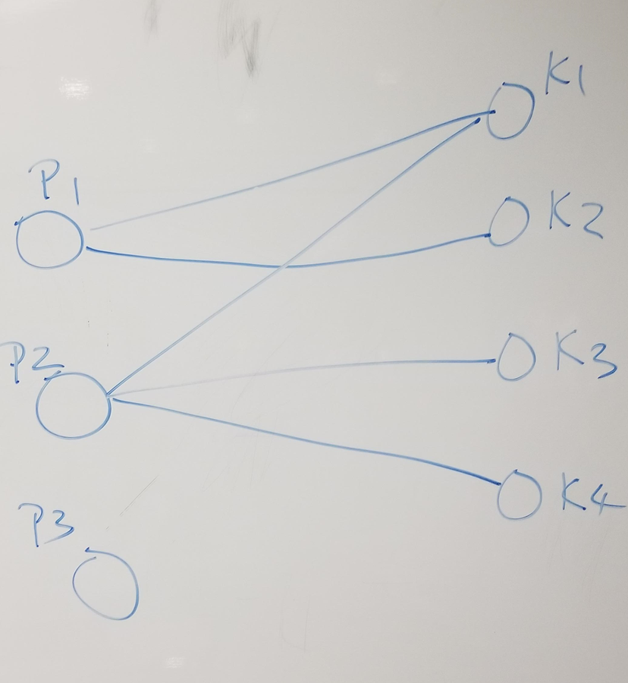
What is the key of the sakila database? Bad question
What are the candidate keys of the table film_actor in Sakila? Good.

