1/30/2020
A concept can be modeled as:
- Class: exist independently, have properties (attributes), form relationship,..
- Attribute
- Association: ask: what are the objects in the association?
- No modeling
SCMS
Create a data model by constructing an UML class diagram to support a portion of a drastically simplified part of a conference management database: SCMS. It only supports a very limited set of functions. Make reasonable assumptions.
SCMS supports hosting Web-based conference systems to manage conferences.
Concepts:
- Conference: class
- Management: relationship, not for the moment; no modeling.
- Conference system: class? (definition: a software managing conferences. E.g. SCMS.) Do we need to store data about the concept? (Do you have many instances of the concept?) no.
- Host: no, or later.
noun likely -> class (e.g. conference)
verb likely -> relationship Mr. A (object) chairs (verb -> relationship) conference B (object)
There are many real world conferences and you can browse a few to get some ideas. However, keep in mind that we are modeling a drastically simplified part only.
SCMS allows members to set up conferences for people to submit papers, review papers, and participate in the conferences.
- Member/People: more specific term -> member (naming is important). Assume people is a synonym of member.
  - Authors submit papers
  - Organizers organizes conference
- Paper
- Submit
- Conference type
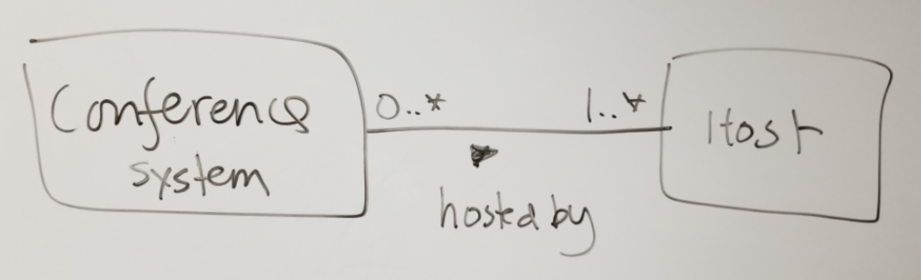
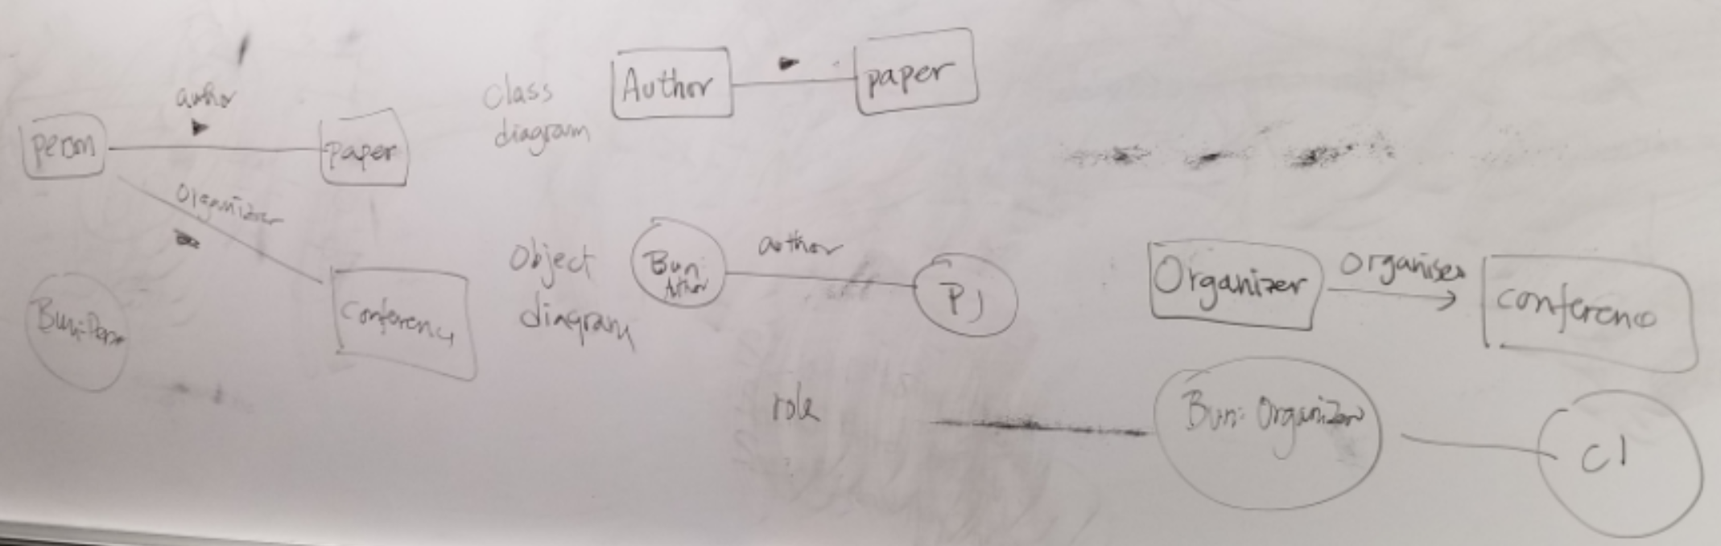

A conference has an unique Id (all Id should be of the type SQL:Id). It must have a name, start date, end date and a venue name. A venue must have an address. Every address must have an unique Id, a street, a city, and a country. It may or may not have a state or a zip code since come countries do not have them. A country has an unique country code and an unique name (e.g. 'US' and 'United States of America').
A conference has a lead organization and any number of support organizations. An organization has an unique Id, a name, and an optional phone (all Phone should be of the type SQL:PhoneType). An organization may have an address and/or a country of origination. For example, the organization 'BASG Houston' may have the address '2909, Bay Area Boulevard, Houston, TX 77058, USA' and a country of origin of 'Germany.'
A conference may have many tracks. For example, the conference 'Artificial Intelligence Application' (AIA) may have the tracks 'Machine Learning', 'Deep Learning', 'Genetic Algorithms', etc. Papers can be submitted to one of these tracks for publications. If a conference does not have any naturally tracks, a generic track, such as 'general', is created. All papers will then be submitted to this 'general' track. A track has an unique id and a track name. Note that a track name is not unique, as, for example, more than one conferences may have the same track names of 'Deep Learning.'
A paper has an unique Id, a title, a submission date (of type SQL:Datetime), and one or more authors. Any person stored in SCMS has a last name, a first name, an email, and an optional phone. Any person can be an author of multiple papers. The position of the authorship of a paper should be recorded. For example, the paper:
Jane Smith, Jade Johnson, Karl Eastmond, A mid-summer night dream of deep learning.
may be submitted to the track 'Deep Learning' of the conference AIA. The authorship information:
Author | Position | EMail | Phone | Organization
Jane Smith | 1 | smithJ111@uhcl.edu | NA | UHCL
Jade Johnson | 2 | JJohnson2088@gmail.com | NA | NA
Karl Eastmond | 3 | eastmondk1@uhcl.edu | 281-283-1000 | UHCL
A person can also review any number of papers. The review comment and outcome must be recorded. Outcomes are selected from a list of defined choices for a conference. For example, for AIA, the possible outcomes may be:
Outcome Id | Outcome # | Outcome
1290 | 1 | Accept with no modification
1291 | 2 | Accept with minor modifications
1292 | 3 | Accept with major modifications
1293 | 4 | Conditional Accept with major modifications
1294 | 5 | Reject
Note that Outcome # is meaningfully used by AIA only whereas Outcome Id is an unique Id across all conferences.
Thus, a person 'Beto Jones' may review the paper "A mid-summer night dream of deep learning" withe result:
- OutcomeId = 1290; 1, Accept with no modification.
- Comment = 'Excellent work.'
A paper can have any number of reviewers.
A paper may have many keywords, which can be shared among papers.
A person needs to be a registered member to participate in a conference. The account name and password of a member should be stored. The address of a member must also be recorded. A member may have an organization associated with him.
A conference must have a member as its chair. It can have any number of members as its managers. A member can attend many conferences.

UML
UML modeling: OO modeling: world in terms of objects and their relationship.
Example:
Problem. An used car dealership application's subsystem: information about cars and their manufacturer.
Specification: A car manufacturer has must have an unique id and name. A car maker may make many cars. For example, Honda, which may have an manufacturer id of 10001, makes Civic and Accord...
Analysis:
- Manufacturer: class (a template that can be used to initiate many manufacturer (instance).
- Honda: object of the class Manufacturer.
- Ambiguous term: manufacturer, may refer to the manufacturer class or a particular manufacturer.
- Synonym: manufacturer, car manufacturer, car maker. Different terms can refer to the same concept.
- Unique id: attribute (name), a property of the manufacturer class.
- Additional assumption: Every manufacturer object must have an unique id.
- 10001: attribute (value) of a manufacturer object.
- Name: a property of manufacturer.
- Additional assumption: Every manufacturer object must have a name.
- Car: a class as there may be many brands of cars.
- Question: Do we need to introduce the concept Model (e.g. Coupe, Sedan, Si Coupe)?
- Civic and Accord: object instance of Car.
- Additional assumption: Every car must have a name as its attribute.
- Make, or manufacture: a relationship between a manufacturer (object) and a car (object).

Class Diagram:
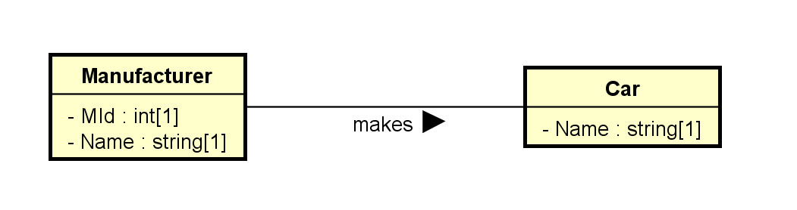
Object Diagram:
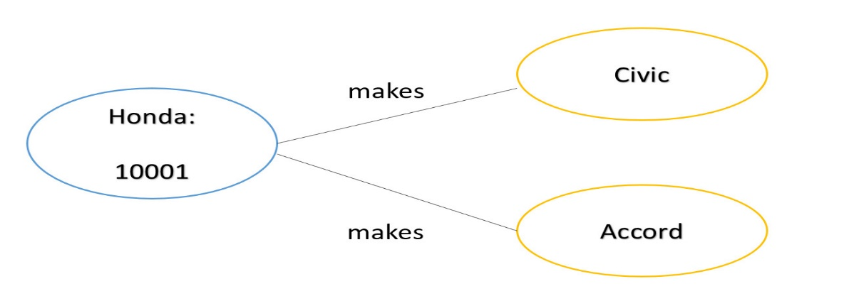
Astah/software tools:
- Underlying concepts: OOM what? Transferrable knowledge
- Graphical User Interface (GUI): less transferrable
Class diagram creation:

