UML
UML modeling: OO modeling: world in terms of objects and their relationship.
Example:
Problem. An used car dealership application's subsystem: information about cars and their manufacturer.
Specification: A car manufacturer has must have an unique id and name. A car maker may make many cars. For example, Honda, which may have an manufacturer id of 10001, makes Civic and Accord...
Analysis:
- Manufacturer: class (a template that can be used to initiate many manufacturer (instance).
- Honda: object of the class Manufacturer.
- Ambiguous term: manufacturer, may refer to the manufacturer class or a particular manufacturer.
- Synonym: manufacturer, car manufacturer, car maker. Different terms can refer to the same concept.
- Unique id: attribute (name), a property of the manufacturer class.
- Additional assumption: Every manufacturer object must have an unique id.
- 10001: attribute (value) of a manufacturer object.
- Name: a property of manufacturer.
- Additional assumption: Every manufacturer object must have a name.
- Car: a class as there may be many brands of cars.
- Question: Do we need to introduce the concept Model (e.g. Coupe, Sedan, Si Coupe)?
- Civic and Accord: object instance of Car.
- Additional assumption: Every car must have a name as its attribute.
- Make, or manufacture: a relationship between a manufacturer (object) and a car (object).

Class Diagram:
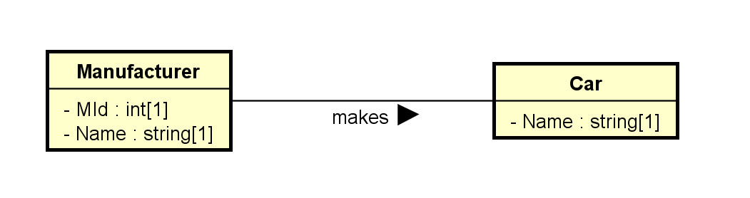
Object Diagram:
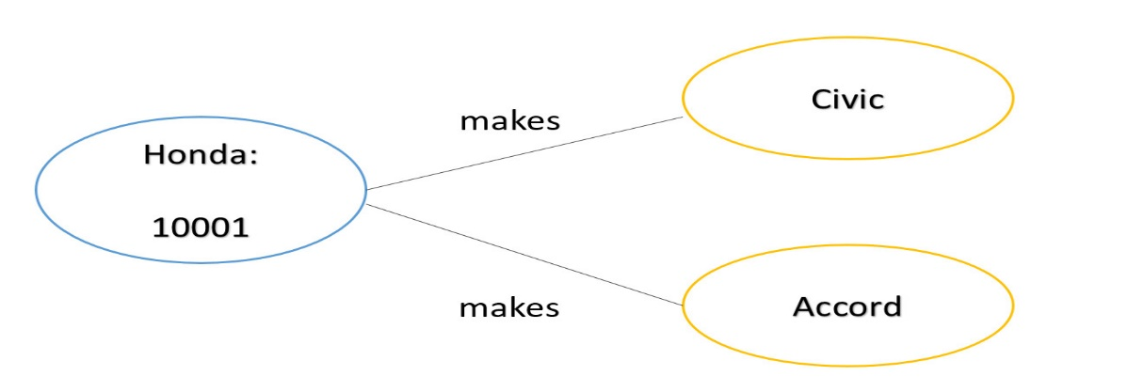
Astah/software tools:
- Underlying concepts: OOM what? Transferrable knowledge
- Graphical User Interface (GUI): less transferrable
Class diagram creation:

