CSCI 1470 CS 1 Annotation
2026/4/2

Functions
CSCI 1470
by K. Yue
1. Functions: Introduction
1.1 Mathematical Functions
- A mathematical function is a rule that takes one or more inputs and produces or returns exactly one output.
Examples:
f(x) = 2 * x + 4
f(y) = 2 * y + 4

g(y) = y ** 2 + 1
h(x,y,z) = x + y + z
f(1) returns 6
f(3) returns 10
g(2) returns 5
g(4) returns 17
h(1,2,3) returns 6
h(f(1),g(2),f(3)+g(4)): h(4,5,27) returns 38
- In f(x) = 2 * x + 4:
  - "2 * x + 4" is the definition or rule that produces the single output.
  - x is the only formal parameter (or parameter, or formal argument) of the function f.
  - x is also called a dummy variable as one can use any name., e.g. f(bun) = 2 * bun + 1.
- In f(2), 2 is the actual argument (or argument, or actual parameter).
- Since a function returns one output value, the output can be used as the actual parameter, or a part of it, of another function. E.g., h(f(1),g(2),f(3)+g(4))
- Thus. functions can be nested.
- The domain of a function is the set of all possible input values.
- The range of a function is the set of all possible output values.
F(x) = x * x
Domain: set of integers: {…,2,-1,0,1,2,…}
Range: set of non-negative integers.
1.2 Python Functions
- Python functions have many similarities with mathematical functions.
  - A function has a definition to compute the return value.
e.g.,
def get_max_value(data_dict: Dict[str, int]) -> Optional[int]:
"""Calculates the maximum of all integer values in the dictionary."""
if len(data_dict) == 0:
return None
else:
return max(data_dict.values())
  - Abstraction: To call a function, the user does not need to know how the function is implemented.
d1 = {}
""" Define five more dictionary for efficent testing here.
"""
d2 = {'a': 100, 'b': 5, 'c': 1, 'd': 40}
d3 = {'hello':1}
d4 = {'a': 100, 'b': 100, 'c': -1, 'd': 40}
d5 = {'a': 100, 'b': 'hello', 'c': 1, 'd': 40}
d6 = {} # to be updated.
"""
Six test cases for the function get_max_value.
"""
print(f"get_max_value({d1}): {get_max_value(d1)}")
print(f"get_max_value({d2}): {get_max_value(d2)}")
print(f"get_max_value({d3}): {get_max_value(d3)}")
print(f"get_max_value({d4}): {get_max_value(d4)}")

  - A function can have 0, 1, or more parameters.
E.g., max(1,2,4,5,6,7)
  - A function returns a single value.
  - A function can be nested.
max(1,2,3,max(4,5),sum(6,7))
  - A function can be recursive: a function can call itself in its definition.
E.g., fib(1) = 0, fib(2) = 1; fib(n) = fib(n-1)+ fib(n-2)
- Python functions also have many differences with mathematical functions. Examples:
  - Can produce different outputs for the same inputs (Python's fucntions can have internal states, e.g., keeping a count.)
  - May have side effects (actions other than the returned values) (e.g., print something inside a function).
    - Functions are preferrably than procedures (do not return a value, work by using side effects).
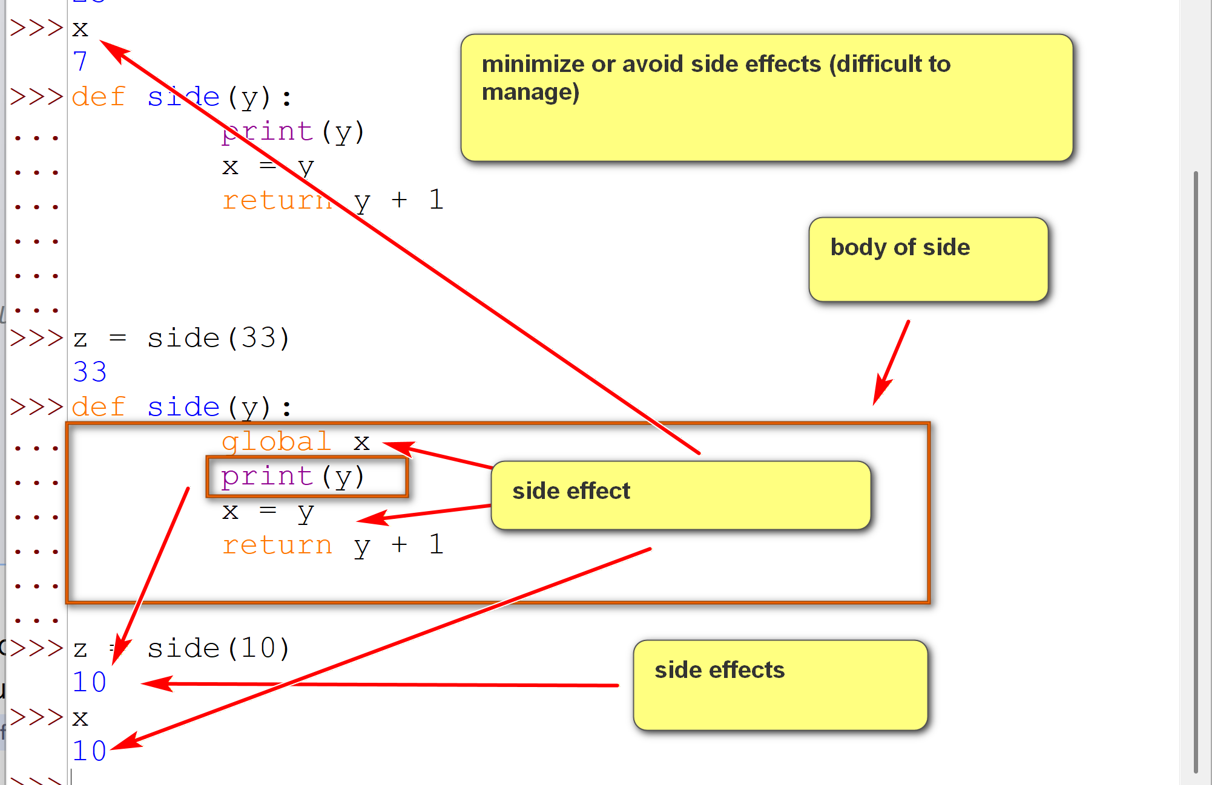
  - Parameters with default values

Math function: sqrt(x): no default value of x.
Prompt: python function with default value examples.
# Function with one default argument
def greet(name="Guest"): # name: parameter, formal parameters. “Guest”: default value.
print(f"Hello, {name}!") # body of the function greet.
# Function calls
greet() # Output: Hello, Guest! (uses the default value)
greet("Varad") # Output: Hello, Varad! (overrides the default value)
# “Varad”: arguments, actual arguments

  - Varying number of parameters
E.g., max(1,2,3,4,5,6)
max(1,2)
  - ...
There are many advantages of using Python's functions. Some advantages include:
- Code Reuse: a function can be called multiple times by many programs.
- Decomposition and modularity: complex code can be decomposed into multiple functions.
- Simpler development: a function represents a single well-defined action.
- Reliability and error reduction: a function can be thoroughly tested before use.
- Improved organization and software architecture: functions can be organized into classes, modules and packages for efficient organization.
- Understandability: when there are no side effects, functions can be thoroughly understood by their return values.
- Encapsulation/abstraction: functions encapsulate a specific set of operations, hiding the internal details from the callers.
2. User-defined Functions
- The format of a user-defined function:
def function_name(parameters):
function_body (indented)
- The return statement is used to exit a function and return a value to the caller.
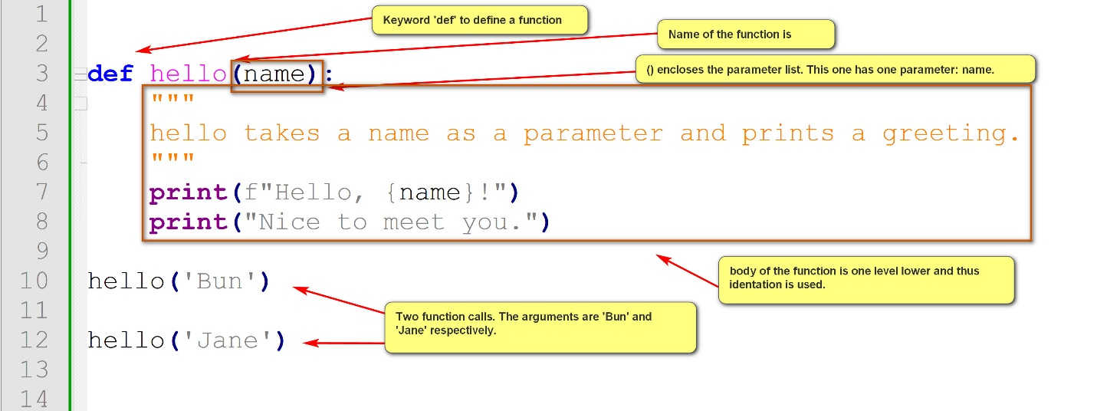
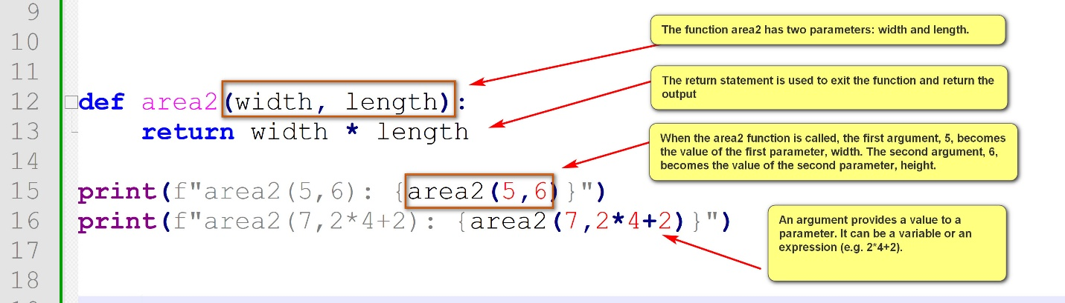
Example:
fun_basic_1.py
def area(width, length):
print(f"Area of a {width} * {length} rectangle: {width * length}")
# The print statement is an example of 'side effect': action other than the return value. Side effects should be avoided as much as possible.
area(5,6)
area(7,10)
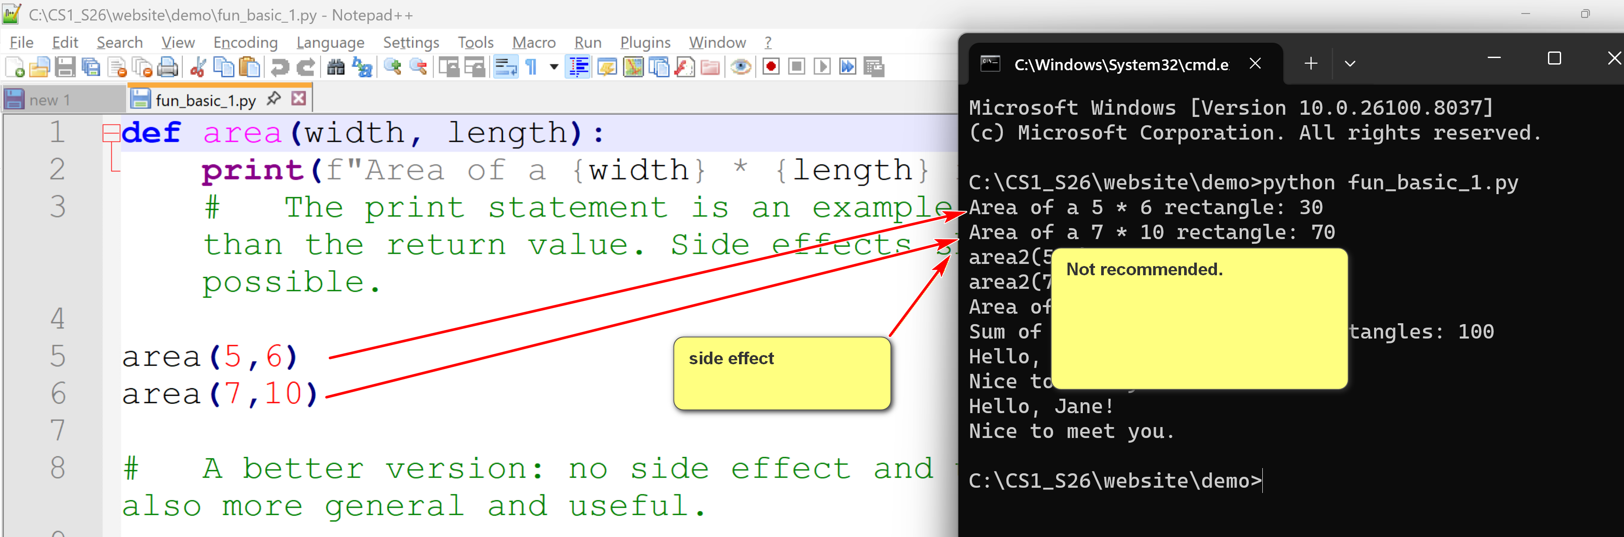
# A better version: no side effect and use the return statement. It is also more general and useful.
def area2(width, length):
return width * length
print(f"area2(5,6): {area2(5,6)}")
print(f"area2(7,2*4+2): {area2(7,2*4+2)}")
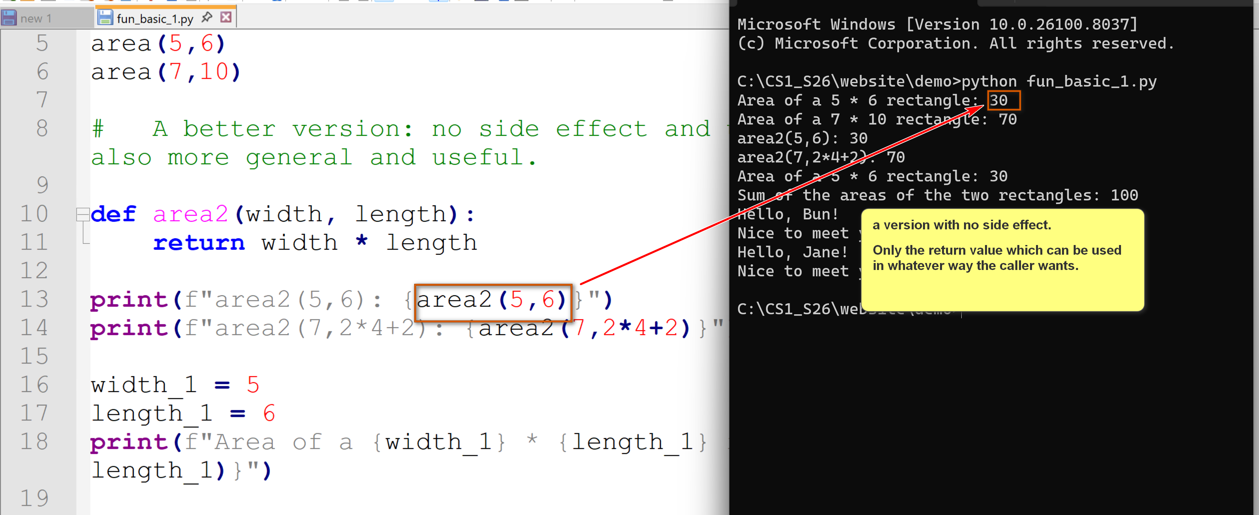
width_1 = 5
length_1 = 6
print(f"Area of a {width_1} * {length_1} rectangle: {area2(width_1, length_1)}")
width_2 = 7
length_2 = 10
print(f"Sum of the areas of the two rectangles: {area2(width_1, length_1) + area2(width_2, length_2)}")
def hello(name):
"""
hello takes a name as a parameter and prints a greeting.
"""
print(f"Hello, {name}!")
print("Nice to meet you.")
hello('Bun')
hello('Jane')
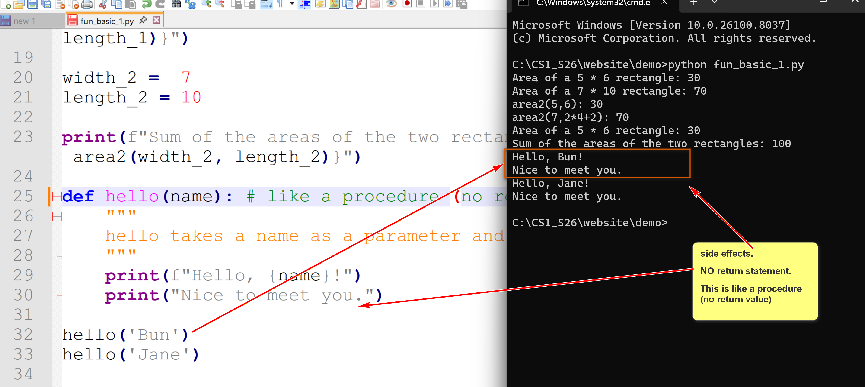
The following example shows some advantages of functions.
Example:
Get the names and ages of three players and display greetings.
Without using function: player_greetings_no_fun.py
# Process player 1 input and display a welcome message.
player_1_name = input("Player 1: please enter your name: ")
player_1_age = int(input("Player 1: please enter your age: "))
if player_1_age >= 18:
print(f"Hello, {player_1_name}! You are an adult.")
else:
print(f"Hello, {player_1_name}! You are a minor.")
# Process player 2 input and display a welcome message.
player_2_name = input("Player 2: please enter your name: ")
player_2_age = int(input("Player 2: please enter your age: "))
if player_2_age >= 18:
print(f"Hello, {player_2_name}! You are an adult.")
else:
print(f"Hello, {player_2_name}! You are a minor.")
# Process player 3 input and display a welcome message.
player_3_name = input("Player 3: please enter your name: ")
player_3_age = int(input("Player 3: please enter your age: "))
if player_3_age >= 18:
print(f"Hello, {player_3_name}! You are an adult.")
else:
print(f"Hello, {player_3_name}! You are a minor.")
- Note the same code for getting input (the input statements) and displaying greetings (the if-then-else statement with print) are repeated three times.
Using two functions: player_greetings.py
def get_user_details(user):
name = input(f"{user}: please enter your name: ")
age = int(input(f"{user}: please your age: "))
return name, age # Python can return multiple values
def display_greeting(name, age):
if age >= 18:
print(f"Hello, {name}! You are an adult.")
else:
print(f"Hello, {name}! You are a minor.")
# Main program
player_1_name, player_1_age = get_user_details("Player 1")
display_greeting(player_1_name, player_1_age)
player_2_name, player_2_age = get_user_details("Player 2")
display_greeting(player_2_name, player_2_age)
player_3_name, player_3_age = get_user_details("Player 3")
display_greeting(player_3_name, player_3_age)
If the way of getting input and displaying greetings are changed, and there are now four players:
player_greetings_v2.py
def get_user_details(user):
name = input(f"{user}: please enter your name: ")
age = int(input(f"{user}: and your age: "))
return name, age
def display_greeting(name, age):
if age >= 90:
print(f"Hello, {name}! Sure want to play? :-)")
else:
print(f"Hello, {name}! Let's roll.")
# Main program
player_1_name, player_1_age = get_user_details("Player 1")
display_greeting(player_1_name, player_1_age)
player_2_name, player_2_age = get_user_details("Player 2")
display_greeting(player_2_name, player_2_age)
player_3_name, player_3_age = get_user_details("Player 3")
display_greeting(player_3_name, player_3_age)
player_4_name, player_4_age = get_user_details("Player 4")
display_greeting(player_4_name, player_4_age)
2.1 Function parameters and arguments
- Parameters (formal parameters, formal arguments) are placeholders defined within the parentheses of a function's def statement.
def get_user_details(user):
name = input(f"{user}: please enter your name: ")
age = int(input(f"{user}: and your age: "))
return name, age
- They receive values from arguments (actual argument, actual parameters)when the function is called.
player_1_name, player_1_age = get_user_details("Player 1")
- Parameters can have default values.
Prompt: “give me a Python function example with two default values”
From Gemini:
def greet(name="World", greeting="Hello"):
"""
Greets a user with a customizable name and greeting.

Args:
name: The name of the person to greet. Defaults to "World".
greeting: The type of greeting to use. Defaults to "Hello".
"""
return f"{greeting}, {name}!"
# Example 1: Call without any arguments (uses both default values)
print(f"No arguments: {greet()}")
# Example 2: Call with one argument (overrides 'name', uses default 'greeting')
print(f"One argument: {greet('Alice')}")
# Example 3: Call with both arguments (overrides both default values)
print(f"Both arguments: {greet('Bob', 'Hi')}")

# Example 4: Call with a specific keyword argument (overrides 'greeting' specifically)
print(f"Keyword argument: {greet(greeting='Greetings')}")

2.1.1 Positional and named arguments
- Positional arguments are assigned to parameters based on their order in the function call. The first argument is assigned to the first parameter, the second to the second, and so on. Some advantages:
  - Simplicity
  - Familiarity: many programming languages support only positional parameters.
  - Clarity and consistency: if there are natural orders.
  - Function evolution
- Named arguments (keyword arguments) are a way to pass values to a function by explicitly specifying the parameter name along with the value. Some advantages:
  - Clarify
  - Order independence
  - Ease of use with default values
Example:
param_1.py:
# positional parameters
def add_two(a,b):
return a+b
print("""
def add_two(a=1,b=0):
return a+b
""")
print(f"add_two(1,4): {add_two(1,4)}")
print(f"add_two(a=1,b=4): {add_two(a=1,b=4)}")
print(f"add_two(-1,40): {add_two(-1,40)}")
def add_two_with_default(a=1,b=2):
return a+b
print("""
def add_two_with_default(a=1,b=2):
return a+b
""")
print(f"add_two_with_default(1,4): {add_two_with_default(1,4)}")
print(f"add_two_with_default(a=1,b=4): {add_two_with_default(a=1,b=4)}")
print(f"add_two_with_default(-1,40): {add_two_with_default(-1,40)}")
print(f"add_two_with_default(8): {add_two_with_default(8)}")
print(f"add_two_with_default(b=1): {add_two_with_default(b=1)}")
print(f"add_two_with_default(): {add_two_with_default()}")
# Positional parameters and keyworded (named) parameters.
# A parameter has a position and a name.
def introduce(name, age):
print(f"My name is {name} and I am {age} years old.")
return 'done'
print("""
def introduce(name, age):
print(f"My name is {name} and I am {age} years old.")
return 'done'
""")
print(f"introduce('Jane', 19): {introduce('Jane', 19)}")
print(f"introduce(19,'Jane'): {introduce(19,'Jane')}")
print(f"introduce(name='Jane', age=19): {introduce(name='Jane', age=19)}")
print(f"introduce(age=19,name='Jane'): {introduce(age=19,name='Jane')}")
- Python functions support multiple arguments: varying number of arguments.
  - *positional_parameter_name can be used to accept multiple number of positional arguments into the parameter positional_parameter_name.
  - * (by itself) signals the end of positional parameters. Parameters thereafter must be named parameters.
  - **named_parameter_name can be used to accept multiple numbers of named arguments into the parameter named_parameter_name.
Example:
param_2.py:
# arbitrary numbers of arguments.
def add(*args):
return sum(args)
print("""
def add(*args):
return sum(args)
""")
print(f"add(1,2,3,4,5): {add(1,2,3,4,5)}")
print(f"add(10,2,3,4,5,6,7): {add(10,2,3,4,5,6,7)}")
def multiplied_sum(*numbers, multiplier=1):
total_sum = sum(numbers)
return total_sum * multiplier
print("""
def multiplied_sum(*numbers, multiplier=1):
total_sum = sum(numbers)
return total_sum * multiplier
""")
print(f"multiplied_sum(1,2,3,4,multiplier=5): {multiplied_sum(1,2,3,4,multiplier=5)}")
print(f"multiplied_sum(1,2,3,4,5): {multiplied_sum(1,2,3,4,5)}")
def area(*, width, length):
return width * length
print("""
def area(*, width, length):
return width * length
""")
print(f"area(width=2,length=3): {area(width=2,length=3)}")
print(
"""
print(f"area(2,3): {area(2,3)}")
TypeError: area() takes 0 positional arguments but 2 were given
"""
)
2.2 Specifying types of functions
- Python allows the specification of parameter and return types in function definitions.
- This specification is type hint for advsiory purpose, and is not enforced by Python runtime.
- However, it is a good practice, especially for big projects.
- It enhances code readability and maintainability, supports collaboration and better IDE features.
Example:
def sum(a: int, b: int) -> int:
return a+b
#
def divide(a: int, b: int) -> in | None:
if b == 0:
return None
else:
return a+b
2.3 Functions are objects
- Functions are first class objects. For examples, they can be assigned to a variable.
- Python's functions are callable objects: objects that can be called.
- This flexibility supports powerful use patterns for constructing solutions.
- In this course, we provide only simple examples behind the concept.
Example:
fun_obj_1.py: functions are callable objects.
def hello(name):
print(f"hello, {name}. Nice to see you.")
def bye(name):
print(f"Bye, {name}. See you next time.")
my_func = hello
my_func('Bun')
my_func = bye
my_func('Bun')
greetings = {
"hello": hello,
"bye": bye
}
greetings["hello"]("Jane")
greetings["bye"]("Jane")
3. Python built-in functions and imported functions
- Python built-in functions are standard functions that come with Python distribution.
- Imported functions are functions defined in Python modules. To use them, two steps are needed.
  - Install the module using pip.
  - Import the module in your program.
3.1 Built-in functions
To understand built-in functions:
- Consult the official Python documentation: https://docs.python.org/3/library/functions.html
- Use the help() function in Python
- Textbook, tutorials, courses, instructors, ...
Example:
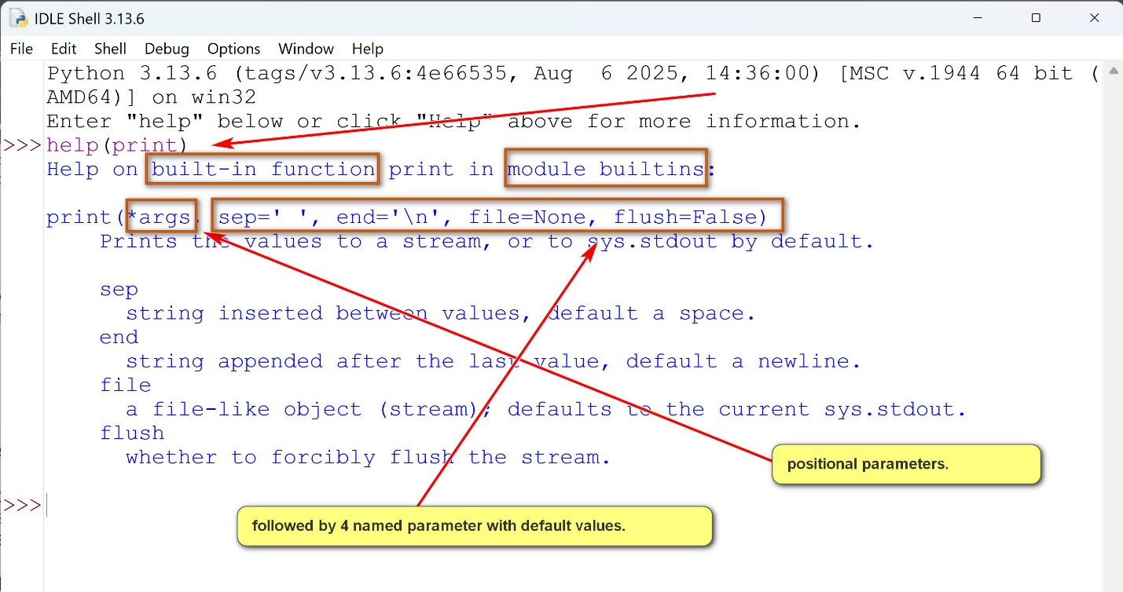
Some categories of built-in functions:
- Type conversions and creation: e.g., int(), float(), str(), list(), tuple(), ...
- Mathematical operations: e.g., max(), min(), sum(), pow(), ...
- Iteration and sequence operations: e.g., len(), range(), enumerate(), reversed(), sorted(), ...
- Object and attribute manipulation operations: e.g., id(), type(), hasattr(), ...
- Input/Output: e.g., input(), print(), open(), ...
- Code execution operations: e.g., eval(), exec(), ...
3.2 Imported functions
- Python modules can be imported by the import statement.
- Functions in the modules can then be called by their full names: module_name.function_name.
- Alternately, functions can be imported by using "from module_name import function_name, ..."
- The imported functions can then be used directly without the modules name: function_name.
Example:
builtin_fun_1.py:
import math
from random import randint
# imported functions of the math module are called by full names: e.g., math.sqrt()
# imported function randint of the random module is called directly.
print(f"math.sqrt(64): {math.sqrt(64)}")
print(f"math.pi: {math.pi}")
print(f"math.sin(1): {math.sin(1)}")
print(f"math.gcd(24,36,126): {math.gcd(24,36,126)}")
print(f"math.lcm(24,36,126): {math.lcm(24,36,126)}")
print(f"randint(1,10): {randint(1,10)}")
print(f"randint(1,10): {randint(1,10)}")
print(f"randint(1,10): {randint(1,10)}")
print(f"randint(1,10): {randint(1,10)}")
print(f"randint(1,10): {randint(1,10)}")
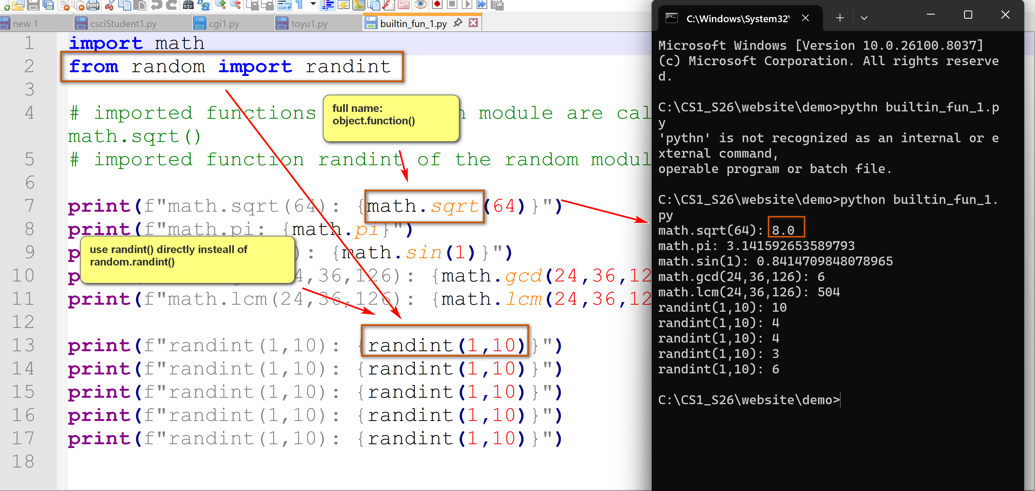

Introduction to pandas in Python
by K. Yue
1. Overview of the pandas module
- Pandas is an open-source Python library used for data manipulation, analysis, and cleaning.
- Resources:
  - Main site: https://pandas.pydata.org/
  - pandas at w3schools: https://www.w3schools.com/python/pandas/default.asp
  - Codebase in Github: https://github.com/pandas-dev/pandas
- Installation: at command line prompt: "pip install pandas"
- Pandas is based on two dimensional tables, similar but more flexible and powerful than Excel's tables.
Two dimensional arrays: Excel worksheet: 2d array:
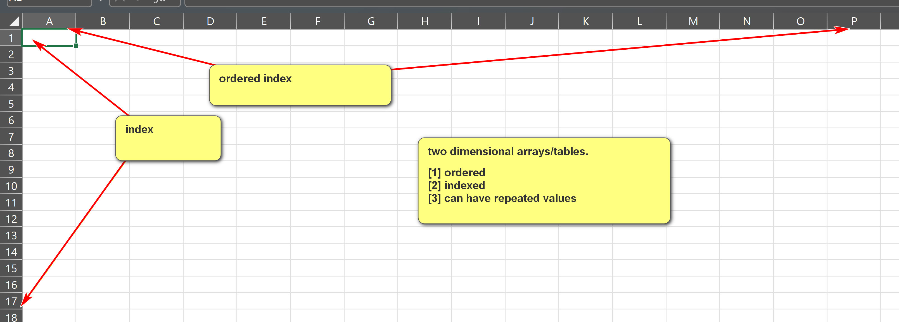
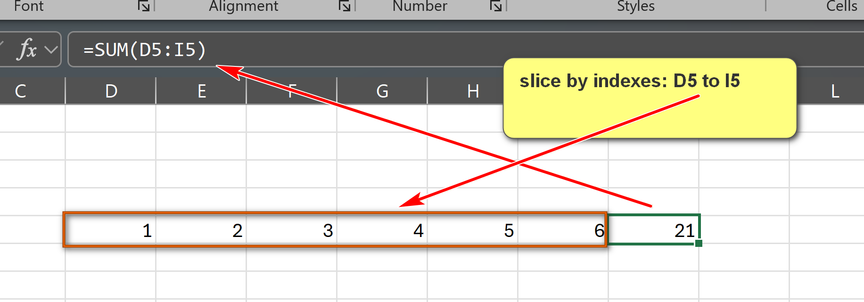

- A table contains ordered or indexed rows and columns.
- Pandas are very fast in analysis of large datasets.
- Pandas provide vectoized (column-wise) operations.
- Two main data structures
  - Series:
    - A one-dimensional array, with labels, usually contains elements of a same type.
    - Similar to a column in a spreadsheet (e.g., Excel).
    - Size-mutable and type-mutable.
  - DataFrame:
    - A two-dimensional array with labeled axes (rows and columns).
    - Similar to an entire worksheet in a spreadsheet or a table in a relational database.
    - Size-mutable and type-mutable.
Examples:
pandas_series_1.py: Please download, run and annotate the program.
Note that numpy.nan is of the numpy data type of numpy.float64 (a 64-bit floating-point number).
import pandas as pd
import numpy as np
# Create a simple Series from a list of values; default integer index is used
data = [10, 20, 30, 40, 50]
series_1 = pd.Series(data)
print(f"series_1: Series from a list: {data}")
print(series_1)
print()
# An empty series.
series_2 = pd.Series()
print("series_2: empty series: []")
print(series_2)
print()
# A series with custom labels/indices.
test_data = [90, 77, 90]
test_index = ["test_1", "test_2", "test_3"]
series_3 = pd.Series(test_data, index=test_index)
print(f"series_3: explicitly labeled series.")
print(f"element values: {test_data}")
print(f"custom index: {test_index}")
print(series_3)
print()
# A series with custom labels/indices and a 'not a number' value (np.nan)
test_data = [90, 77, 90, np.nan]
test_index = ["test_1", "test_2", "test_3", "test_4"]
series_4 = pd.Series(test_data, index=test_index)
print(f"series_4: explicitly labeled series.")
print(f"element values: {test_data}")
print(f"custom index: {test_index}")
print(series_4)
print()
# Example methods of Series
print(f"series_4.head(): {series_4.head()}")
print()
print(f"series_4.describe(): {series_4.describe()}")
print()
print(f"series_4.value_counts(): {series_4.value_counts()}")
print()
print(f"series_4.sort_values():\n{series_4.sort_values()}")
print()
print(f"series_4:\n{series_4}")
print()
print(f"series_4.dropna():\n{series_4.dropna()}")
print()
print(f"series_4:\n{series_4}")
pandas_df_1.py: Please download, run and annotate the program.
import pandas as pd
import numpy as np
data_1 = {
'id': ['1011231', '2201031', '0882541', '3452211'],
'Name': ['John Sawyer', 'Alice Johnson', 'Lee Tran', 'Bobby Jones'],
'major': ['CS', 'CIS', 'CS', 'MATH']
}
df1 = pd.DataFrame(data_1)
print(f"df1:\n{df1}")
print()
data_2 = {
'CIS': [110,151,138,145,120,114],
'CS': [132,153,128,160,130,126],
'ITEC': [80,99,110,115,121,115]
}
year = [2021,2022,2023,2024,2025,2026]
df2 = pd.DataFrame(data_2, index=year)
print(f"df2:\n{df2}")
print()
# sum
print(f"df2.sum(axis=0):\n{df2.sum(axis=0)}")
print()
print(f"df2.sum(axis=1):\n{df2.sum(axis=1)}")
print()
print("Descriptive statistics for all columns in df2 (df2.describe()):")
print(df2.describe())
print()
print(f"df2.head(3):\n{df2.head(3)}")
print()
print(f"df2.tail(3):\n{df2.tail(3)}")
print()
print(f"df2.loc[2023]:\n{df2.loc[2023]}")
print()
print(f"df2.loc[2025]:\n{df2.loc[2025]}")
print()

