CSCI 1470 CS 1 Annotation
2026/4/9
Introduction to pandas in Python
by K. Yue
1. Overview of the pandas module
- Pandas is an open-source Python library used for data manipulation, analysis, and cleaning.
- Resources:
  - Main site: https://pandas.pydata.org/
  - pandas at w3schools: https://www.w3schools.com/python/pandas/default.asp
  - Codebase in Github: https://github.com/pandas-dev/pandas
- Installation: at command line prompt: "pip install pandas"
- Pandas is based on two dimensional tables, similar but more flexible and powerful than Excel's tables.
Two dimensional arrays: Excel worksheet: 2d array:
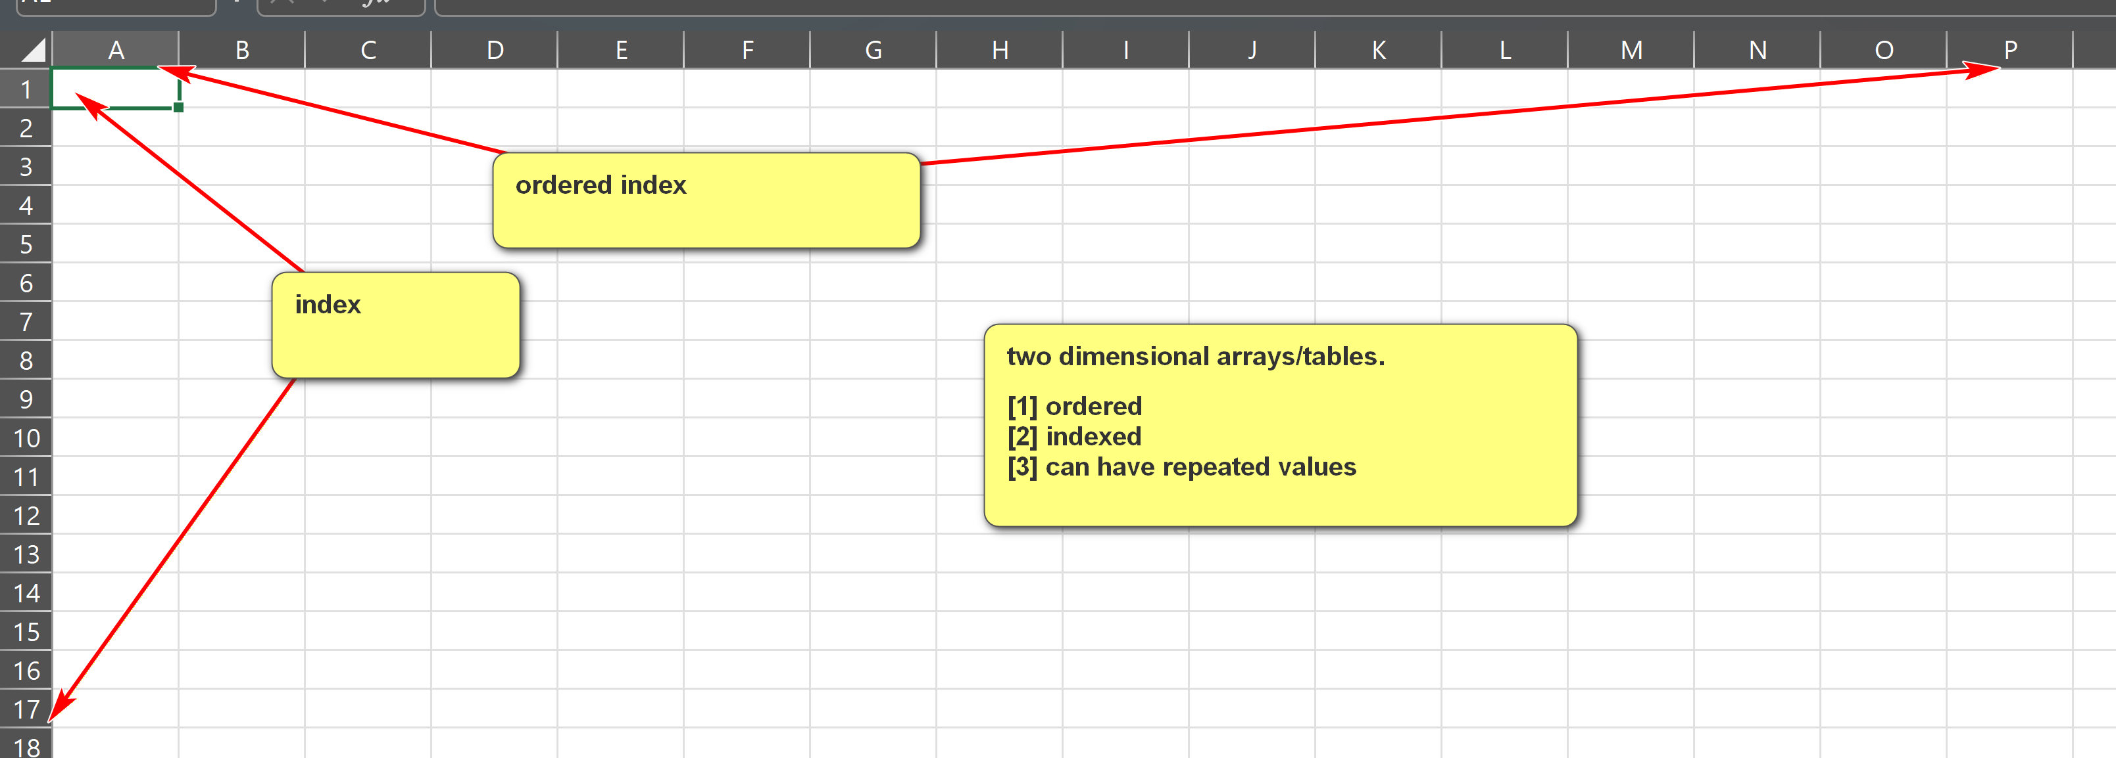
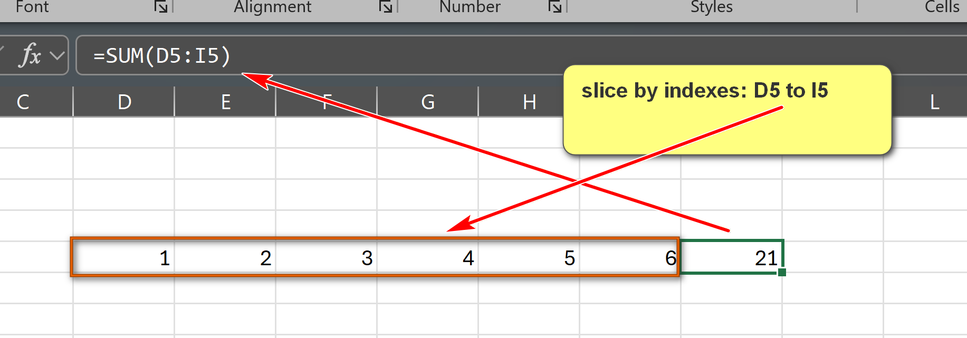

- A table contains ordered or indexed rows and columns.
- Pandas are very fast in analysis of large datasets.
- Pandas provide vectoized (column-wise) operations.
- Two main data structures
  - Series:
    - A one-dimensional array, with labels, usually contains elements of a same type.
    - Similar to a column in a spreadsheet (e.g., Excel).
    - Size-mutable and type-mutable.
  - DataFrame:
    - A two-dimensional array with labeled axes (rows and columns).
    - Similar to an entire worksheet in a spreadsheet or a table in a relational database.
    - Size-mutable and type-mutable.
Examples:
pandas_series_1.py: Please download, run and annotate the program.
Note that numpy.nan is of the numpy data type of numpy.float64 (a 64-bit floating-point number).
import pandas as pd
import numpy as np
# Create a simple Series from a list of values; default integer index is used
data = [10, 20, 30, 40, 50]
series_1 = pd.Series(data)
print(f"series_1: Series from a list: {data}")
print(series_1)
print()
# An empty series.
series_2 = pd.Series()
print("series_2: empty series: []")
print(series_2)
print()
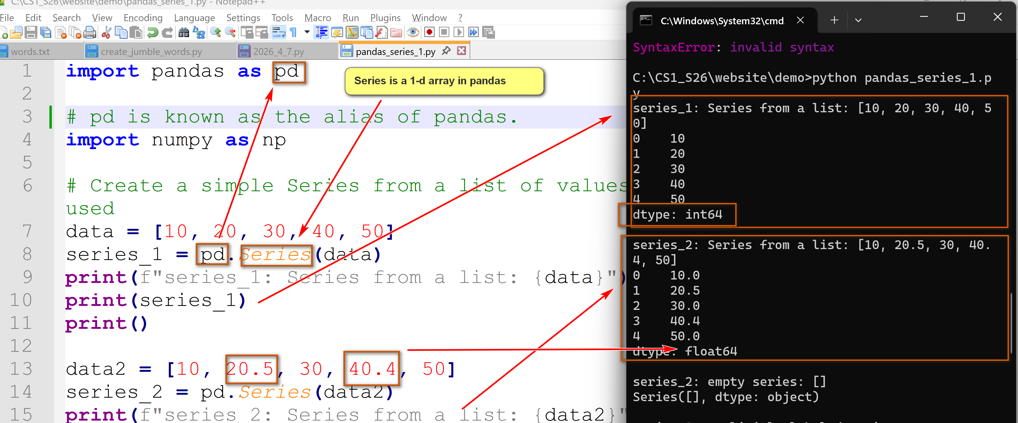
# A series with custom labels/indices.
test_data = [90, 77, 90]
test_index = ["test_1", "test_2", "test_3"]
series_3 = pd.Series(test_data, index=test_index)
print(f"series_3: explicitly labeled series.")
print(f"element values: {test_data}")
print(f"custom index: {test_index}")
print(series_3)
print()
# A series with custom labels/indices and a 'not a number' value (np.nan)
test_data = [90, 77, 90, np.nan]
test_index = ["test_1", "test_2", "test_3", "test_4"]
series_4 = pd.Series(test_data, index=test_index)
print(f"series_4: explicitly labeled series.")
print(f"element values: {test_data}")
print(f"custom index: {test_index}")
print(series_4)
print()
# Example methods of Series
print(f"series_4.head(): {series_4.head()}")
print()
print(f"series_4.describe(): {series_4.describe()}")
print()
print(f"series_4.value_counts(): {series_4.value_counts()}")
print()
print(f"series_4.sort_values():\n{series_4.sort_values()}")
print()
print(f"series_4:\n{series_4}")
print()
print(f"series_4.dropna():\n{series_4.dropna()}")
print()
print(f"series_4:\n{series_4}")
pandas_df_1.py: Please download, run and annotate the program.
import pandas as pd
import numpy as np
data_1 = {
'id': ['1011231', '2201031', '0882541', '3452211'],
'Name': ['John Sawyer', 'Alice Johnson', 'Lee Tran', 'Bobby Jones'],
'major': ['CS', 'CIS', 'CS', 'MATH']
}
df1 = pd.DataFrame(data_1)
print(f"df1:\n{df1}")
print()
data_2 = {
'CIS': [110,151,138,145,120,114],
'CS': [132,153,128,160,130,126],
'ITEC': [80,99,110,115,121,115]
}
year = [2021,2022,2023,2024,2025,2026]
df2 = pd.DataFrame(data_2, index=year)
print(f"df2:\n{df2}")
print()
# sum
print(f"df2.sum(axis=0):\n{df2.sum(axis=0)}")
print()
print(f"df2.sum(axis=1):\n{df2.sum(axis=1)}")
print()
print("Descriptive statistics for all columns in df2 (df2.describe()):")
print(df2.describe())
print()
print(f"df2.head(3):\n{df2.head(3)}")
print()
print(f"df2.tail(3):\n{df2.tail(3)}")
print()
print(f"df2.loc[2023]:\n{df2.loc[2023]}")
print()
print(f"df2.loc[2025]:\n{df2.loc[2025]}")
print()

Strings
CSCI 1470
by K. Yue
1. String Reviews
- String creation: either use ' or "
  - One quote strings: one line
  - Three quote strings: multiple line.
- Special characters: ' and " (starts or ends a string)
- Escape characters: \
  - \\: \ within a string
  - \': ' within a string
  - \": " within a string
  - \n: newline
  - \t: tab
  - ...
- Strings are immutable.
- Strings are objects.
- String is a sequence type that is iterable.
- Iterable objects can use:
  - index for refering to an elment.
  - slice for refering to a range of elements.
Example:
string_basic_1.py: strings are immutable.
# strings are immutable.
a = 'abcdefgh'
print(f"a: {a}")
print(f"a.upper(): {a.upper()}")
print(f"a: {a}")
# As a comparison, lists are mutable
list_a = ['a', 'b', 'c']
list_b = list_a
list_c = list(list_a)
print(f"list_a: {list_a}")
print(f"list_b: {list_b}")
print(f"list_c: {list_c}")
print("result = list_a.append('d')")
result = list_a.append('d')
print(f"list_a: {list_a}")
print(f"list_b: {list_b}")
print(f"list_c: {list_c}")
print(f"result: {result}")
2. Iterable index and slice
- Python iterable includes strings, lists, tuples, etc.
- Index is 0-based. The first index is 0.
- A slice of an iterable uses the format of iterable[start:stop:step].
  - start: The optional starting index of the slice (inclusive). If omitted, it defaults to 0.
  - stop: The optional ending index of the slice (exclusive). If omitted, it defaults to the end of the iterable, i.e., len(iterable).
  - step: The optional increment between elements. If omitted, it defaults to 1. A negative step value reverses the order of the slice.
Example:
string_slice_1.py: assure that you understand the output.
s = "0123456789"
print(f"s: {s}")
print(f"len(s): {len(s)}")
print(f"s[0]: {s[0]}")
print(f"s[1]: {s[1]}")
print(f"s[5]: {s[5]}")
print(f"s[9]: {s[9]}")
print("""
try:
print(f"s[10]: {s[10]}")
except IndexError:
print("s[10] out of range")
""")
try:
print(f"s[10]: {s[10]}")
except IndexError:
print("s[10] out of range")
print()
print(f"s[1:3]: {s[1:3]}")
print(f"s[1:]: {s[1:]}")
print(f"s[:3]: {s[:3]}")
print(f"s[1:8:2]: {s[1:8:2]}")
print(f"s[1::2]: {s[1::2]}")
print(f"s[::2]: {s[::2]}")
print(f"s[:7:2]: {s[:7:2]}")
print(f"s[::-1]: {s[::-1]}")
print(f"s[::-2]: {s[::-2]}")
print(f"s[1:8:-1]: {s[1:8:-1]}")
print(f"s[8:1:-1]: {s[8:1:-1]}")
print(f"s[8:1:-3]: {s[8:1:-3]}")
3. String's Methods
- In Python, a string is an object of the built-in class str.
- An object has functions, called methods.
- A method is called using the dot notation: an_object.a_method().
- Python has a rich collection of built-in string methods.
- Since strings are immutable, if a string method returns a string, the string is a new object and the original string does not change.
- Python string methods: https://docs.python.org/3/library/stdtypes.html#string-methods
- w3school has a good collection of string methods with examples: https://www.w3schools.com/python/python_strings_methods.asp
3.1 String Comparisions
- String comparison operators: ==, !=, >, >=, <, <=.
- Lexicographical Comparison:
  - Comparison is done character by character until the result is known.
  - Character comparison by their unicode values.
Example:
string_comp_1.py:
# unicode
for char in '0123456789abcdefghijklmnopqrstuvwxyzABCDEFGHIJKLMNOPQRSTUVWXYZ':
print(f"ord('{char}'), unicode value: {ord(char)}")
print()
print()
# string comparisons.
a = 'hello'
b = 'Hello'
c = 'Hell'
d = '1234'
e = '57'
f = '553'
print(f"'{a}'=='hello': {a=='hello'}")
print(f"'{a}'!='hello': {a!='hello'}")
print(f"'{a}'>'hello': {a>'hello'}")
print(f"'{a}'>='hello': {a>='hello'}")
print(f"'{a}'<'hello': {a<'hello'}")
print(f"'{a}'<='hello': {a<='hello'}")
print()
print(f"'{b}'=='Hello': {b=='Hello'}")
print()
print(f"'{a}'=='{b}': {a==b}")
print(f"'{a}'!='{b}': {a!=b}")
print(f"'{a}'>'{b}': {a>b}")
print(f"'{a}'>='{b}': {a>=b}")
print(f"'{a}'<'{b}': {a<b}")
print(f"'{a}'<='{b}': {a<=b}")
print()
print(f"'{a}'=='{c}': {a==c}")
print(f"'{a}'!='{c}': {a!=c}")
print(f"'{a}'>'{c}': {a>c}")
print(f"'{a}'>='{c}': {a>=c}")
print(f"'{a}'<'{c}': {a<c}")
print(f"'{a}'<='{c}': {a<=c}")
print()
print(f"'{b}'=='{c}': {b==c}")
print(f"'{b}'!='{c}': {b!=c}")
print(f"'{b}'>'{c}': {b>c}")
print(f"'{b}'>='{c}': {b>=c}")
print(f"'{b}'<'{c}': {b<c}")
print(f"'{b}'<='{c}': {b<=c}")
print()
print(f"'{d}'=='{e}': {d==e}")
print(f"'{d}'!='{e}': {d!=e}")
print(f"'{d}'>'{e}': {d>e}")
print(f"'{d}'>='{e}': {d>=e}")
print(f"'{d}'<'{e}': {d<e}")
print(f"'{d}'<='{e}': {d<=e}")
print()
print(f"'{d}'=='{f}': {d==f}")
print(f"'{d}'!='{f}': {d!=f}")
print(f"'{d}'>'{f}': {d>f}")
print(f"'{d}'>='{f}': {d>=f}")
print(f"'{d}'<'{f}': {d<f}")
print(f"'{d}'<='{f}': {d<=f}")
print()
print(f"'{e}'=='{f}': {e==f}")
print(f"'{e}'!='{f}': {e!=f}")
print(f"'{e}'>'{f}': {e>f}")
print(f"'{e}'>='{f}': {e>=f}")
print(f"'{e}'<'{f}': {e<f}")
print(f"'{e}'<='{f}': {e<=f}")
3.2 Splitting and joining string
- The string.split() method is a built-in string method to split or divide a string into a list of substrings based on a specified delimiter.
- Format: a_string.split(separator, maxsplit).
  - separater: a delimiter string for splitting. Default: white spaces.
  - maxsplit: number of splits. Default: -1 meaning as many as possible.
- The string.join() method is used to concatenate the elements of an iterable (such as a list, tuple, or set) into a single string.
- Format: a_separator_string.join(a_list): returns the result of concatenating the elements of an iterable with a_separator_string inserted as the delimter between the element.
Example:
string_split_1.py: Ensure that you understand the output thoroughly.
# string splitting and joining.
s = "a dog, two dogs and a cat."
print(f"s: {s}")
print(f"s.split():{s.split()}")
print("The delimiter is not in the result list.")
print("s.split() does not change s.")
print(f"s: {s}")
print(f"s.split('a'):{s.split('a')}")
print(f"s.split('dog'):{s.split('dog')}")
print(f"s.split(maxsplit=-1):{s.split(maxsplit=-1)}")
print(f"s.split(maxsplit=1):{s.split(maxsplit=1)}")
print(f"s.split(maxsplit=2):{s.split(maxsplit=2)}")
print(f"'a man and a woman'.split(): {'a man and a woman'.split()}")
print(f"'a man and a woman'.split('a'): {'a man and a woman'.split('a')}")
s2 = "a 'long' and 'meaningful' journey."
print(f"s2: {s2}")
print(f"s2.split():{s2.split()}")
print("""
print(f"s2.split('\''):{s2.split('\'')}")
produce an error since SyntaxError: f-string expression part cannot include a backslash
""")
result = s2.split("'")
print(f"s2.split(\"'\"): {result}")
sep = "; "
print(f"sep: {sep}")
print(f"sep.join(['cat', 'dog', 'rabbit']): '{sep.join(['cat', 'dog', 'rabbit'])}'")
print(f"sep.join(['cat', 'dog']): '{sep.join(['cat', 'dog'])}'")
print(f"sep.join(['cat']): '{sep.join(['cat'])}'")
print(f"sep.join([]): '{sep.join([])}'")
print(f"','.join(['cat', 'dog', 'rabbit']): '{','.join(['cat', 'dog', 'rabbit'])}'")
print("""
print(f"','.join(['cat', ['dog', 'mouse'], 'rabbit']): '{','.join(['cat', ['dog', 'mouse'], 'rabbit'])}'")
print(f"','.join(['cat', ['dog', 'mouse'], 'rabbit']): '{','.join(['cat', ['dog', 'mouse'], 'rabbit'])}'")
TypeError: sequence item 1: expected str instance, list found
""")
print("""
print(f"','.join([1,2,3]): '{','.join([1,2,3])}'")
print(f"','.join([1,2,3]): '{','.join([1,2,3])}'")
TypeError: sequence item 0: expected str instance, int found
""")
3.3 Other string functions
- There are many string manipulation packages and libraries.
  - Standard Python string functions and methods that do not need to be imported (what we have learned so far)
  - Built-in Python modules that need to be imported. (Will not be covered in this class.) E.g.,
    - string: string constant.
    - re: regular expressions.
  - Third party modules. (Will not be covered in this class.) E.g.,
    - FunStrings: small individual project.
    - panda: data analytics module.
4. Palindrome as an example
Zybooks 7.9 Lab: Palindrome asks you develop code for checking whether a string is a palindrome or not. A palindrome is "a word, phrase, or sequence that reads the same backword as forward." The Lab:
- assumes the string is in lower case characters, and
- asks you to ignore spaces.
In this classroom demonstrate, we will develop four versions of a palindrome functions using the following skeleton.
palindrome_1_shell.py.txt:
# ref: Zybooks Chapter 7.9 Lab: Palindrome
# simple is_palindrome.
def is_palindrome_1(s):
pass
# using an alternative method.
def is_palindrome_2(s):
pass
def is_palindrome_3(s):
# case insensitive
pass
def is_palindrome_4(s):
# case insensitive and remove non-alphabetic characters.
pass
s1 = "racecar"
s2 = "Racecar"
s3 = "Hello world"
s4 = "A Toyota's a Toyota."
print(f"s1: {s1}")
print(f"s2: {s2}")
print(f"s3: {s3}")
print(f"s4: {s4}")
"""
print(f"is_palindrome_1(s1): {is_palindrome_1(s1)}")
print(f"is_palindrome_1(s2): {is_palindrome_1(s2)}")
print(f"is_palindrome_1(s3): {is_palindrome_1(s3)}")
print(f"is_palindrome_1(s4): {is_palindrome_1(s4)}")
print(f"is_palindrome_2(s1): {is_palindrome_2(s1)}")
print(f"is_palindrome_2(s2): {is_palindrome_2(s2)}")
print(f"is_palindrome_2(s3): {is_palindrome_2(s3)}")
print(f"is_palindrome_2(s4): {is_palindrome_2(s4)}")
print(f"is_palindrome_3(s1): {is_palindrome_3(s1)}")
print(f"is_palindrome_3(s2): {is_palindrome_3(s2)}")
print(f"is_palindrome_3(s3): {is_palindrome_3(s3)}")
print(f"is_palindrome_3(s4): {is_palindrome_3(s4)}")
print(f"is_palindrome_4(s1): {is_palindrome_4(s1)}")
print(f"is_palindrome_4(s2): {is_palindrome_4(s2)}")
print(f"is_palindrome_4(s3): {is_palindrome_4(s3)}")
print(f"is_palindrome_4(s4): {is_palindrome_4(s4)}")
"""

