CSCI 1470 CS 1 Annotation
2026/3/3
Conditional Statements
CSCI 1470
by K. Yue
1. Conditional Statements
- Python conditional statements allow a program to execute different blocks of code based on whether certain conditions are met.
- Conditional statements in Python include:
  - if
  - if-else
  - if-elif-...-else
  - match-case
- The simplest form is the if statement without any else part. It executes a block of code only if a condition is evaluated to True.
- In Python, indentation is not optional. The block of code to be executed in an if statement needs to be indented one levl.
1.1 Simple if statement
- format:
if condition:
block_of_statements
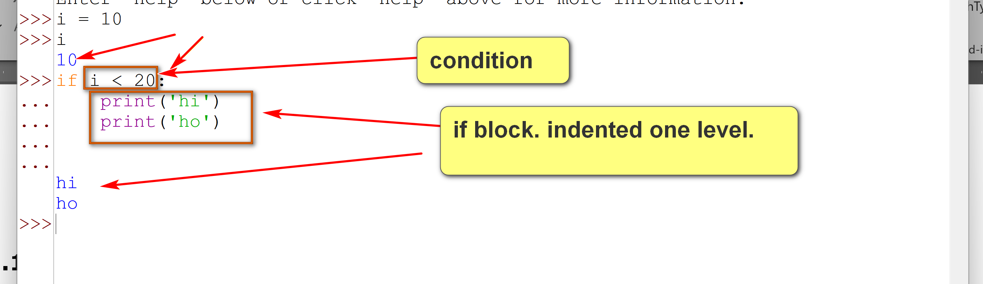
- if the condition is satisfied (evaluated to True), the block of statements is executed. If condition not satisfied, the block of statements is not executed.
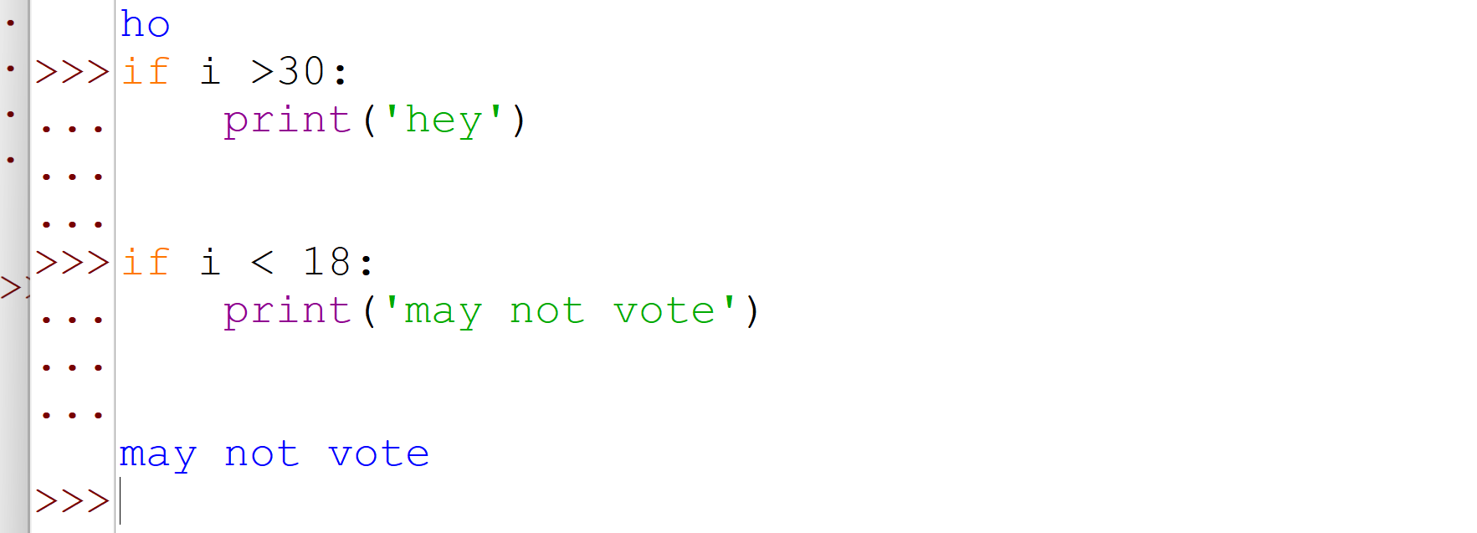
cond_1.py: download, execute and tinker with it.
# conditional statements.
# Examples of a simple if statement.
# score passing?
score = int(input("Your exam score: "))
if score >= 70:
print("Congratulations! You passed the exam.")
print("Keep up the good work.")
# version 2: improper identation.
score = int(input("Your exam score: "))
if score >= 70:
print("Congratulations! You passed the exam.")
print("Keep up the good work.")
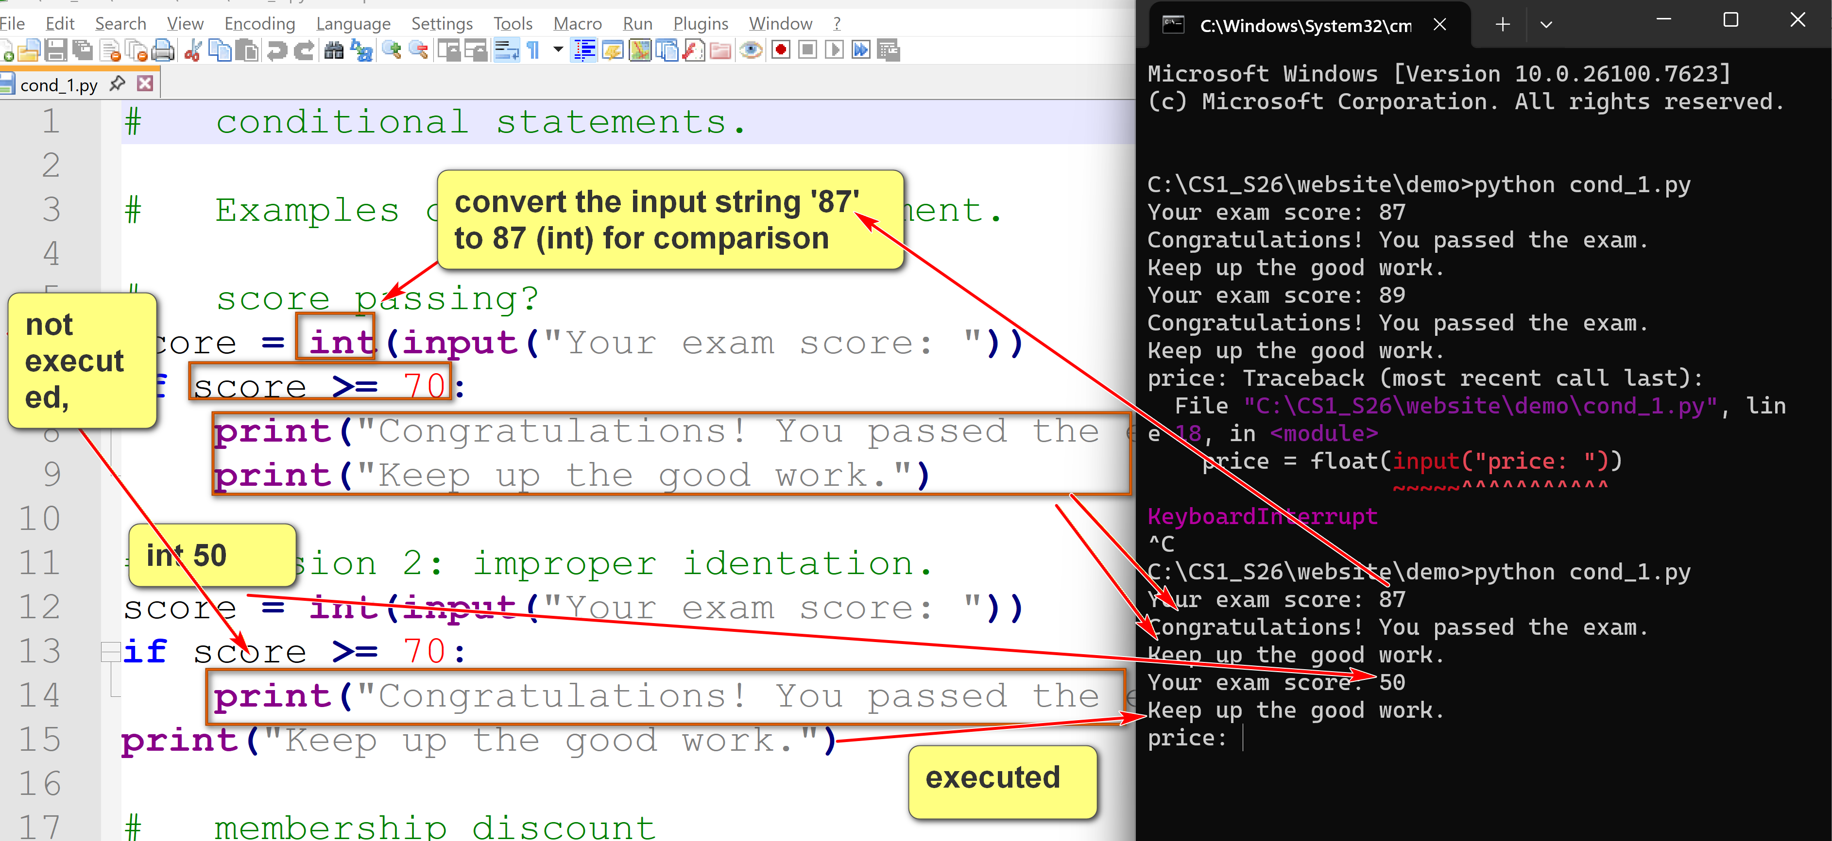
# membership discount
price = float(input("price: "))
is_member = True # Assume to be a member.
if is_member:
price *= 0.9 # Apply 10% discount
print(f"Final member price: ${price:.2f}")
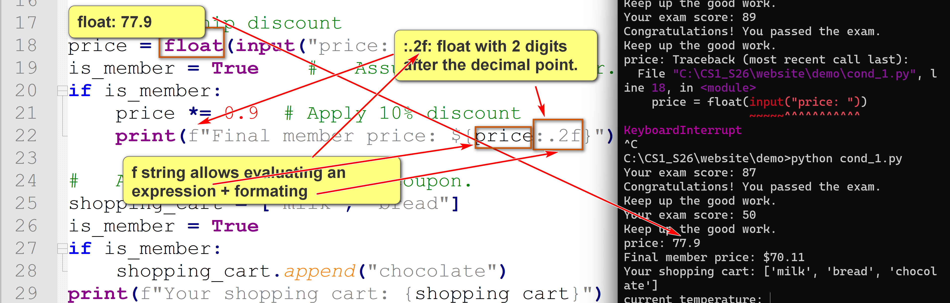
# Add free chocolate for coupon.
shopping_cart = ["milk", "bread"]
is_member = True
if is_member:
shopping_cart.append("chocolate")
print(f"Your shopping cart: {shopping_cart}")
# set is_hot_day. v1
temperature = float(input("current temperature: "))
is_hot_day = False
if temperature > 85:
is_hot_day = True
print(f"Is it a hot day ({temperature} C)? {is_hot_day}")
# set is_hot_day. v2
temperature = float(input("current temperature: "))
if temperature > 85:
is_hot_day = True
else:
is_hot_day = False
print(f"Is it a hot day ({temperature} C)? {is_hot_day}")
# set is_hot_day. v3
temperature = float(input("current temperature: "))
is_hot_day = temperature > 85
print(f"Is it a hot day ({temperature} C)? {is_hot_day}")
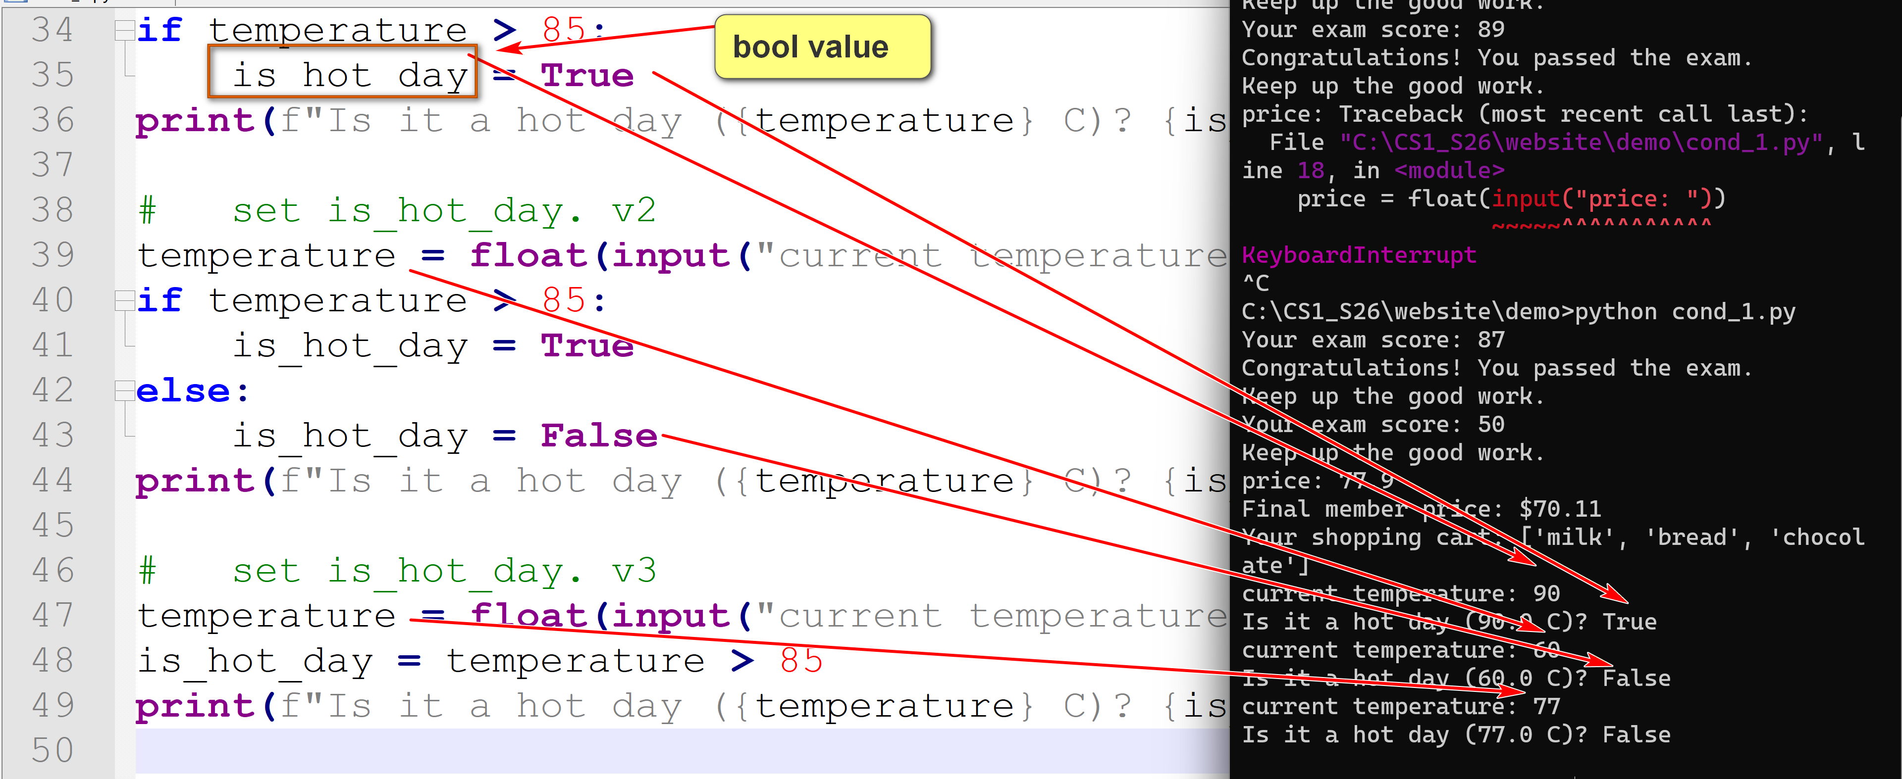
1.2 if-else statement
- format:
if condition:
block_1_of_statements
else:
block_2_of statements
- if the condition is satisfied (evaluated to True), block_1_of_statements is executed. Otherwise, block_2_of_statements is executed.
Tool: Skipped
breakpoint_1.py:
This tool accepts a command line argument as the name of an input Python program and executes the input program. It processes a Python comment line "#breakpoint" as a breakpoint. A breakpoint is handled by showing:
- The block of statements with line numbers since the last breakpoint or the beginning of the program.
- The output produced by the block.
- The changes in variable values from the last breakpoint or the beginnig of the program.
Consider bk_test.py:
# bk_test.py
a = 1
print(f"a: {a}")
#breakpoint
b = 2
a = b + 2
print(f"a: {a}")
print(f"b: {b}")
#breakpoint
a = a * b
print(f"a: {a}")
print(f"b: {b}")
#breakpoint
Try:
python breakpoint_1.py bk_test.py
1.3 if-elif-else statement
- format:
if condition_1:
block_1_of_statements
elif condition_2:
block_2_of_statements
elif condition_3:
block_3_of_statements
...
else:
block_else_of statements
- The conditions are checked sequentially (from condition_1, condition_2, and so on).
- The first condition_i that is evaluated to True results in the evaluation of block_i_of_statement.
- If no condition is satisfied, the else block is executed.
Example:
score = 75
if score >= 90:
grade = 'A'
elif score >= 80:
grade = 'B'
elif score >= 70:
grade = 'C'
elif score >= 60:
grade = 'D'
else:
grade = 'F'
print(f"Grade: {grade}")
output:
Grade: C
In this case, better than nested-if-then-else:

score = 65
if score >= 90:
grade = 'A'
else:
if score >= 80:
grade = 'B'
else:
if score >= 70:
grade = 'C'
else:
if score >= 60:
grade = 'D'
else:
grade = 'F'
print(f"Grade: {grade}")

Example:
cond_2.py (skipped, but encouraged)
# conditional statements
# simple if then else
#breakpoint (#breakpoint is for use of the program breakpoint_1.py)
age = 21
if age >= 18:
print("You may vote.")
#breakpoint
# simple if then else
#breakpoint
predicted_value = 0.85
threshold = 0.7
if predicted_value >= threshold:
prediction_outcome = "Positive"
else:
prediction_outcome = "Negative"
print(f"Prediction outcome: {prediction_outcome}")
#breakpoint
# using short hand form.
#breakpoint
predicted_value_2 = 0.85
threshold_2 = 0.7
prediction_outcome_2 = "Positive" if predicted_value_2 >= threshold_2 else "Negative"
print(f"Prediction outcome (shorthand): {prediction_outcome_2}")
#breakpoint
# DS: Long form
text_data = "Data science is fascinating."
keyword = "science"
if keyword in text_data:
contains_keyword = True
else:
contains_keyword = False
print(f"Contains keyword: {contains_keyword}")
#breakpoint
# DS: Short form
text_data = "Data science is very fascinating."
keyword = "science"
contains_keyword_2 = True if keyword in text_data else False
print(f"Contains keyword (shorthand): {contains_keyword_2}")
#breakpoint
# DS: Not using conditionals.
text_data = "Data science is very, very fascinating."
keyword = "science"
contains_keyword_3 = keyword in text_data
print(f"Contains keyword (shorthand): {contains_keyword_3}")
#breakpoint
# elif
score = 75
if score >= 90:
grade = 'A'
elif score >= 80:
grade = 'B'
elif score >= 70:
grade = 'C'
elif score >= 60:
grade = 'D'
else:
grade = 'F'
print(f"Grade: {grade}")
For you to do:
Run python breakpoint_1.py cond_2.py
and ensure you thoroughly understand the output.
1.4 Nested if statement
- A nested if statement in Python refers to an if statement that is placed inside another if, elif, or else block.
- This allows for checking multiple conditions where the inner condition is only evaluated if the outer condition is met.
- A nested if statement may have many levels.
Try out grade_point.py, which compute the grade point of a score in three ways: [1] if-elif-else, [2] nested if, and [3] dict.
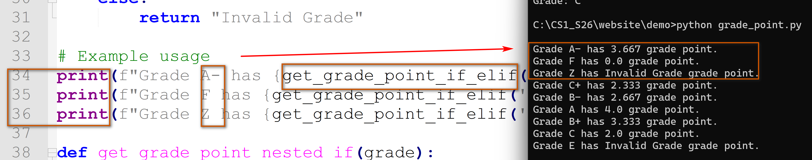
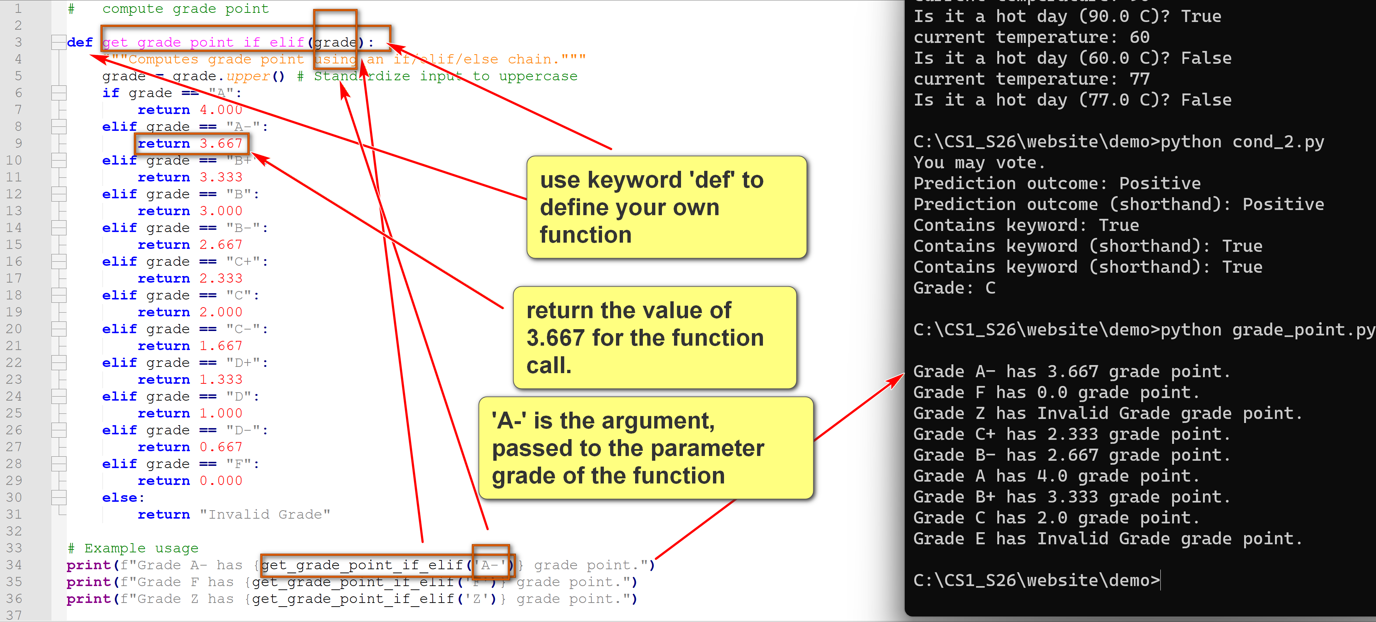
1.5 Short hand if-else expression
- Python supports conditional expression mimicking an if-else statement.
- Format:
value_if_true if condition else value_if_false
- It is a ternary operator that take on three arguments.
- The else part is mandatory.
- 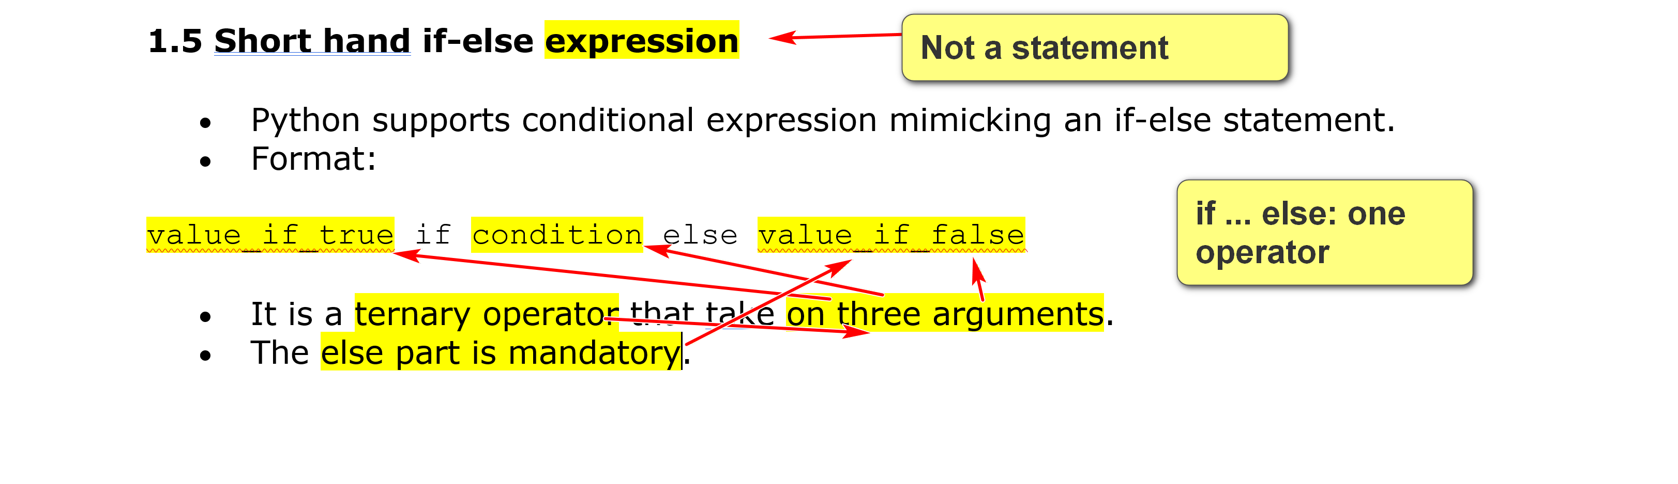
Example:
cond_expr_ex.py:
# conditional expressions
(3+7) if 7 <= 3 else 2
(3+7) if 7 > 3 else 2
"hello world" if True else "Eat ice cream"
"hello world" if False else "Eat ice cream"
mood = 'good'
"hello world" if mood=='good' else "Eat ice cream"
mood = 'bad'
action = "hello world" if mood=='good' else "Eat ice cream"
f"To do: {action}"
Running python eval_expr.py cond_expr_ex.py: (skipped)
C:\...\examples>python eval_expr.py cond_expr_ex.py
# conditional expressions
[line 2] (3+7) if 7 <= 3 else 2: 2
[line 3] (3+7) if 7 > 3 else 2: 10
[line 4] "hello world" if True else "Eat ice cream": hello world
[line 5] "hello world" if False else "Eat ice cream": Eat ice cream
mood = 'good'
[line 7] "hello world" if mood=='good' else "Eat ice cream": hello world
mood = 'bad'
action = "hello world" if mood=='good' else "Eat ice cream"
[line 10] f"To do: {action}": To do: Eat ice cream
2. Operator Precedence Revisited
- Operator precedence dictates the order in which operators in an expression are evaluated.
Examples: arithmetic operations for integer mathematics
10 - 5 - 4: 1 (not 9)
10 – (5 – 4): 9
10 – 3 * 2: 4 (not 14)
3 * 2 ** 2: 12 (not 25)
2.1 Python Operator precedence
The precedence order of common Python operators starting from the highest precedence is shown below.
- Parenthesis
- Arithmetic operators:
  - Exponentiation: ** (right associative: right ** evaluated first)
  - Unary operators: -, +, ~ (bitwise not); left associative
  - Multiplication, Division, Floor Division, Modulus *, /, //, %: These have equal precedence and are evaluated from left to right (i.e. left associative)
  - Addition and subtract; + and -: left associative.
- Bitwise operators (other than ~):
  - Left and right shift, >> and <<: left associative.
  - Bitwise AND &.
  - Bitwise XOR ^.
  - Bitwise OR |.
- Comparison operators ==, !=, >, >=, <, <=, is, is not, in, not in: left associative.
- Logical operators:
  - Logical NOT, not.
  - Logical AND, and.
  - Logical OR, or.
- Assignment operators =, :=, +=, -=, etc.: lowest precedence, left associative.
Tools:
eval_expr.py:
This simple program reads an input python file name as the command line argument and shows the result of evaluating the expressions in the file. If no command line argument is provided, it defaults to the file expr_ex.py. The input Python file should contain only Python expressions. You may not need to know the logic of this program.
If a line in the input Python file is a Python comment, it is echoed. Otherwise, the line is assumed to be a Python expression and is evaluated. The result is shown with a line number in the input file. A good way to study is to construct Python expressions with explanatory comments to highlight precedence and associativity.
The program has limitations.
You can try it out with expr_examples.py or create your own example file.
expr_precedence.py:
The program shows the intermediate steps and results in executing expressions in Python, highlight precedence and associativity. If a command line argument is provided, it is assumed to be a Python program containing only expressions. The expression will be executed one by one. If there is no command line argument, it will prompt user for input expression until user indicating quite.
You do not need to understand the logic of this program. The program has limitations.
You can try it out with expr_examples.py or create your own example file.
expr_examples.py:
# - is left associative
9 - 3 - 1
# a parenthesis is needed if the right - is required to be executed first
9 - (3 - 1)
# * has higher precedence than + or 1.
4 + 2 * 5 - 6
# //, / and * are left associative.
6 // 4 / 2
# //, / and * are left associative.
4 * 8 // 5
# () is needed with the right // should be executed first. It returns a different result.
4 * (8 // 5)
# ** is right associative
2 ** 3 ** 2
# () is needed if the left ** should be executed first.
(2 ** 3) ** 2
# bitwise left shift is left associative.
6 >> 3 >> 1
# a pair of parentheis is need if the right >> should be executed first.
6 >> (3 >> 1)
# comparison operators have a higher precedence than relational operators. and has a higher precedence than or.
1 < 2 or 3 < 4 and 4 > 6
(1 < 2 or 3 < 4) and 4 > 6
1 < 2 or (3 < 4 and 4 > 6)
3. The match-case Statement (optional)
- The match-case statement was introduced in Python 3.10.
- It is similar to the switch-case statements in other languages, such as Java.
- However, it also provides a more powerful structural pattern matching mechanism.
- The syntax of the match-case statement:
match subject:
case pattern1:
# Code to execute if subject matches pattern1
case pattern2:
# Code to execute if subject matches pattern2
case _:
# Default case (if no other pattern matches)
- In contrast, the switch-case statement in Java:
switch (expression) {
case value1:
// Code to execute if expression matches value1
break; // Optional: exits the switch block
case value2:
// Code to execute if expression matches value2
break;
// ... more case statements ...
default:
// Optional: Code to execute if no case matches
break;
}
- Note that in Java, the terms "expression", "value1", etc., are used. An expression is evaluated and compared to the values value1, value2, and so on. Pattern matching is not supported.
- subject can be a tuple of mutliple values.
- _ can be used to match any value of an element in the subject.
Example:
match_1.py:
def check_http_status(status_code):
"""Prints a message based on the HTTP status code."""
match status_code:
case 200:
print("200. Status: OK")
case 403:
print("403. Status: Forbidden")
case 404:
print("404. Status: Page Not Found")
case 405:
print("405. Status: Method not supported")
case 500:
print("500. Status: Server Error")
case _: # The wildcard case for any other value
print("Other code. Status: Unknown")
check_http_status(200)
check_http_status(403)
check_http_status(404)
check_http_status(405)
check_http_status(500)
check_http_status(999)
# This is a more advanced example that will not appear in exams.
def process_command(command):
"""Parses and executes a command represented as a list of strings."""
match command:
case ["quit"]:
print("Exiting...")
case ["go", direction]: # the second argument of 'command' is stored in the variable direction
print(f"Moving in direction: {direction}")
case ["get", *item]: # the second and following arguments of 'command', if exist, is stored in the list item.
if item:
print(f"Picking up item {item}")
else:
print("What do you want to get?")
case _:
print("Invalid command.")
print(f"process_command(['go', 'east']): ", end='')
process_command(['go', 'east'])
print(f"process_command(['get', 'sword']): ", end='')
process_command(['get', 'sword'])
print(f"process_command(['get']): ", end='')
process_command(['get'])
print(f"process_command(['use', 'sword']): ", end='')
process_command(['use', 'sword'])
print(f"process_command(['quit']): ", end='')
process_command(['quit'])
- There are relative merits of using nested if statement, if/elif/else statement, and match-case statement.
- The following example illustrates how they can be used to implement the same logic.
Example:
if_else_match.py: run to see and understand the output. You do not need to know the module itertools and its function product.
from itertools import product
# Scenario: Determine a user's access level based on their role and subscription status.
# Roles: 'admin', 'editor', 'member'
# Subscription Status: 'premium', 'standard', 'free'
role = 'editor'
subscription = 'premium'
def print_access(role, subscription):
print(" using nested If Statement: ", end="")
if role == 'admin':
if subscription == 'premium':
print("Admin with Premium Access: Full control.")
else: # Admin with standard or free subscription
print("Admin with Basic Access: Limited control.")
else:
if role == 'editor':
if subscription == 'premium':
print("Editor with Premium Access: Advanced editing features.")
else:
if subscription == 'standard':
print("Editor with Standard Access: Basic editing features.")
else: # Editor with free subscription
print("Editor with Free Access: Read-only access.")
else: # Member role
if subscription == 'premium':
print("Member with Premium Access: Ad-free content.")
else:
if subscription == 'standard':
print("Member with Standard Access: Limited ads.")
else: # Member with free subscription
print("Member with Free Access: Ad-supported content.")
print(" using elsif: ", end="")
if role == 'admin' and subscription == 'premium':
print("Admin with Premium Access: Full control.")
elif role == 'admin': # Admin with standard or free subscription
print("Admin with Basic Access: Limited control.")
elif role == 'editor' and subscription == 'premium':
print("Editor with Premium Access: Advanced editing features.")
elif role == 'editor' and subscription == 'standard':
print("Editor with Standard Access: Basic editing features.")
elif role == 'editor': # Editor with free subscription
print("Editor with Free Access: Read-only access.")
elif role == 'member' and subscription == 'premium':
print("Member with Premium Access: Ad-free content.")
elif role == 'member' and subscription == 'standard':
print("Member with Standard Access: Limited ads.")
else: # Member with free subscription
print("Member with Free Access: Ad-supported content.")
print(" using match and case (Python 3.10+): ", end="")
match (role, subscription):
case ('admin', 'premium'):
print("Admin with Premium Access: Full control.")
case ('admin', _): # Any subscription for admin
print("Admin with Basic Access: Limited control.")
case ('editor', 'premium'):
print("Editor with Premium Access: Advanced editing features.")
case ('editor', 'standard'):
print("Editor with Standard Access: Basic editing features.")
case ('editor', _): # Any other subscription for editor
print("Editor with Free Access: Read-only access.")
case ('member', 'premium'):
print("Member with Premium Access: Ad-free content.")
case ('member', 'standard'):
print("Member with Standard Access: Limited ads.")
case ('member', _): # Any other subscription for member
print("Member with Free Access: Ad-supported content.")
case _: # Fallback for any other unhandled cases
print("Unknown role or subscription combination.")
def main():
# Roles: 'admin', 'editor', 'member'
# Subscription Status: 'premium', 'standard', 'free'
roles = ['admin', 'editor', 'member']
subscriptions = ['premium', 'standard', 'free']
for role, subscription in product(roles, subscriptions):
print(f"role: {role}; subscription: {subscription} =>")
print_access(role, subscription)
if __name__ == '__main__':
main()

Introduction to the numpy package in Python
by K. Yue
1. Overview of the numpy package
- NumPy (Numerical Python) is a popular rich Python library used for numerical computations, such as arrays.
- Resources:
  - Main site: https://numpy.org/
  - numpy at w3schools: https://www.w3schools.com/python/numpy/default.asp
  - Codebase in Github: https://github.com/numpy/numpy
- Installation: at command line prompt: "pip install numpy"
- One main data structure in numpy is "ndarray": the class of n-dimensional arrays. (e.g. excel worksheet is a 2d array)
  - One dimensional arrays: vectors.
  - Two dimensional arrays: matrices.
  - n dimensional arrays (n >= 3): tensors.
  - The array() in numpy is used to create objects of the class ndarray.
1.1 Python's lists vs numpy's arrays
Python's lists (review):
- Python's lists are mutatable.
- Python's lists are of varying sizes.
- Python's lists are heterogeneous (an element of a list can be any object).
- Python's lists are very flexible but slow.
Numpy's ndarray:
- ndarray objects are immutable. (When changed, a new ndarray object is created.)
- ndarray objects are of fixed sizes.
- ndarray objects are homogeneous (all elements have the same types.
- ndarray are very fast comparing to Python's lists, offering 5x to 100x speedups, depending on the kind of operations.
- Numpy provides rich functionality, including vectorization (operaions involving whole arrays).
2. Examples
numpy_stat_1.py.txt: print basic statistics of a file of data using numpy. Run and annotate the program.
import numpy as np
import os # For checking if the file exists
def calculate_statistics(filename):
"""
Reads a text file of integers using NumPy and prints basic statistics.
Args:
filename (str): The name of the input text file.
"""
if not os.path.exists(filename):
print(f"Error: The file '{filename}' was not found.")
print(f"Please ensure '{filename} is in the same directory as this script.")
return
try:
# Use np.loadtxt to read data from the file
# This function is flexible and can handle various delimiters (space, comma, etc.)
data = np.loadtxt(filename, dtype=int)
# Flatten the array in case the data is read as a 2D array
# This ensures all statistics are calculated on a single list of numbers. Uncomment the next two print statements to see the effect.
# print(data)
flat_data = data.flatten()
# print(flat_data)
print("-" * (len(filename) + 25))
print(f"--- Statistics for '{filename}' ---")
print(f"--- Data points found: {flat_data.size}")
print(f"--- Data type: {flat_data.dtype}")
print("-" * (len(filename) + 25))
# Calculate and print basic statistics
print(f"Mean (Average): {np.mean(flat_data):.2f}")
print(f"Median (Middle): {np.median(flat_data):.2f}")
print(f"Minimum Value: {np.min(flat_data)}")
print(f"Maximum Value: {np.max(flat_data)}")
print(f"Standard Deviation: {np.std(flat_data):.2f}")
print(f"Sum of all values: {np.sum(flat_data)}")
except ValueError as e:
print(f"Error reading file: {e}")
print("Ensure the file only contains integers and standard delimiters (spaces/commas).")
except Exception as e:
print(f"An unexpected error occurred: {e}")
if __name__ == "__main__":
# Specify the name of your data file
input_file = input("Please input the data file name: ")
calculate_statistics(input_file)
For the input file numpy_stat_1_data_1.txt:
1 2 3 2 5
2 1 4 5 9
7 8 10 4 3
9 2 3 4 6
Running the program:
C:\...>python numpy_stat_1.py
Please input the data file name: numpy_stat_1_data_1.txt
------------------------------------------------
--- Statistics for 'numpy_stat_1_data_1.txt' ---
--- Data points found: 20
--- Data type: int64
------------------------------------------------
Mean (Average): 4.50
Median (Middle): 4.00
Minimum Value: 1
Maximum Value: 10
Standard Deviation: 2.73
Sum of all values: 90
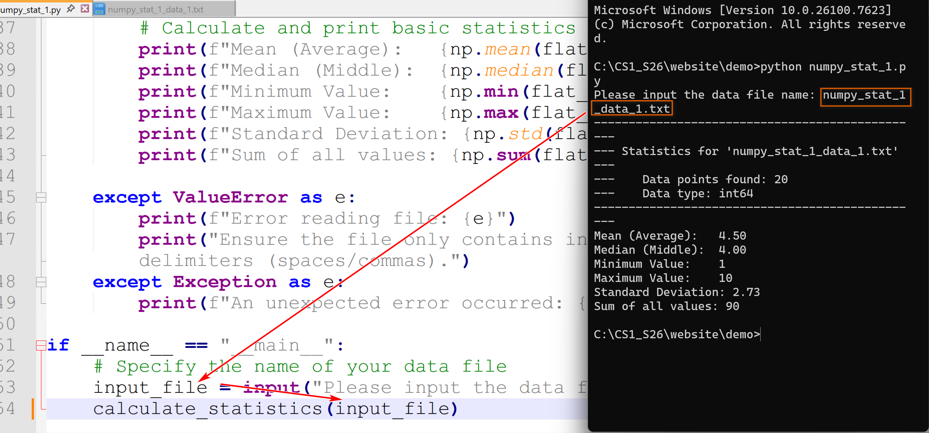
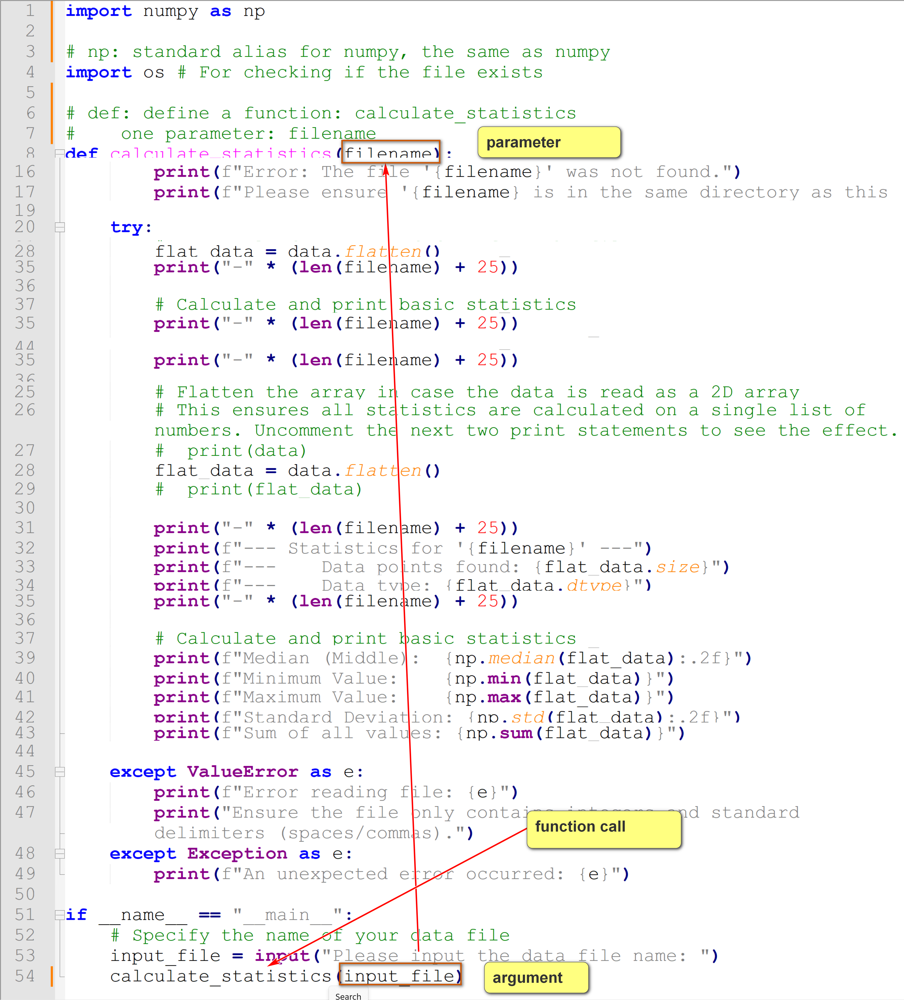
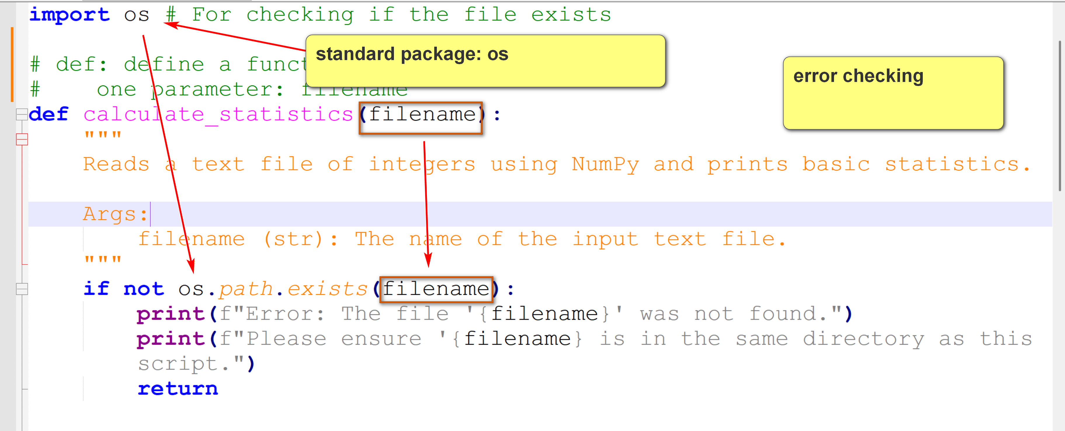
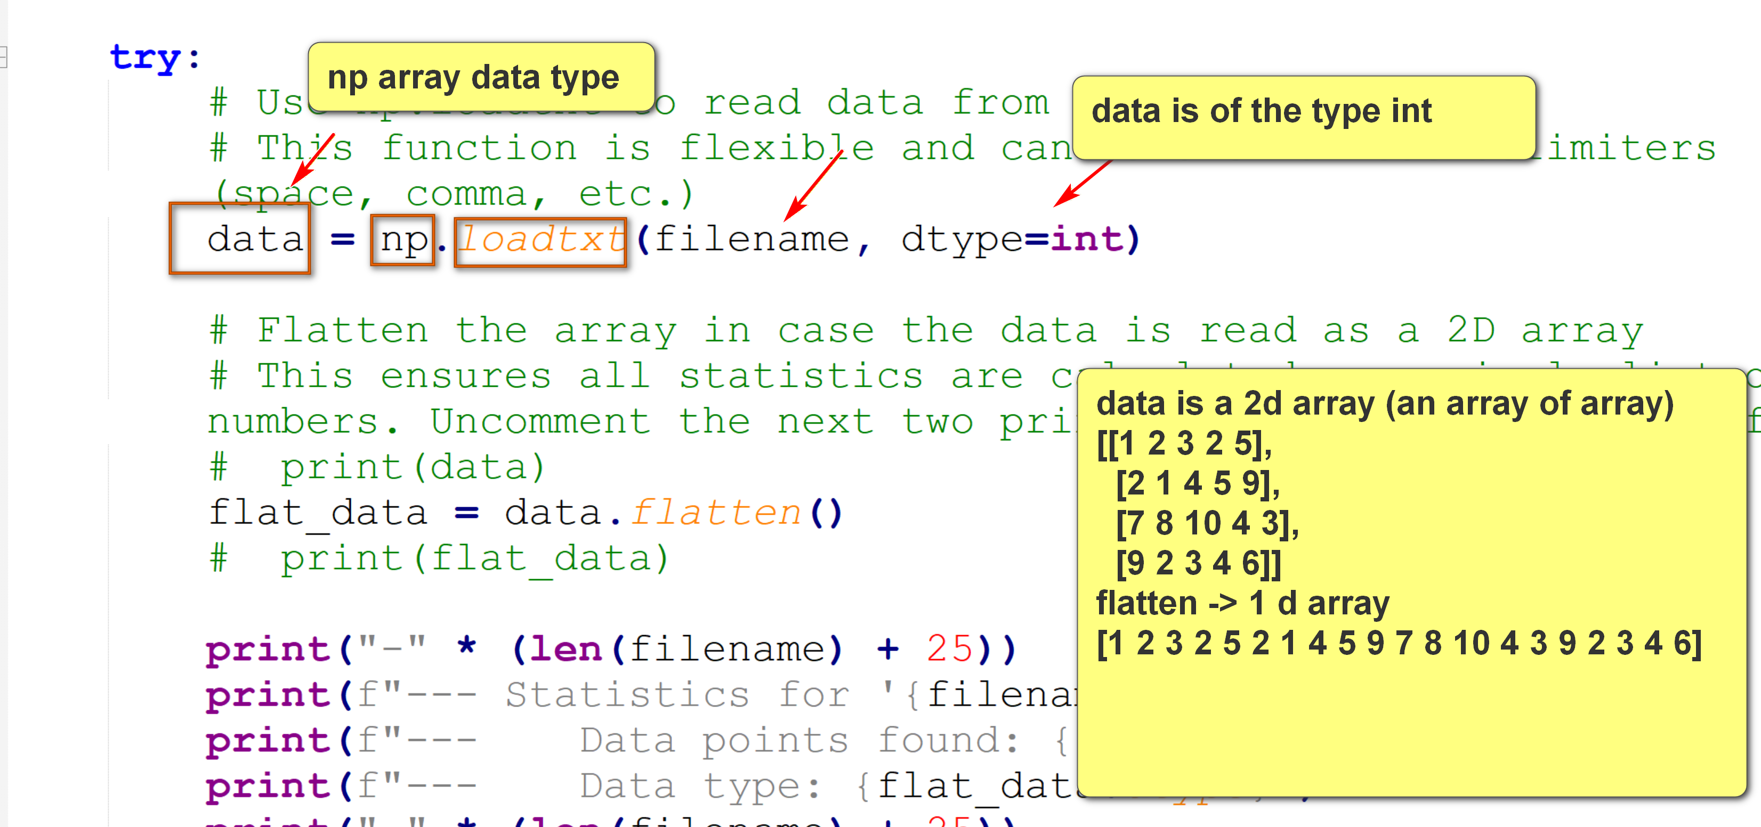
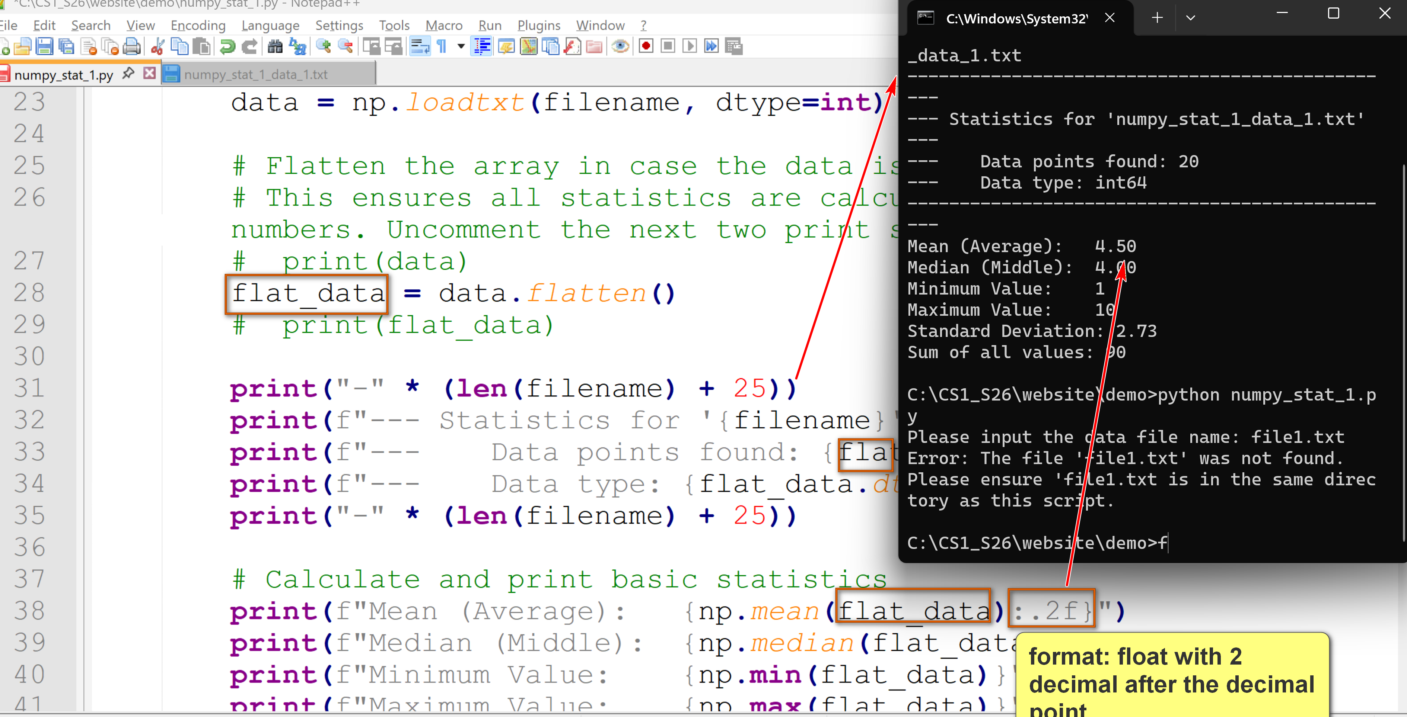
3. Performance Matters (a lot)
- One big advantage of numpy is its superior performance as compared to the built-in lists in Python.
- Performance is always a big consideration in software development.
Example:
numpy_array_vs_lists.py: compare the times for using three methods to create a list/array by adding two other lists/arrays. Run and annotate the program. Methods:
- Using Python's lists and an explicit loop.
- Using Python's lists and an implicit loop and the zip function.
- Using numpy's array and vectorized operations.
import numpy as np
import time
NUM_ELEMENTS = 10000000
a = list(range(NUM_ELEMENTS))
b = list(range(NUM_ELEMENTS))
c = []
start_time = time.process_time()
for i in range(len(a)):
c.append(a[i] + b[i])
end_time = time.process_time()
print(f"Time taken for adding two lists/arrays of {NUM_ELEMENTS} elements to create a third.")
print()
print(f"Time taken for Python's lists with an explicit loop: {end_time - start_time} seconds")
start_time = time.process_time()
c = [x + y for x, y in zip(a, b)]
end_time = time.process_time()
print(f"Time taken for Python's lists with no explicit loop but using zip(): {end_time - start_time} seconds")
a_np = np.arange(NUM_ELEMENTS)
b_np = np.arange(NUM_ELEMENTS)
start_time = time.process_time()
c_np = a_np + b_np # Single vectorized operation
end_time = time.process_time()
print(f"Time taken for nparray with vectorization: {end_time - start_time} seconds")
A run of the program (result times may differ from runs to runs):
C:\...>python numpy_array_vs_lists.py
Time taken for adding two lists/arrays of 10000000 elements to create a third.
Time taken for Python's lists with an explicit loop: 2.03125 seconds
Time taken for Python's lists with no explicit loop but using zip(): 0.953125 seconds
Time taken for nparray with vectorization: 0.03125 seconds

Iteration Statements
CSCI 1470
by K. Yue
1. Iteration: for loop
- Python offers several iteration statements to repeatedly loop through and execute a block of code.
- The primary iteration statements in Python are [1] for loops and [2] while loops.
- A loop statement may have several components:
  - Initialization: preparatory logic before entering the loop. To be executed once.
  - Continuing condition: when the loop should be exit.
  - Iteration code: a block of code to be executed. To be executed as many times as the loop continues.
  - Update code: update the variables involved in the continuing condition to prepare whether the loop should continues.
- An iteration statement executes step [1] once, and steps [2] to [4] as many times as the continuing condition is evaluated to true.
- The for loop in Python is significantly different in both syntax and meaning to the for loop in a Java/C/C#/C++.
Example in Java:
for (int i = 0; i < 10; i++) { // Iterates if I from 0 to 9
System.out.println(i);
}
- Initialization: int i = 0; Set the variable i = 0.
- Continuing condition: i < 10; so long as i is less than 10.
- Iteration code: what logic demands. E.g., System.out.println(i);
- Update code: i++ Increment i by 1
Example in Python:
for i in range(10): # Iterates from 0 to 9
print(i)
- Initialization: i is set to 0 implicitly. This is because the lower limit of range(10) is 0.
- Continuing condition: i < 10. This is because the lower limit of range(10) is 10.
- Iteration code: what logic demands. E.g., print(i);
- Update code: i is implicitly incremented by 1.
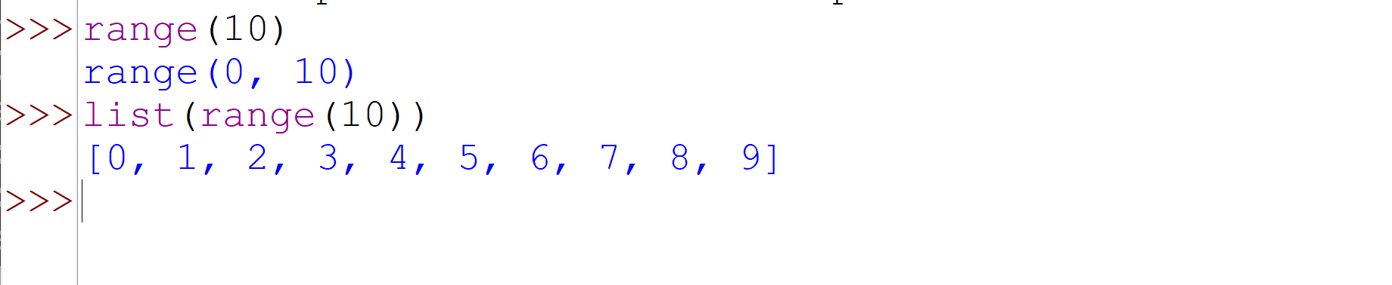
range():
The syntax for range() is:
range(start, stop, step)
W3Schools
- start (optional): An integer specifying the starting position of the sequence (inclusive). The default is 0.
- stop (required): An integer specifying the position to stop before (exclusive). This value is never included in the sequence generated.
- step (optional): An integer specifying the incrementation (or decrementation) value. The default is 1. The step value cannot be zero, as it would cause a ValueError

- A Python for loop is used for iterating over iterable objects:
  - a sequence data type (such as a list, tuple, string, and range): the main focus of this course.
for c in s:
print(c)
  - iterable objects returned by function calls: some of these functions will be covered in this course.
  - objects of user-defined iterable classes: may not be covered later in the course.
Tools:
bk.py:
This is a simple Python module that supports one function break_and_show(). When the function is called, it represents a break point. It shows the old and new values of all variables that have been changed. It contains many limitations.
To use the module, put bk.py in your working project directory and add the following line in your python program:
from bk import break_and_show
Format:
for iteration_variable in iterable_object:
# A block of iteration code to be executed.
# Indentation is required as the block is one level lower.
Examples:
Try the following three python programs on for loops.
for_1.py:
from bk import break_and_show
debug = False # set debug to False if you do not want to see breakpoints.
# Version 1: loop five times from 0 to 4.
for i in range(5): # range(stop): start assumes to be 0.
if debug: break_and_show()
print(f"square({i}): {i * i}")
# Version 2: loop five times from 1 to 5.
for i in range(1, 6): # range(start, stop)
if debug: break_and_show()
print(f"square({i}): {i * i}")
# Version 3: loop three times: 1, 3, 5.
for i in range(1, 6, 2): # range(start, stop, step)
if debug: break_and_show()
print(f"square({i}): {i * i}")
# summing a list:
list_1 = [3,4,1,7,8,3,6]
print(f"list_1: {list_1}")
print(f"len(list_1): {len(list_1)}")
list_sum = 0
for i in range(len(list_1)):
if debug: break_and_show()
list_sum += list_1[i]
print(f"sum of list_1: {list_sum}")
print(f"sum(list_1): {sum(list_1)}")
for_2.py:
from bk import break_and_show
debug = False # set debug to False if you do not want to see breakpoints.
data_points = [10, 25, 30, 15, 40]
for point in data_points:
if debug: break_and_show()
print(f"Data point: {point}")
my_string = "love"
for char in my_string:
if debug: break_and_show()
print(char)
numbers = [11, 22, 33, 44, 55]
total_sum = 0
for num in numbers:
total_sum += num
if debug: break_and_show()
print(f"Total sum: {total_sum}")
for_3.py:
from bk import break_and_show
debug = True # set debug to False if you do not want to see breakpoints.
raw_scores = [25, 82, 58, 98]
scaled_scores = []
i = 1
for score in raw_scores:
scaled_scores.append(score / 100)
i += 1
if debug: break_and_show()
print(f"Scaled scores: {scaled_scores}")
2. while loop
- In Python, a loop statement executes a block of code 0 or more times, as long as a specified condition remains evaluated to True.
Format:
while condition:
# Code to be executed repeatedly
# Indentation is required for the block.
- The while loop terminates when
  - the condition is evaluated to False, or
  - when a break statement is executed.
- The break statement can be used to exit a while loop immediately (without completing the current iteration).
- The continue statement skips the rest of the current iteration and proceeds to the next iteration of the loop (which starts by evaluating the condition).
Recall that there are four components of a loop statement.
- Initialization: preparatory logic before entering the loop. To be executed once.
- Continuing condition: when the loop should be exit.
- Iteration code: a block of code to be executed. To be executed as many times as the loop continues.
- Update code: update the variables involved in the continuing condition to prepare whether the loop should continues.
Thus, the general structure of a while loop:
# [1] initialization code
while condition: # [2] continuing condition.
# Code to be executed repeatedly: [3] Iteration code
# [4] Update code is usually at the end of the while block
- The for loop is used to iterate through sequences or iterable objects. The number of iterations is generally known before the loop starts.
- The while loop is used when the continue condition is determined during runtime and the number of iterations is generally not known before the loop starts.
Examples: loop five times from 1 to 5.
Using for loop:
# loop five times from 1 to 5 using for loop and range function
for i in range(1, 6): # range(start, stop)
if debug: break_and_show()
print(f"square({i}): {i * i}")
Using while loop: while_1.py
# loop five times from 1 to 5 using while loop
i = 1
while i < 6:
if debug: break_and_show()
print(f"square({i}): {i * i}")
i += 1
while_2.py: simple while loops and how to improve them.
from bk import break_and_show
debug = True # set debug to False if you do not want to see breakpoints.
# version #1
required_samples = 3
collected_samples = 0
data_points = []
while collected_samples < required_samples:
data_input = input(f"Enter data point {collected_samples + 1}/{required_samples}: ")
data_points.append(data_input)
collected_samples += 1
print(f"Data point '{data_input}' recorded.")
print("\nAll required data samples collected:")
for data in data_points:
print(f"Sample: {data}")
# version #2
required_samples = 3
data_points = []
while len(data_points) < required_samples:
data_input = input(f"Enter data point {len(data_points) + 1}/{required_samples}: ")
data_points.append(data_input)
print(f"Data point '{data_input}' recorded.")
# Also print sample #.
print("\nAll required data samples collected:")
i = 0
while i < len(data_points):
print(f"Sample #{i+1}: {data_points[i]}")
i += 1
# Alternate solution using enumerate
print("\nAll required data samples collected:")
for i, data in enumerate(data_points):
print(f"Sample {i+1}: {data}")
while_yes_no.py: a simple use case of getting a yes or no user input and why a function is defined.
def get_yes_no_input(prompt_message):
"""
Prompts the user for a yes/no input and returns True for yes, False for no.
Handles variations like 'y', 'yes', 'n', 'no' (case-insensitive).
"""
while True:
user_input = input(f"{prompt_message} (yes/no): ").lower().strip() # conver to lower case and remove trailing white spaces.
if user_input in ('yes', 'y'):
return True
elif user_input in ('no', 'n'):
return False
else:
print("Invalid input. Please enter 'yes' or 'no'.")
# Example usage:
if get_yes_no_input("Do you want to continue?"):
print("Good. Here is another question.")
else:
print("User chose to stop.")
answer = get_yes_no_input("Is life a box of chocolate?")
if answer:
print("Great!")
else:
print("Then, get pizza.")
Fibonacci numbers: 0,1,1,2,3,5,8,13,21,
fib(1) = 0
fib(2) = 1
fib(n) = fib(n-1) + fib(n-2)
for_fib_1.py: print the first 20 Fibonacci numbers
- A for loop is used since we know the number of iterations.
- How do you improve on the code below?
# Initialize the first two Fibonacci numbers
a, b = 0, 1
# Print the first two numbers
print(a)
print(b)
# Loop to calculate and print the remaining 18 Fibonacci numbers
for _ in range(18): # We need 18 more numbers after the initial two
next_fib = a + b
print(next_fib)
a = b
b = next_fib
- Note the multiple assignment statement: a, b = 0, 1
- Note the use of _ in for _ in range(18). _ is an anonymous variable. It stores a value but the value is not used (referenced).
- The effect is the same as for i in range(18). In this case, since i is not used, it is better to be replaced by _ to improve brevity and simplicity.
- Clarity and simplicity are very important in computer science.
while_fib_1.py: print all Fibonacci numbers smaller than 50,000.
- Each iteration prints one Fibonacci number.
- Since we do not know how many Fibonacci numbers are smaller than 50,000, a while loop is used.
LIMIT = 50000
# Initialize the first two Fibonacci numbers
a, b = 0, 1
# Print the starting number 0, since it is less than the limit
print(a)
# Use a while loop to generate and print the sequence
while b < LIMIT:
print(b)
# Update the values for the next iteration
# The new 'a' becomes the old 'b', and the new 'b' is their sum
a, b = b, a + b
while_valid_number.py:
# input validation
while True:
try:
user_input = input("Please enter an integer: ")
number = int(user_input)
break # Exit the loop if input is a valid integer
except ValueError:
print(f"Not an integer: {user_input}. Pleas try again. ")
print(f"You entered the number: {number}")
- If the input is valid, the break statement is used to exit the while loop.
- Note the use of the try-except block for error handling. Error handling will be covered later with more details.
while_nested_1.py: what is the output of this code?
i = 1
while i <= 3:
j = 1
while j <= i:
print(f"Outer loop variable, i: {i}, Inner loop variable, j: {j}")
j += 1
i += 1

