CSCI 1470 CS 1 Annotation
2026_2_5
Introduction to Python's Modules
CSCI 1470
by K. Yue
1. Introduction to Python's Modules
- A module is a file containing Python definitions and statements.
- The file name is the module name with the suffix .py appended as the file extension. Examples: sys.py, turtle.py, wikipedia.py
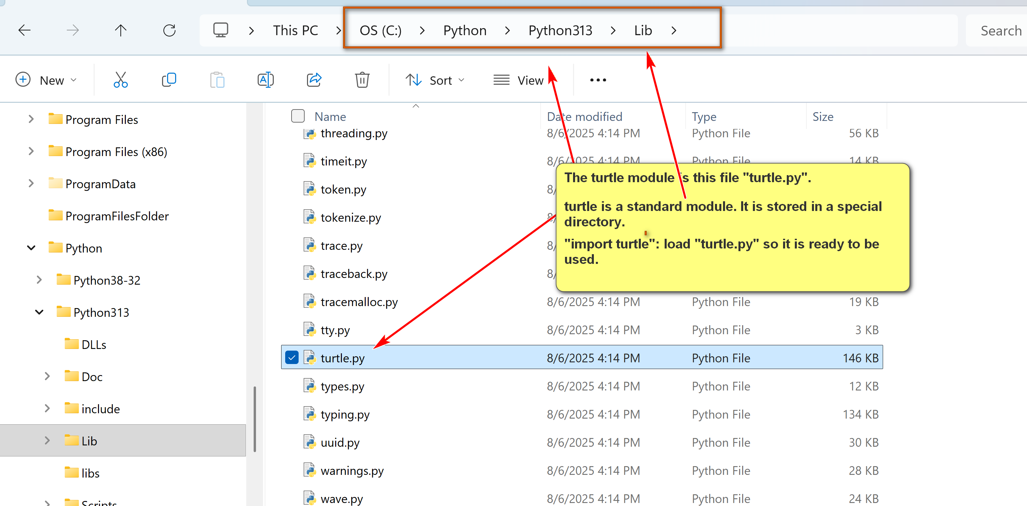
- Documentation: https://docs.python.org/3/tutorial/modules.html.
- There are many advantages of using Python modules:
  - Code reusability: uses Python code developed and tested by experienced Python developers.
  - Code organization: allows local grouping of related code into files.
  - Other advantages...
- The Python program being executed is known as the main module.
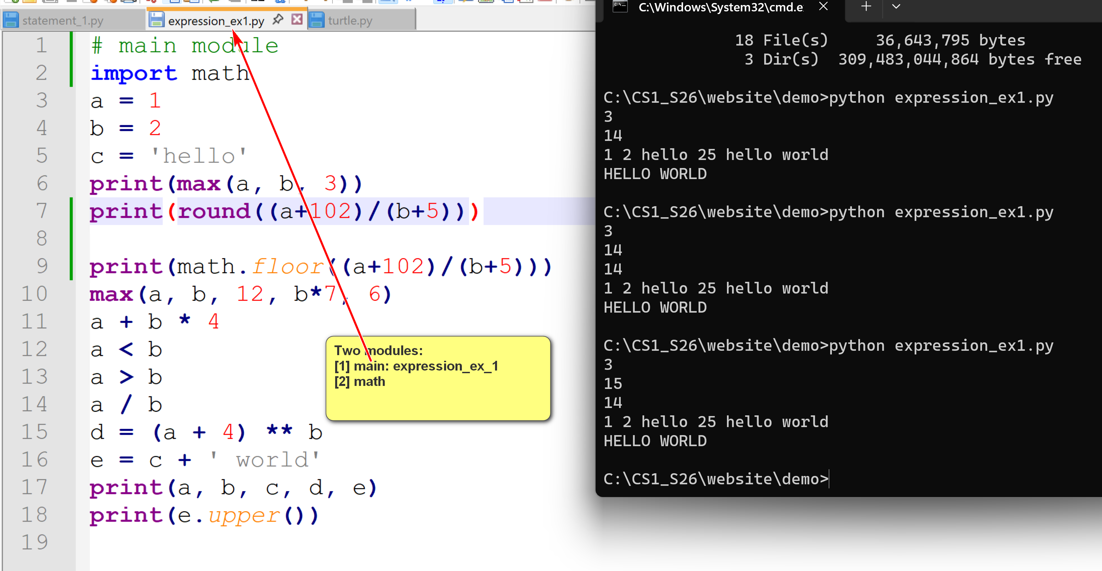
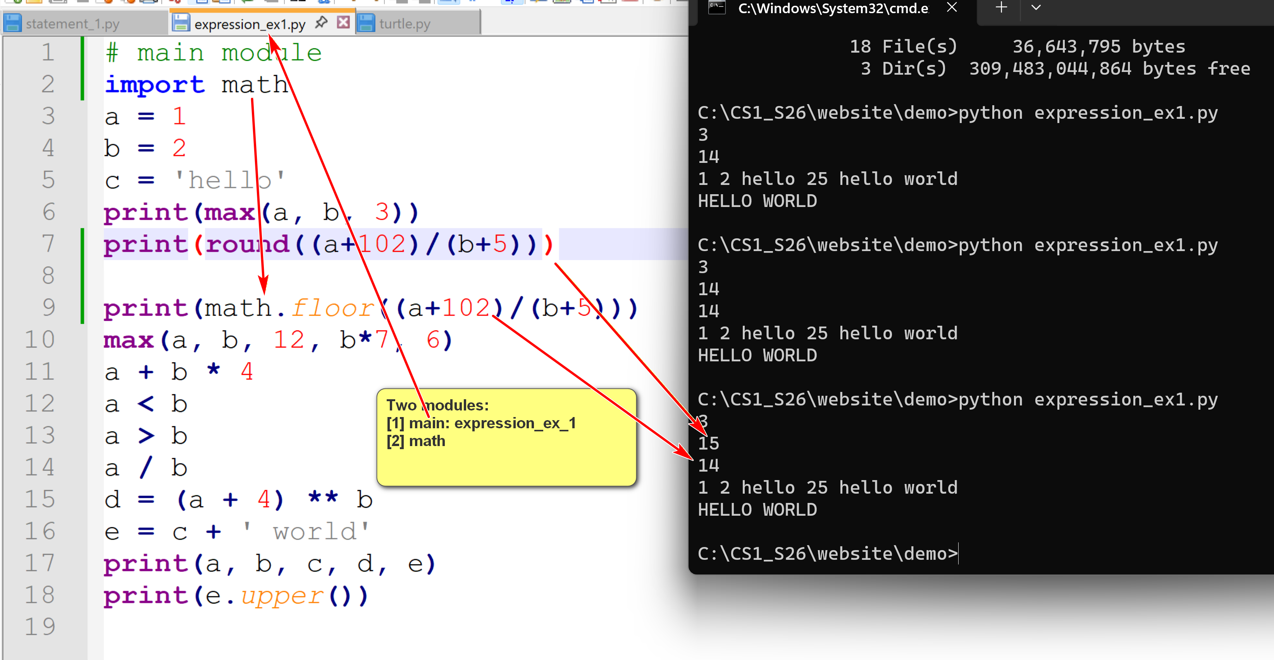

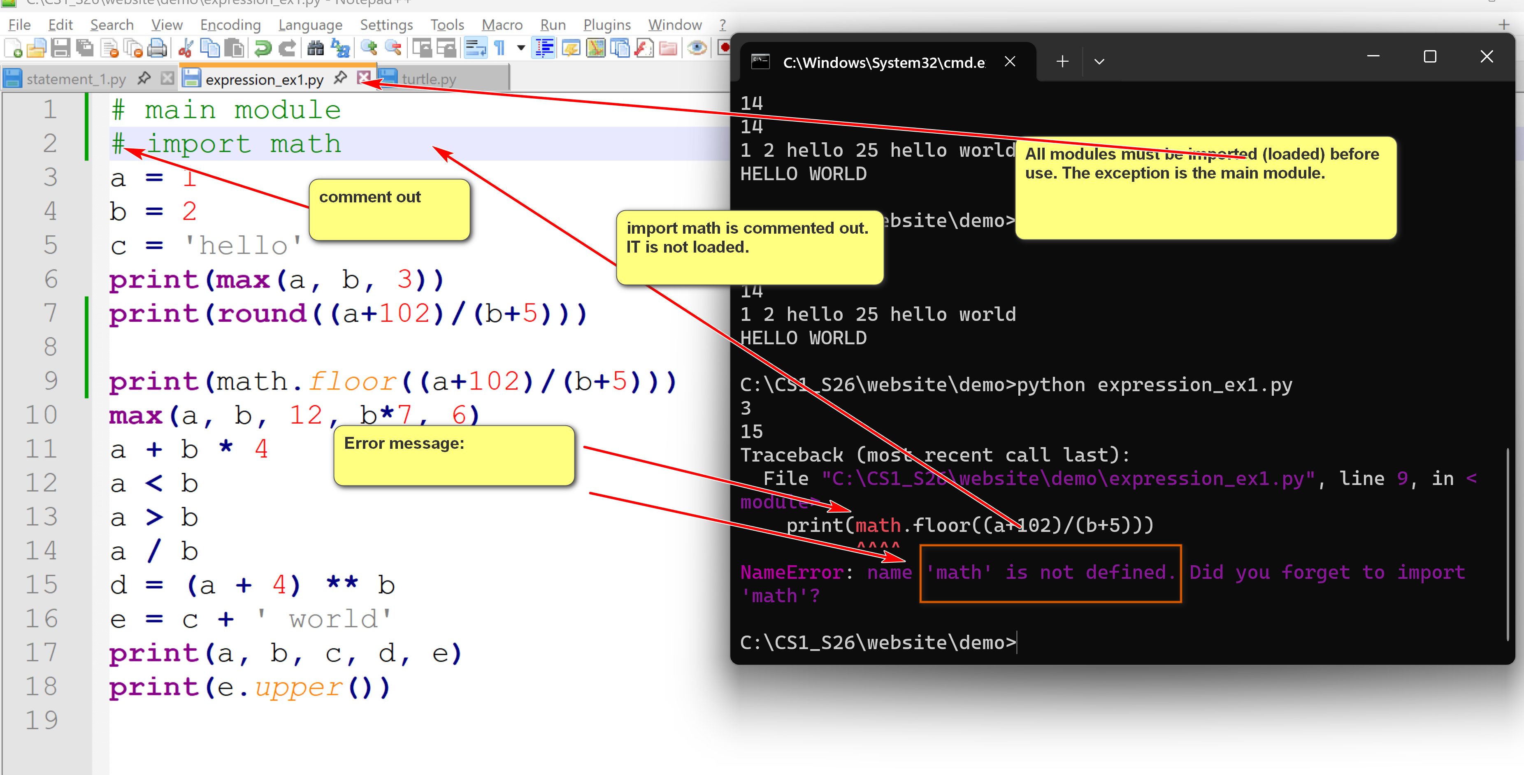
- A module can use other modules by importing them.
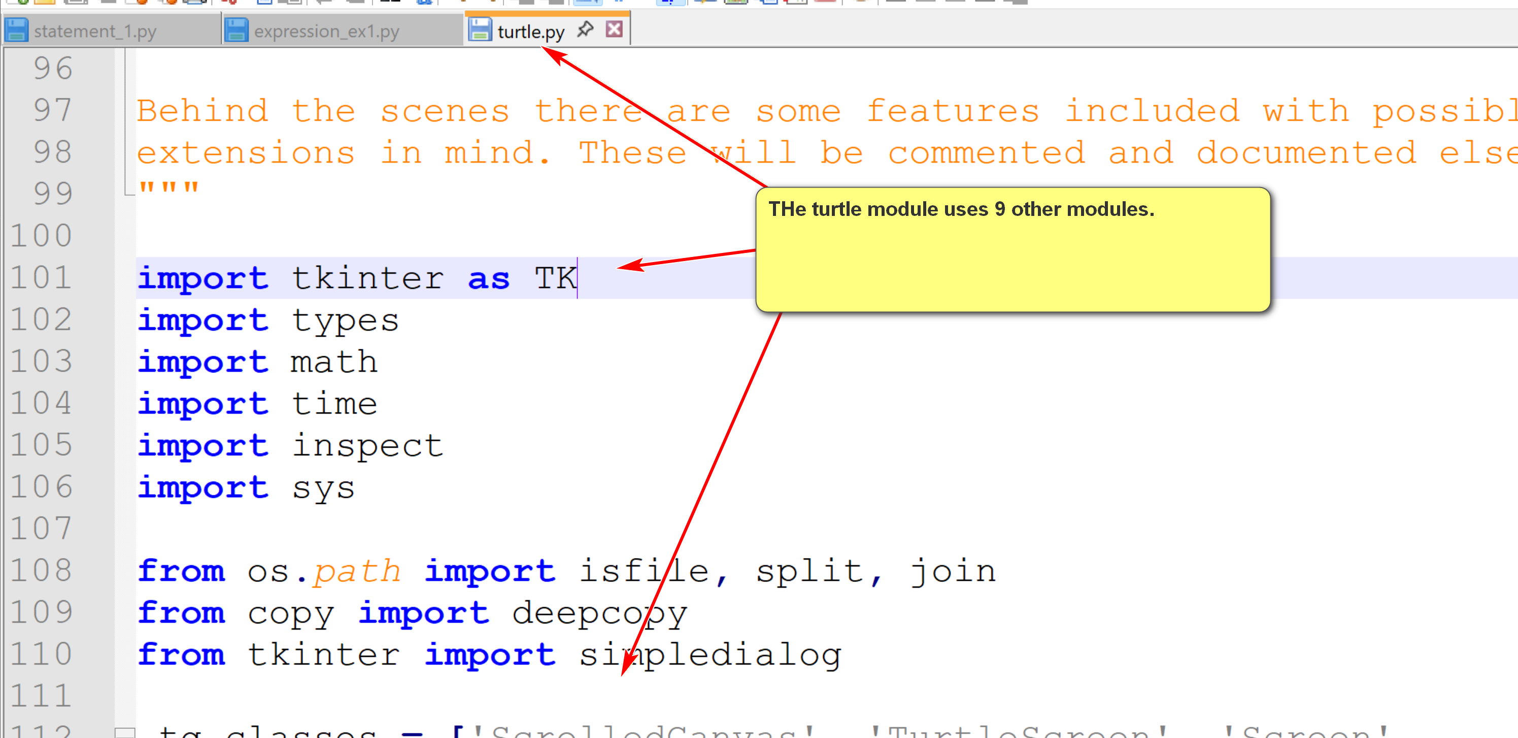
- "Within a module, the module’s name (as a string) is available as the value of the global variable __name__." (dunder: double underscore) Dunder do not conflict with user-defined variables. Users should not define a variable starting with __.
For:

if __name__ == "__main__":
main()
If the name of the current is __main__, call the main() function (main body of your program).

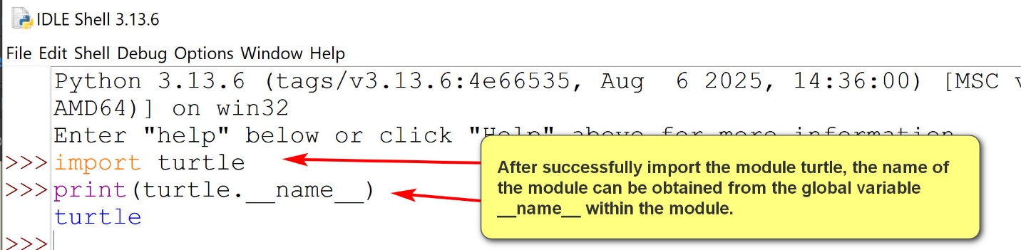
- A Python package is a way to organize related modules into a directory hierarchy.
1.1 Built-in Python modules
- Built-in Python modules are pre-installed Python modules that come with the Python installation.
- It can be regarded as Python's standard library.
- Users do not need to install built-in Python modules themselves. They are already there.
- To manage and access Python modules effectively, they are stored in specific folders (usually the Lib sub-directory of the Python installation.
- Example:
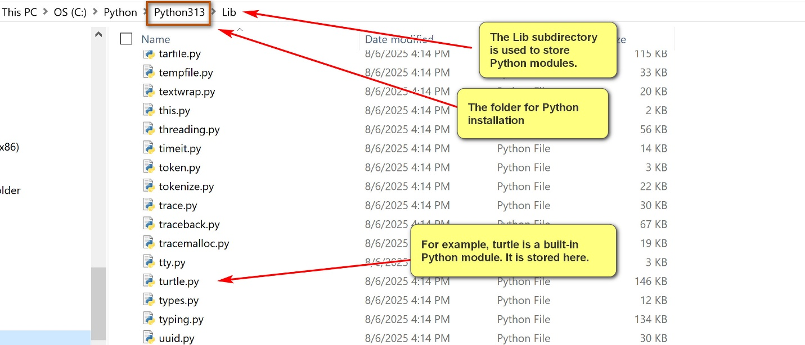
2. External Python modules and Python
- External Python modules are modules not come with Python standard library.
- They are also known as third party modules.
- Packages containing these external Python modules need to be downloaded and properly installed before using.
- pip (Pip Installs Packages) is the python program for installing and managing Python packages.
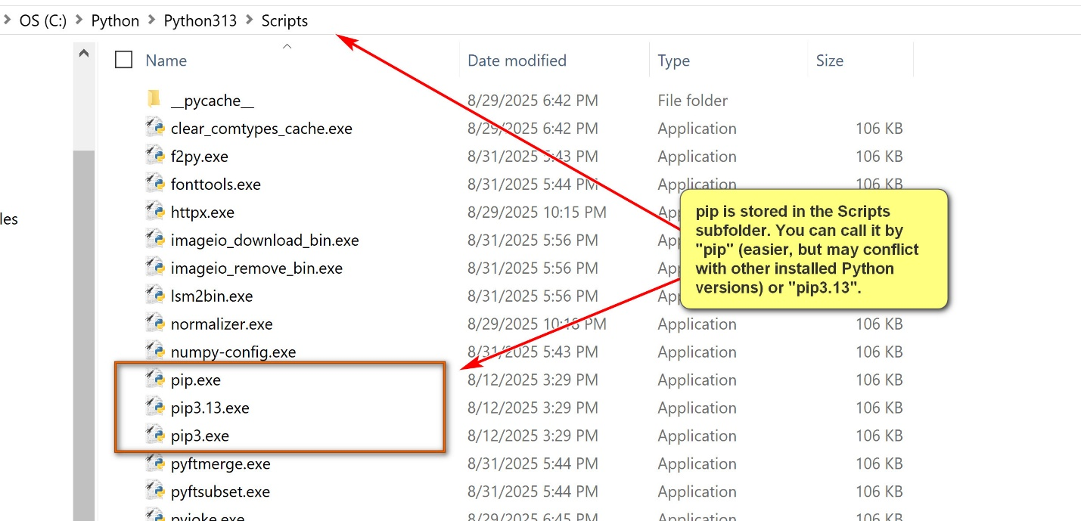

Rule: be as specific as possible. Pip3.13 is more specific than pip.
- Use "pip install <<module_to_be_install>>" in a command prompt to install a package.
- The Python Package Index (PyPI) is the official repository for Python software packages.
- When using "pip install wikipedia" (for example), pip will check PyPI for the package wikipedia, and then download, unpack and install the package.
Examples:
pip3.13 install numpy
pip3.12 install numpy
pip3 install scipy
pip install wikipedia
- Other common pip commands:
  - pip3.13 help
  - pip3.13 list
  - pip3.13 uninstall

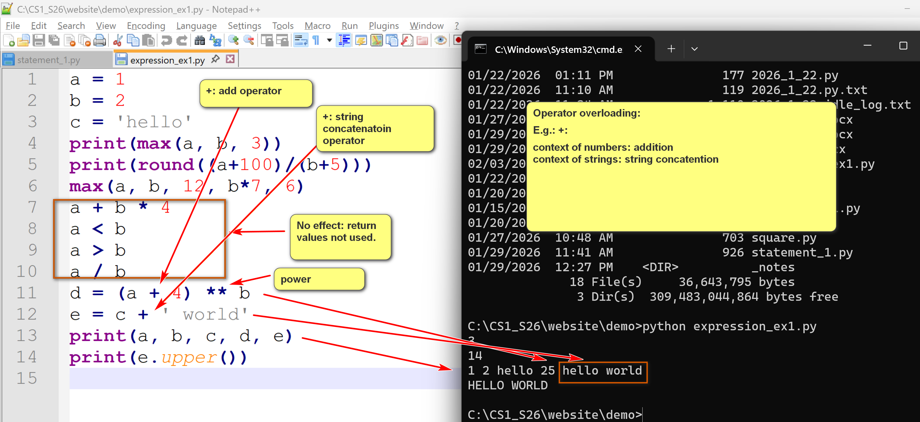

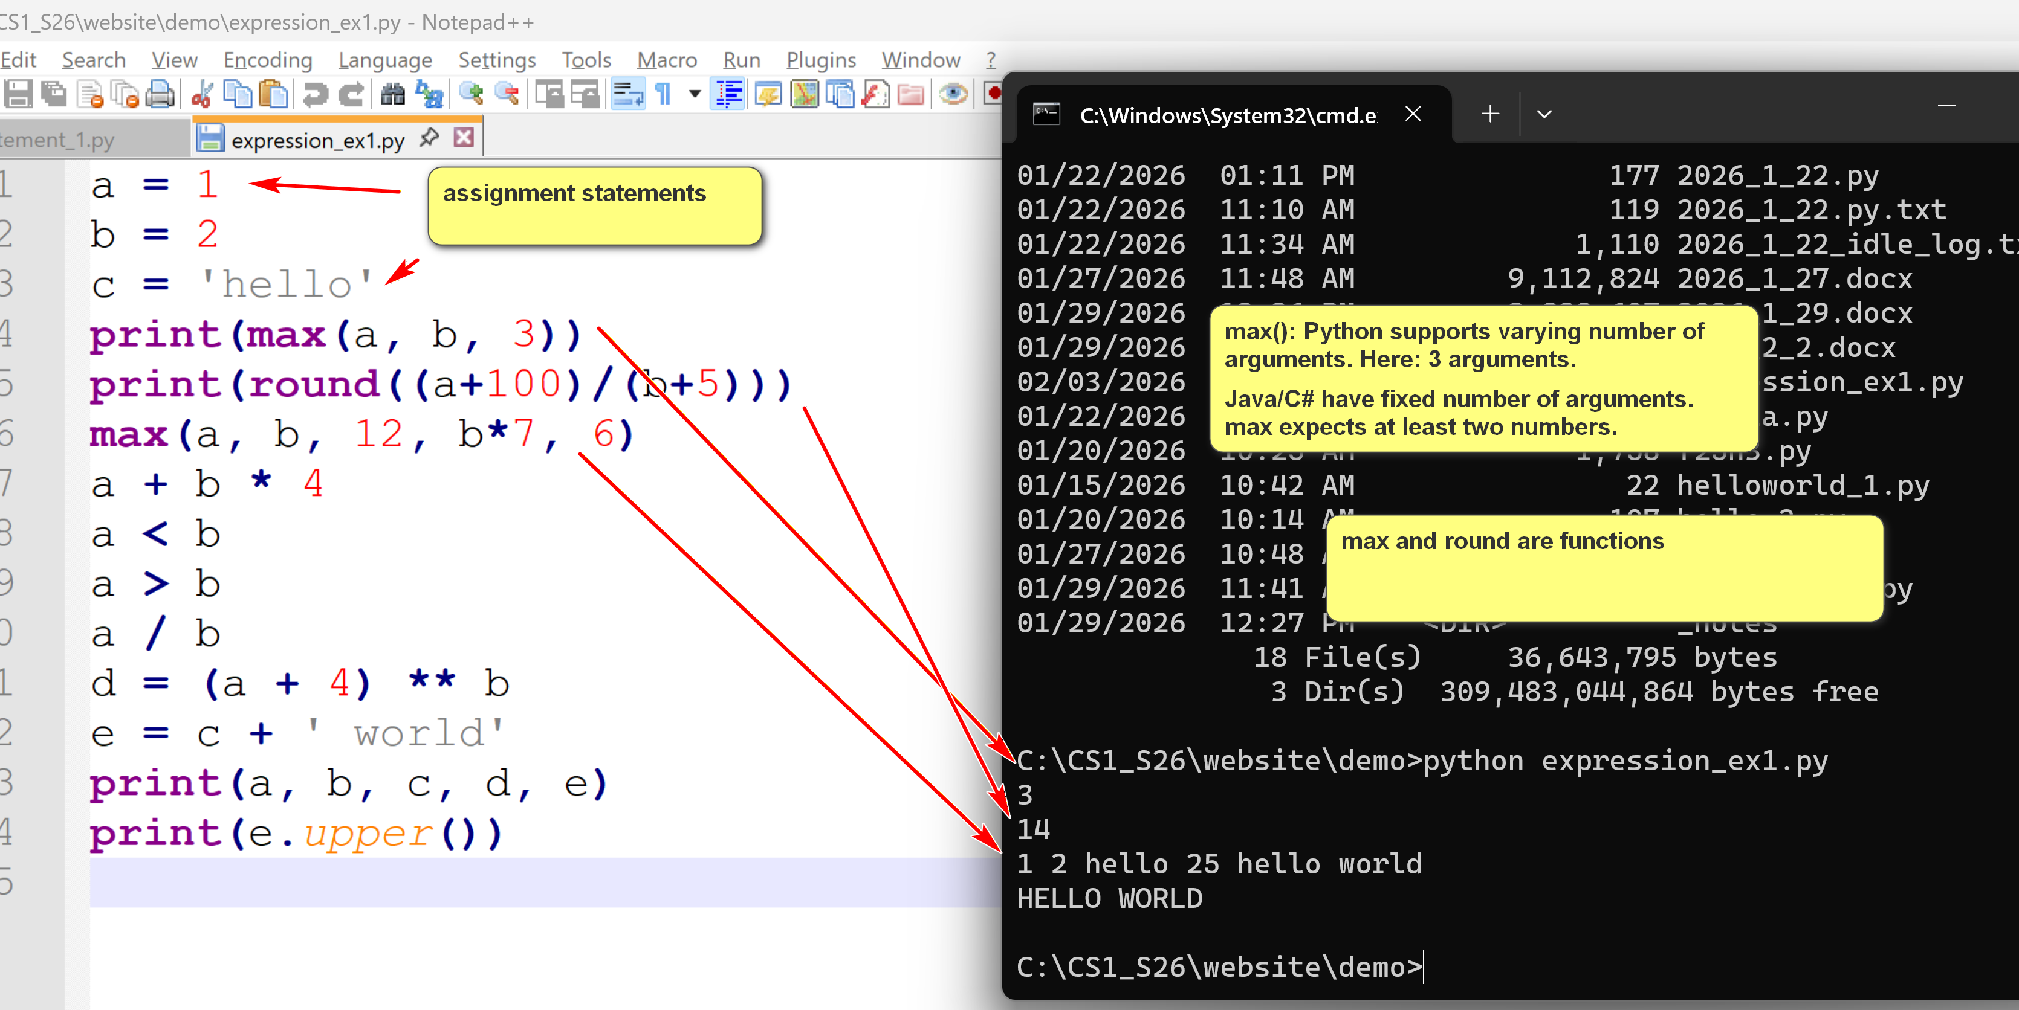
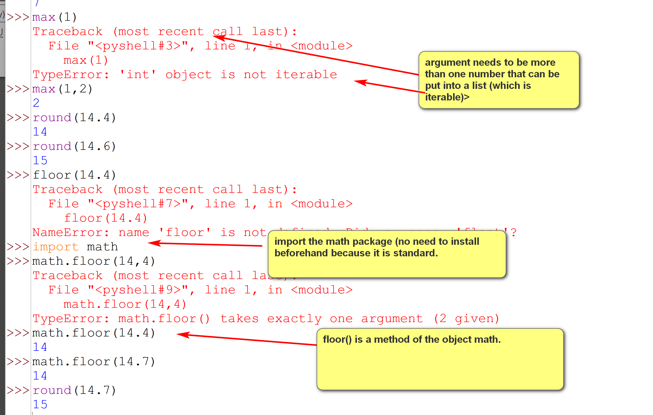
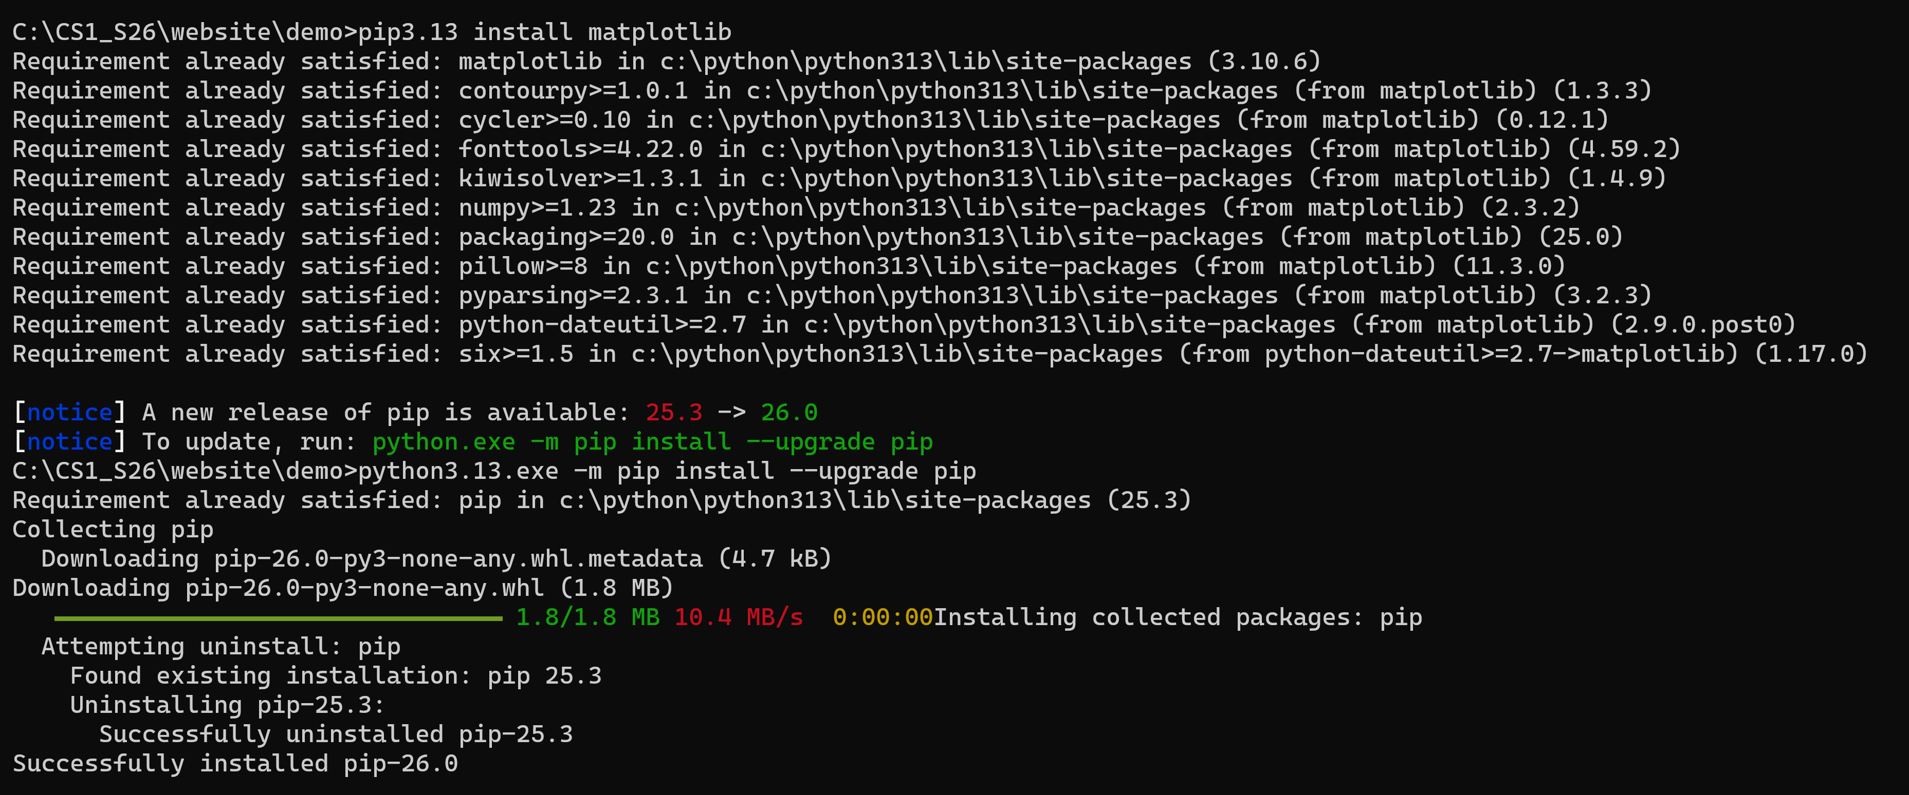

Introduction to Mathplotlib in Python
by K. Yue
1. Overview of Mathplotlib module
- "Matplotlib is a comprehensive library for creating static, animated, and interactive visualizations in Python."
- Resources:
  - Main site: https://matplotlib.org/
  - mathplotlib at w3schools: https://www.w3schools.com/python/matplotlib_intro.asp
  - Codebase in Github: https://github.com/matplotlib/matplotlib
- Installation: at command line prompt: "pip install matplotlib"
- Two types of interfaces:
  - User interfaces: a set of rules and protocols of a software program to communicate with its users.
  - Application Programming Interface (API): a set of rules and protocols for two software programs to communicate with each other.
Example:
- mathplotlib module is a software program.
- A program, e.g., simple_plot_1.py, that use mathplotlib is another program.
- mathplotlib provides API for simple_plot_1.py to use its functionality.
2. Simple Mathplotlib programs
- Mathplotlib provides two main interfaces in its API:
  - Pyplot API:
    - It provides a collection of command-style functions that implicitly track the current figure and axes, making it work like MATLAB.
    - It is generally simpler for quick, interactive plots and basic scripting.
  - Object-Oriented (OO) API:
    - It provides a collection of objects for greater control and customization.
    - It is the recommended approach.
  - Two main objects to start with:
    - Figure: The top-level container for all plot elements. A figure may contain more than one plots.
    - Axes: Represents a single plot area (e.g., an x-y graph) within the Figure and contains most of the plot elements like ticks, labels, and lines.
What is an object in Python?
In Python, an object is the fundamental abstraction for data for convenient organization and management, and virtually every "thing" in Python is an object.
Conceptually, an object can be understood as a self-contained entity that bundles together three main components:
- Attributes: constants or variables that define the object's structures, properties and internal states.
- Methods: functions defining the behavior of the object: what it can do or how it interacts with other objects.
- Identity: A unique identifier (which can be checked using the id() function) that distinguishes it from other objects in memory.
An object is a specific instance of a class, which acts as a blueprint or template for creating objects with a specific structure and behavior.
Example: Consider the string s = 'hello, world'
- s is an object of the class str.
- A string is an immutable sequence of Unicode characters. Attributes cannot be accessed directly.
- A string object (of the class str) has many methods: e.g., count, index, upper, lower, ...
Random line graph from the Web:
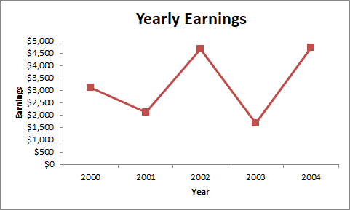
Computational Thinking #4:
2.5 Abstraction
- Focus on essential and high level features. Hide complex lower level implementation and irrelevant details.
- Difference between building X and using X.
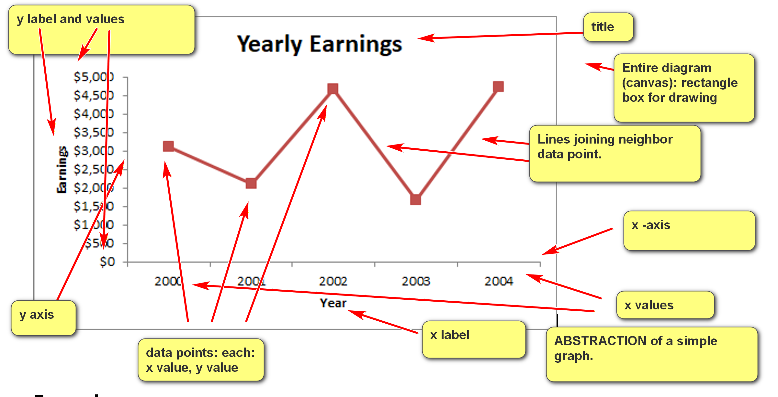
Find out:
- Appropriate modules that supports the graph abstraction.
- Obejcts, methods, etc. that should use.
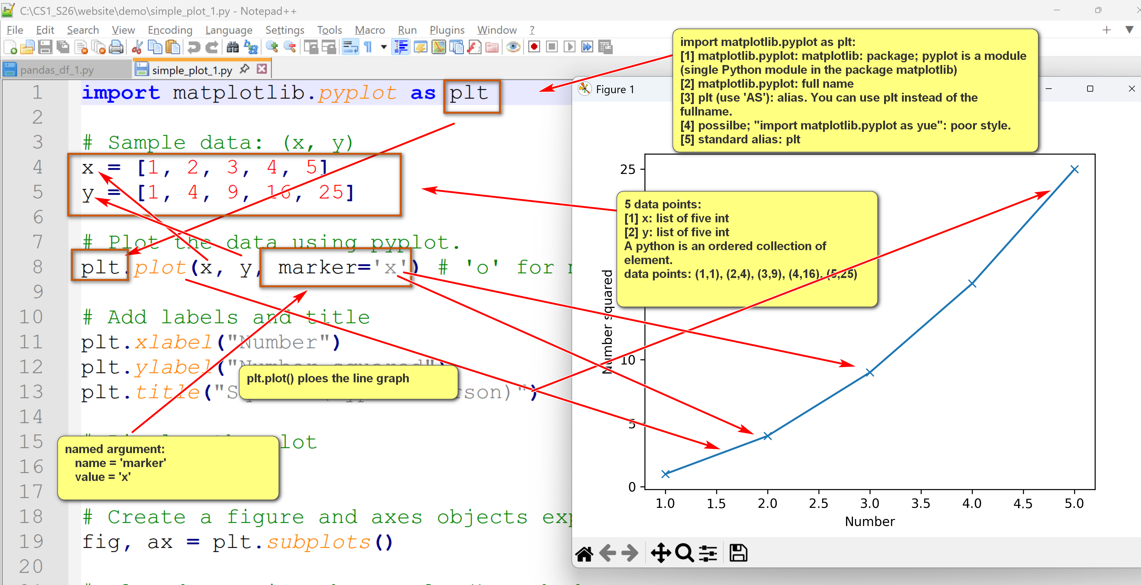
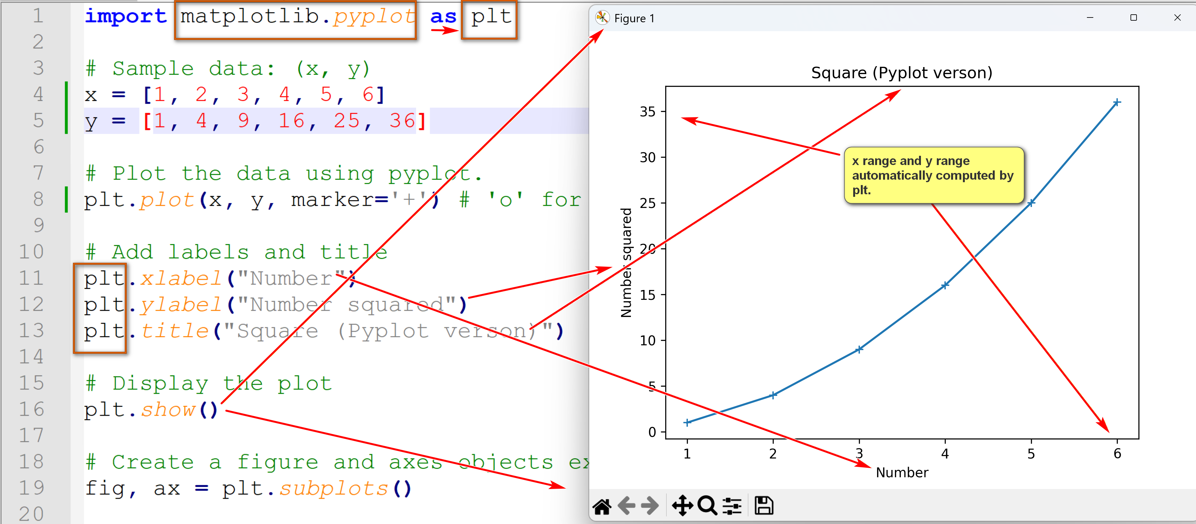
Example:
simple_plot_1.py: run, study and annotate it.
import matplotlib.pyplot as plt
# Sample data: (x, y)
x = [1, 2, 3, 4, 5]
y = [1, 4, 9, 16, 25]
# Plot the data using pyplot.
plt.plot(x, y, marker='x') # 'o' for markers
# Add labels and title
plt.xlabel("Number")
plt.ylabel("Number squared")
plt.title("Square (Pyplot verson)")
# Display the plot
plt.show()
# Create a figure and axes objects explicitly
fig, ax = plt.subplots()
# Plot data using the ax.plot() method
ax.plot(x, y, marker='o')
# Set labels and title using axes methods
ax.set_xlabel("Number")
ax.set_ylabel("Number squared")
ax.set_title("Square (OO version)")
# Display the plot
plt.show()

