CSCI 1470 CS 1 Annotation
2026_2_2

Python's Basics
CSCI 1470
by K. Yue
1. Python's Interpreter
- An interpreter is a program that executes code from a high-level programming language one statement at a time.
- A Python interpreter is a program that executes Python code one statement at a time.
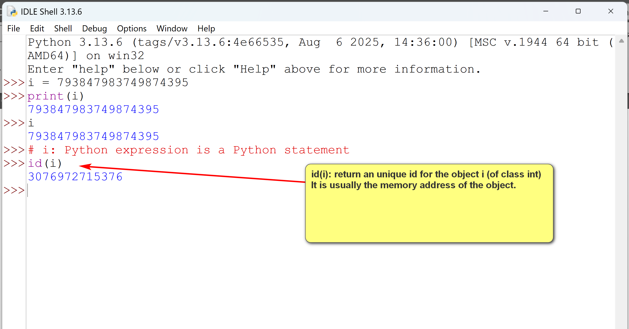
- In windows, the Python interpreter is usually 'python.exe' in the installed Python directory.

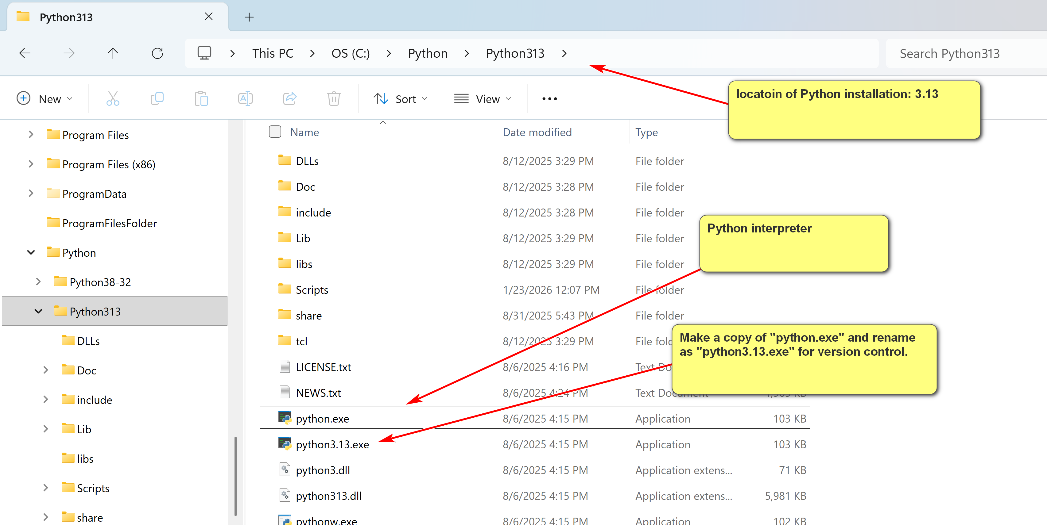
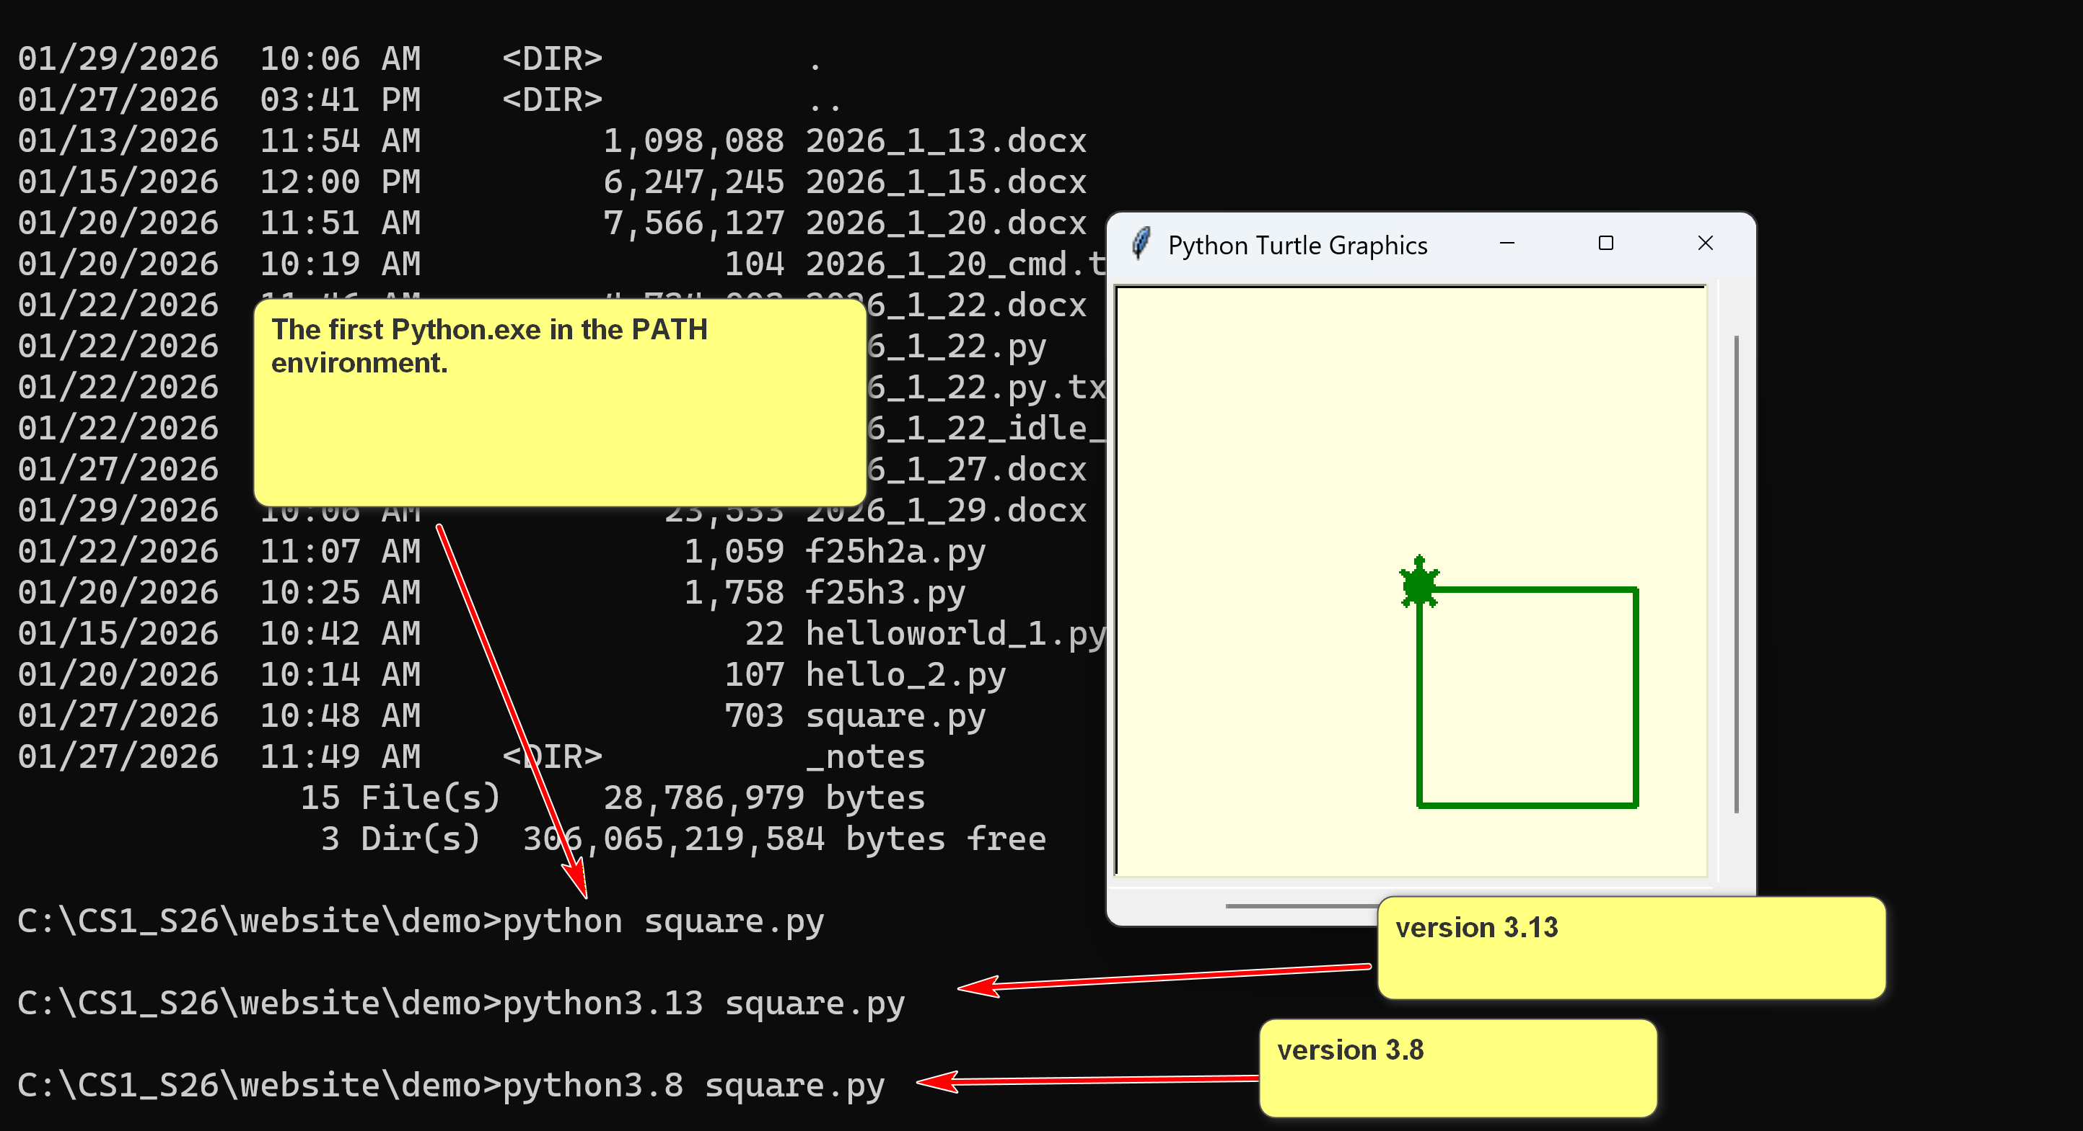
The first Python.exe in the PATH environment.
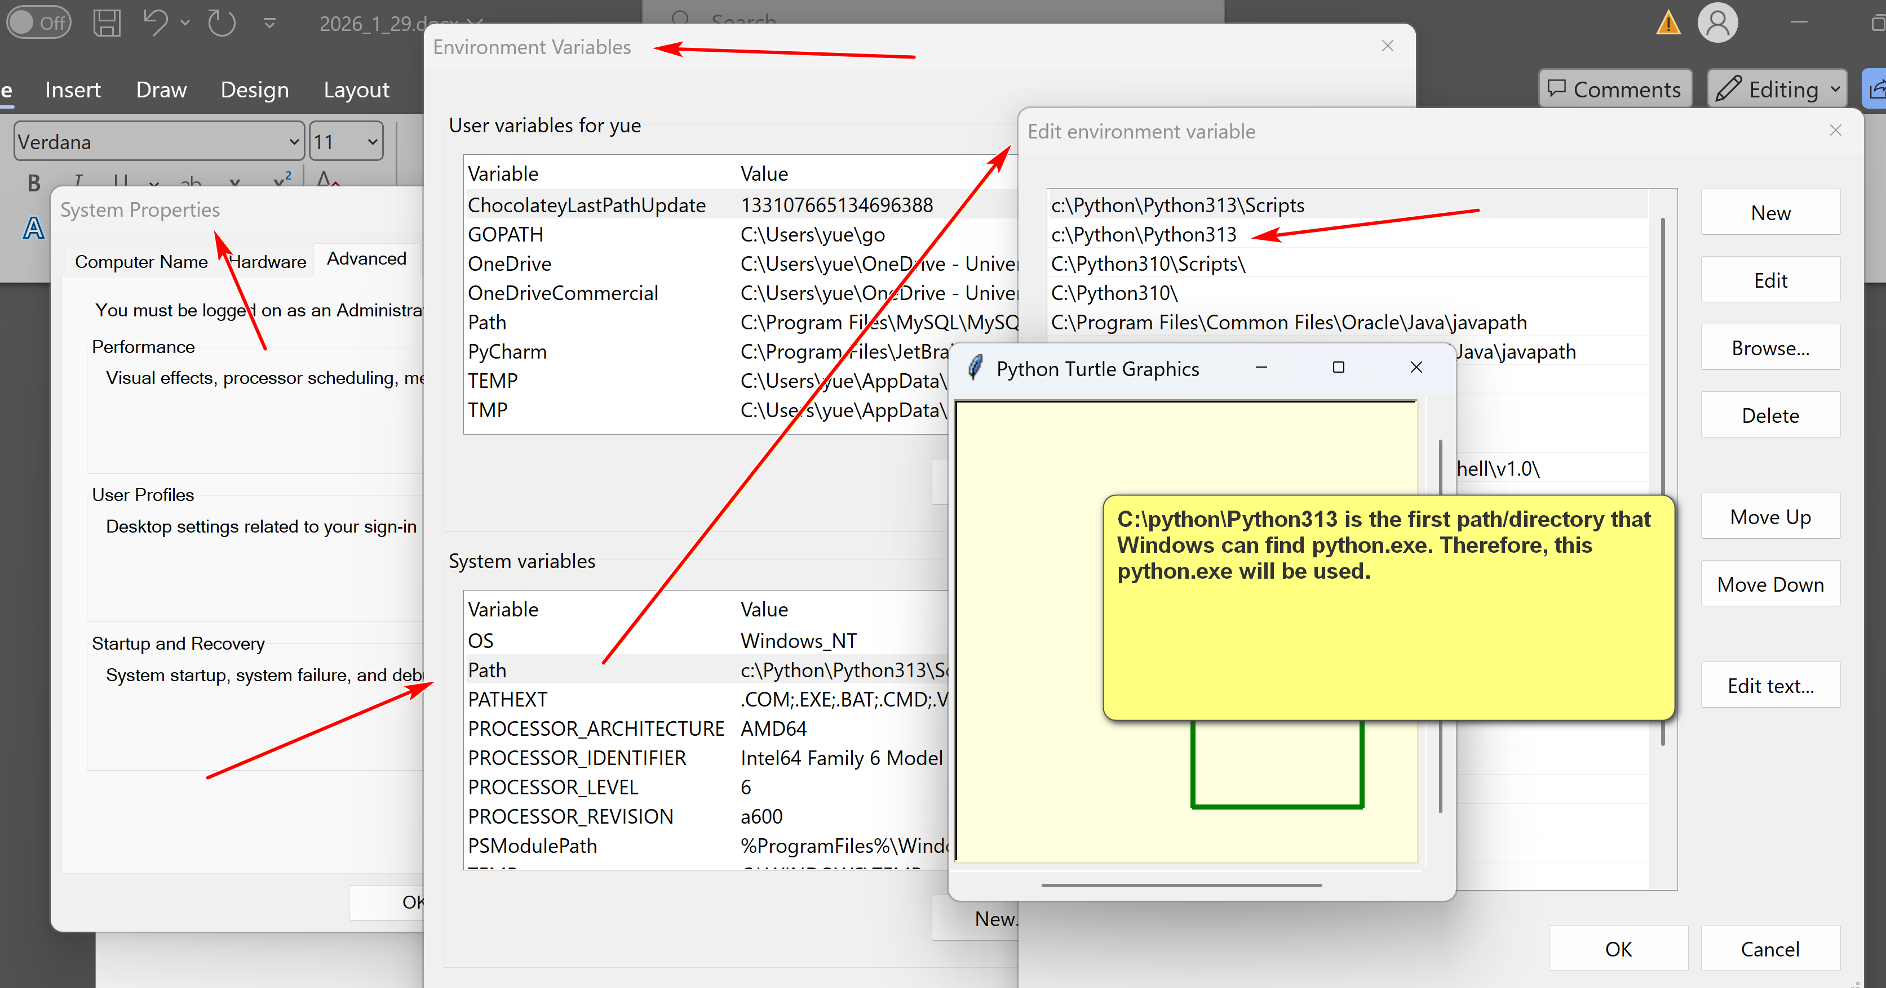

Example:
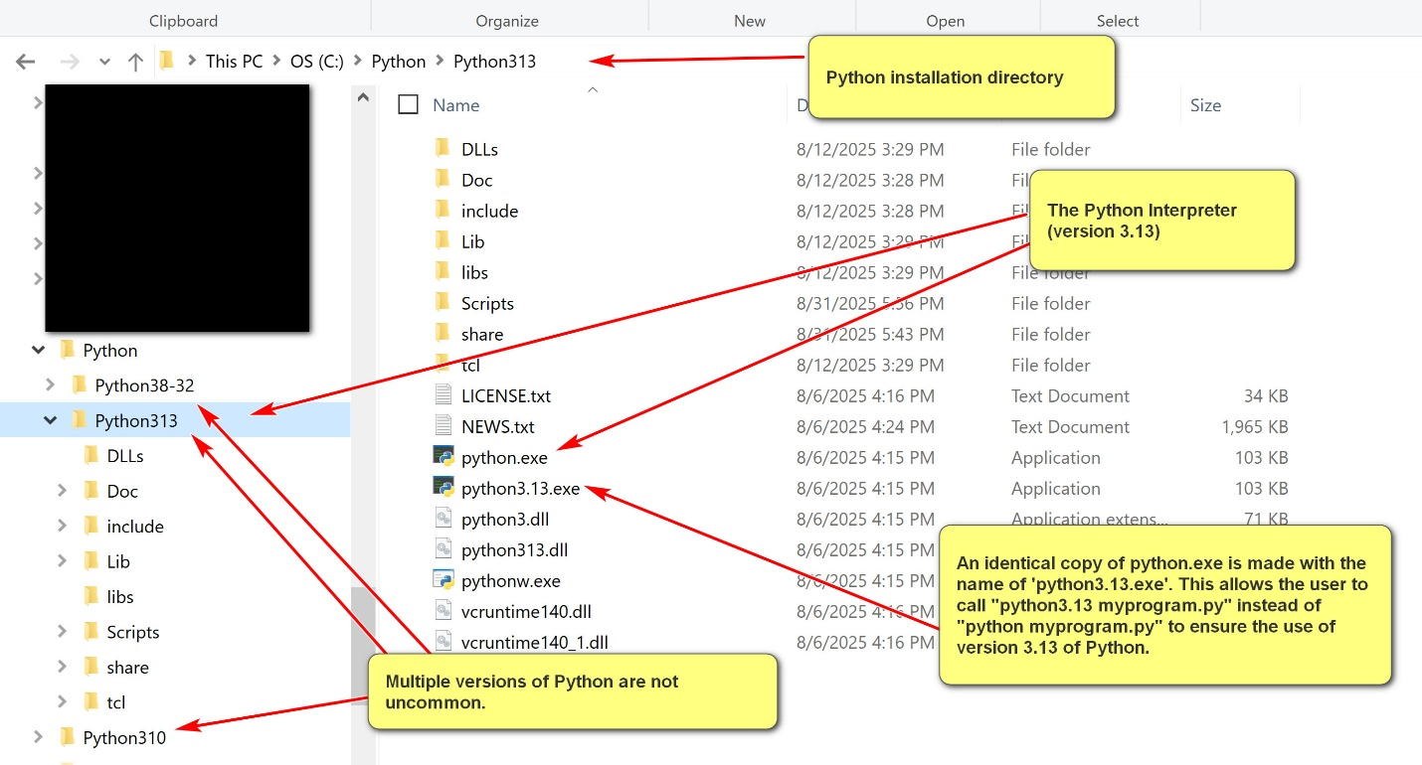
- In contrast, many high-level programming languages do not have interpreters. Instead, they use compilers. (e.g. CS II class: Java) Execution of a program involves two steps. Program executions require two steps:
  - Compilation: compile the program to machine code or other low level code.
  - Execution: execute the machine or low-level code.
Example:
In Java, to run a program, Hello.java:
[1] "javac Hello.java": compile Hello.java into Hello.class, a Java bytecode program. Java bytecode has .class as its file extension. It is a platform independent intermediate level programming language.
[2] "java Hello": invoke the Java Virtual Machine (JVM) to run the Java bytecode program Hello.class. Note that the instruction is not "java Hello.class" as the file extension of .class is assumed.
1.1 Python Interpreter
- The Python interpreter is invoked by running "<<python_installation_path>>\python.exe" (e.g., c:\python\python313\python.exe)
- When invoking by itself, the Python interactive interpreter is started, executing one Python statement at a time.
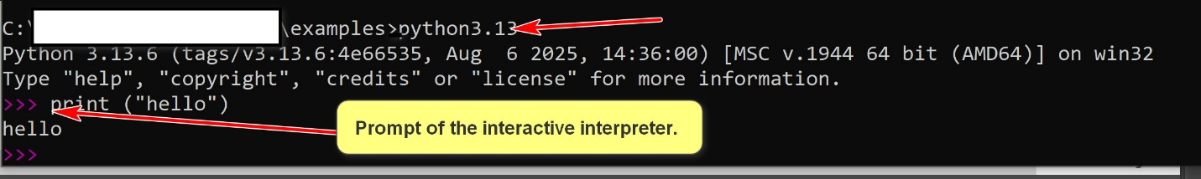
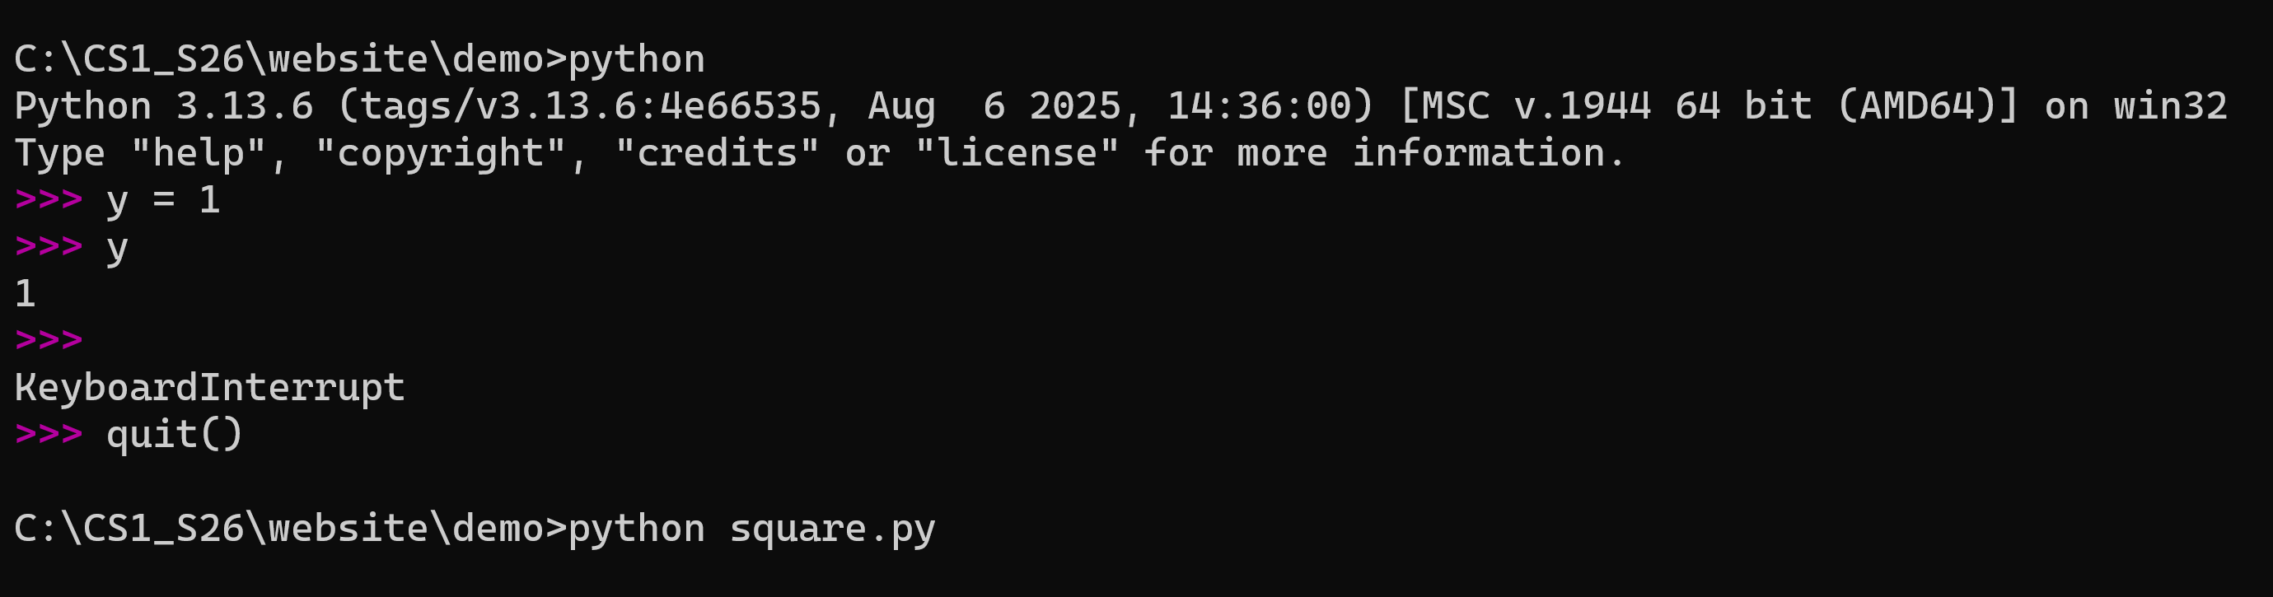
- The interactive Python interpreter is good for exploration and learning. However, it is limited by one user input Python statement at a time.
- To perform serious work, it is necessary to run Python programs that contain many Python statements.
- One can use it to execute a program, e.g. "Python hello.py"
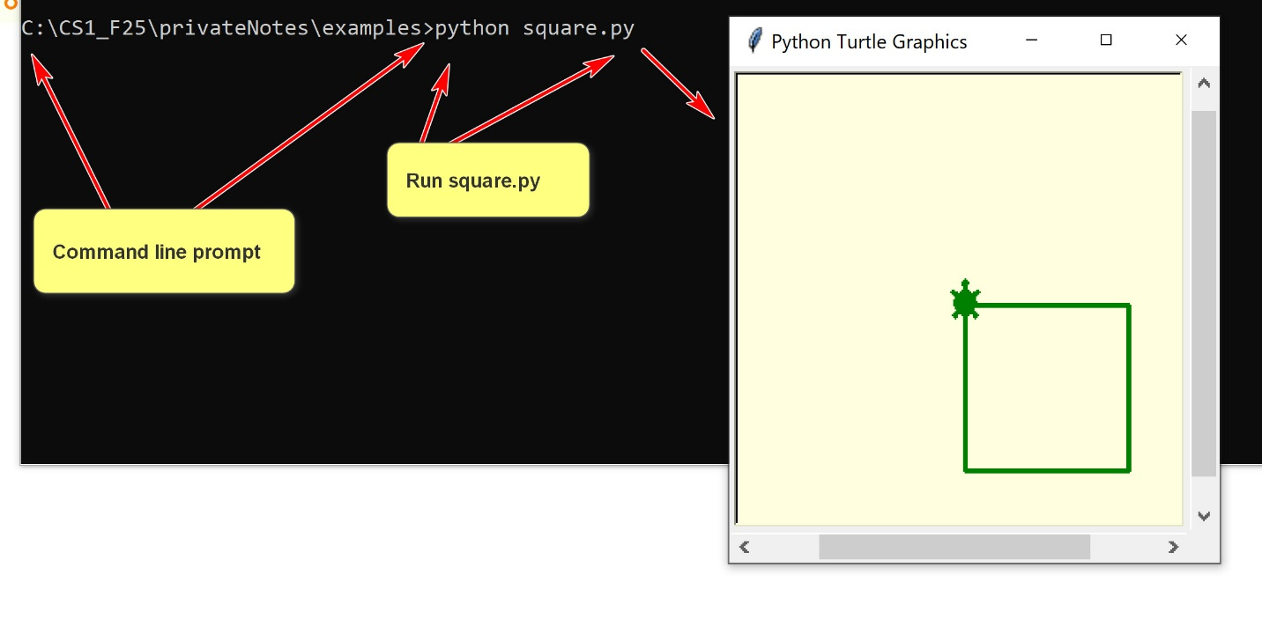
1.1 Python IDLE
- The Python IDLE is more than the Python interactive interpreter. It is a simple IDE with an editor and can execute a Python program.
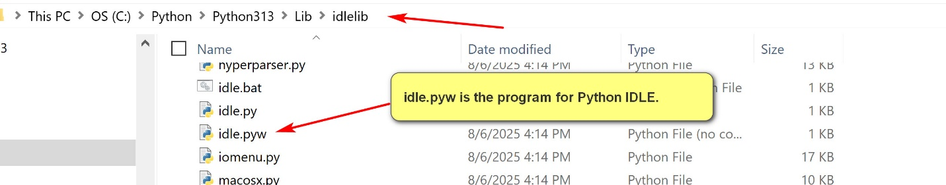
2. Python Programs
2.1 Python Literals and Variables
- Literals in Python are fixed values written directly in the source code that represent constant data.
E.g.,
# constants.py
PI = 3.141592653589793 (physical constant)
SPEED_OF_LIGHT = 299792458 # meters per second (physical constant)
MAX_CONNECTIONS = 1000 (setting for the program, not to be changed
Constant: upper characters, meaningful, connected by _.
UNIVERSITY_NAME = 'University of Houston-Clear Lake'
# Use case: not suppose to change the university.
- There are many types of literals: number literals, string literals, Boolean iterals, etc.
- Identifiers are names used to identify variables, functions, classes (e.g. , ‘str’ <class 'str'>)modules (e.g. turtle), or other objects in Python code.
IN “x = s.upper()”: identifiers: x, s, upper
- A Python variable has a symbolic name (identifier) that refers to objects or values stored in the computer's memory.
x = 15;
- Python gets a location to store 15.
- Store the address of x in the symbol table.
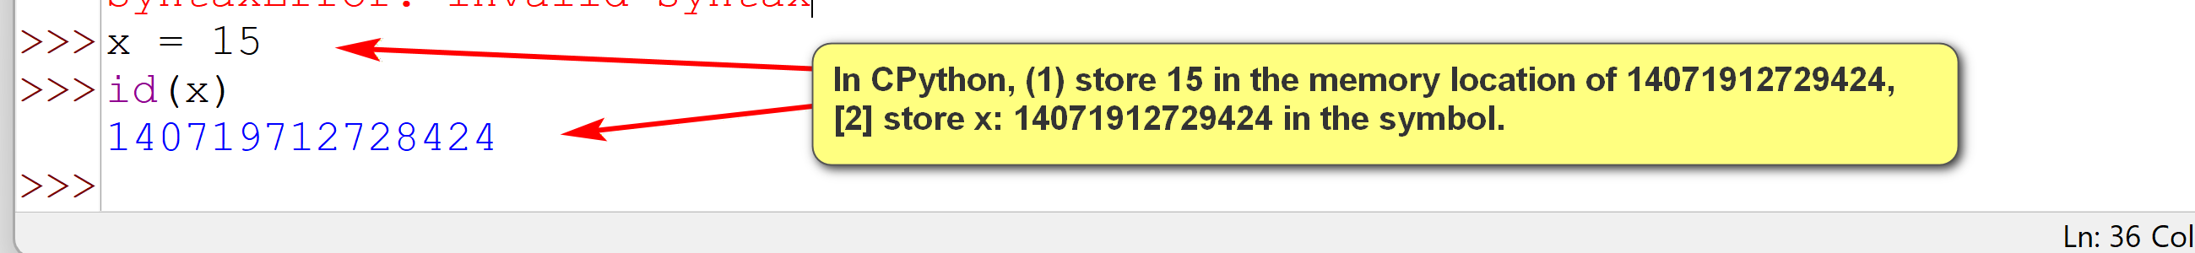

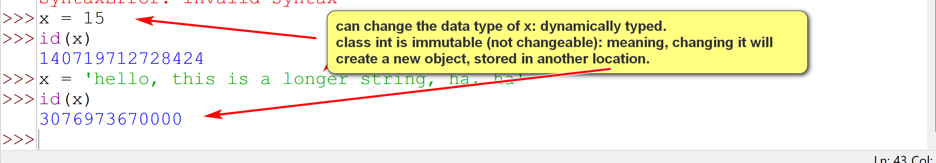
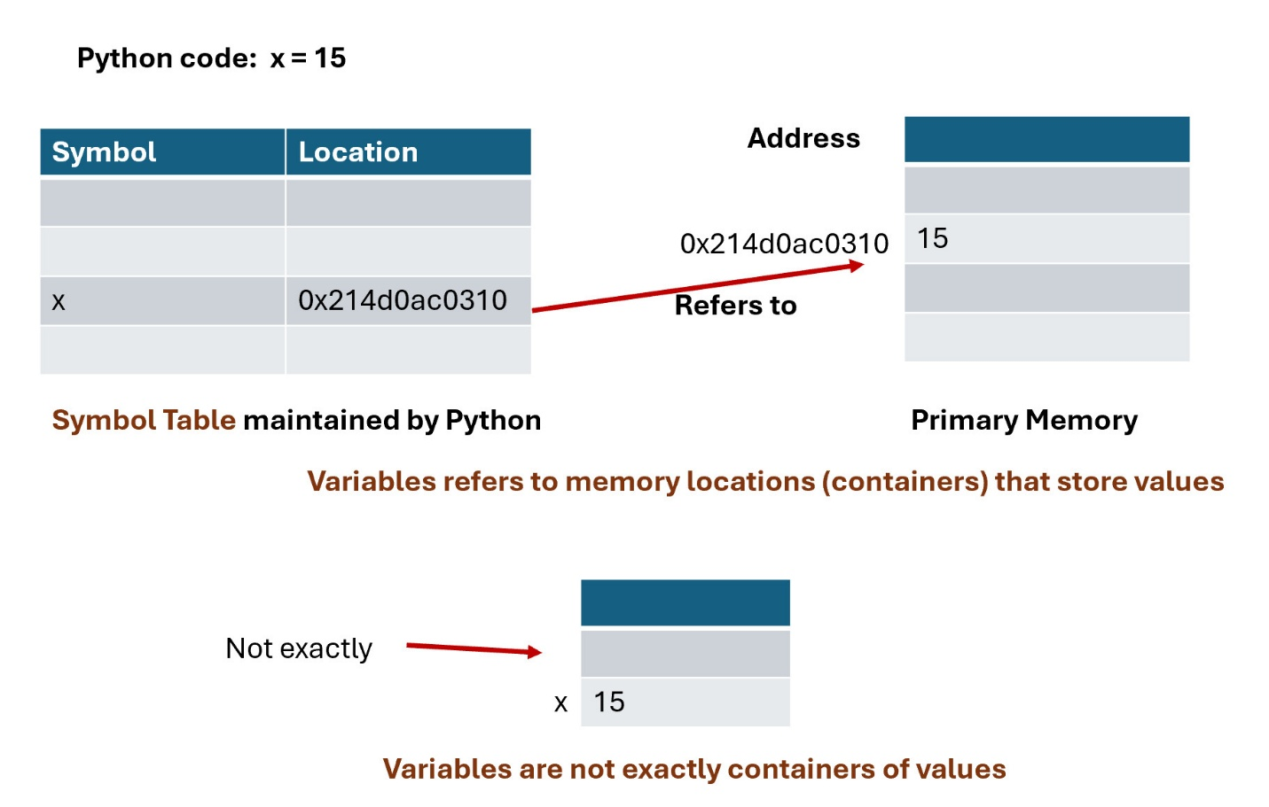
2.2 Python Statements
- A Python statement is an instruction that the Python interpreter can execute.
- A statement is a basic execution unit in Python.
- There are many types of statements in Python.
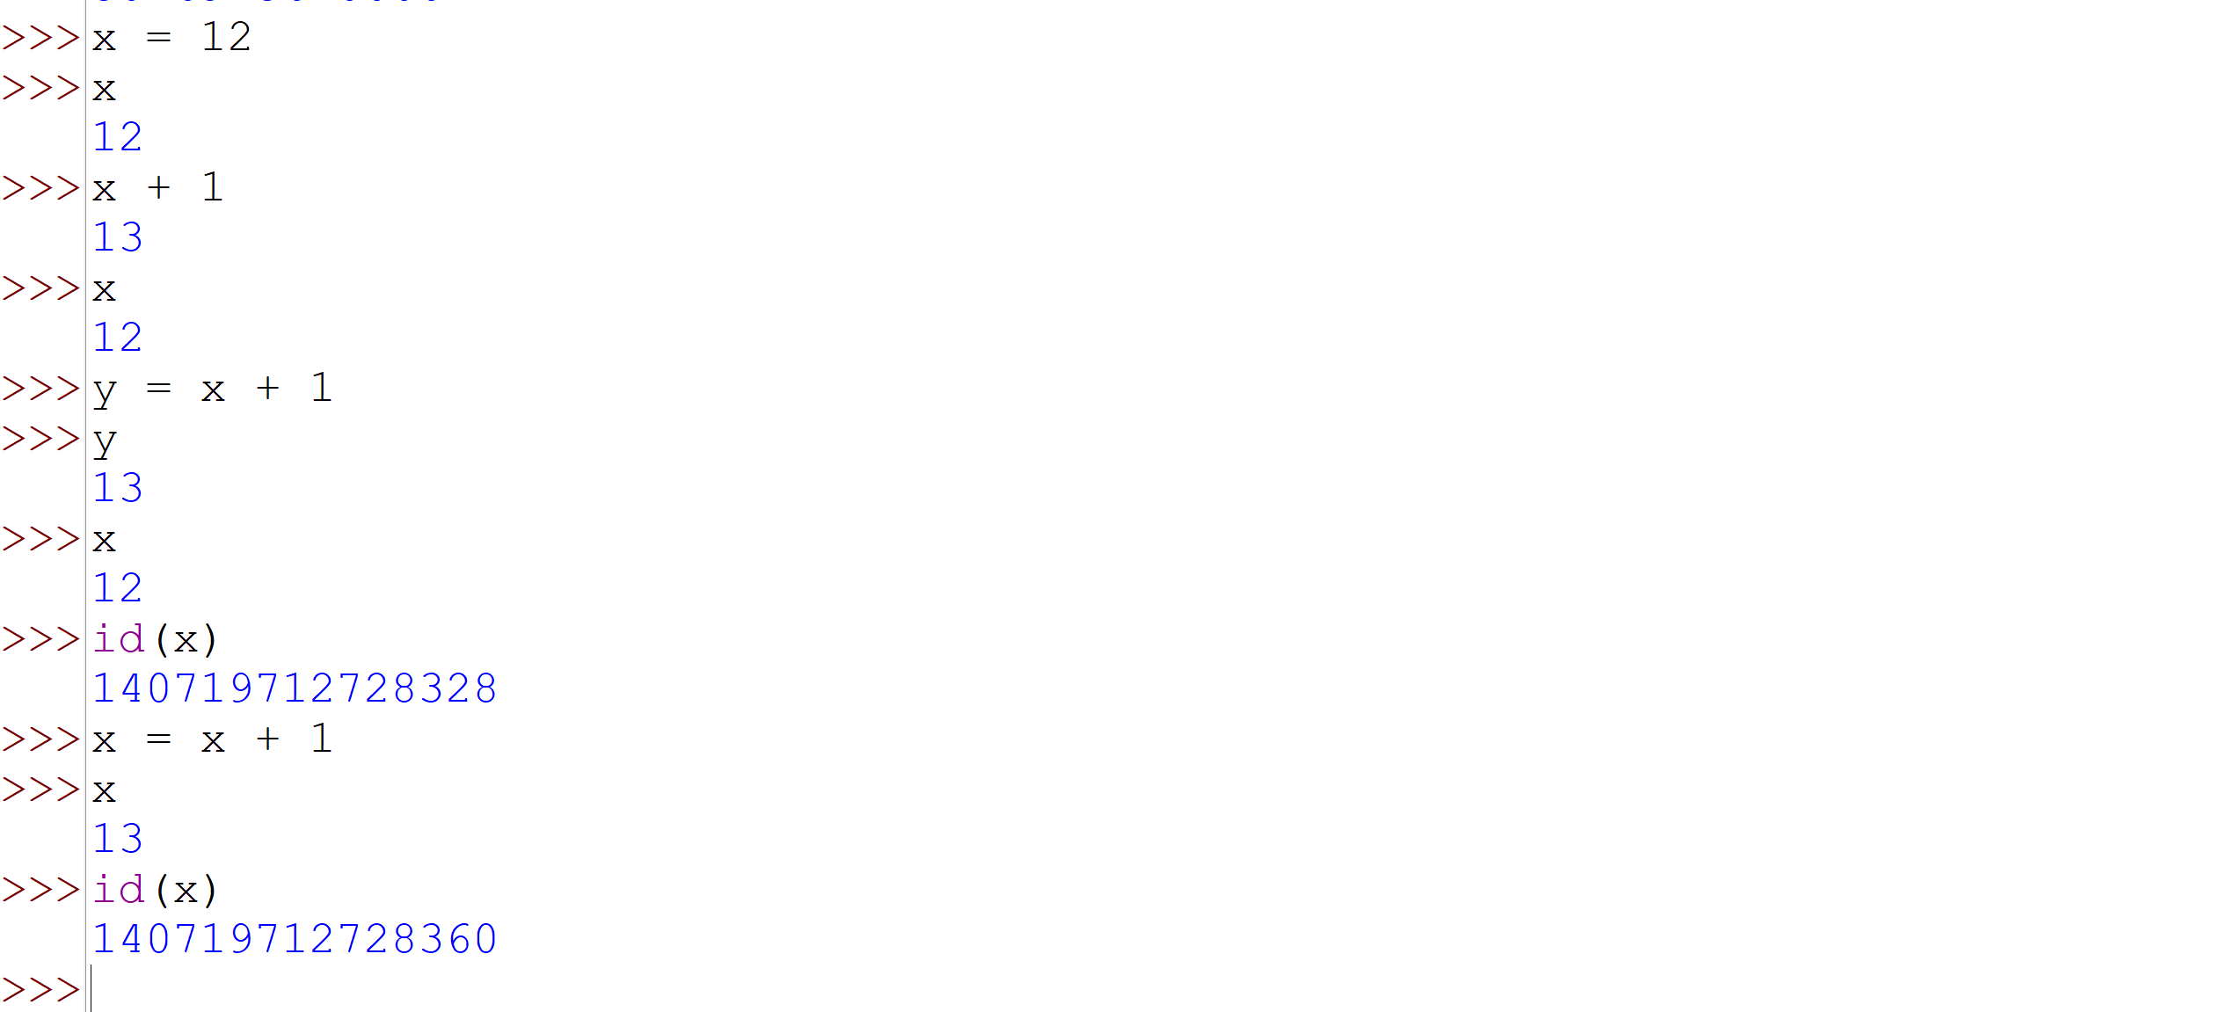
use cases of id() in python:

The primary use of Python's id() function is for debugging and understanding memory management by returning a unique integer identifier for an object, which corresponds to its memory address in the CPython implementation.
- A Python statement usually terminates at the end of a physical line, denoted by a newline character: ('\n').
\: escape characters.
- Regular meaning: ‘n’: means ‘n’
- Special meaning in context: ‘\n’ (one character with special meaning): newline.
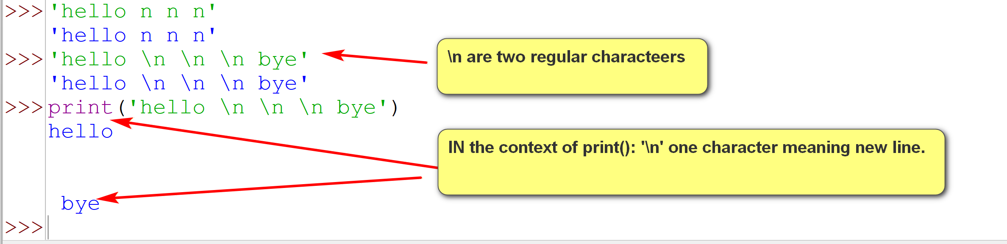
- The character ; is a terminator of Python statement. It is not required and is seldomly used.
- The character \ can be used to extend a Python statement beyond the current physical line.
- Python can also detect that some Python statements are not terminating and extend them to the next physical line.
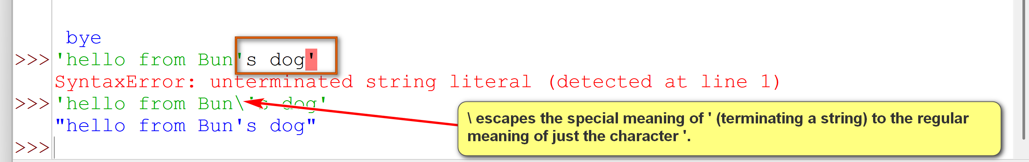
Try out statement_1.py
# Python statements
# A Python statement is terminated by the end of the physical line,
# represented by the end of line character: \n.
print('hello')
print('hello again');
# Not recommended Python style.
print('hello '); print('world');
# the second argument (end = ' ') indicates that the end string
# for the print statement is ' ', and not the default '\n'
print('hello ', end = ' '); print('world');
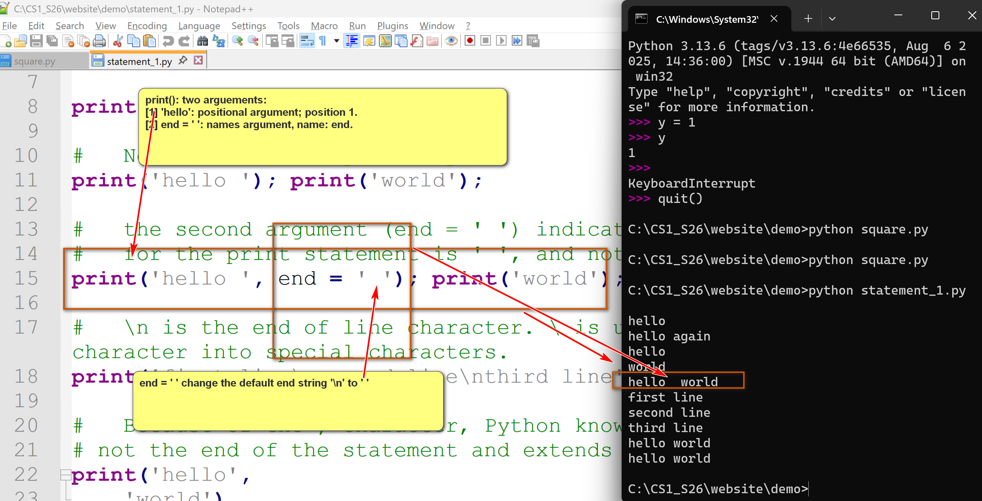
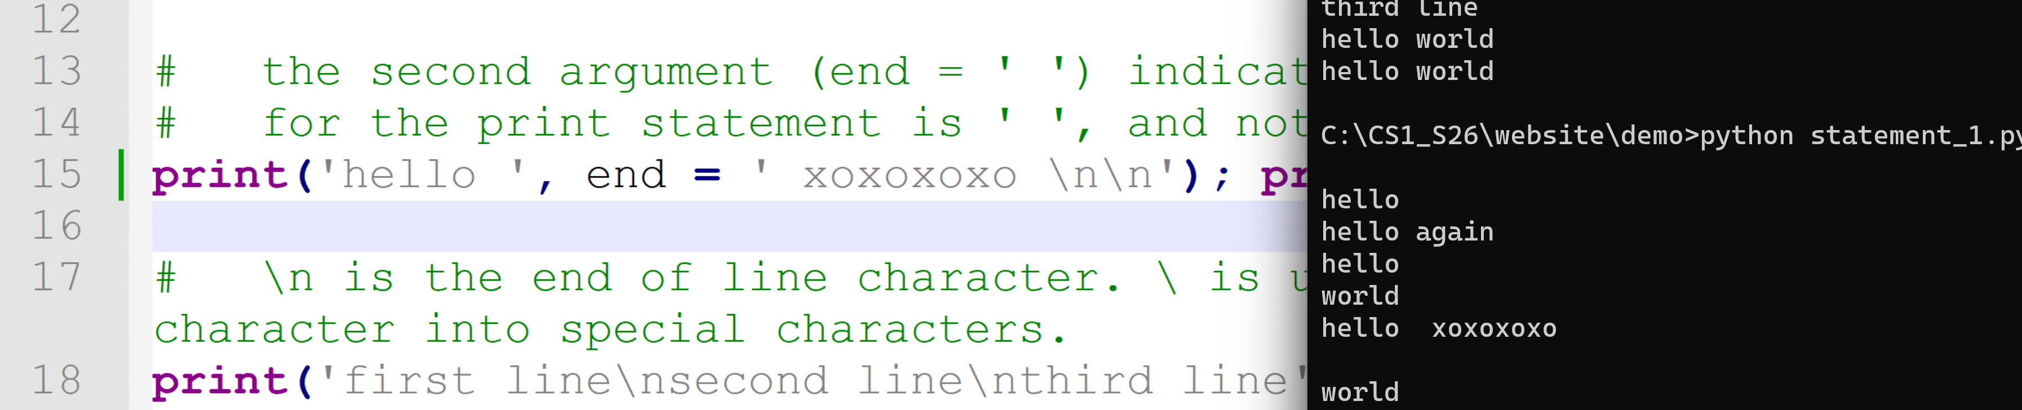
# \n is the end of line character. \ is used here for 'escaping' a character into special characters.
print('first line\nsecond line\nthird line');
# Because of the , character, Python knows that this
# not the end of the statement and extends it to the next line.
print('hello',
'world')
# The character \ extends the statement to the next line.
# There should not be any character after \.
print('hello' \
, 'world')
2.3 Expressions, Functions, Operators and Methods
- Function: sqrt(x): x: 1 argument; random(): no argument; max(1,2,3,4): 4 arguments.
- Operators: functions with special. E.g., 3 + 5 (binary operator); similar to add(3,5)
- In Python, an expression is a piece of code that the Python interpreter evaluates to produce a value.
- The evaluation of an expression always returns a value.
- Expressions can be constructed by using:
  - literals: constants
  - variables: identifiers to refering an object or a value.
  - functions: standalone functions similar to mathemtical functions. Have arguments and return a value. E.g., max()
  - operators: special symbols representing operations. E.g., a + b.
  - methods: functions belonging to an object using the object method invocation syntax: object.method(). E.g., if s is a string, we can call s.upper()
Examples:
Try out expression_ex1.py
a = 1
b = 2
c = 'hello'
print(max(a, b, 3))
print(round((a+100)/(b+5)))
max(a, b, 12, b*7, 6)
a + b * 4
a < b
a > b
a / b
d = (a + 4) ** b
e = c + ' world'
print(a, b, c, d, e)
print(e.upper())

Introduction to Python's Modules
CSCI 1470
by K. Yue
1. Introduction to Python's Modules
- A module is a file containing Python definitions and statements.
- The file name is the module name with the suffix .py appended as the file extension. Examples: sys.py, turtle.py, wikipedia.py
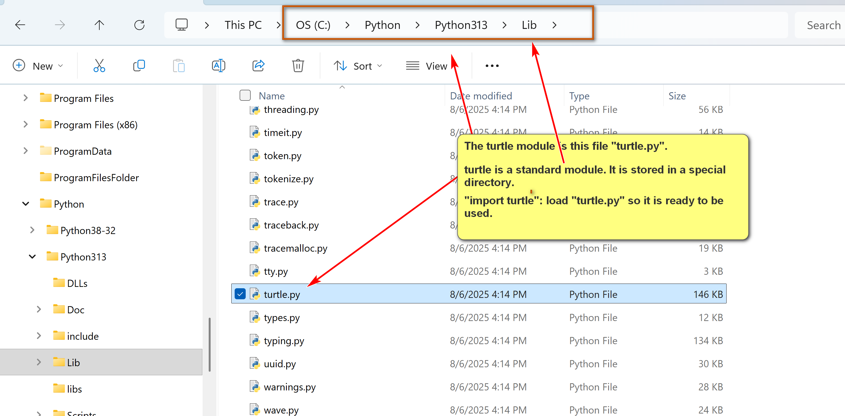
- Documentation: https://docs.python.org/3/tutorial/modules.html.
- There are many advantages of using Python modules:
  - Code reusability: uses Python code developed and tested by experienced Python developers.
  - Code organization: allows local grouping of related code into files.
  - Other advantages...
- The Python program being executed is known as the main module.
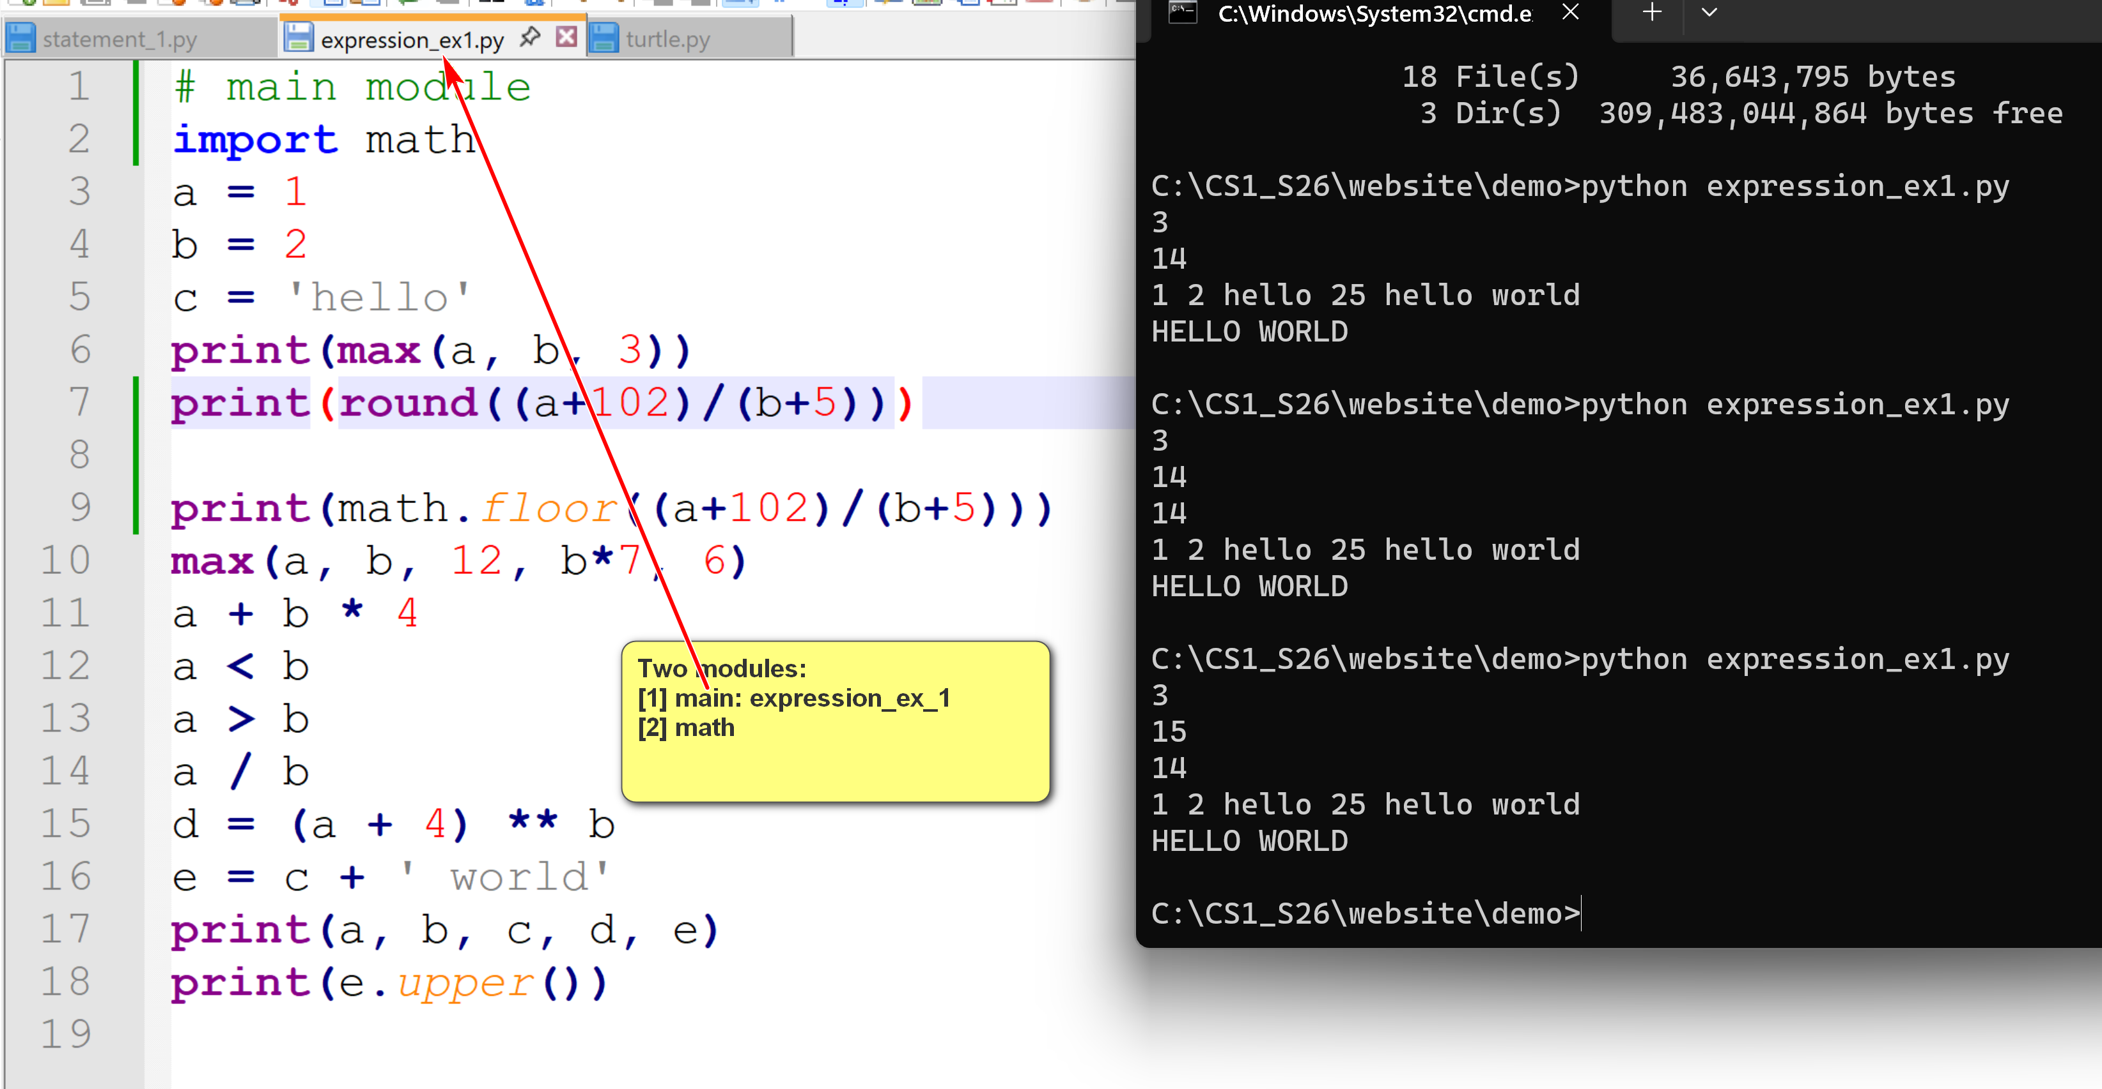
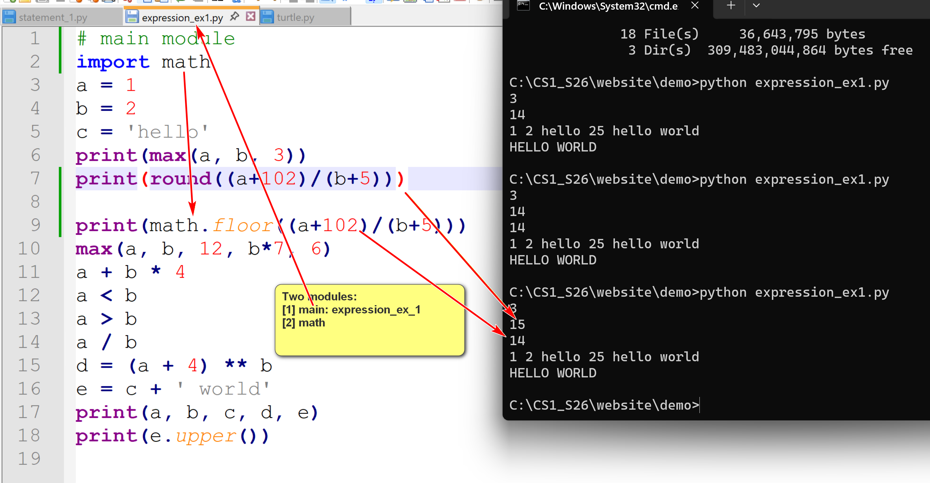

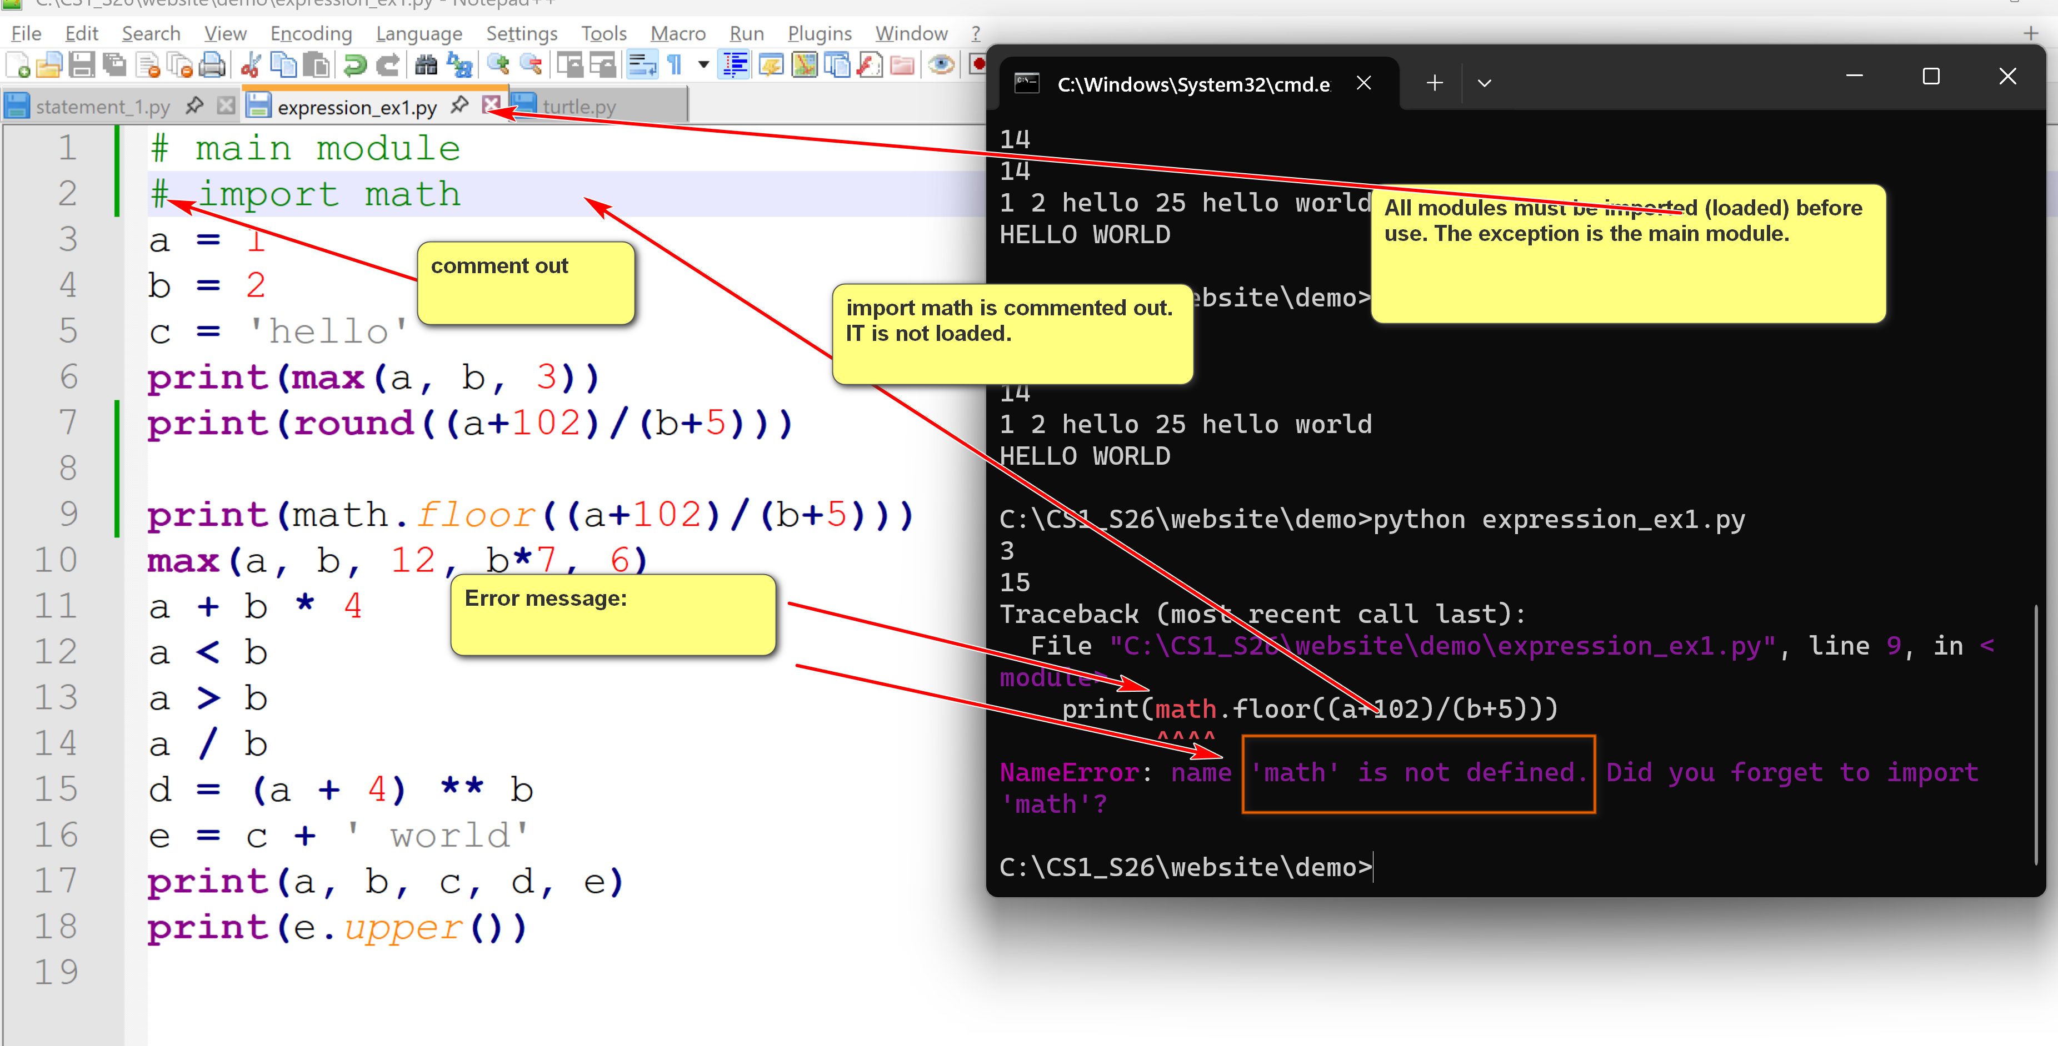
- A module can use other modules by importing them.
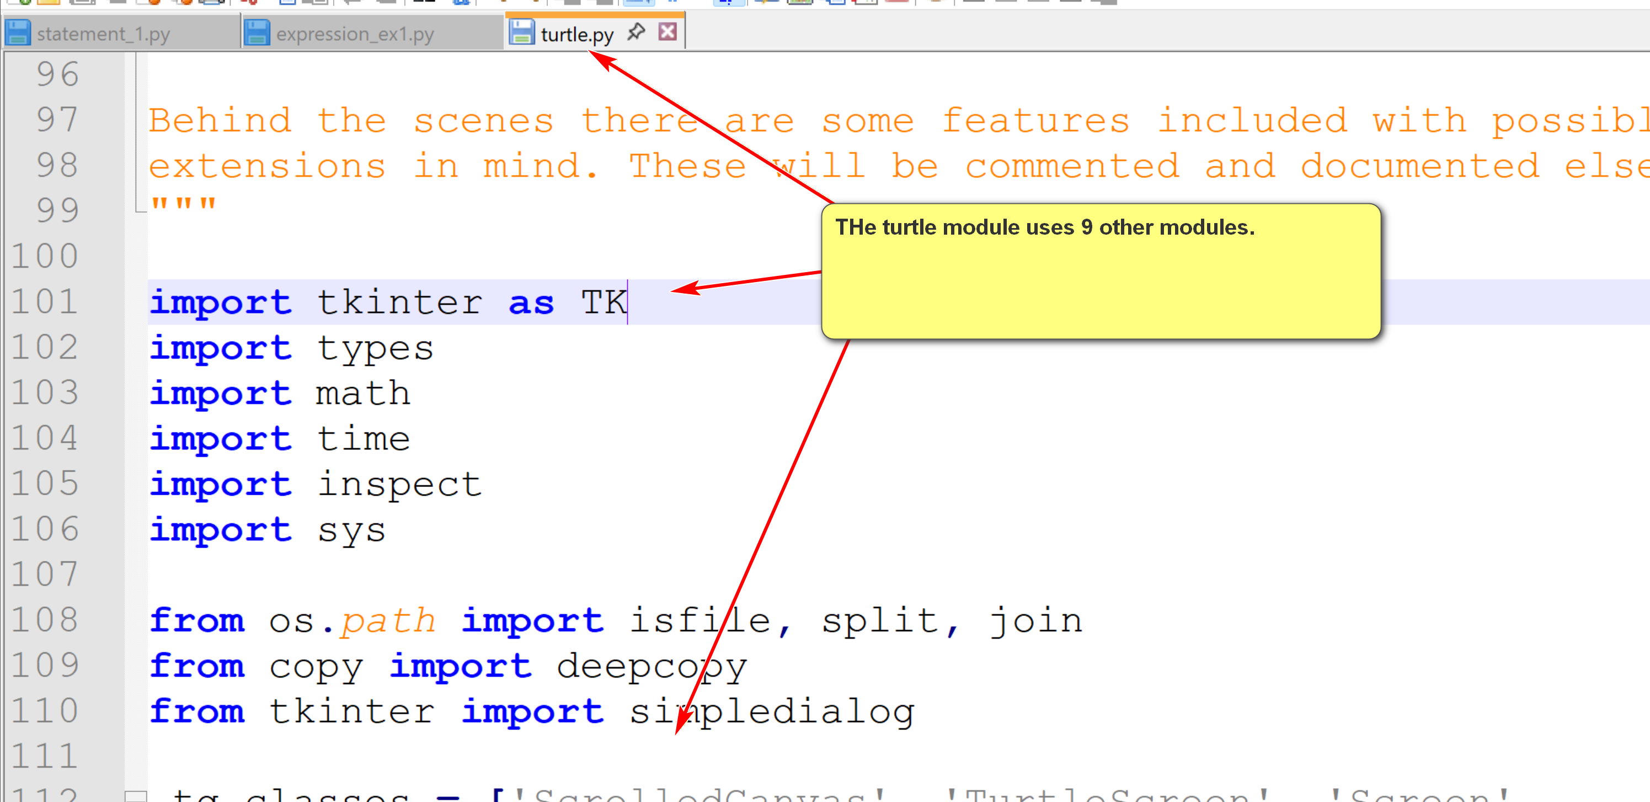
- "Within a module, the module’s name (as a string) is available as the value of the global variable __name__." (dunder: double underscore) Dunder do not conflict with user-defined variables. Users should not define a variable starting with __.
For:

if __name__ == "__main__":
main()
If the name of the current is __main__, call the main() function (main body of your program).

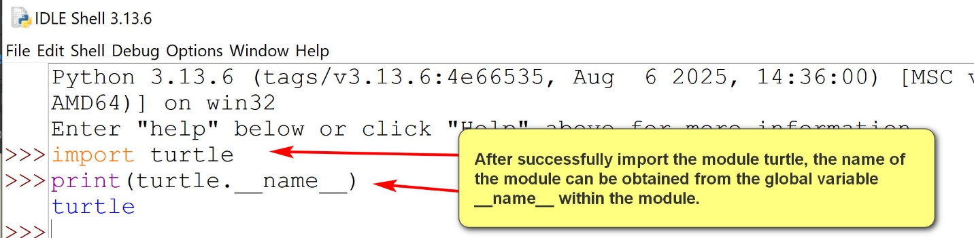
- A Python package is a way to organize related modules into a directory hierarchy.
1.1 Built-in Python modules
- Built-in Python modules are pre-installed Python modules that come with the Python installation.
- It can be regarded as Python's standard library.
- Users do not need to install built-in Python modules themselves. They are already there.
- To manage and access Python modules effectively, they are stored in specific folders (usually the Lib sub-directory of the Python installation.
- Example:
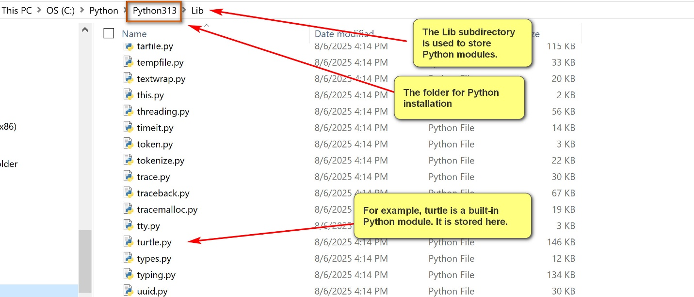
2. External Python modules and Python
- External Python modules are modules not come with Python standard library.
- They are also known as third party modules.
- Packages containing these external Python modules need to be downloaded and properly installed before using.
- pip (Pip Installs Packages) is the python program for installing and managing Python packages.
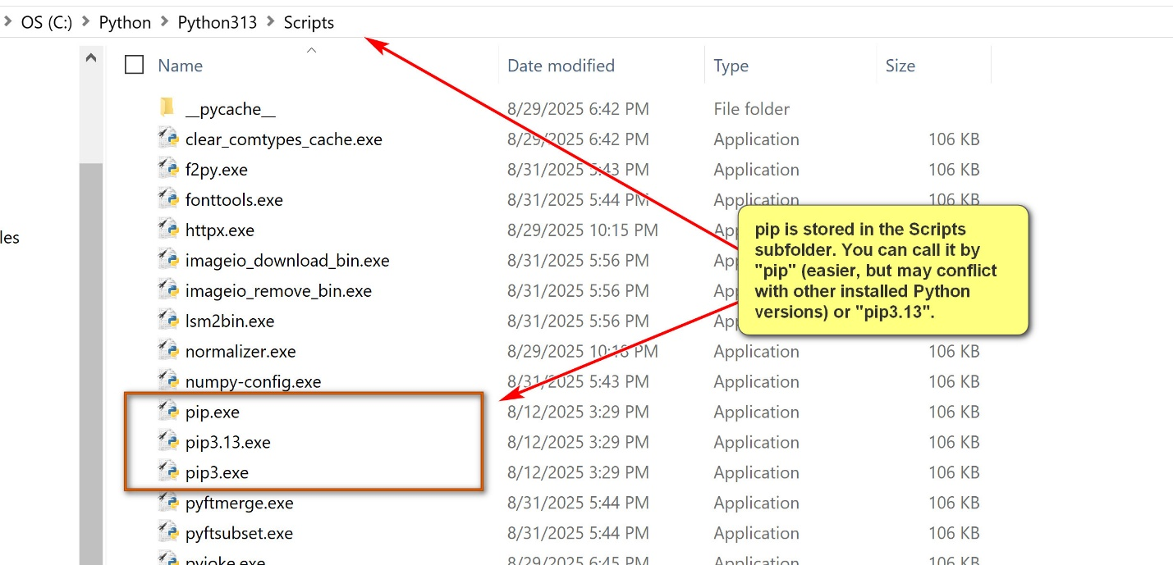

Rule: be as specific as possible. Pip3.13 is more specific than pip.
- Use "pip install <<module_to_be_install>>" in a command prompt to install a package.
- The Python Package Index (PyPI) is the official repository for Python software packages.
- When using "pip install wikipedia" (for example), pip will check PyPI for the package wikipedia, and then download, unpack and install the package.
Examples:
pip3.13 install numpy
pip3.12 install numpy
pip3 install scipy
pip install wikipedia
- Other common pip commands:
  - pip3.13 help
  - pip3.13 list
  - pip3.13 uninstall

