CSCI 1470 CS 1 Annotation
2026_1_29
Visual Studio Code: free and powerful IDE; PyCharm: Python IDE
Introduction to Computation Thinking
by K. Yue
1. Discipline-based thinking
- Discipline-based thinking refers to the process and methods of understanding and applying knowledge within a specific field of study.
- A discipline-based thinking comes with:
  - Methods
  - Traits and Characteristics
  - Values
- The way of thinking in one discipline can be applicable outside the discipline as well as in real life.
Example: Philosophical thinking: one definition: "a method of inquiry that seeks to explore fundamental questions and concepts, relying on reason, analysis, and critical thinking to gain deeper insights into the nature of reality, knowledge, ethics, and the human experience."
- Methods: critical thinking, conceptual analysis, reflection, rational argumentation, ...
- Traits and Characteristics: reasoning, wonderment, curiosity, contemplation, ...
- Values: truth, meaning, rational, ..,
Scientific methods: Richard Feymann, “Surely you’re joking, Mr. Feynman”: Feynmann’s method of learning.
2. Computational Thinking
2.1 Methods of Computation Thinking
- Computation thinking is "a set of problem-solving methods that involve expressing problems and their solutions in ways that a computer could also execute: from wikipedia.
- Four core components:
  - Algorithms - developing a step-by-step solution.
  - Decomposition - breaking down a complex problem or system into smaller, more manageable parts.
  - Pattern recognition – looking for recurring structures in problems, data sets and solutions.
  - Abstraction – focusing on the important information only, ignoring irrelevant and lower level implementations details
2.2 Algorithms
- Develop and implement step by step instruction for problem solving.
Examples:
- Python program
- Cooking recipe
2.3 Decomposition
If decomposition is done well, there are many potential advantages. For examples:
- Simplification for easier understanding.
- Reduced complexity.
- Better efficiency.
- Component reuse.
- Better and concurrent task assignments.
There are criteria for good decompositions: e.g., modularity, independence, ease of understanding, ...
Examples:
- functions
- classes
- modules
- college degree
- ...
2.4 Pattern Recognitions
- Identify recurring patterns and structures to better understand and specify problem and construct solutions.
- Human being relies on pattern recognitions a lot.
Examples:
- Dark cloud -> likely to rain -> bring an umbrella.
- Very dark cloud -> very like to have thunderstorm -> stay home.
2.5 Abstraction
- Focus on essential and high level features. Hide complex lower level implementation and irrelevant details.
- Difference between building X and using X.
Examples:
- In driving, you need to control the engine (by stepping of the gas pedal). A good driver does not need to know how the engine work,
- You can call the function input() in Python withoug knowing how the input() function is actually implemented.

Python's Basics
CSCI 1470
by K. Yue
1. Python's Interpreter
- An interpreter is a program that executes code from a high-level programming language one statement at a time.
- A Python interpreter is a program that executes Python code one statement at a time.
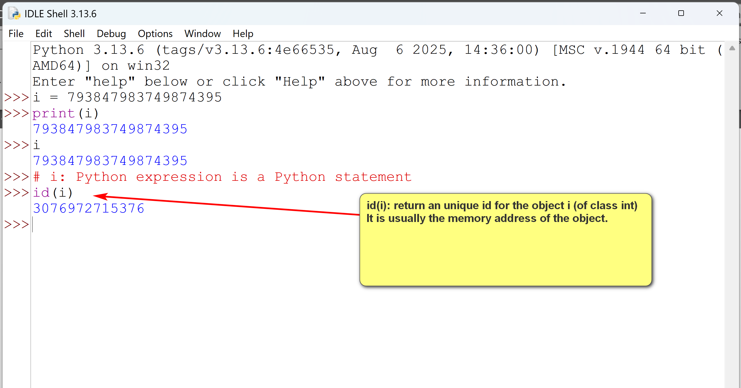
- In windows, the Python interpreter is usually 'python.exe' in the installed Python directory.

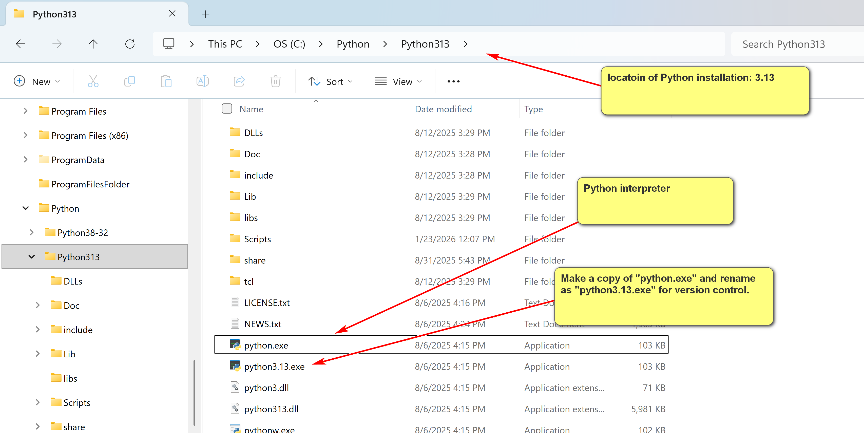
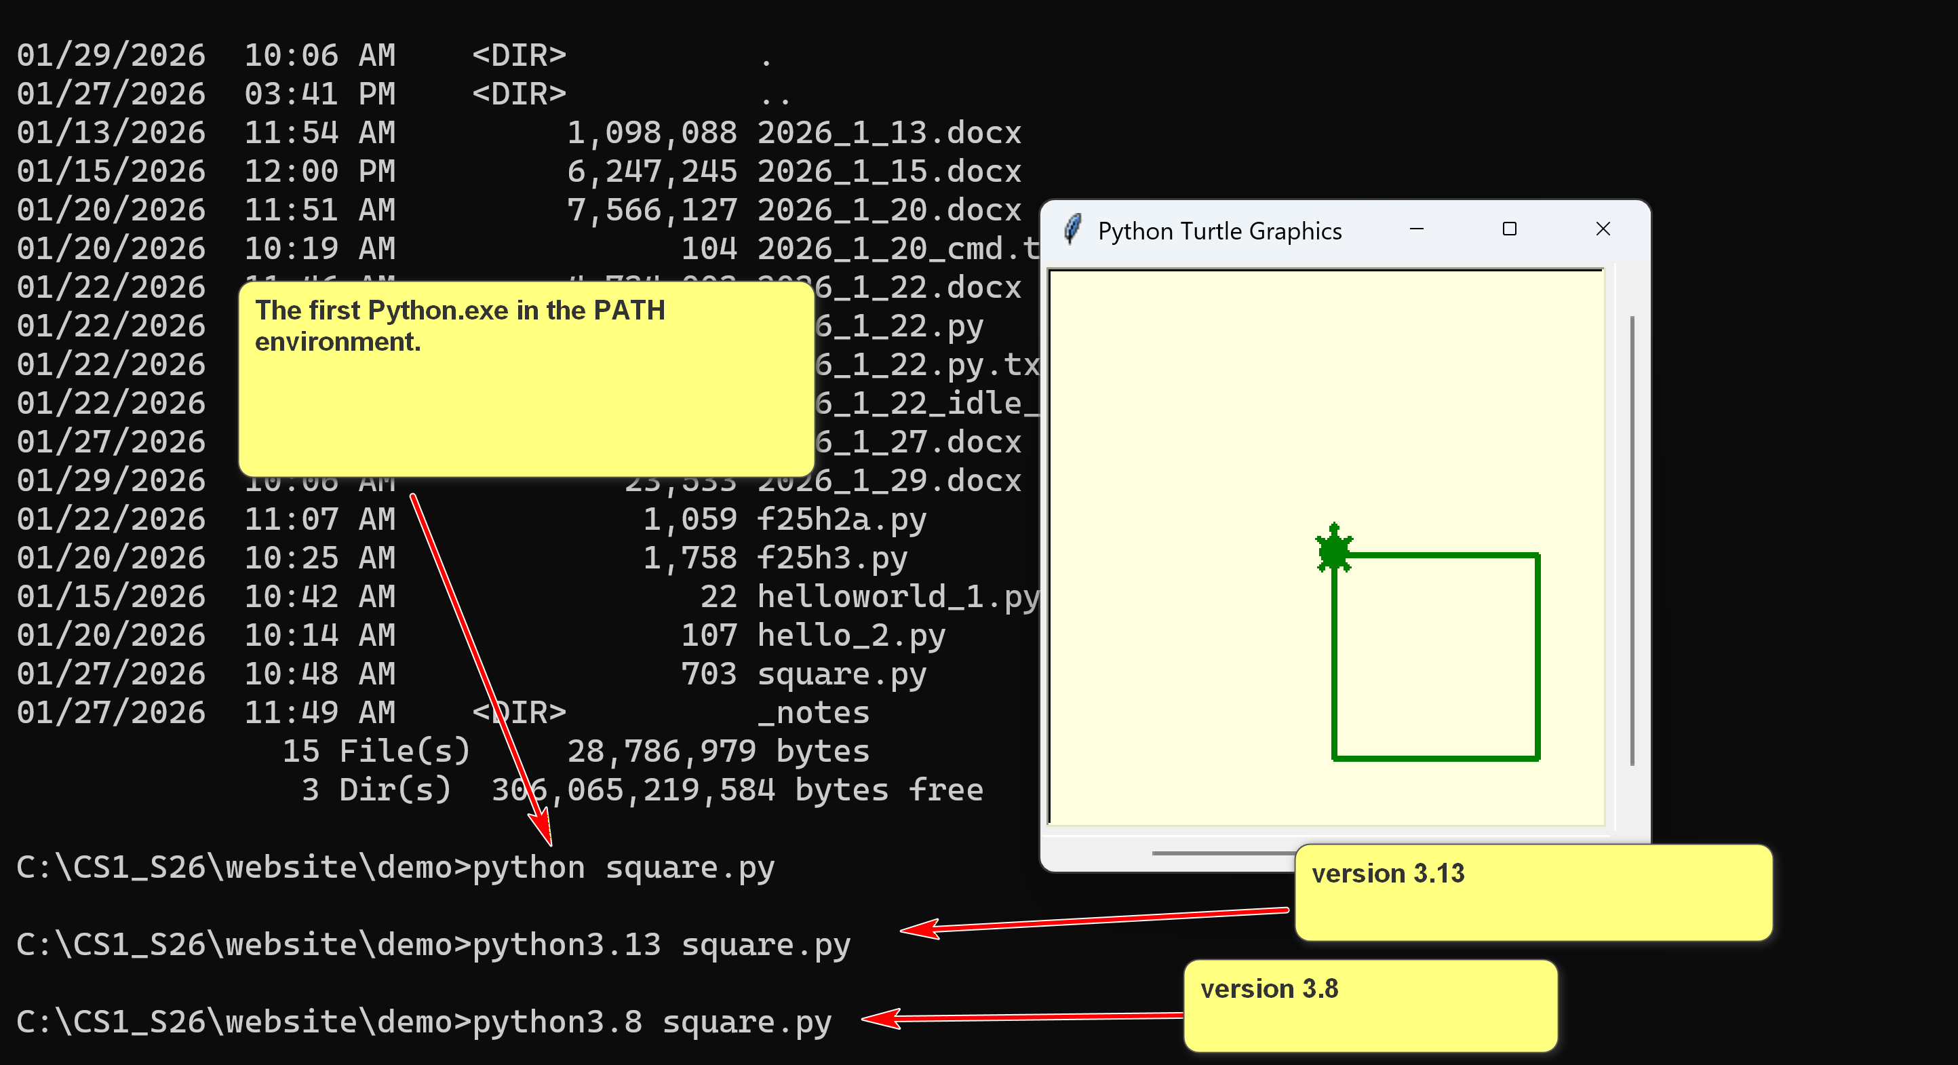
The first Python.exe in the PATH environment.
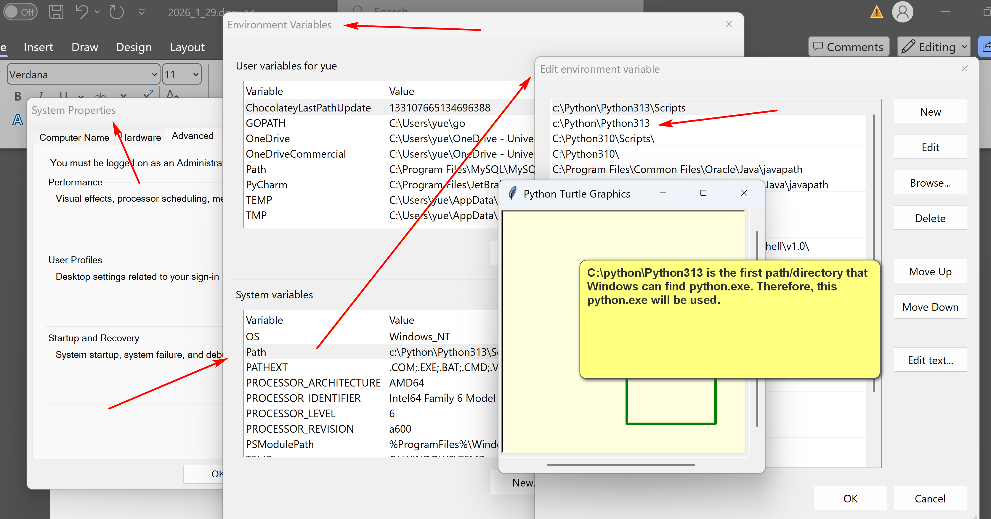

Example:
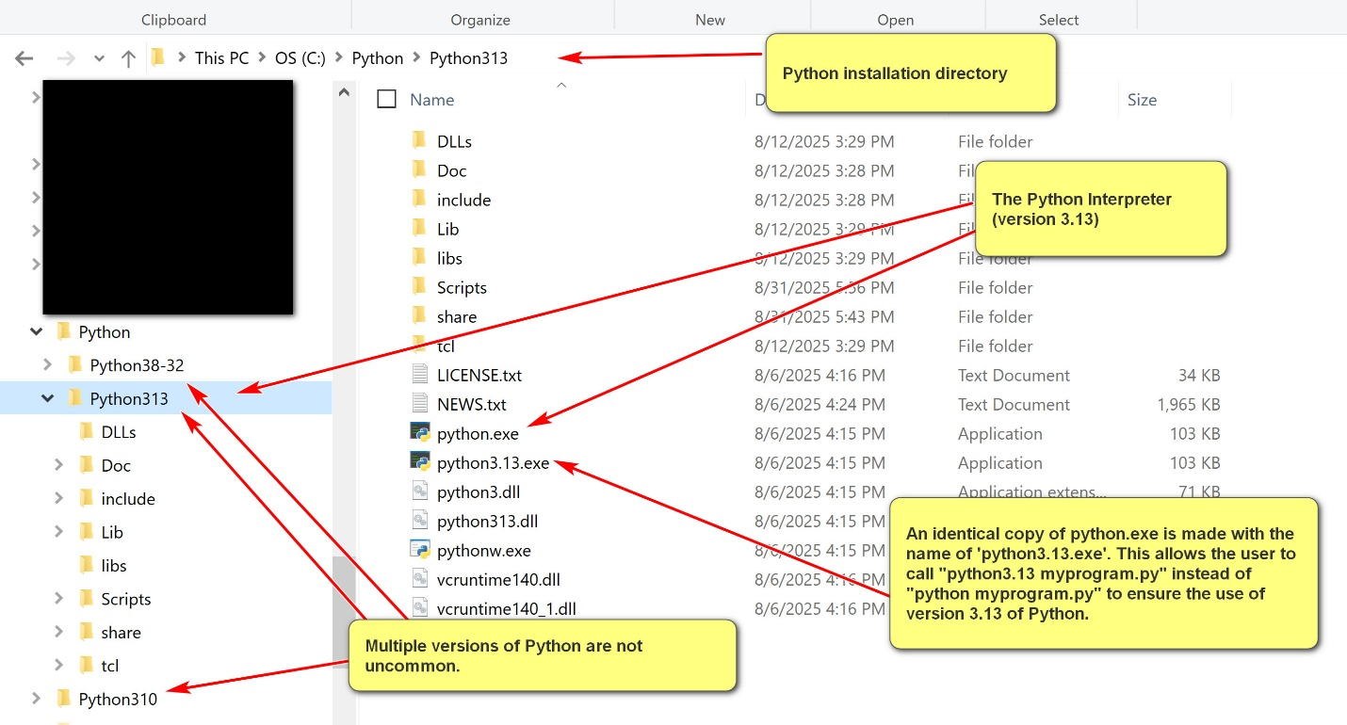
- In contrast, many high-level programming languages do not have interpreters. Instead, they use compilers. (e.g. CS II class: Java) Execution of a program involves two steps. Program executions require two steps:
  - Compilation: compile the program to machine code or other low level code.
  - Execution: execute the machine or low-level code.
Example:
In Java, to run a program, Hello.java:
[1] "javac Hello.java": compile Hello.java into Hello.class, a Java bytecode program. Java bytecode has .class as its file extension. It is a platform independent intermediate level programming language.
[2] "java Hello": invoke the Java Virtual Machine (JVM) to run the Java bytecode program Hello.class. Note that the instruction is not "java Hello.class" as the file extension of .class is assumed.
1.1 Python Interpreter
- The Python interpreter is invoked by running "<<python_installation_path>>\python.exe" (e.g., c:\python\python313\python.exe)
- When invoking by itself, the Python interactive interpreter is started, executing one Python statement at a time.
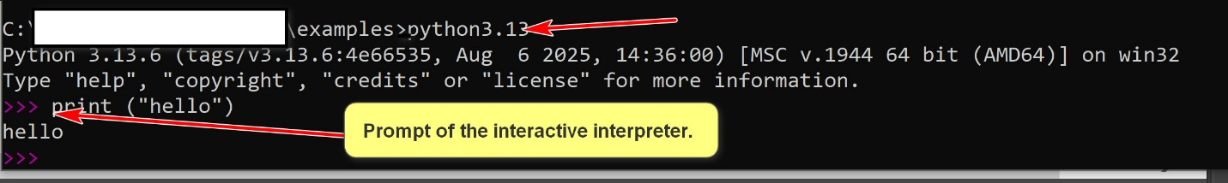
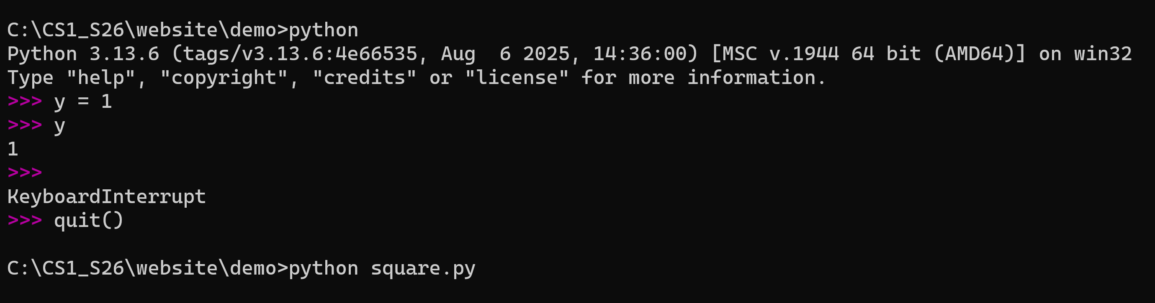
- The interactive Python interpreter is good for exploration and learning. However, it is limited by one user input Python statement at a time.
- To perform serious work, it is necessary to run Python programs that contain many Python statements.
- One can use it to execute a program, e.g. "Python hello.py"
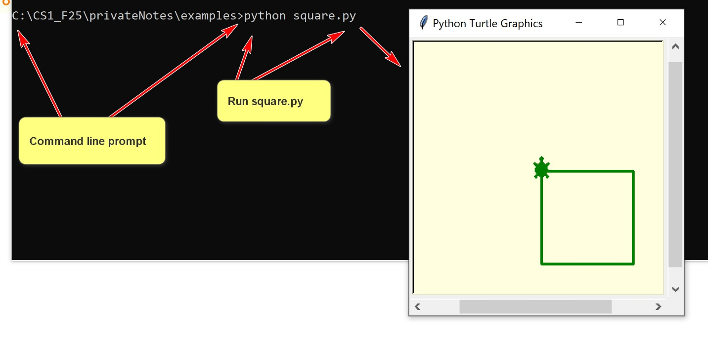
1.1 Python IDLE
- The Python IDLE is more than the Python interactive interpreter. It is a simple IDE with an editor and can execute a Python program.
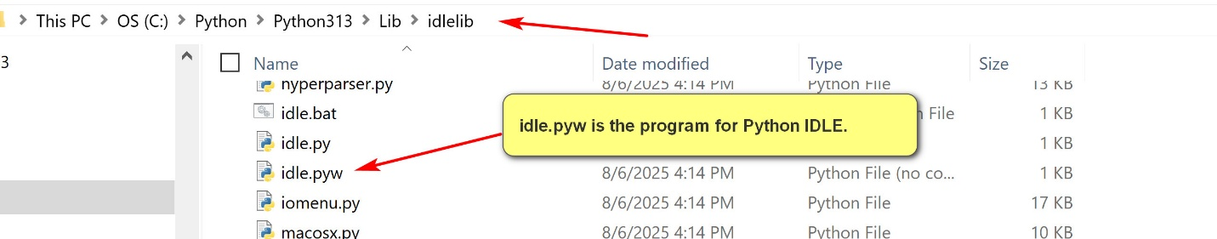
2. Python Programs
2.1 Python Literals and Variables
- Literals in Python are fixed values written directly in the source code that represent constant data.
E.g.,
# constants.py
PI = 3.141592653589793 (physical constant)
SPEED_OF_LIGHT = 299792458 # meters per second (physical constant)
MAX_CONNECTIONS = 1000 (setting for the program, not to be changed
Constant: upper characters, meaningful, connected by _.
UNIVERSITY_NAME = 'University of Houston-Clear Lake'
# Use case: not suppose to change the university.
- There are many types of literals: number literals, string literals, Boolean iterals, etc.
- Identifiers are names used to identify variables, functions, classes (e.g. , ‘str’ <class 'str'>)modules (e.g. turtle), or other objects in Python code.
IN “x = s.upper()”: identifiers: x, s, upper
- A Python variable has a symbolic name (identifier) that refers to objects or values stored in the computer's memory.
x = 15;
- Python gets a location to store 15.
- Store the address of x in the symbol table.
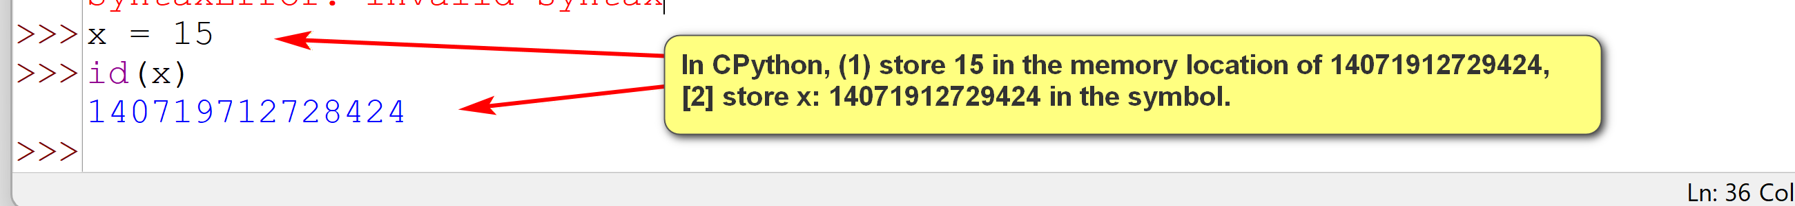

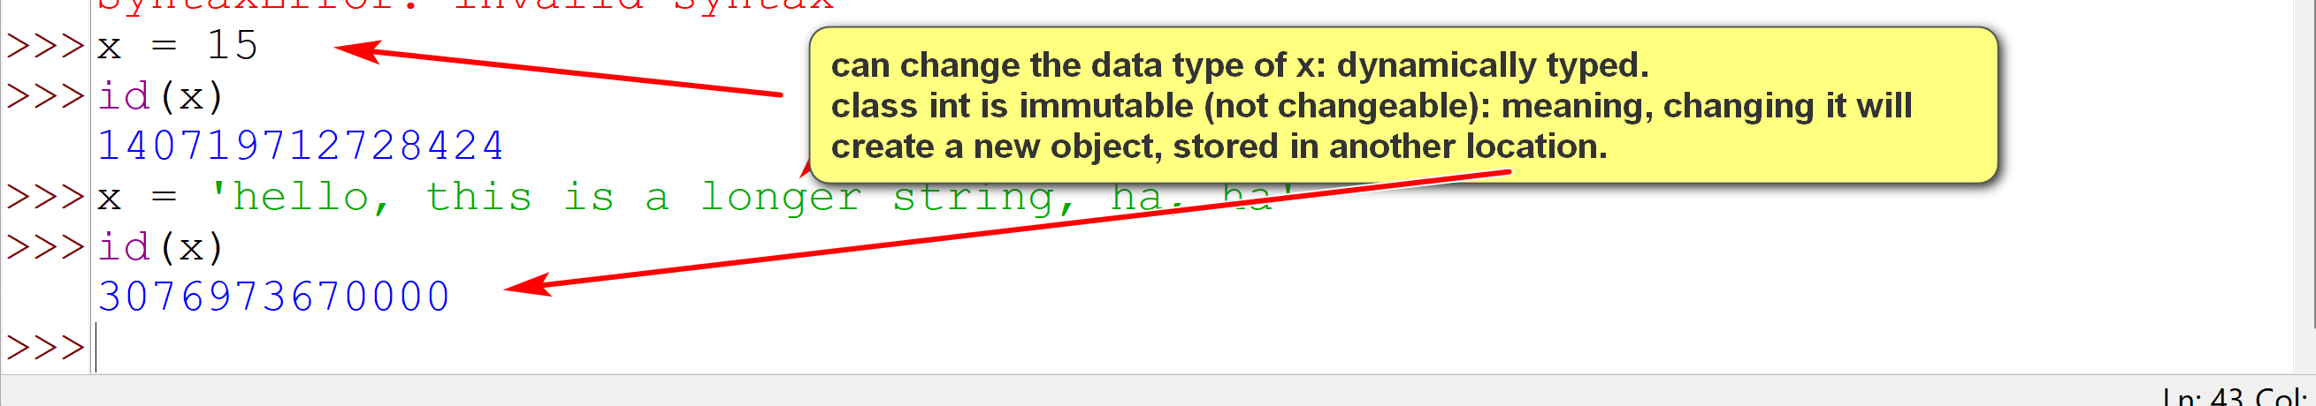
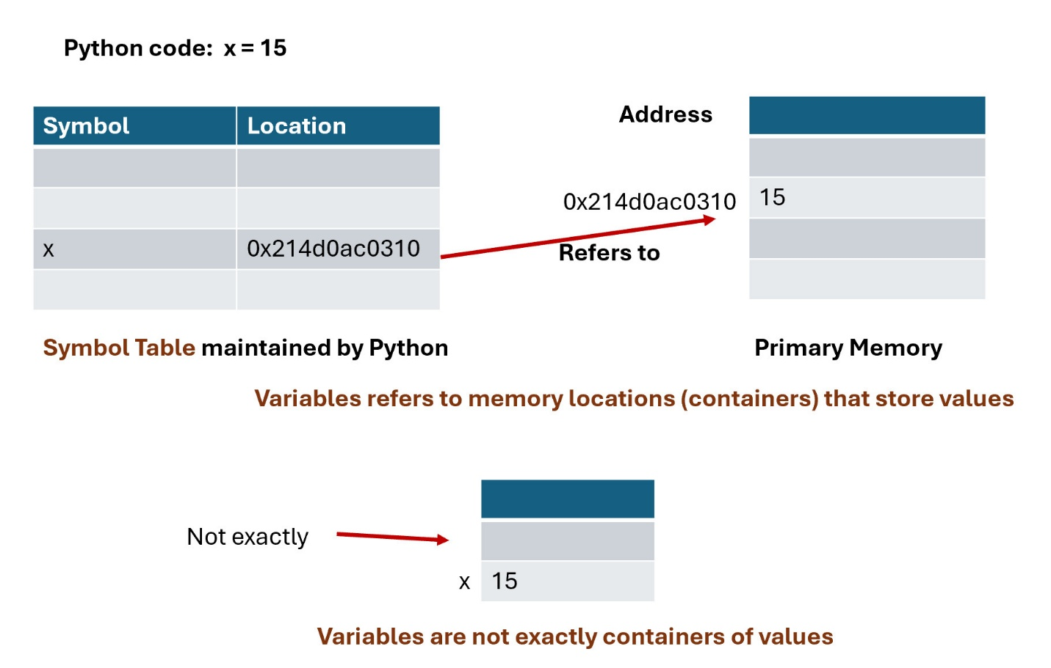
2.2 Python Statements
- A Python statement is an instruction that the Python interpreter can execute.
- A statement is a basic execution unit in Python.
- There are many types of statements in Python.
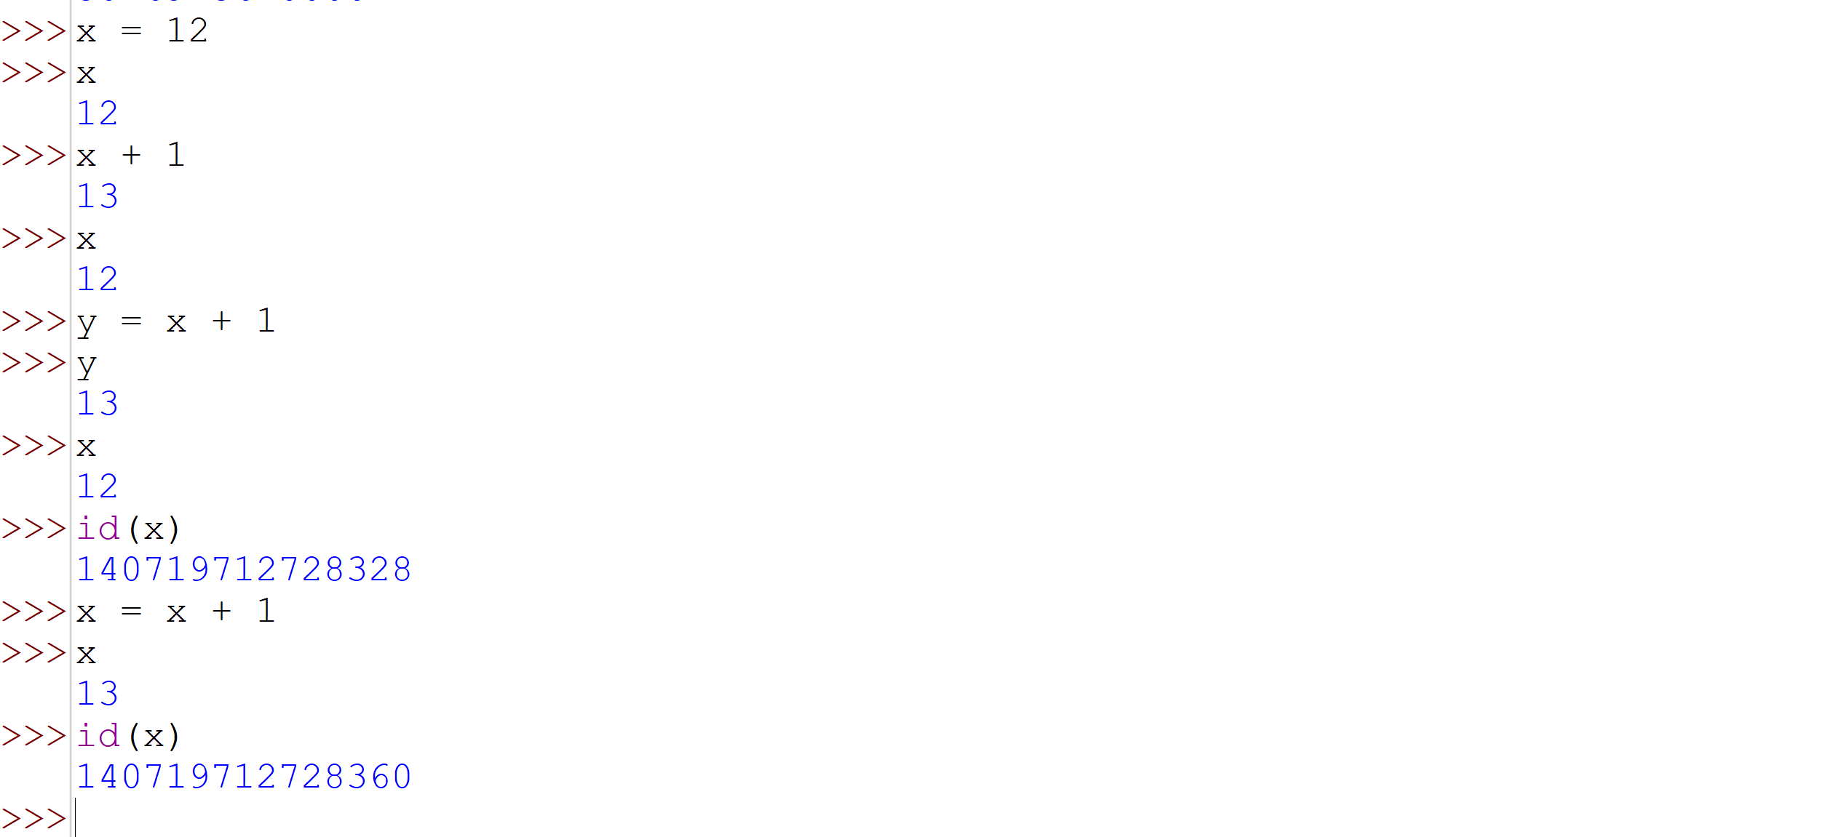
use cases of id() in python:

The primary use of Python's id() function is for debugging and understanding memory management by returning a unique integer identifier for an object, which corresponds to its memory address in the CPython implementation.
- A Python statement usually terminates at the end of a physical line, denoted by a newline character: ('\n').
\: escape characters.
- Regular meaning: ‘n’: means ‘n’
- Special meaning in context: ‘\n’ (one character with special meaning): newline.
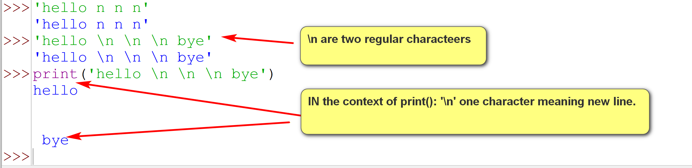
- The character ; is a terminator of Python statement. It is not required and is seldomly used.
- The character \ can be used to extend a Python statement beyond the current physical line.
- Python can also detect that some Python statements are not terminating and extend them to the next physical line.
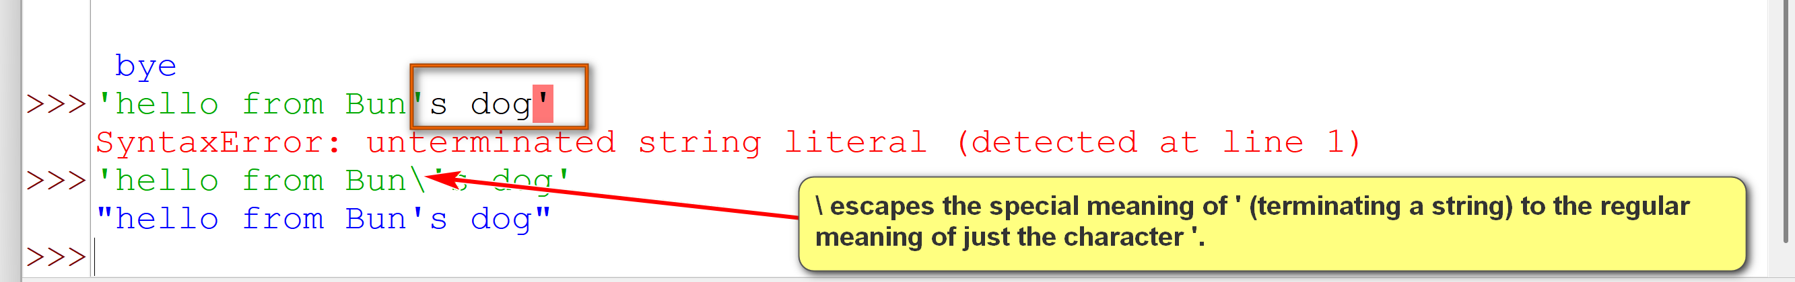
Try out statement_1.py
# Python statements
# A Python statement is terminated by the end of the physical line,
# represented by the end of line character: \n.
print('hello')
print('hello again');
# Not recommended Python style.
print('hello '); print('world');
# the second argument (end = ' ') indicates that the end string
# for the print statement is ' ', and not the default '\n'
print('hello ', end = ' '); print('world');
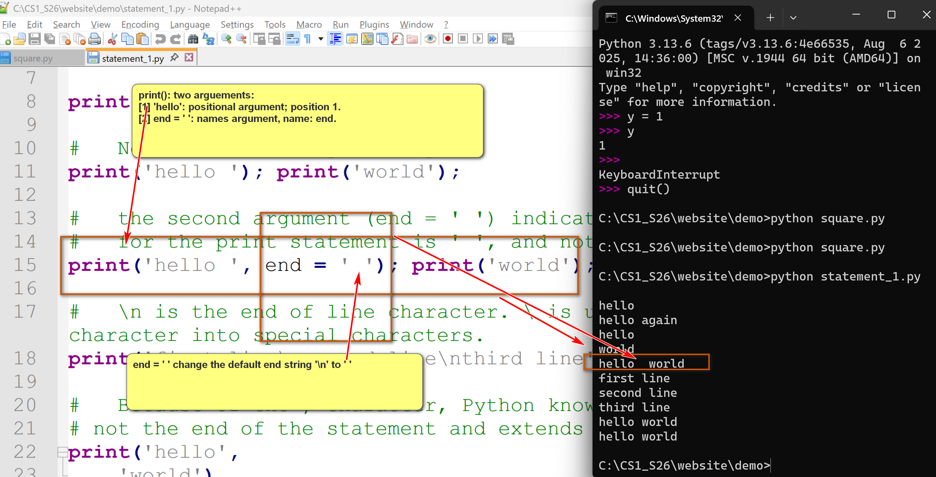
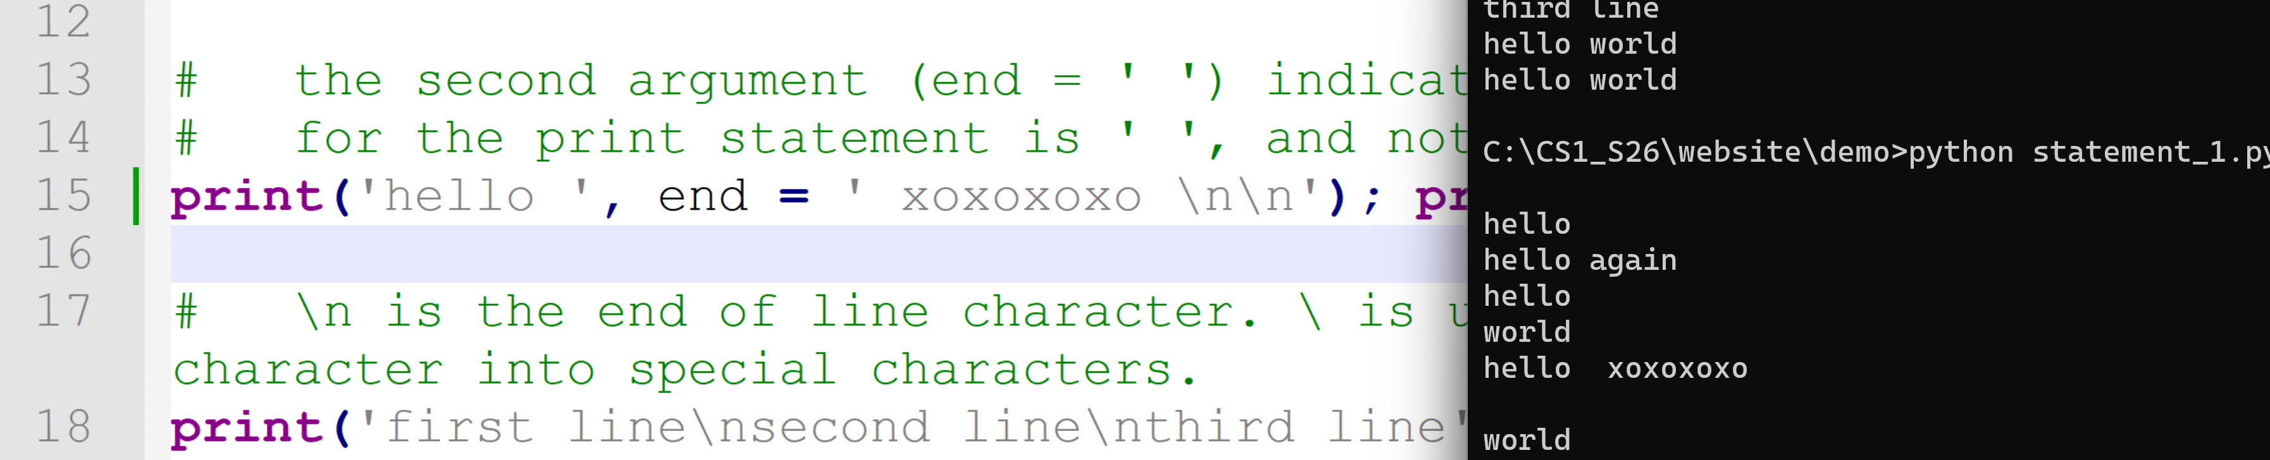
# \n is the end of line character. \ is used here for 'escaping' a character into special characters.
print('first line\nsecond line\nthird line');
# Because of the , character, Python knows that this
# not the end of the statement and extends it to the next line.
print('hello',
'world')
# The character \ extends the statement to the next line.
# There should not be any character after \.
print('hello' \
, 'world')
2.3 Expressions, Functions, Operators and Methods
- In Python, an expression is a piece of code that the Python interpreter evaluates to produce a value.
- The evaluation of an expression always returns a value.
- Expressions can be constructed by using:
  - literals: constants
  - variables: identifiers refering an object or a value.
  - functions: standalone functions similar to mathemtical functions. Have arguments and return a value. E.g., max()
  - operators: special symbols representing operations. E.g., a + b.
  - methods: functions belonging to an object using the object method invocation syntax: object.method(). E.g., if s is a string, we can call s.upper()
Examples:
Try out expression_ex1.py
a = 1
b = 2
c = 'hello'
print(max(a, b, 3))
print(round((a+100)/(b+5)))
max(a, b, 12, b*7, 6)
a + b * 4
a < b
a > b
a / b
d = (a + 4) ** b
e = c + ' world'
print(a, b, c, d, e)
print(e.upper())

