CSCI 1470 CS 1 Annotation
2026_1_27
Simple Python Development:
- Use IDLE for testing/learning/experiment
- Use Notepad++ and command line prompt (in project directory) for development.
- Learn from example: run and annotate statement by statement in IDLE.
CSCI 1470.3 Fall 2025 Homework #2
Partial:
[1] Open Python IDLE. Execute the following statements one by one: s = "This is a very good day." print(s) print(s.upper()) print (s.lower()) print (len(s)) print(s.len()) print(upper(s)) Save the shell session in a log file named h2q1.log (which is a .txt file). Upload h2q1.log to Canvas. Study the output of these statements.

Solution:
# h2.py
def main():
input_string = input("Please enter a string -> ")
print(f"length of the string: {len(input_string)}")
print(f"in upper case: {input_string.upper()}")
print(f"in lower case: {input_string.lower()}")

if __name__ == "__main__":
main()

IDLE: Alt-P goes to the previous command.

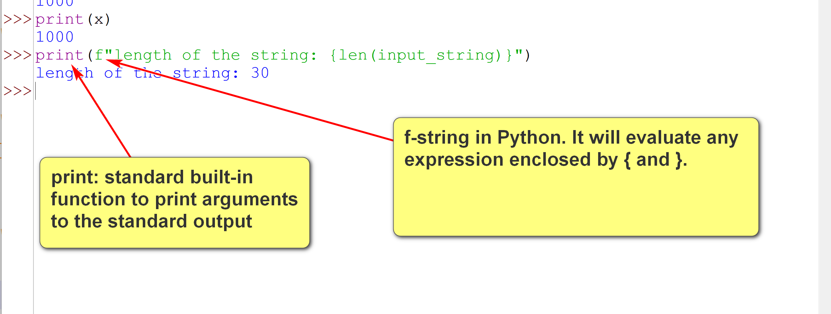

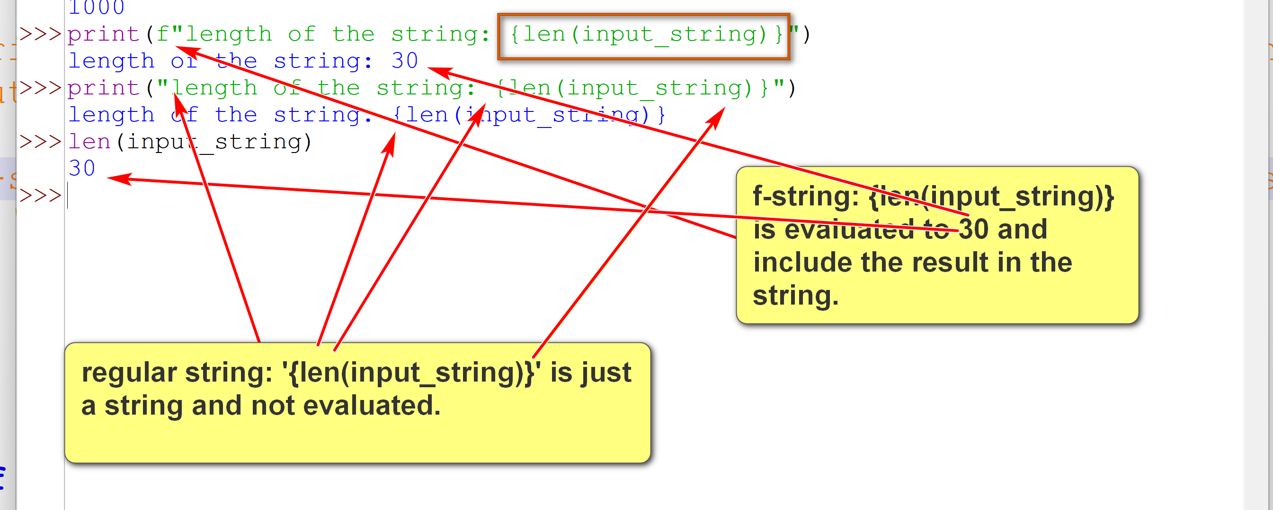

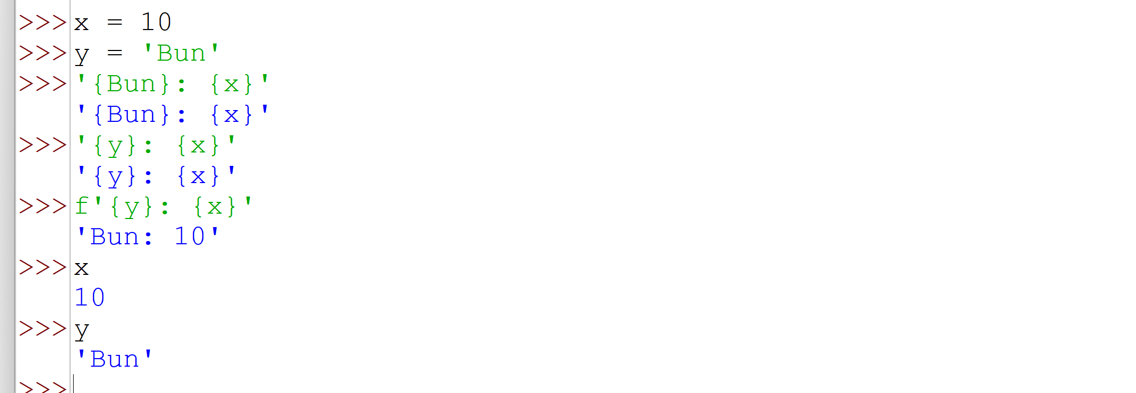

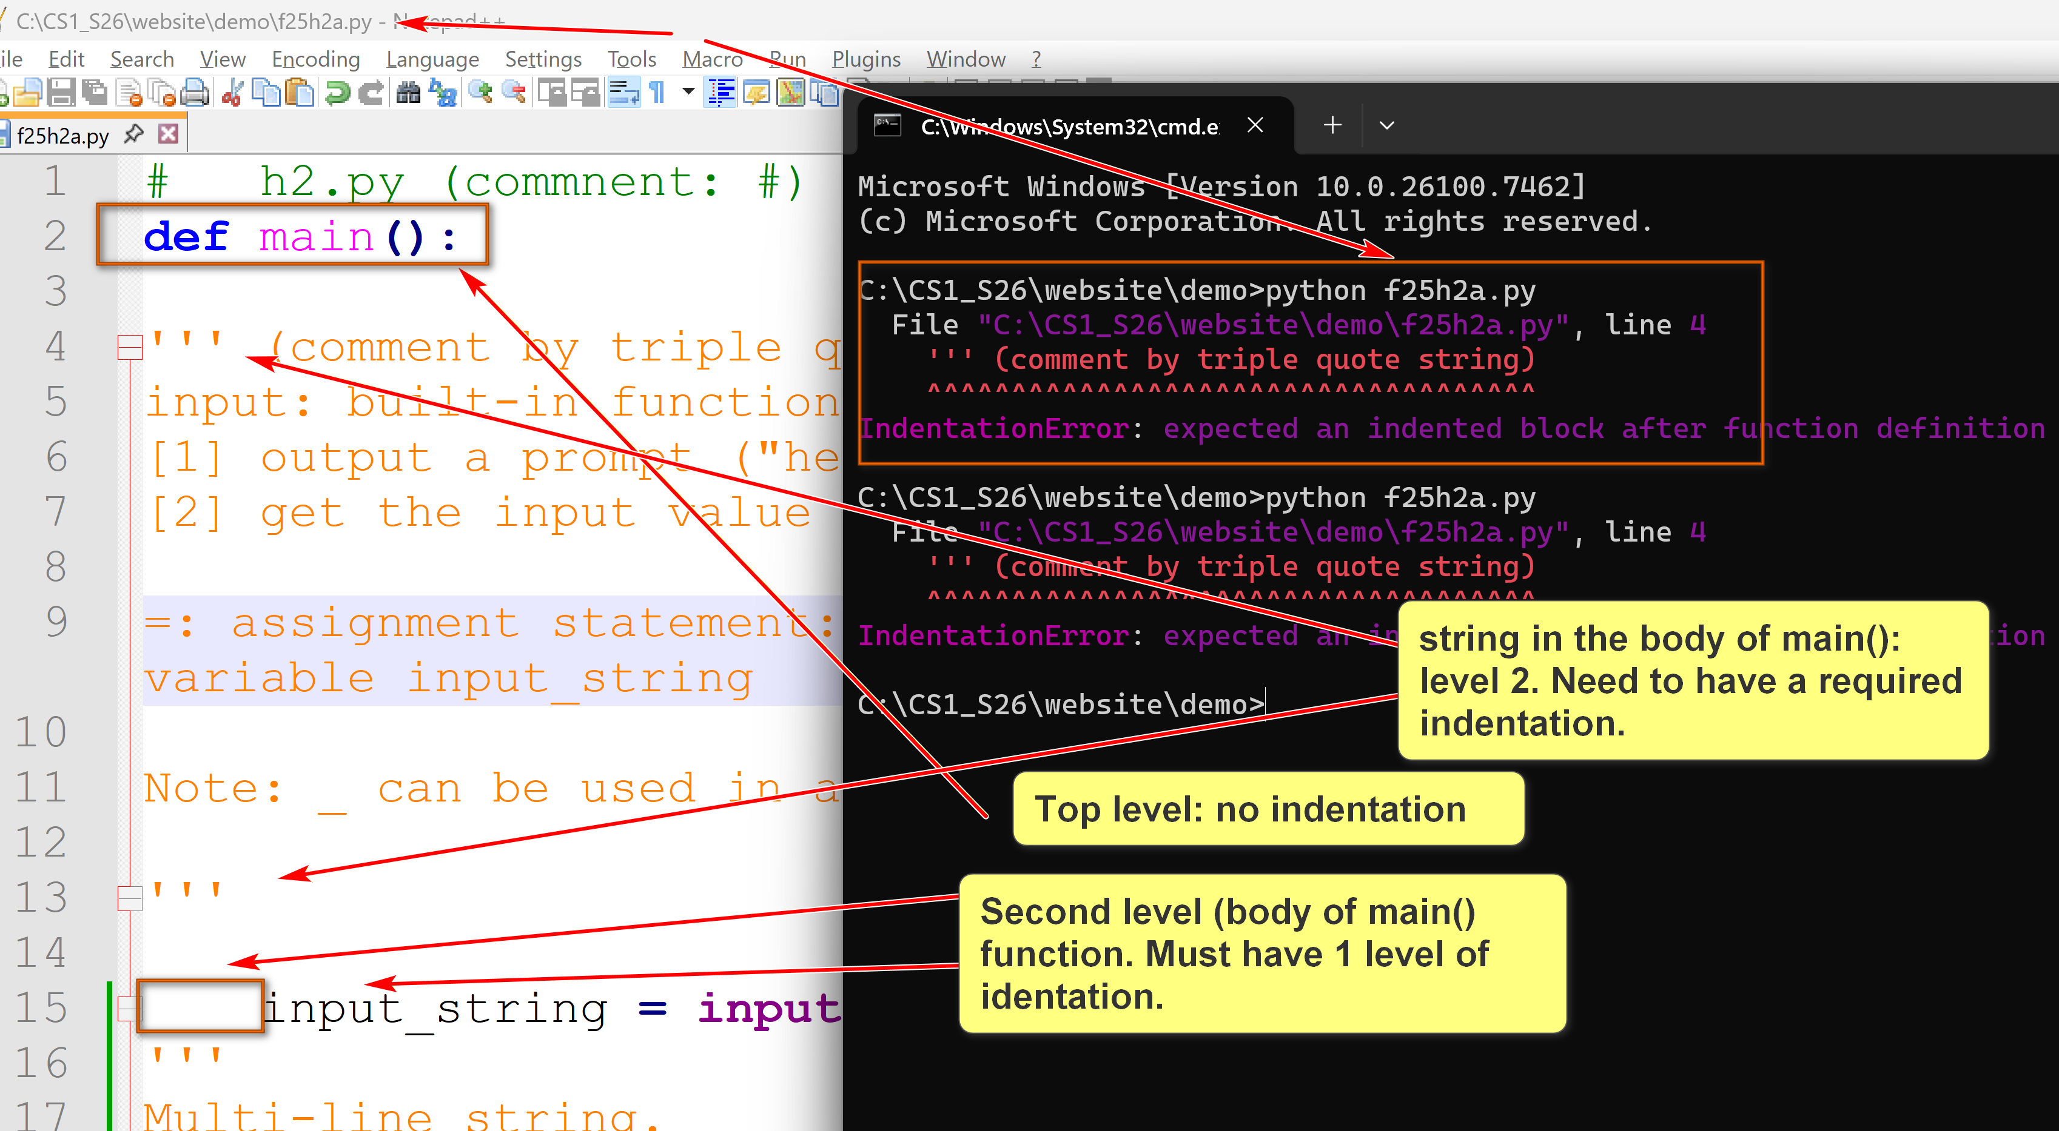
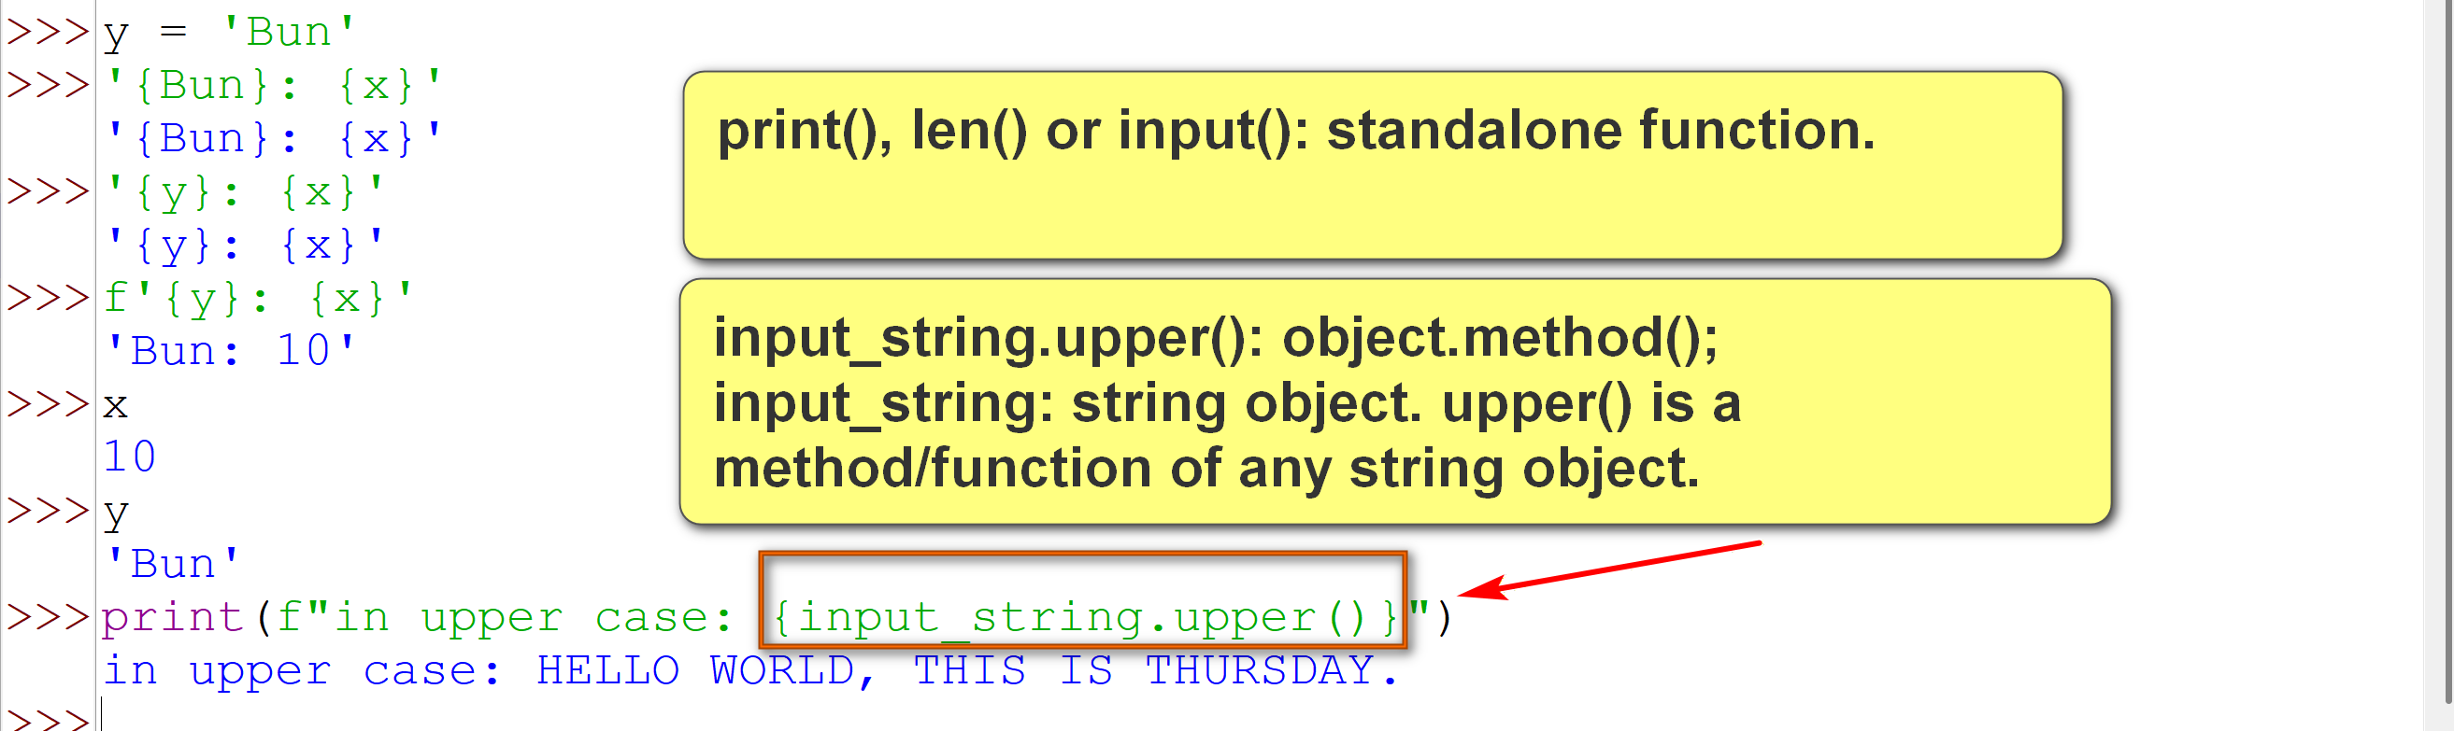

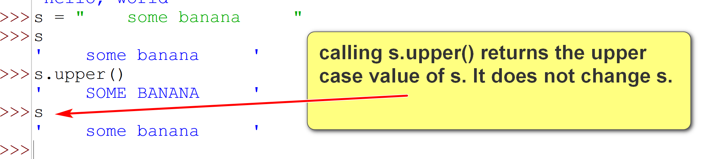

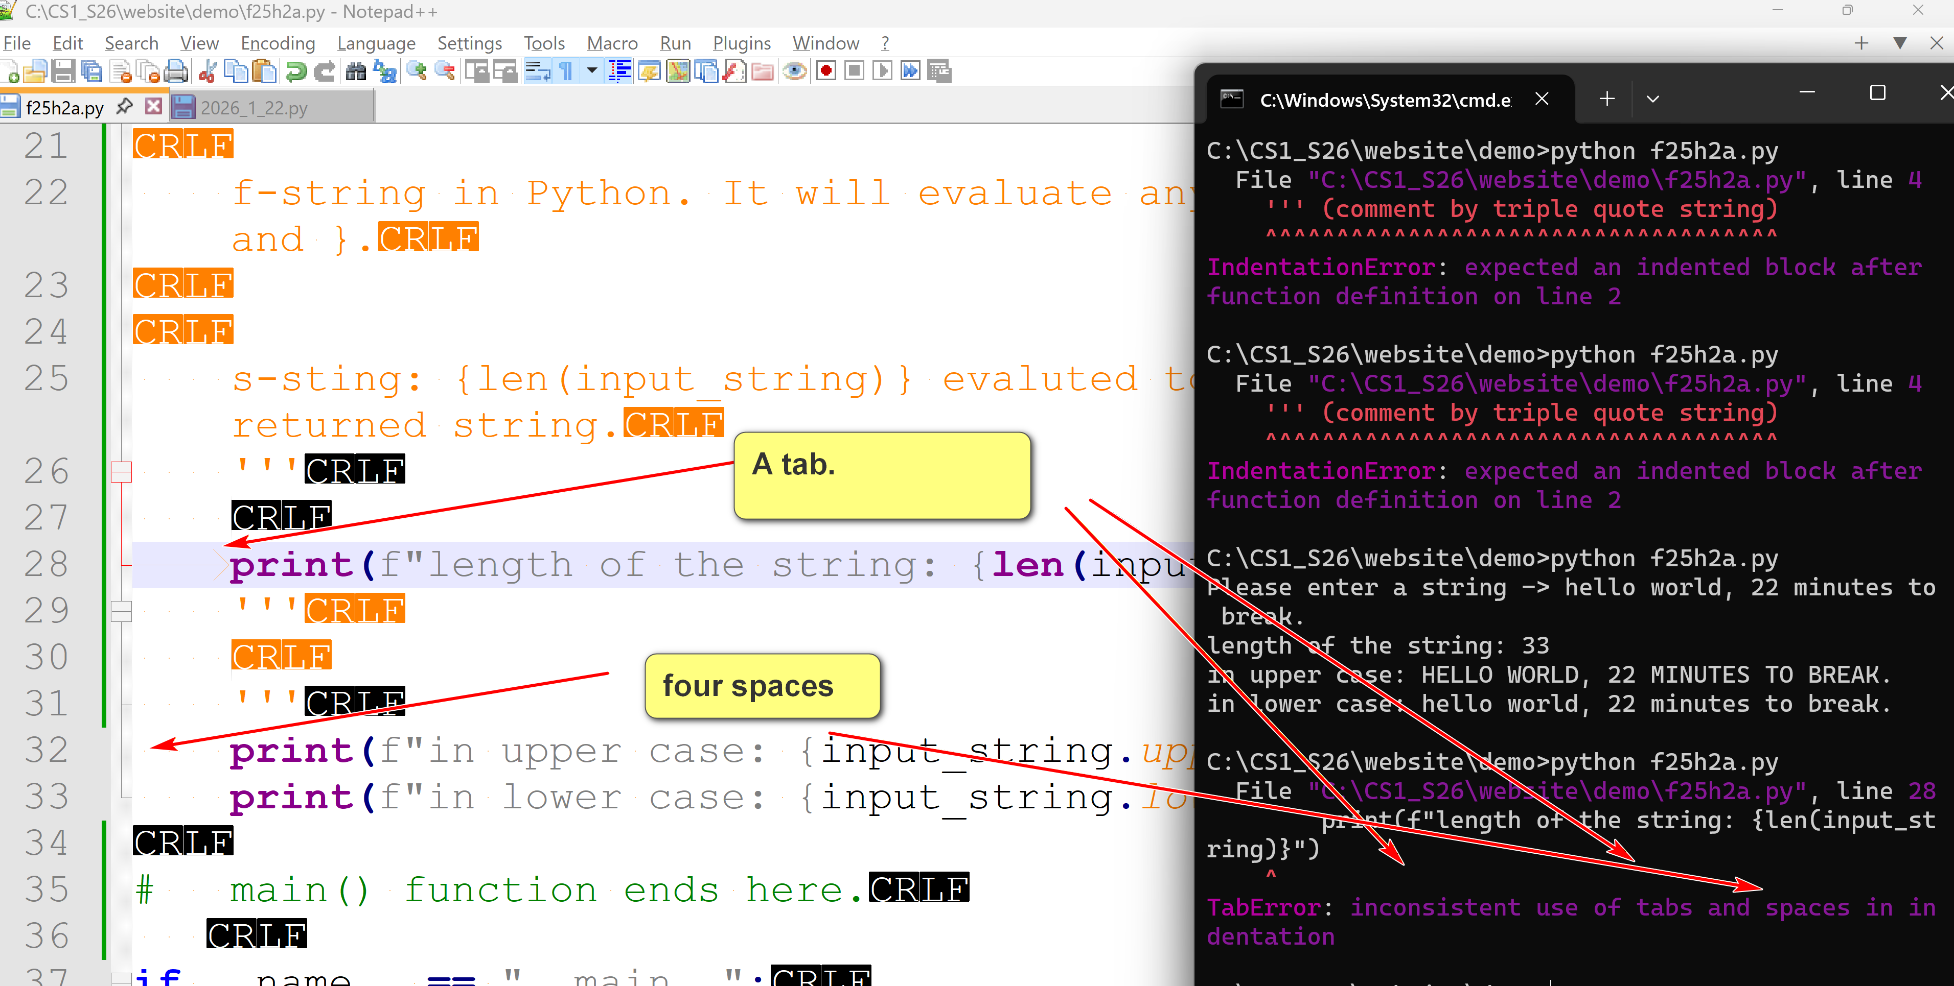

Notepad++: set to use spaces instead of tab.
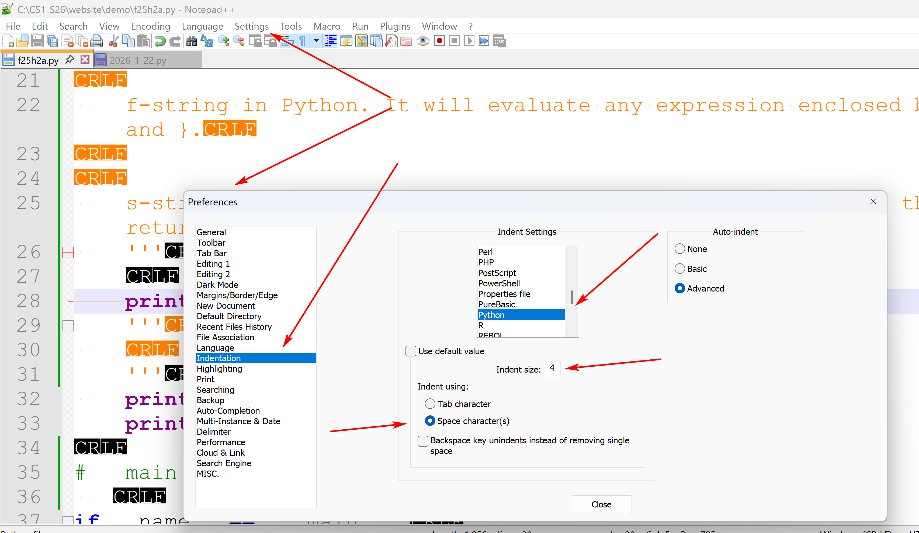
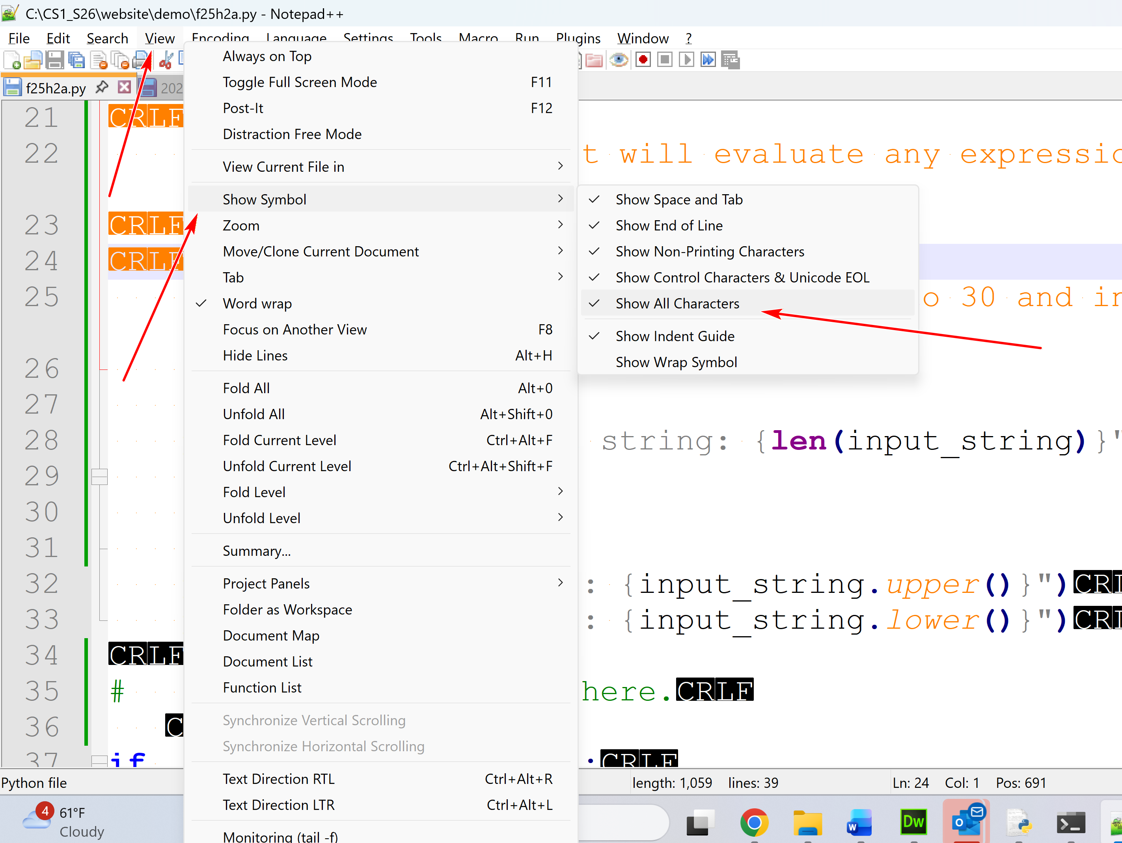

Python IDLE
by K. Yue
1. Python IDLE
  - Python IDLE is bundled in the Python distribution. There is no need for separate installation.
  - IDLE can be regarded as a very simple Integrated Development Environment (IDE). (E.g., Pycharm: sophisticated IDE.) It is used in this class.
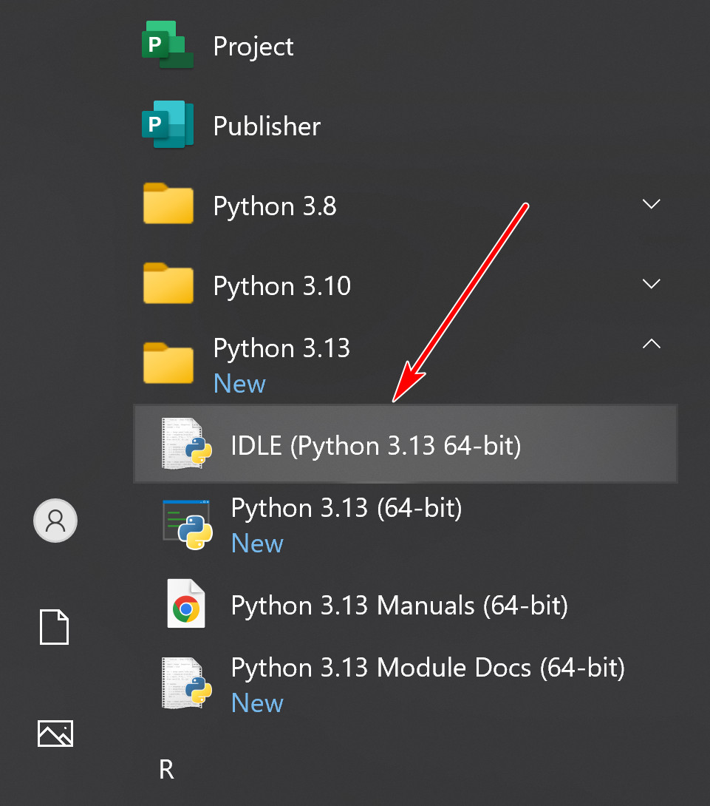
  - A short IDLE tutorial: https://www.youtube.com/watch?v=WIlQukiXs-E. (a little dated)
  - https://realpython.com/python-idle/ is a very good tutorial on IDLE. However, it contains many topics not needed in this class.
2. Running IDLE shell as interpreter
  - When you start IDLE, a shell window appears.
  - IDLE shell is an interactive interpreter with REPL (Read-Evaluate/Execute-Print loop)
    - Read a Python statement, single-lined or multiple-lined.
    - Evaluate or execute the statement.
    - Print the result of execution of the statement.
  - A shell contains the collection of Python code the user entered interactively.
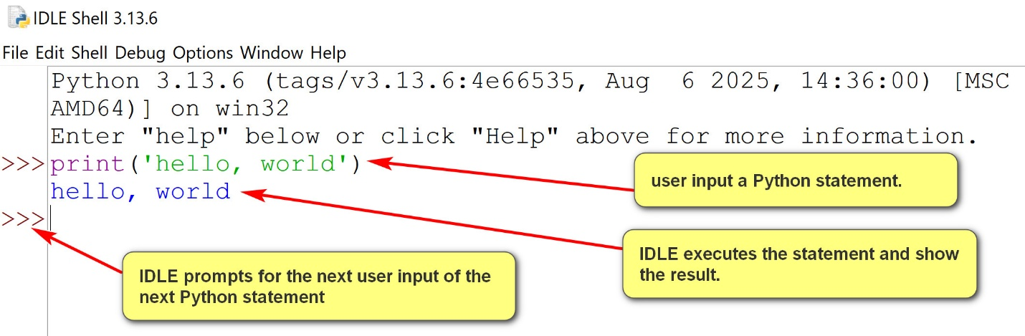
2.1 Logging a shell session
  - Logging is a crucial practice and habit in software development.
  - Logging tracks program behavior and problems, enables debugging, supports performance analysis, supports auditing, monitors security and informs users, administrators, and developers.
  - IDLE shell session can be logged by saving it in a file.
Suggestions/principles:
- As specific as possible.
- Separation of concerns.
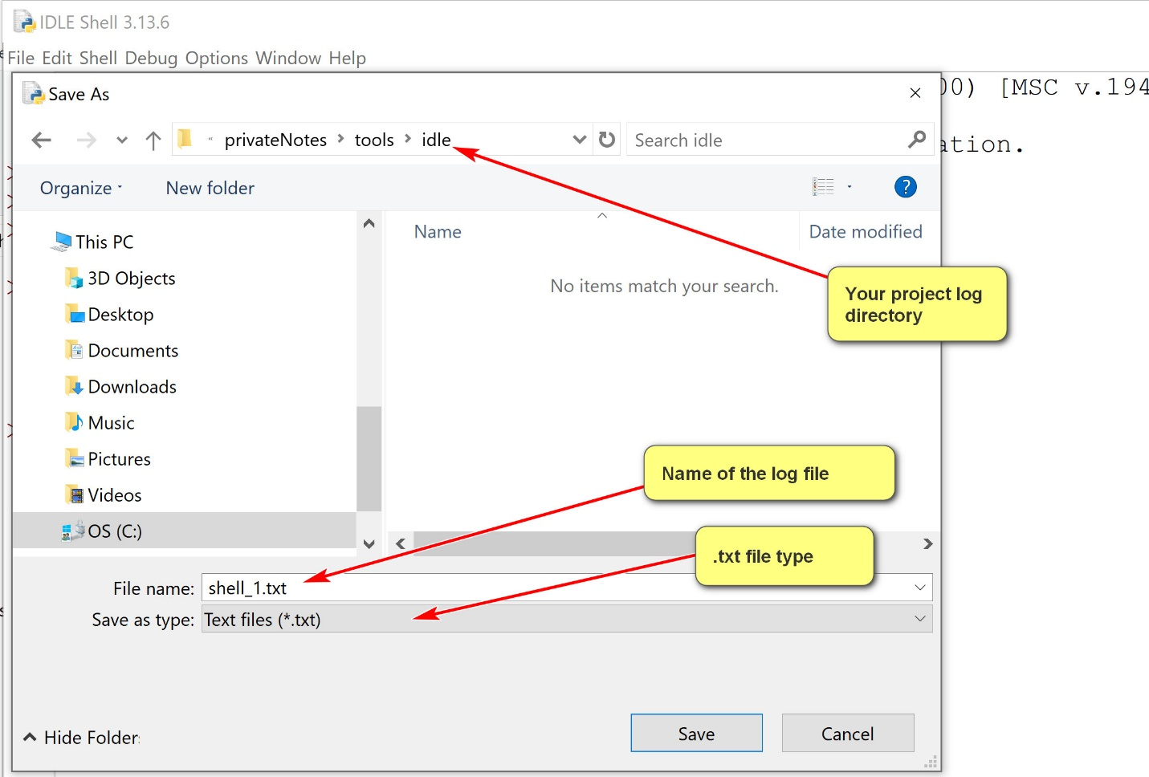
Shell Menu
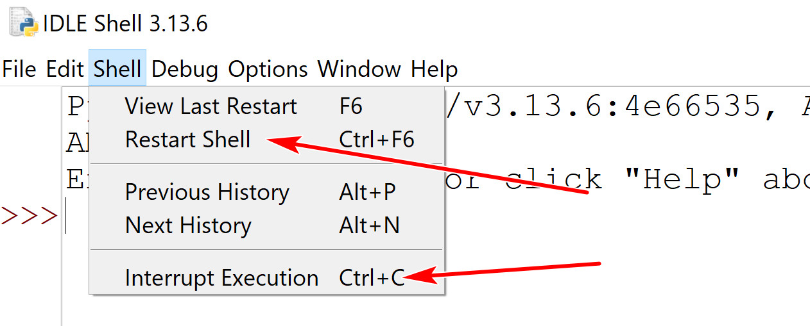
  - Two buttons you may use:
    - Restart shell: start a new shell session.
    - Interrupt Execution: stop the execution (in case you get into an infinite loop)
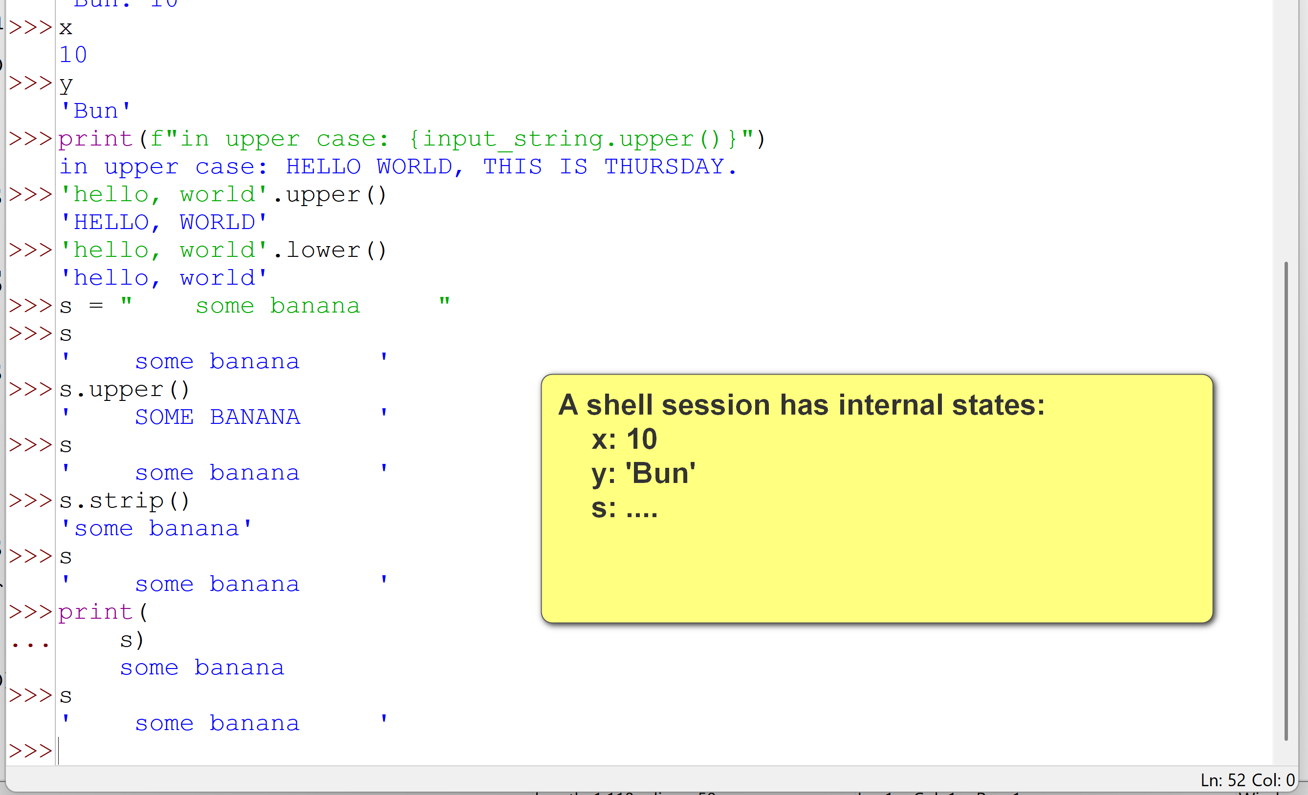
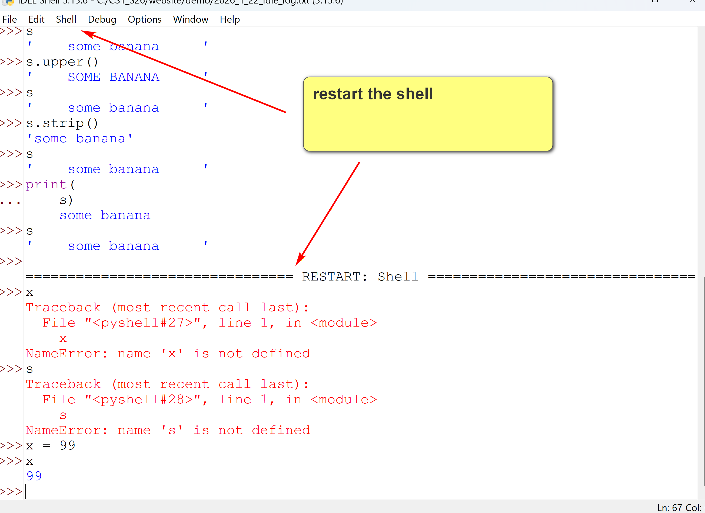
3. Python program file editing and execution
  - Shell includes a text editor.
  - One can open an existing Python program file, or create anew Python program file.
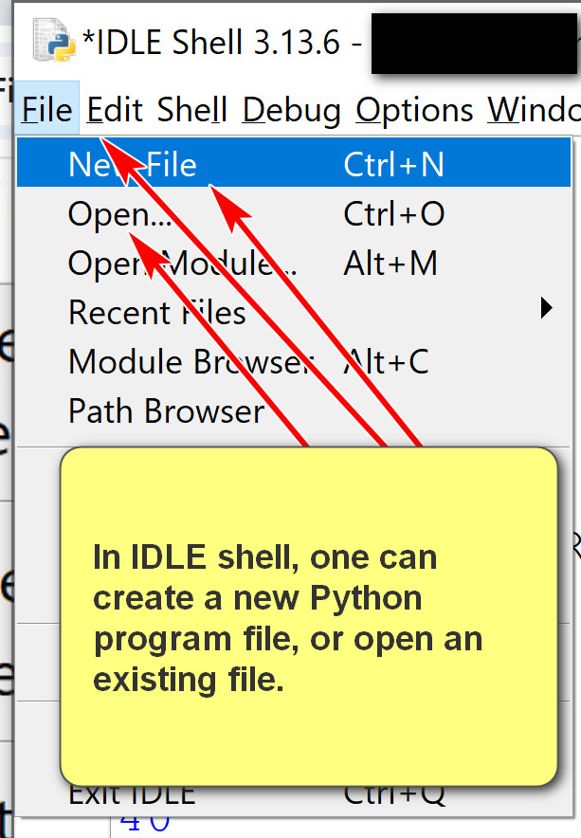
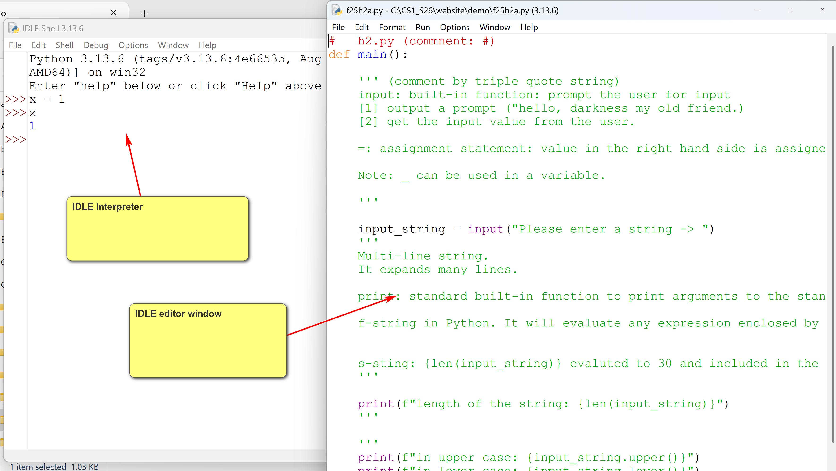
  - The file editor has many features.
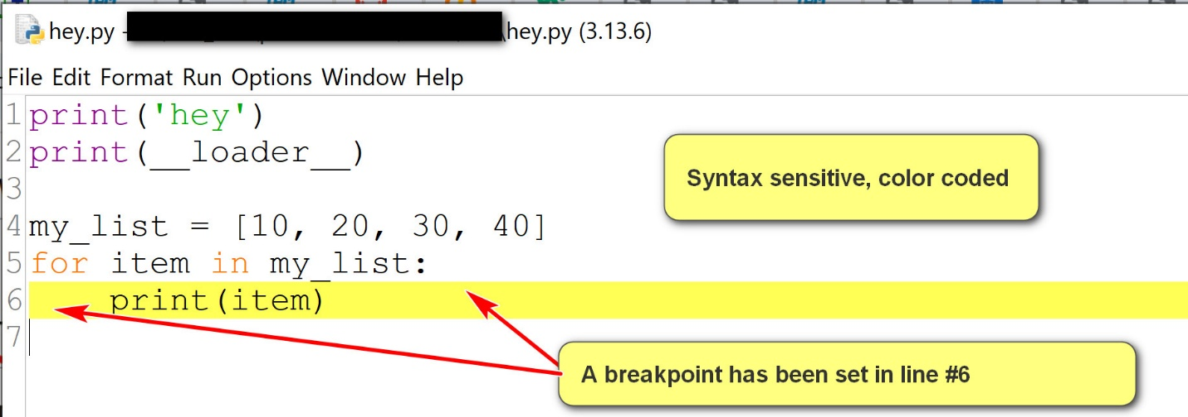
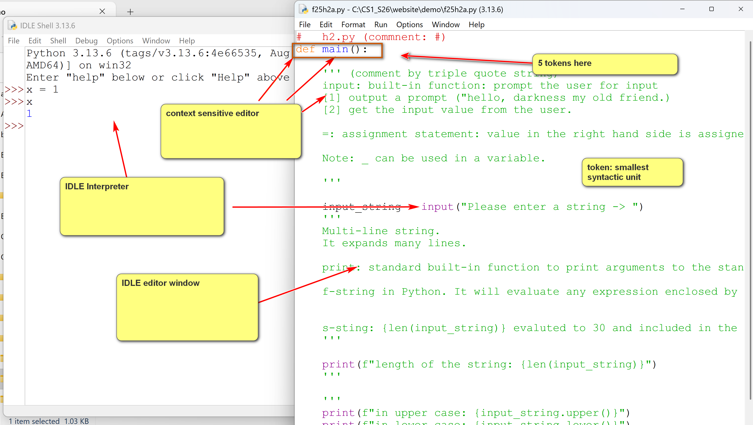
  - Some features you may use:
    - Use the options menu to show line number.
    - Set and clear breakpoints for debugging.
    - Run the program by using Run->Run Module.
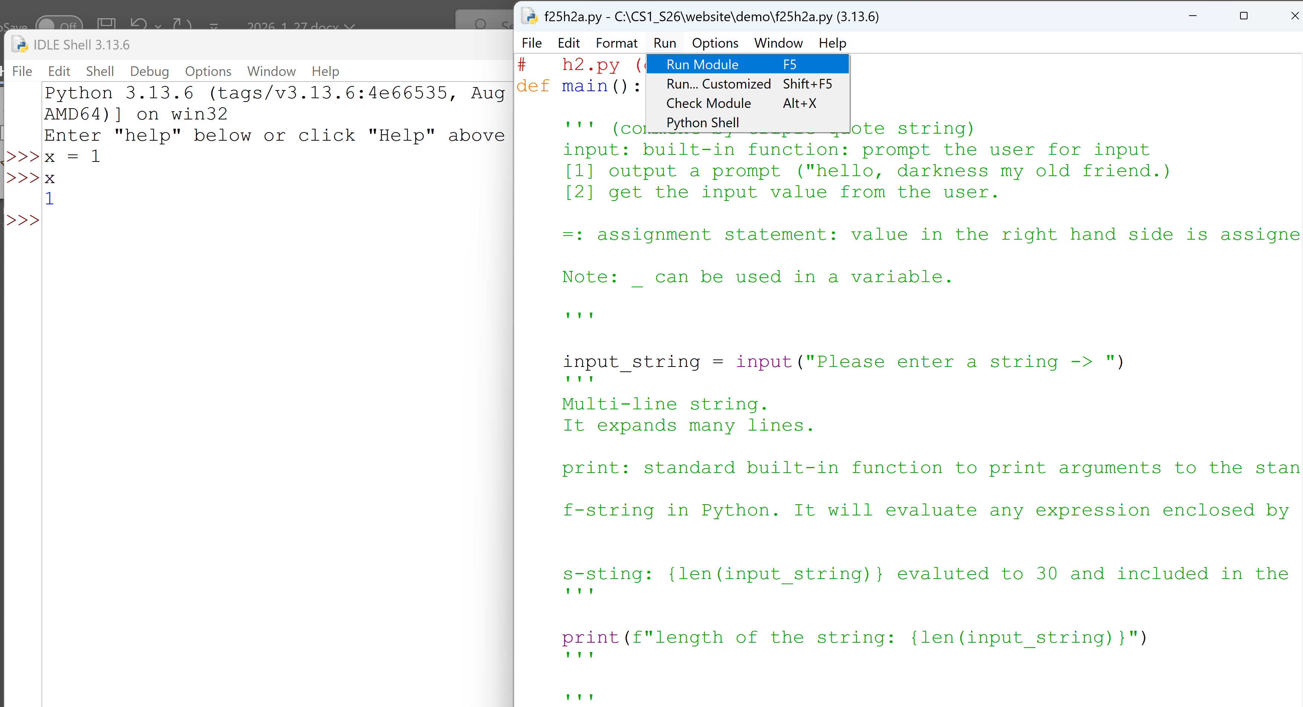
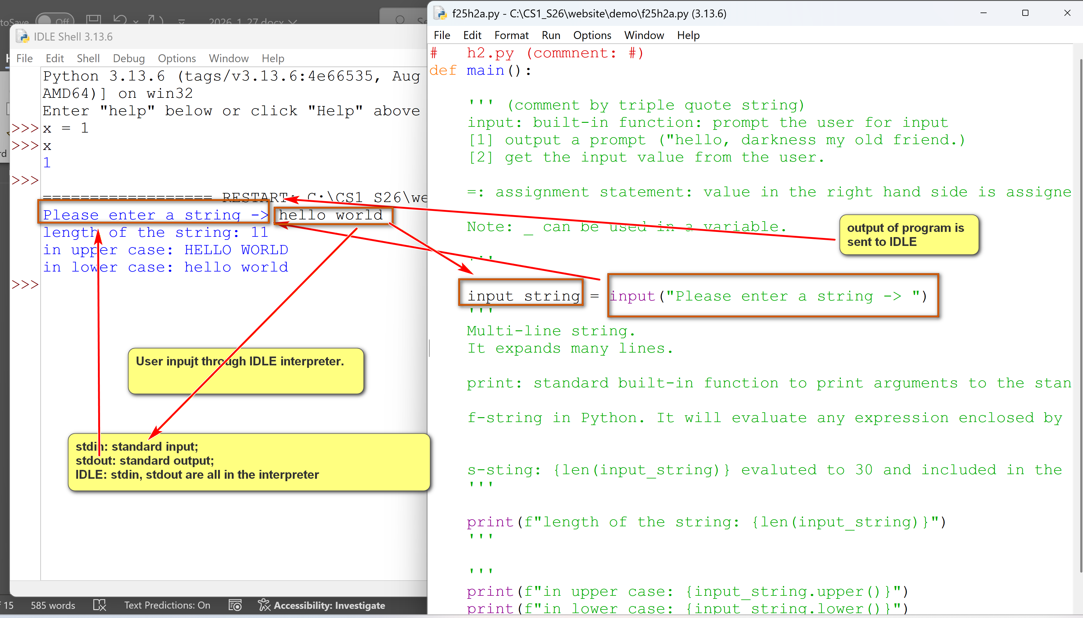
4. Debugging in IDLE
  - A good tutorial in IDLE: https://www.cs.uky.edu/~keen/help/debug-tutorial/debug.html. Contain more than needed in the class.
  - To debug a Python program:
    - Open the Python program using IDLE Shell: File -> Open.
    - Turn on the Shell debugger: Go->Debugger
    - Run the program in the editor using Run->Run Module.
    - Use the debugger window.
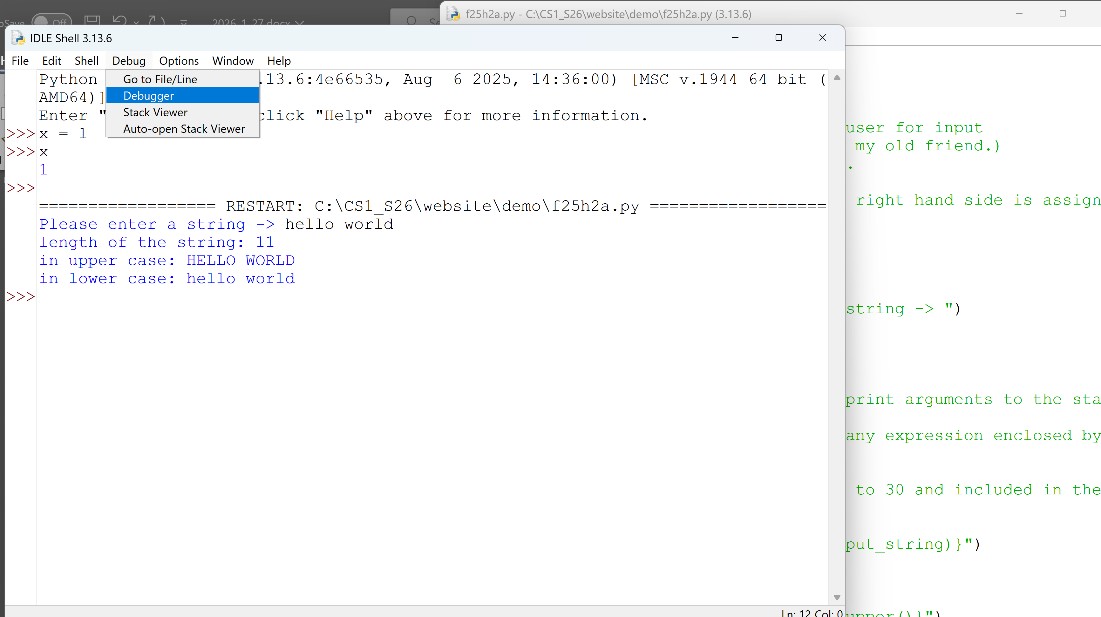
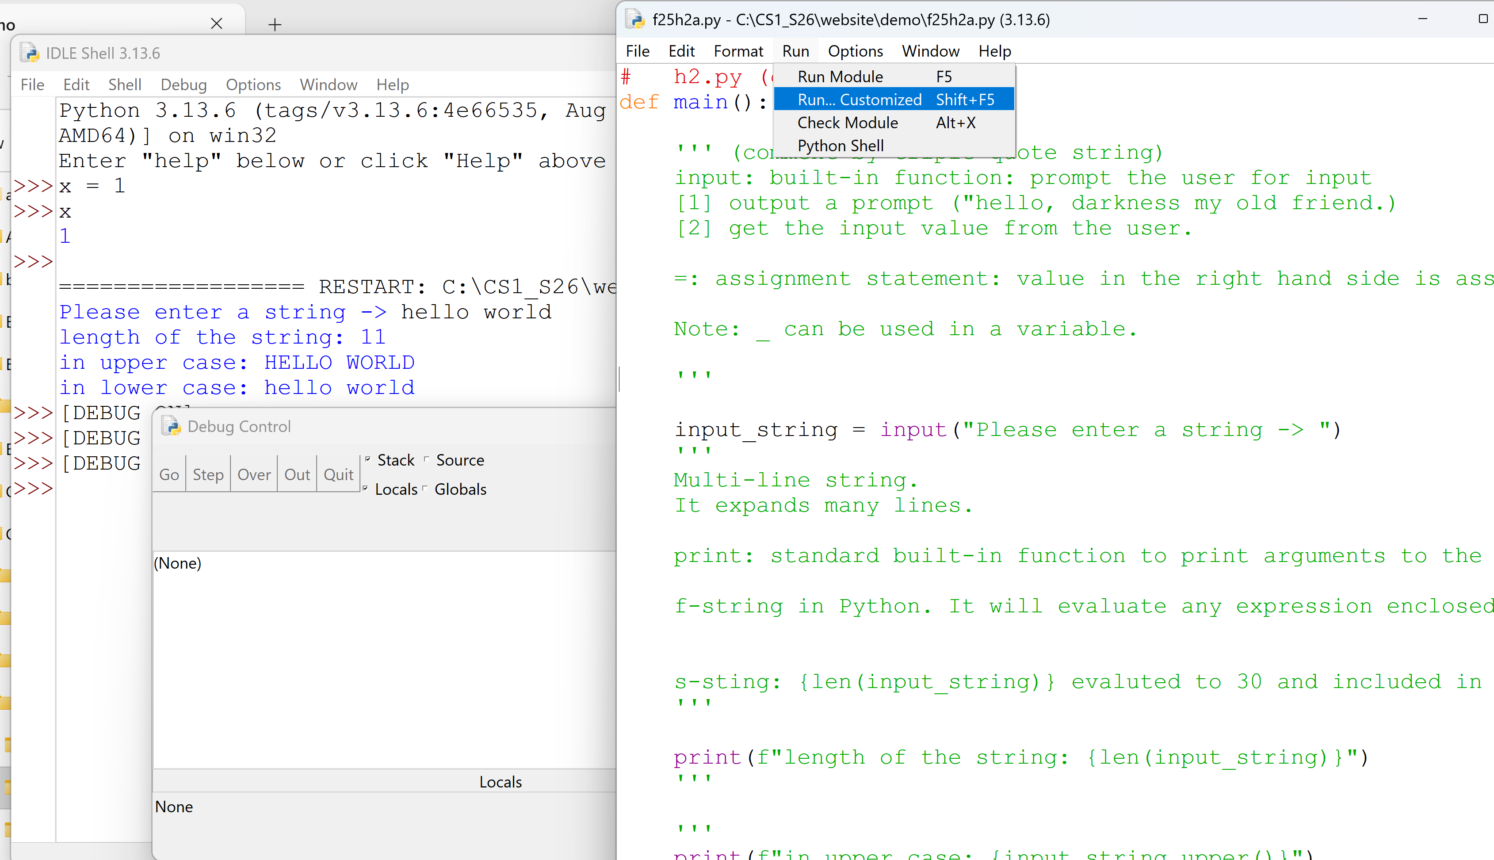
  - Some basics:
    - Use the go button in the debugger window to execute.
    - Set and clear breakpoint in the editor.
    - Examine the locals window in the debugger.
When the debugger window is started, in the example below, the locals window shows values of local variables.
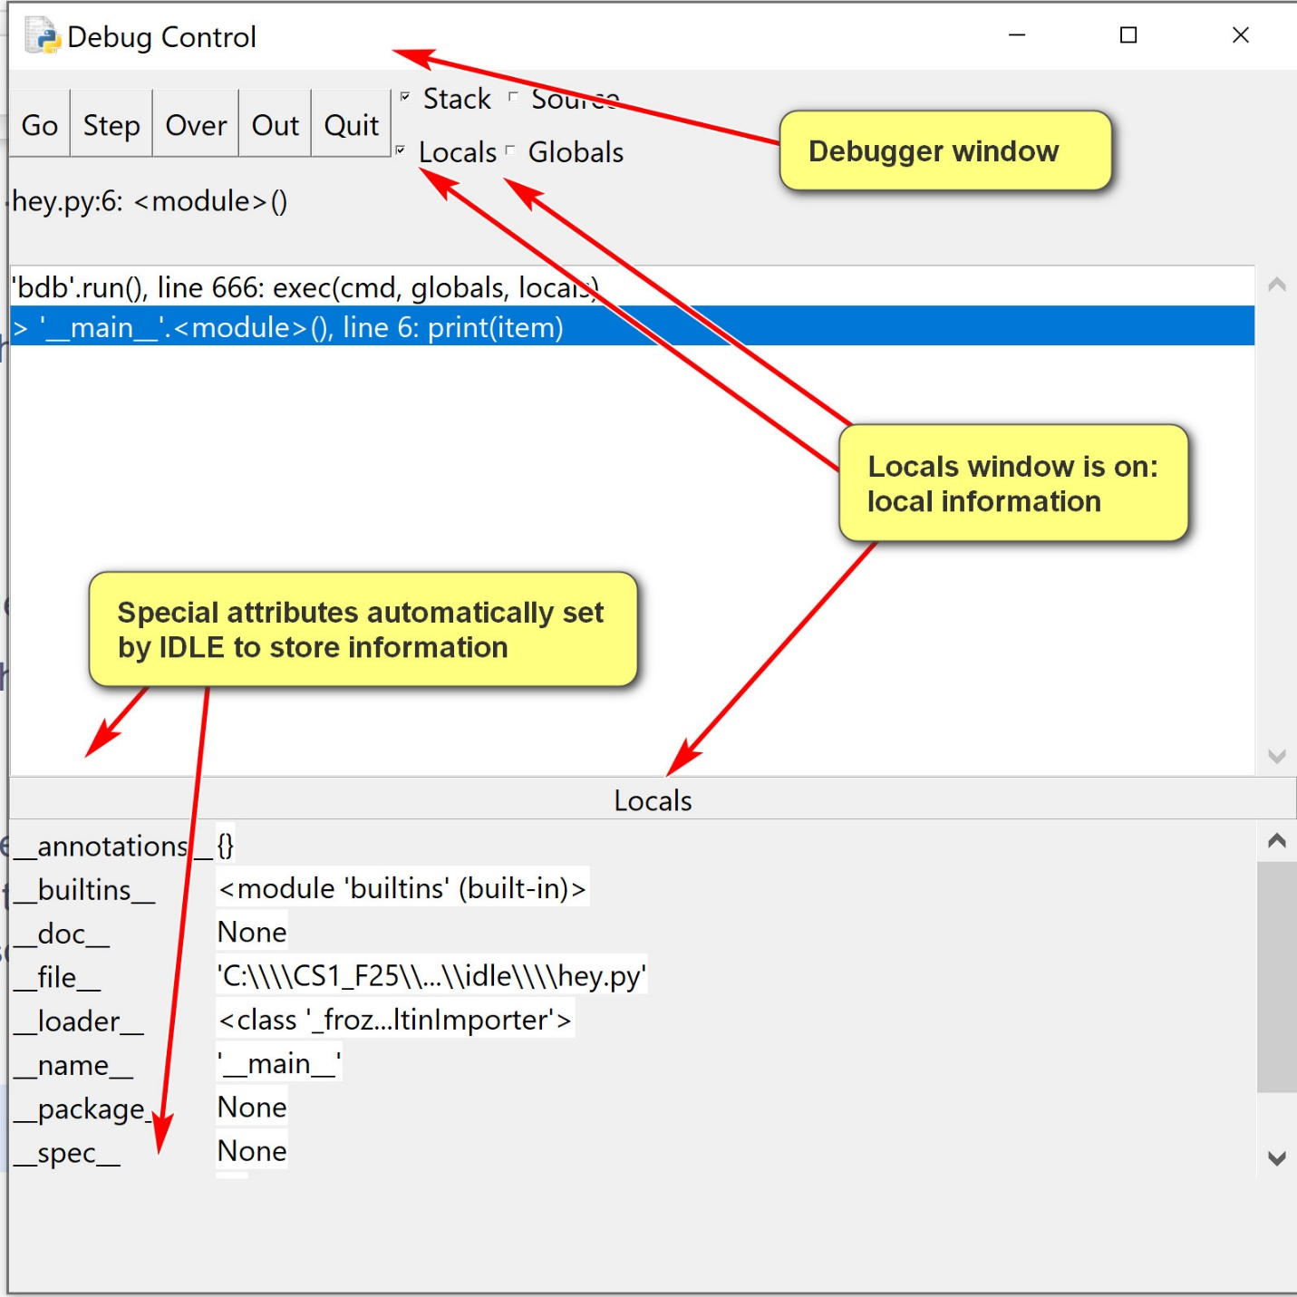
An example of using breakpoints:
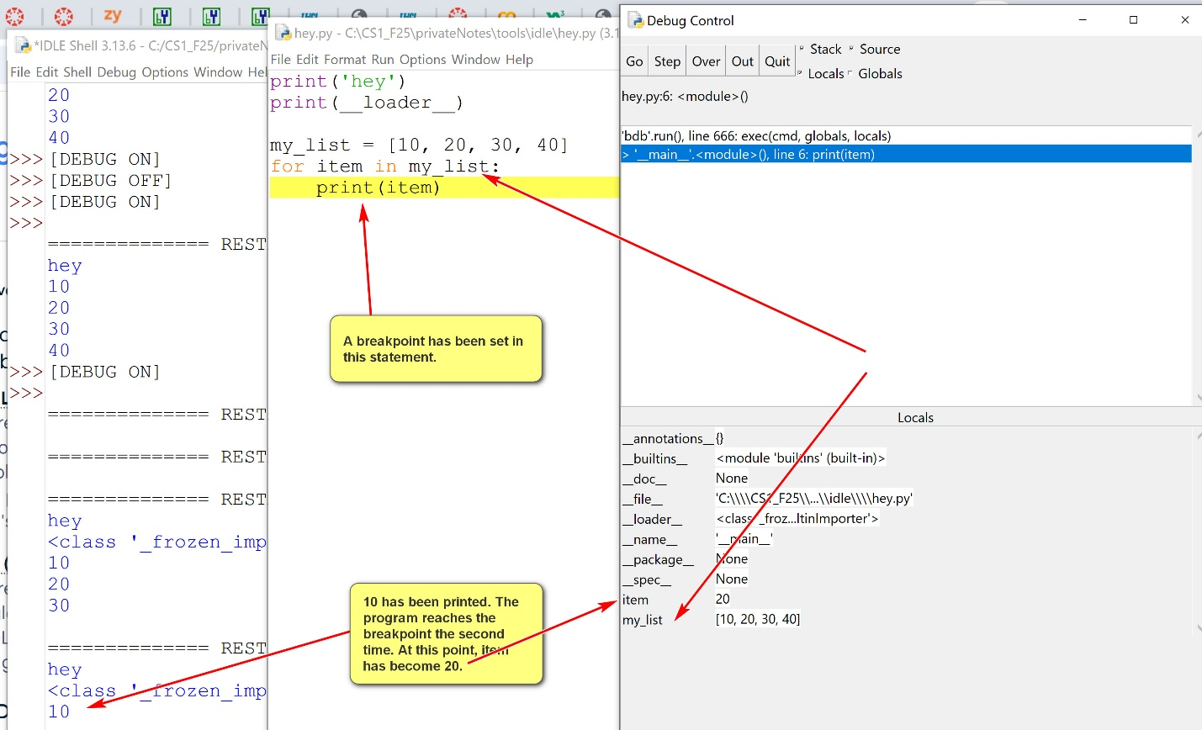
  - Useful debugger options:
    - step: one step at a time, including lower level function calls.
    - over: one step at a time, not including lower level function calls. Probably more useful than 'step'.
    - go: executes full the program.

Introduction to Turtle Graphics in Python
by K. Yue
1. Turtle Graphics Package
- The Python turtle module (files that contain Python code that you can use) is a built-in library (use them without installation) that provides a way to create graphics and drawings.
- In turtle graphics, there are two major concepts:
  - A window/screen/digit canvas for the turtle to move and draw.
  - A turtle with a pen that can move and draw (if the pen is down).
Turtle:
- The turtle is:
  - in a co-ordinate location (x,y), initially (0,0)
  - facing a direction (initially right)
  - holding a pen which can be up and down (initially down). If the pen is down, the turtle draws while moving.
- There are functions to control the turtle. Two popular ones are:
  - forward(distance): move the turtle forward by a distance. If the pen is down, the turtle also draws.
  - right(degree): turn its face to right with a degree.
Example:
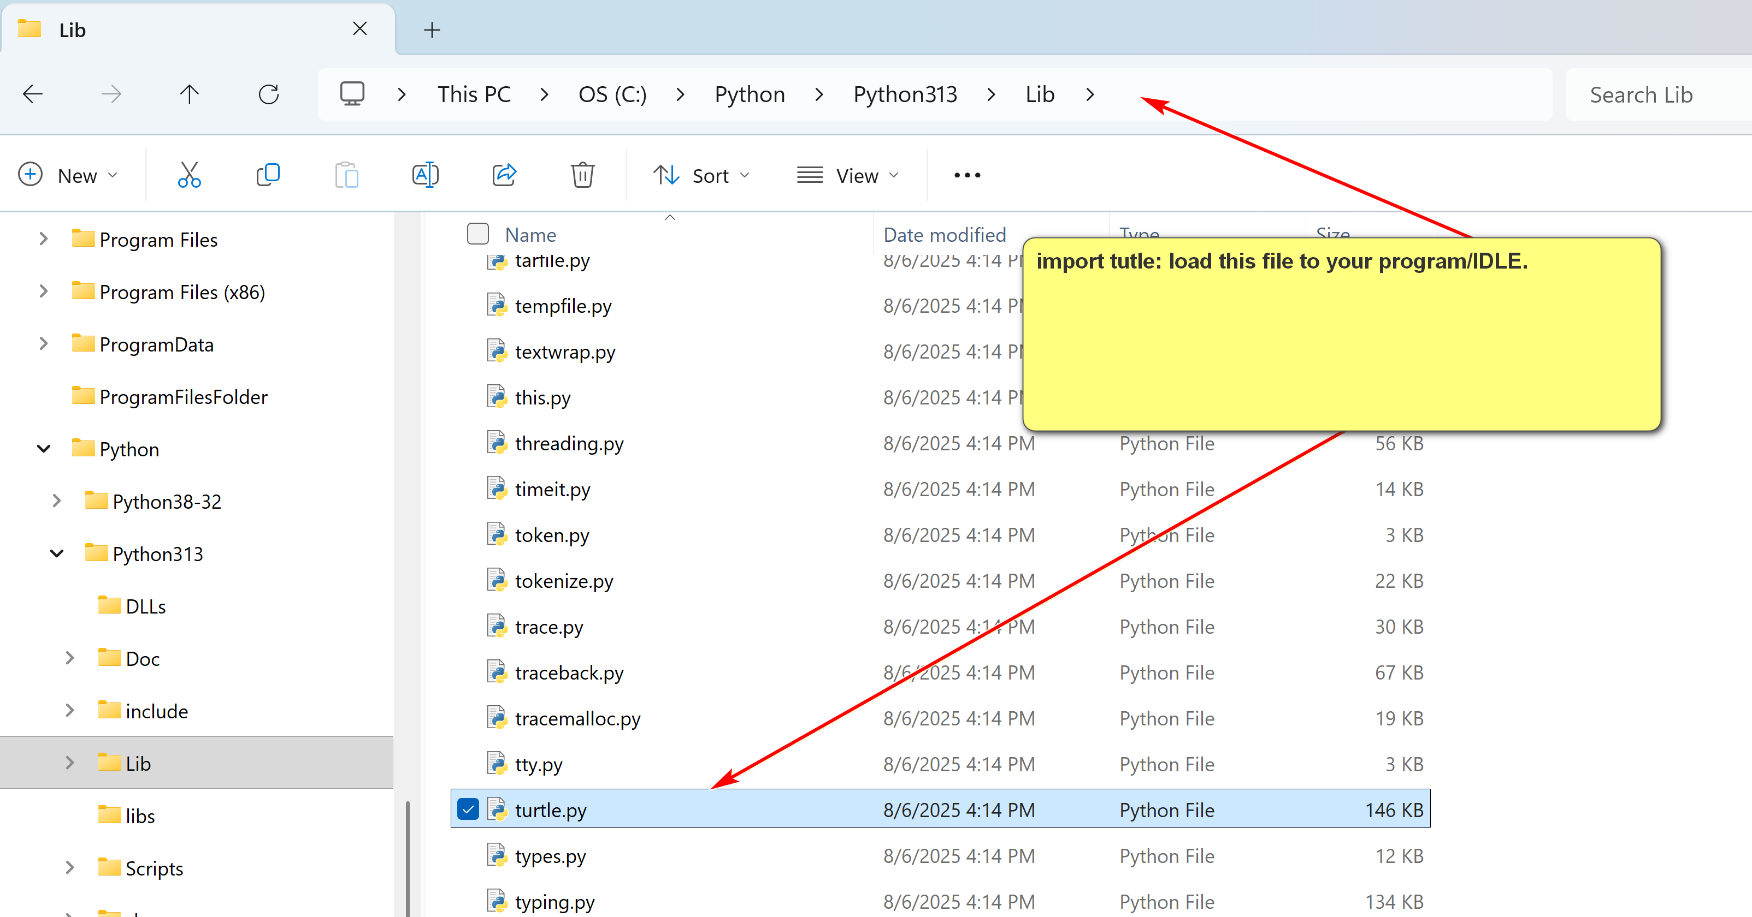
Consider square.py.txt (remove .txt when download):
import turtle
# Create a screen object in turtle
screen = turtle.Screen()
# Set screen dimensions
screen.setup(width=300, height=300)
# Set background color
screen.bgcolor("lightyellow")
# Create a turtle object
pen = turtle.Turtle()
pen.shape("turtle") # Change the turtle's shape
pen.color("green") # Set the turtle's color
pen.pensize(3) # Set the pen's size
pen.forward(100) # Move forward by 100 units
pen.right(90)
pen.forward(100) # Move forward by 100 units
pen.right(90)
pen.forward(100) # Move forward by 100 units
pen.right(90)
pen.forward(100) # Move forward by 100 units
screen.exitonclick()
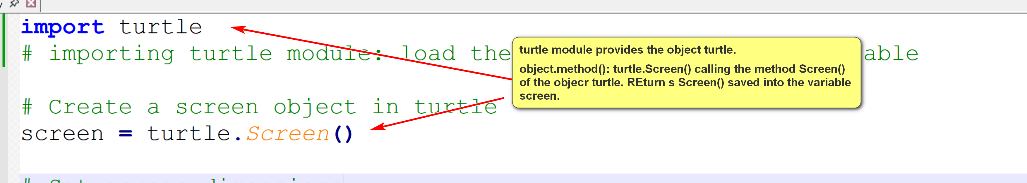
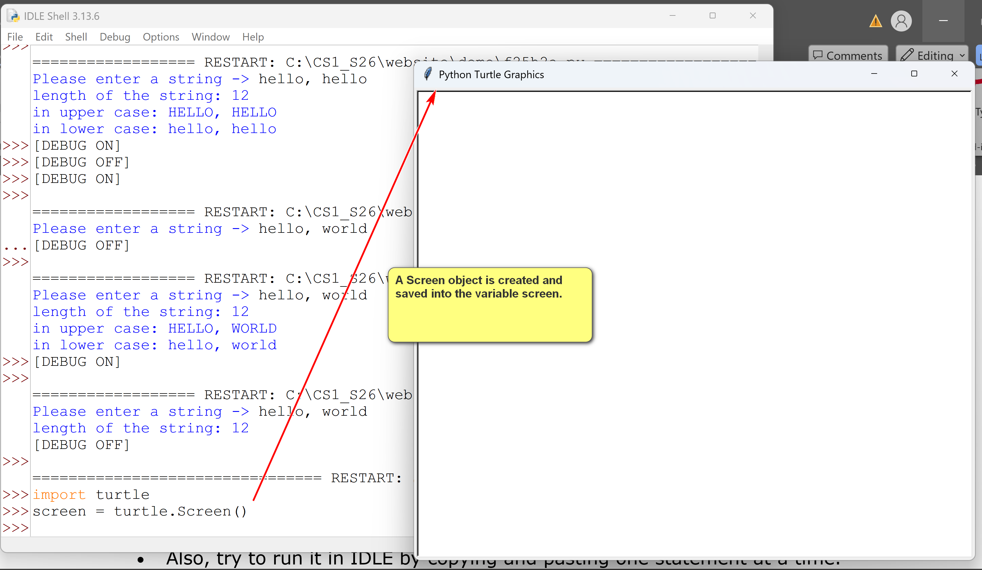
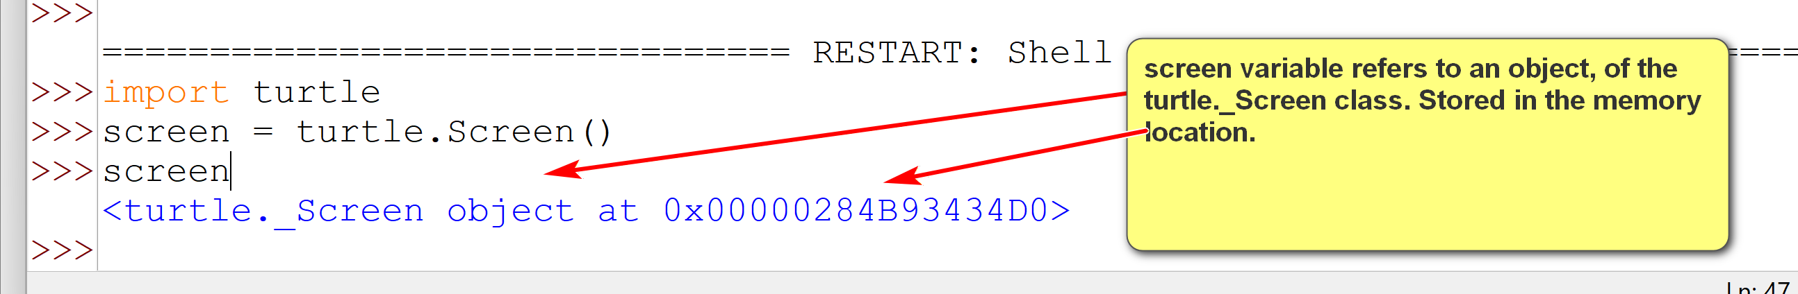
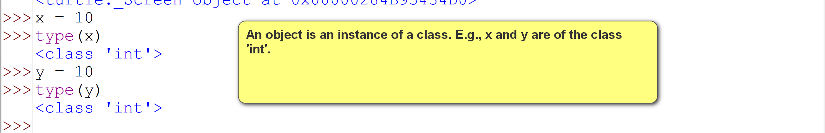
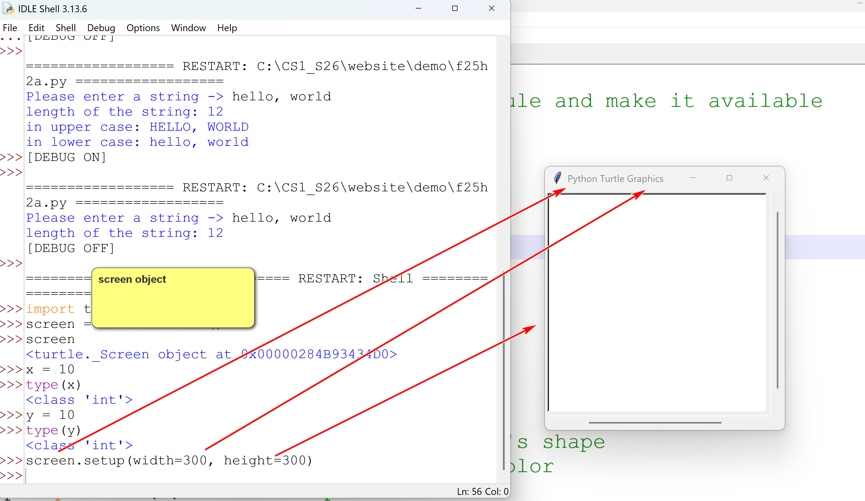
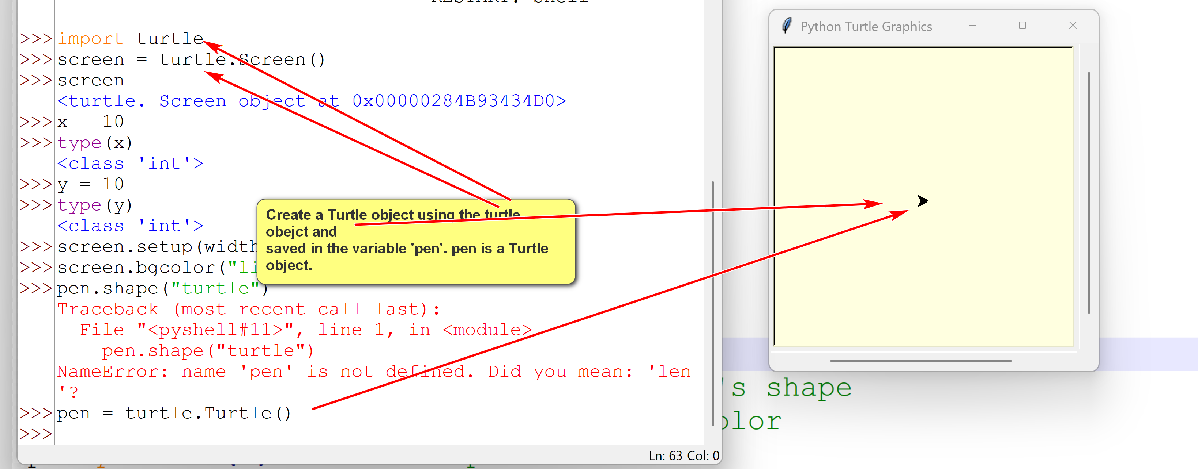
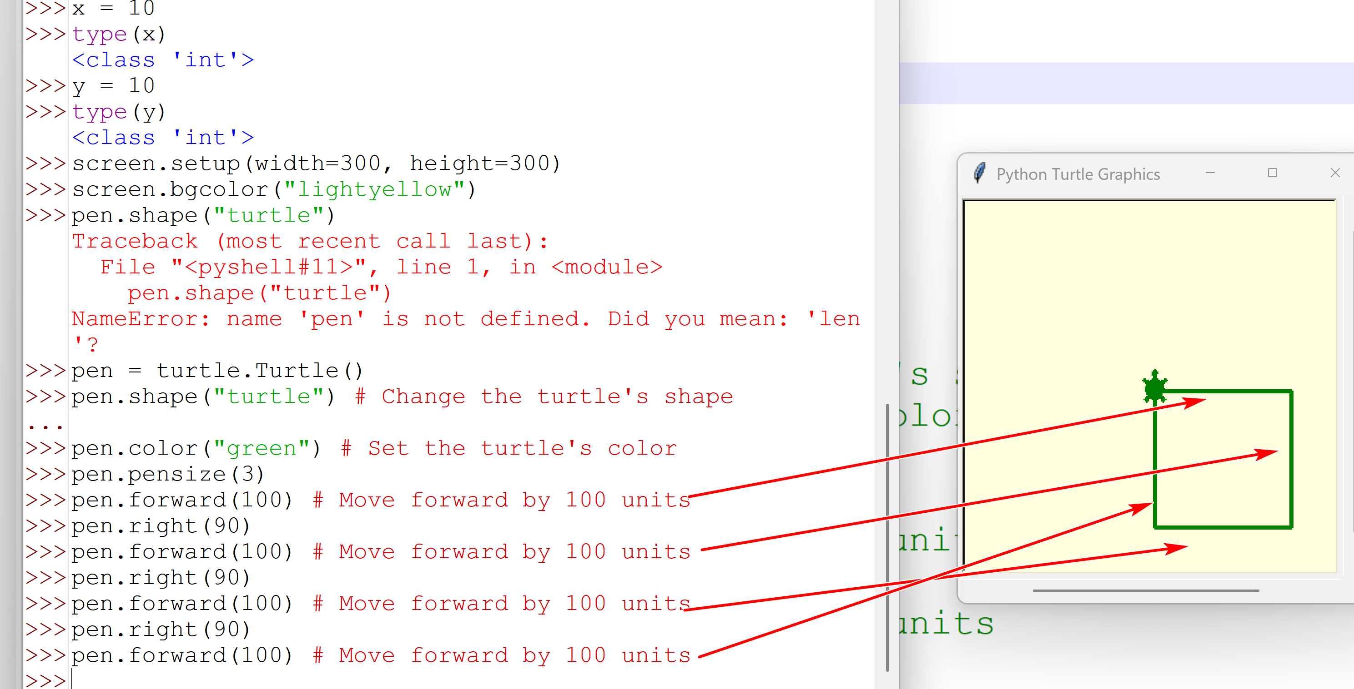
- Download and run square2.py.txt. This is a version of square.py.txt that you can use as the basis of your HW assignment.
- Also, try to run it in IDLE by copying and pasting one statement at a time.
Explanations:
- "import turtle": import the built-in turtle module. This allows the program to use the turtle object.
- "pen = turtle.Turtle()" creates a turtle object and refers to it as "pen"
- "pen.forward(100)" moves the pen. Since the pen is down, the turtle also draws.
- "pen.right(90)" turns the turtle right 90 degrees.
- screen.exitonclick(): pause until the screen is clicked on to exit.

Introduction to Computation Thinking
by K. Yue
1. Discipline-based thinking
- Discipline-based thinking refers to the process and methods of understanding and applying knowledge within a specific field of study.
- A discipline-based thinking comes with:
  - Methods
  - Traits and Characteristics
  - Values
- The way of thinking in one discipline can be applicable outside the discipline as well as in real life.
Example: Philosophical thinking: one definition: "a method of inquiry that seeks to explore fundamental questions and concepts, relying on reason, analysis, and critical thinking to gain deeper insights into the nature of reality, knowledge, ethics, and the human experience."
- Methods: critical thinking, conceptual analysis, reflection, rational argumentation, ...
- Traits and Characteristics: reasoning, wonderment, curiosity, contemplation, ...
- Values: truth, meaning, rational, ..,
Scientific methods: Richard Feymann, “Surely you’re joking, Mr. Feynman”: Feynmann’s method of learning.
2. Computational Thinking
2.1 Methods of Computation Thinking
- Computation thinking is "a set of problem-solving methods that involve expressing problems and their solutions in ways that a computer could also execute: from wikipedia.
- Four core components:
  - Algorithms - developing a step-by-step solution.
  - Decomposition - breaking down a complex problem or system into smaller, more manageable parts.
  - Pattern recognition – looking for recurring structures in problems, data sets and solutions.
  - Abstraction – focusing on the important information only, ignoring irrelevant and lower level implementations details
2.2 Algorithms
- Develop and implement step by step instruction for problem solving.
Examples:
- Python program
- Cooking recipe
2.3 Decomposition
If decomposition is done well, there are many potential advantages. For examples:
- Simplification for easier understanding.
- Reduced complexity.
- Better efficiency.
- Component reuse.
- Better and concurrent task assignments.
There are criteria for good decompositions: e.g., modularity, independence, ease of understanding, ...
Examples:
- functions
- classes
- modules
- college degree
- ...
2.4 Pattern Recognitions
- Identify recurring patterns and structures to better understand and specify problem and construct solutions.
- Human being relies on pattern recognitions a lot.
Examples:
- Dark cloud -> likely to rain -> bring an umbrella.
- Very dark cloud -> very like to have thunderstorm -> stay home.
2.5 Abstraction
- Focus on essential and high level features. Hide complex lower level implementation and irrelevant details.
- Difference between building X and using X.
Examples:
- In driving, you need to control the engine (by stepping of the gas pedal). A good driver does not need to know how the engine work,
- You can call the function input() in Python withoug knowing how the input() function is actually implemented.

