CSCI 1470 CS 1 Annotation
2026_1_22
Simple Python Development:
- Use IDLE for testing/learning/experiment
- Use Notepad++ and command line prompt (in project directory) for development.
- Learn from example: run and annotate statement by statement in IDLE.
CSCI 1470.3 Fall 2025 Homework #2
Partial:
[1] Open Python IDLE. Execute the following statements one by one: s = "This is a very good day." print(s) print(s.upper()) print (s.lower()) print (len(s)) print(s.len()) print(upper(s)) Save the shell session in a log file named h2q1.log (which is a .txt file). Upload h2q1.log to Canvas. Study the output of these statements.

Solution:
# h2.py
def main():
input_string = input("Please enter a string -> ")
print(f"length of the string: {len(input_string)}")
print(f"in upper case: {input_string.upper()}")
print(f"in lower case: {input_string.lower()}")

if __name__ == "__main__":
main()

IDLE: Alt-P goes to the previous command.

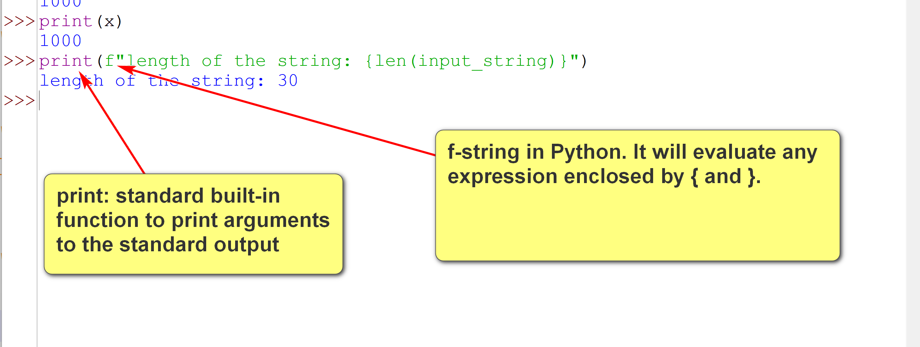

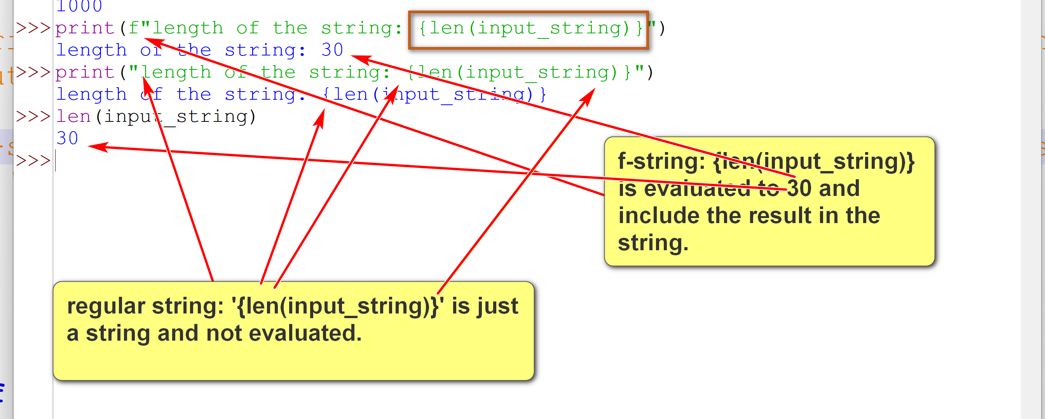

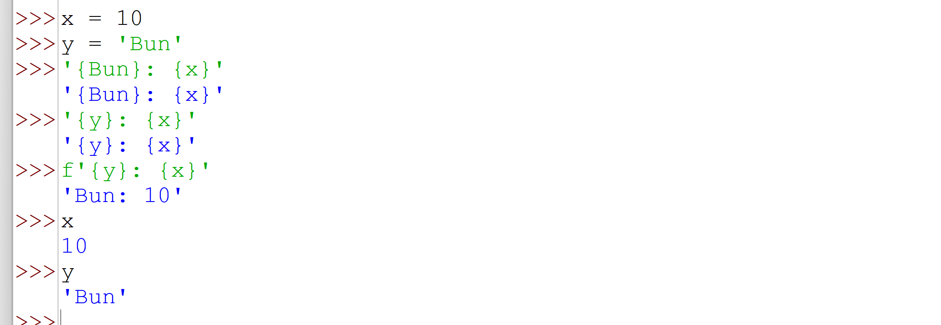

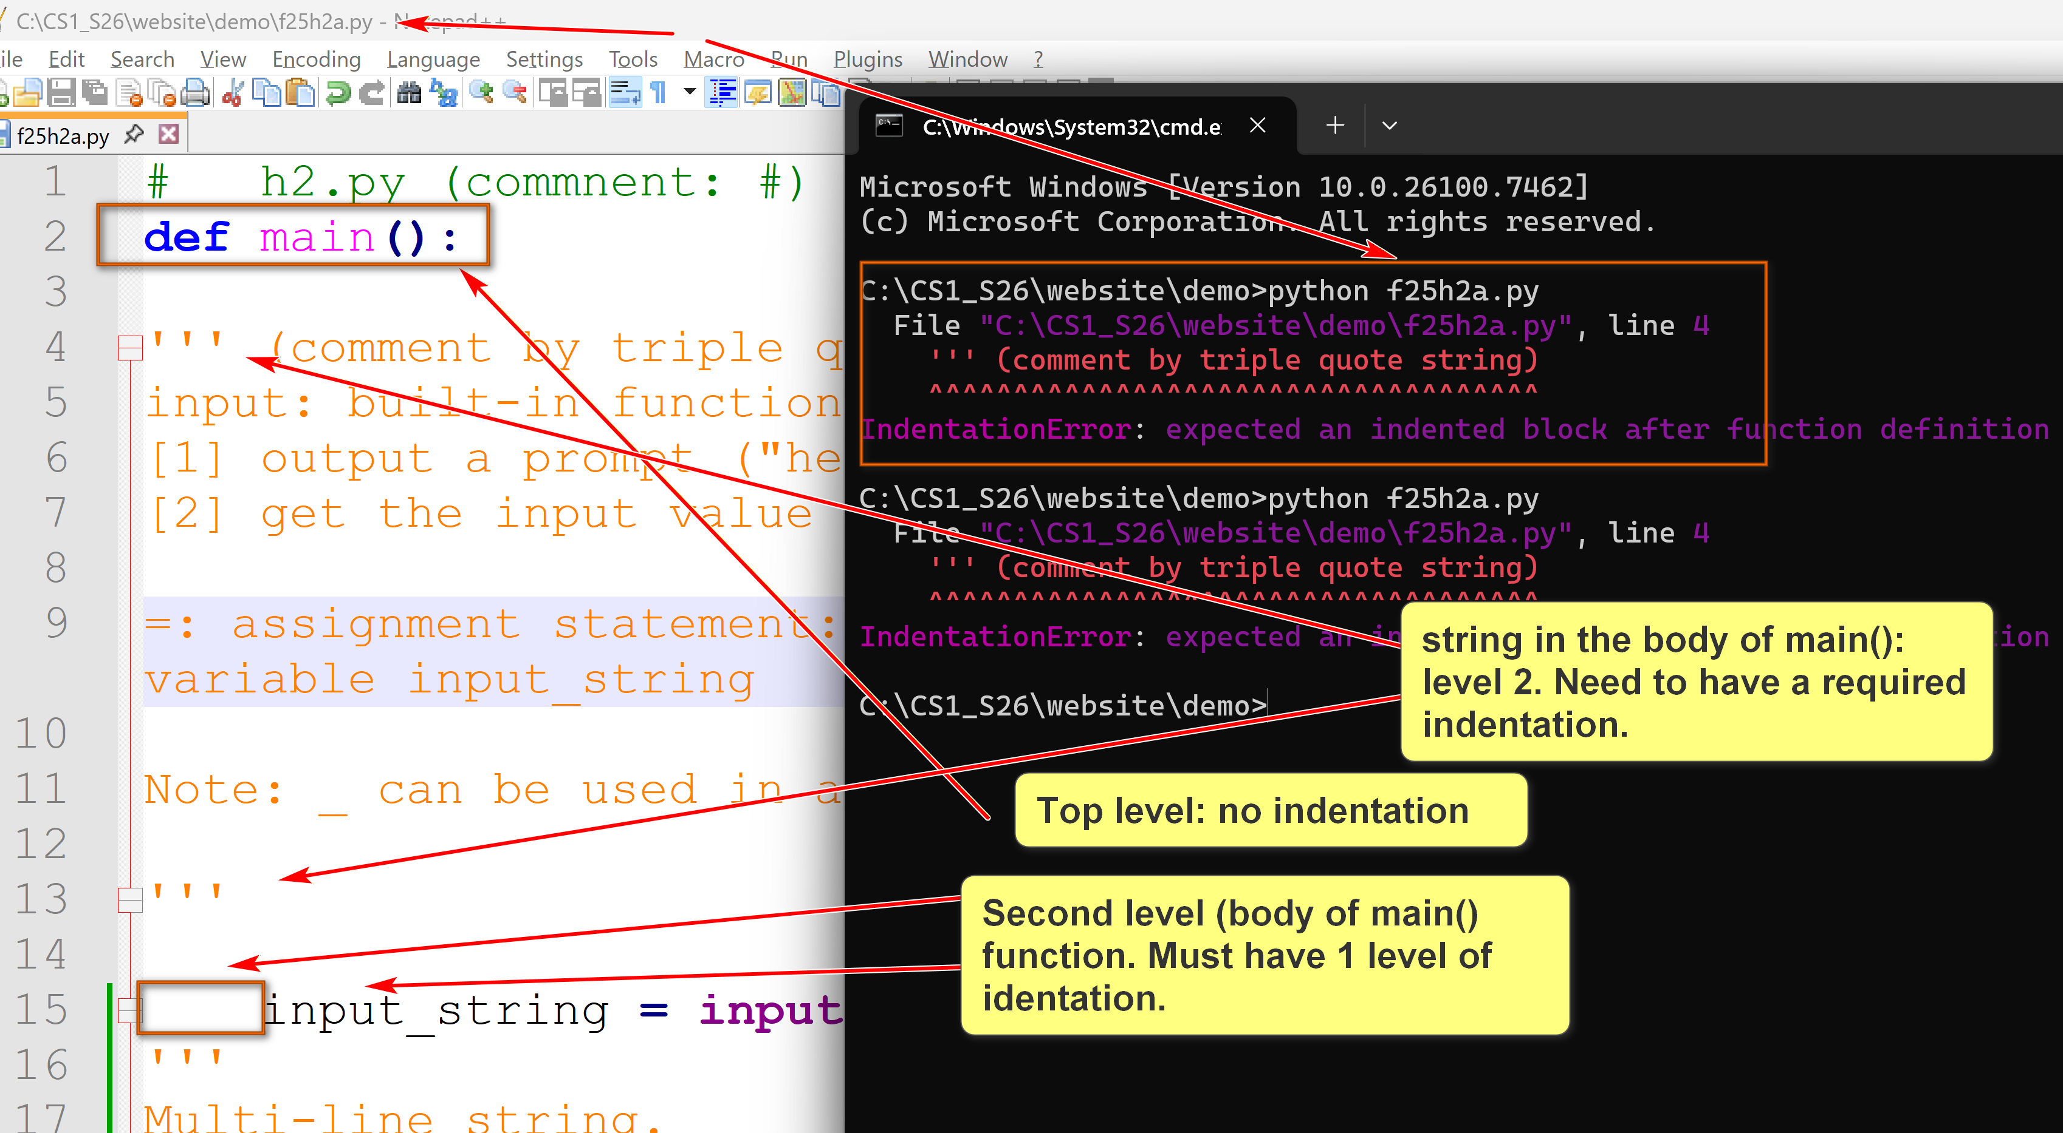
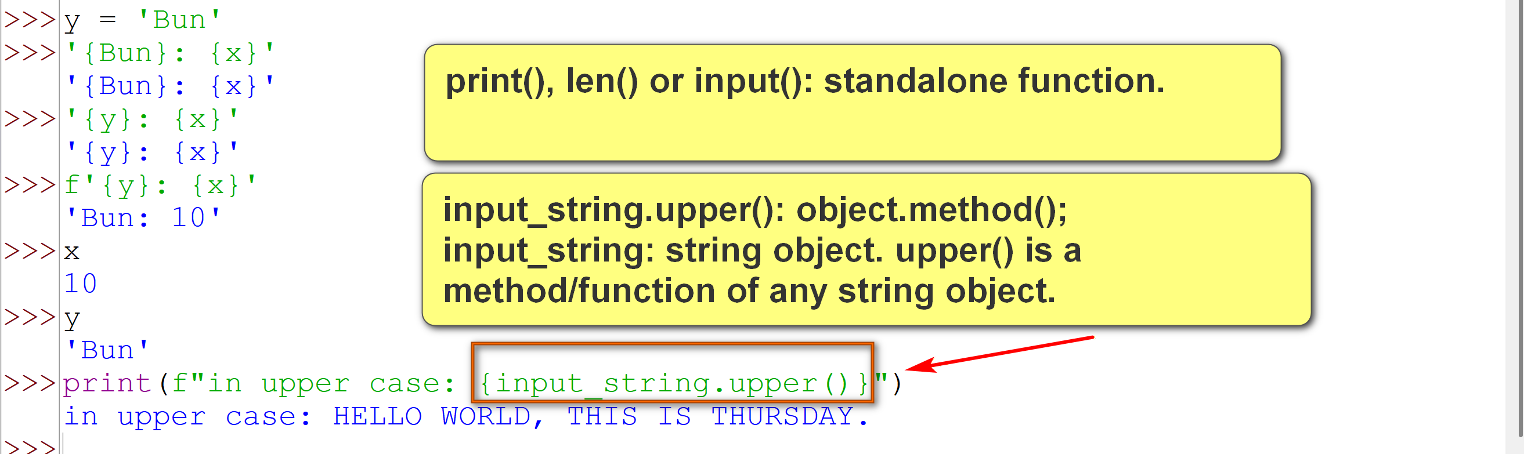

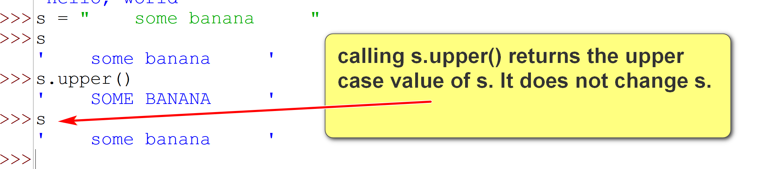

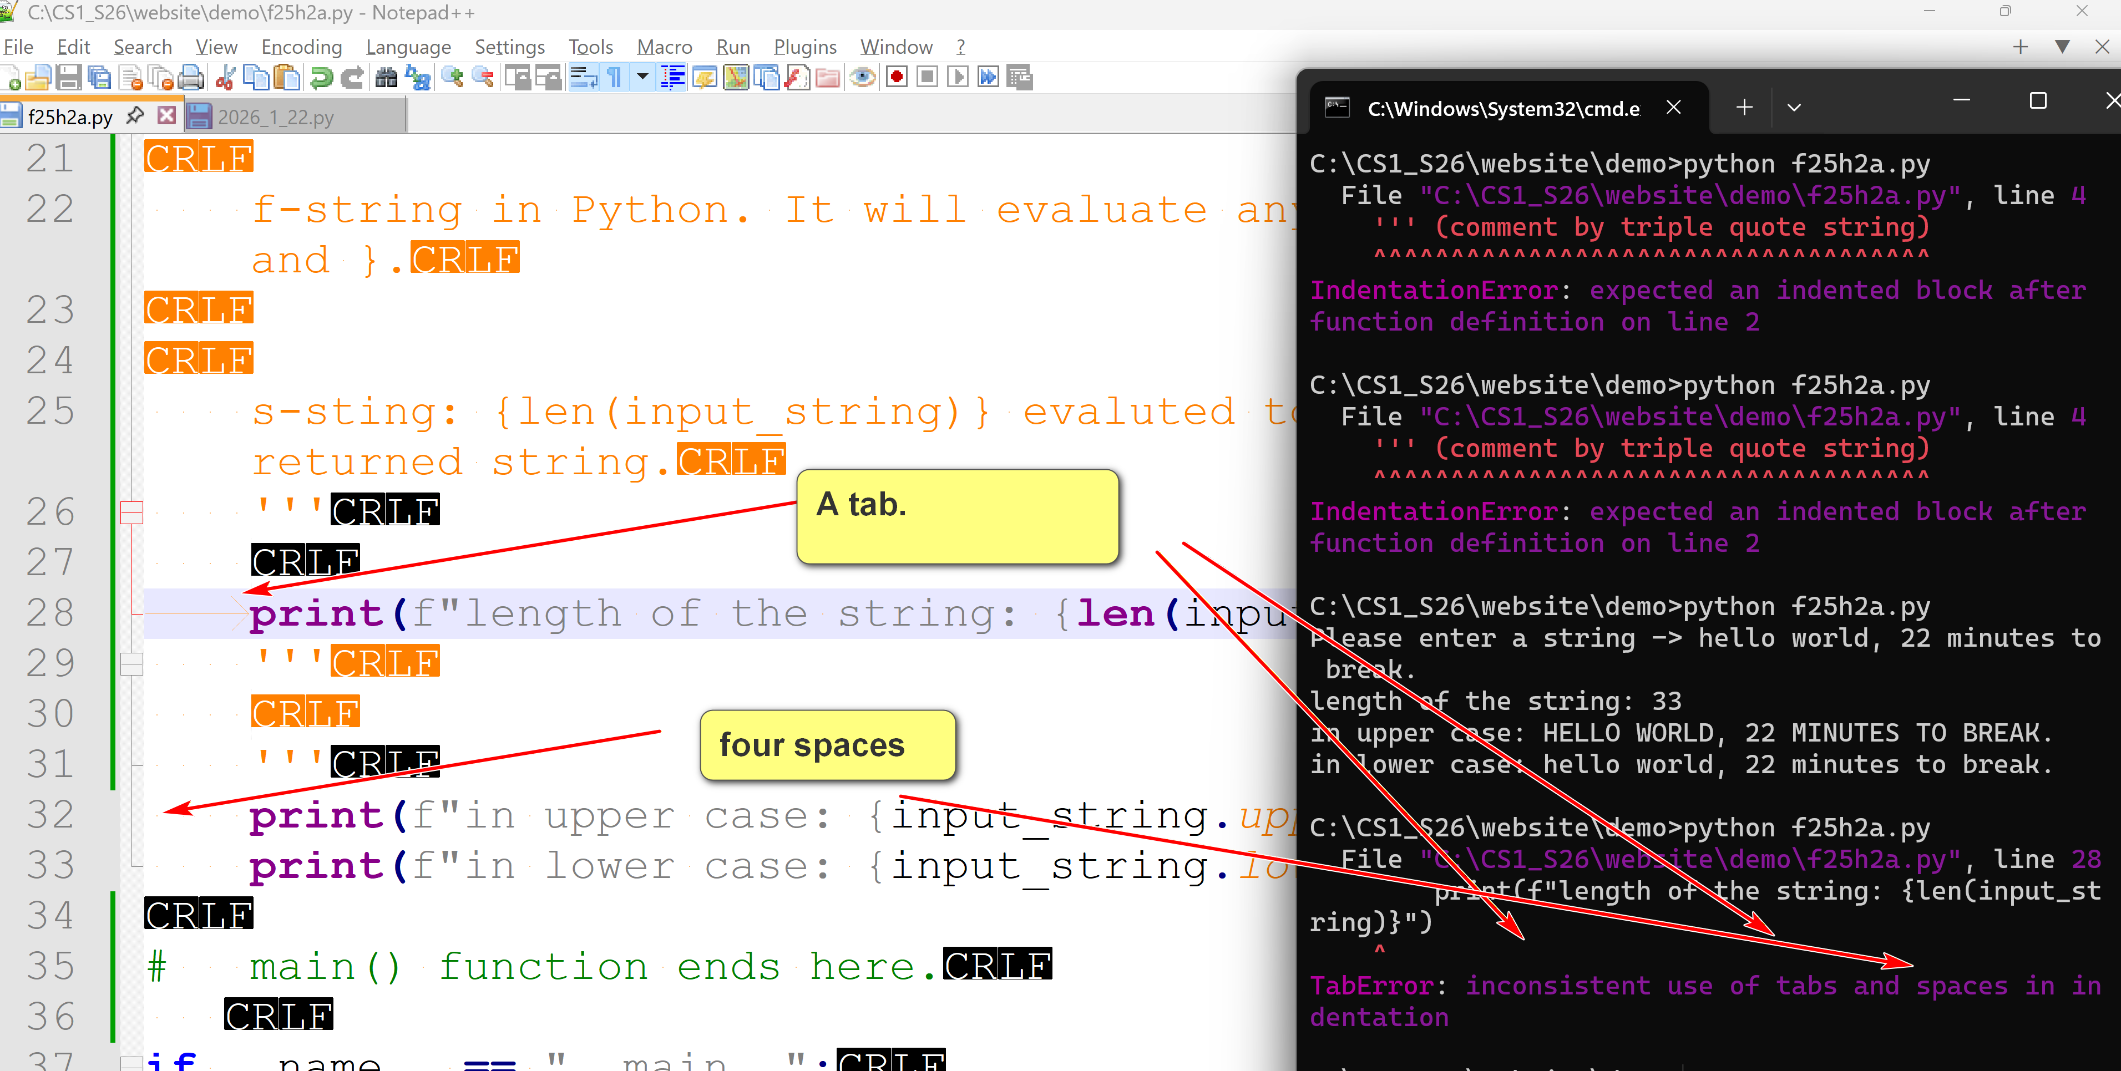

Notepad++: set to use spaces instead of tab.
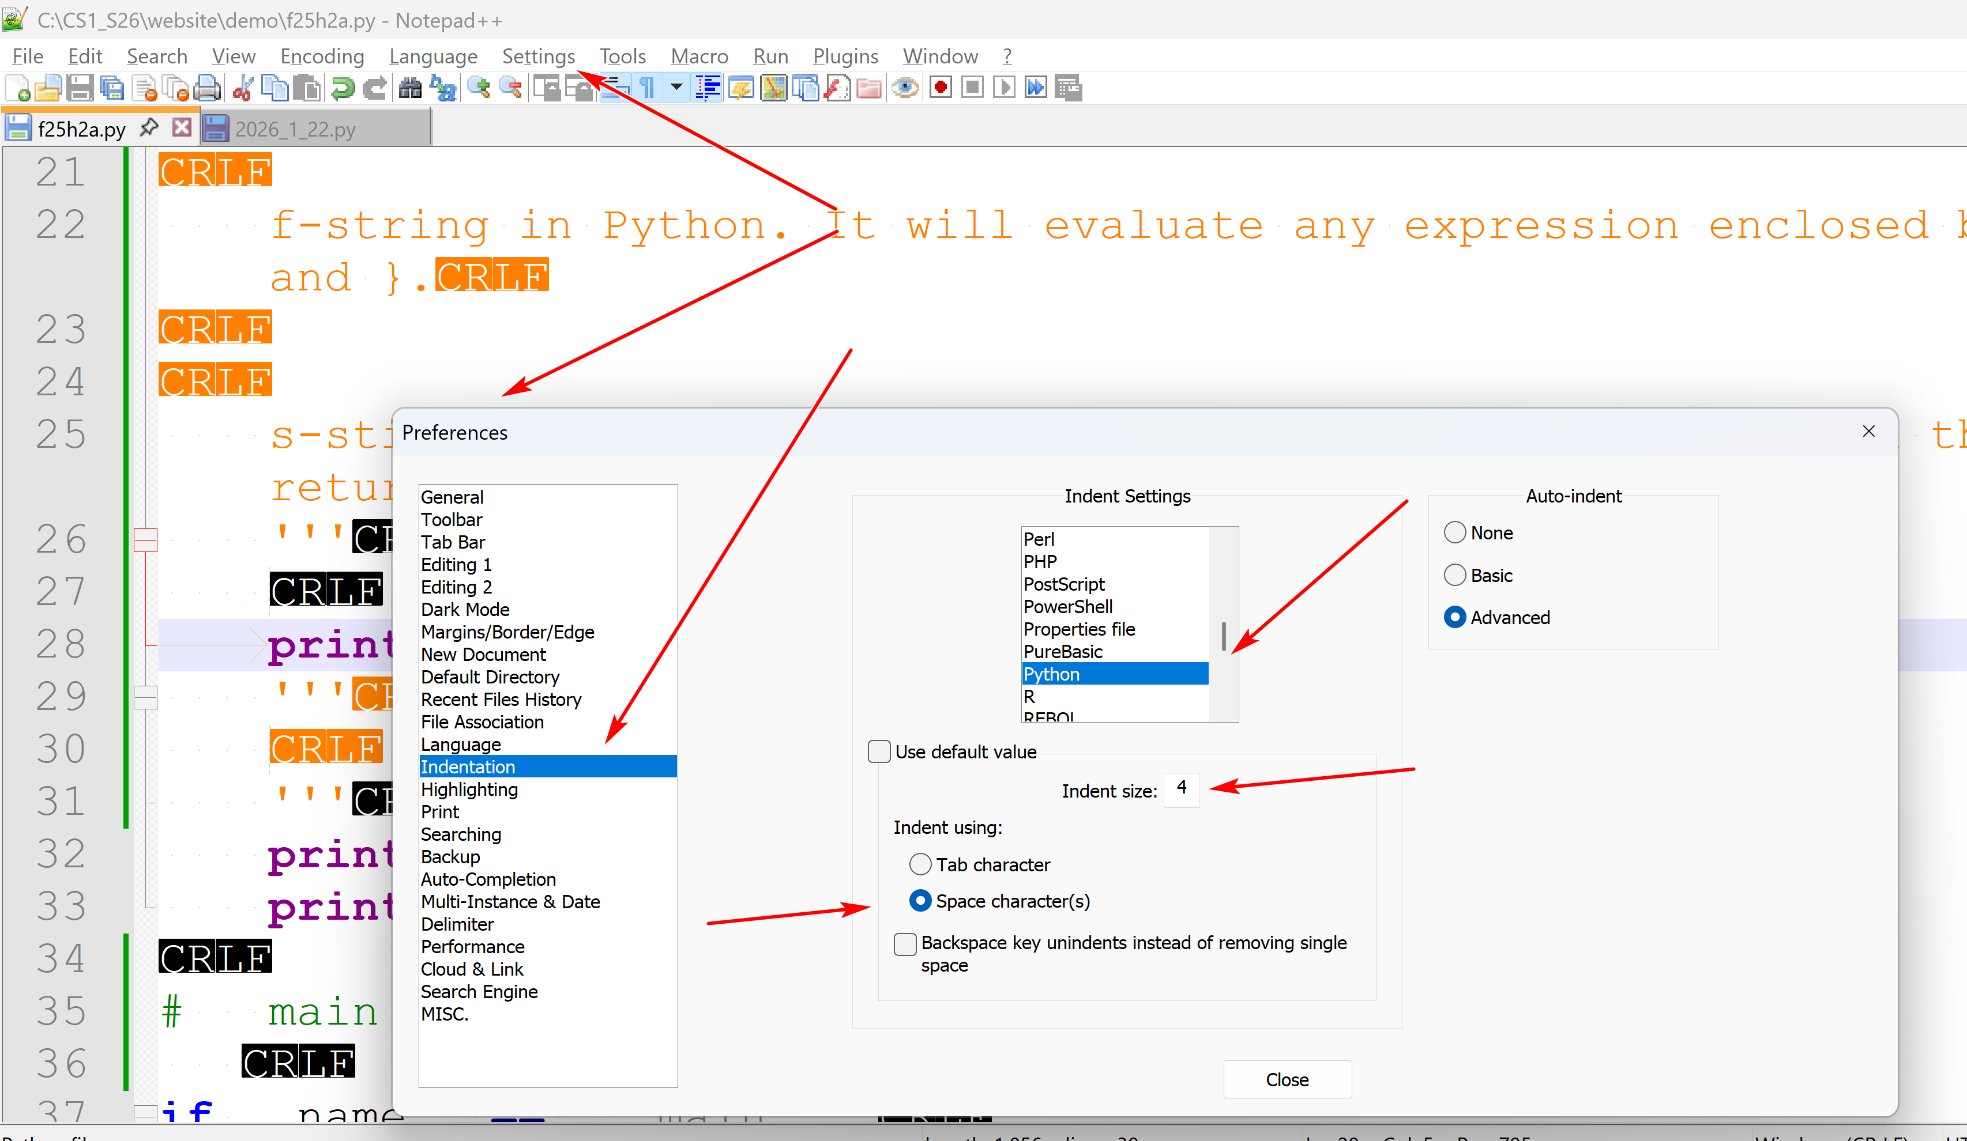
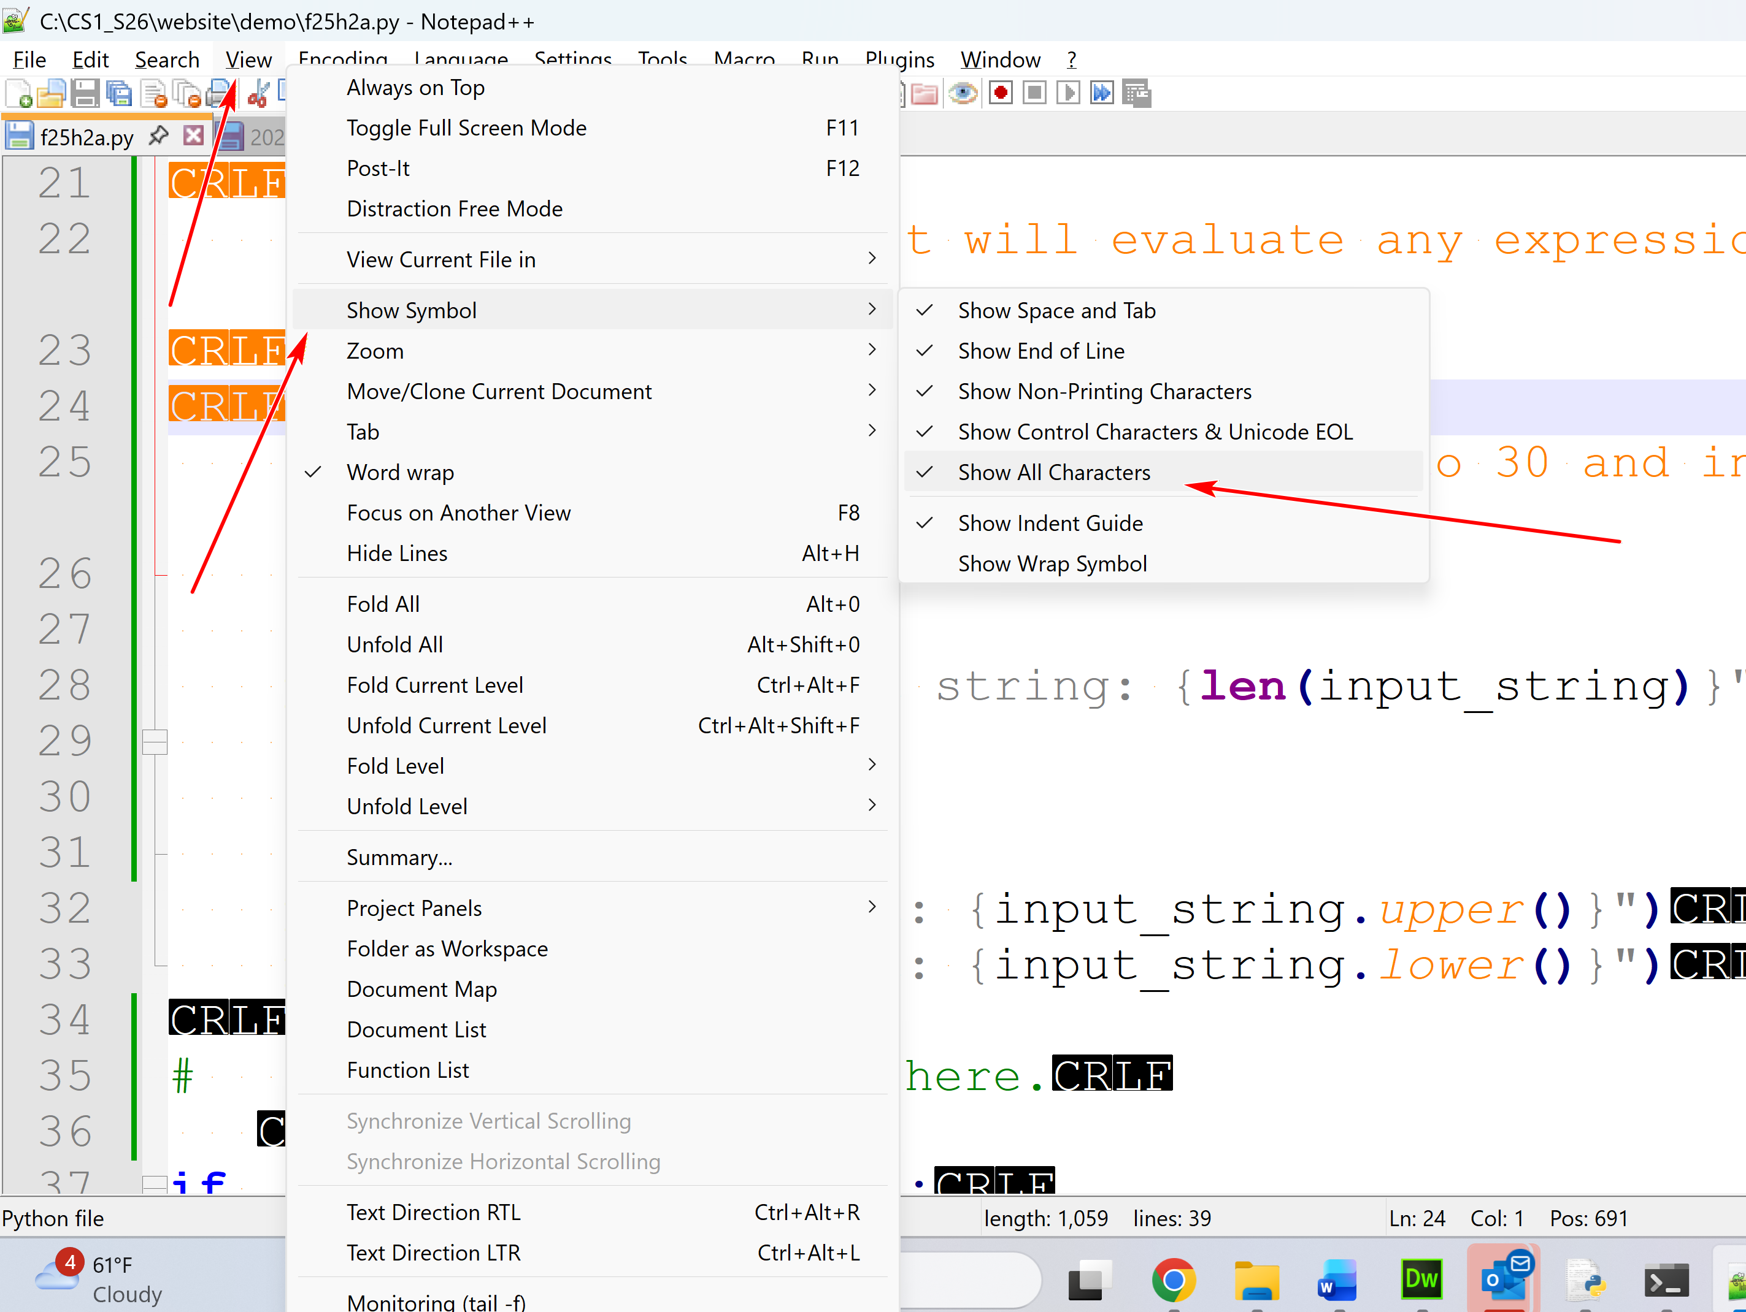

Python IDLE
by K. Yue
1. Python IDLE
  - Python IDLE is bundled in the Python distribution. There is no need for separate installation.
  - IDLE can be regarded as a very simple Integrated Development Environment (IDE). (E.g., Pycharm: sophisticated IDE.) It is used in this class.
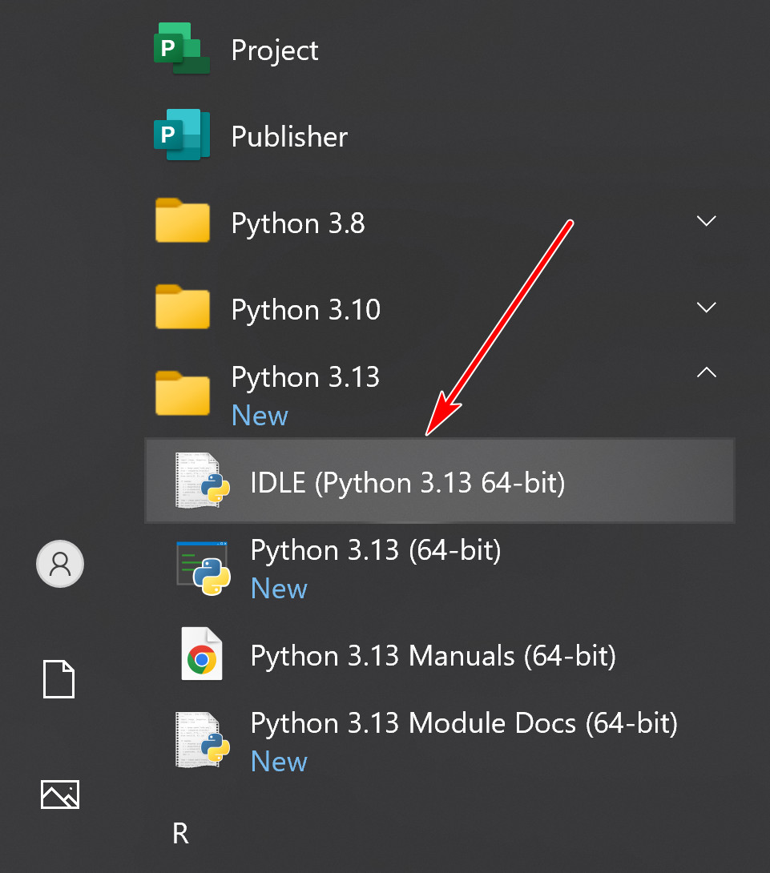
  - A short IDLE tutorial: https://www.youtube.com/watch?v=WIlQukiXs-E. (a little dated)
  - https://realpython.com/python-idle/ is a very good tutorial on IDLE. However, it contains many topics not needed in this class.
2. Running IDLE shell as interpreter
  - When you start IDLE, a shell window appears.
  - IDLE shell is an interactive interpreter with REPL (Read-Evaluate/Execute-Print loop)
    - Read a Python statement, single-lined or multiple-lined.
    - Evaluate or execute the statement.
    - Print the result of execution of the statement.
  - A shell contains the collection of Python code the user entered interactively.
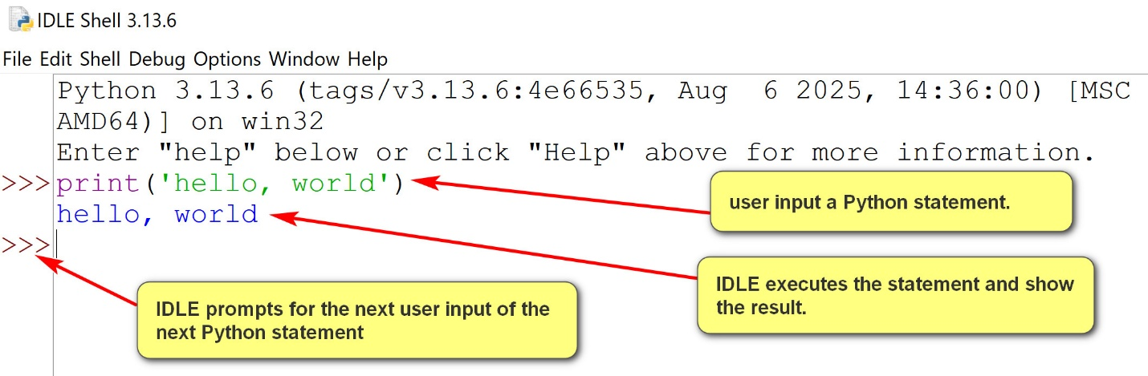
2.1 Logging a shell session
  - Logging is a crucial practice and habit in software development.
  - Logging tracks program behavior and problems, enables debugging, supports performance analysis, supports auditing, monitors security and informs users, administrators, and developers.
  - IDLE shell session can be logged by saving it in a file.
Suggestions/principles:
- As specific as possible.
- Separation of concerns.
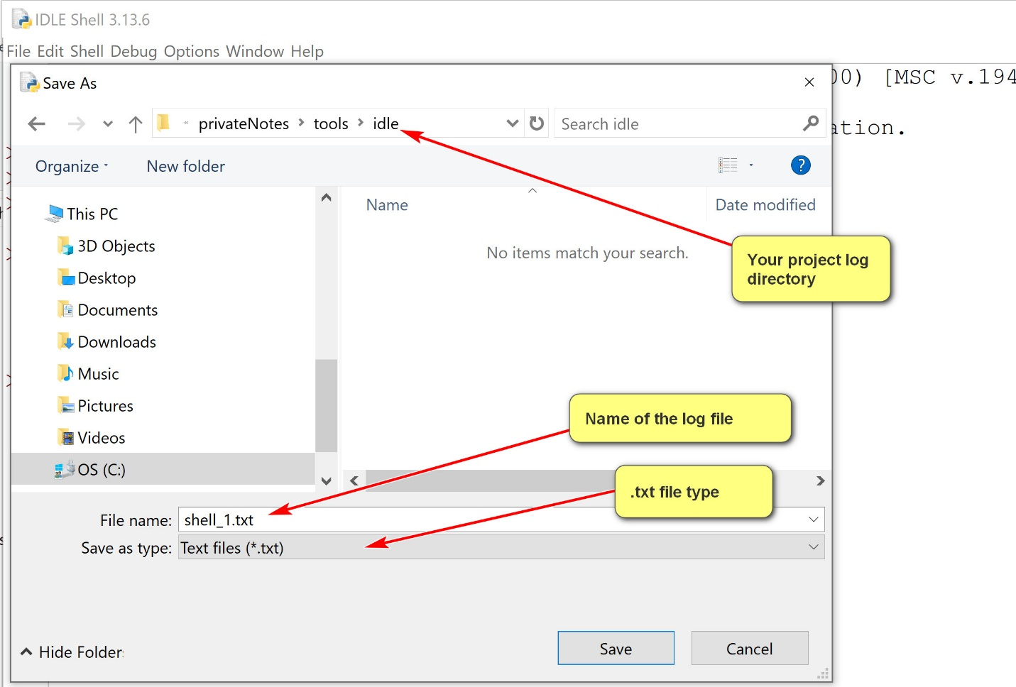
Shell Menu
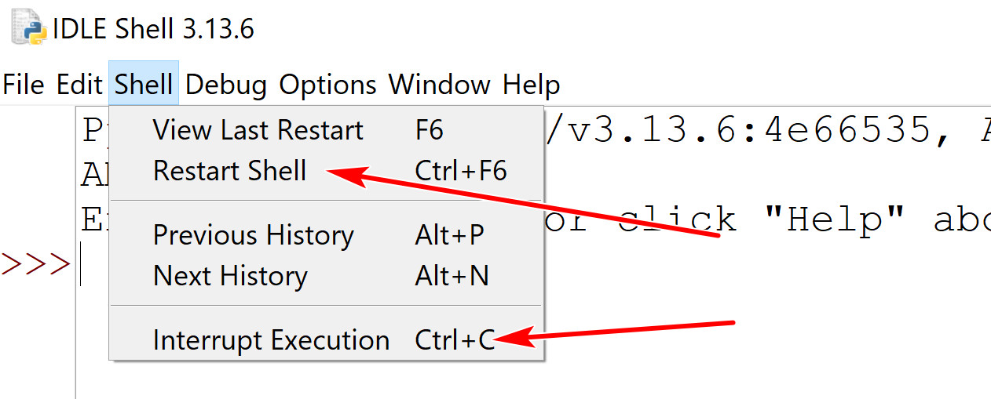
  - Two buttons you may use:
    - Restart shell: start a new shell session.
    - Interrupt Execution: stop the execution (in case you get into an infinite loop)
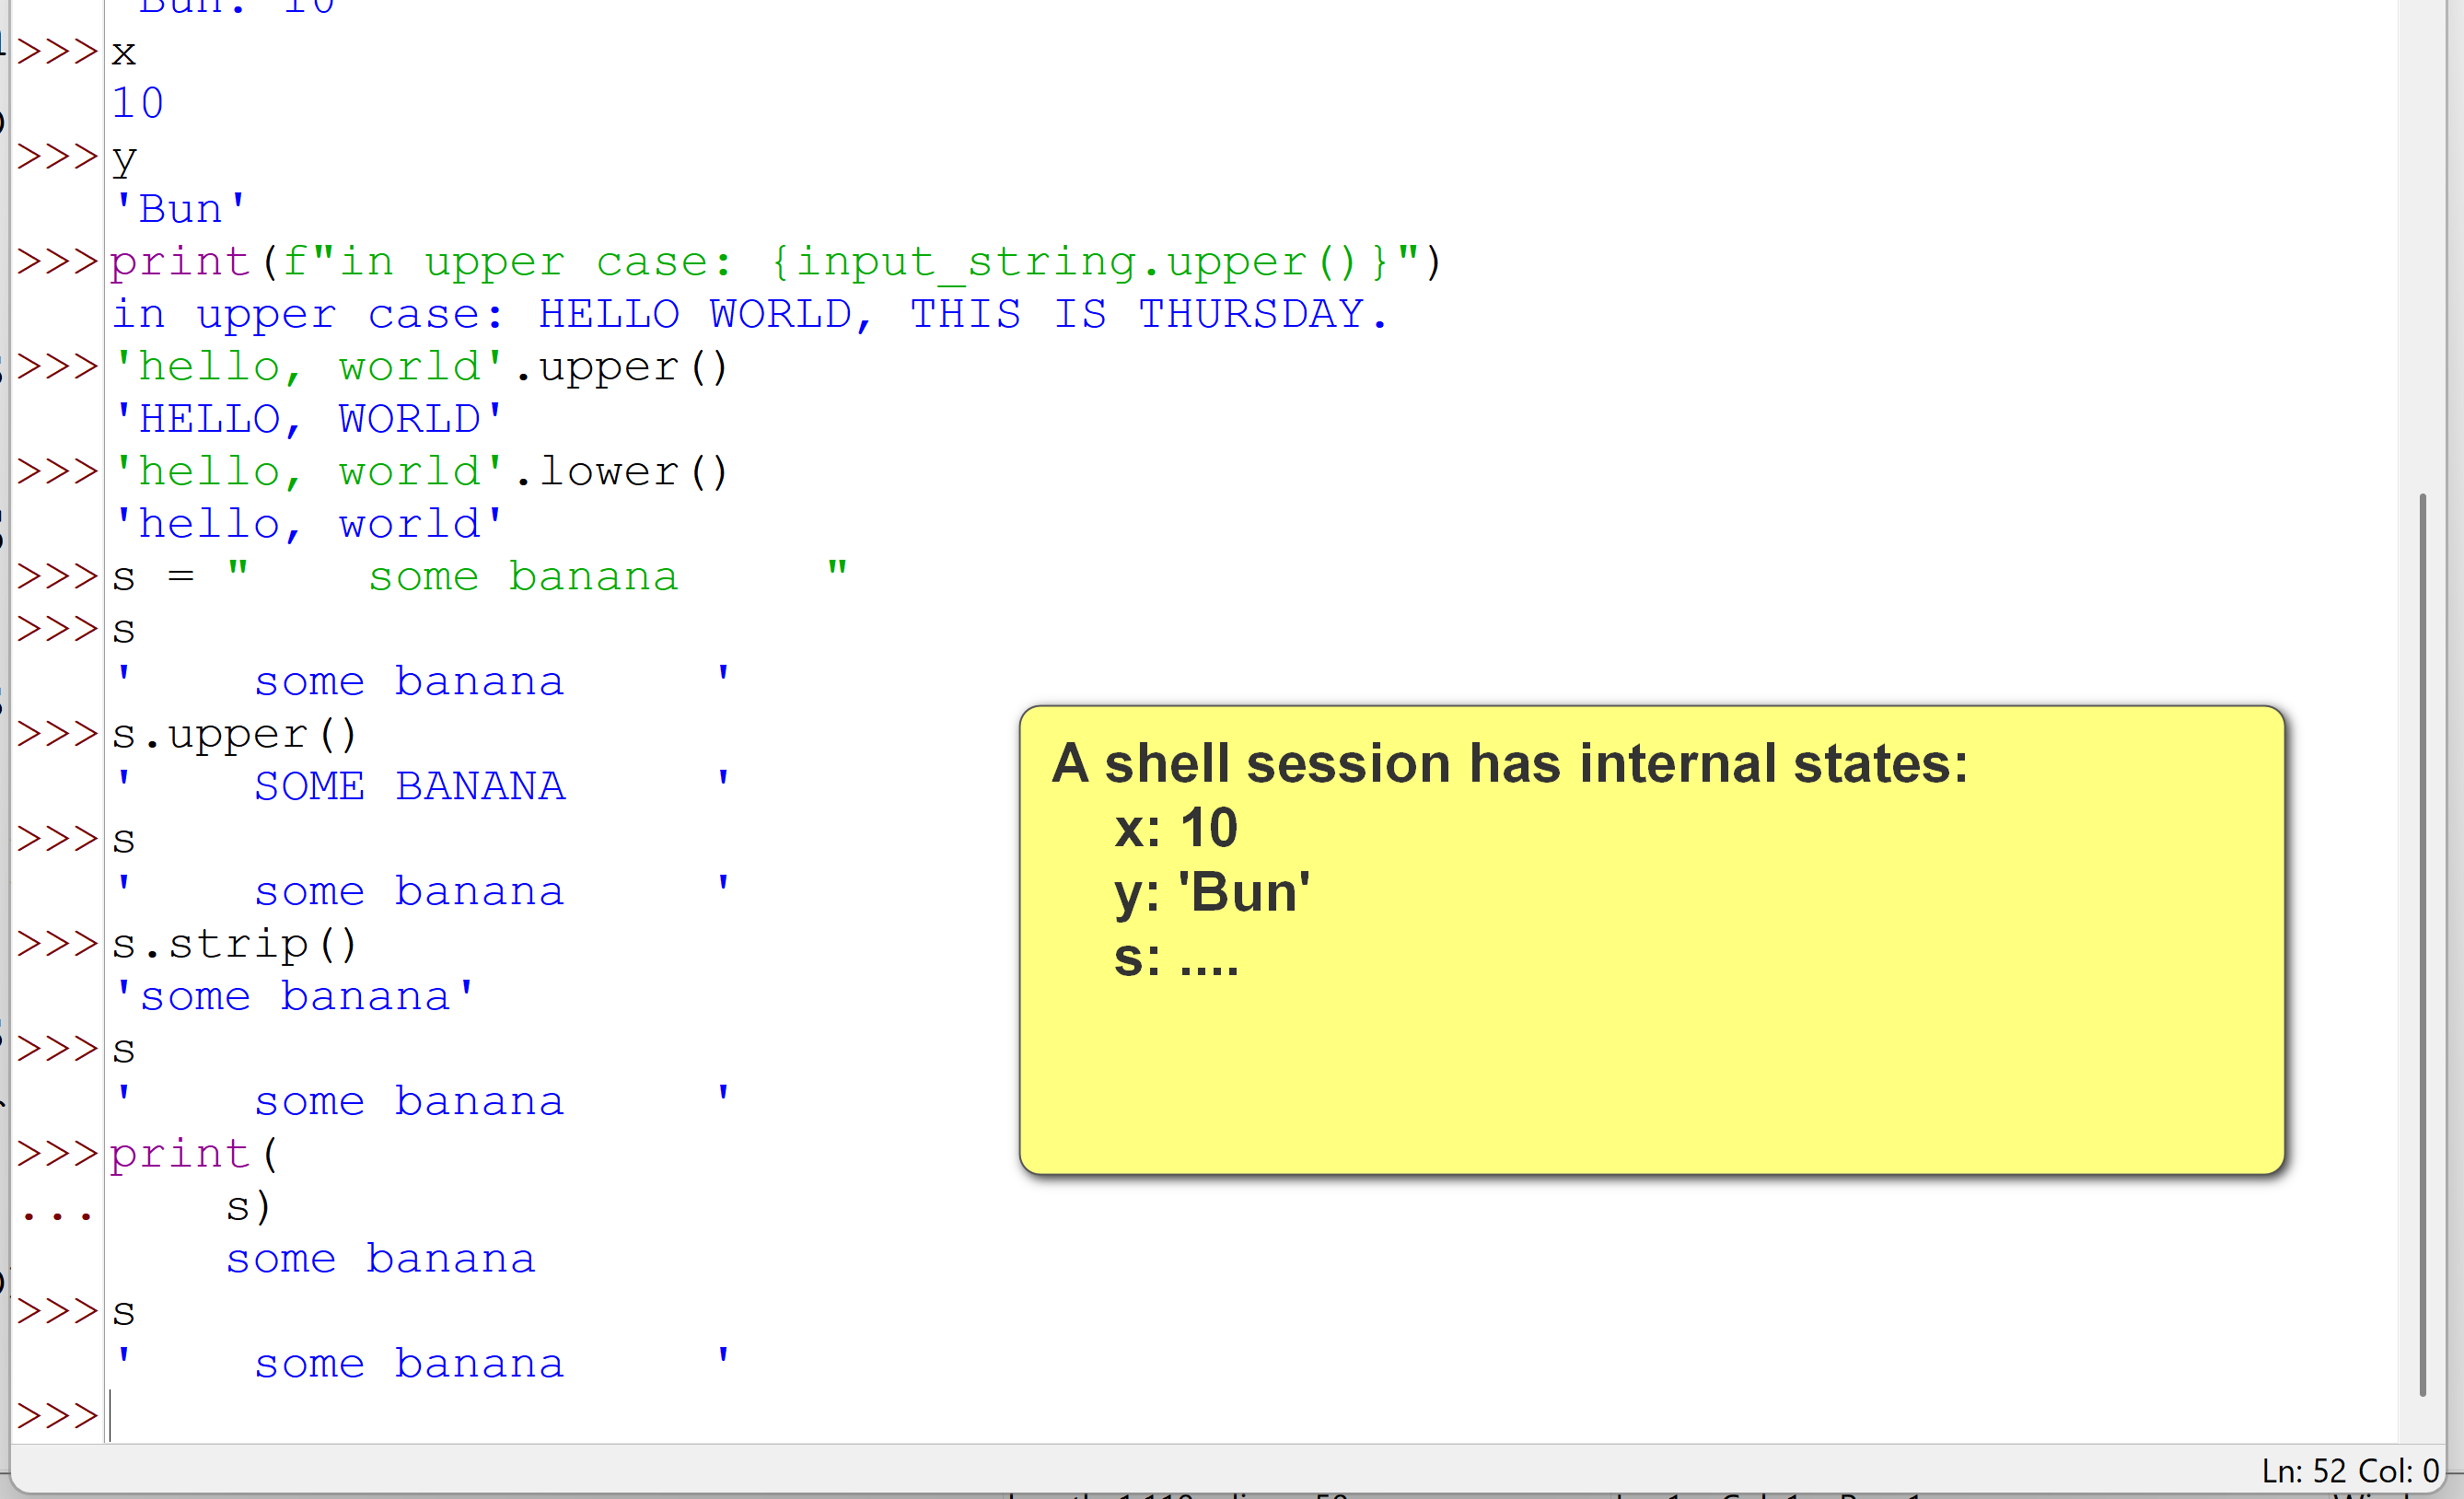
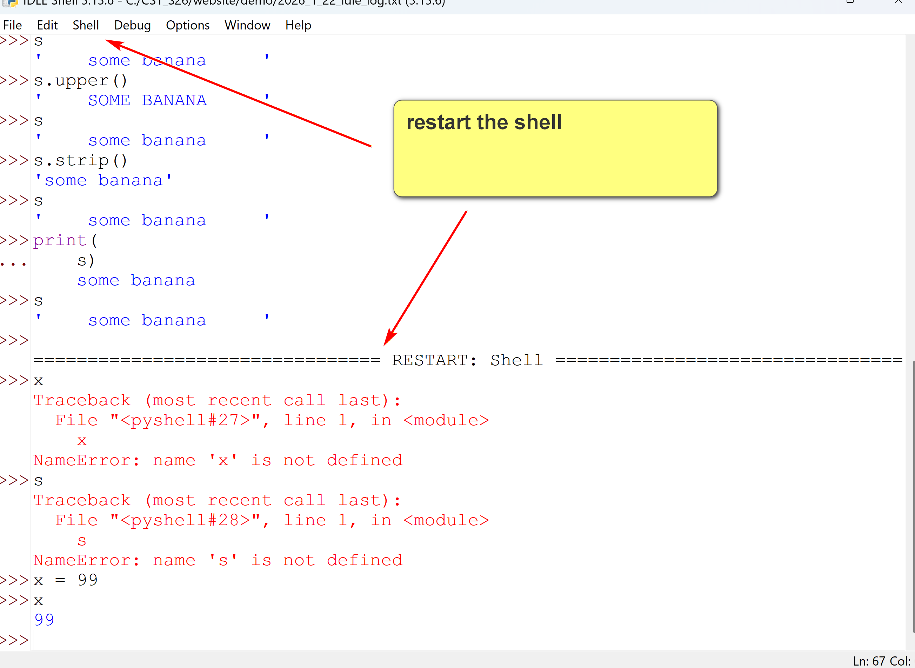
3. Python program file editing and execution
  - Shell includes a text editor.
  - One can open an existing Python program file, or create anew Python program file.
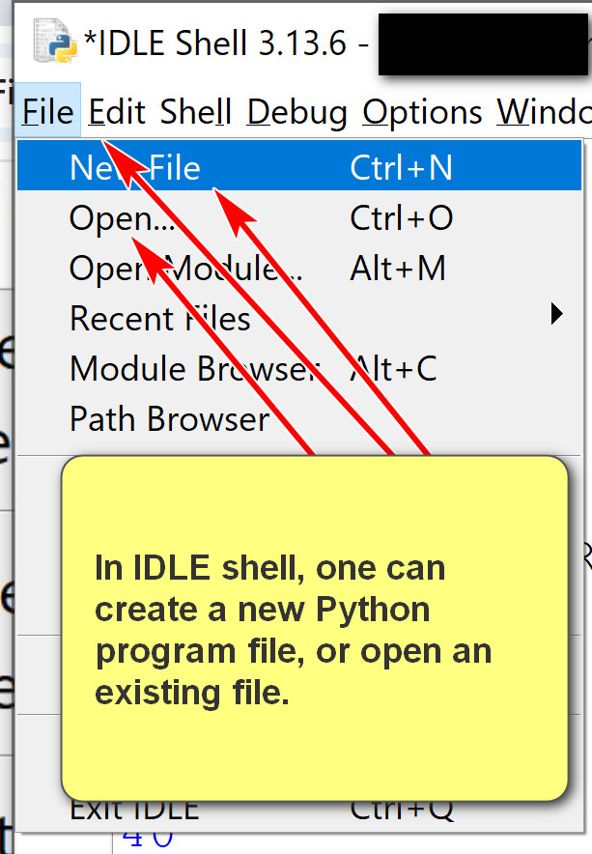
  - The file editor has many features.
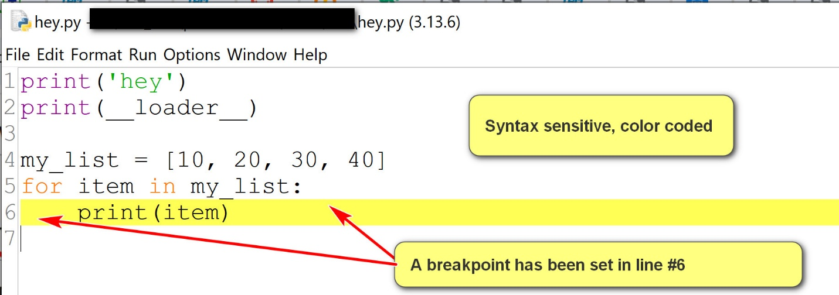
  - Some features you may use:
    - Use the options menu to show line number.
    - Set and clear breakpoints for debugging.
    - Run the program by using Run->Run Module.
4. Debugging in IDLE
  - A good tutorial in IDLE: https://www.cs.uky.edu/~keen/help/debug-tutorial/debug.html. Contain more than needed in the class.
  - To debug a Python program:
    - Open the Python program using IDLE Shell: File -> Open.
    - Turn on the Shell debugger: Go->Debugger
    - Run the program in the editor using Run->Run Module.
    - Use the debugger window.
  - Some basics:
    - Use the go button in the debugger window to execute.
    - Set and clear breakpoint in the editor.
    - Examine the locals window in the debugger.
When the debugger window is started, in the example below, the locals window shows values of local variables.
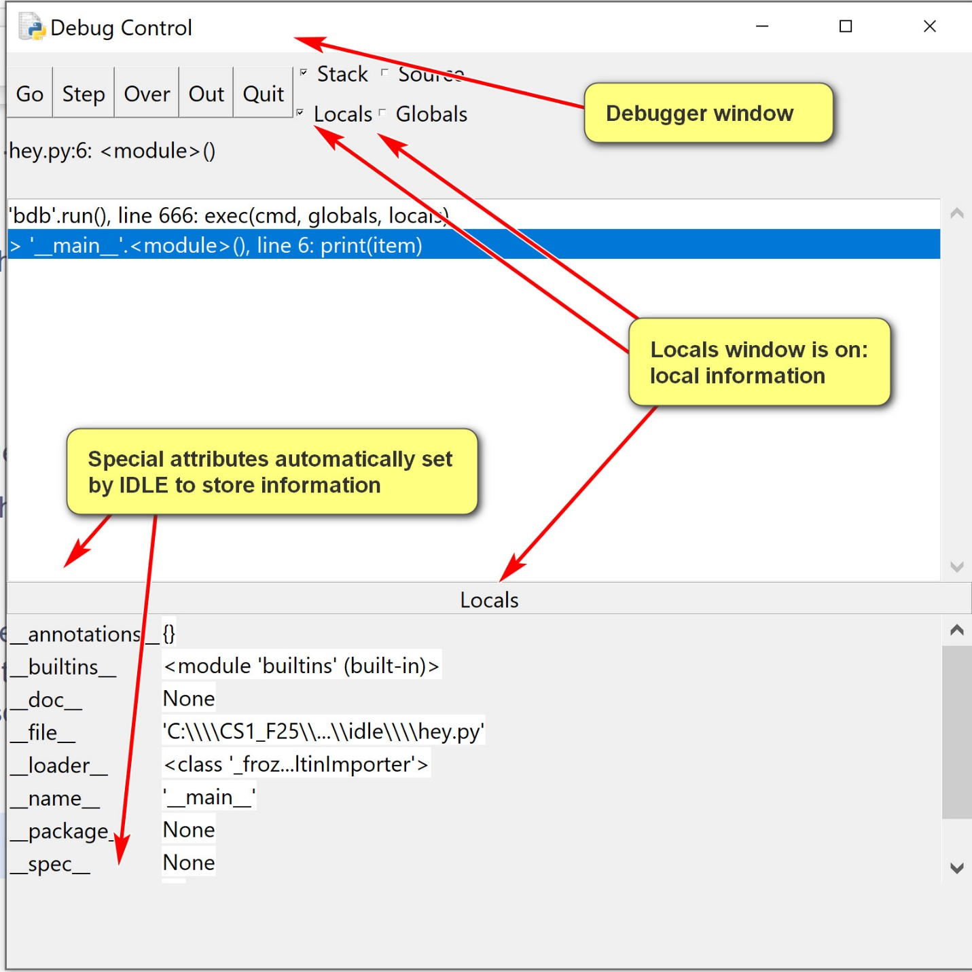
An example of using breakpoints:
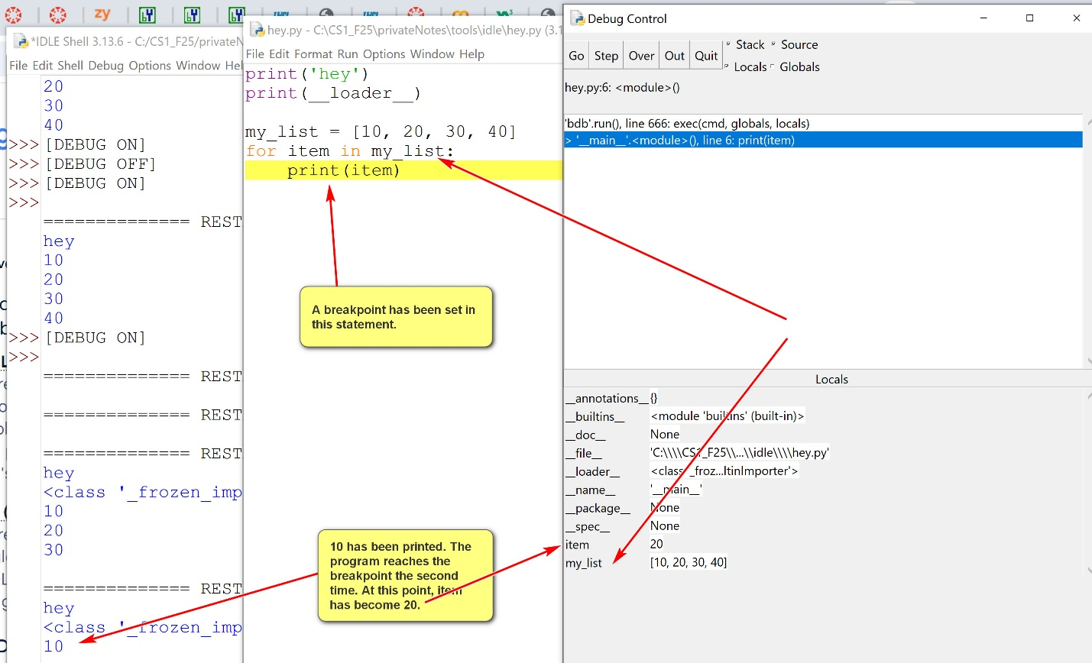
  - Useful debugger options:
    - step: one step at a time, including lower level function calls.
    - over: one step at a time, not including lower level function calls. Probably more useful than 'step'.
    - go: executes full theprogram.

