CSCI 1470 CS 1
2026_1_20 Self Annotation
Previous:
Running Pythons in Windows
by K. Yue
1. Organizing Windows for Python Development
- This is about a simple setup of Python development in Windows using text editors.
E.g. Windows notepad: edit text (such as ASCII formats)
“ASCII (/ˈæski/ ⓘ ASS-kee),^{[3]: 6} an acronym for American Standard Code for Information Interchange, is a character encoding standard for representing a particular set of 95 (English language focused) printable and 33 control characters – a total of 128 code points.”
- It does not include the uses of Integrated Development Environment (IDE), such as PyCharm, VS Code, etc.
- It does not include the uses of Python platforms (such as for Web development, Graphical User Interface (GUI) applications of data science).
Screen capture software: Windows snipping tool, faststone,
Install notepad++: free text editor
Crtl-A: select all
Crtl-C: copy
Crtl-V: paste
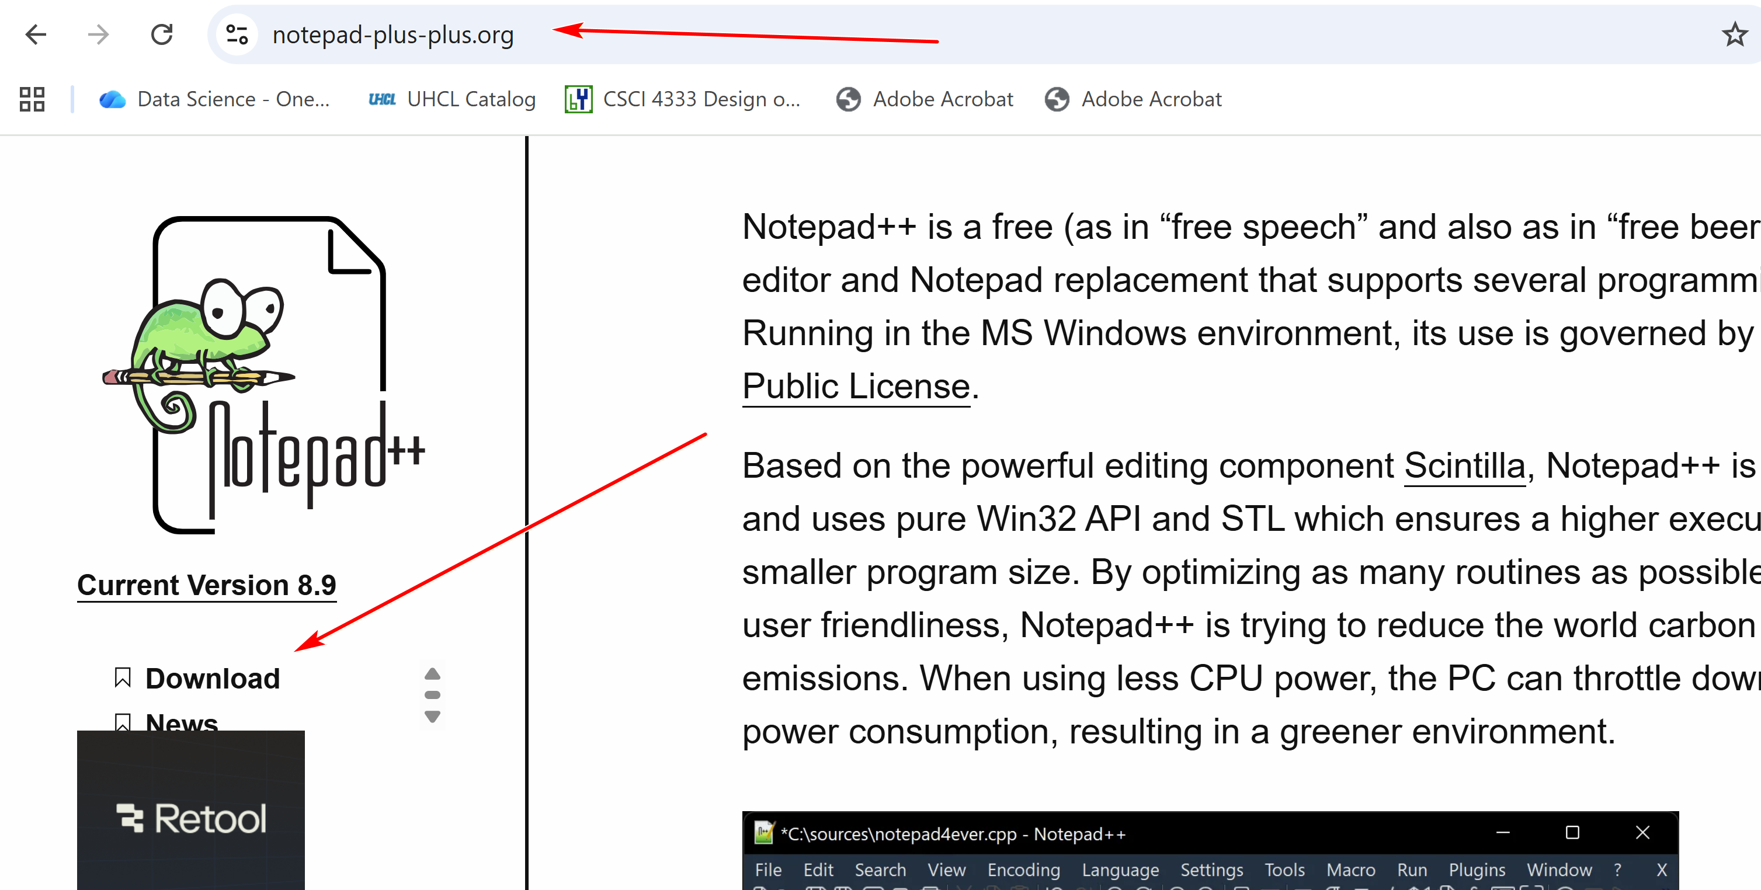

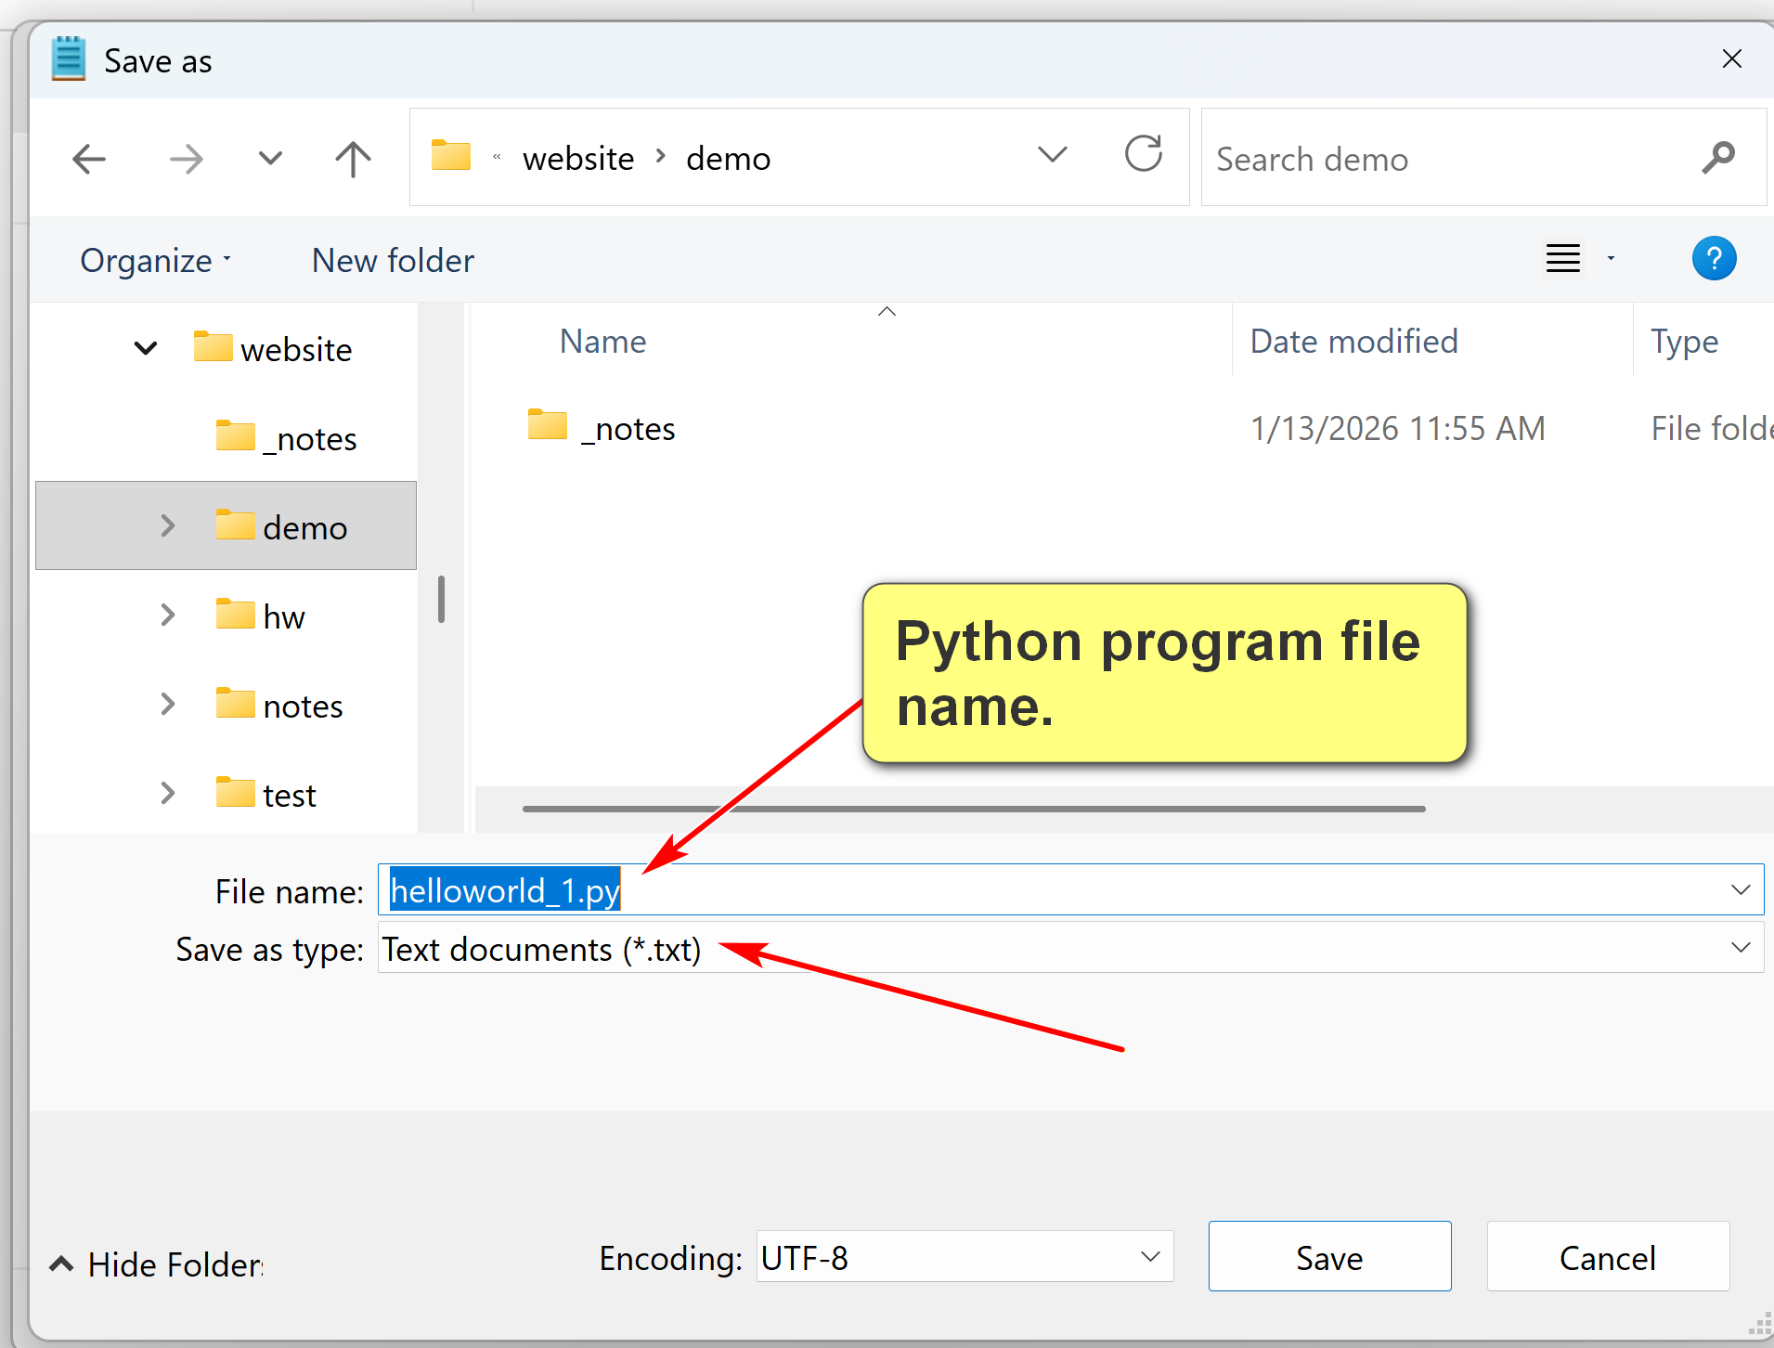
NotePad++ has many advanced texting editing features: e.g. line number, language sensitive syntax display,…
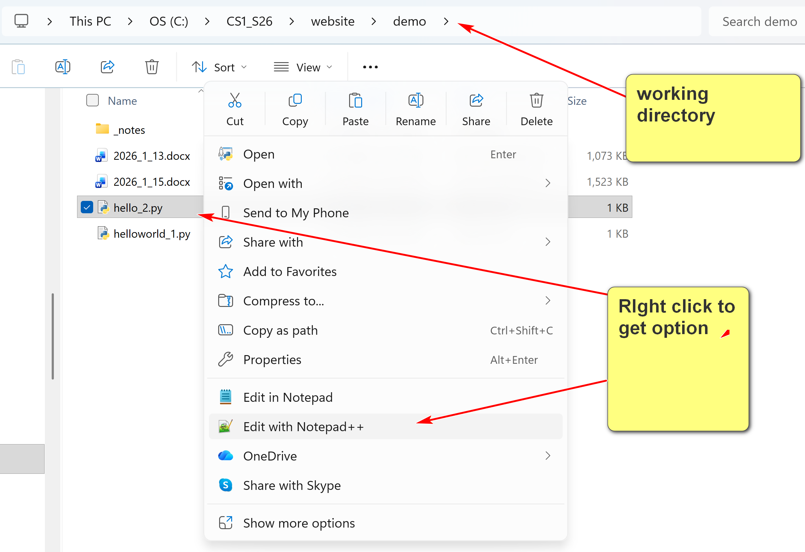

Command Prompt/Terminal
- The Command Prompt in Windows is a Command Line Interface (CLI) for executing commands to interact with the operating systems.
- In Mac and Linux, it is known as a command terminal or terminal.
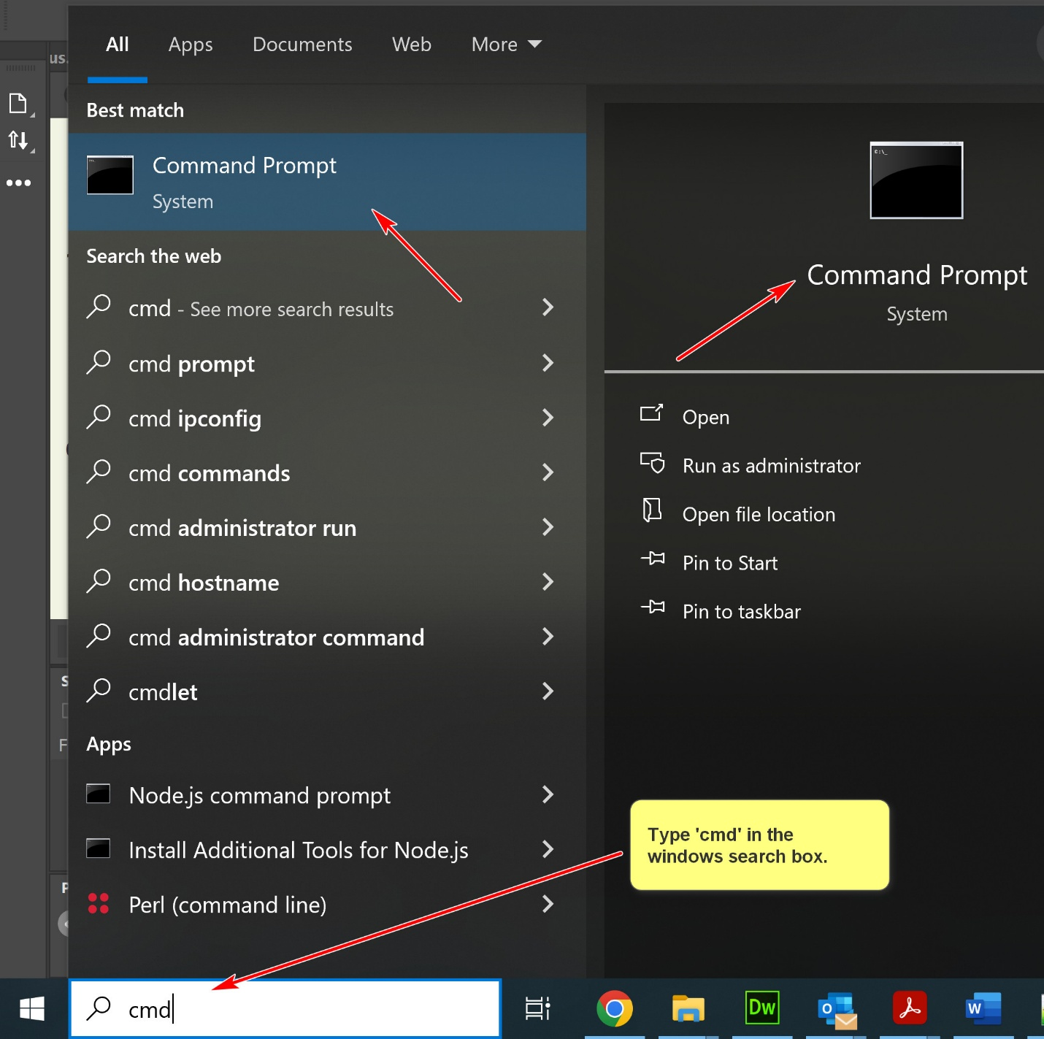
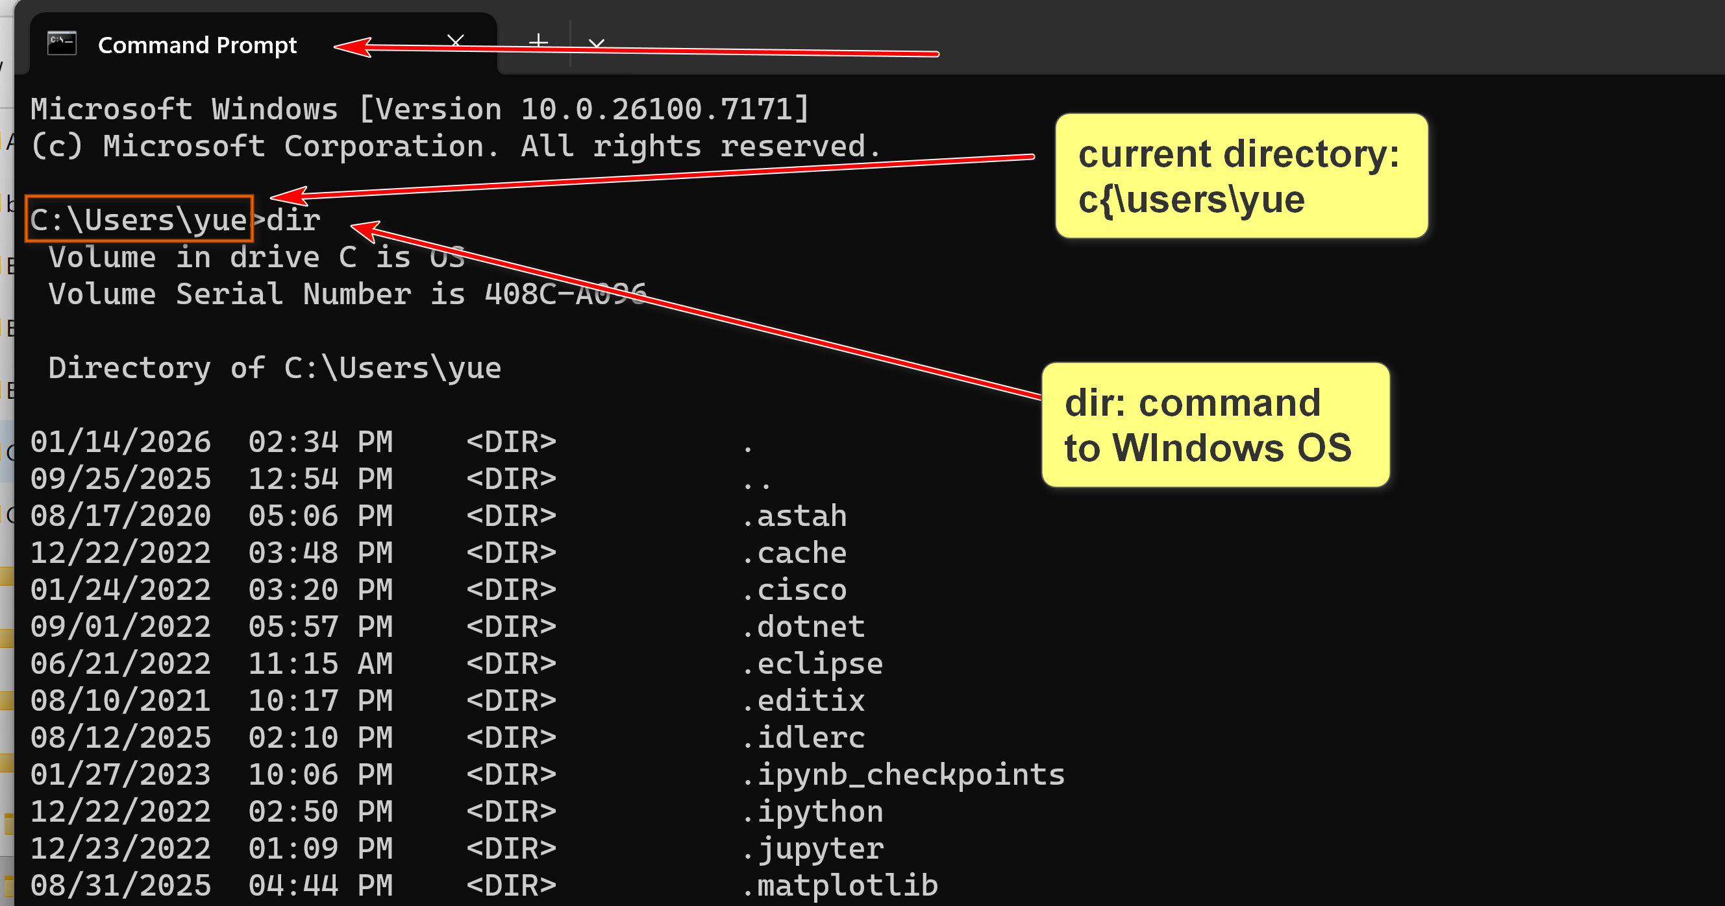
OS commands are relative to the current directory.
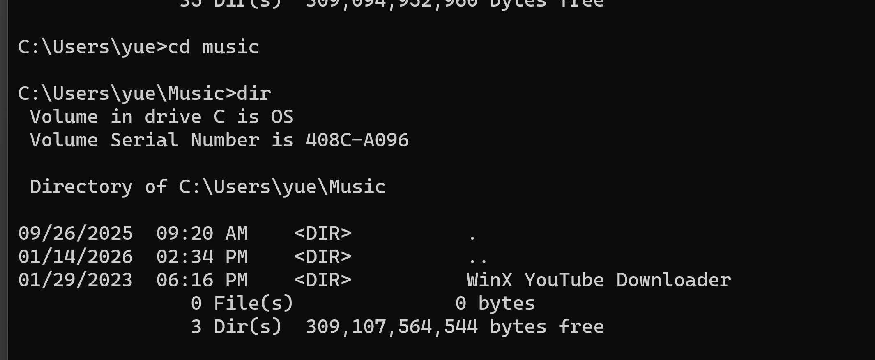
Project Directory
- It is beneficial to create a directory for a project.
- For example, for this course, you may create a folder: Documents\uhcl\csci1470, and put all files related to CSCI 1470 there.
- You may create additional sub-folders for better organization.
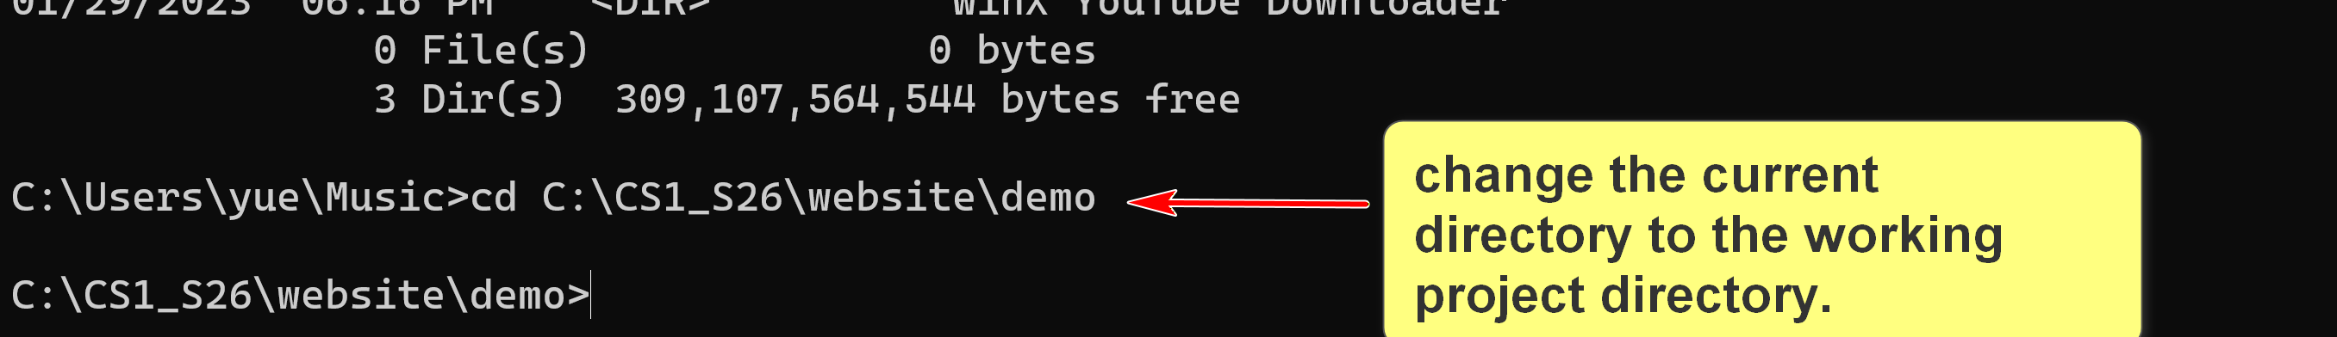

Upper and lower arrow key may be used to traverse the command history.
Working Directory
- A working directory, ore current working directory (CWD), is the specific location within a computer's file system where commands are executed, such as in the command prompt.
- It is common practice to set the working directory to the appropriate folder of your project directory. For example, you may then use relative file names.
2. Running Python in Windows
2.1 Python Interpreter
- To start the Python interpreter, open a command line prompt in your working directory and execute, for example:
set path=C:\Python311;%path%
python
- You may need to replace "C:\Python311" with the actual location of your python installation.
- You may set the environmental variable PATH in your OS. If so, you will not need to execute the set path command.
To run h3.py from Fall 2025:
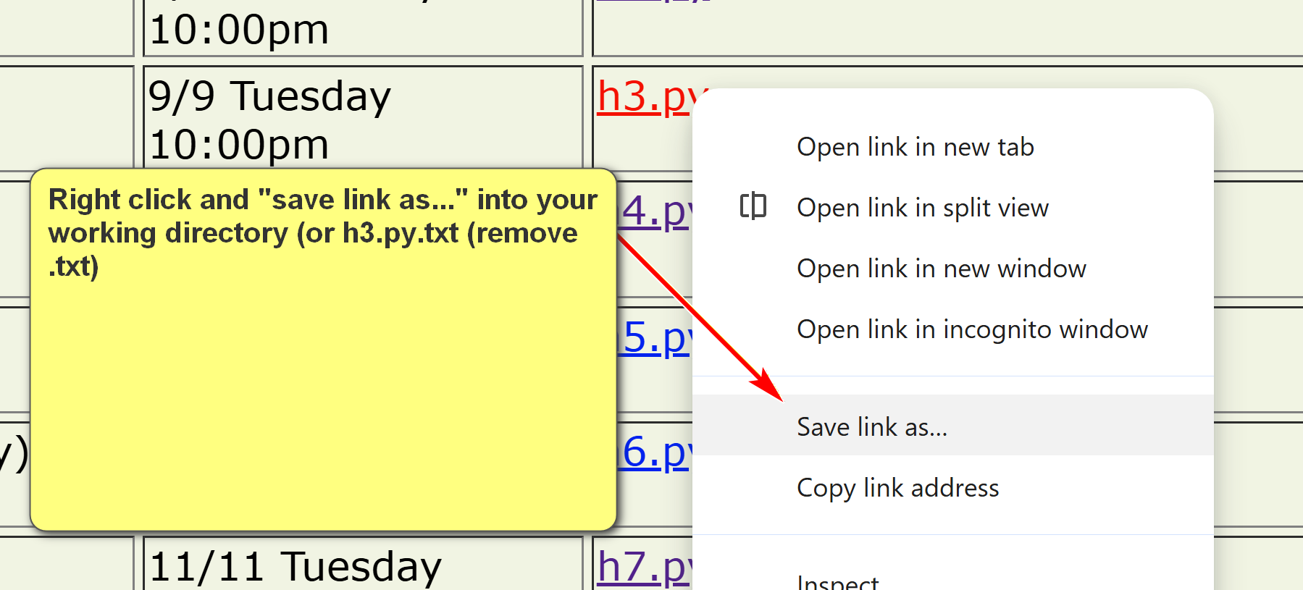
2.2 Python IDLE
- Integrated Development and Learning Environment (IDLE) is a bundled Python environment for simple development and learning.
- It is a very simple Integrated Development Environment (IDE).
- Industrial strength IDE: Visual Studio Code, PyCharm,
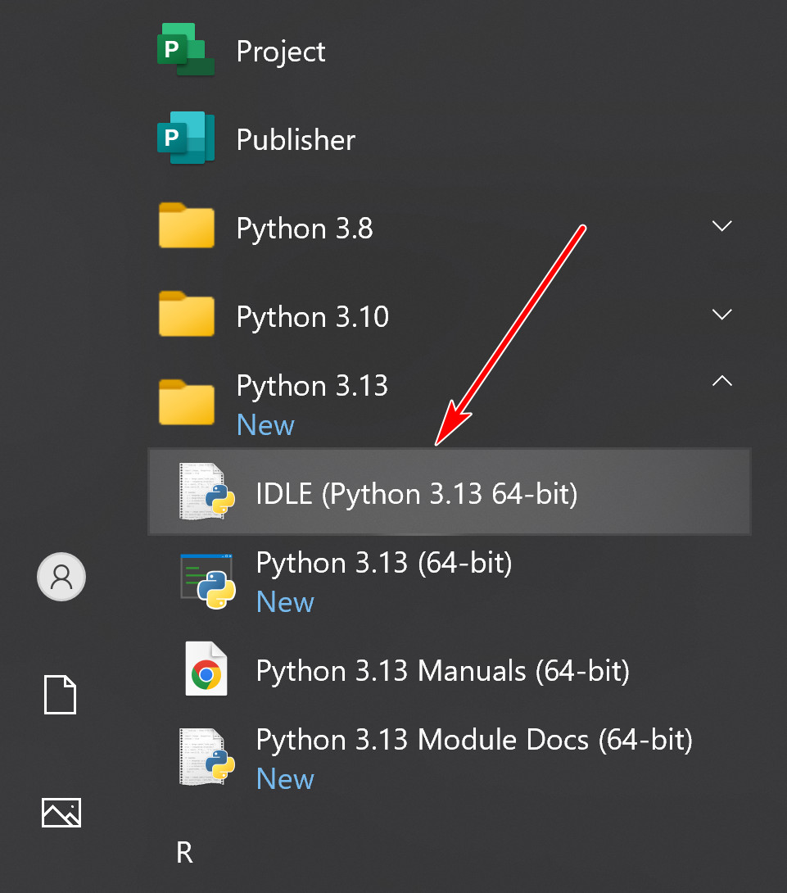
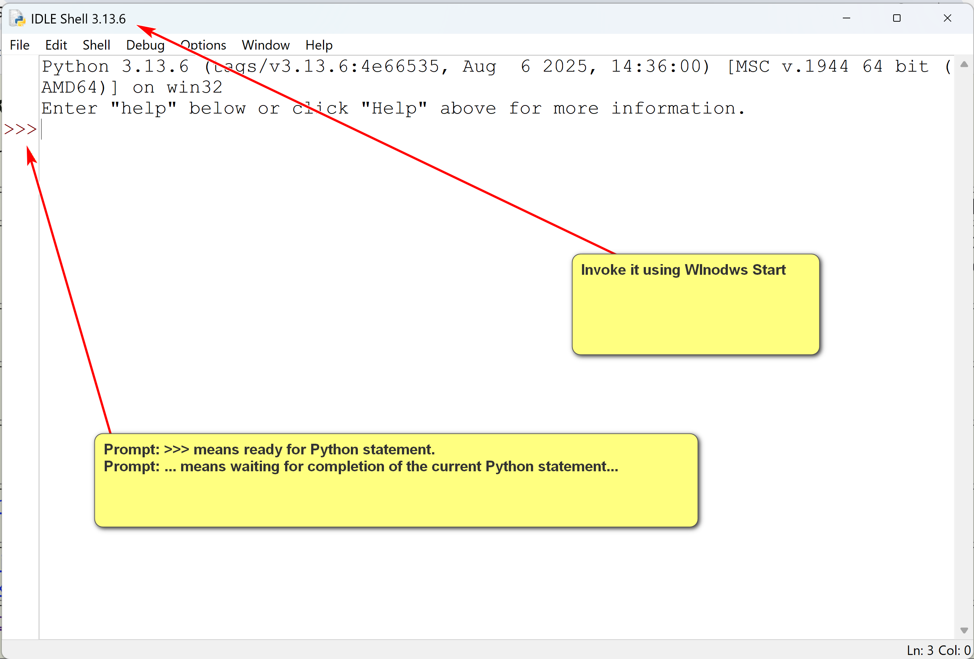
Sqrt(2)
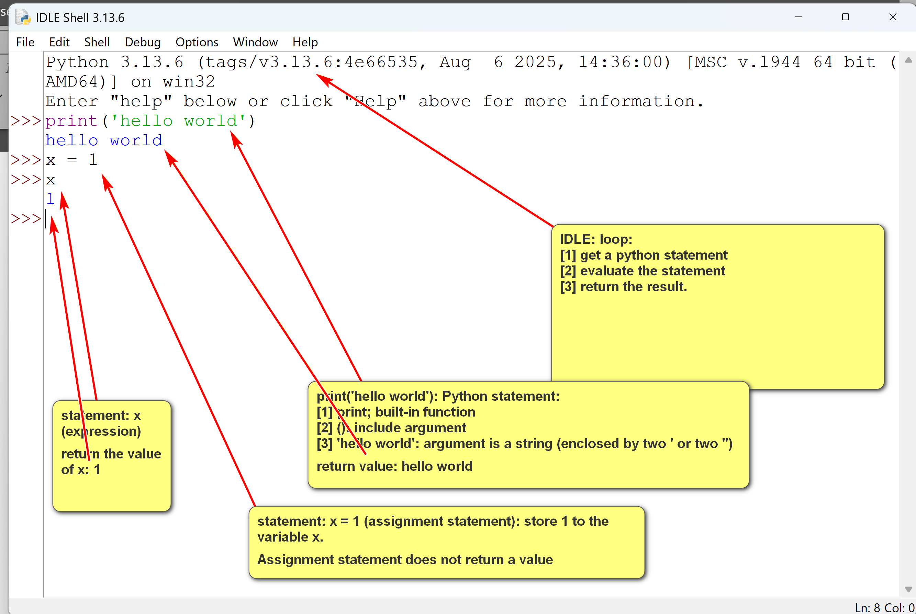

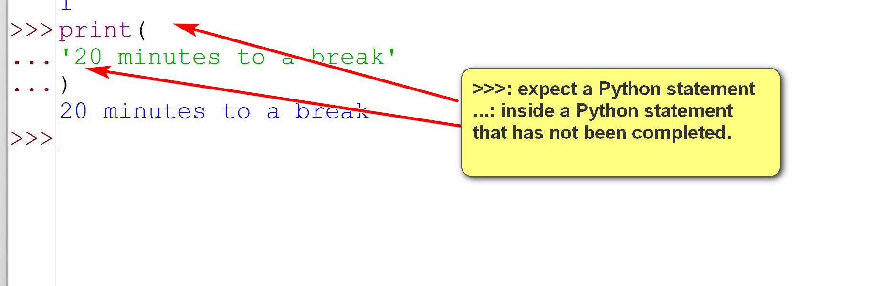
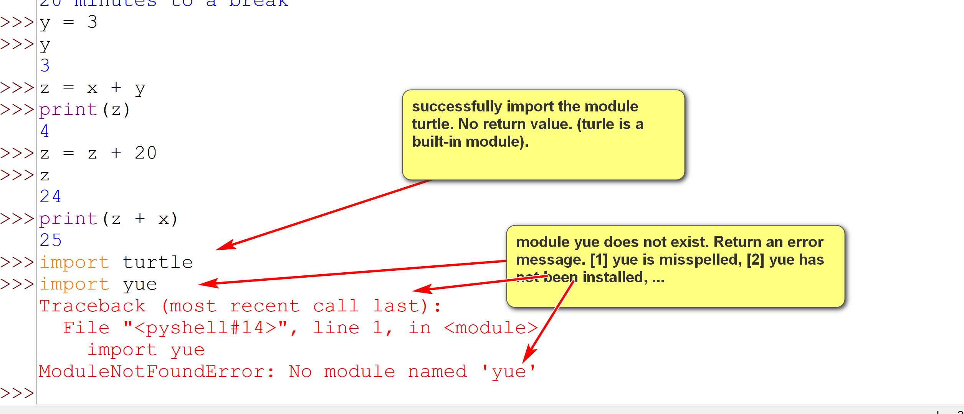
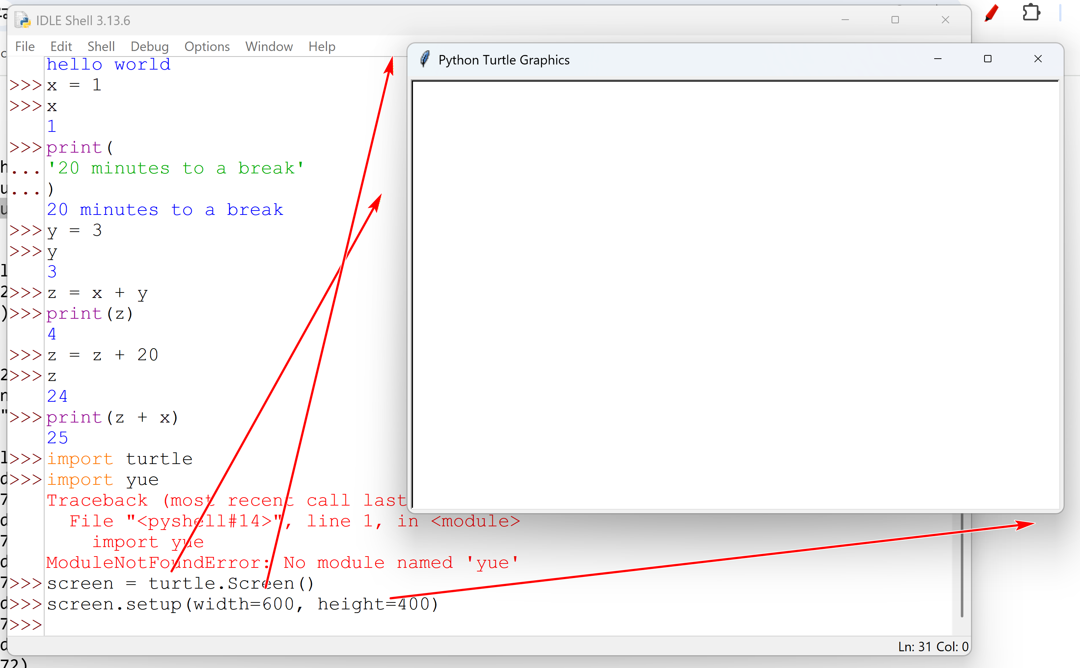
Running Python Program
- To run a Python program, helloworld.py, in a command line prompt (in the project directory), use:
python helloworld.py
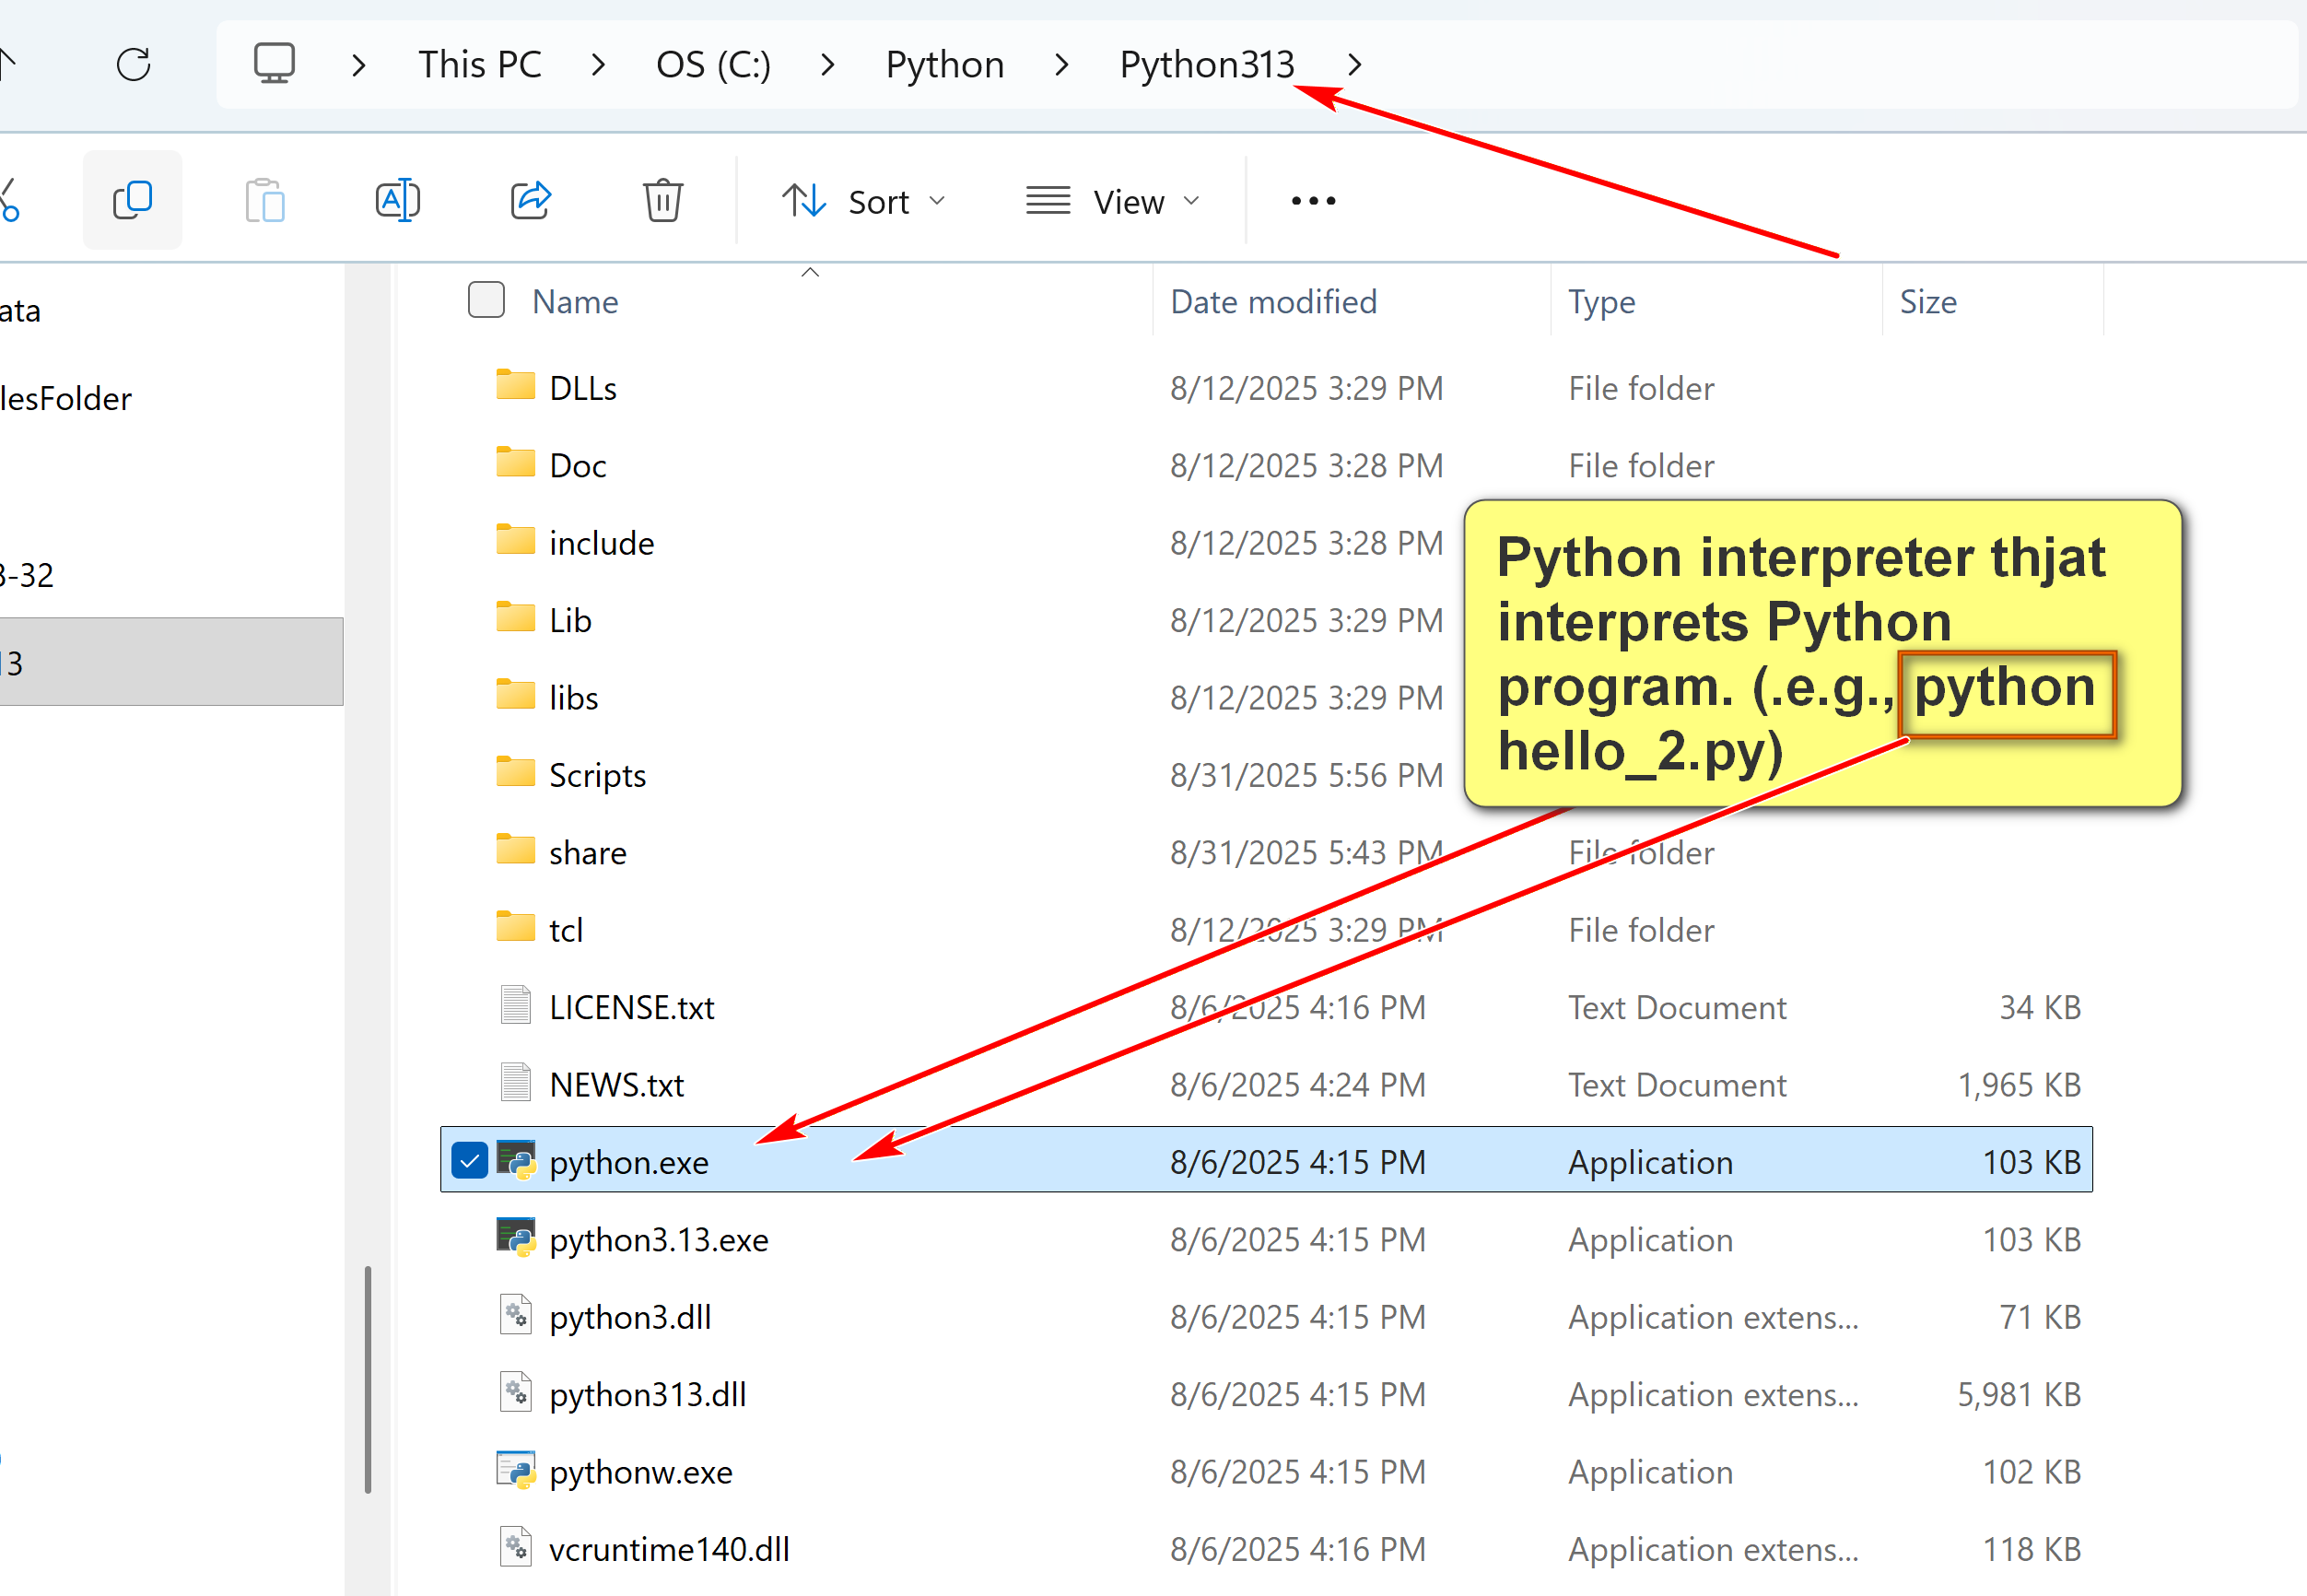

Installing Python in Windows
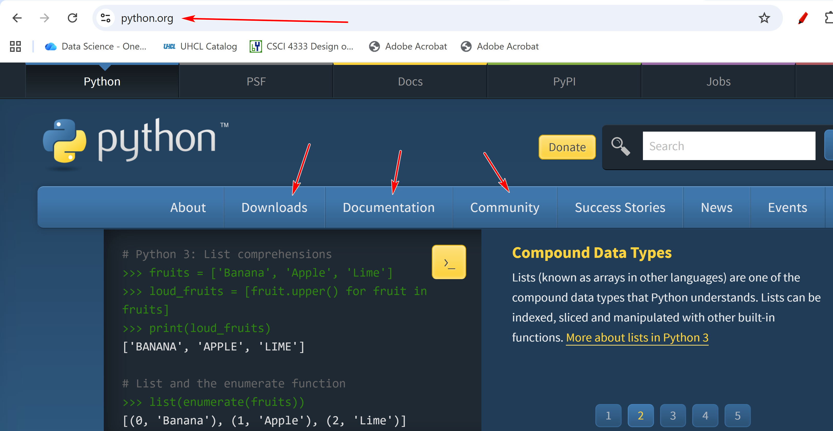
Install latest stable version.
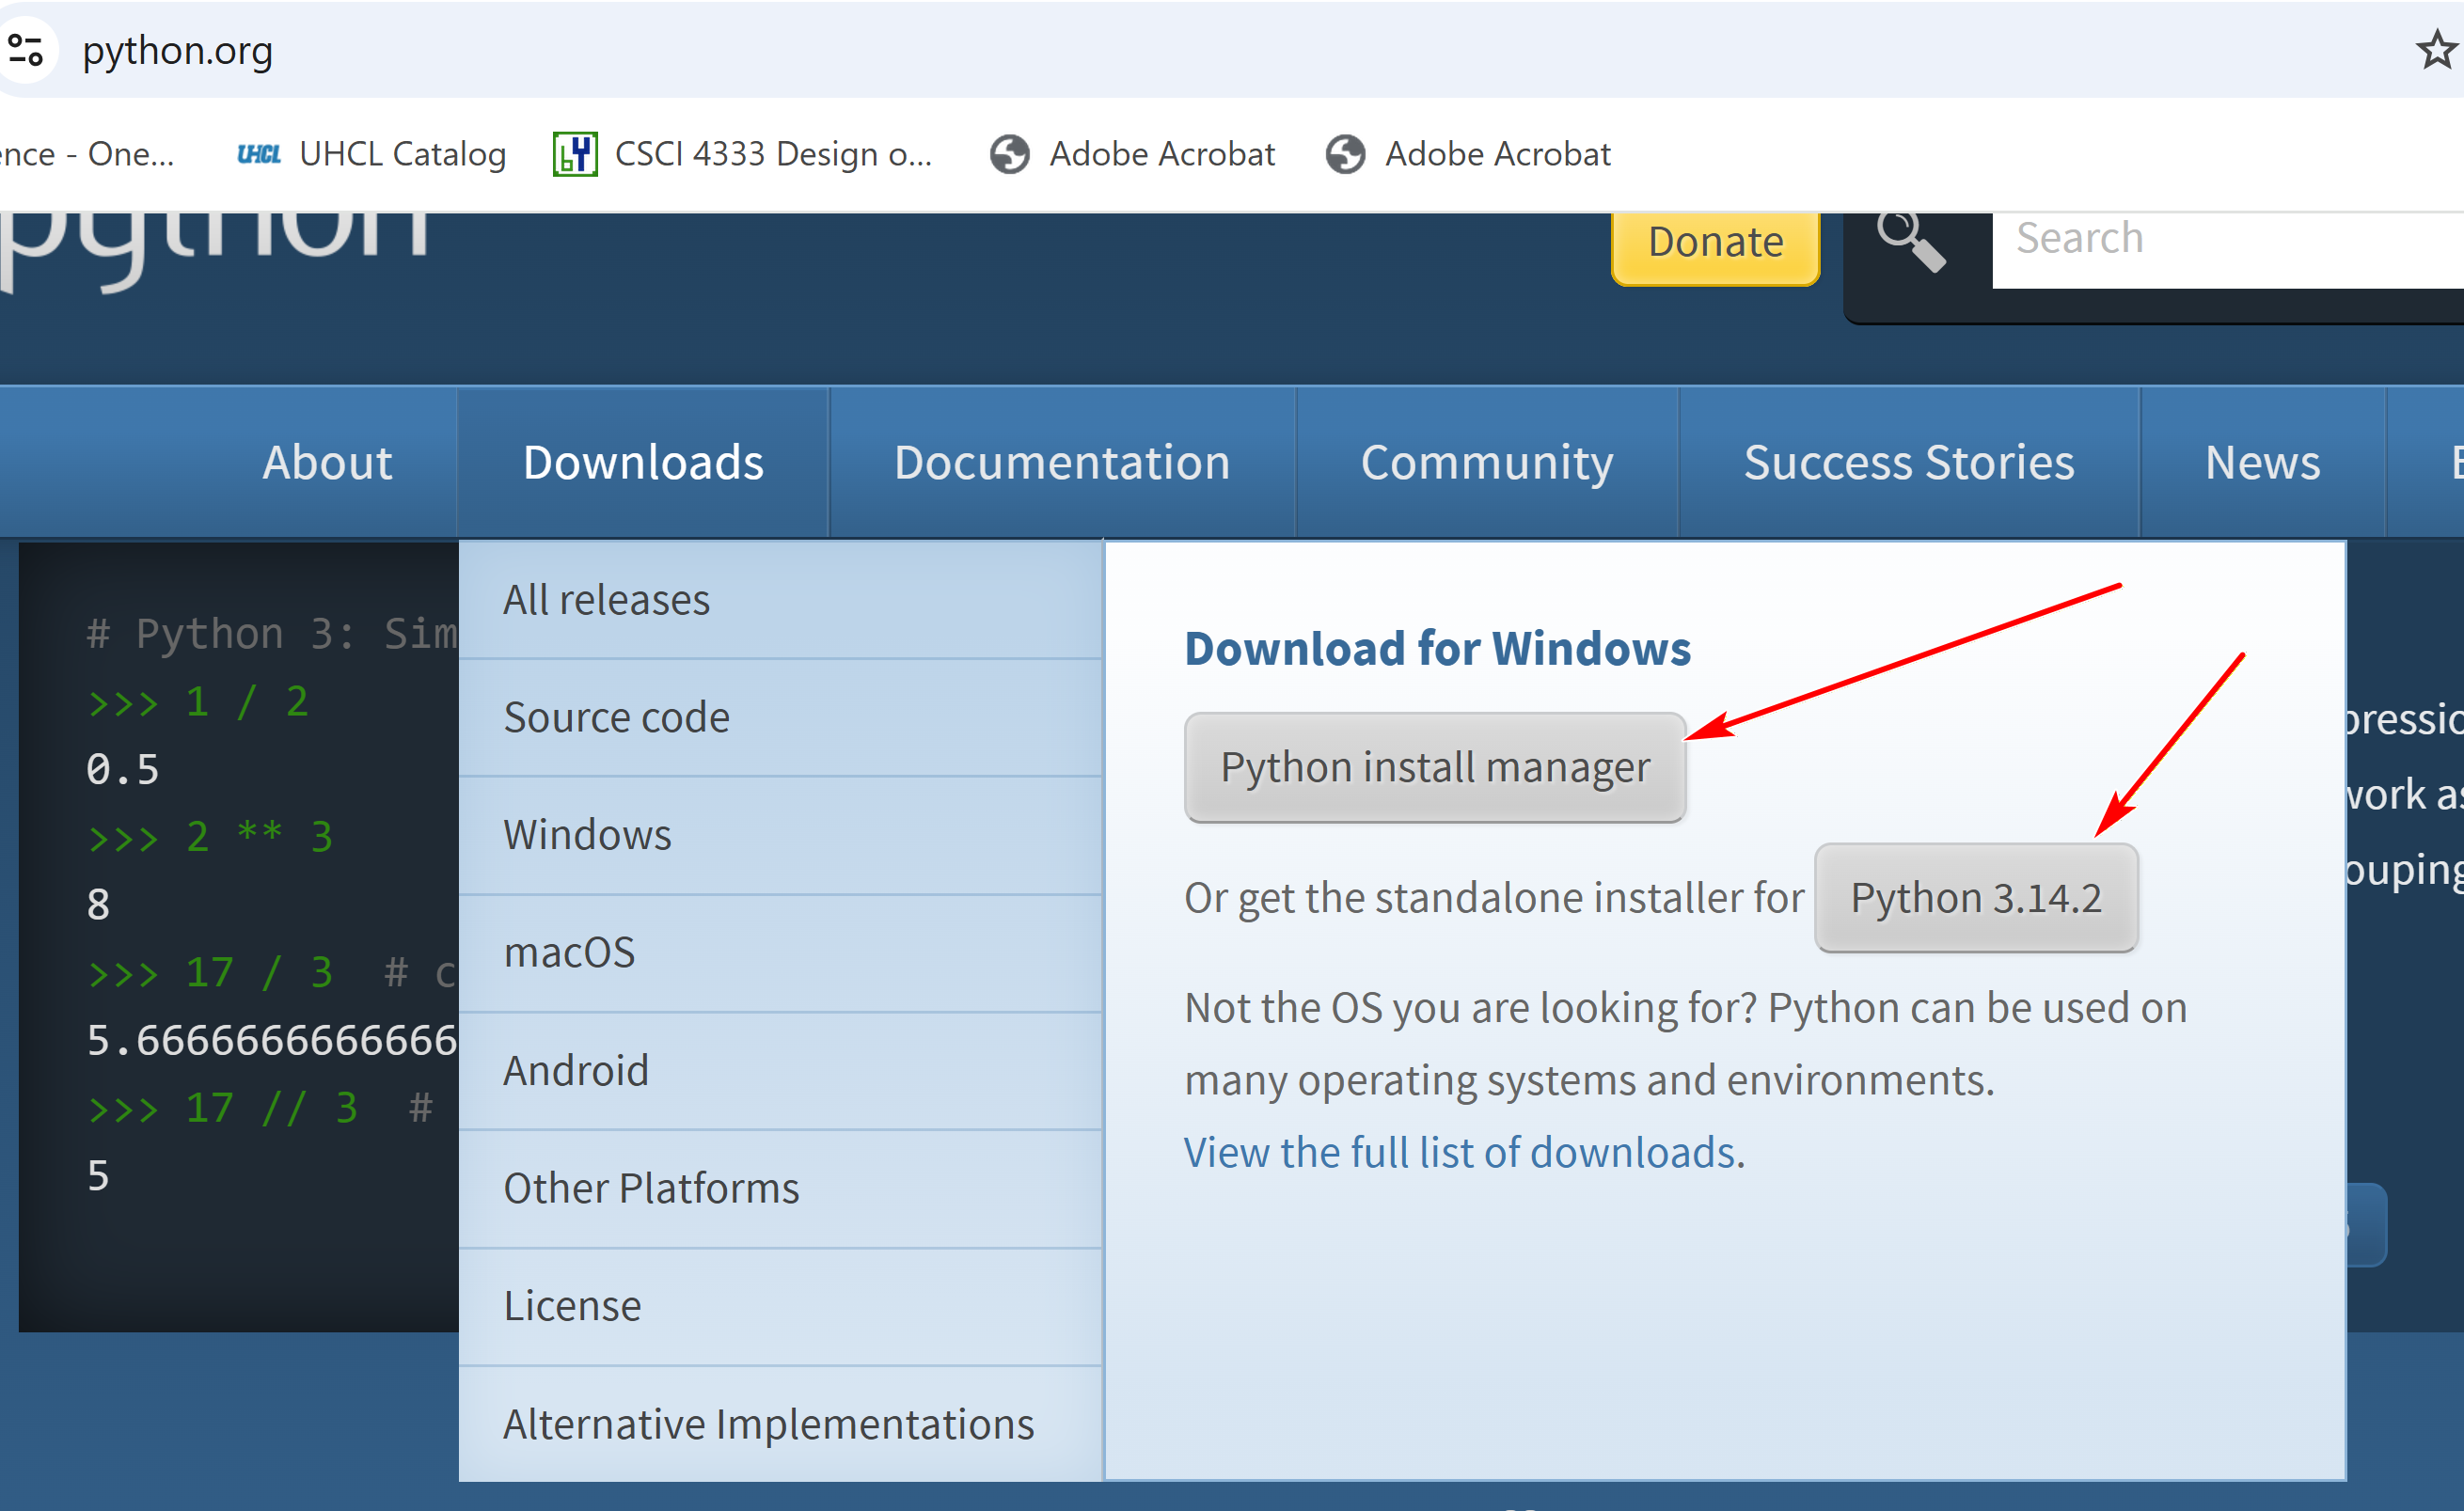
Do this option:
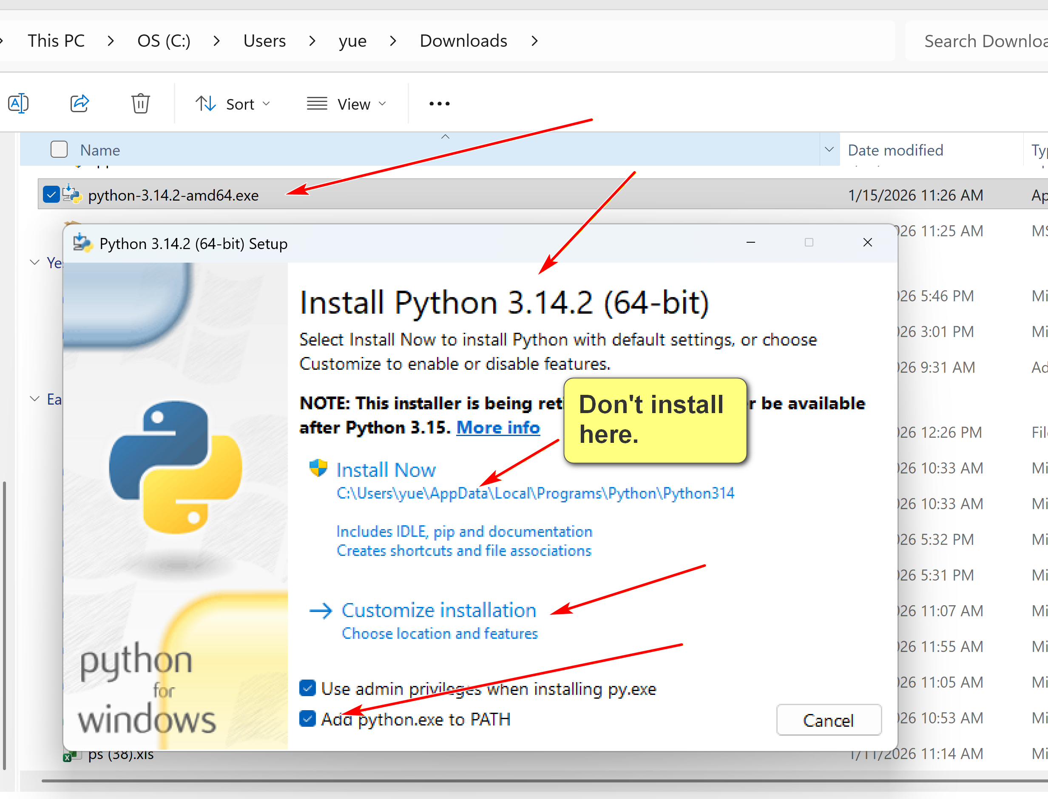

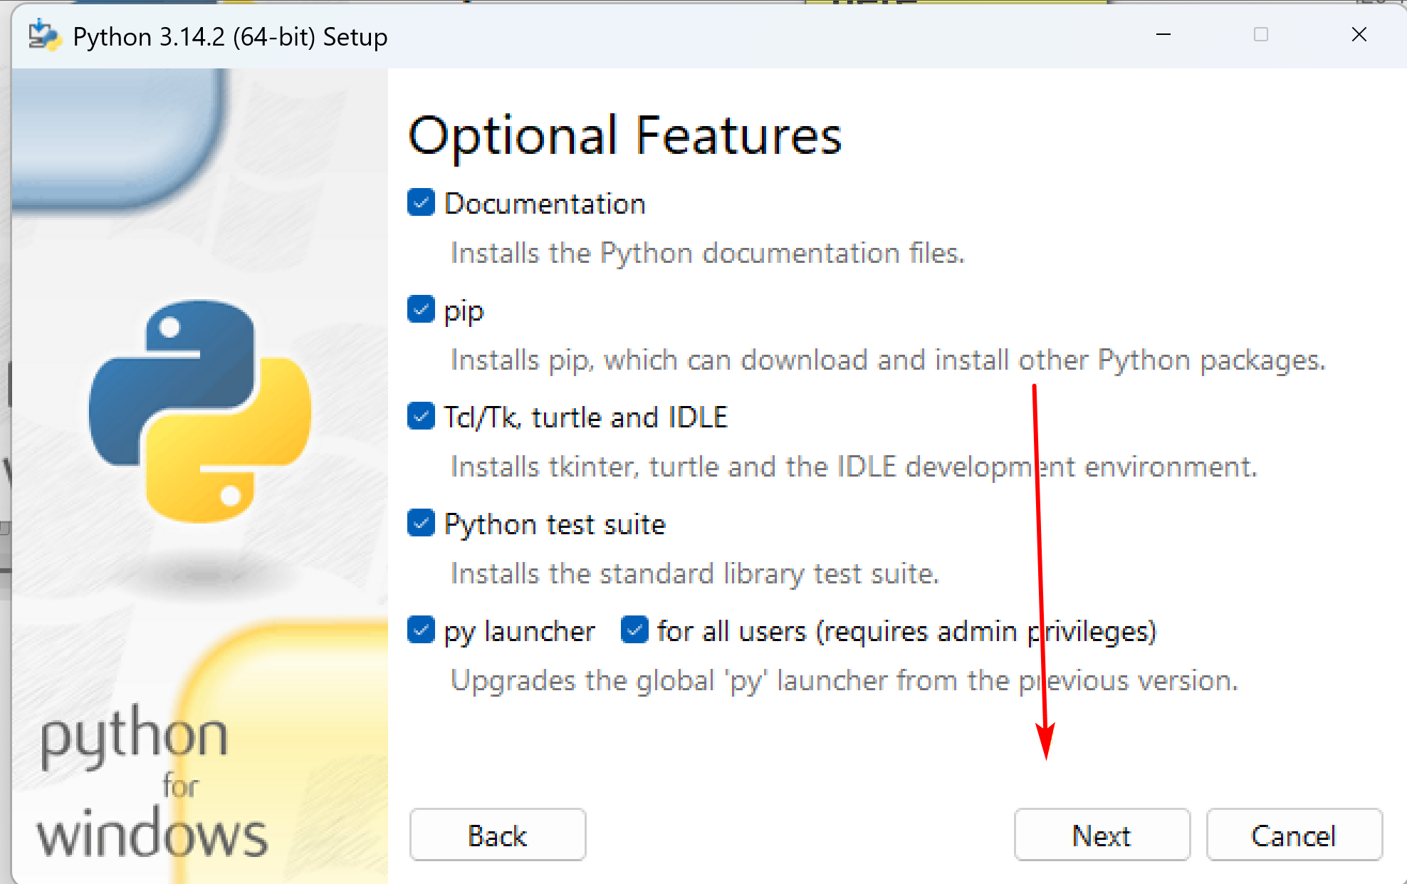
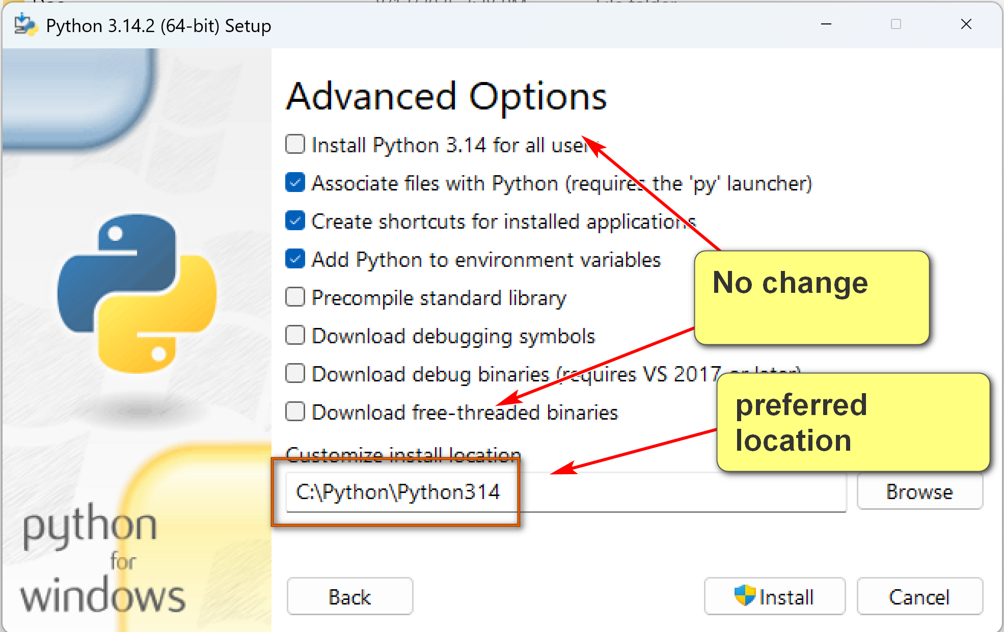

Environment Variables:
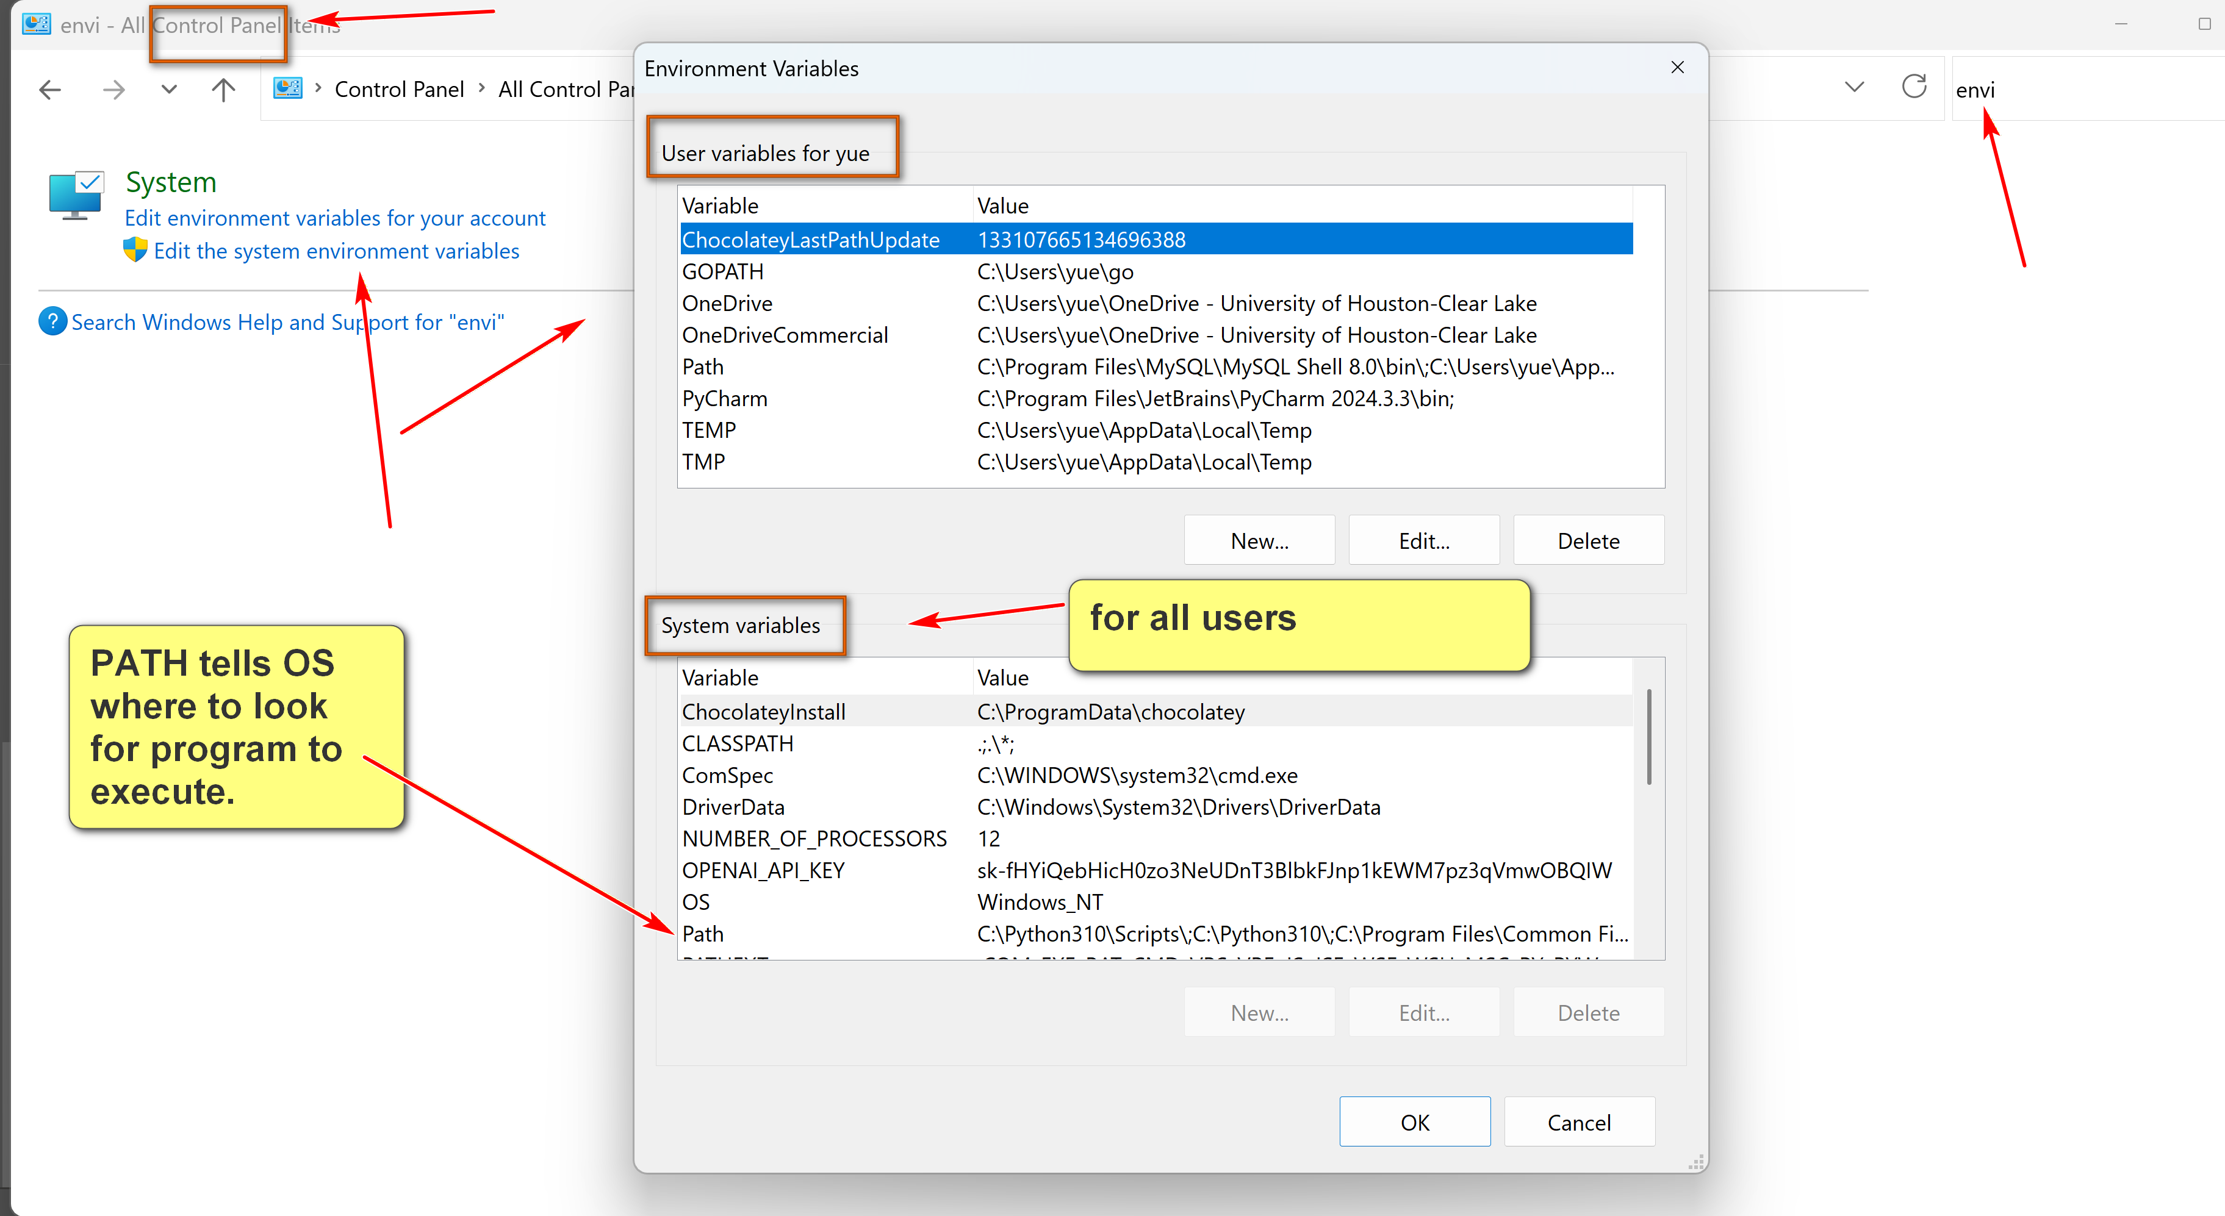
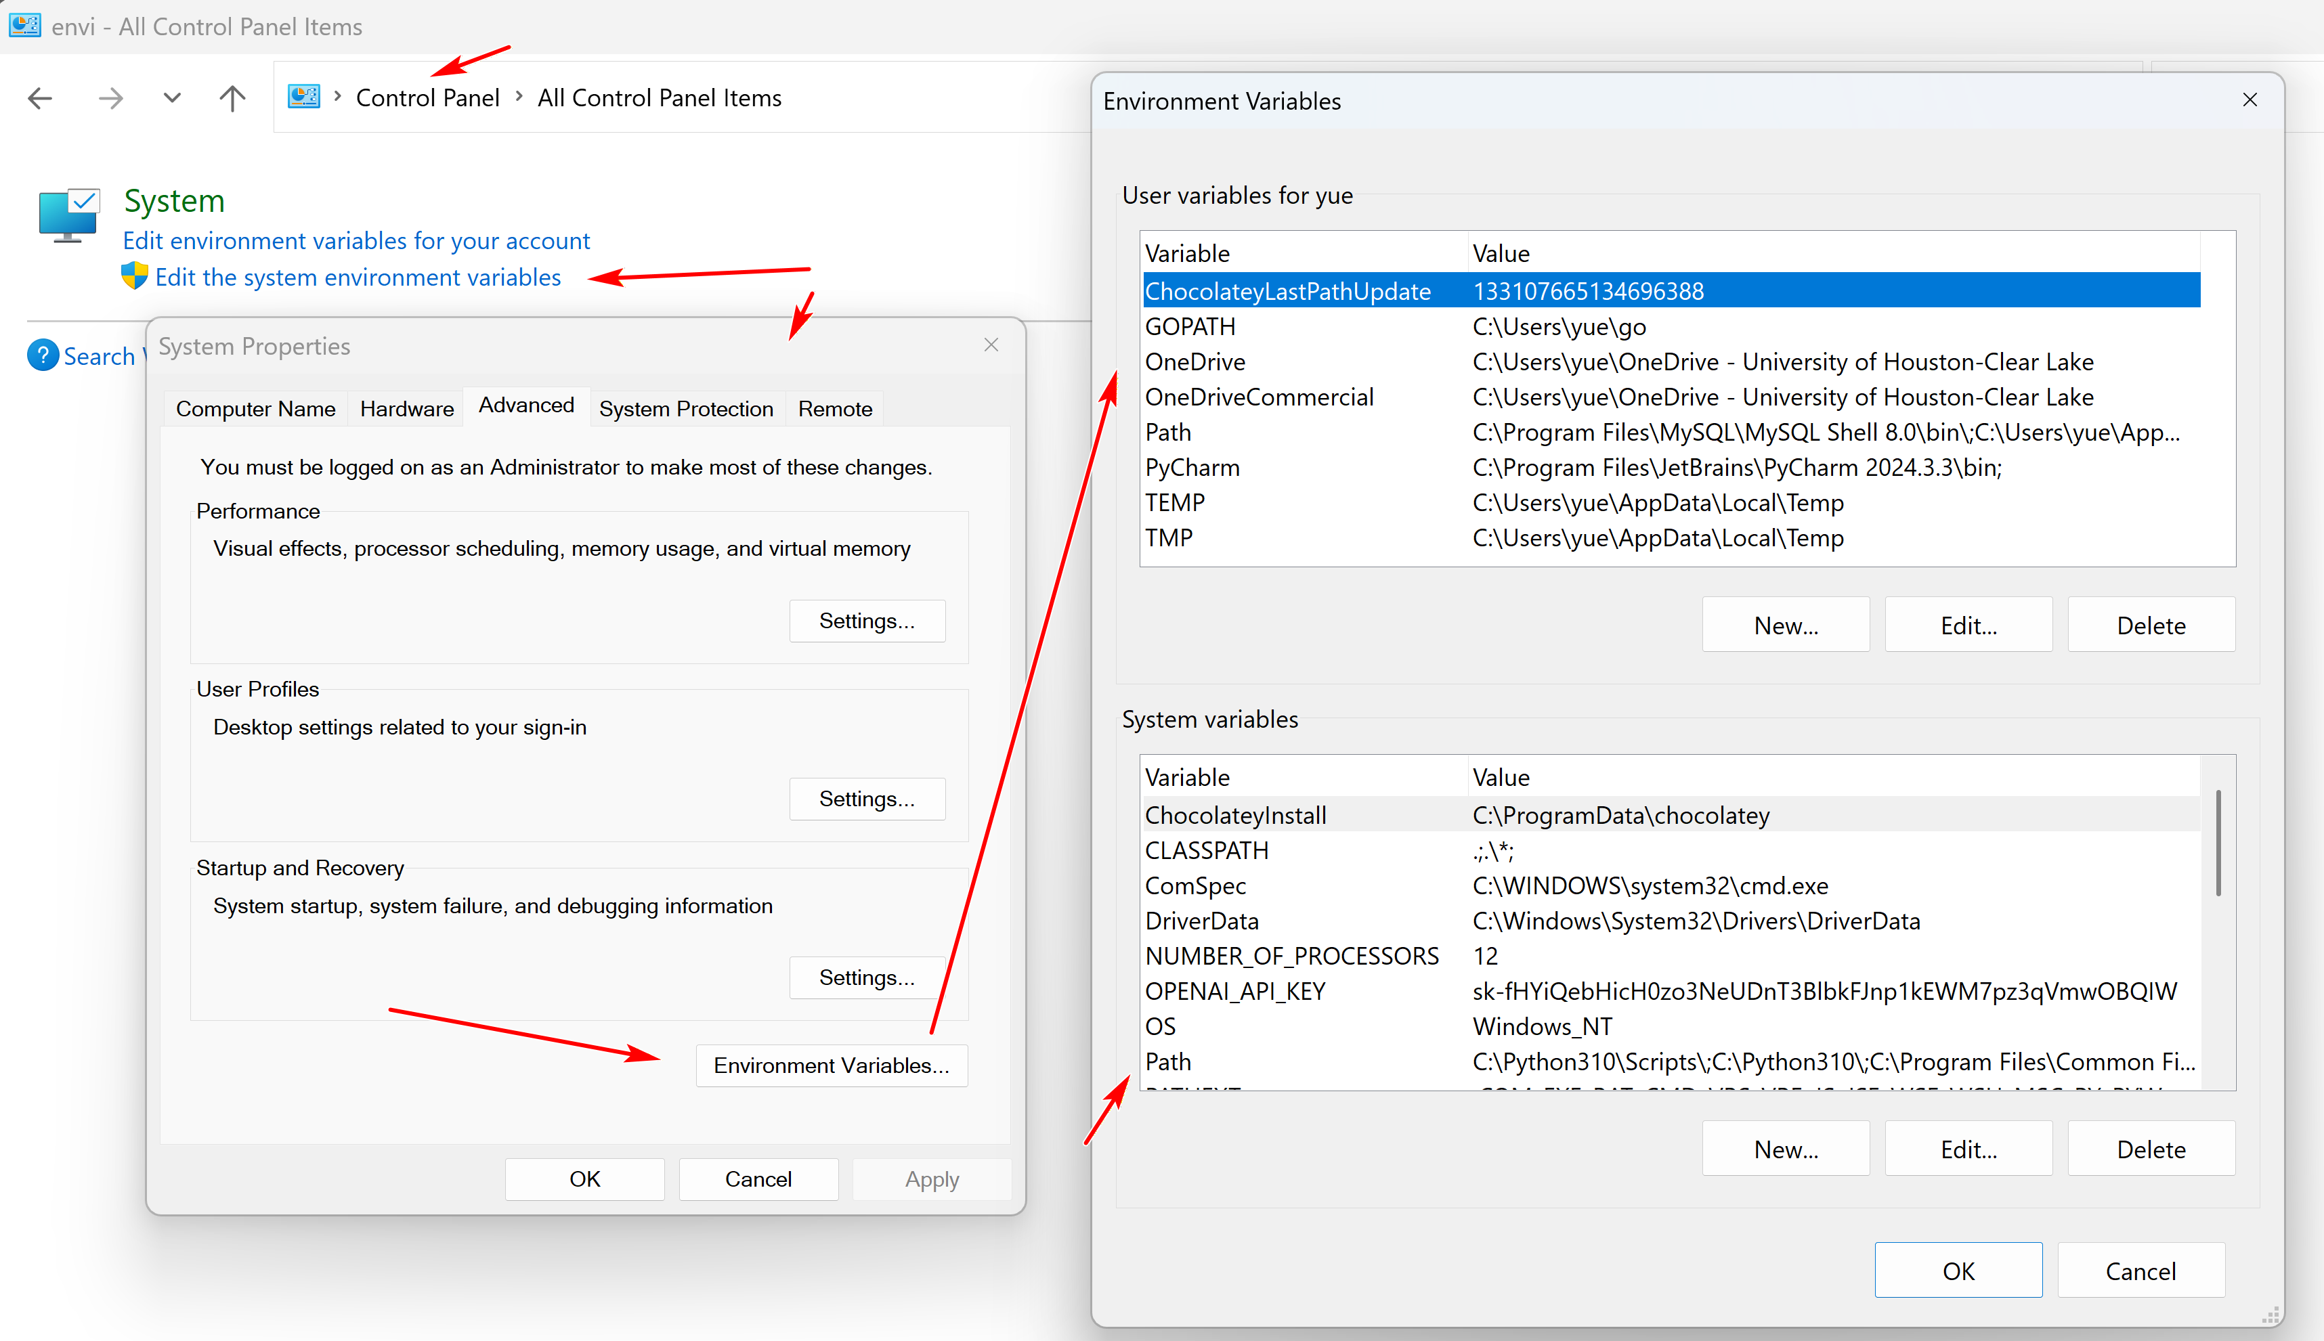

Python Resources
by K. Yue
1. Python's Manual
- Version 3.13: (navigate to your version).
  - Manual: http://docs.python.org/3.13/reference/index.html
  - Python Interpreter tutorial: https://docs.python.org/3.13/tutorial/interpreter.html (including IDLE information).
  - Standard library: https://docs.python.org/3.13/library/index.html
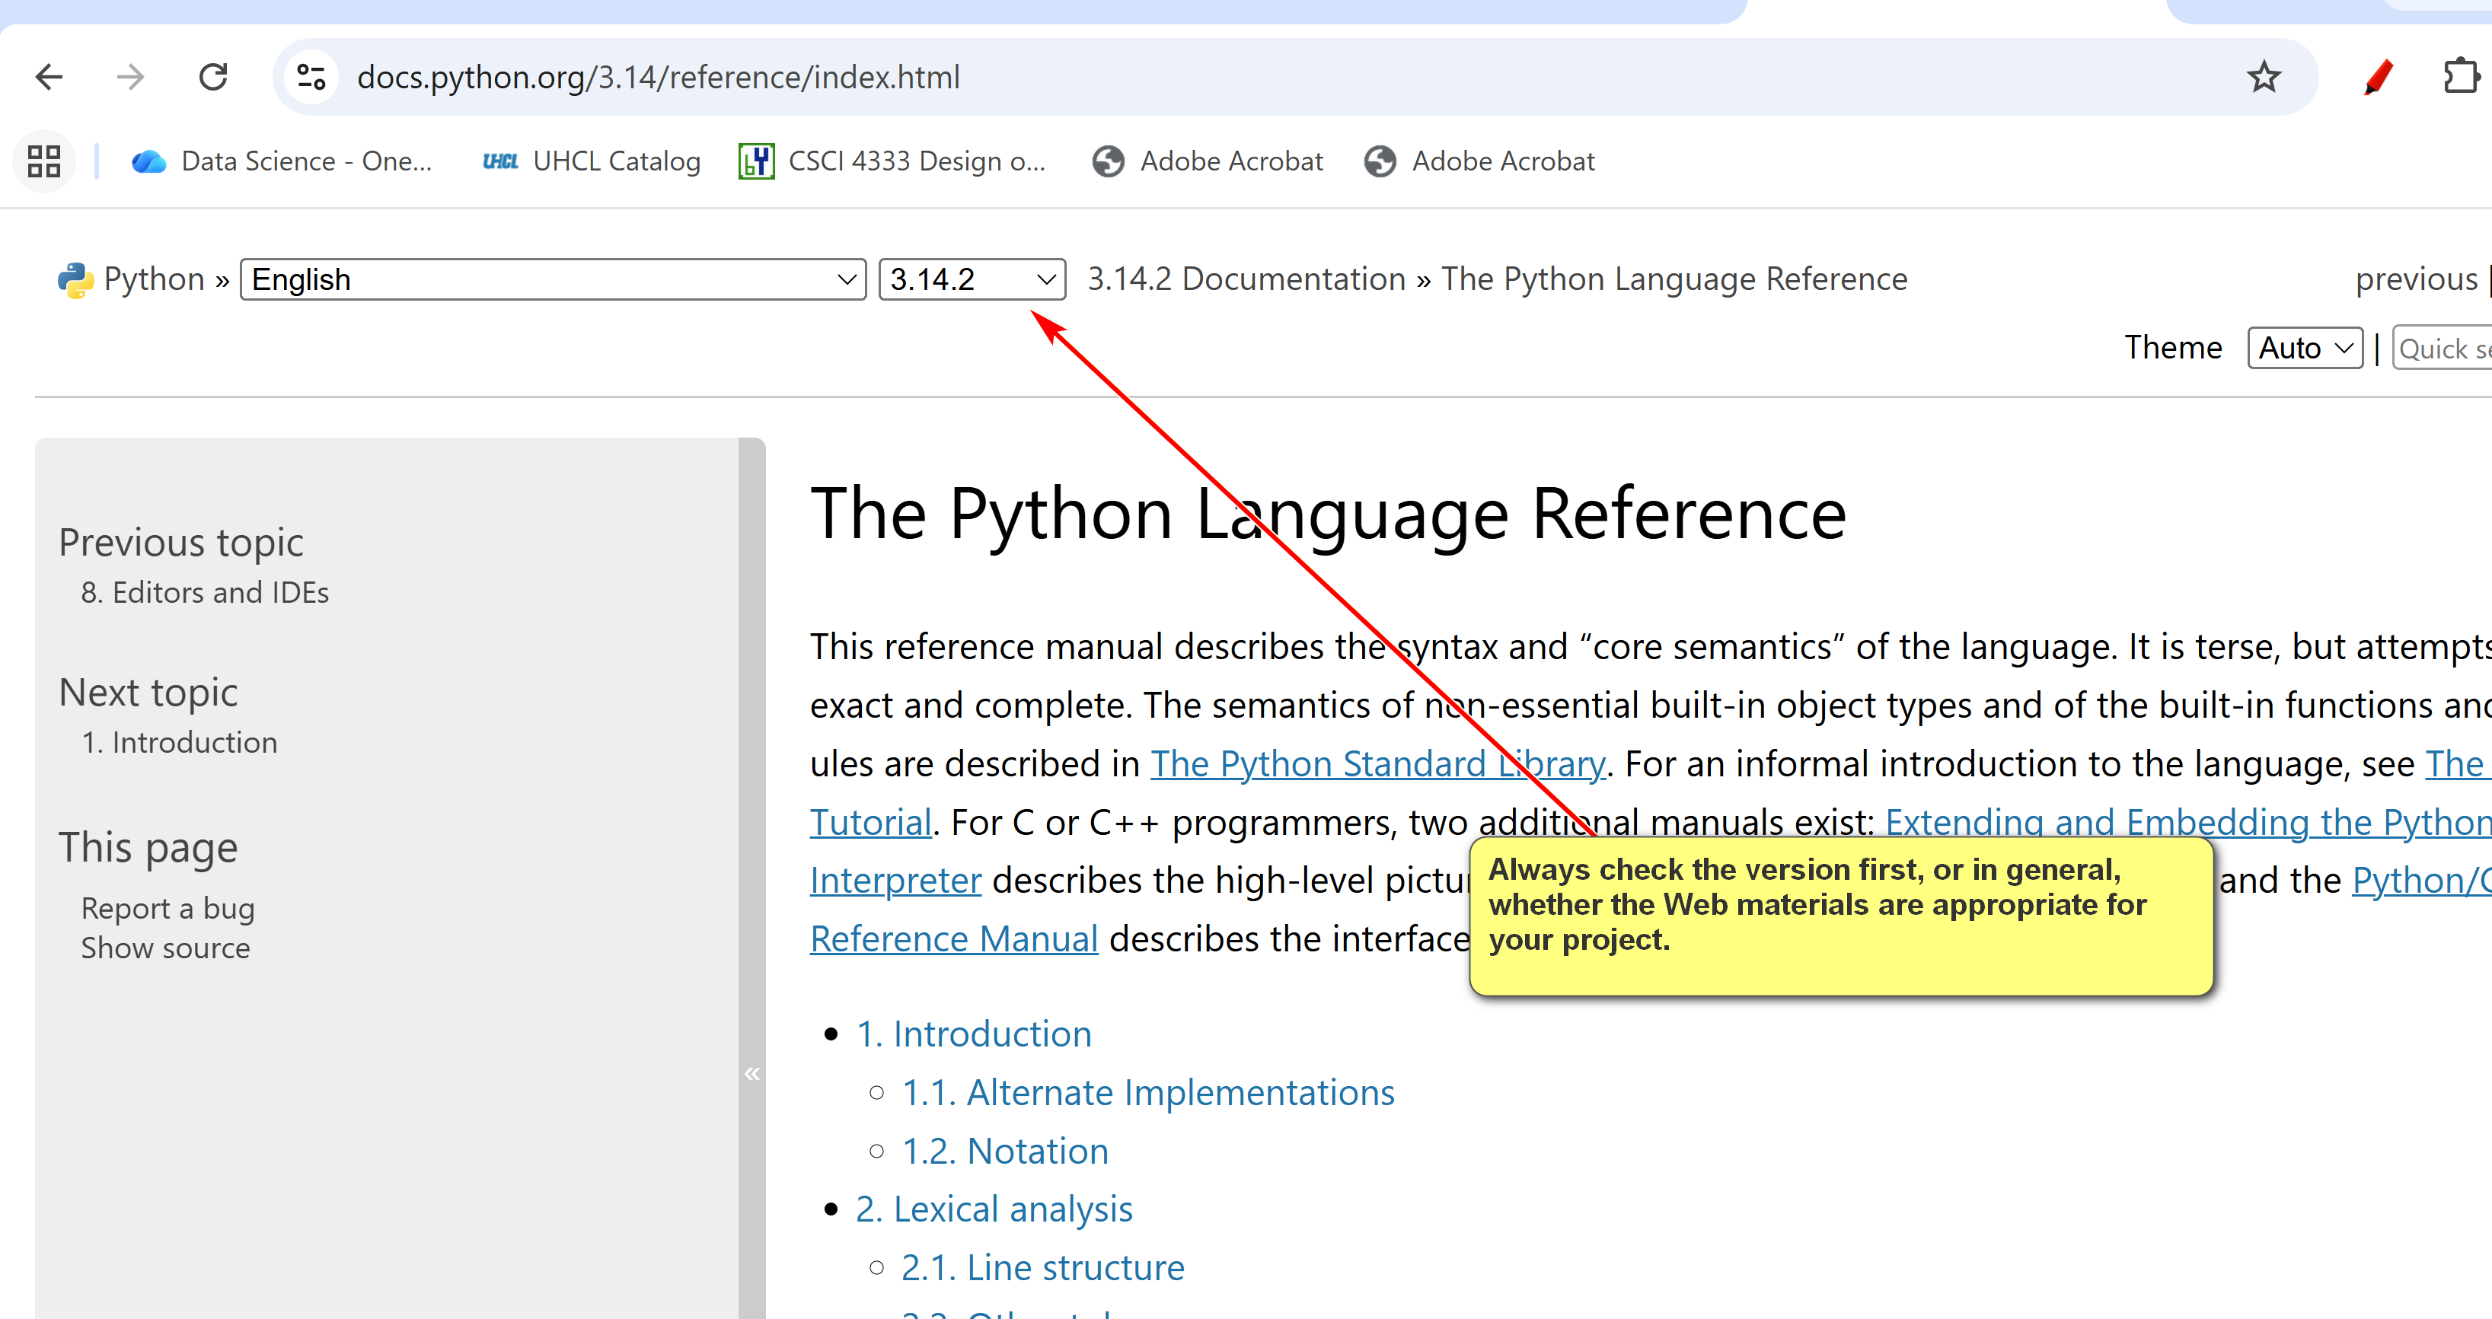
Standard library example:
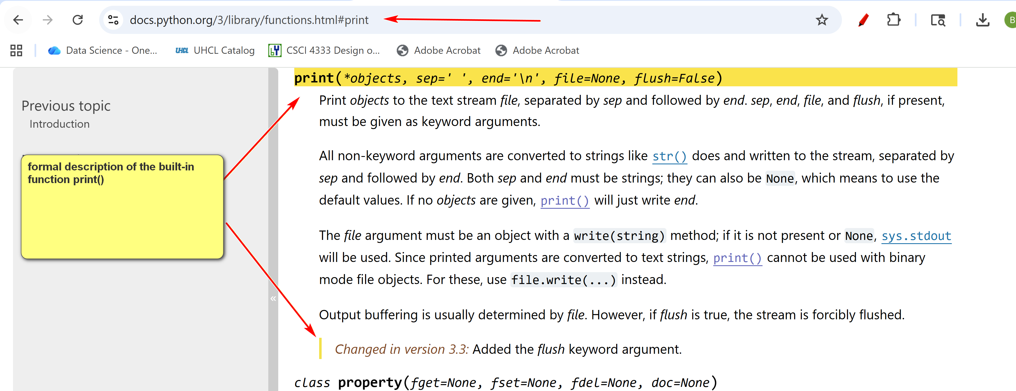
2. Python Books (Free)
- A Byte of Python: https://homepages.uc.edu/~becktl/byte_of_python.pdf. Free download, good coverage of topics in this class.
- Think Python: How to Think Like a Computer Scientist, version 3: https://allendowney.github.io/ThinkPython/. Include computational thinking. Contain Juptyer's Notebooks.
- Python for everyone: https://www.py4e.com/. Free, good, sometimes with videos, but may contain too much information for this class.
3. Learning Tutorials and Materials
- Tutorial at w3shools: https://www.w3schools.com/python/. Plenty of examples. Good for beginners and this class.
- https://www.learnpython.org/: popular, but w3schools is better. Beware of ads.
- https://www.programiz.com/python-programming: also contains some advanced topic.
- Google has a tutorial on Python: https://developers.google.com/edu/python. However, it is more for somewhat experienced programmers.
- For experienced programmers: https://learnxinyminutes.com/docs/python3/: one of my favorites.
4. Online Python's interpreter or IDE
- There are many possible advantages of online Python tools: convenience, accessibility, lightweight, collaboration, etc.
- There are also many possible disadvantages: restrictions, limited features, security and privacy, etc.
- Some online Python interpreters:
  - https://www.online-python.com/
  - https://www.programiz.com/python-programming/online-compiler/
  - https://www.w3schools.com/python/python_compiler.asp
- This course does not recommend the use of online Python IDE. Instead use IDLE and Notepad++ for standalone Python program.
5. Cheat Sheets
- If you like cheat sheet types of examples and summary:
  - https://scouv.lisn.upsaclay.fr/python-memento/memento-python3-en-latest.pdf: basic and short.
  - https://github.com/ehmatthes/pcc_3e/releases/download/v1.0.0/beginners_python_cheat_sheet_pcc_all.pdf: much longer.

Simple Python Development:
- Use IDLE for testing/learning/experiment
- Use Notepad++ and command line prompt (in project directory) for development.
- Learn from example: run and annotate statement by statement in IDLE.
CSCI 1470.3 Fall 2025 Homework #2
Partial:
[1] Open Python IDLE. Execute the following statements one by one: s = "This is a very good day." print(s) print(s.upper()) print (s.lower()) print (len(s)) print(s.len()) print(upper(s)) Save the shell session in a log file named h2q1.log (which is a .txt file). Upload h2q1.log to Canvas. Study the output of these statements.

Solution:
# h2.py
def main():
input_string = input("Please enter a string -> ")
print(f"length of the string: {len(input_string)}")
print(f"in upper case: {input_string.upper()}")
print(f"in lower case: {input_string.lower()}")

if __name__ == "__main__":
main()
