CSCI 1470 CS 1
2026_1_15 Self Annotation
Running Pythons in Windows
by K. Yue
1. Organizing Windows for Python Development
- This is about a simple setup of Python development in Windows using text editors.
E.g. Windows notepad: edit text (such as ASCII formats)
“ASCII (/ˈæski/ ⓘ ASS-kee),^{[3]: 6} an acronym for American Standard Code for Information Interchange, is a character encoding standard for representing a particular set of 95 (English language focused) printable and 33 control characters – a total of 128 code points.”
- It does not include the uses of Integrated Development Environment (IDE), such as PyCharm, VS Code, etc.
- It does not include the uses of Python platforms (such as for Web development, Graphical User Interface (GUI) applications of data science).
Install notepad++: free text editor
Crtl-A: select all
Crtl-C: copy
Crtl-V: paste
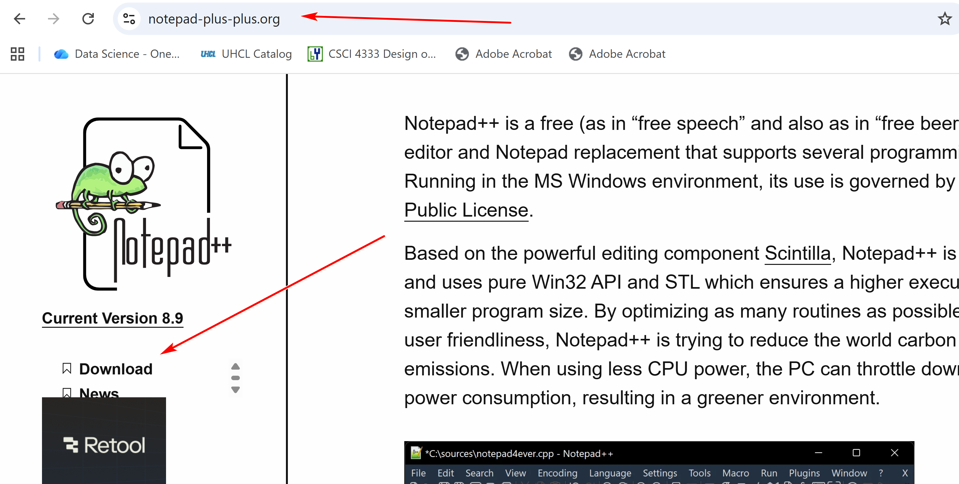

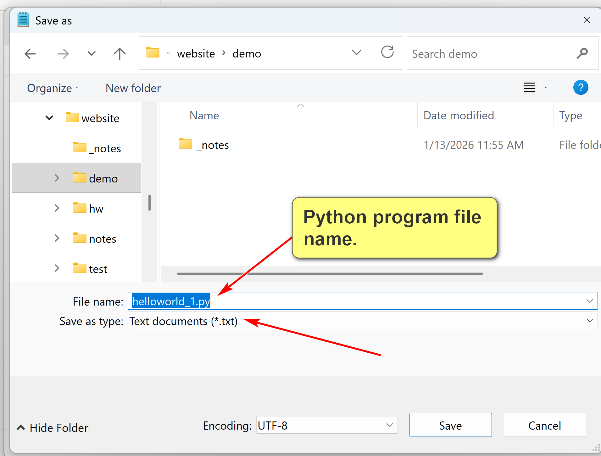
NotePad++ has many advanced texting editing features: e.g. line number, language sensitive syntax display,…
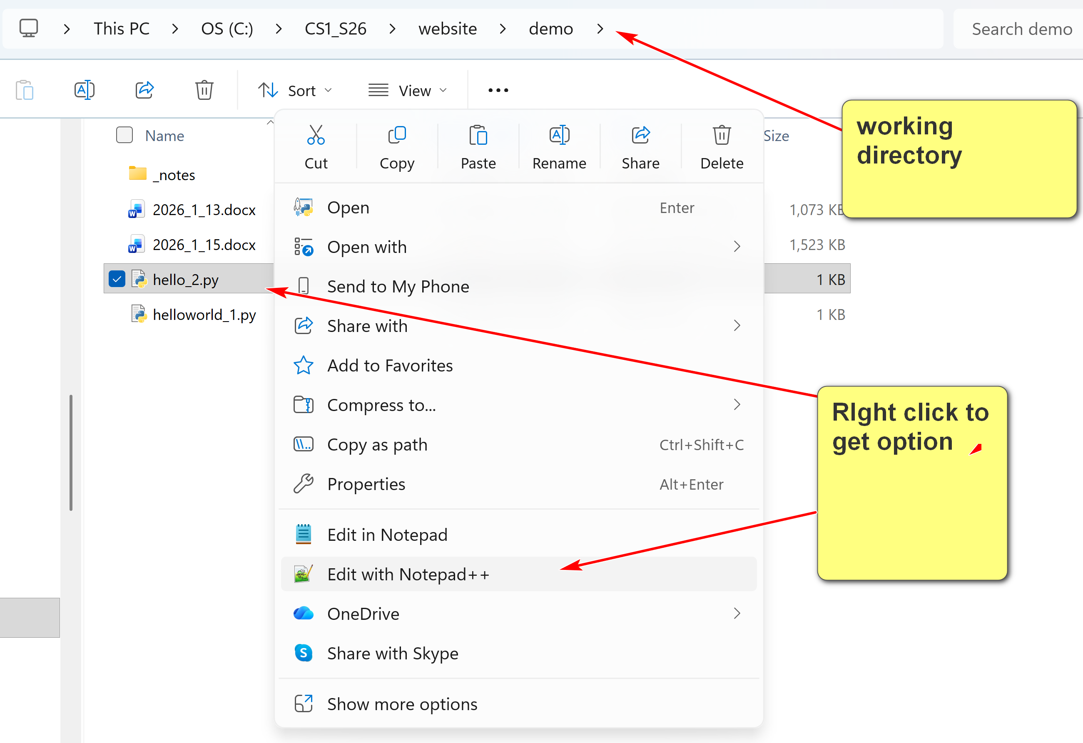

Command Prompt/Terminal
- The Command Prompt in Windows is a Command Line Interface (CLI) for executing commands to interact with the operating systems.
- In Mac and Linux, it is known as a command terminal or terminal.
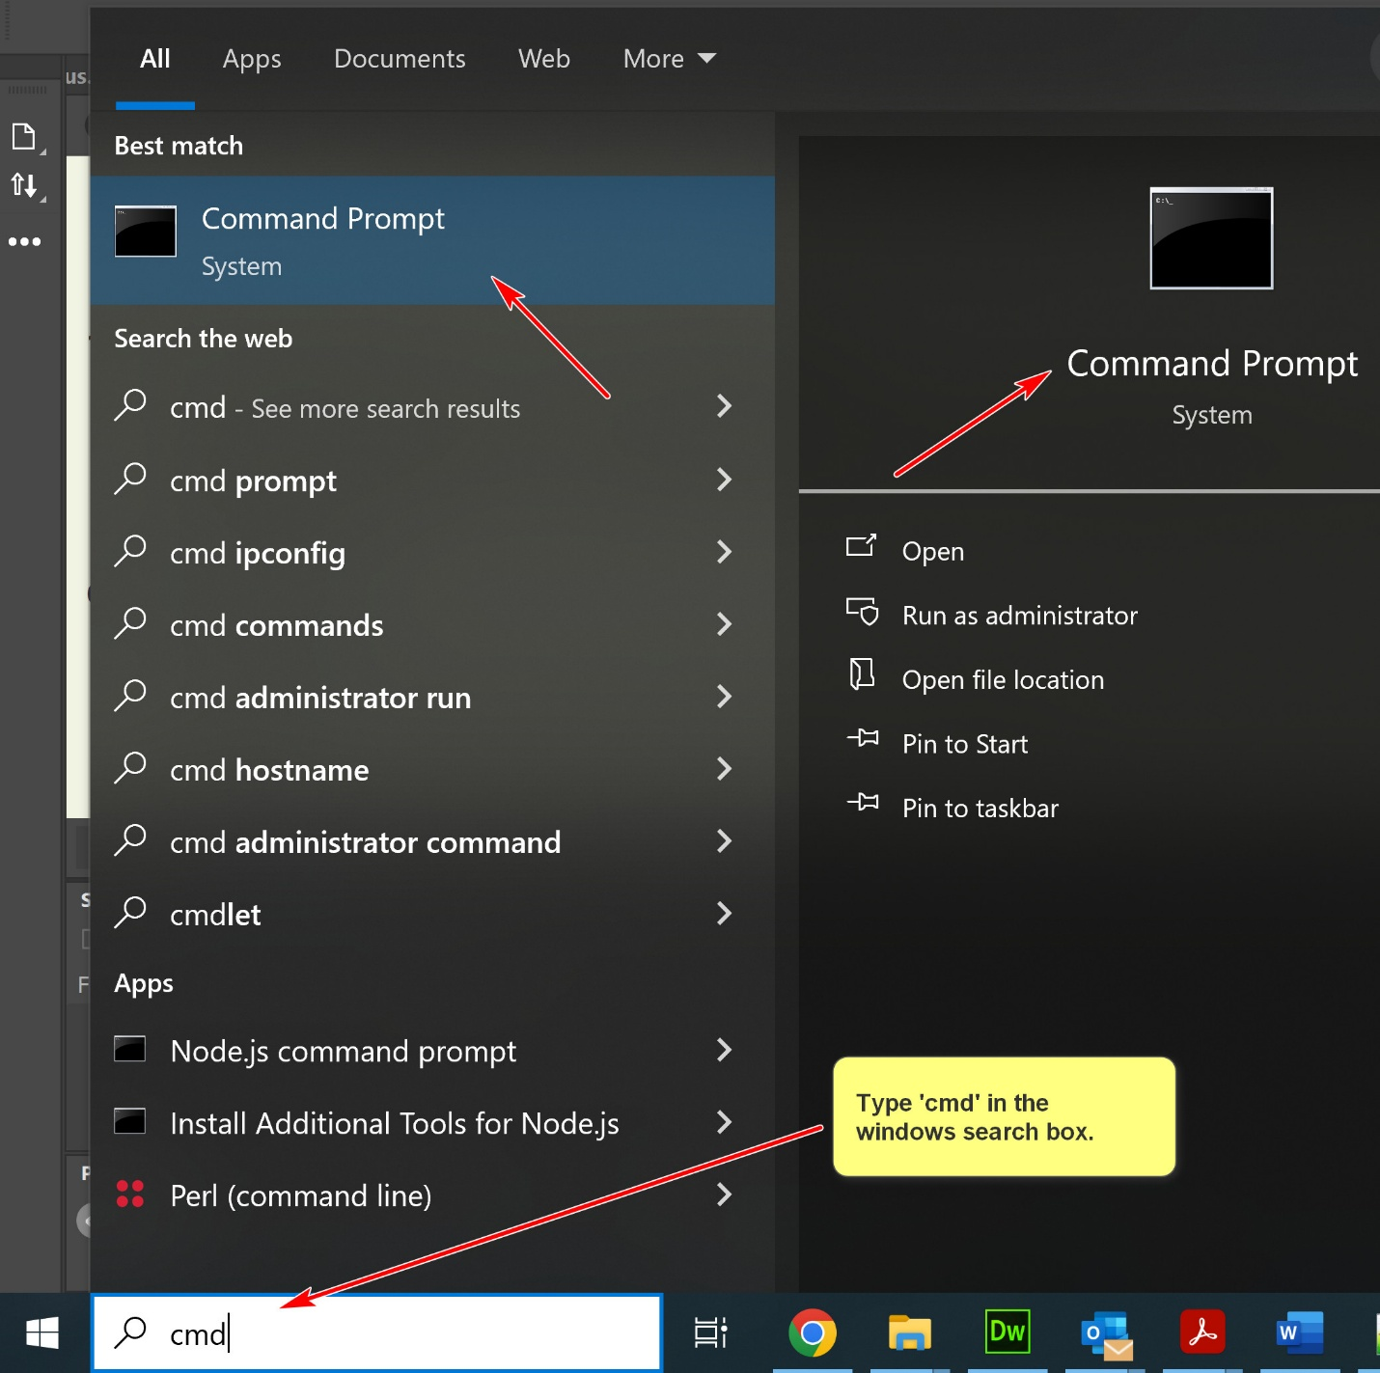
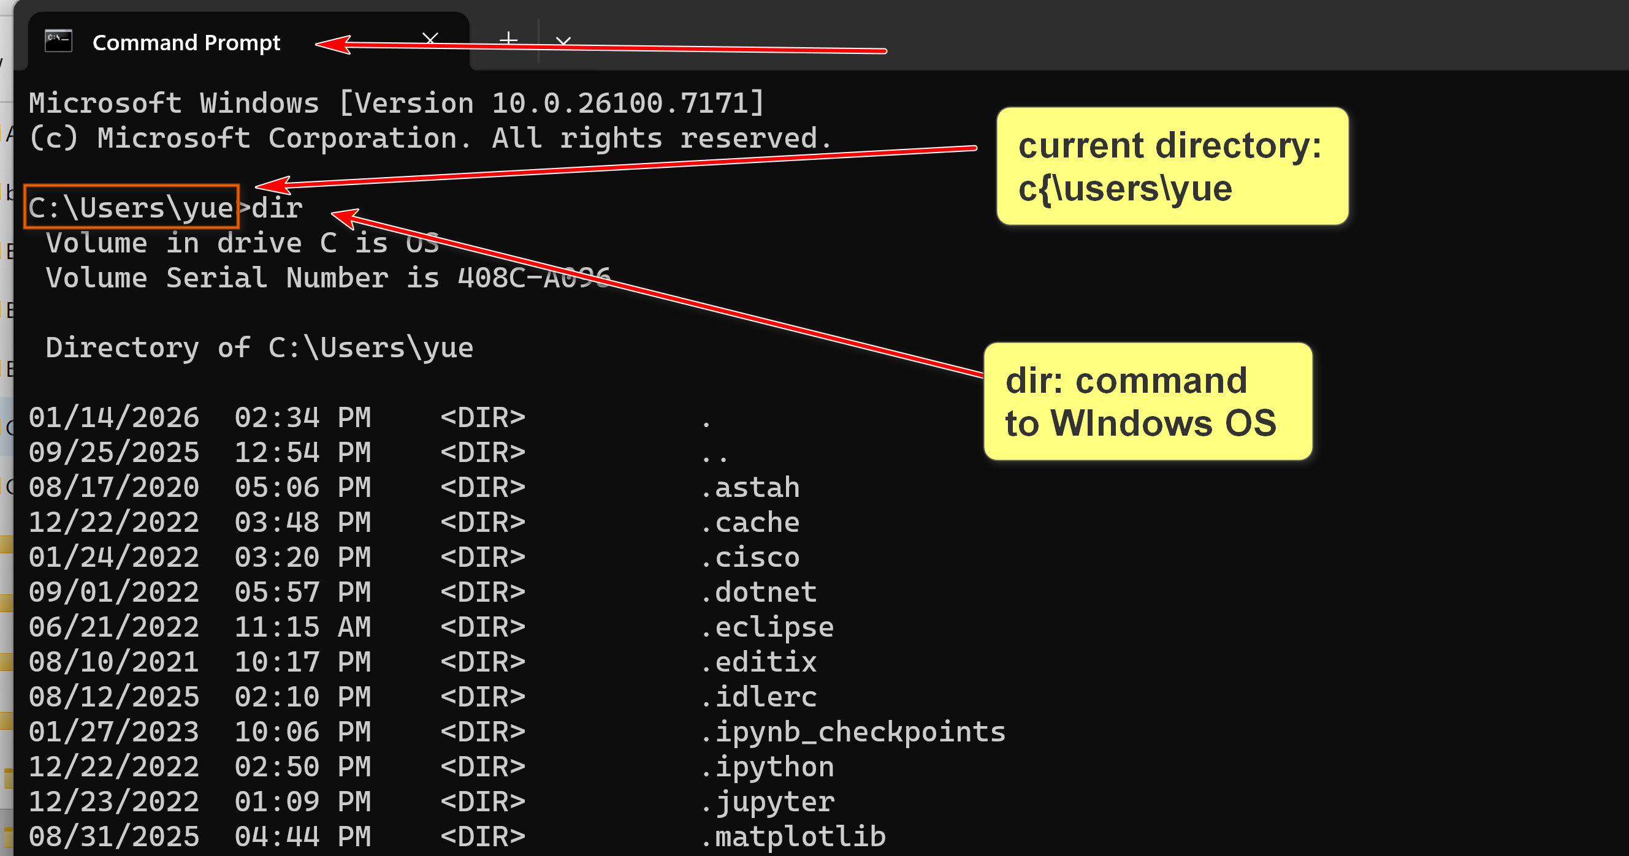
OS commands are relative to the current directory.
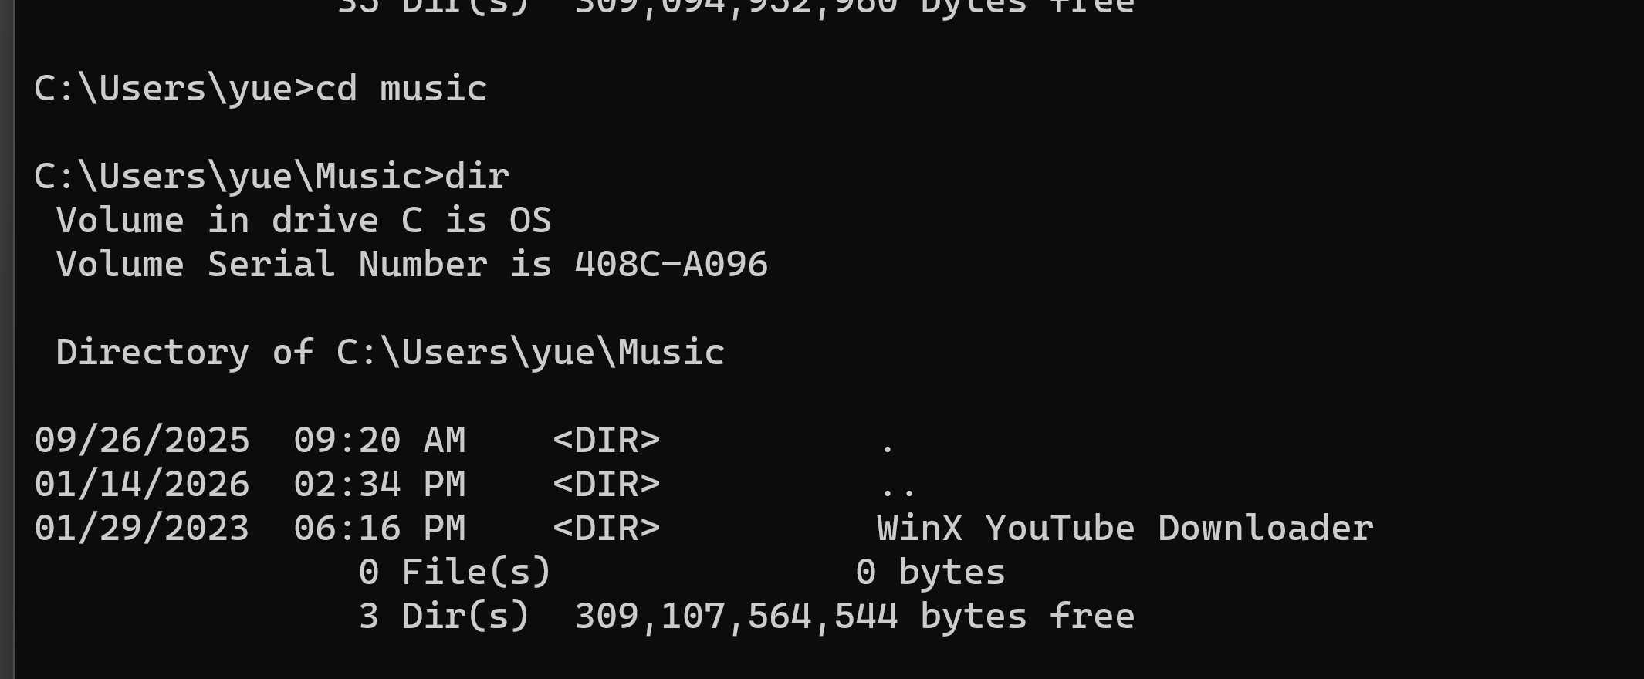
Project Directory
- It is beneficial to create a directory for a project.
- For example, for this course, you may create a folder: Documents\uhcl\csci1470, and put all files related to CSCI 1470 there.
- You may create additional sub-folders for better organization.
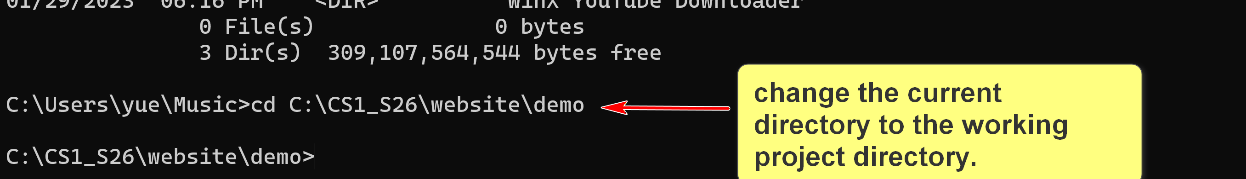

Upper and lower arrow key may be used to traverse the command history.
Working Directory
- A working directory, ore current working directory (CWD), is the specific location within a computer's file system where commands are executed, such as in the command prompt.
- It is common practice to set the working directory to the appropriate folder of your project directory. For example, you may then use relative file names.
2. Running Python in Windows
2.1 Python Interpreter
- To start the Python interpreter, open a command line prompt in your working directory and execute, for example:
set path=C:\Python311;%path%
python
- You may need to replace "C:\Python311" with the actual location of your python installation.
- You may set the environmental variable PATH in your OS. If so, you will not need to execute the set path command.
2.2 Python IDLE
- Integrated Development and Learning Environment (IDLE) is a bundled Python environment for simple development and learning.
- It is a simple Integrated Development Environment (IDE).

Running Python Program
- To run a Python program, helloworld.py, in a command line prompt (in the project directory), use:
python helloworld.py
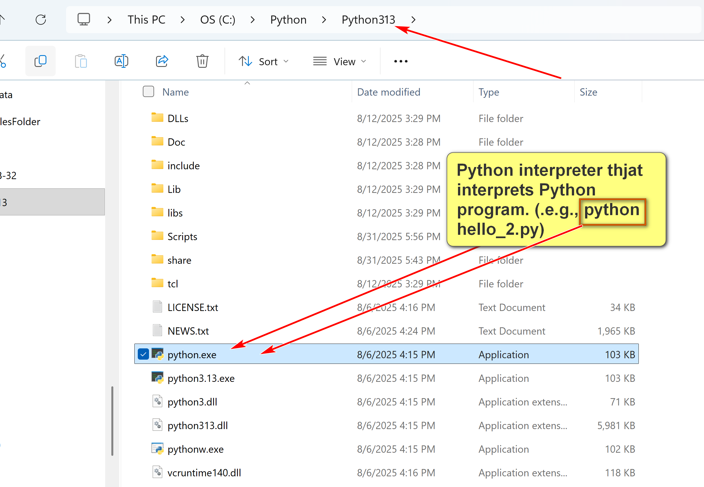

Installing Python in Windows
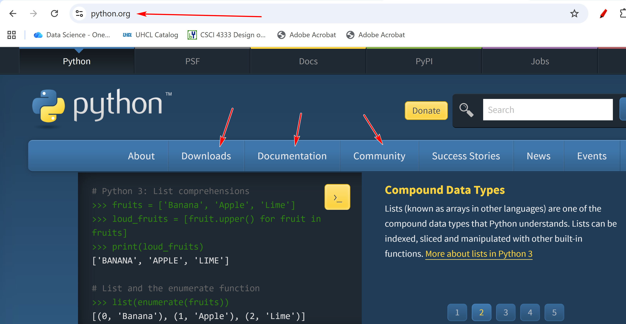
Install latest stable version.
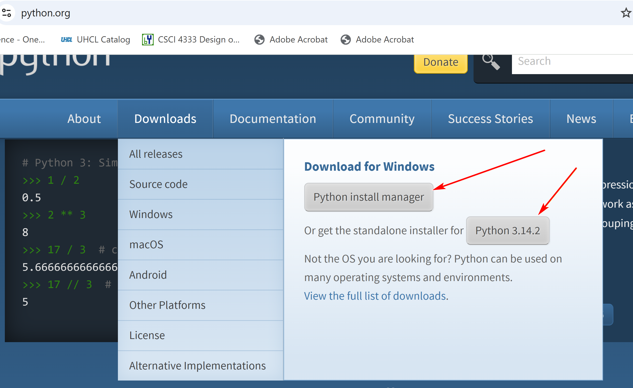
Do this option:
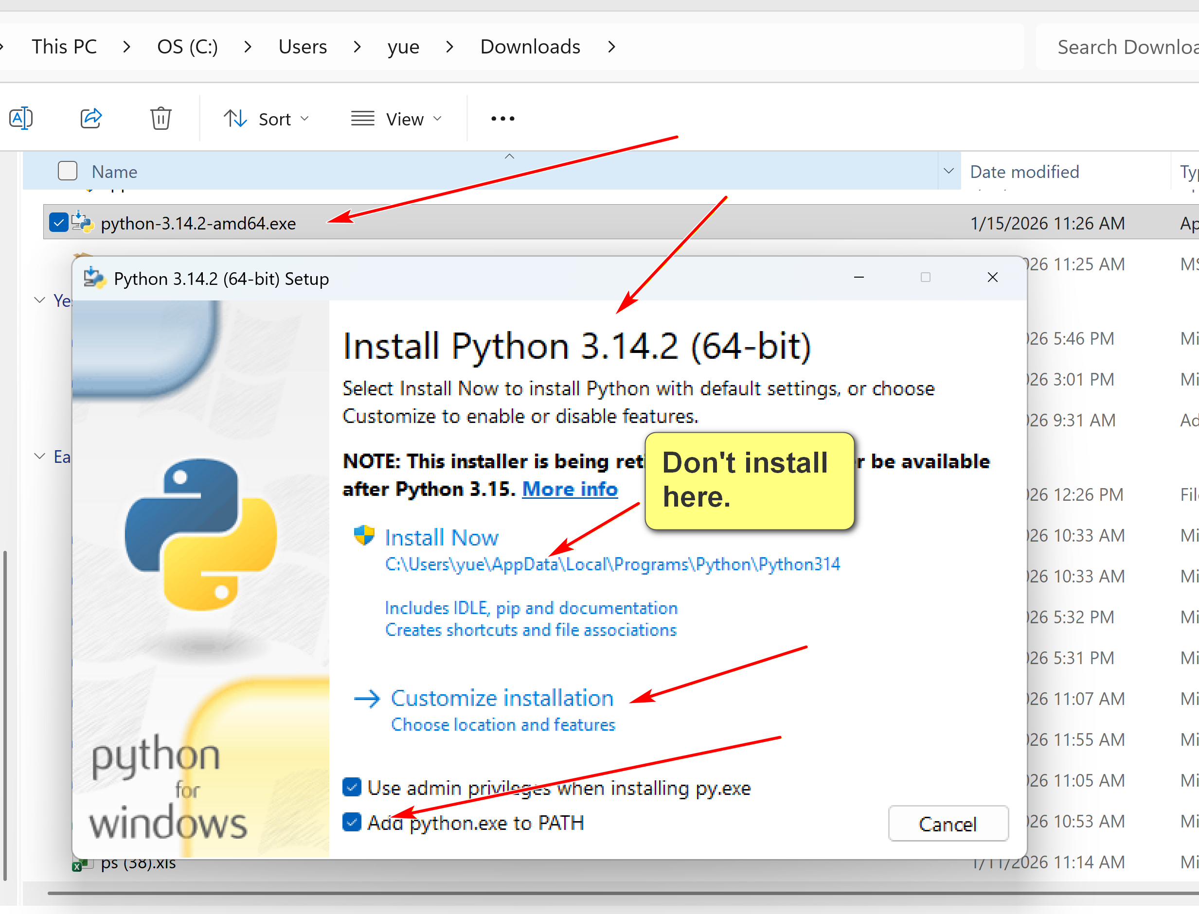

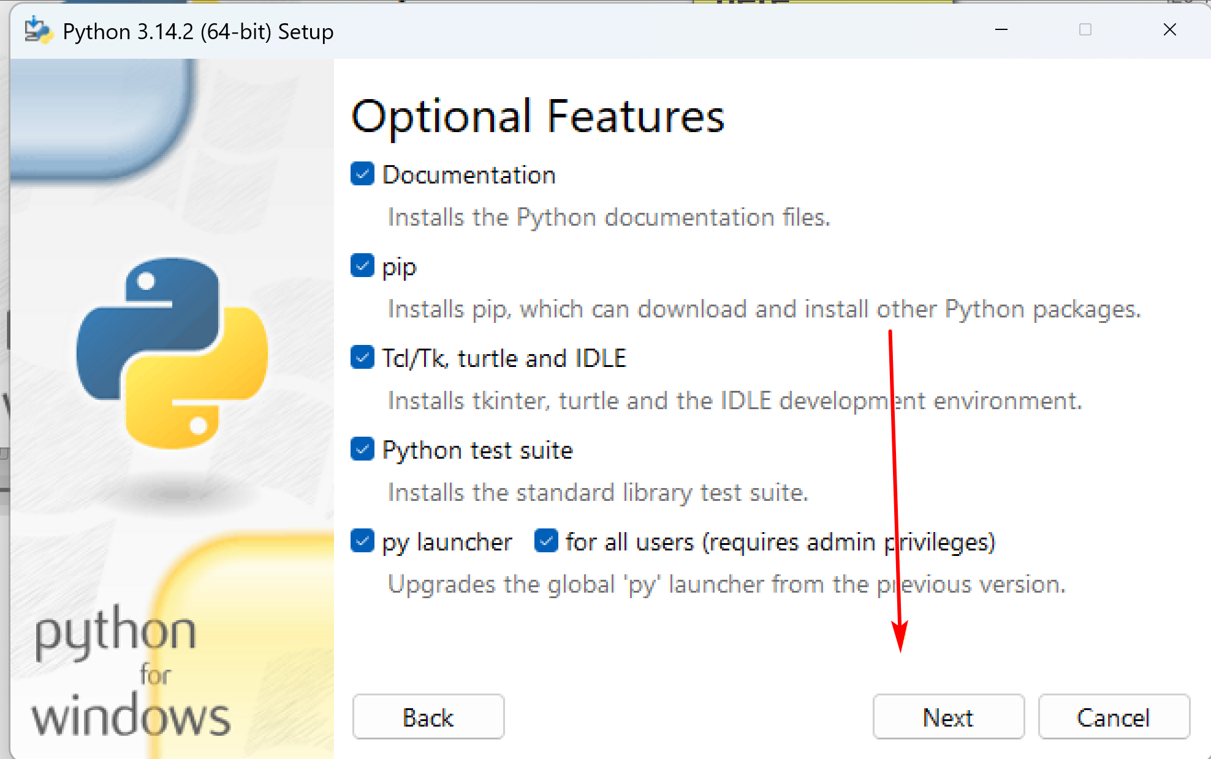
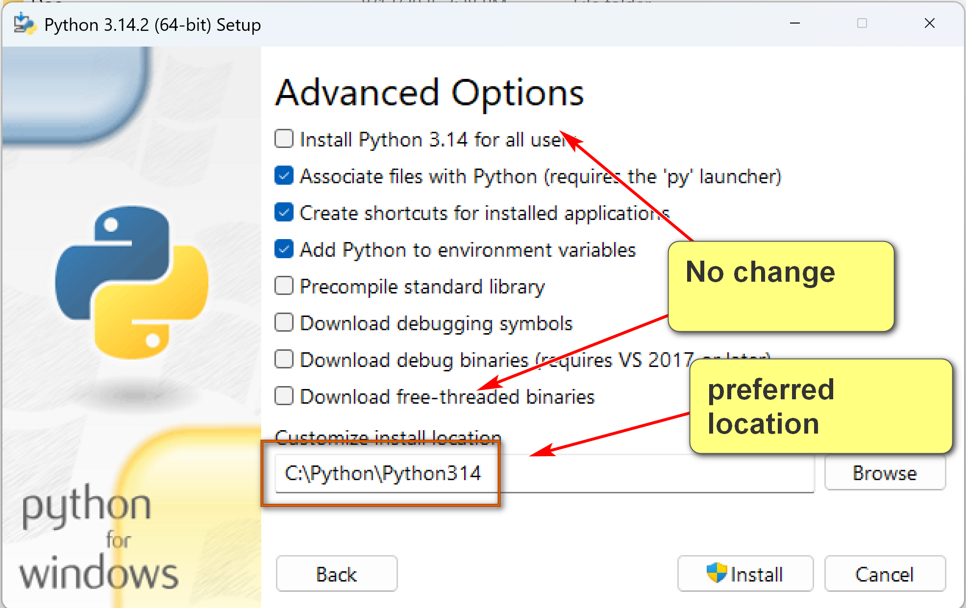

Environment Variables:
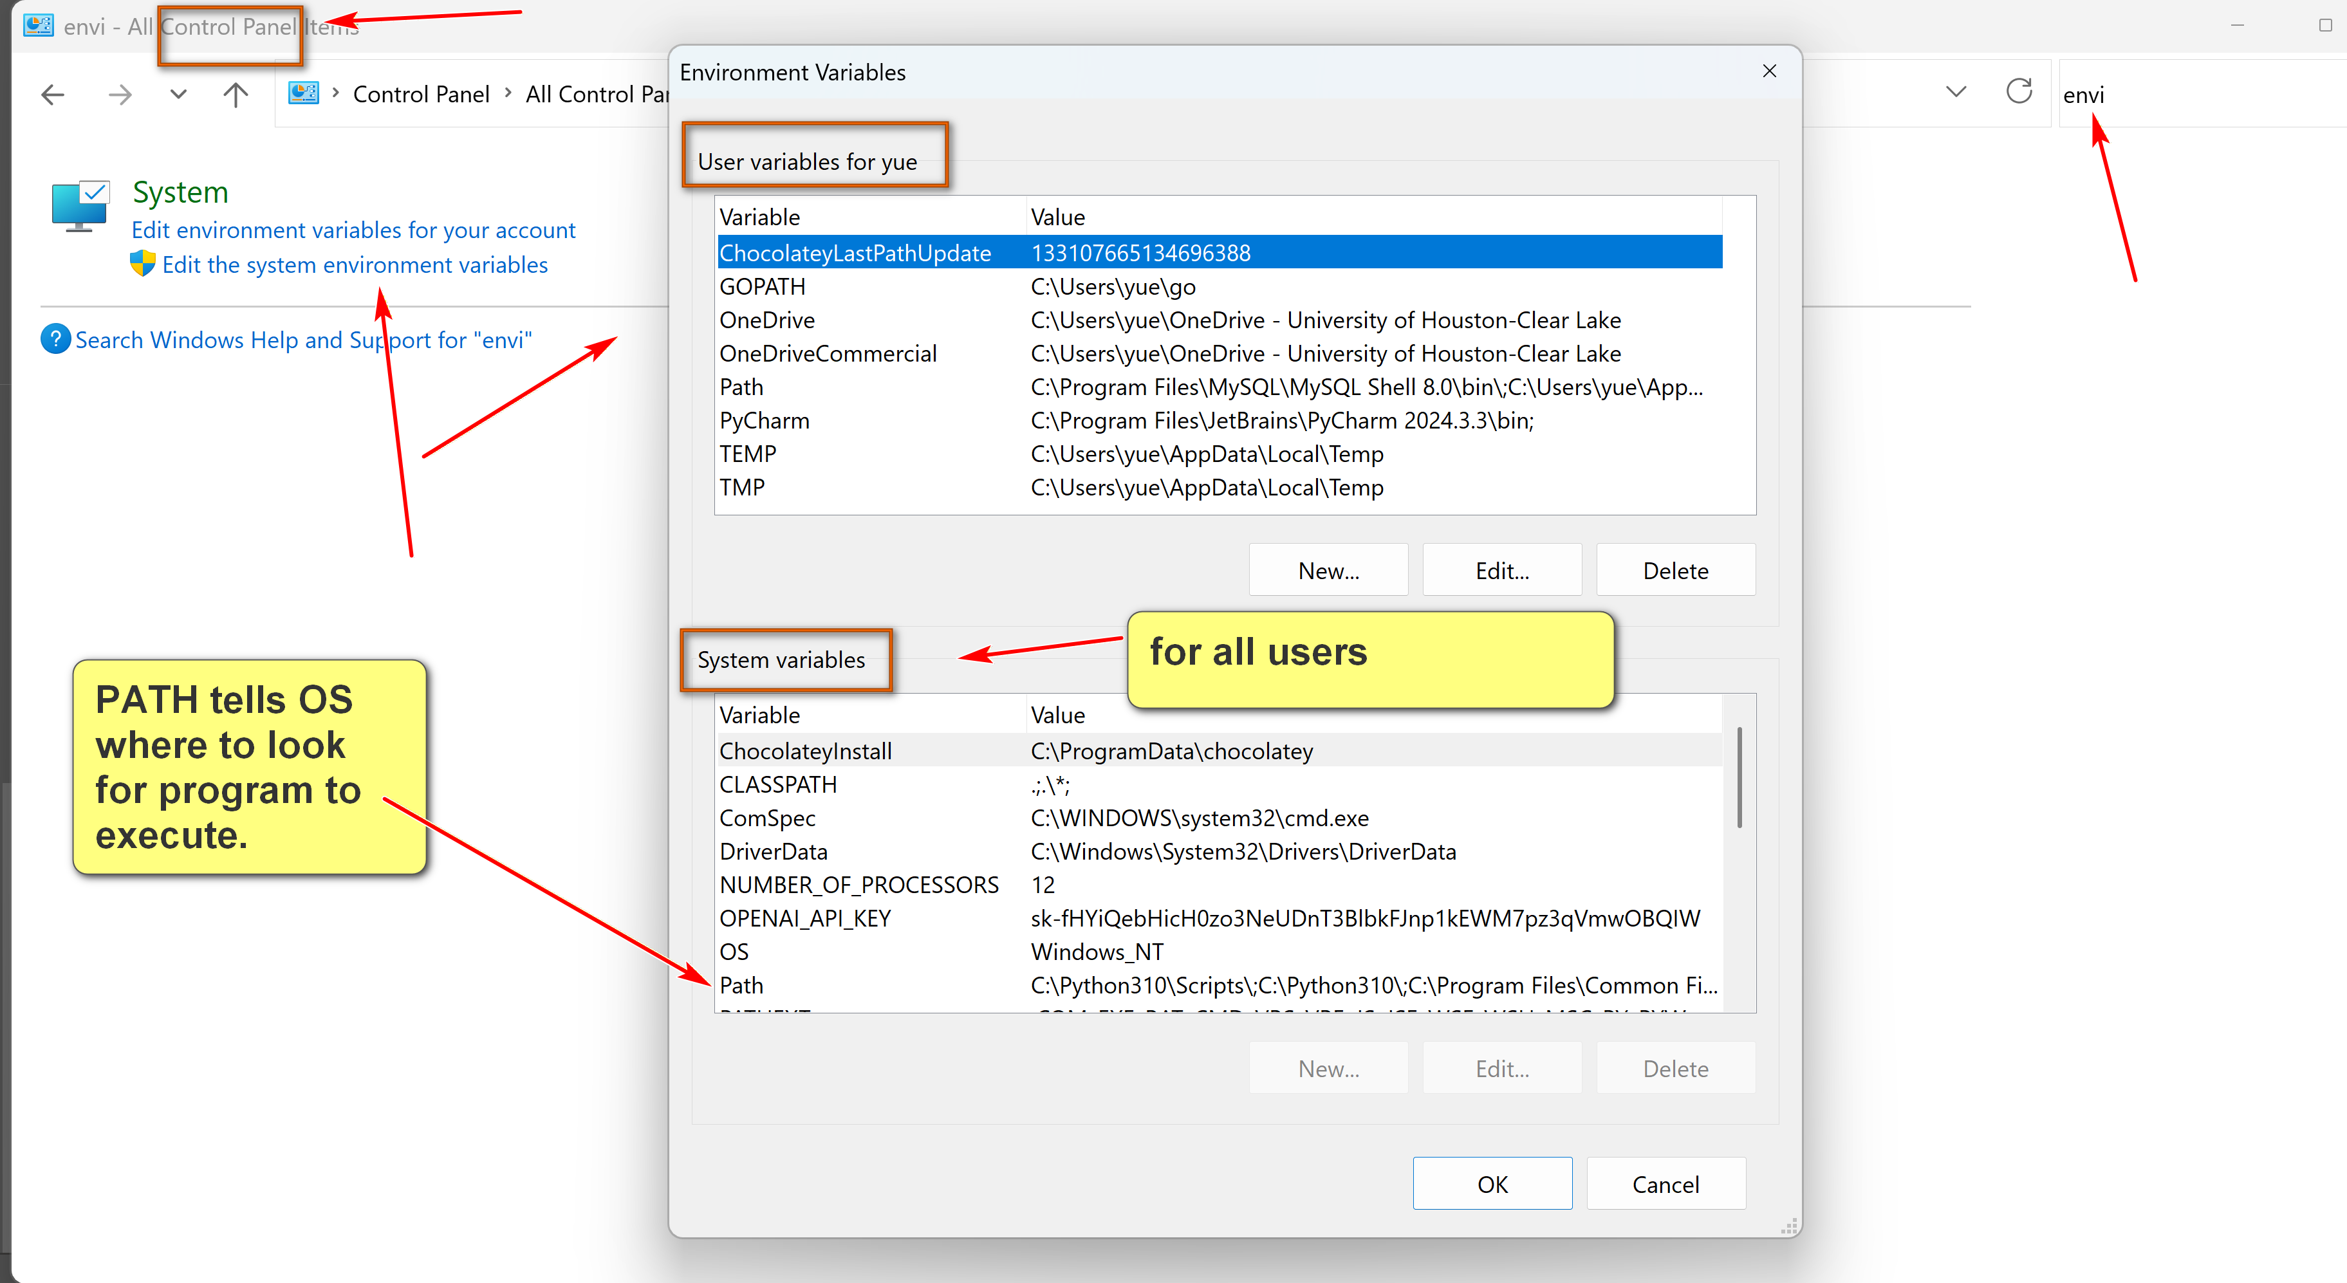
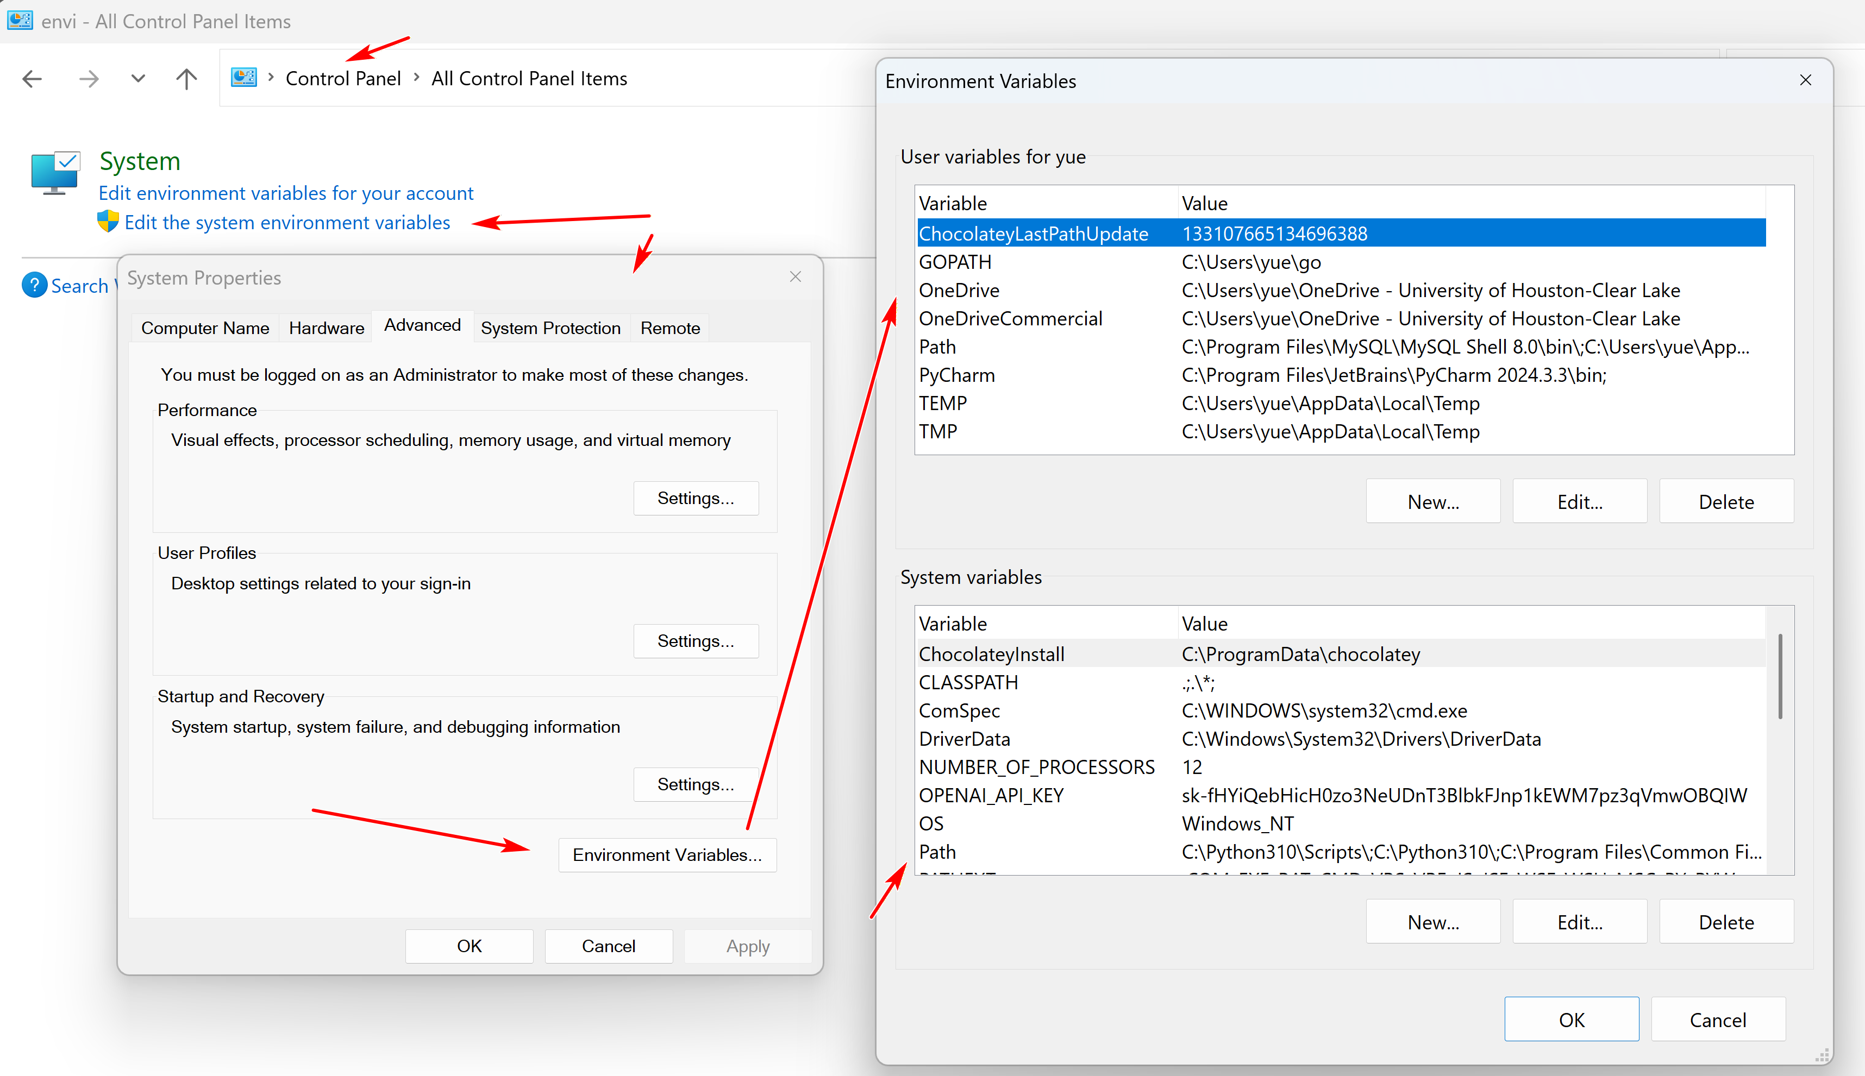
1/13/2026
How to I access EZBook?
Book: UHCLCSCI1470Spring2026

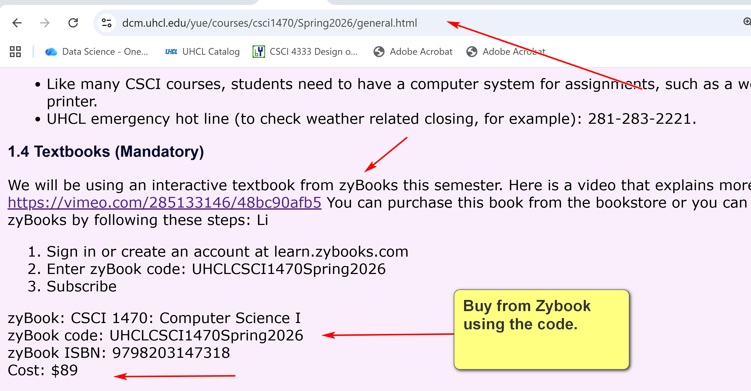
My screenshot tool: faststone capture; Windows snipping tools
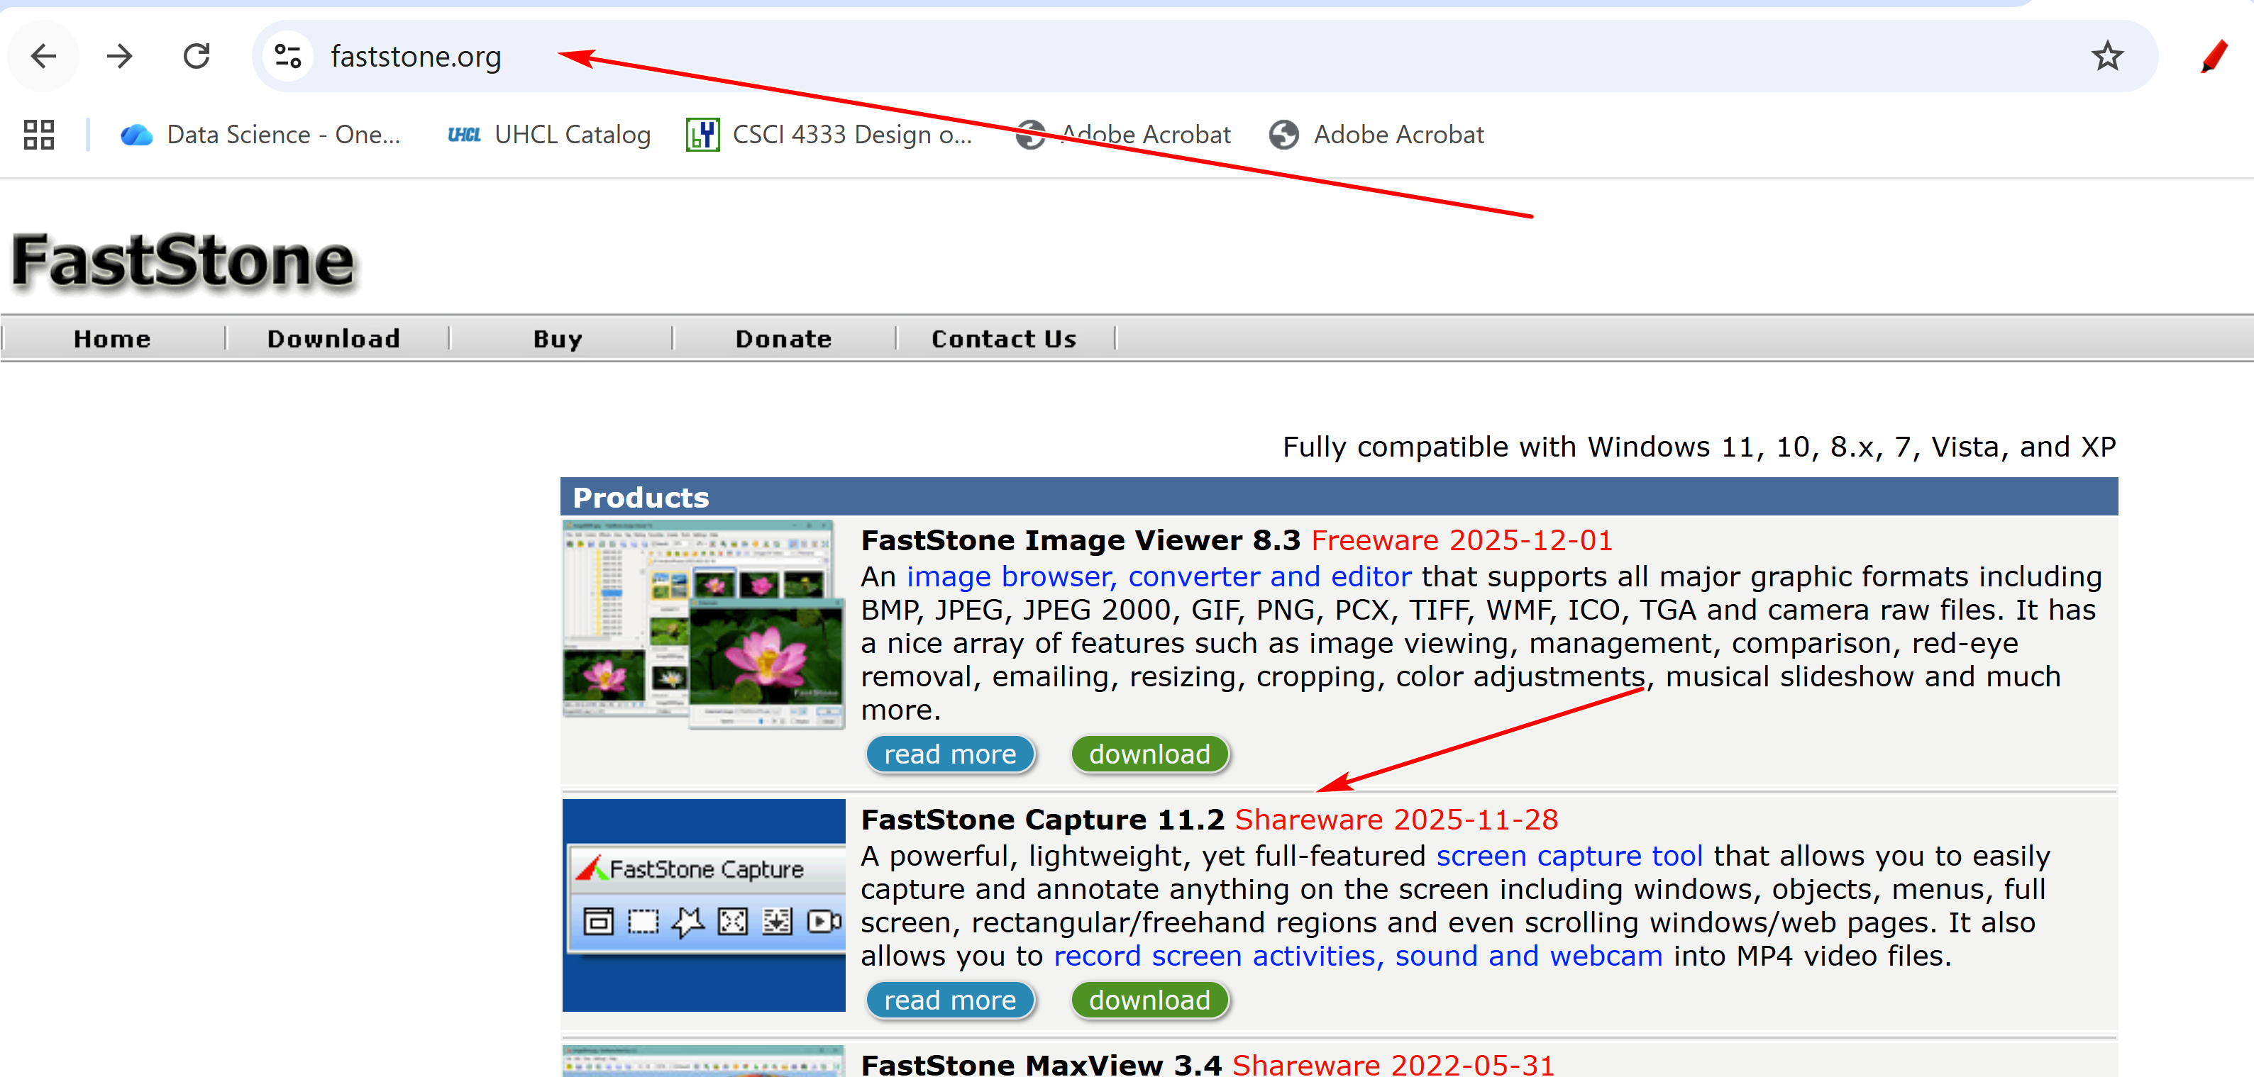
Learning by doing: practicing, annotation, teaching, explaining to laymen, ….
Expectation: average students 10-15 hours outside classroom.

Introduction to the course
CSCI 1470
by K. Yue
1. Promotion
- This course is (hopefully) one of the more useful CS courses for students.
- Programming is essential for computing careers.
- Python is very popular.
Search for “popularity of python” in Google:
- TIOBE Index: As of May 2025, Python is ranked as the #1 programming language, achieving the highest rating for any single language in the index's history.
- PYPL Index: Python is the #1 language, based on the highest share of tutorial searches on Google, indicating strong interest from new learners.
- GitHub: In 2024, Python became the most used language on GitHub, surpassing JavaScript in total activity across all contribution types.
- Stack Overflow Survey (2025): Python is the fourth most used language overall among all respondents, but it is the second most used as a primary language and the top choice for those learning to code (71.8%) and professionals using AI (73.8%)

2.General Learning Suggestions
- Everyone is different and unique in learning.
- Engagement and learning by doing.
- Teaching is an excellent way of learning: help your classmates.
- Prepare your own notes: the best notes for you are written by yourself
- Consider crowd learning.
- Come to my office often, especially in groups.
- Please consider forming the habit of listening carefully and asking a lot of questions.
3. How to be successful in the course
General Professionalism:
- Attitude
- Be considerate.
- Be helpful and useful to others.
- Be a good listener.
- Be responsive.
- Hardworking
- Attention to details.
- Focus: uni-tasking
Some general tips:
- Engagement: Participate. Ask questions, a lot of them. Help others. Plan ahead.
- Preparation: start as early as possible and do not fall behind.
- Don’t copy and paste. Instead, copy, integrate, and apply.
- SEE-I: State, Elaborate, Exemplify and illustrate. (assess your learning depth)
  - State the concept in your own words.
  - 2. Elaborate the concept in your own words: more details, supporting sub-concept, nuance, etc.
  - Exemplify: provide concrete examples to illustrate and explain the concept.
- Form good habits.

Some good traits of software developers
- Habits of trying to make sense of stuff.
- Intellectual curiosity.
- Tinkering and experimentation.
- Attention to details.
- Continuous small and big improvement.
- A large tool set.
- ...

Make you own notes
by K. Yue
1. Why?
- You make the best notes for yourself.
- Making notes are engaging activities: learning by doing.
- Providing chances for understanding the materials in a much deeper and more effective way.
- Provide documentation for review and further exploration.
2. How
- Develop your own style.
- Copy useful sources and annotate.
- Ask questions, deliberate concepts, write examples for the future you.
  - Use State, Elaborate, and Exemplify on the concept.
- Tinker by constructing examples and experiments.
- Use colors, tables or whatever means to distinguish between concepts.
- Visual learning is effective. Have a good snipping and editing tool.
- Don't worry too much about format, grammatical mistakes for the moment: quick and dirty notes initially just for yourself.

The Computational Paradigm
by K. Yue
1. Paradigm
- Every discipline has a paradigm: targets, objectives, considerations, bodies of knowledge, methodologies, standards, etc.
Example #1: In pure mathematics (as opposed to applied mathematics)
- An important objective to prove theorems which are true under a set of axioms (statements assumed to be true without proof).
- Methodologies: theorem proving, ...
- Quality considerations:
  - primary: truth or correctness.
  - simplicity and beauty.
- ...
E.g., the Pythagorean theorem: the sum of the squares of the two shorter sides (legs) of a right-angled triangle is equal to the square of the longest side (hypotenuse)
- Axioms: Five basic axioms of Euclidean geometry.

- A mathematical conjecture is a statement that is believed to be true based on observations and patterns but has not yet been proven or disproven.
E.g., Goldbach's Conjecture (stated in 1742): Every even integer greater than 2 can be expressed as the sum of two prime numbers. E.g.,
- 16 = 5 + 11
- 100 = 3 + 97 = 11 +89 = 17 + 83 = 29 + 71 ...
The Goldbach's conjecture is very easy to state but extremely hard to prove (one way or the other).
Example #2: History
- An important objective: understand the past to better comprehend the present and potentially inform the future.
- Methodology: a range of techniques and procedures for gathering, analyzing, and interpreting evidence from primary and secondary sources to construct a narrative and understanding of historical events.
- Some quality considerations:
  - Source selection, evaluation and preparation
  - Objectivity and bias mitigation
  - Methodology rigor
  - Narrative and communication
2. Computing and software development
- What is computer science?
- An example: Computer science (CS) is the study of computers and algorithmic processes, including their principles, their hardware and software designs, their applications, and their impact on society. (Tucker et al., 2003.)
- It is difficult to find another discipline more applicative than computer science.
- Computer professionals should be generalists.
Software Development
- primary objective: problem solving using software.
- methodologies: computer and software development techniques (that is what your computing degree means).
- One clear quality consideration: correctness, or does the program provide the right answer (expected output)?
  - Software testing is about increasing confidence in correctness.
  - A test case specifies:
    - input
    - expected output
  - A test case is passed when the expected output is equal to the actual output.
E.g., a Python to output the square of an input integer.
Test cases:
Case # | Input | Expected Output
1 | 3 | 9
2 | 65 | 4425
3 | 0 | 0
4 | -65 | 4425
5 | 123456789 | 15241578750190521
6 | 'hello' | Error: input is not an integer.
- Some important software development quality considerations:
  - Correctness:
    - Software verification:
      - Software built according to the software specification. Is the software built right?
      - Internal correctness
      - e.g. does the program output the square of the input number right?
    - Software validation:
      - Software met the needs of the problem. Is it the right software?
      - Constructing the right software specification: requirement analysis.
      - External correctness
      - E.g., do the users want the square of the input number?
  - Performance
  - Cost
  - Meeting timeline
  - Effectiveness
  - Reliability
  - Maintenance: software has a life cycle
  - Security and privacy
- Do not just focus on internal correctness or software verification.
3. Skills/Traits/Quality/Characteristics of software developers
- People of course have different opinions.
- However, there are many commonalities.
3.1 A simple non-scientific experiment
Conducted a simple Google search for good software developer quality.
Four sources:
- Coding Temple, 6 Key Qualities of Successful Software Engineers, https://www.codingtemple.com/blog/6-key-qualities-of-successful-software-engineers/.
- MatchTech, 7 qualities exceptional developers possess, https://www.matchtech.com/resources/7-qualities-exceptional-developers-possess.
- UMBC, How To Know If Software Development Is The Right Job For You, 8 Hard To Learn Software Developer Skills You Need, https://www.umbctraining.com/software-developer-skills/.
- AlltheCode blog, Software Engineer Personality: 5 Traits For A Great Career, https://allthecode.co/blog/post/software-engineer-personality.
Results:
Coding Temple | MatchTech | UMBC | AlltheCode
Technical Expertise | Solid technical knowledge | Curiosity | Curiosity
Problem-Solving Skills | Maintains an end-user focus | Creativity | Persistence
Attention to details | Fast self learner | Empathy | Ability to learn
Strong communications and collaboration skills | Strong communication skills | Patience, Perseverance and Problem-Solving | Focus
Continuous learning and adaptability | Dependent time and task management | Analytical | Pragmatism
Passion for the craft | A good team player | Detail-oriented and organized
 | 'Never say die' attitude | Adaptability
 |  | Communication
- Although you can see their differences, some focus more on skills and qualities. Others focus more on traits.
- However, there are some common themes:
  - Strong technical knowledge and expertise
  - Strong problem-solving skills: analytical
  - Good problem understanding: empathy, focus on end users, ...
  - Strong communication skills
  - Strong collaboration skills: good team play, dependable
  - Continuous and fast self-learning
  - Curiosity: passion for the craft
  - Persistence: never day die, passion for the craft
  - Organization and management skills
  - Detail-oriented
  - Adaptability
Some Lessons
- We tend to focus on technical matters in our computing degrees.
- Success in the computing profession requires much more than technical expertise. It will be increasing more so.
- Personal traits, characteristics, habits, etc. take a lot of effort and time to develop.
- Consider spending effort and time to cultivate them early and persistently.
- Your university degree may give you an entrance ticket to the job market but it is not sufficient by itself.

