CSCI 1470 CS 1
2026_1_13 Self Annotation
How to I access EZBook?
Book: UHCLCSCI1470Spring2026

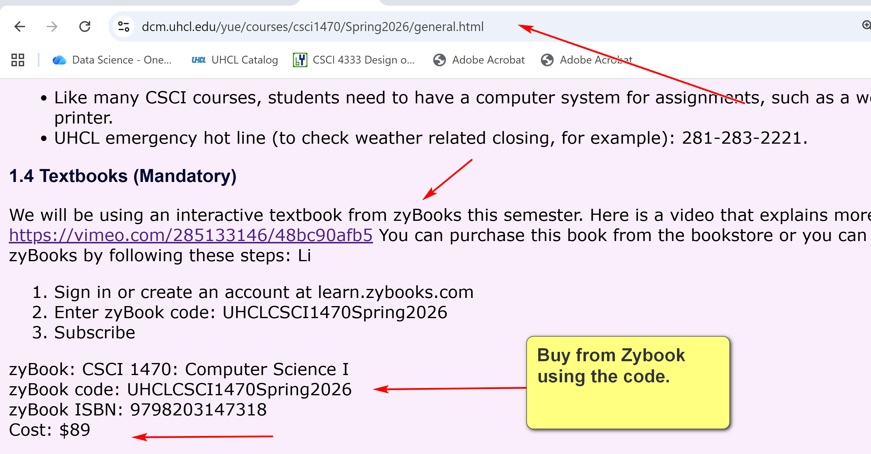
My screenshot tool: faststone capture
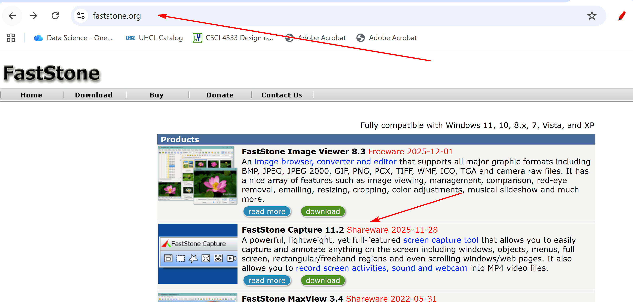
Learning by doing: practicing, annotation, teaching, explaining to laymen, ….
Expectation: average students 10-15 hours outside classroom.

Introduction to the course
CSCI 1470
by K. Yue
1. Promotion
- This course is (hopefully) one of the more useful CS courses for students.
- Programming is essential for computing careers.
- Python is very popular.
Search for “popularity of python” in Google:
- TIOBE Index: As of May 2025, Python is ranked as the #1 programming language, achieving the highest rating for any single language in the index's history.
- PYPL Index: Python is the #1 language, based on the highest share of tutorial searches on Google, indicating strong interest from new learners.
- GitHub: In 2024, Python became the most used language on GitHub, surpassing JavaScript in total activity across all contribution types.
- Stack Overflow Survey (2025): Python is the fourth most used language overall among all respondents, but it is the second most used as a primary language and the top choice for those learning to code (71.8%) and professionals using AI (73.8%)

2.General Learning Suggestions
- Everyone is different and unique in learning.
- Engagement and learning by doing.
- Teaching is an excellent way of learning: help your classmates.
- Prepare your own notes: the best notes for you are written by yourself
- Consider crowd learning.
- Come to my office often, especially in groups.
- Please consider forming the habit of listening carefully and asking a lot of questions.
3. How to be successful in the course
General Professionalism:
- Attitude
- Be considerate.
- Be helpful and useful to others.
- Be a good listener.
- Be responsive.
- Hardworking
- Attention to details.
- Focus: uni-tasking
Some general tips:
- Engagement: Participate. Ask questions, a lot of them. Help others. Plan ahead.
- Preparation: start as early as possible and do not fall behind.
- Don’t copy and paste. Instead, copy, integrate, and apply.
- SEE-I: State, Elaborate, Exemplify and illustrate.
  - State the concept in your own words.
  - 2. Elaborate the concept in your own words: more details, supporting sub-concept, nuance, etc.
  - Exemplify: provide concrete examples to illustrate and explain the concept.
- Form good habits.

Some good traits of software developers
- Habits of trying to make sense of stuff.
- Intellectual curiosity.
- Tinkering and experimentation.
- Attention to details.
- Continuous small and big improvement.
- A large tool set.
- ...

Make you own notes
by K. Yue
1. Why?
- You make the best notes for yourself.
- Making notes are engaging activities: learning by doing.
- Providing chances for understanding the materials in a much deeper and more effective way.
- Provide documentation for review and further exploration.
2. How
- Develop your own style.
- Copy useful sources and annotate.
- Ask questions, deliberate concepts, write examples for the future you.
  - Use State, Elaborate, and Exemplify on the concept.
- Tinker by constructing examples and experiments.
- Use colors, tables or whatever means to distinguish between concepts.
- Visual learning is effective. Have a good snipping and editing tool.
- Don't worry too much about format, grammatical mistakes for the moment: quick and dirty notes initially just for yourself.

The Computational Paradigm
by K. Yue
1. Paradigm
- Every discipline has a paradigm: targets, objectives, considerations, bodies of knowledge, methodologies, standards, etc.
Example #1: In pure mathematics (as opposed to applied mathematics)
- An important objective to prove theorems which are true under a set of axioms (statements assumed to be true without proof).
- Methodologies: theorem proving, ...
- Quality considerations:
  - primary: truth or correctness.
  - simplicity and beauty.
- ...
E.g., the Pythagorean theorem: the sum of the squares of the two shorter sides (legs) of a right-angled triangle is equal to the square of the longest side (hypotenuse)
- Axioms: Five basic axioms of Euclidean geometry.
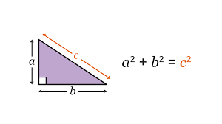
- A mathematical conjecture is a statement that is believed to be true based on observations and patterns but has not yet been proven or disproven.
E.g., Goldbach's Conjecture (stated in 1742): Every even integer greater than 2 can be expressed as the sum of two prime numbers. E.g.,
- 16 = 5 + 11
- 100 = 3 + 97 = 11 +89 = 17 + 83 = 29 + 71 ...
The Goldbach's conjecture is very easy to state but extremely hard to prove (one way or the other).
Example #2: History
- An important objective: understand the past to better comprehend the present and potentially inform the future.
- Methodology: a range of techniques and procedures for gathering, analyzing, and interpreting evidence from primary and secondary sources to construct a narrative and understanding of historical events.
- Some quality considerations:
  - Source selection, evaluation and preparation
  - Objectivity and bias mitigation
  - Methodology rigor
  - Narrative and communication
2. Computing and software development
- What is computer science?
- An example: Computer science (CS) is the study of computers and algorithmic processes, including their principles, their hardware and software designs, their applications, and their impact on society. (Tucker et al., 2003.)
- It is difficult to find another discipline more applicative than computer science.
- Computer professionals should be generalists.
Software Development
- primary objective: problem solving using software.
- methodologies: computer and software development techniques (that is what your computing degree means).
- One clear quality consideration: correctness, or does the program provide the right answer (expected output)?
  - Software testing is about increasing confidence in correctness.
  - A test case specifies:
    - input
    - expected output
  - A test case is passed when the expected output is equal to the actual output.
E.g., a Python to output the square of an input integer.
Test cases:
Case # | Input | Expected Output
1 | 3 | 9
2 | 65 | 4425
3 | 0 | 0
4 | -65 | 4425
5 | 123456789 | 15241578750190521
6 | 'hello' | Error: input is not an integer.
- Some important software development quality considerations:
  - Correctness:
    - Software verification:
      - Software built according to the software specification. Is the software built right?
      - Internal correctness
      - e.g. does the program output the square of the input number right?
    - Software validation:
      - Software met the needs of the problem. Is it the right software?
      - Constructing the right software specification: requirement analysis.
      - External correctness
      - E.g., do the users want the square of the input number?
  - Performance
  - Cost
  - Meeting timeline
  - Effectiveness
  - Reliability
  - Maintenance: software has a life cycle
  - Security and privacy
- Do not just focus on internal correctness or software verification.
3. Skills/Traits/Quality/Characteristics of software developers
- People of course have different opinions.
- However, there are many commonalities.
3.1 A simple non-scientific experiment
Conducted a simple Google search for good software developer quality.
Four sources:
- Coding Temple, 6 Key Qualities of Successful Software Engineers, https://www.codingtemple.com/blog/6-key-qualities-of-successful-software-engineers/.
- MatchTech, 7 qualities exceptional developers possess, https://www.matchtech.com/resources/7-qualities-exceptional-developers-possess.
- UMBC, How To Know If Software Development Is The Right Job For You, 8 Hard To Learn Software Developer Skills You Need, https://www.umbctraining.com/software-developer-skills/.
- AlltheCode blog, Software Engineer Personality: 5 Traits For A Great Career, https://allthecode.co/blog/post/software-engineer-personality.
Results:
Coding Temple | MatchTech | UMBC | AlltheCode
Technical Expertise | Solid technical knowledge | Curiosity | Curiosity
Problem-Solving Skills | Maintains an end-user focus | Creativity | Persistence
Attention to details | Fast self learner | Empathy | Ability to learn
Strong communications and collaboration skills | Strong communication skills | Patience, Perseverance and Problem-Solving | Focus
Continuous learning and adaptability | Dependent time and task management | Analytical | Pragmatism
Passion for the craft | A good team player | Detail-oriented and organized
 | 'Never say die' attitude | Adaptability
 |  | Communication
- Although you can see their differences, some focus more on skills and qualities. Others focus more on traits.
- However, there are some common themes:
  - Strong technical knowledge and expertise
  - Strong problem-solving skills: analytical
  - Good problem understanding: empathy, focus on end users, ...
  - Strong communication skills
  - Strong collaboration skills: good team play, dependable
  - Continuous and fast self-learning
  - Curiosity: passion for the craft
  - Persistence: never day die, passion for the craft
  - Organization and management skills
  - Detail-oriented
  - Adaptability
Some Lessons
- We tend to focus on technical matters in our computing degrees.
- Success in the computing profession requires much more than technical expertise. It will be increasing more so.
- Personal traits, characteristics, habits, etc. take a lot of effort and time to develop.
- Consider spending effort and time to cultivate them early and persistently.
- Your university degree may give you an entrance ticket to the job market but it is not sufficient by itself.

