CSCI 1470.3 Classroom Notes and Demonstrations
9/8/2025
Python IDLE
by K. Yue
1. Python IDLE
- Python IDLE is bundled in the Python distribution. There is no need for separate installation.
- IDLE can be regarded as a very simple Integrated Development Environment (IDE). It is used in this class.
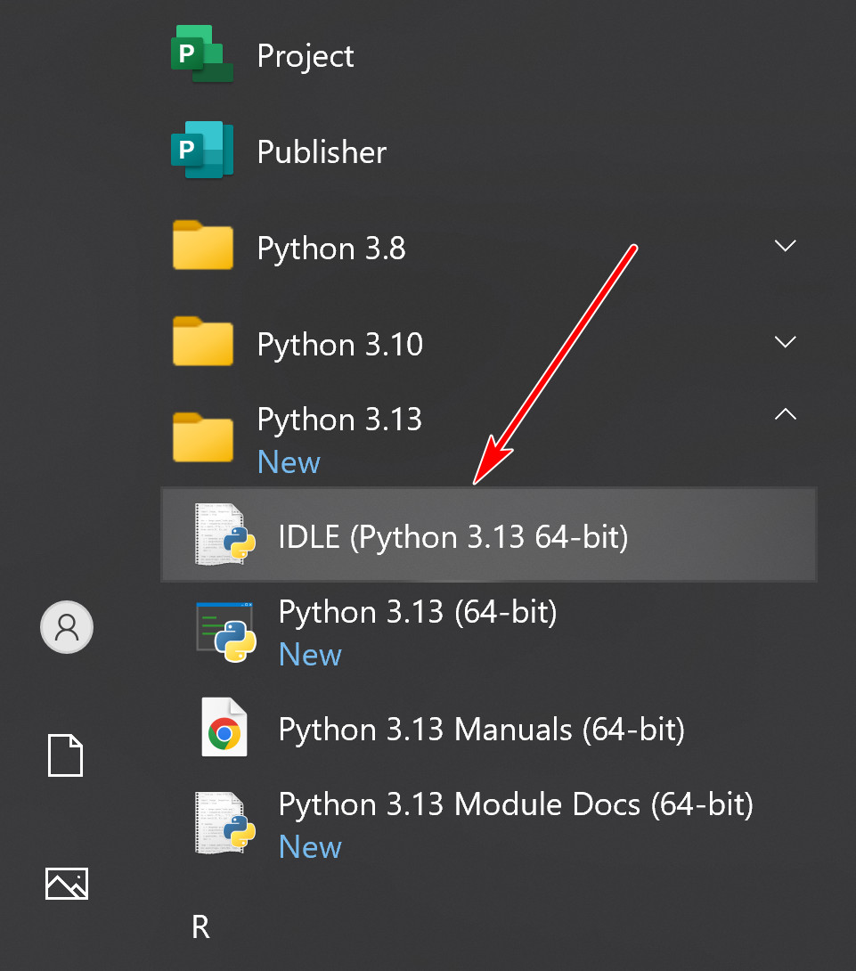
- A short IDLE tutorial: https://www.youtube.com/watch?v=WIlQukiXs-E. (a little dated)
- https://realpython.com/python-idle/ is a very good tutorial on IDLE. However, it contains many topics not needed in this class.
2. Running IDLE shell as interpreter
- When you start IDLE, a shell window appears.
- IDLE shell is an interactive interpreter with REPL (Read-Evaluate-Print loop)
  - Read a Python statement, single-lined or multiple-lined.
  - Evaluate or execute the statement.
  - Print the result of execution of the statement.
- A shell contains the collection of Python code the user entered interactively.
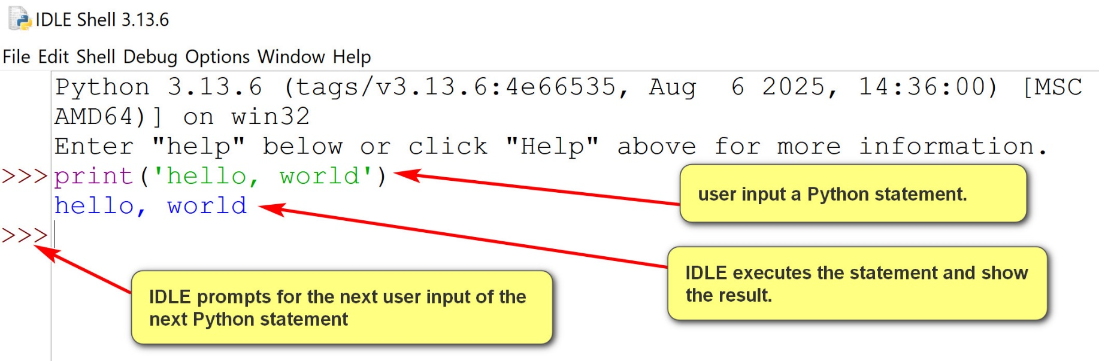
2.1 Logging a shell session
- Logging is a crucial practice and habit in software development.
- Logging tracks program behavior and problems, enables debugging, supports performance analysis, supports auditing, monitors security and informs users, administrators, and developers.
- IDLE shell session can be logged by saving it in a file.
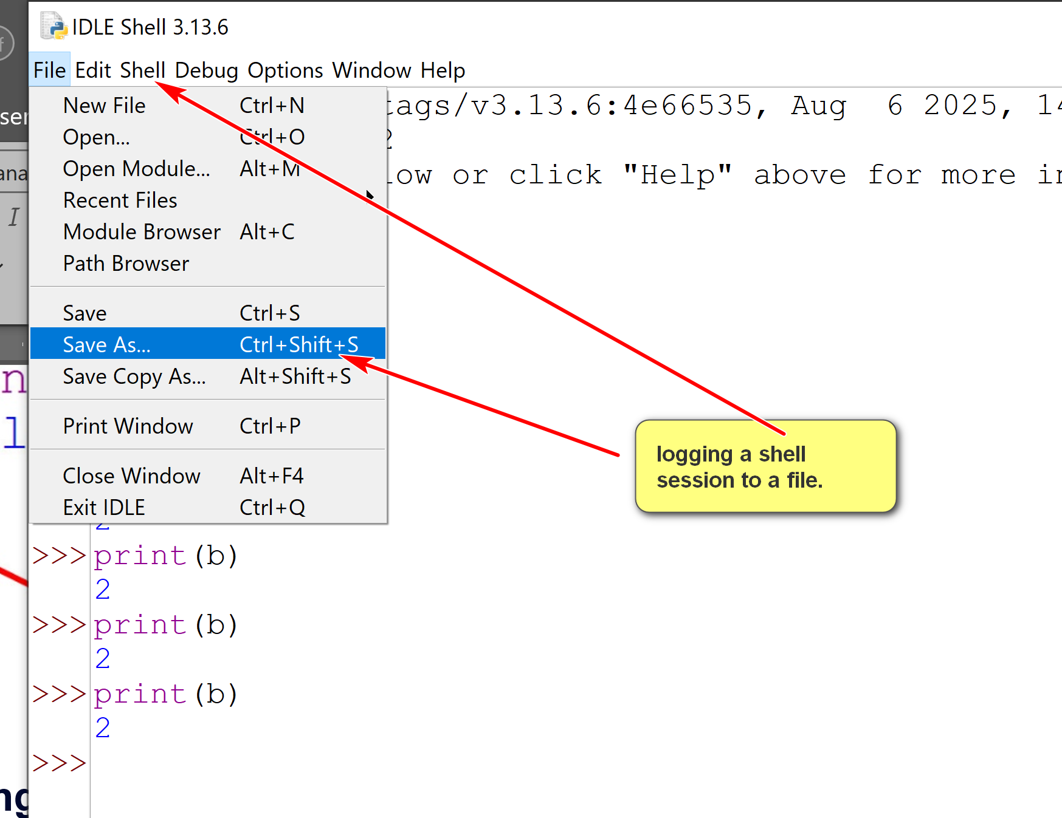
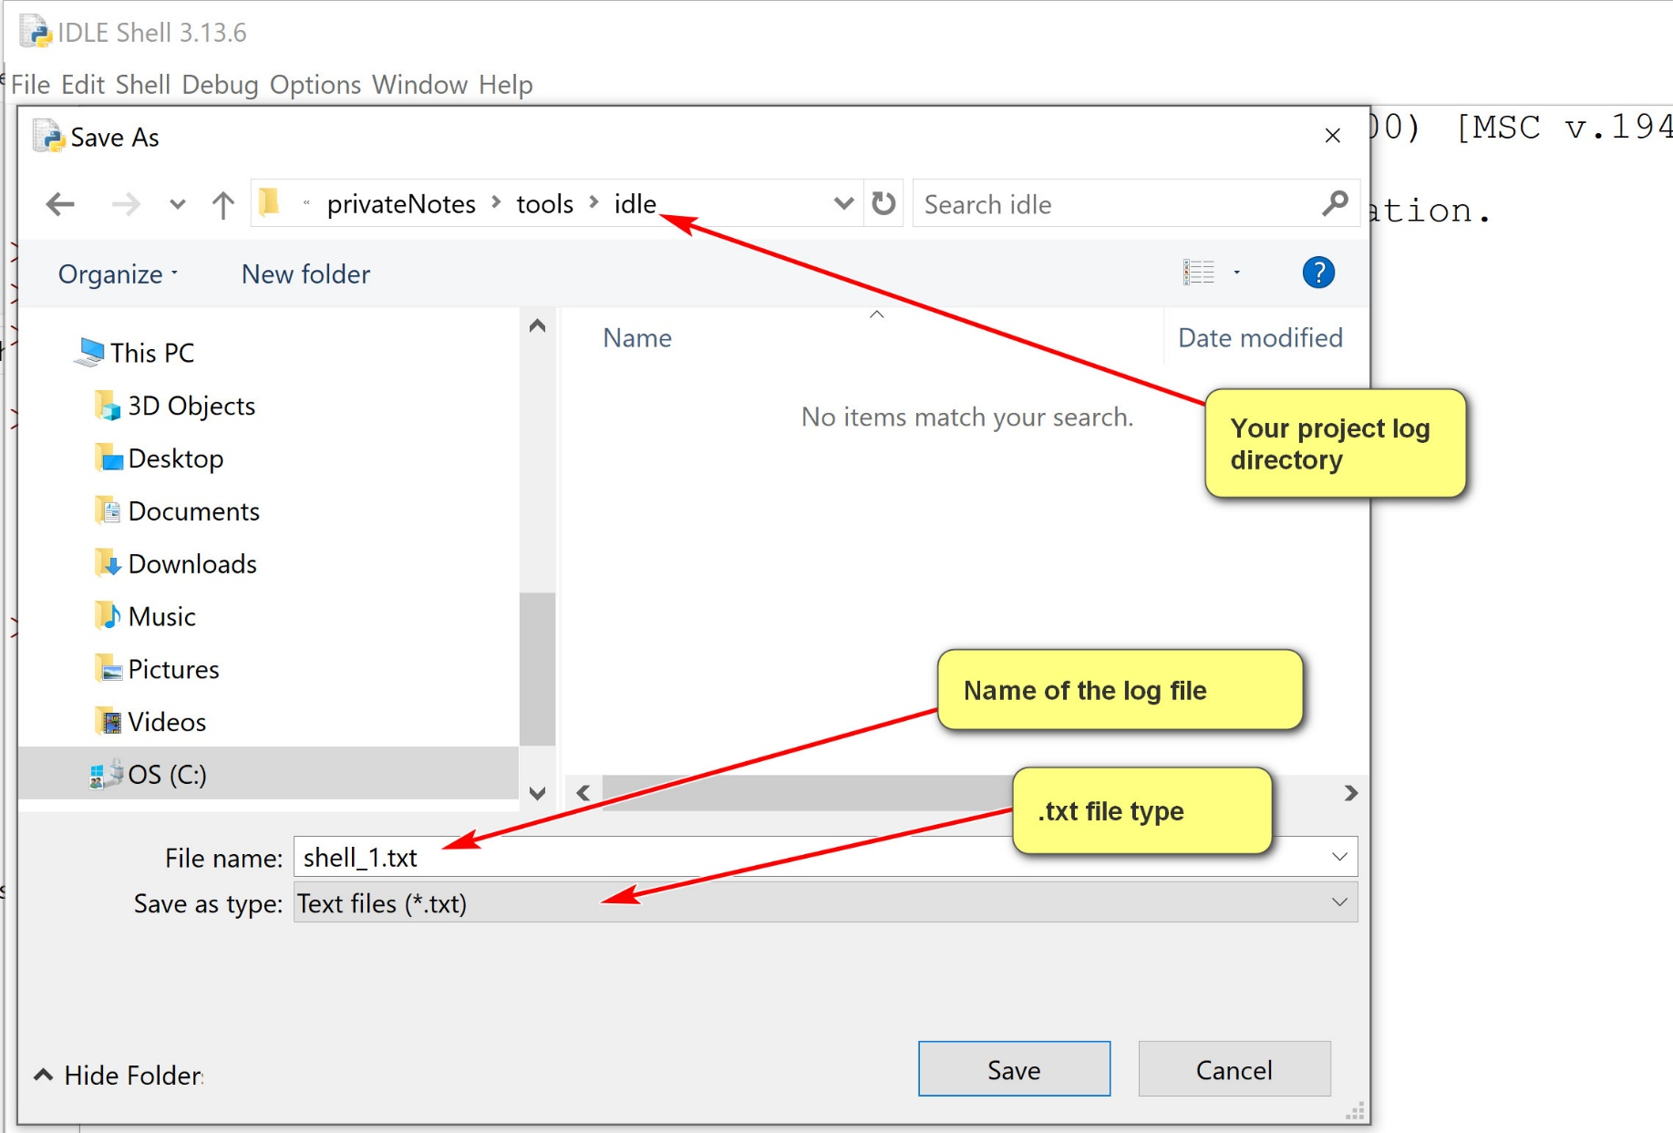
A shell session has internal states.
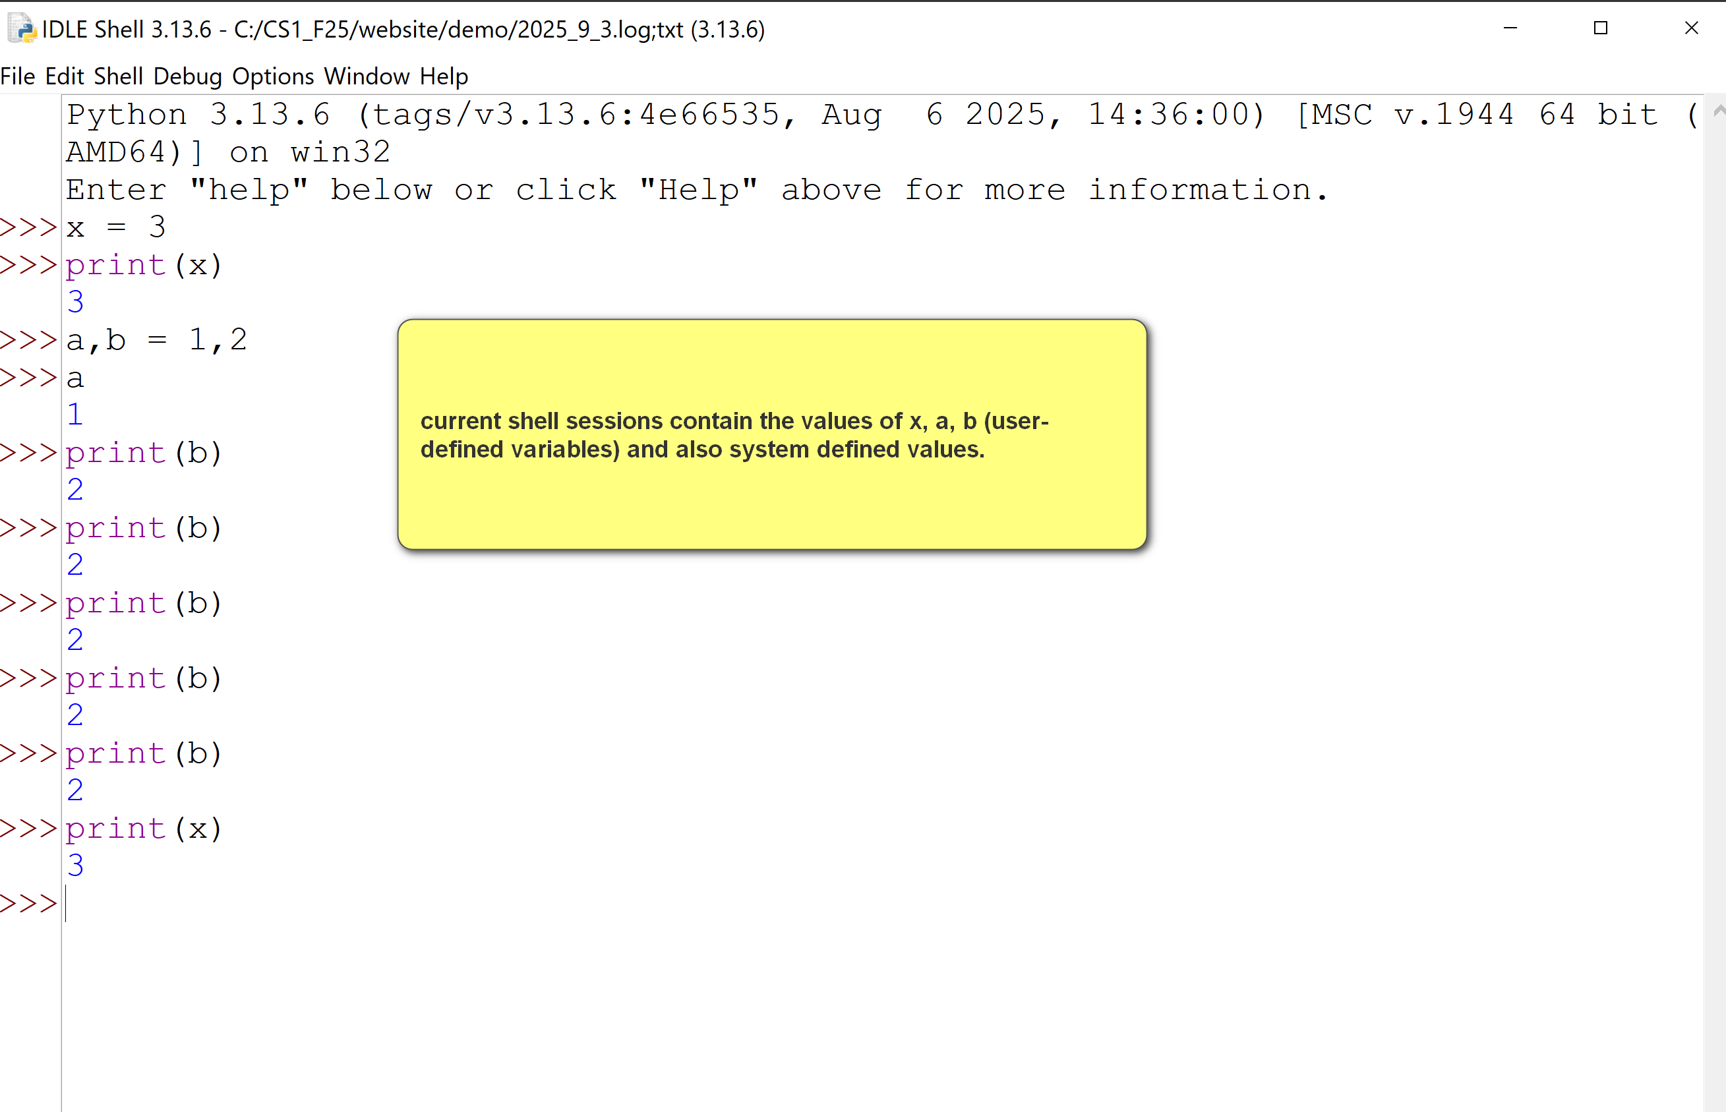
Restarting shell -> clean up the internal state.
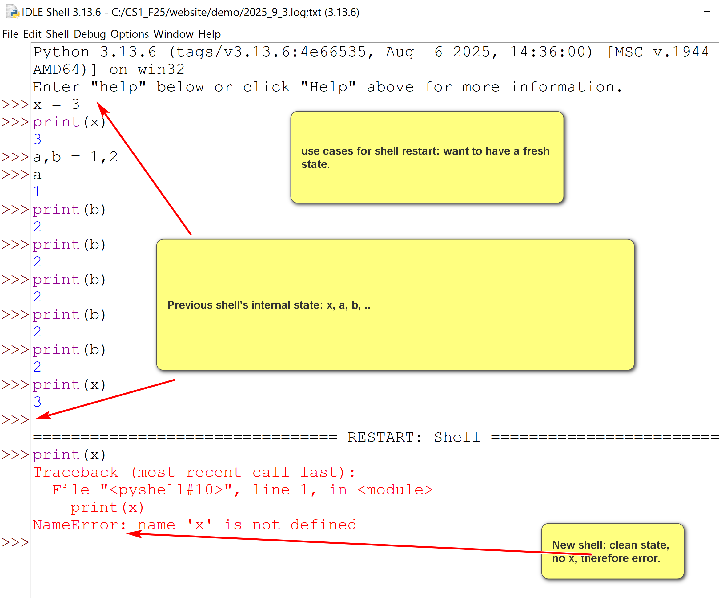
Shell Menu
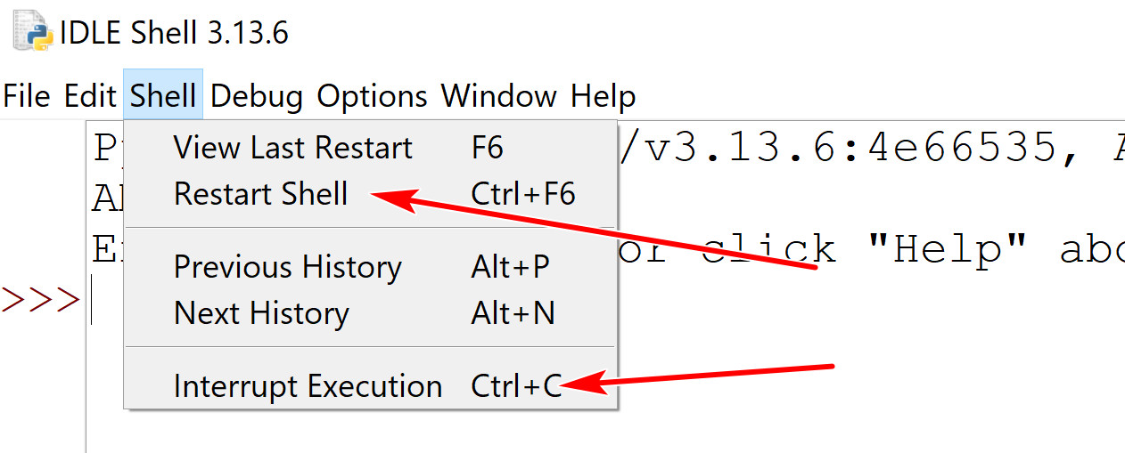
- Two buttons you may use:
  - Restart shell: start a new shell session.
  - Interrupt Execution: stop the execution (in case you get into an infinite loop)
3. Python program file editing and execution
- Shell includes a text editor.
- One can open an existing Python program file, or create anew Python program file.
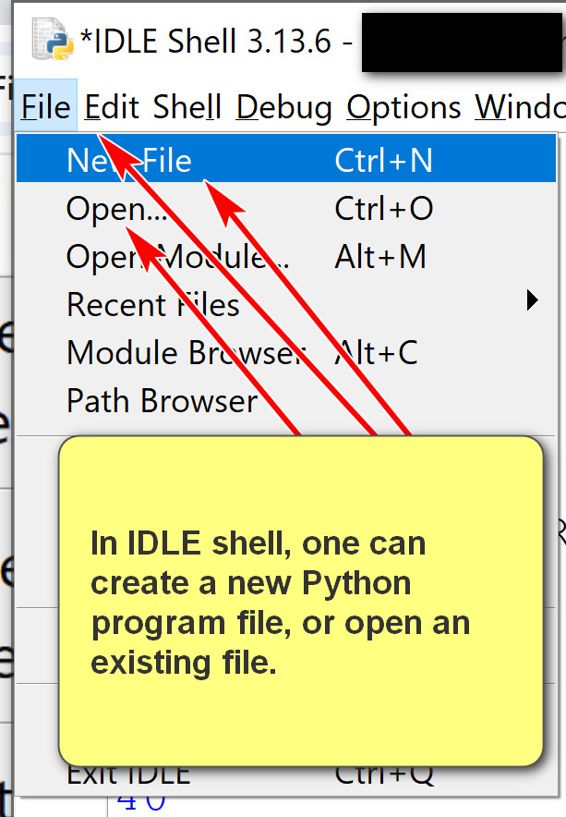

Open an existing file, square.py:
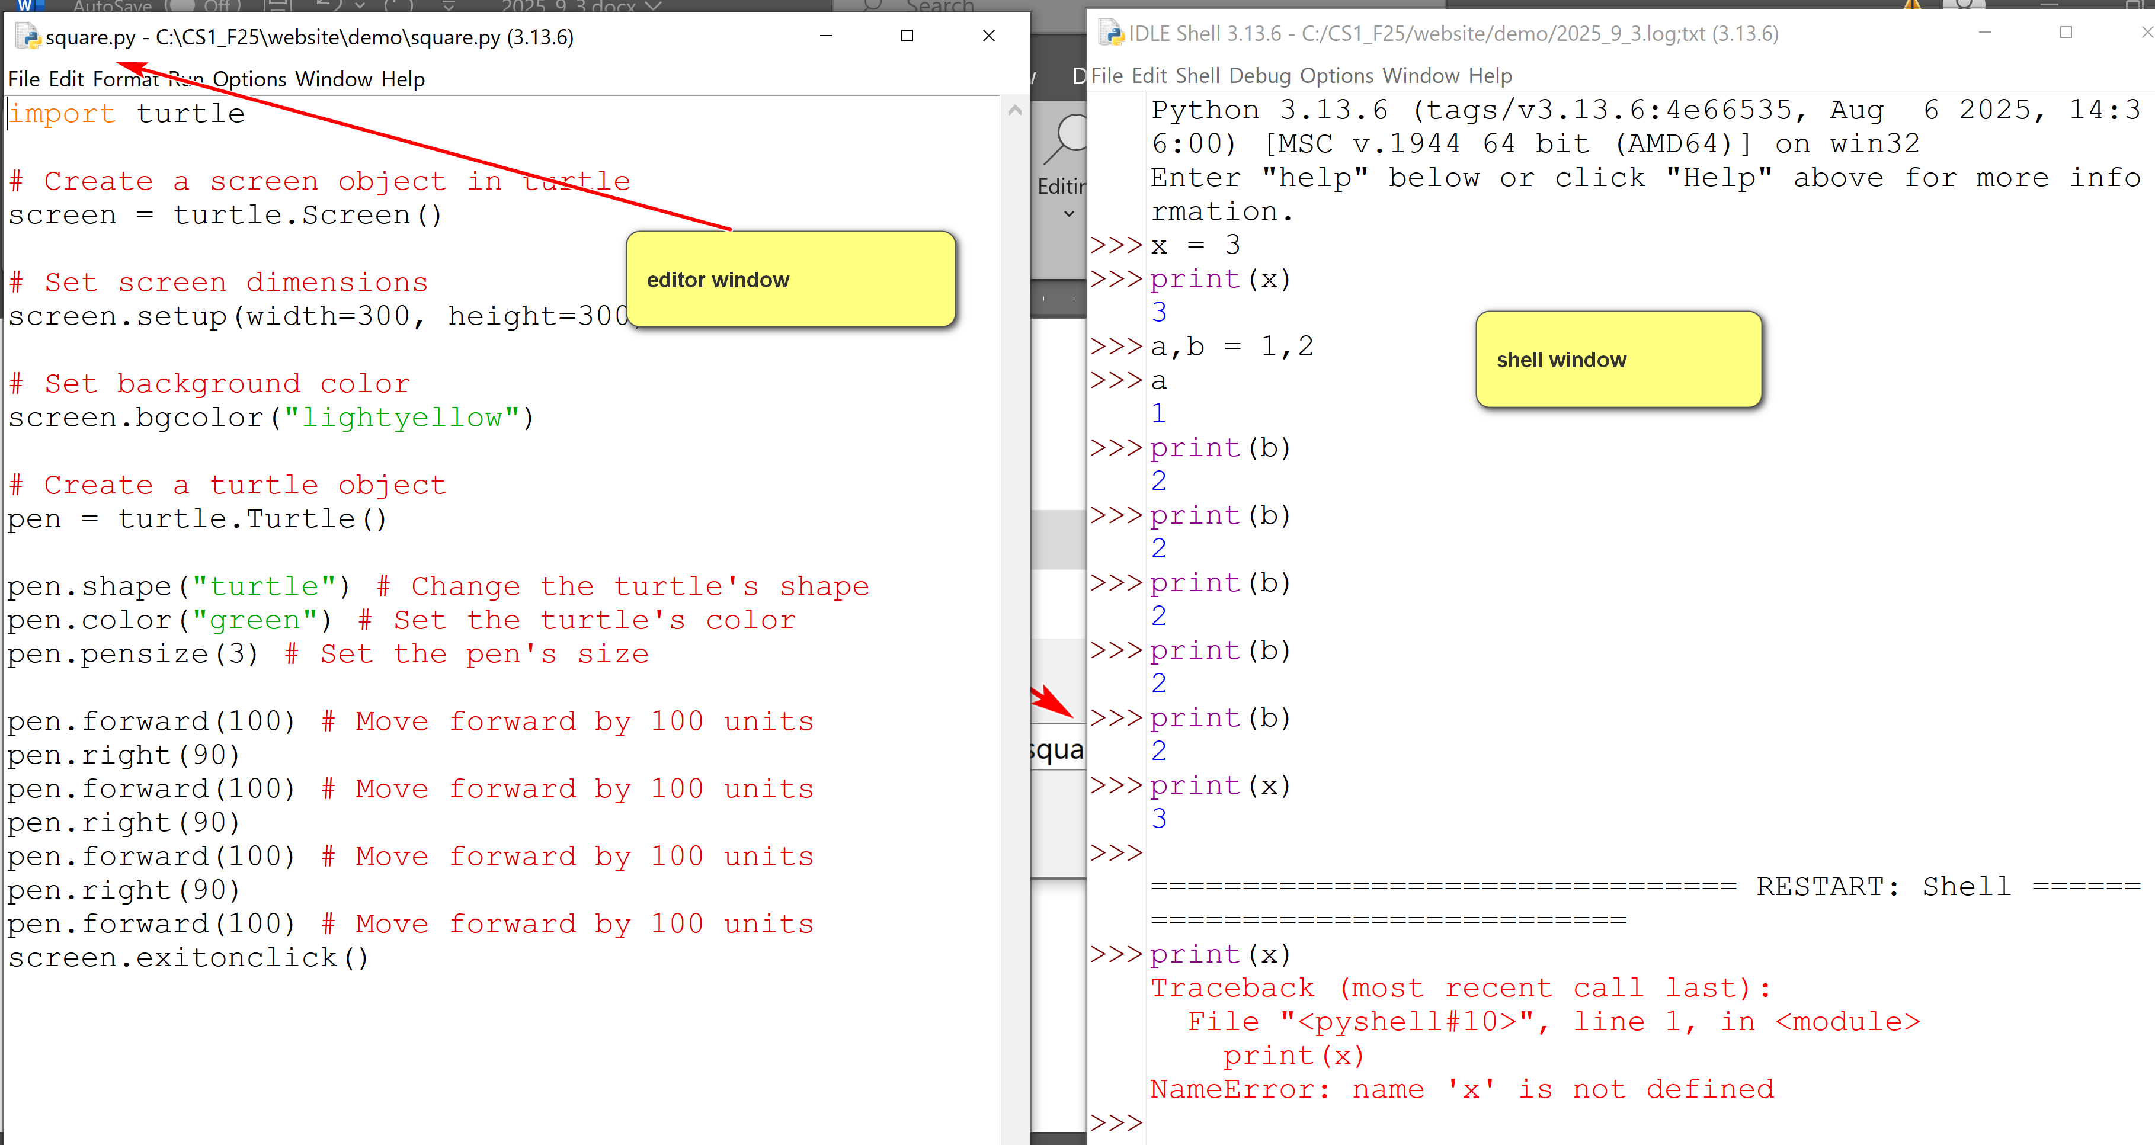

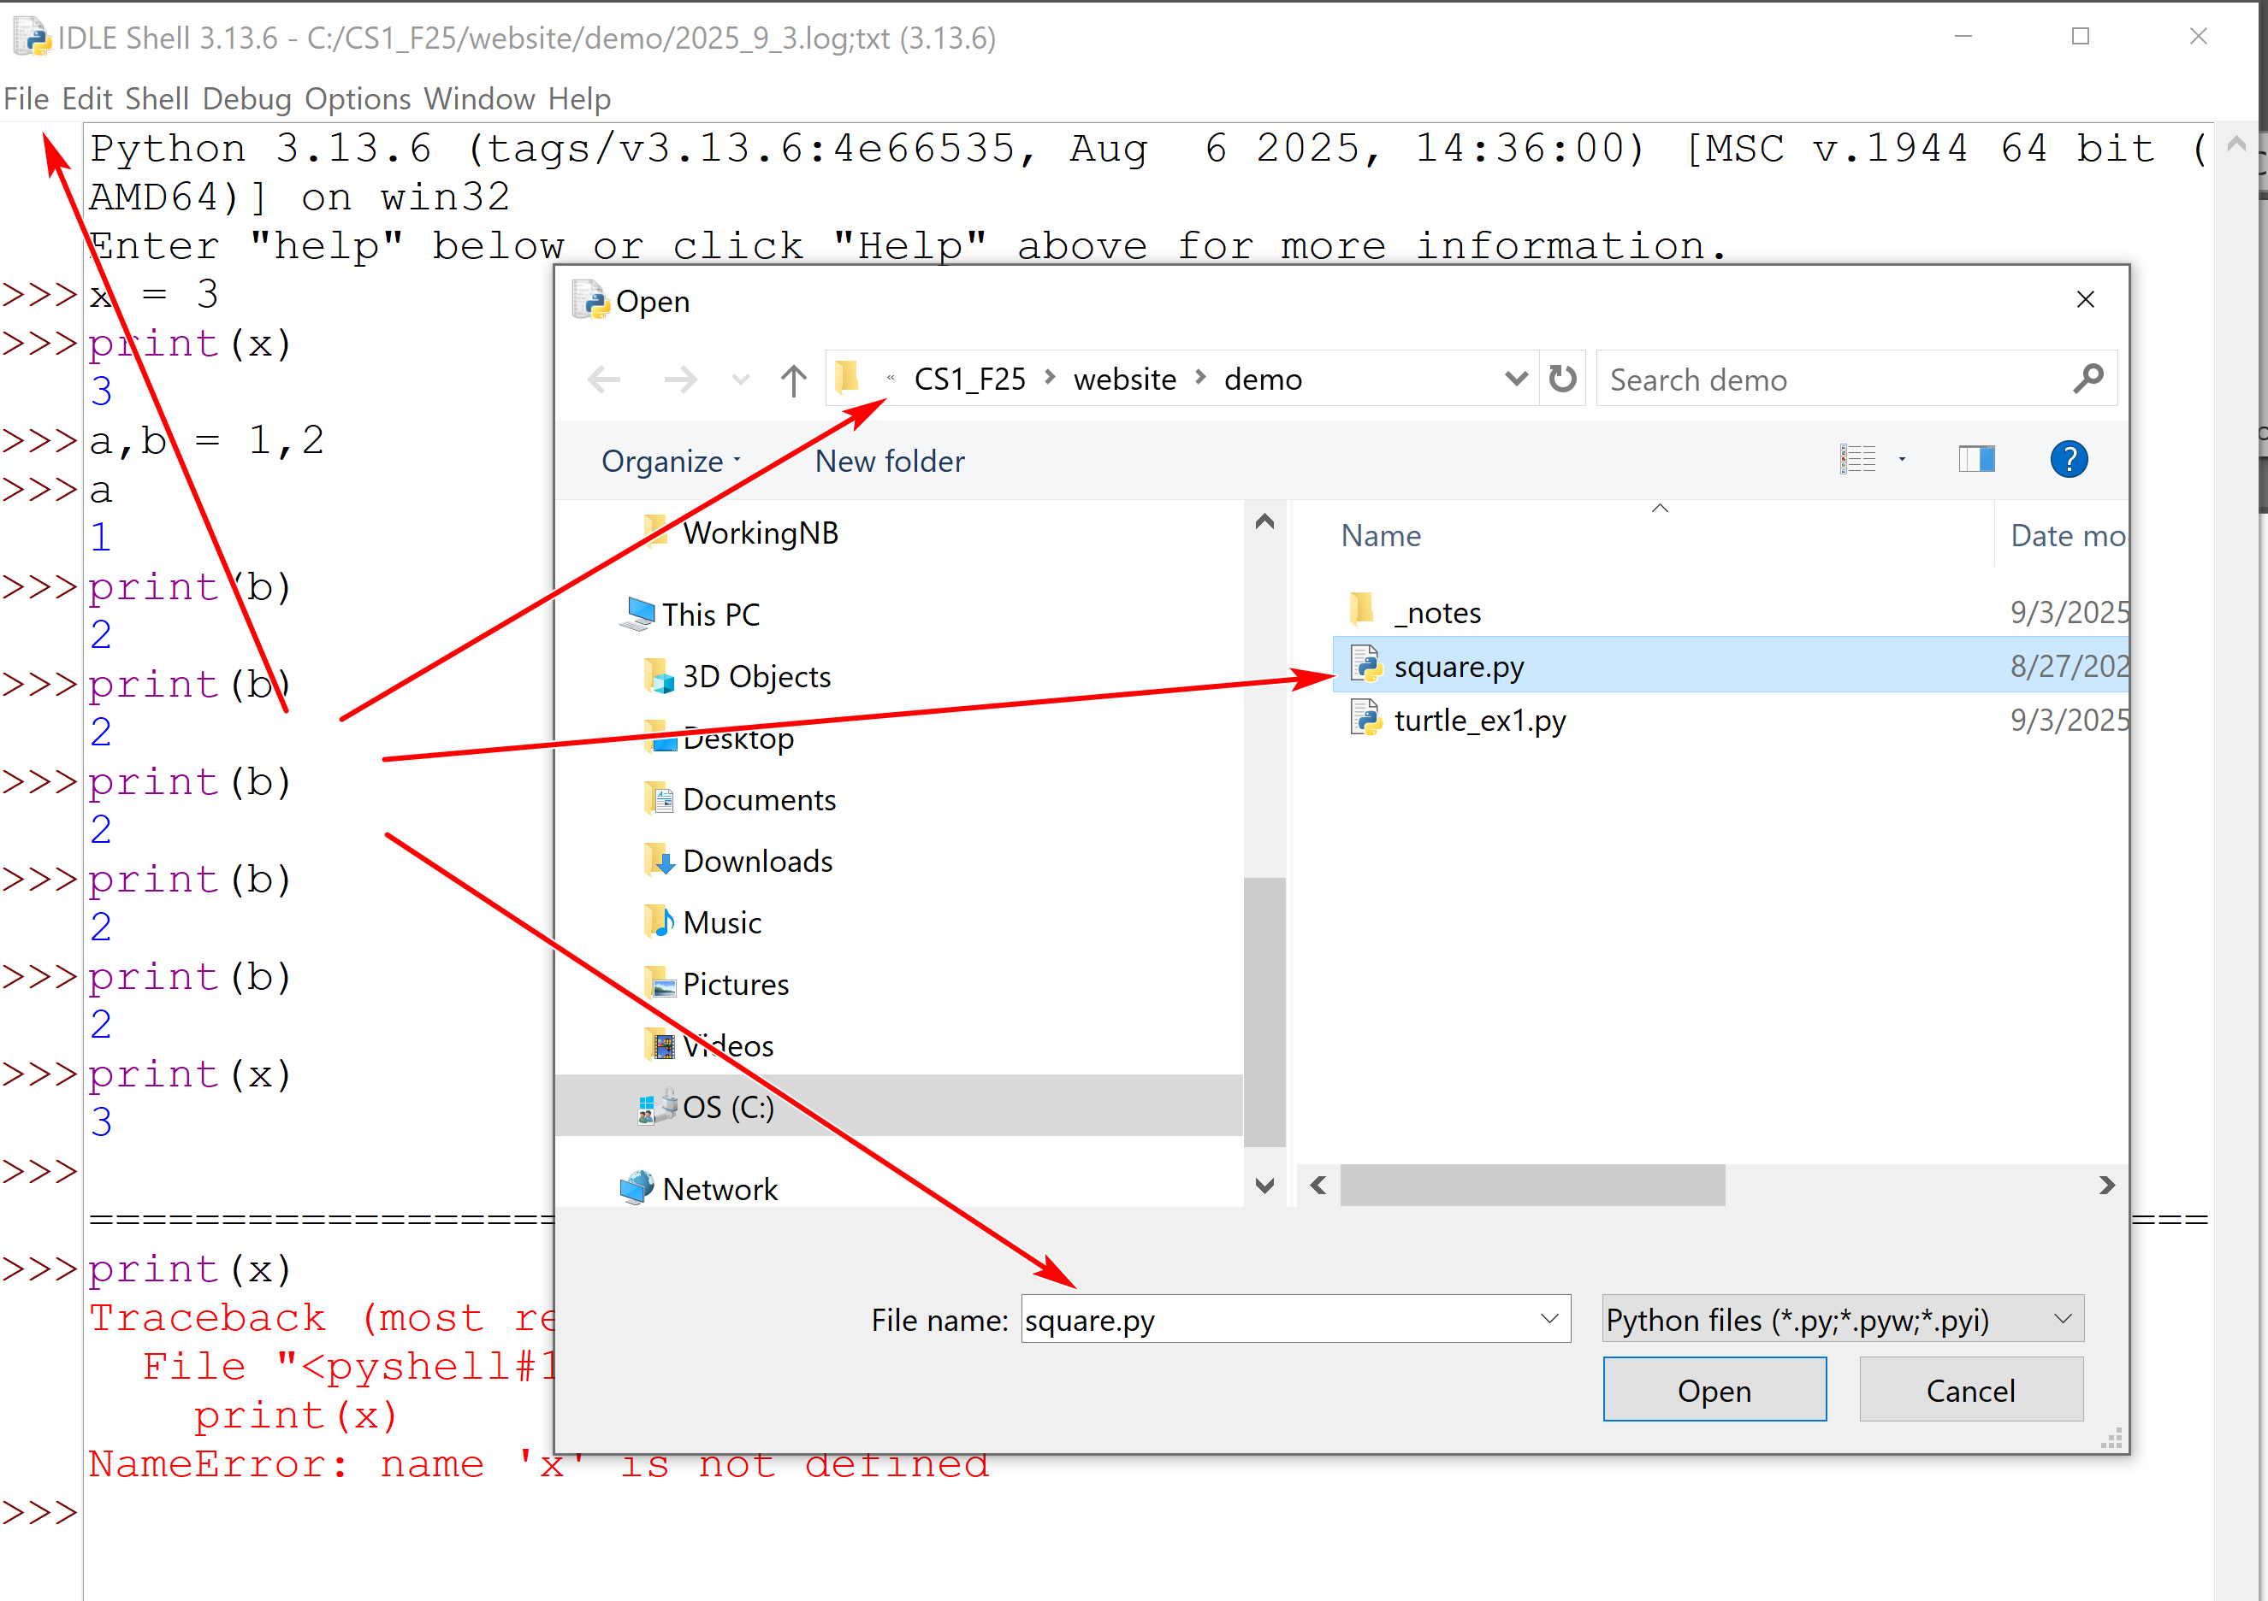
Running square.py
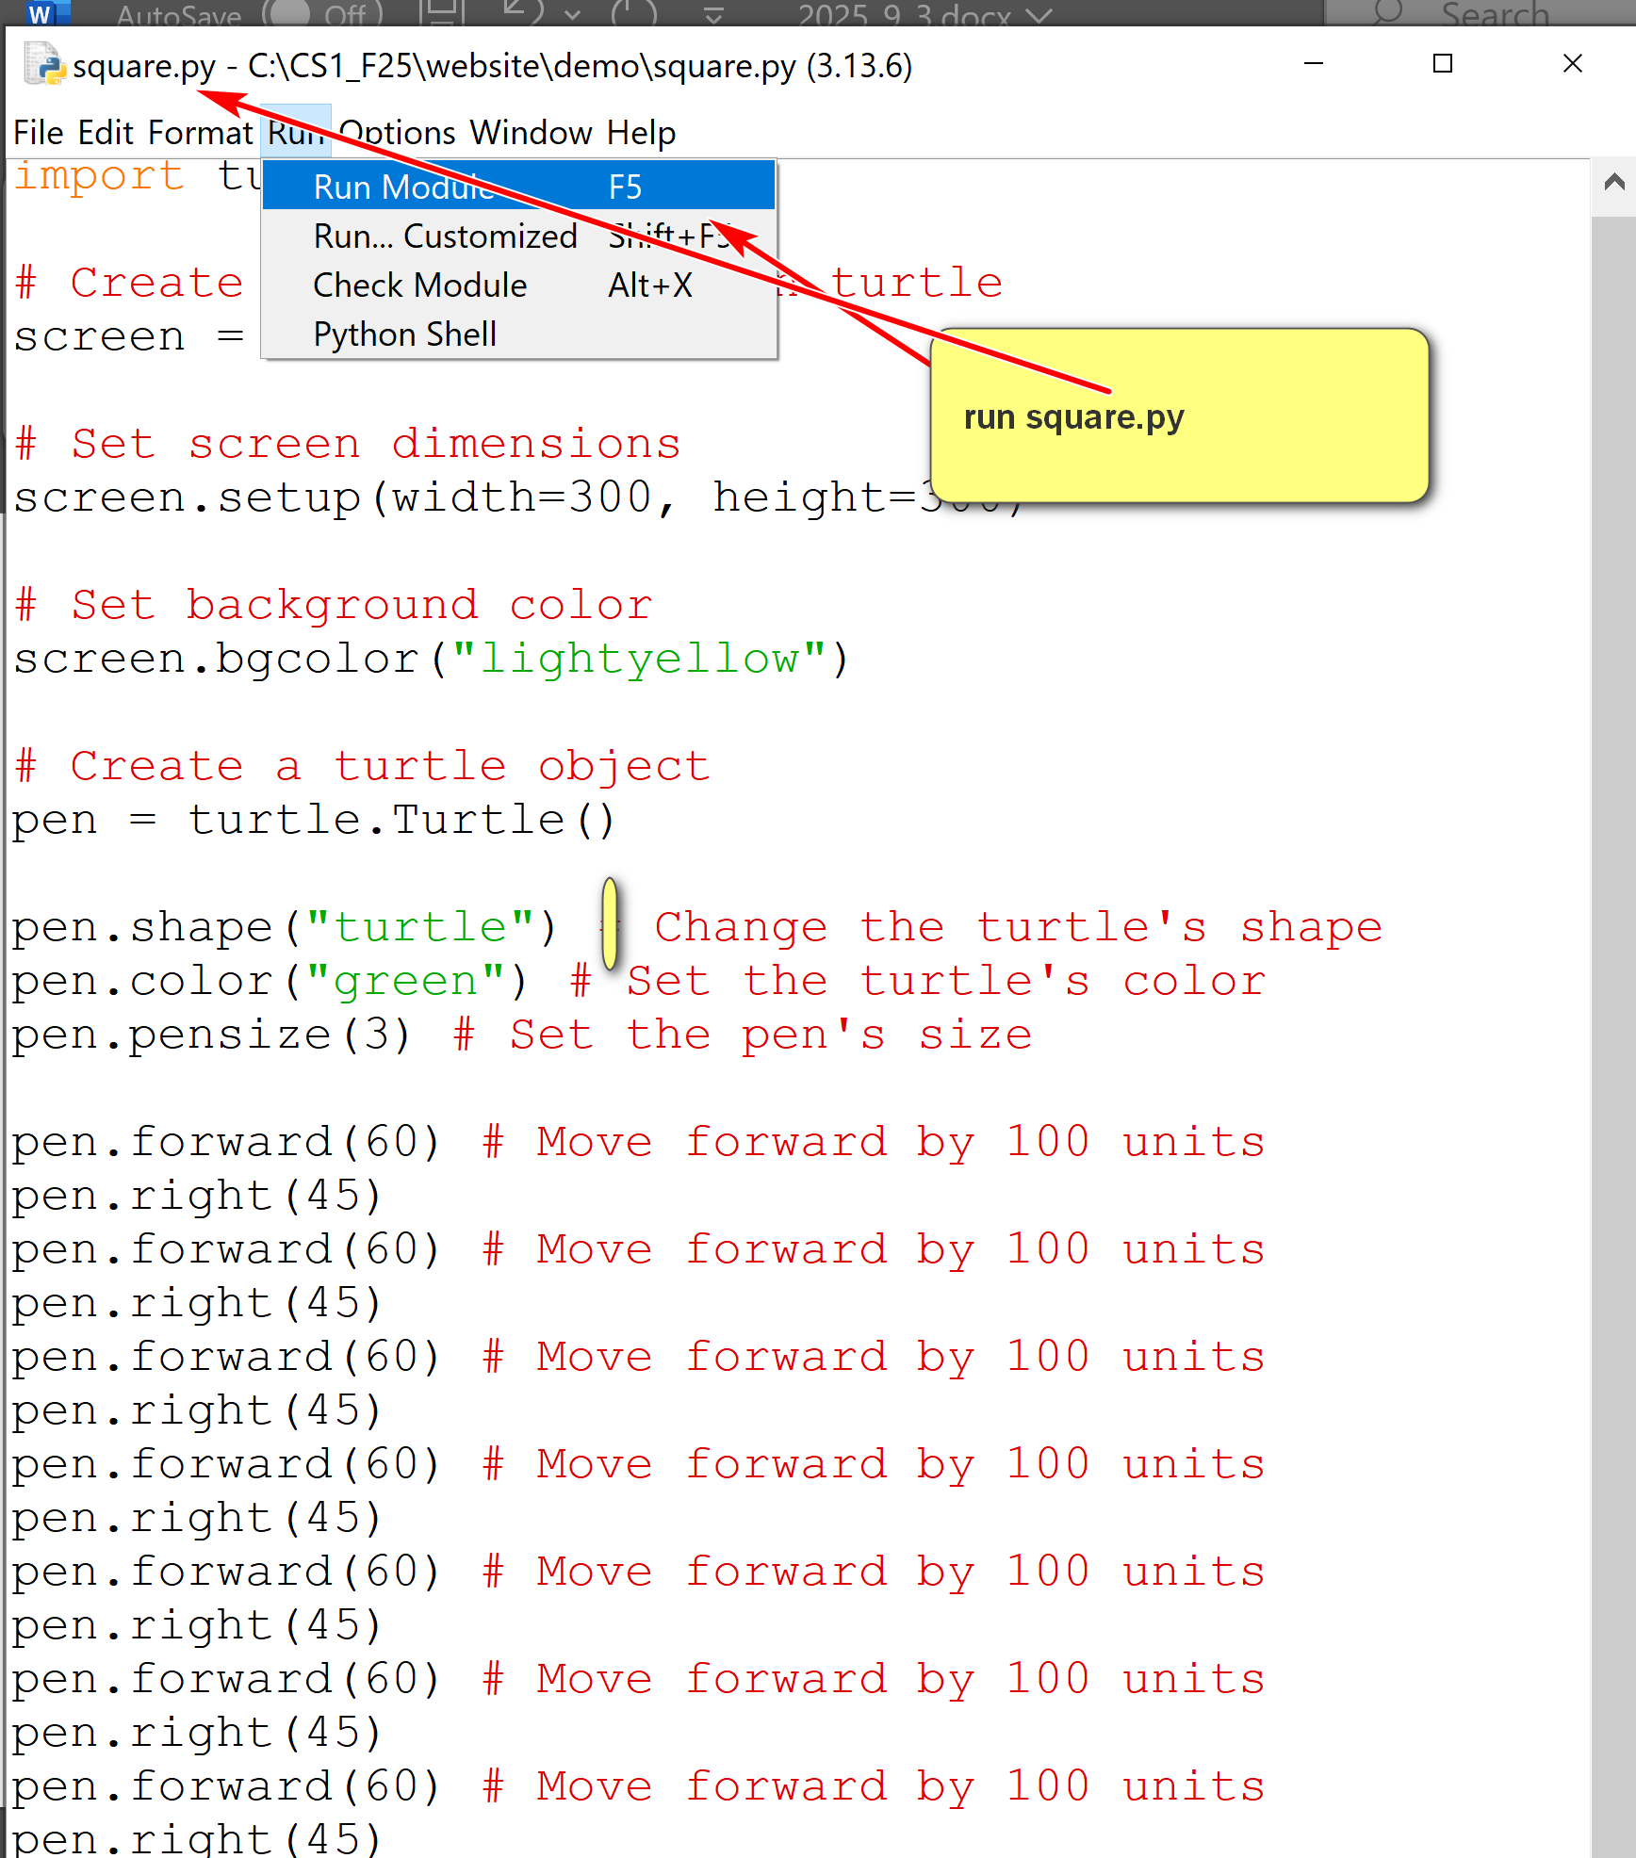

- The file editor has many features.
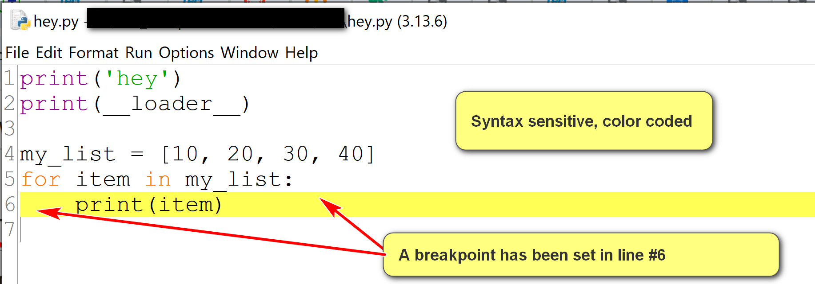
- Some features you may use:
  - Use the options menu to show line number.
  - Set and clear breakpoints for debugging.
  - Run the program by using Run->Run Module.
4. Debugging in IDLE
- A good tutorial in IDLE: https://www.cs.uky.edu/~keen/help/debug-tutorial/debug.html. Contain more than needed in the class.
- To debug a Python program:
  - Open the Python program using IDLE Shell: File -> Open.
  - Turn on the Shell debugger: Go->Debugger
  - Run the program in the editor using Run->Run Module.
  - Use the debugger window.
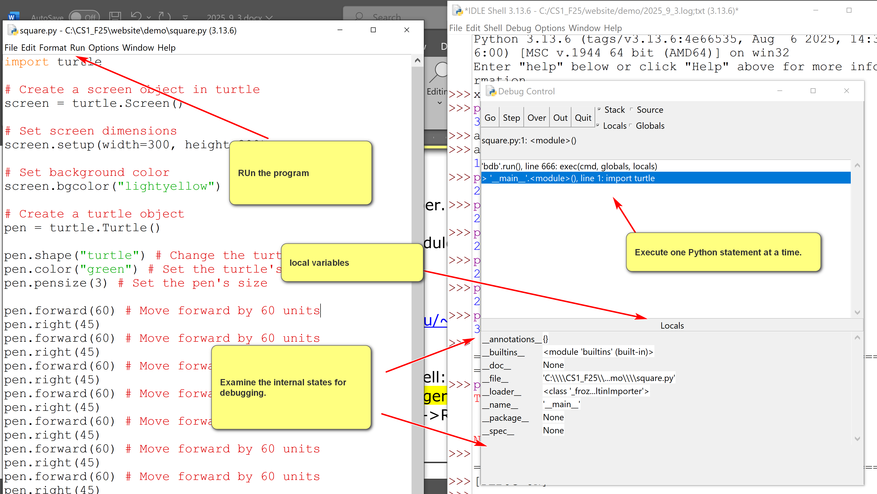
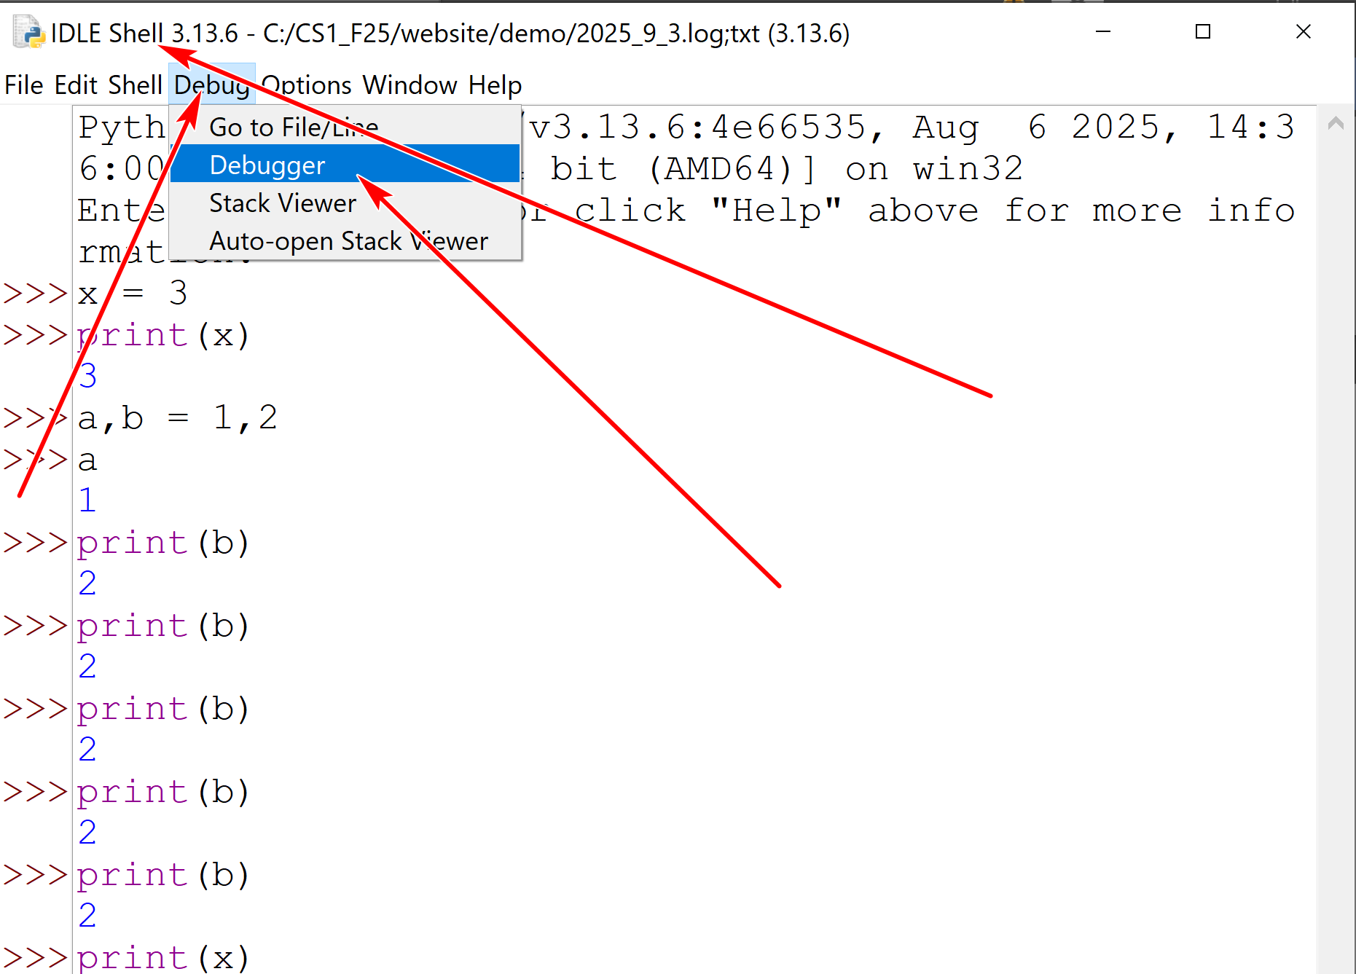
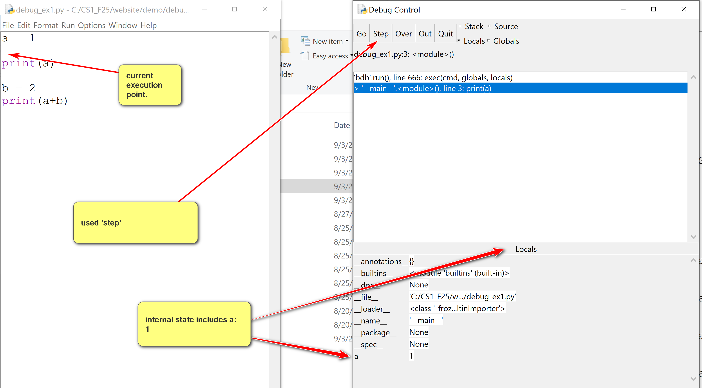
- Some basics:
  - Use the go button in the debugger window to execute.
  - Set and clear breakpoint in the editor.
  - Examine the locals window in the debugger.
When the debugger window is started, in the example below, the locals window shows values of local variables.
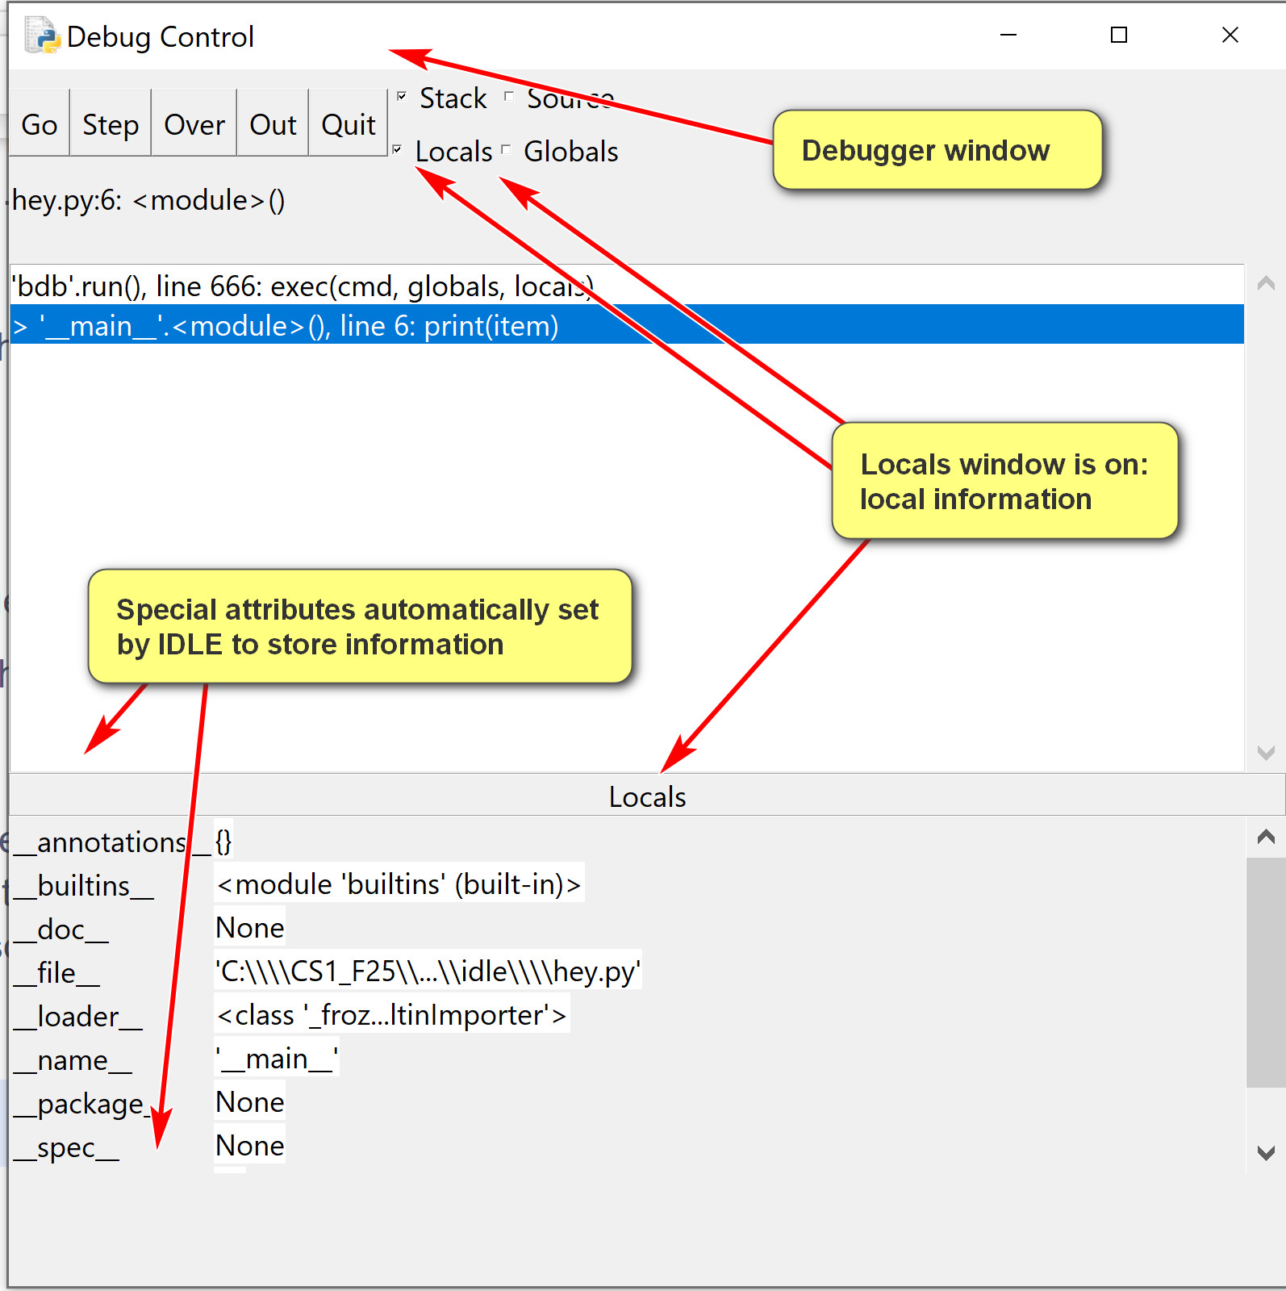
An example of using breakpoints:
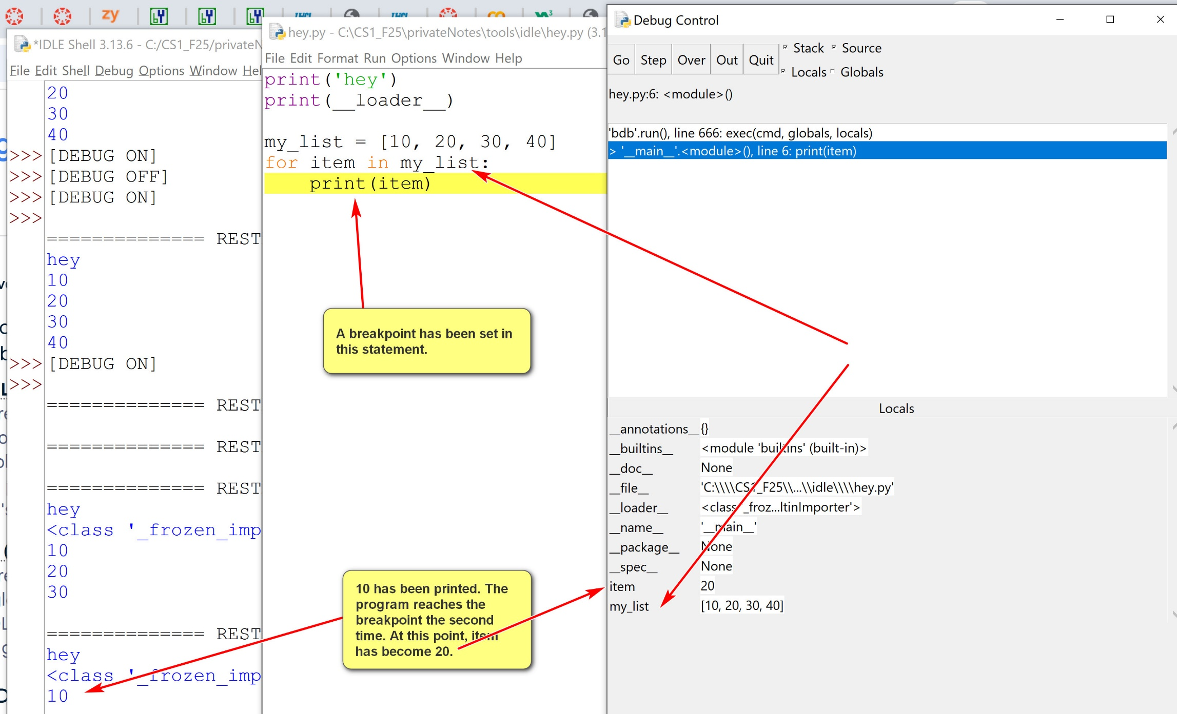

- Useful debugger options:
    - step: one step at a time, including lower level function calls.
    - over: one step at a time, not including lower level function calls. Probably more useful than 'step'.
    - go: executes full theprogram.

  - Set breakpoints.
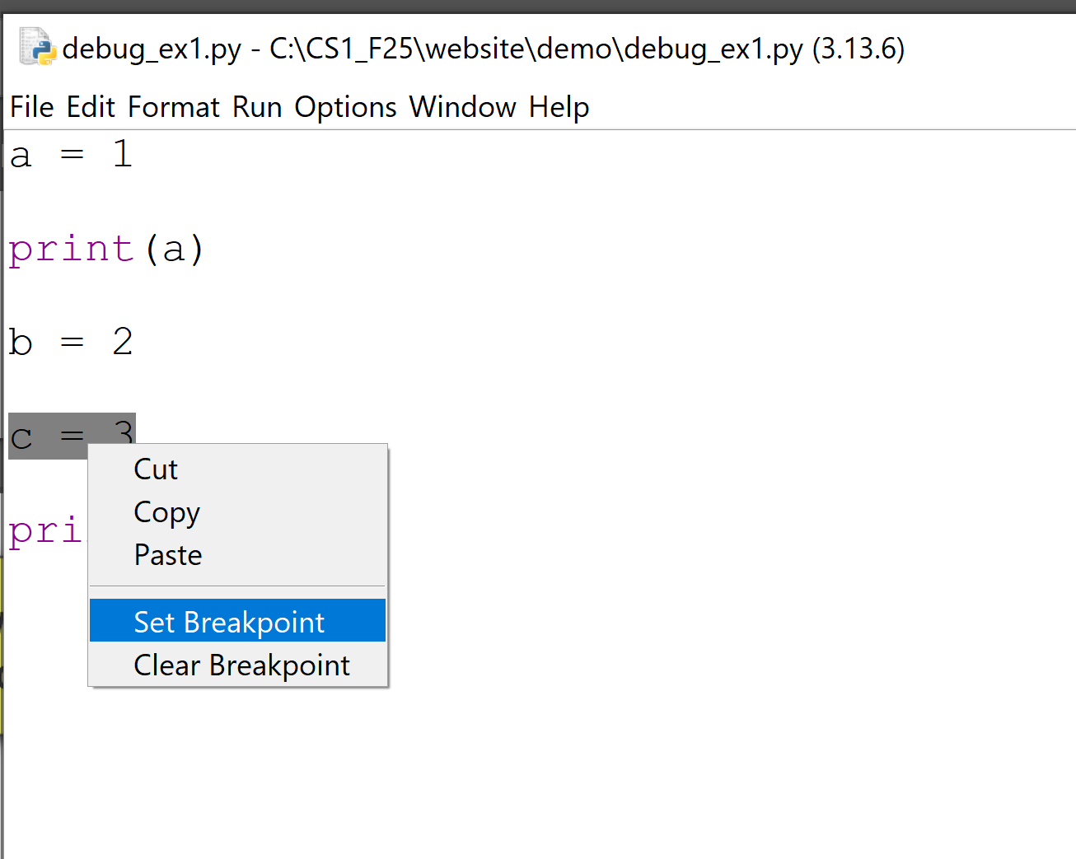

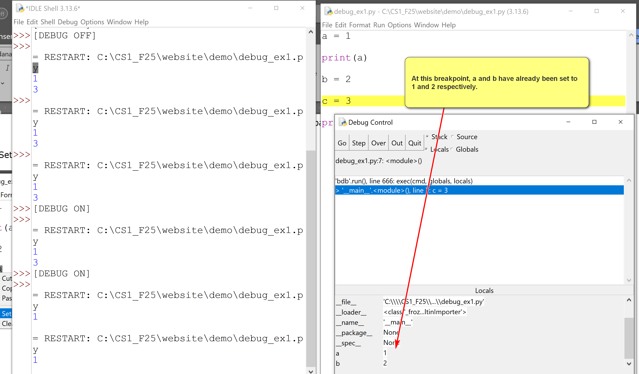

Computer Systems: an introduction
CSCI 1470
by K. Yue
1. Computers
- A computer contains four major components:
  - Input: devices for entering data to the computer. E.g., mouse, keyboard, drawing pad, microphone, etc.
  - Processing: components for processing data. E.g., Computer Processing Unit (CPU), Graphical Processing Unit (GPU), etc.
  - Storage: storage of data
    - Transient data: data will be lost after programs or systesm terminate. Mainly primary memory (stored in random access memoery, RAM)
    - Persistent data: data will persist after programs or systems terminate. Secondary memory such as hard disk and flash memory.
  - Output: devices for presenting results, such as monitors and printers.
2. Computer Data
- Data is represented, transmitted and processed as bits.
- A bit is a binary digit, 0 or 1. It is the smallest information unit.
- A Byte is a group of 8 bits.
- A word is a fixed-sized datum handled as a unit by the instruction set of a computer processor. It is the size of primary registers of a CPU.
- Note that terms may have different meanings under different context. For example, in Microsoft's Application Program Interface (API), WORD is 2 Bytes or 16 bits.
Example:
Intel 4004:
- Launched in 1971.
- Intel's first 4 bit processor.
- First microprocessor chipset
- Data Width: 4 bits
- Address Width: 12 bits (addressable space: 2 ** 12 = 4096)
- Max CPU's clock rate: 740 KHz to 750 KHz
- Number of transistors: 2,300
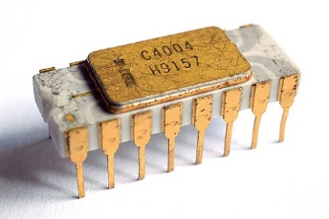
Intel 8008:
- Launched in 1972.
- Intel's first 8 bit processor.
- Data Width: 8 bits
- Address Width: 14 bits
- Max CPU's clock rate: 500KHz to 800 KHz
- Number of transistors: 3,500
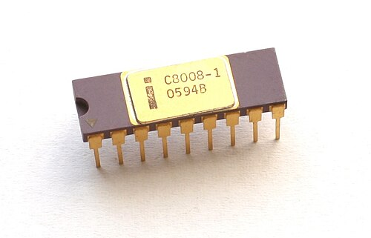
Intel 8086:
- Launched in 1978.
- Intel's first 16 bit processor.
- Launched x86 architecture.
- Data Width: 16 bits
- Address Width: 20 bits
- Max CPU's clock rate: 5MHz to 10 MHz
- Number of transistors: 29,000
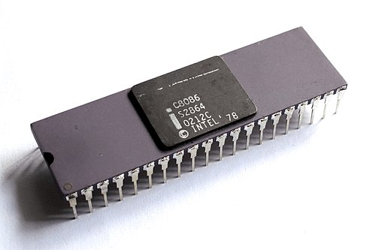
Intel 80386:
- Launched in 1985.
- Intel's first 32 bit processor.
- Data Width: 32 bits
- Address Width: 32 bits
- Max CPU's clock rate: 12.5MHz to 40 MHz
- Number of transistors: 275,000
- 132 pins
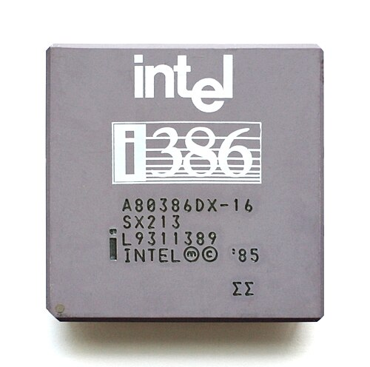
Intel Pentium 4 Prescott (E0 Revision)
- Launched in 2005.
- Intel's first 64 bit processor for desktop computer (Intel 64 bit for server, Itanium, was launched in 2001),
- Data Width: 64 bits
- Address Width: 64 bits
- Max CPU's clock rate: 2.8 to 3.8 GHz
- Number of transistors: 125 millions
- 478 pins
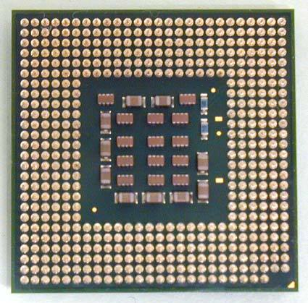
Intel Core i9-14900K
- Launched in 2023.
- $438 at Amazon, checked 8/24/2025.
- Data Width: 64 bits
- Address Width: 64 bits
- Max CPU's clock rate: 6.0 GHz
- Number of transistors: 28.5 billions
- Number of cores: 24
- Pinless design: use LGA 1700 socket to interact with the motherboard, which has 1,700 interaction with the motherboard.
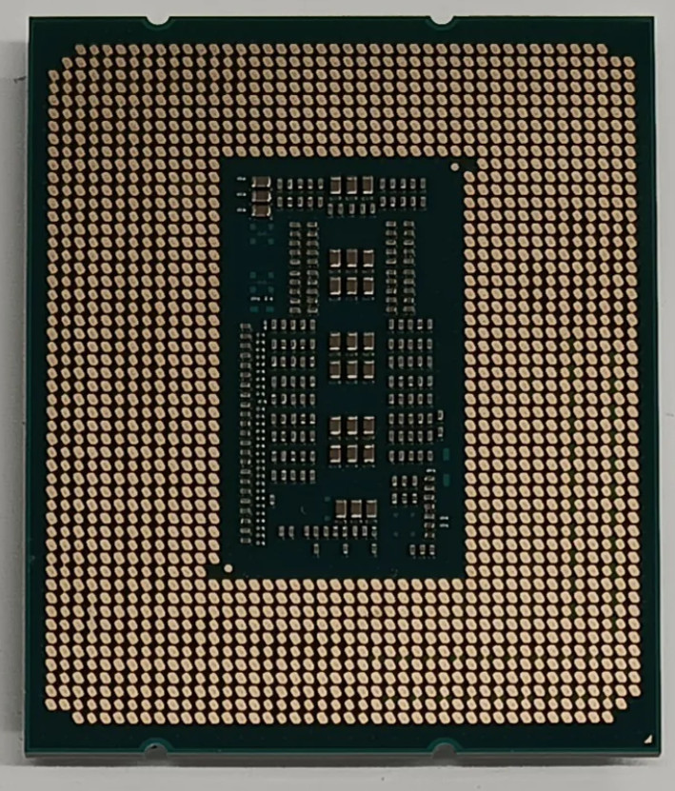
3. Assembly Language
- Assembly language is a low-level programming language to instruct the CPU execution.
- Assembly language instruction has a strong, often one-to-one, correspondence with the machine code instructions that a computer's processor directly executes.
- Before a CPU can process data, data need to be hold in storage areas: registers.
- An assembly language program mainly involves more data in and out of registers and perform instructions on these registers.
- An assembly language is low level, allowing very detailed control of the computer execution. It is used mostly in systems programming and embedded systems.
- As a result, a high level language, such as Python, is used for application programming.
Example:
An assembly language program in x86 under Linux to add two numbers is shown below. You do not need to know the meaning. Note that eax, ebx, ecx, etc. are general purpose registers.
section .data
num1 dd 5 ; First number (double word - 4 bytes)
num2 dd 3 ; Second number
result dd 0 ; Variable to store the sum
section .text
global _start ; Entry point for the linker
_start:
; Load the first number into EAX register
mov eax, [num1]
; Add the second number to EAX
add eax, [num2]
; Store the result from EAX into the 'result' variable
mov [result], eax
; Exit the program (Linux specific system call)
mov eax, 1 ; System call number for sys_exit
xor ebx, ebx ; Exit code 0
int 0x80 ; Invoke kernel
In Python:
num1 = 3
num2 = 5
result = num1 + num2

Python's Basics
CSCI 1470
by K. Yue
1. Python's Interpreter
- An interpreter is a program that executes code from a high-level programming language one statement at a time.
- A Python interpreter is a program that executes Python code one statement at a time.
- In windows, the Python interpreter is usually 'python.exe' in the installed Python directory.
Java: compiled programming language, not an interpreted language.
CS 2 uses Java

Example:
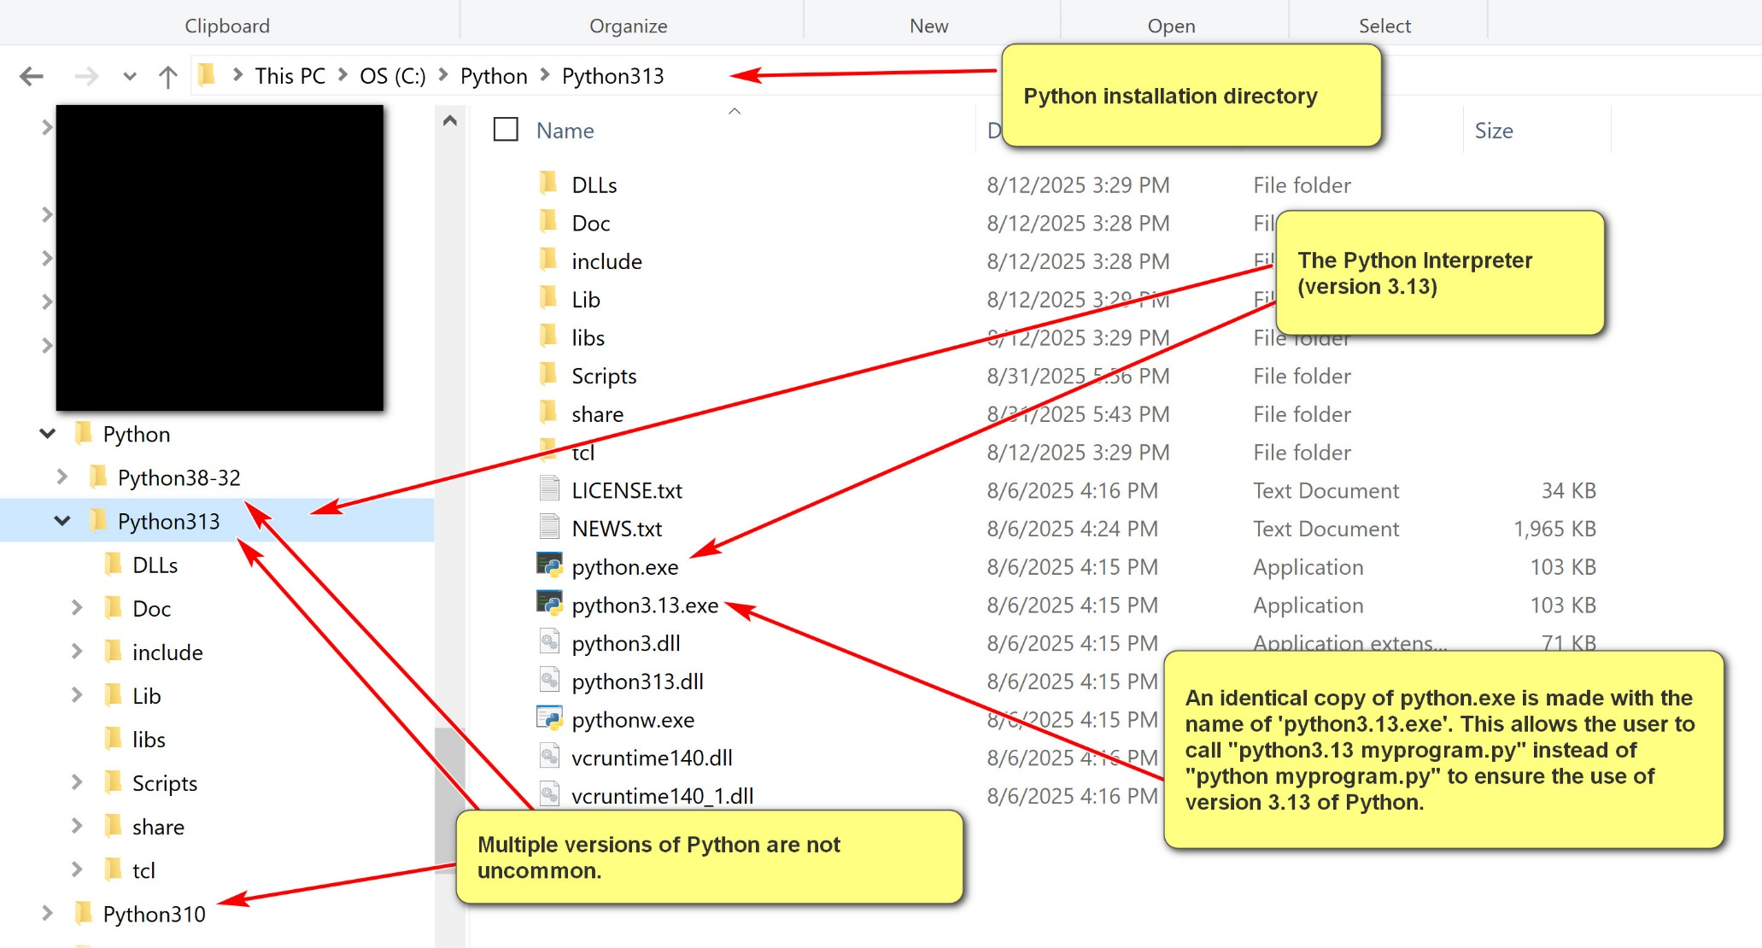
- In contrast, many high-level programming languages do not have interpreters. Instead, they use compilers. Execution of a program involves two steps. Program executions require two steps:
  - Compilation: compile the program to machine code or other low level code.
  - Execution: execute the machine or low-level code.
Example:
In Java, to run a program, Hello.java:
[1] "javac Hello.java": compile Hello.java into Hello.class, a Java bytecode program. Java bytecode has .class as its file extension. It is a platform independent intermediate level programming language.
[2] "java Hello": invoke the Java Virtual Machine (JVM) to run the Java bytecode program Hello.class. Note that the instruction is not "java Hello.class" as the file extension of .class is assumed.
1.1 Python Interpreter
- The Python interpreter is invoked by running "<<python_installation_path>>\python.exe" (e.g., c:\python\python313\python.exe)
- When invoking by itself, the Python interactive interpreter is started, executing one Python statement at a time.
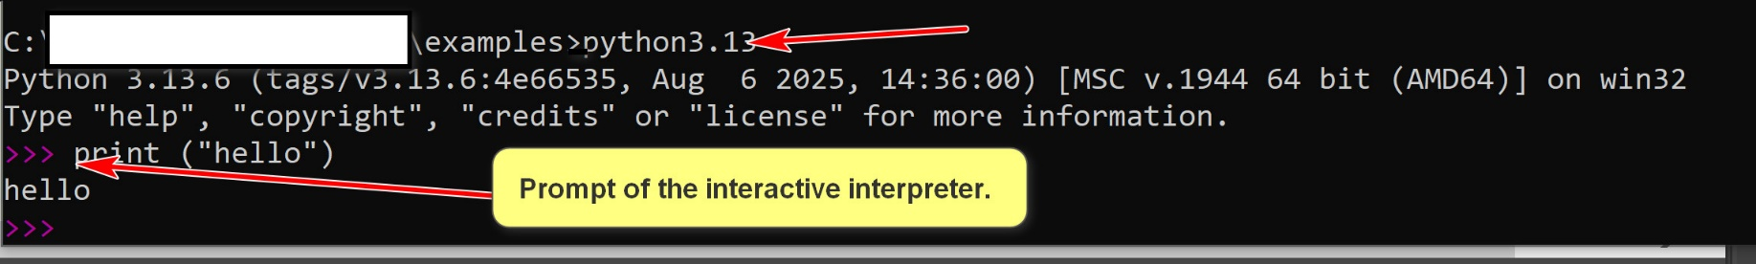
- The interactive Python interpreter is good for exploration and learning. However, it is limited by one user input Python statement at a time.
- To perform serious work, it is necessary to run Python programs that contain many Python statements.
- One can use it to execute a program, e.g. "Python hello.py"
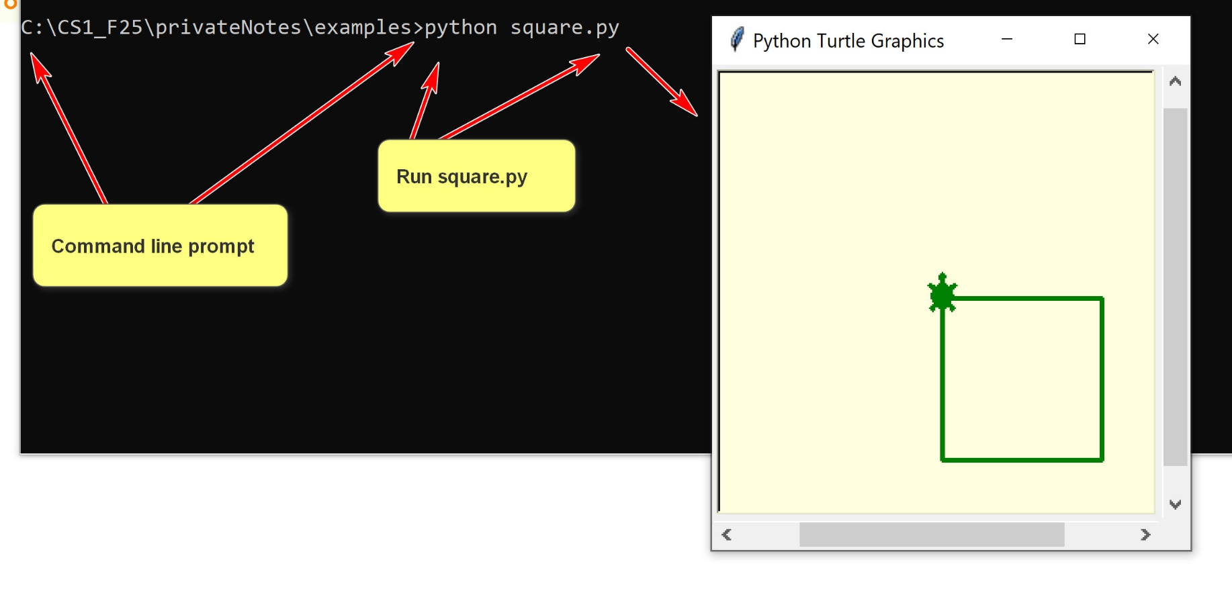
1.1 Python IDLE
- The Python IDLE is more than the Python interactive interpreter. It is a simple IDE with an editor and can execute a Python program.
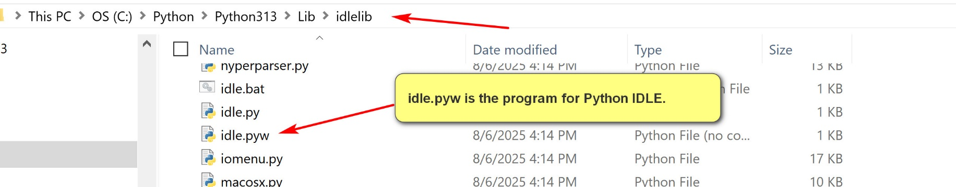
2. Python Programs
2.1 Python Literals and Variables
- Literals in Python are fixed values written directly in the source code that represent constant data (cannot be changed).
- There are many types of literals: number literals, string literals, Boolean literals, etc.
- Identifiers are names used to identify variables, functions, classes, modules, or other objects in Python code.
- A Python variable has a symbolic name (identifier) that refers to objects or values stored in the computer's memory.
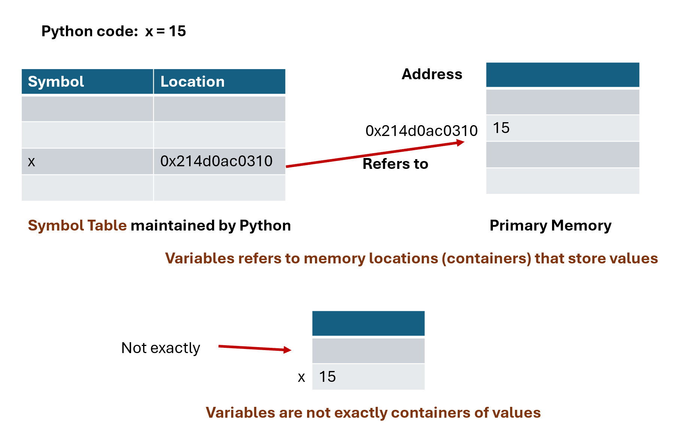

What is the modulo operator? %

Y = 16
id(y)
140726140499336 (possibly the memory address storing 16.
'0x7ffd5b9d7588' is the hexadecimal representation of 140726140499336 (decimal address): six byte address or hexadecimal # with 12 digits.
2.2 Python Statements
- A Python statement is an instruction that the Python interpreter can execute.
- A statement is a basic execution unit in Python.
- There are many types of statements in Python.
- A Python statement usually terminates at the end of a physical line, denoted by a newline character: ('\n').
- The character ; is a terminator of Python statement. It is not required and is seldomly used.
- The character \ can be used to extend a Python statement beyond the current physical line.
- Python can also detect that some Python statements are not terminating and extend them to the next physical line.
Try out statement_1.py
# Python statements
# A Python statement is terminated by the end of the physical line,
# represented by the end of line character: \n.
print('hello')
print('hello again');
# Not recommended Python style.
print('hello '); print('world');
# the second argument (end = ' ') indicates that the end string
# for the print statement is ' ', and not the default '\n'
print('hello ', end = ' '); print('world');
# \n is the end of line character. \ is used here for 'escaping' a character into special characters.
print('first line\nsecond line\nthird line');
# Because of the , character, Python knows that this
# not the end of the statement and extends it to the next line.
print('hello',
'world')
# The character \ extends the statement to the next line.
# There should not be any character after \.
print('hello' \
, 'world')
2.3 Expressions, Functions, Operators and Methods
- In Python, an expression is a piece of code that the Python interpreter evaluates to produce a value.
- The evaluation of an expression always returns a value.
- Expressions can be constructed by using:
  - literals: constants
  - variables: identifiers refering an object or a value.
  - functions: standalone functions similar to mathemtical functions. Have arguments and return a value. E.g., max()
  - operators: special symbols representing operations. E.g., a + b.
  - methods: functions belonging to an object using the object method invocation syntax: object.method(). E.g., if s is a string, we can call s.upper()
Examples:
Try out expression_ex1.py
a = 1
b = 2
c = 'hello'
print(max(a, b, 3))
print(round((a+100)/(b+5)))
max(a, b, 12, b*7, 6)
a + b * 4
a < b
a > b
a / b
d = (a + 4) ** b
e = c + ' world'
print(a, b, c, d, e)
print(e.upper())

