CSCI 1470.3 Classroom Notes and Demonstrations
9/3/2025

https://docs.python.org/3/library/turtle.html
Form a habit to read the manuals.
Python Resources
by K. Yue
1. Python's Manual
- Version 3.13: (navigate to your version).
  - Manual: http://docs.python.org/3.13/reference/index.html
  - Python Interpreter tutorial: https://docs.python.org/3.13/tutorial/interpreter.html
  - Standard library: https://docs.python.org/3.13/library/index.html
2. Python Books (Free)
- A Byte of Python: https://homepages.uc.edu/~becktl/byte_of_python.pdf. Free download, good coverage of topics in this class.
- Think Python: How to Think Like a Computer Scientist, version 3: https://allendowney.github.io/ThinkPython/. Include computational thinking.
- Python for everyone: https://www.py4e.com/. Free, good, sometimes with videos, but may contain too much information for this class.
3. Learning Tutorials and Materials
- Tutorial at w3shools: https://www.w3schools.com/python/. Plenty of examples. Good for beginners and this class.
- https://www.learnpython.org/: popular, but w3schools is better. Beware of ads.
- https://www.programiz.com/python-programming: also contains some advanced topic.
- Google has a tutorial on Python: https://developers.google.com/edu/python. However, it is more for somewhat experienced programmers.
- For experienced programmers: https://learnxinyminutes.com/docs/python3/: one of my favorites.
4. Online Python's interpreter or IDE
- There are many possible advantages of online Python tools: convenience, accessibility, lightweight, collaboration, etc.
- There are also many possible disadvantages: restrictions, limited features, security and privacy, etc.
- Some online Python interpreters:
  - https://www.online-python.com/
  - https://www.programiz.com/python-programming/online-compiler/
  - https://www.w3schools.com/python/python_compiler.asp
- This course does not recommend the use of online Python IDE.
5. Cheat Sheets
- If you like cheat sheet types of examples and summary:
  - https://scouv.lisn.upsaclay.fr/python-memento/memento-python3-en-latest.pdf: basic and short.
  - https://github.com/ehmatthes/pcc_3e/releases/download/v1.0.0/beginners_python_cheat_sheet_pcc_all.pdf: much longer.

Python code can be put together into modules

Python IDLE
by K. Yue
1. Python IDLE
- Python IDLE is bundled in the Python distribution. There is no need for separate installation.
- IDLE can be regarded as a very simple Integrated Development Environment (IDE). It is used in this class.
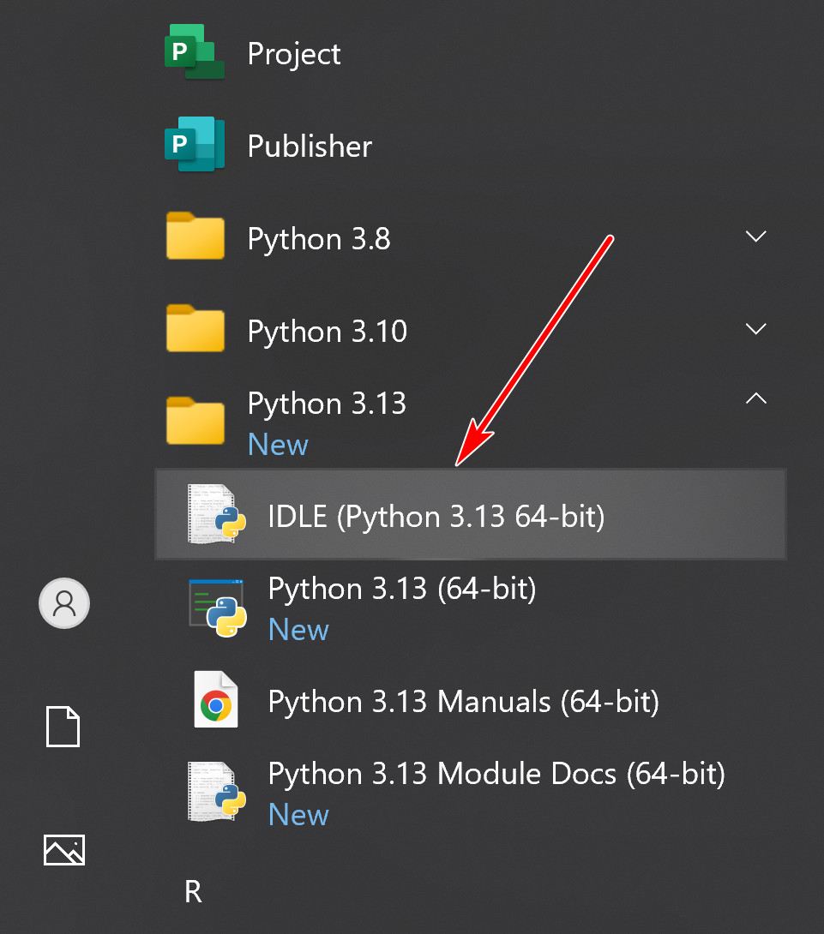
- A short IDLE tutorial: https://www.youtube.com/watch?v=WIlQukiXs-E. (a little dated)
- https://realpython.com/python-idle/ is a very good tutorial on IDLE. However, it contains many topics not needed in this class.
2. Running IDLE shell as interpreter
- When you start IDLE, a shell window appears.
- IDLE shell is an interactive interpreter with REPL (Read-Evaluate-Print loop)
  - Read a Python statement, single-lined or multiple-lined.
  - Evaluate or execute the statement.
  - Print the result of execution of the statement.
- A shell contains the collection of Python code the user entered interactively.
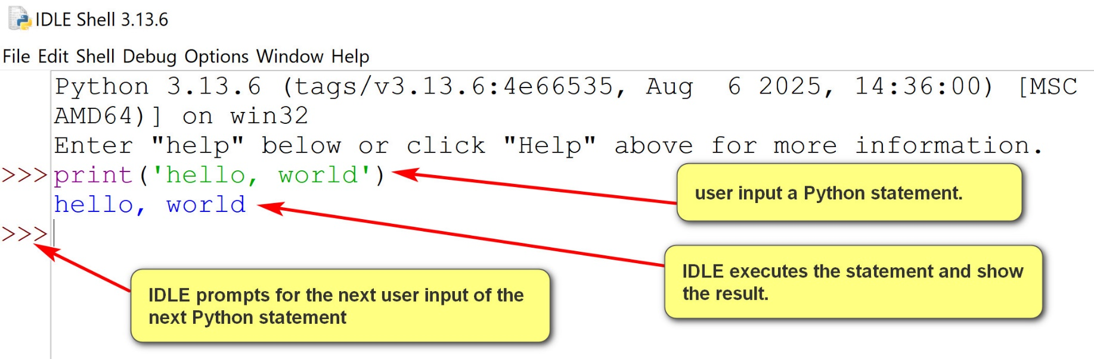
2.1 Logging a shell session
- Logging is a crucial practice and habit in software development.
- Logging tracks program behavior and problems, enables debugging, supports performance analysis, supports auditing, monitors security and informs users, administrators, and developers.
- IDLE shell session can be logged by saving it in a file.
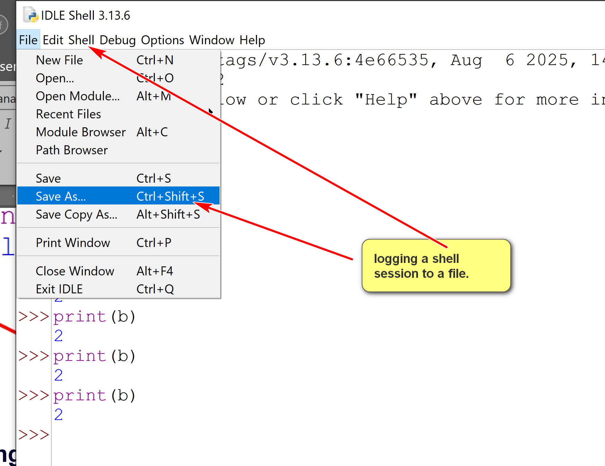
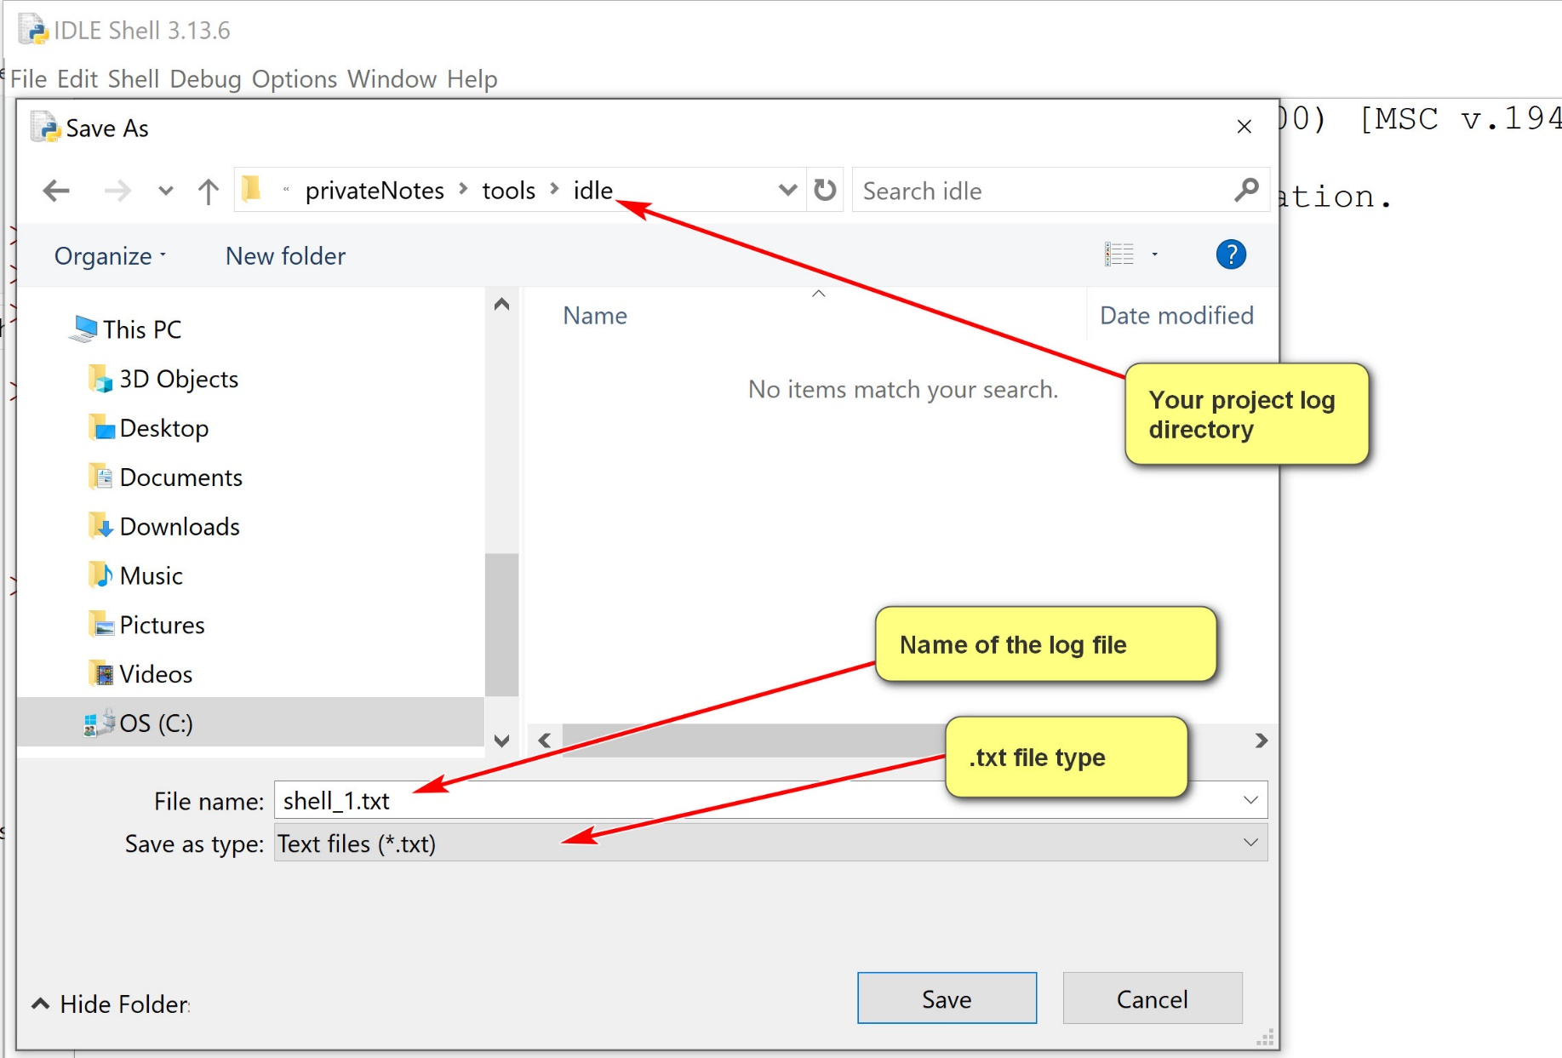
A shell session has internal states.
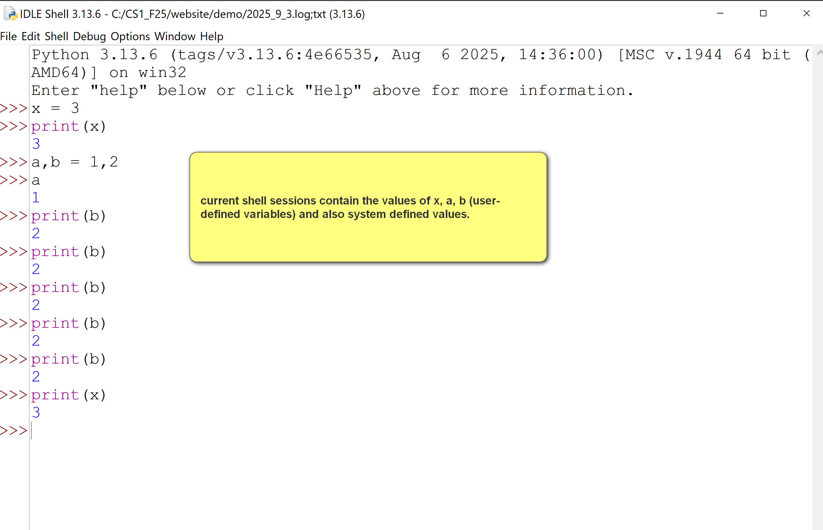
Restarting shell -> clean up the internal state.
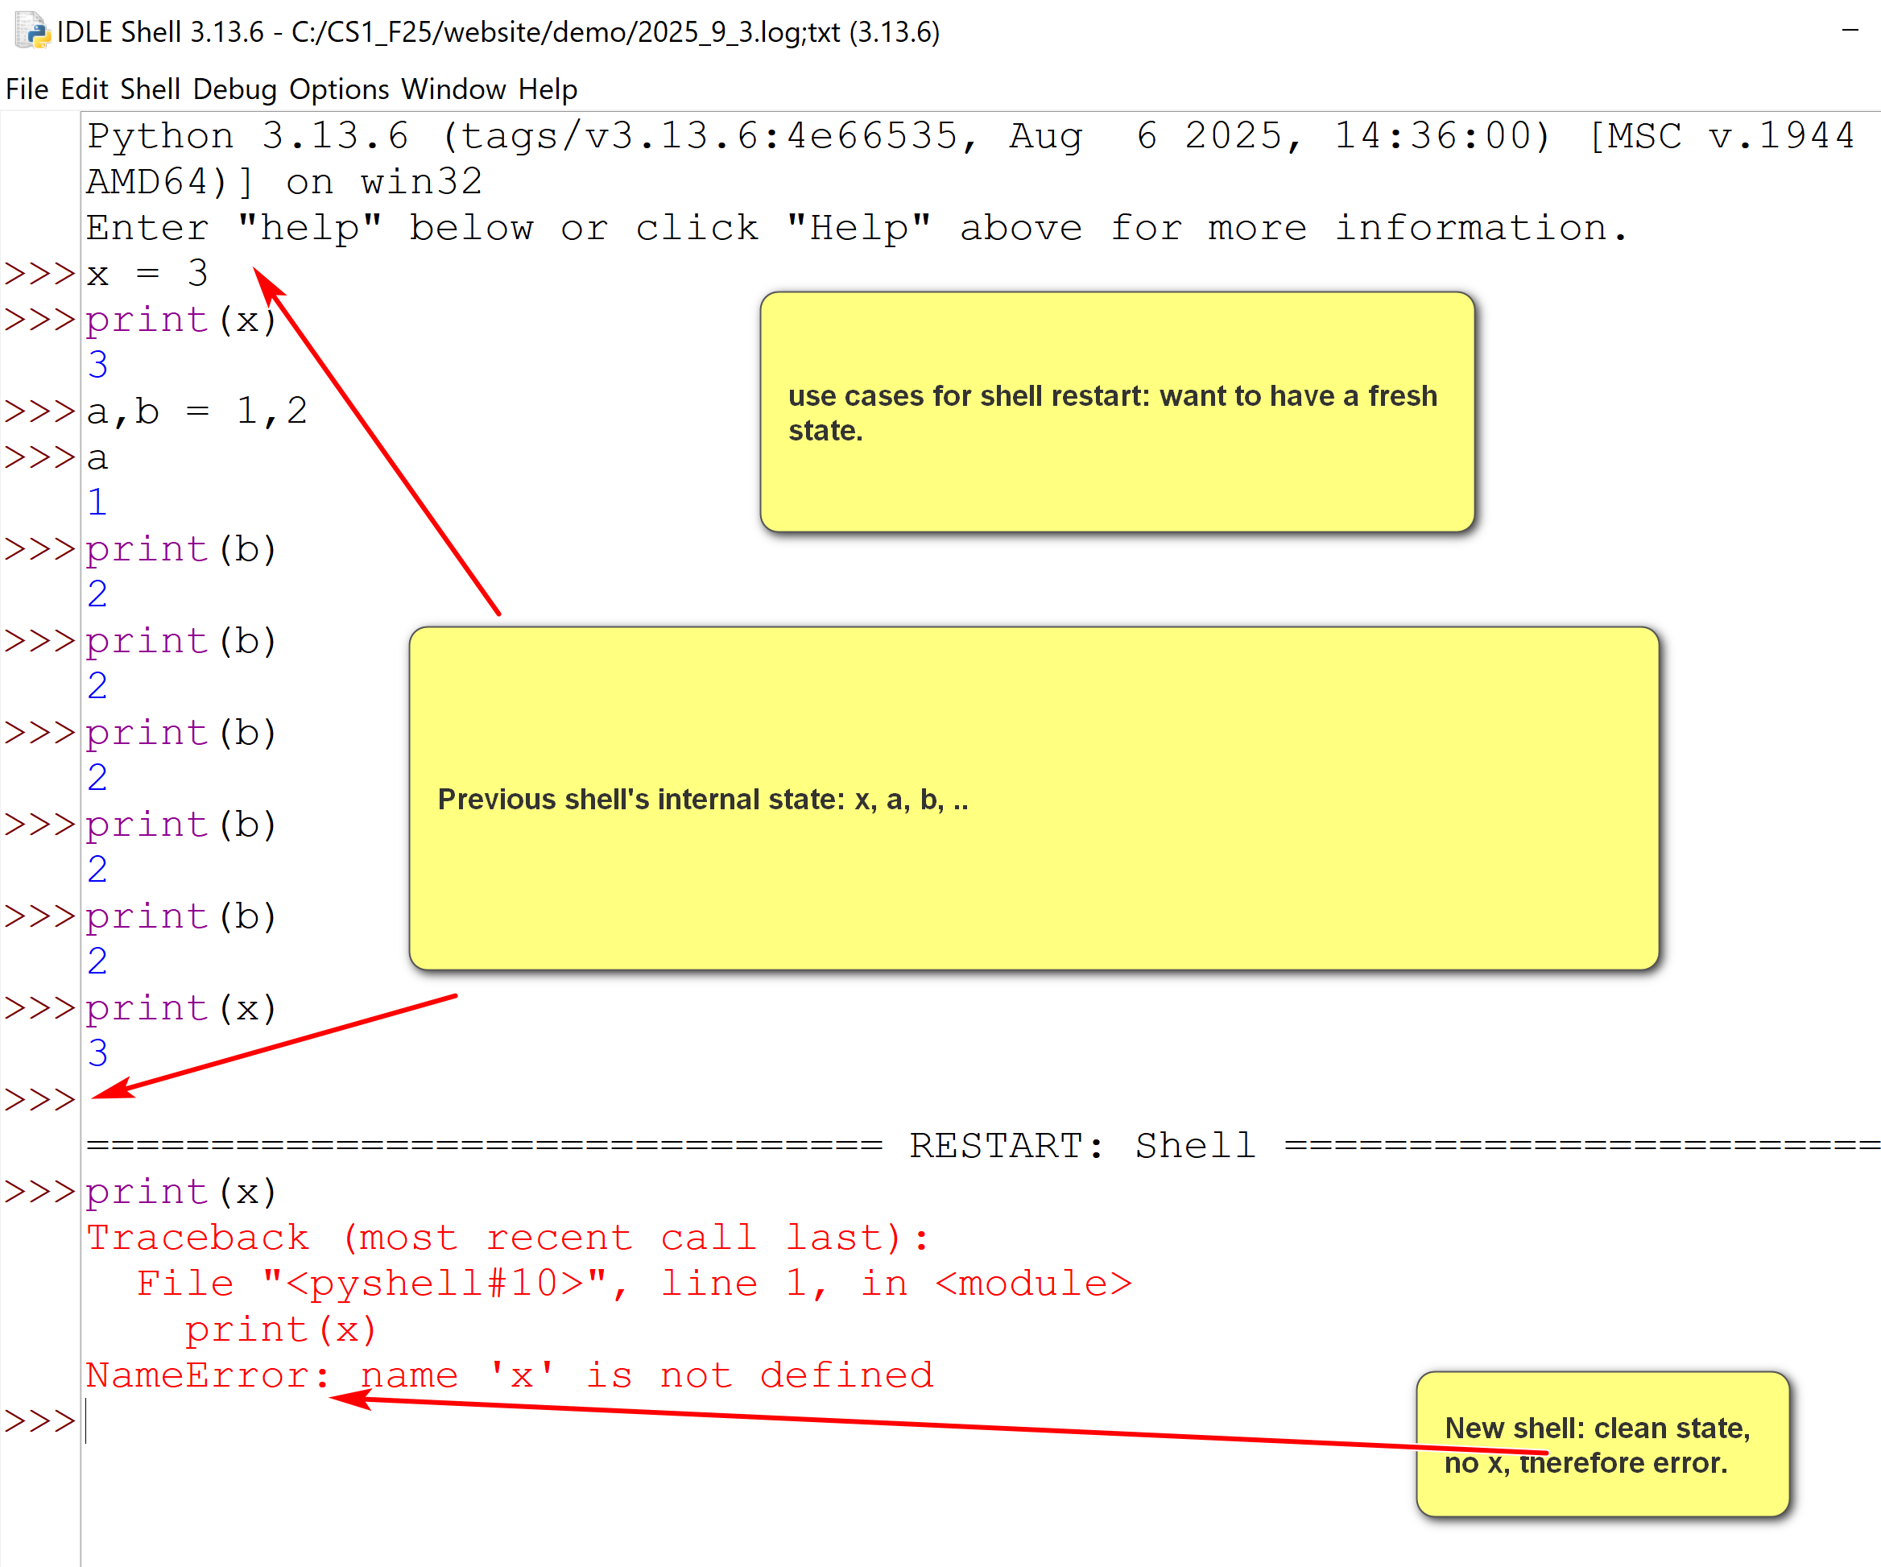
Shell Menu
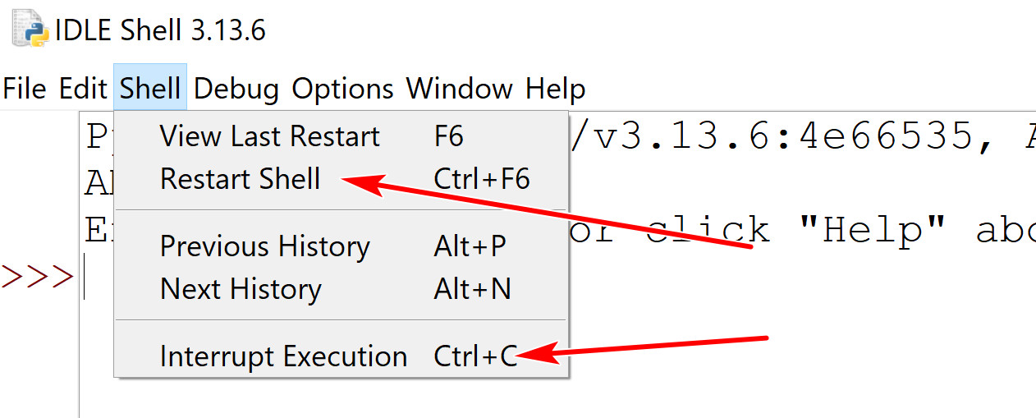
- Two buttons you may use:
  - Restart shell: start a new shell session.
  - Interrupt Execution: stop the execution (in case you get into an infinite loop)
3. Python program file editing and execution
- Shell includes a text editor.
- One can open an existing Python program file, or create anew Python program file.
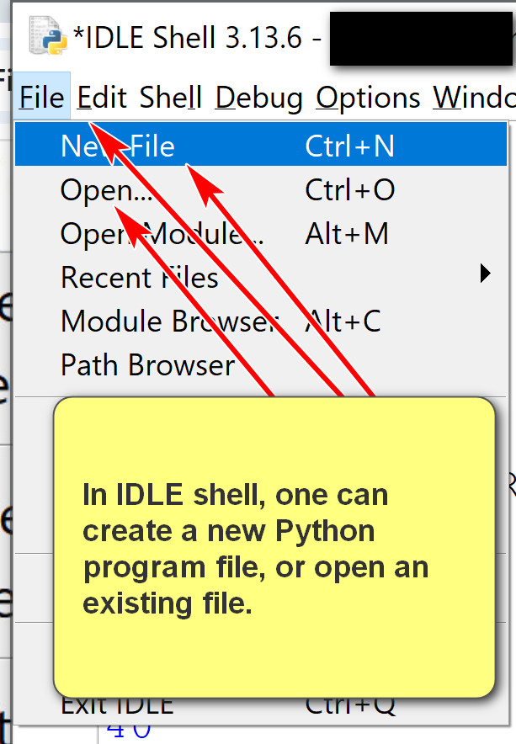

Open an existing file, square.py:
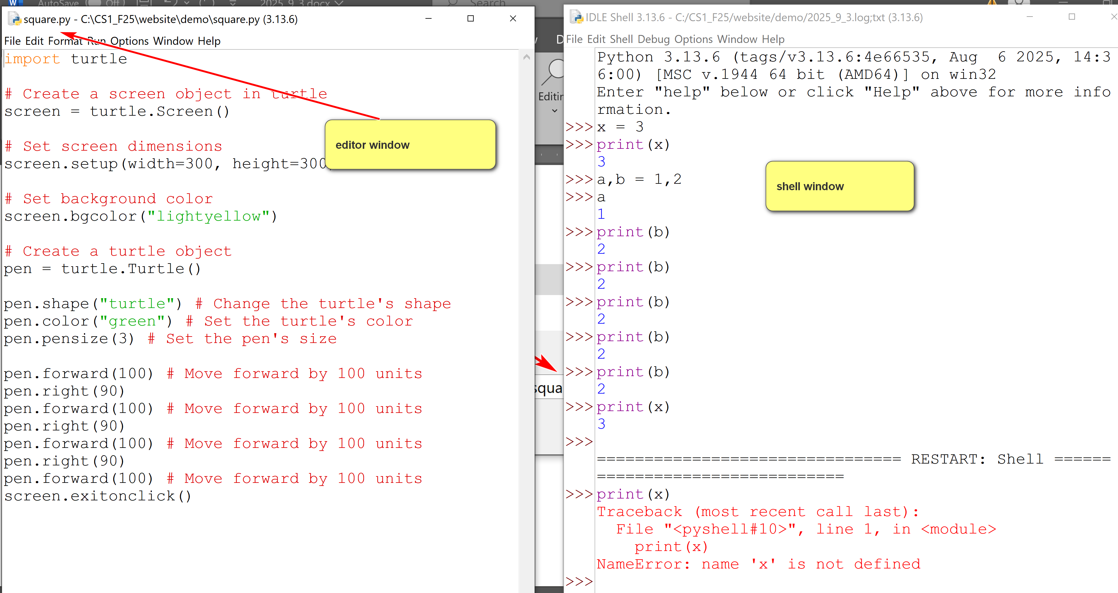

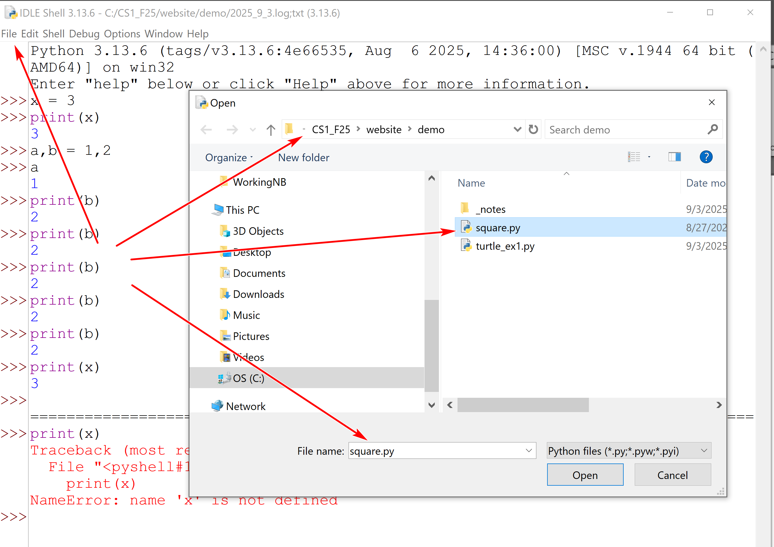
Running square.py
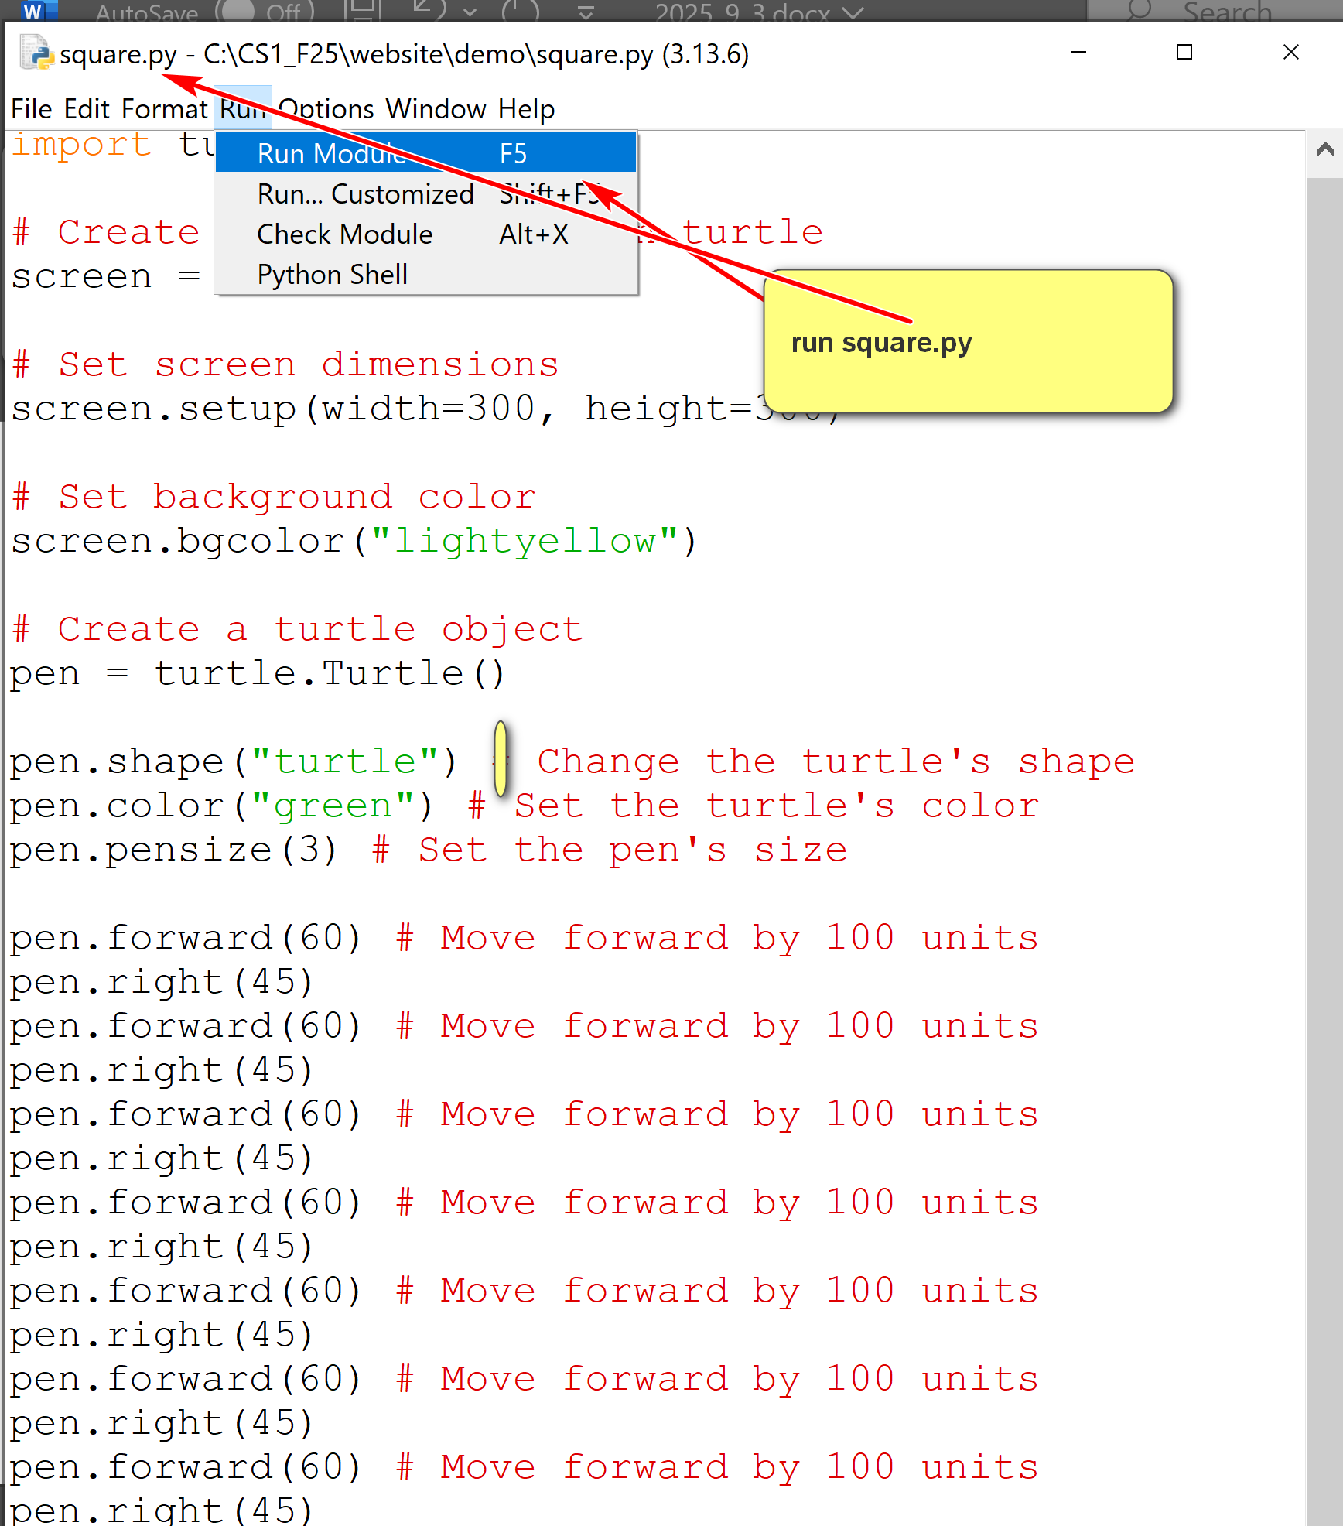

- The file editor has many features.
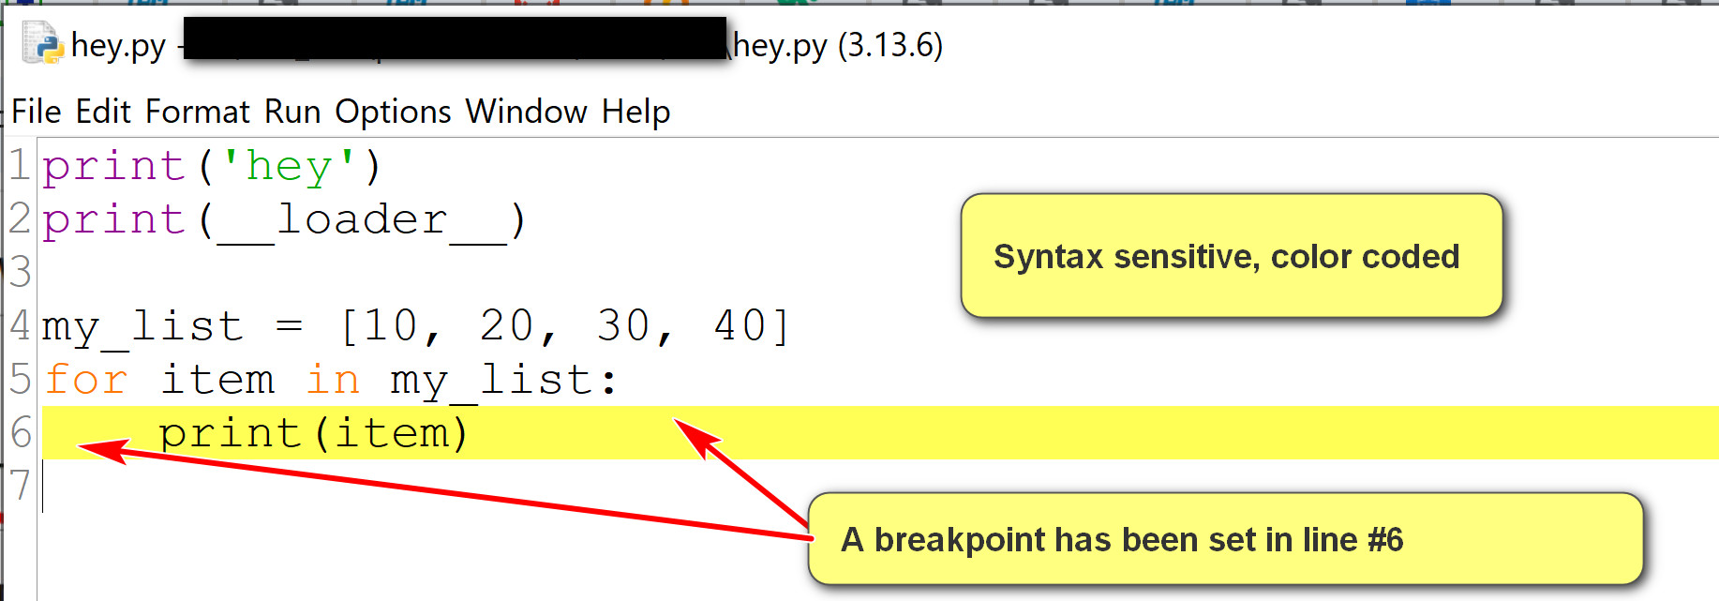
- Some features you may use:
  - Use the options menu to show line number.
  - Set and clear breakpoints for debugging.
  - Run the program by using Run->Run Module.
4. Debugging in IDLE
- A good tutorial in IDLE: https://www.cs.uky.edu/~keen/help/debug-tutorial/debug.html. Contain more than needed in the class.
- To debug a Python program:
  - Open the Python program using IDLE Shell: File -> Open.
  - Turn on the Shell debugger: Go->Debugger
  - Run the program in the editor using Run->Run Module.
  - Use the debugger window.
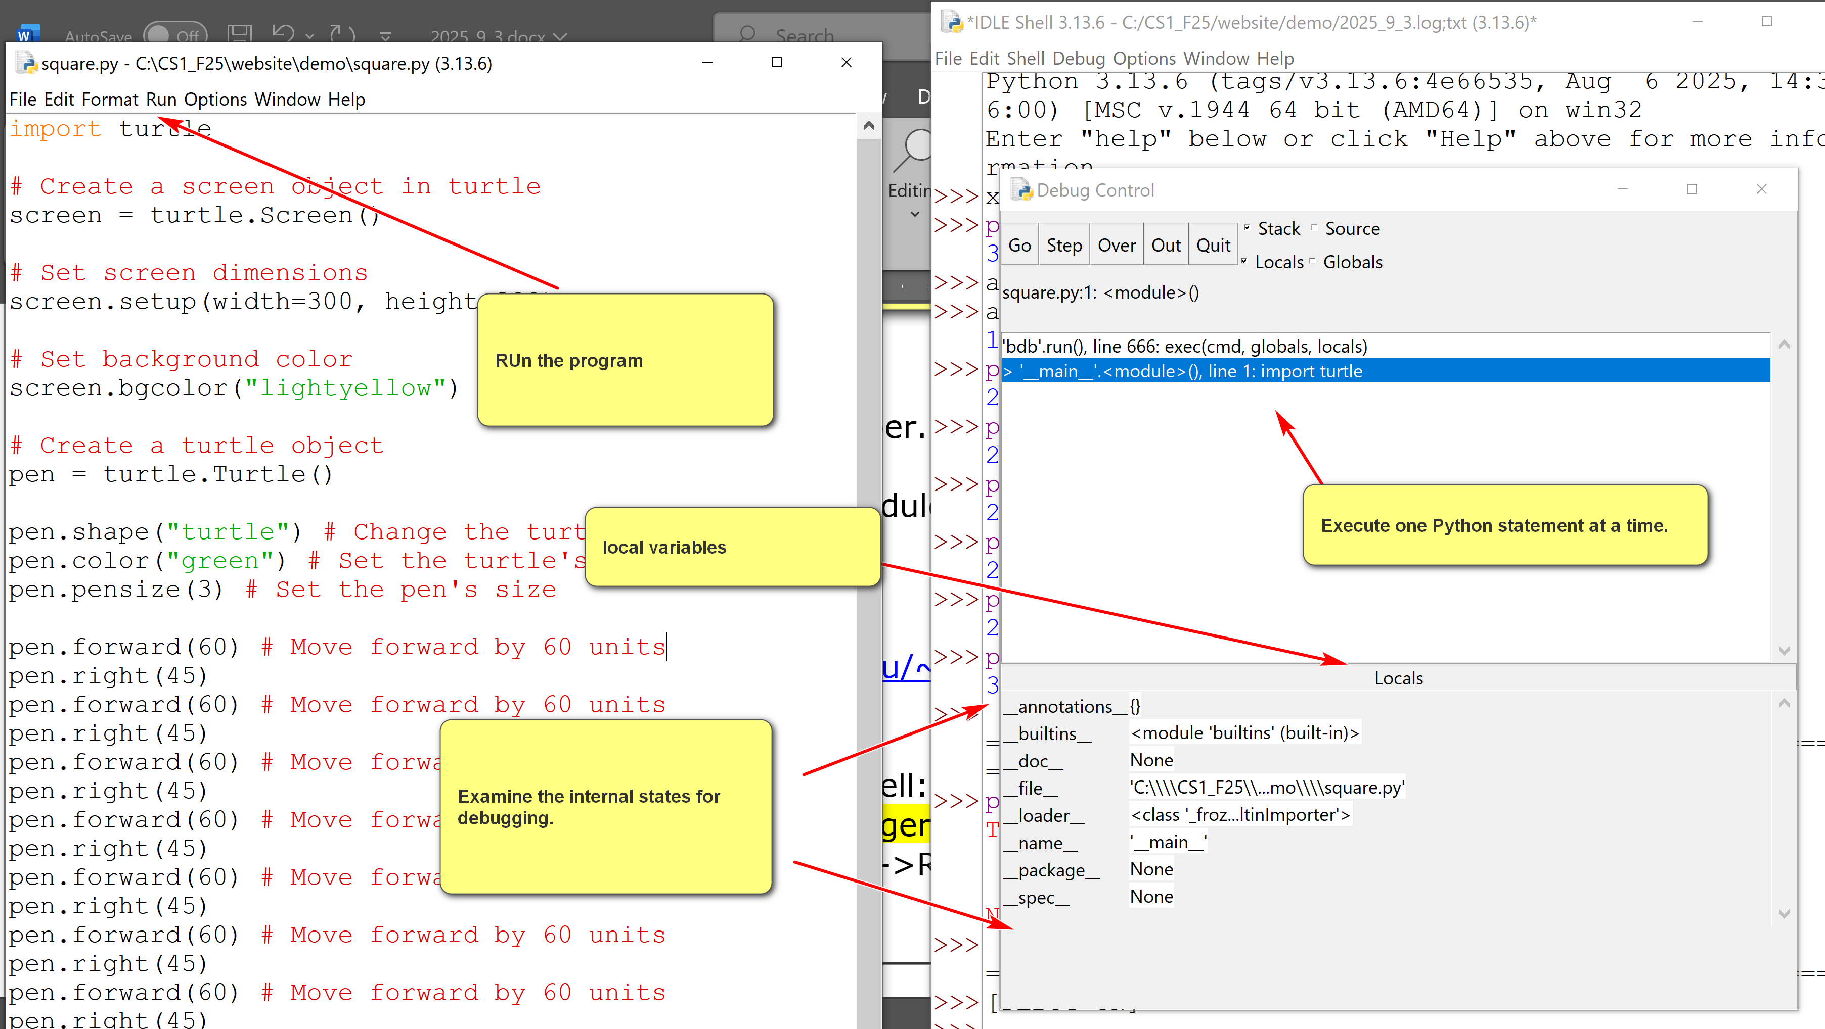
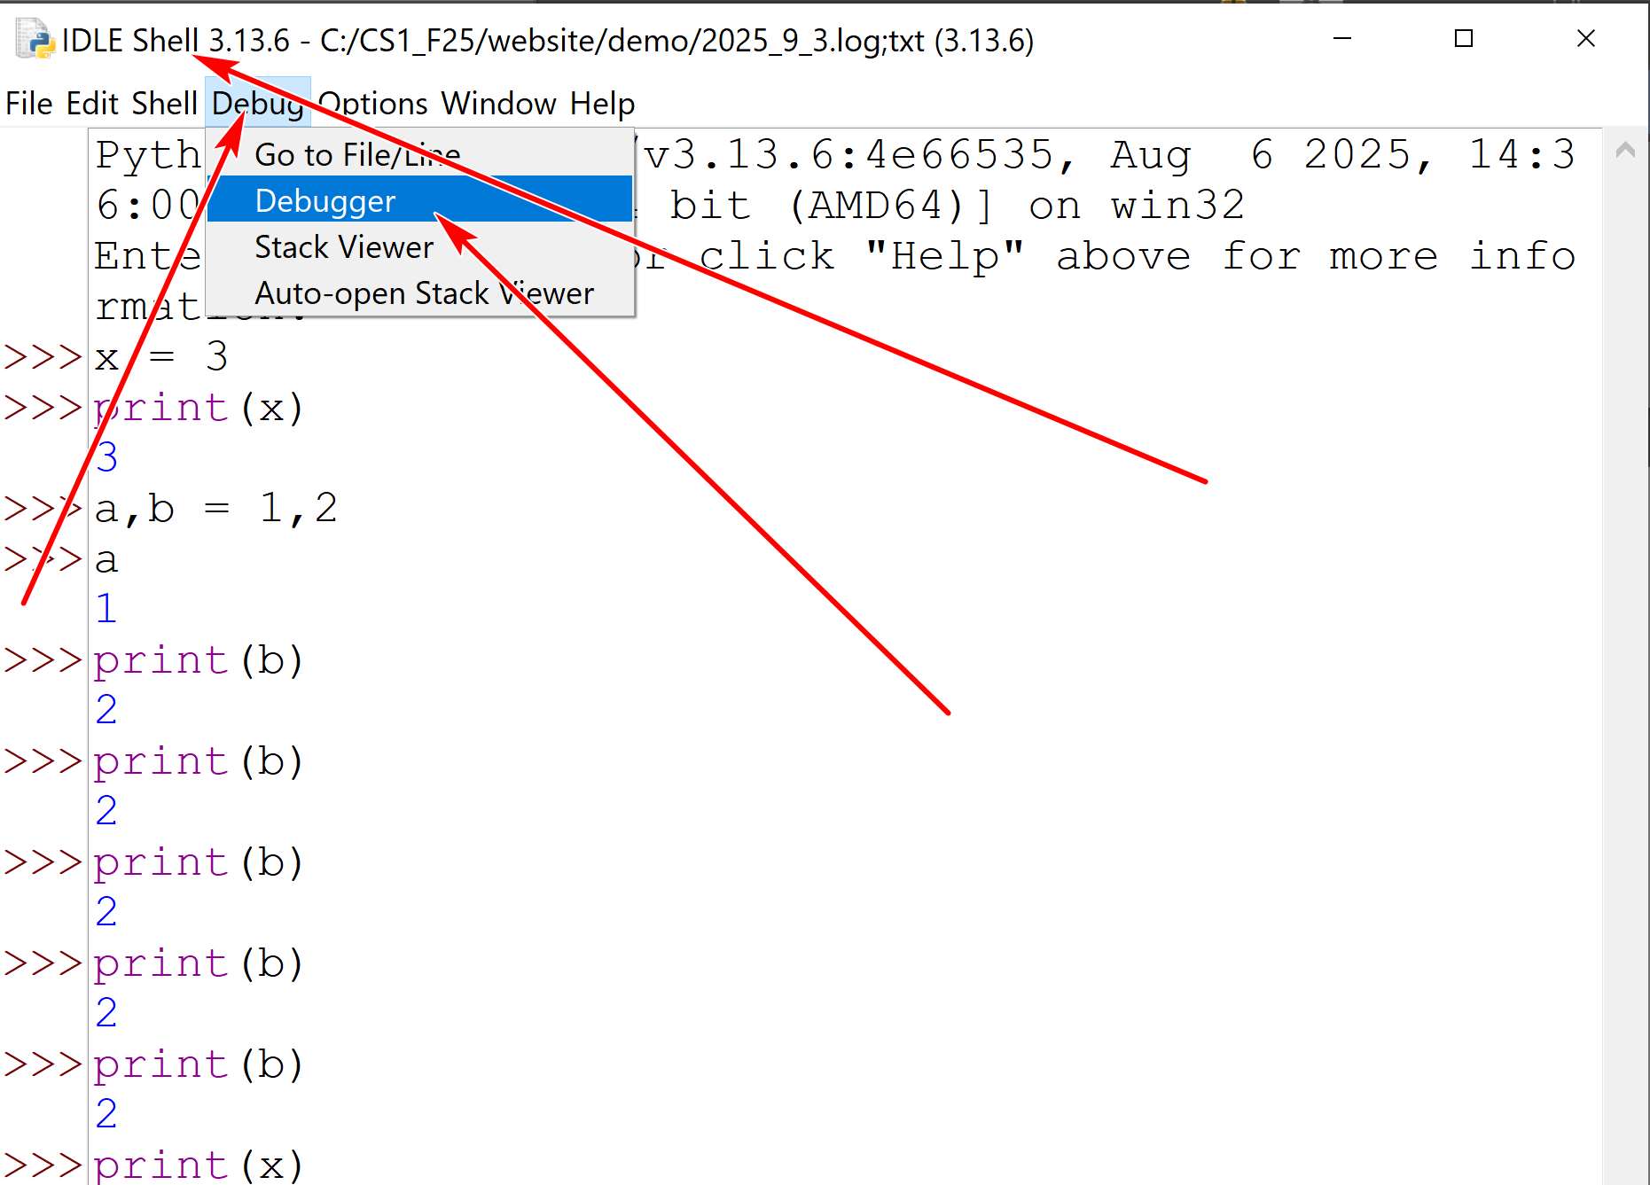
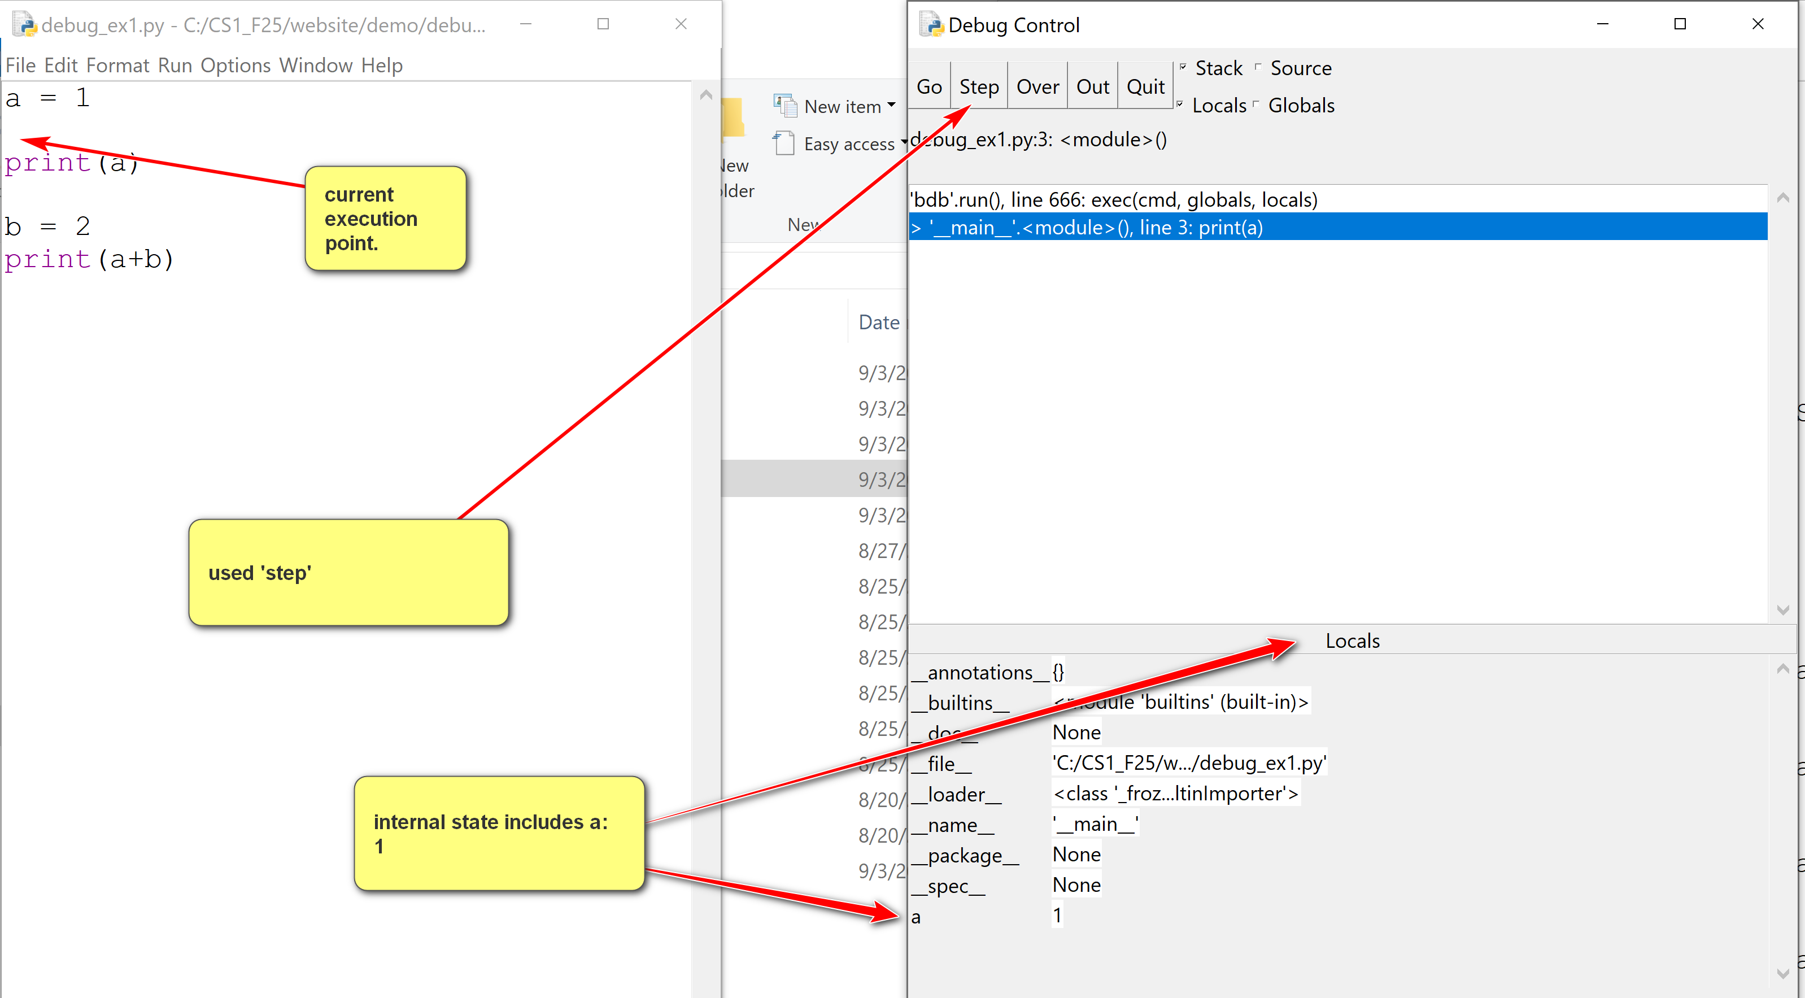
- Some basics:
  - Use the go button in the debugger window to execute.
  - Set and clear breakpoint in the editor.
  - Examine the locals window in the debugger.
When the debugger window is started, in the example below, the locals window shows values of local variables.
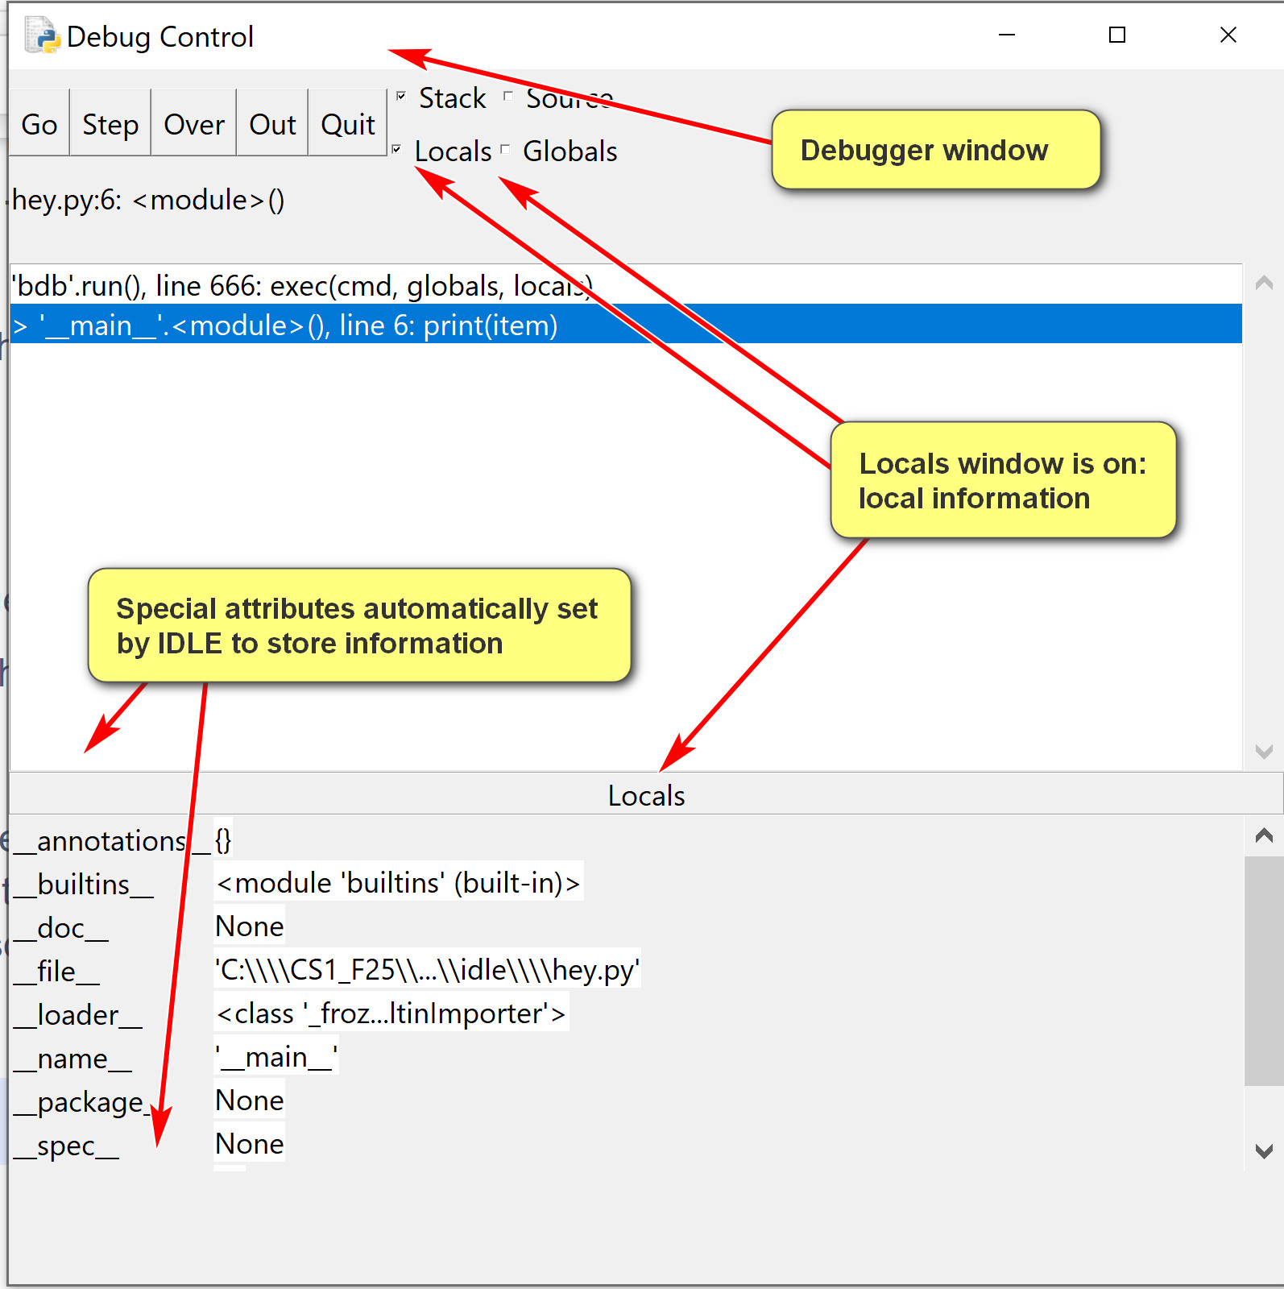
An example of using breakpoints:
