CSCI 1470.3 Classroom Notes and Demonstrations
8/27/2025
The Computational Paradigm
by K. Yue
1. Paradigm
- Every discipline has a paradigm: targets, objectives, considerations, bodies of knowledge, methodologies, standards, etc.
Example #1: In pure mathematics (as opposed to applied mathematics)
- An important objective to prove theorems which are true under a set of axioms (statements assumed to be true without proof).
- Methodologies: theorem proving, ...
- Quality considerations:
  - primary: truth or correctness.
  - simplicity and beauty.
- ...
E.g., the Pythagorean theorem: the sum of the squares of the two shorter sides (legs) of a right-angled triangle is equal to the square of the longest side (hypotenuse)
- Axioms: Five basic axioms of Euclidean geometry.
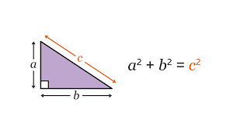
- A mathematical conjecture is a statement that is believed to be true based on observations and patterns but has not yet been proven or disproven.
E.g., Goldbach's Conjecture (stated in 1742): Every even integer greater than 2 can be expressed as the sum of two prime numbers. E.g.,
- 16 = 5 + 11
- 100 = 3 + 97 = 11 +89 = 17 + 83 = 29 + 71 ...
The Goldbach's conjecture is very easy to state but extremely hard to prove (one way or the other).
Example #2: History
- An important objective: understand the past to better comprehend the present and potentially inform the future.
- Methodology: a range of techniques and procedures for gathering, analyzing, and interpreting evidence from primary and secondary sources to construct a narrative and understanding of historical events.
- Some quality considerations:
  - Source selection, evaluation and preparation
  - Objectivity and bias mitigation
  - Methodology rigor
  - Narrative and communication
2. Computing and software development
- What is computer science?
- An example: Computer science (CS) is the study of computers and algorithmic processes, including their principles, their hardware and software designs, their applications, and their impact on society. (Tucker et al., 2003.)
- It is difficult to find another discipline more applicative than computer science.
- Computer professionals should be generalists.
Software Development
- primary objective: problem solving using software.
- methodologies: computer and software development techniques (that is what your computing degree means).
- One clear quality consideration: correctness, or does the program provide the right answer (expected output)?
  - Software testing is about increasing confidence in correctness.
  - A test case specifies:
    - input
    - expected output
  - A test case is passed when the expected output is equal to the actual output.
E.g., a Python to output the square of an input integer.
Test cases:
Case # | Input | Expect Output
1 | 3 | 9
2 | 65 | 4425
3 | 0 | 0
4 | -65 | 4425
5 | 123456789 | 15241578750190521
6 | 'hello' | Error: input is not an integer.
- Some important software development quality considerations:
  - Correctness:
    - Software verification:
      - Software built according to the software specification. Is the software built right?
      - Internal correctness
      - e.g. does the program output the square of the input number right?
    - Software validation:
      - Software met the needs of the problem. Is it the right software?
      - Constructing the right software specification: requirement analysis.
      - External correctness
      - E.g., do the users want the square of the input number?
  - Performance
  - Cost
  - Meeting timeline
  - Effectiveness
  - Reliability
  - Maintenance: software has a life cycle
  - Security and privacy
- Do not just focus on internal correctness or software verification.
3. Skills/Traits/Quality/Characteristics of software developers
- People of course have different opinions.
- However, there are many commonalities.
3.1 A simple non-scientific experiment
Conducted a simple Google search for good software developer quality.
Four sources:
- Coding Temple, 6 Key Qualities of Successful Software Engineers, https://www.codingtemple.com/blog/6-key-qualities-of-successful-software-engineers/.
- MatchTech, 7 qualities exceptional developers possess, https://www.matchtech.com/resources/7-qualities-exceptional-developers-possess.
- UMBC, How To Know If Software Development Is The Right Job For You, 8 Hard To Learn Software Developer Skills You Need, https://www.umbctraining.com/software-developer-skills/.
- AlltheCode blog, Software Engineer Personality: 5 Traits For A Great Career, https://allthecode.co/blog/post/software-engineer-personality.
Results: quality/trait/characteristics of good software developers.
Coding Temple | MatchTech | UMBC | AlltheCode
Technical Expertise | Solid technical knowledge | Curiosity | Curiosity
Problem-Solving Skills | Maintains an end-user focus | Creativity | Persistence
Attention to details | Fast self learner | Empathy | Ability to learn
Strong communications and collaboration skills | Strong communication skills | Patience, Perseverance and Problem-Solving | Focus
Continuous learning and adaptability | Dependent time and task management | Analytical | Pragmatism
Passion for the craft | A good team player | Detail-oriented and organized
 | 'Never say die' attitude | Adaptability
 |  | Communication
- Although you can see their differences, some focus more on skills and qualities. Others focus more on traits.
- However, there are some common themes:
  - Strong technical knowledge and expertise
  - Strong problem-solving skills: analytical
  - Good problem understanding: empathy, focus on end users, ...
  - Strong communication skills
  - Strong collaboration skills: good team play, dependable
  - Continuous and fast self-learning
  - Curiosity: passion for the craft
  - Persistence: never day die, passion for the craft
  - Organization and management skills
  - Detail-oriented
  - Adaptability
Some Lessons
- We tend to focus on technical matters in our computing degrees.
- Success in the computing profession requires much more than technical expertise. It will be increasing more so.
- Personal traits, characteristics, habits, etc. take a lot of effort and time to develop.
- Consider spending effort and time to cultivate them early and persistently.
- Your university degree may give you an entrance ticket to the job market but it is not sufficient by itself.

Function:
E.g. f(x,y) = x + 2 * y;
f(2,3) -> 8

Python code can be put together into modules

Introduction to Turtle Graphics in Python
by K. Yue
1. Turtle Graphics
- The Python turtle module is a built-in library (no need to download from an external source) that provides a way to create graphics and drawings.
- In turtle graphics, there are two major concepts:
  - A window/screen/digit canvas for the turtle to move and draw.
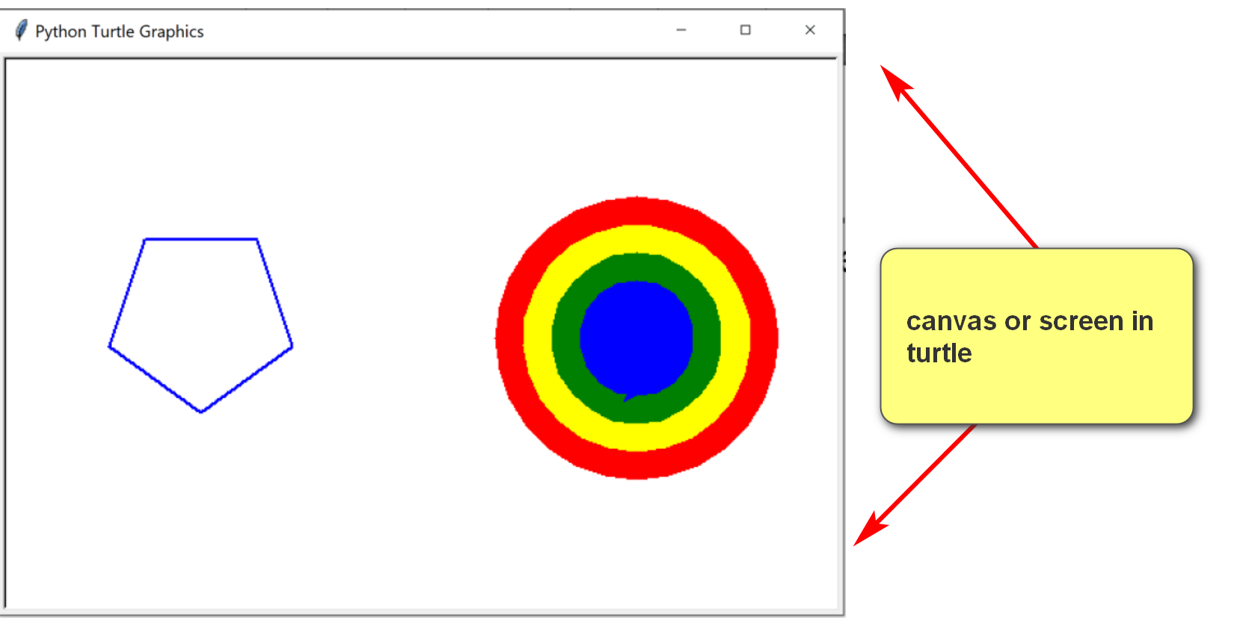
  - A turtle with a pen that can move and draw (if the pen is down).
Turtle:
- The turtle is:
  - in a co-ordinate location (x,y), initially (0,0)
  - facing a direction (initially right)
  - holding a pen which can be up and down (initially down). If the pen is down, the turtle draws while moving.
- There are functions to control the turtle. Two popular ones are:
  - forward(distance): move the turtle forward by a distance. If the pen is down, the turtle also draws.
  - right(degree): turn its face to right with a degree.
Example:
Consider square.py.txt (remove .txt when download):
import turtle
# Create a screen object in turtle
screen = turtle.Screen()
# Set screen dimensions
screen.setup(width=300, height=300)
# Set background color
screen.bgcolor("lightyellow")
# Create a turtle object
pen = turtle.Turtle()
pen.shape("turtle") # Change the turtle's shape
pen.color("green") # Set the turtle's color
pen.pensize(3) # Set the pen's size
pen.forward(100) # Move forward by 100 units
pen.right(90)
pen.forward(100) # Move forward by 100 units
pen.right(90)
pen.forward(100) # Move forward by 100 units
pen.right(90)
pen.forward(100) # Move forward by 100 units
screen.exitonclick()

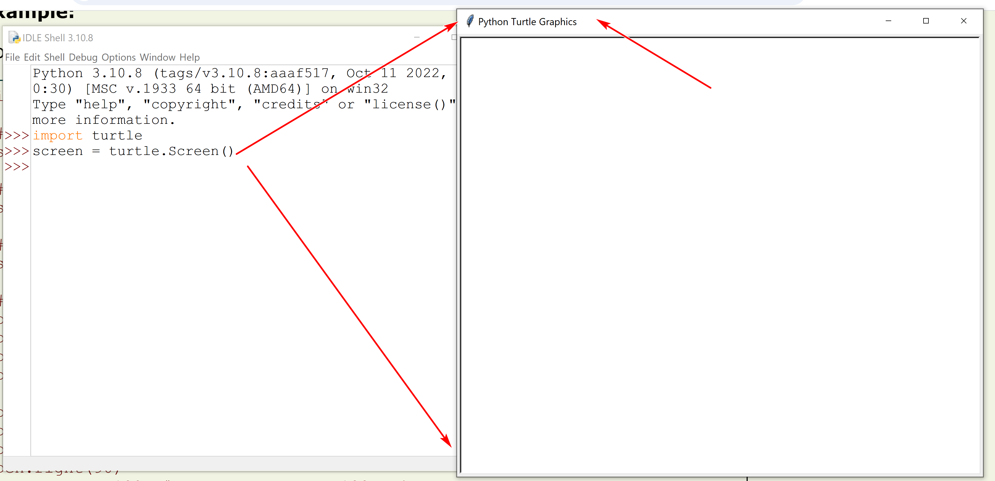
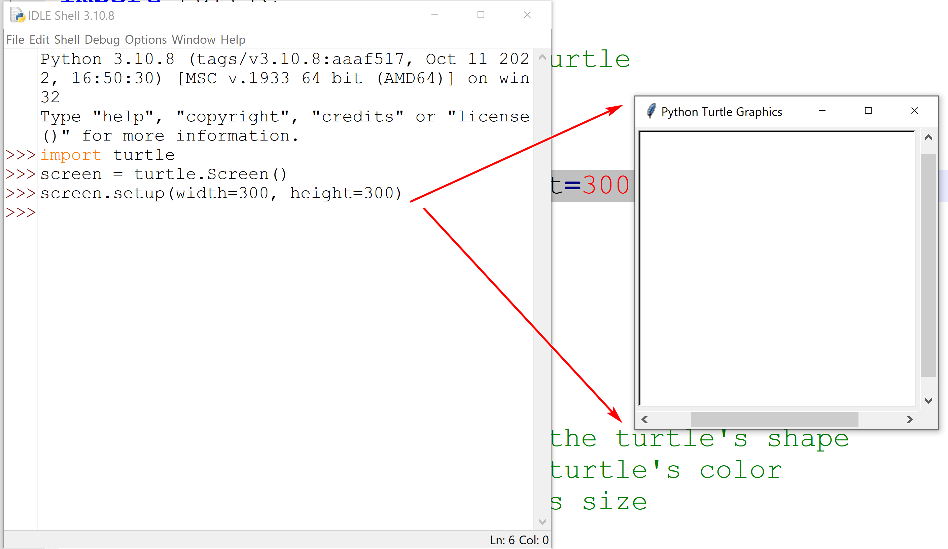

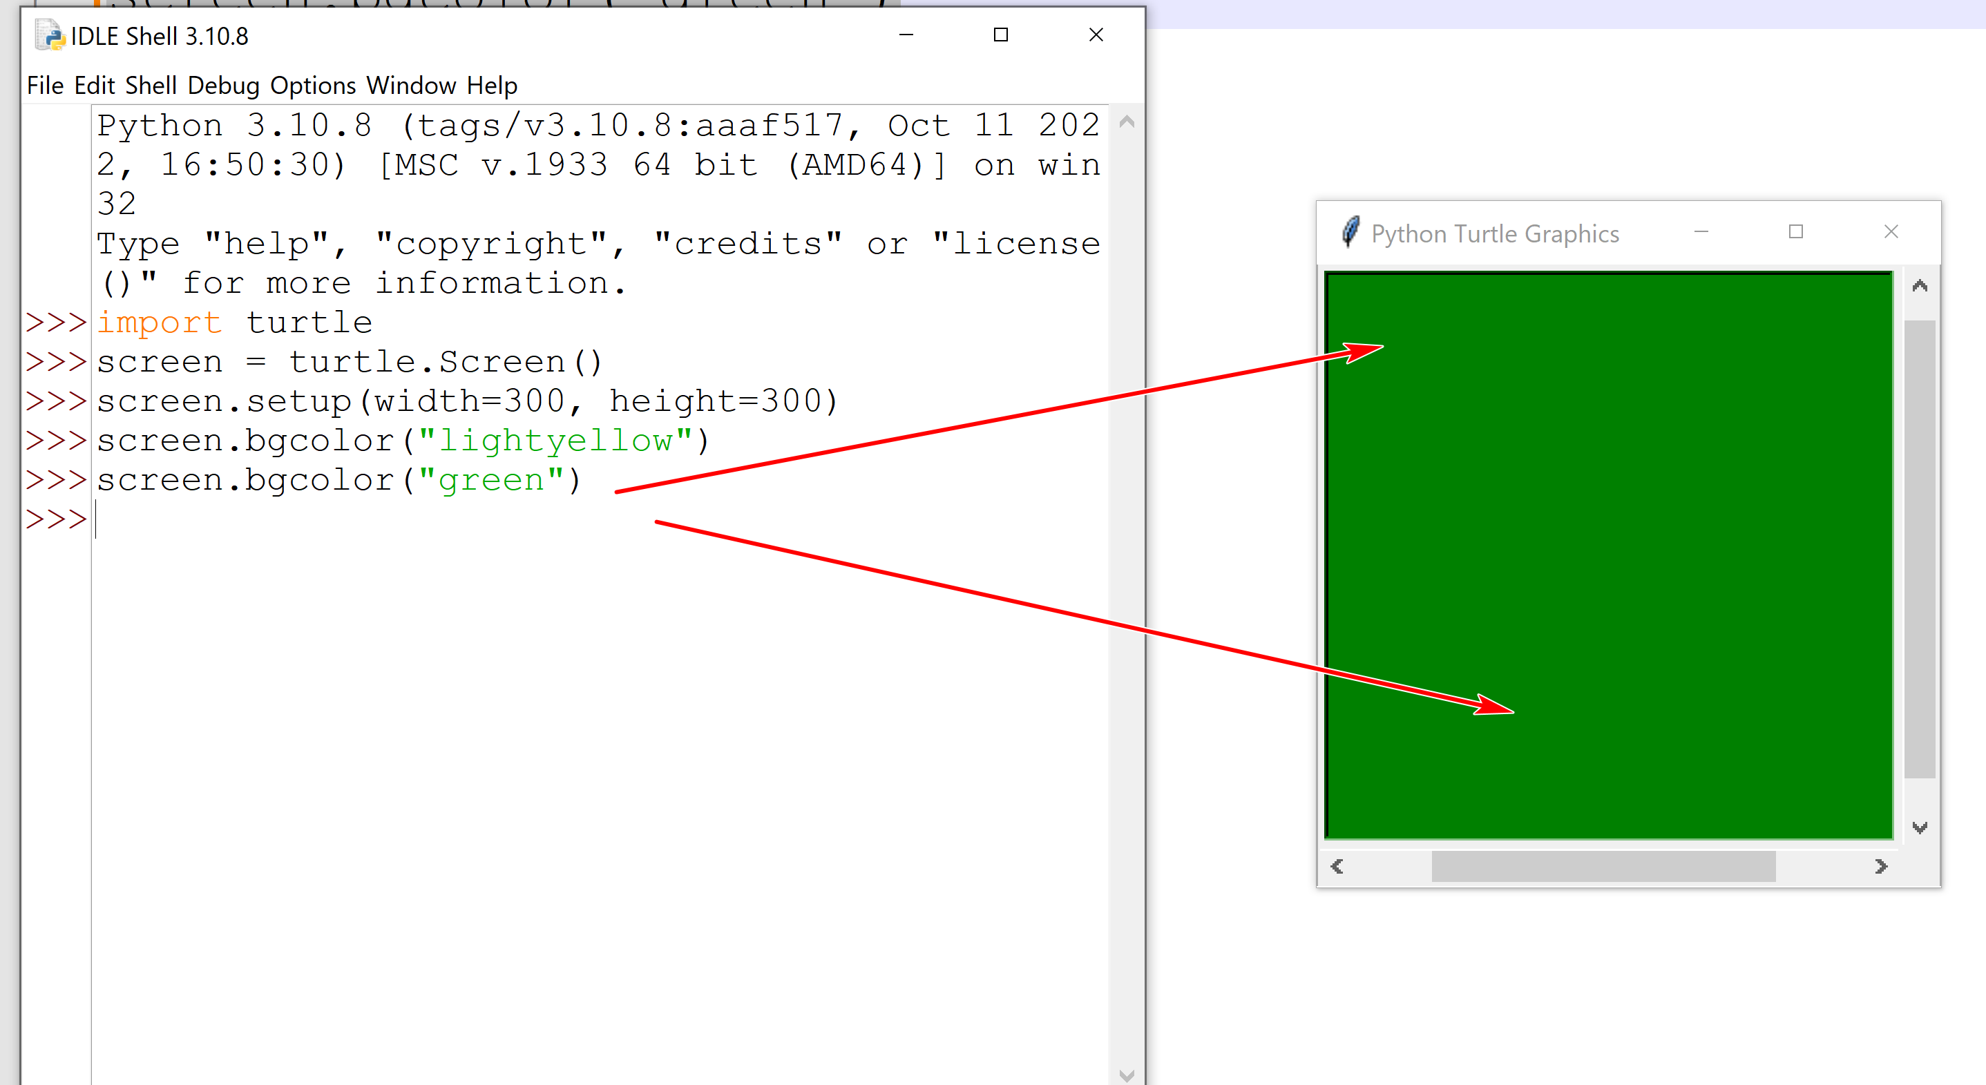
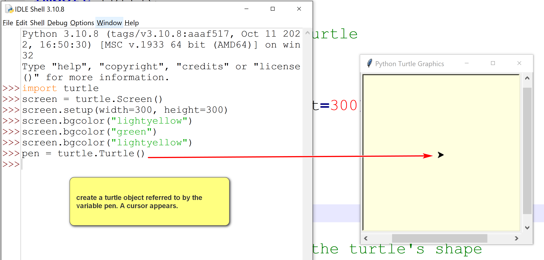
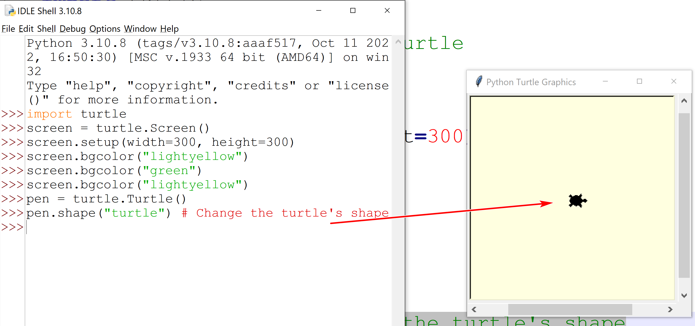

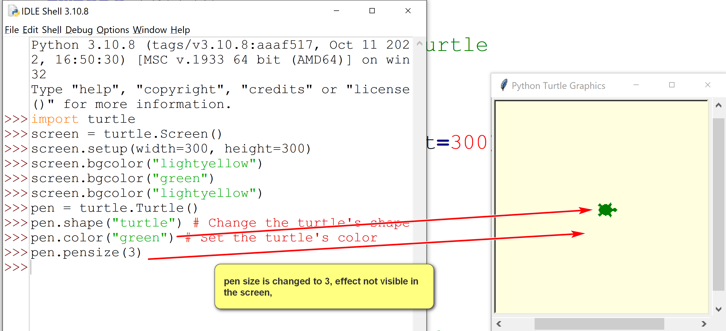

Current turtle location: (0,0) facing right (default initial setting of the turtle).
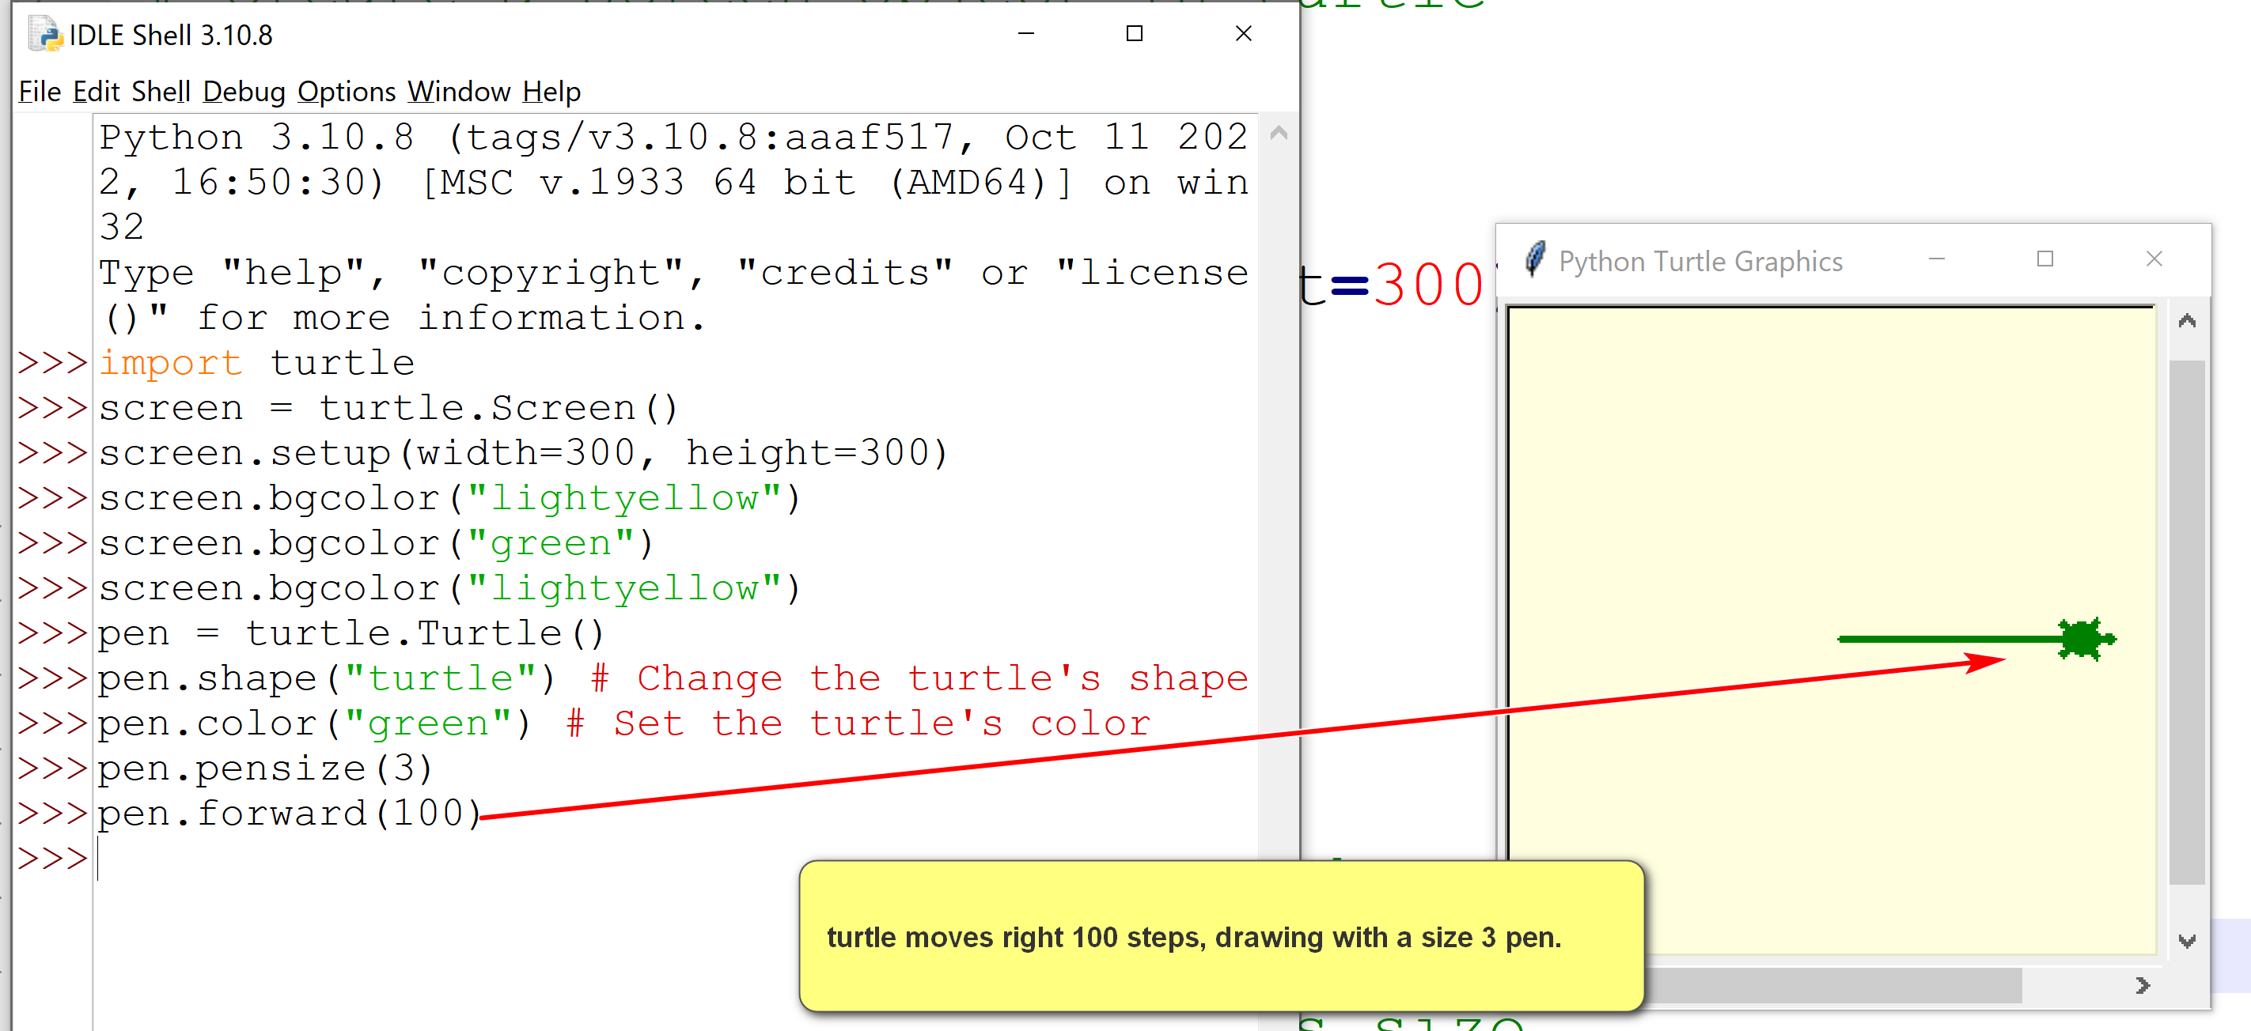
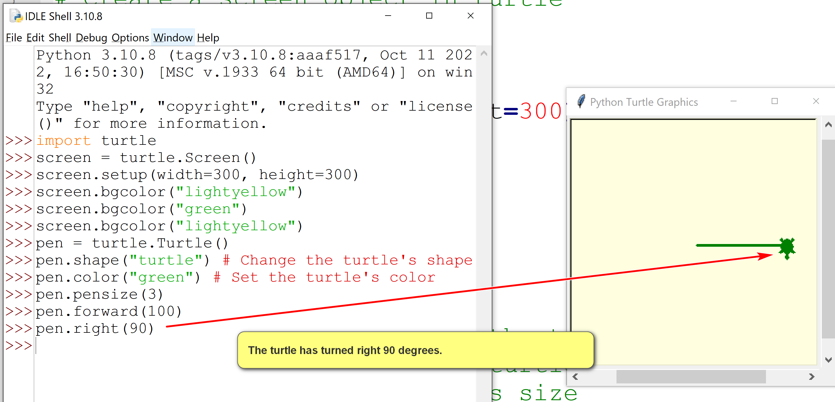
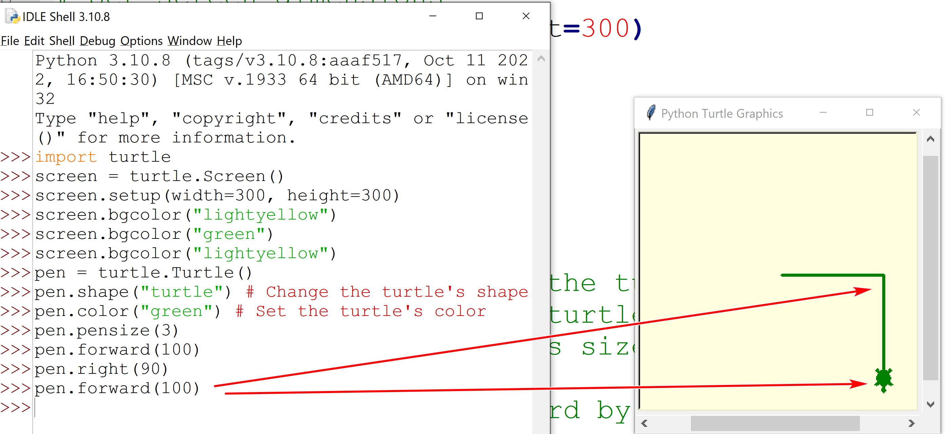

- Download and run square2.py.txt. This is a version of square.py.txt that you can use as the basis of your HW assignment.
- Also, try to run it in IDLE by copying and pasting one statement at a time.
Explanations:
- "import turtle": import the built-in turtle module. This allows the program to use the turtle object.
- "pen = turtle.Turtle()" creates a turtle object and refers to it as "pen"
- "pen.forward(100)" moves the pen. Since the pen is down, the turtle also draws.
- "pen.right(90)" turns the turtle right 90 degrees.
- screen.exitonclick(): pause until the screen is clicked on to exit.

