**CSCI 1470.3 Classroom Notes and Demonstrations**

8/25/2025

**Running Pythons in Windows**

by K. Yue

**1. Organizing Windows for Python Development**

* This is about a simple setup of Python development in Windows using text editors.
* It does not include the uses of Integrated Development Environment (IDE), such as PyCharm, VS Code, etc.
* It does not include the uses of Python platforms (such as for Web development, Graphical User Interface (GUI) appications of data science).

**Command Prompt**

* The Command Prompt in Windows is a Command Line Interface (CLI) for executing commands to interact with the operating systems.
* In Mac and Linux, it is known as a command terminal or terminal.

**Project Directory**

* It is beneficial to create a directory for a project.

E.g. C:\Users\yue\Documents



* For example, for this course, you may create a folder: Documents\uhcl\csci1470, and put all files related to CSCI 1470 there.
* You may create additional subfolder for better organization.

**Working Directory**

* A working directory, ore current working directory (CWD), is the specific location within a computer's file system where commands are executed, such as in the command prompt.
* It is a common practice to set the working directory to the appropriate folder of your project directory. For example, you may then use relative file names.

**2. Running Python in Windows**

**2.1 Python Interpreter**

* To start the Python interpreter, open a command line prompt in your working directory and execute, for example:

set path=C:\Python311;%path%  
python

* You may need to replace "C:\Python311" by the location of your python installation.
* You may set the environmental variable PATH in your OS. If so, you will not need to execute the set path command.

Python interpreter: C:\Python\Python313\python.exe

Demo1.py:

x = int(input())

y = int(input())

z = x + y

print(z)

Notepad++: text editor

TO run:

C:\Users\yue\demo\uhcl\csci1470\hw>python demo1.py

97

21

118

After removing the type conversion function int().

Demo1.py is not good: silent and not providing any context for users to follow.

f(x) = x2

f(1) returns 1  
f(2) returns 4

g(x,y) = x + y; x is the first argument; y is the second argument.

input() is a Python built-in function.

Python has a lot of built-in functions.

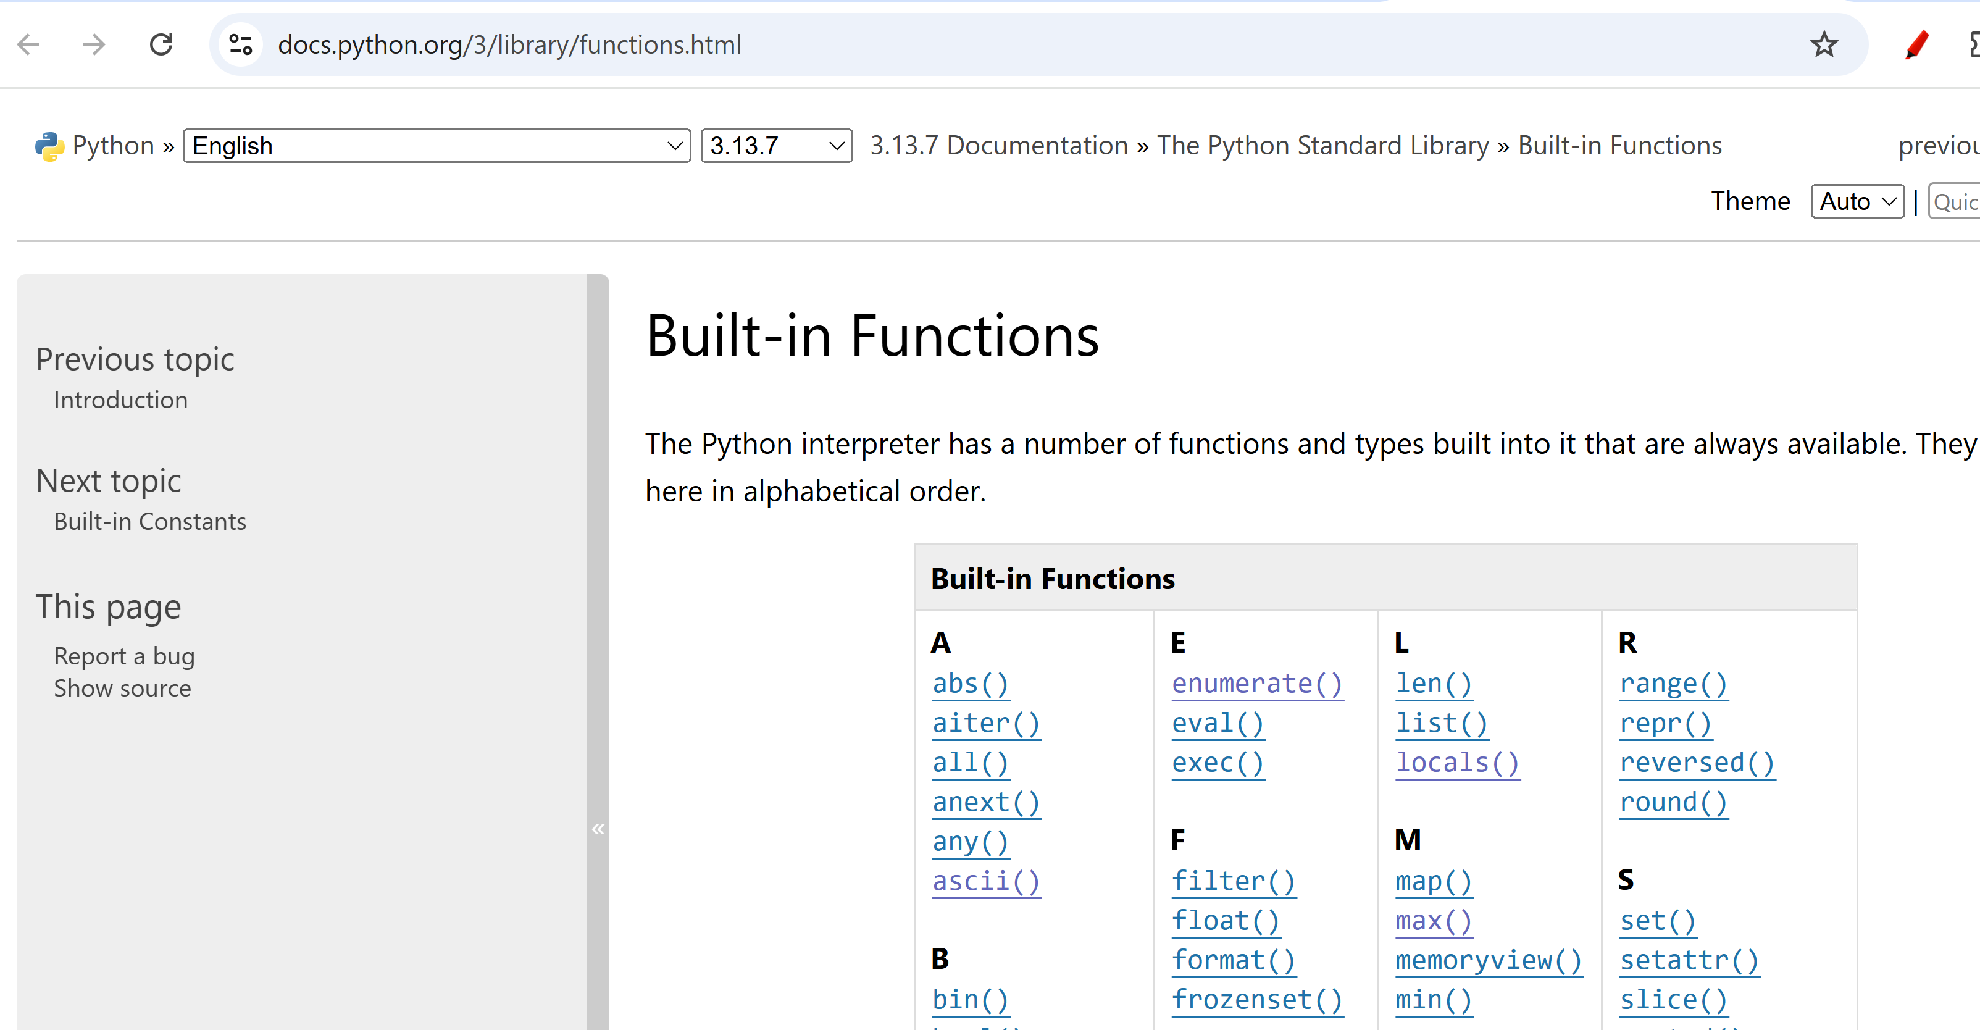

See <https://docs.python.org/3/library/functions.html#input> for input() in Python manual.

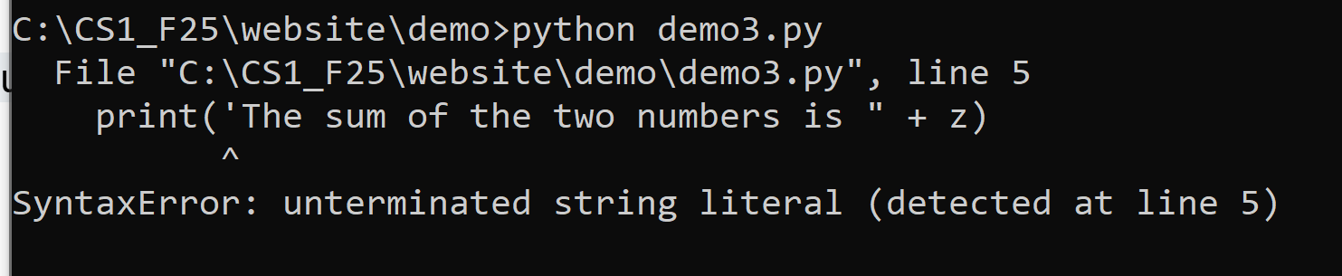

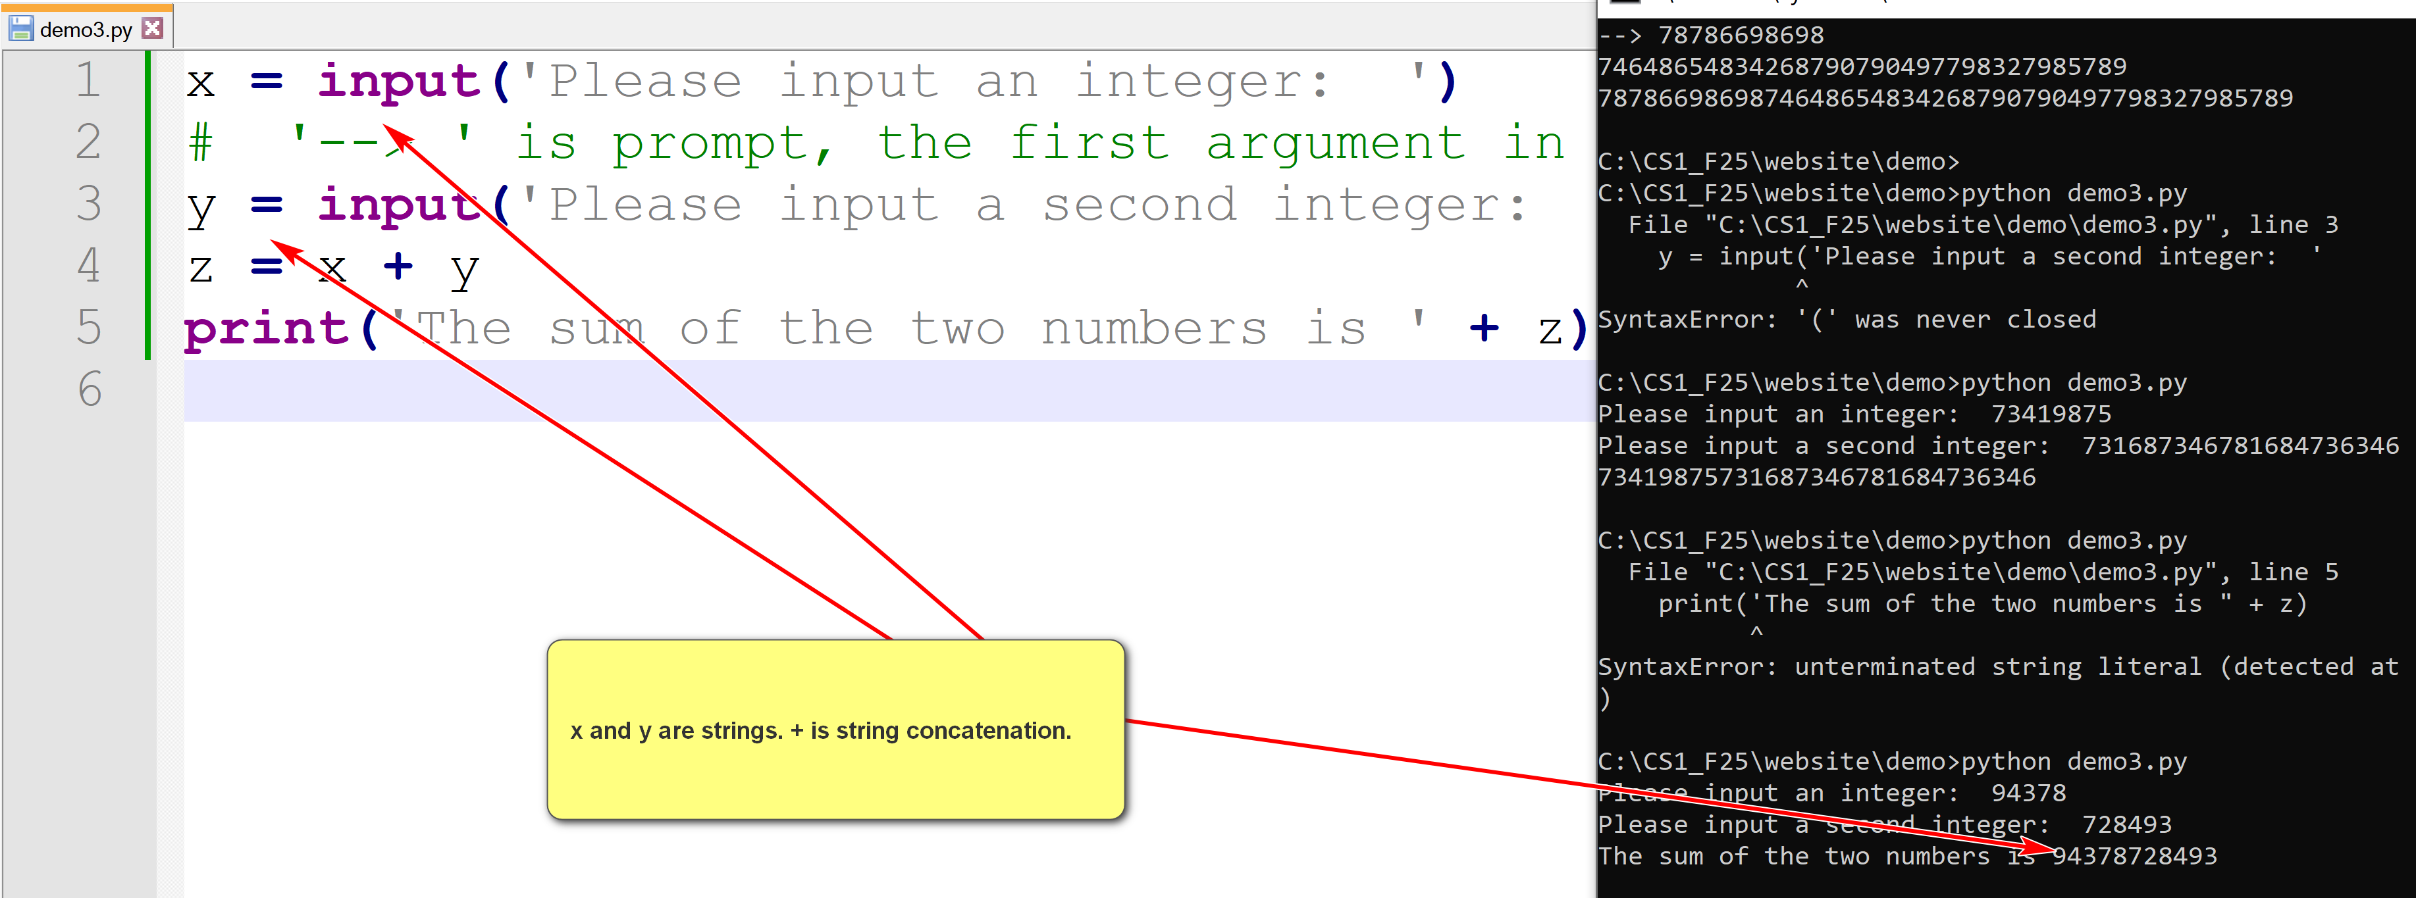

Setting TAB to become 4 spaces

**2.2 Python IDLE**

* Integrated Development and Learning Environment  (IDLE) is a bundled Python environment for simple development and learning.
* It is a simple Integrated Development Environment (IDE).

**Running Python Program**

* To run a Python program, helloworld.py, in a command line prompt (in the project directory), use:

python helloworld.py