CSCI 1470.3 Classroom Notes and Demonstrations
8/18/2025

Need to access Canvas frequently.

Open course page: https://dcm.uhcl.edu/yue/courses/csci1470/Fall2025/
- Classroom Demonstration: demonstration files developed during the lecture.
- May visit the classroom demonstration at the end of the lecture for further study.
How to start a program in the right way?

DO you encourage the use of AI?
Some common programming mistakes?
Ailge software development? Thumb up or down?
Instructor: My regular office hour will be held o8/18/2025 to 11/24/2025: MW 11:20AM to 11:50AM, 2:50PM to 3:45PM. They will be conducted in person (Delta 163)
Q: can I come to your office other than the office hours?

Action item:
- subscribe to zybook.
Familiar with zybooks.
We will be using an interactive textbook from zyBooks this semester. Here is a video that explains more about “What is a zyBook?” https://vimeo.com/285133146/48bc90afb5 You can purchase this book from the bookstore or you can purchase it directly from zyBooks by following these steps:
- Sign in or create an account at learn.zybooks.com
- Enter zyBook code: UHCLCSCI1470YueFall2025
- Subscribe
- If you paid the UHCL book store, just put in the UHCL code sent to you through an email. Don’t pay again.
zyBook: CSCI 1470: Computer Science I
zyBook code: UHCLCSCI1470YueFall2025
zyBook ISBN:979-8-203-02909-6

Intro to CS 1:
1. Promotion
- This course is (hopefully) one of the more useful CS courses for students.
- Programming is essential for computing careers.
- Python is very popular.
https://www.tiobe.com/tiobe-index/
Aug 2025 | Aug 2024 | Change | Programming Language |  | Ratings | Change
1 | 1 |  |  | Python | 26.14% | +8.10%
2 | 2 |  |  | C++ | 9.18% | -0.86%
3 | 3 |  |  | C | 9.03% | -0.15%
4 | 4 |  |  | Java | 8.59% | -0.58%
5 | 5 |  |  | C# | 5.52% | -0.87%
6 | 6 |  |  | JavaScript | 3.15% | -0.76%
7 | 8 |  |  | Visual Basic | 2.33% | +0.15%
8 | 9 |  |  | Go | 2.11% | +0.08%
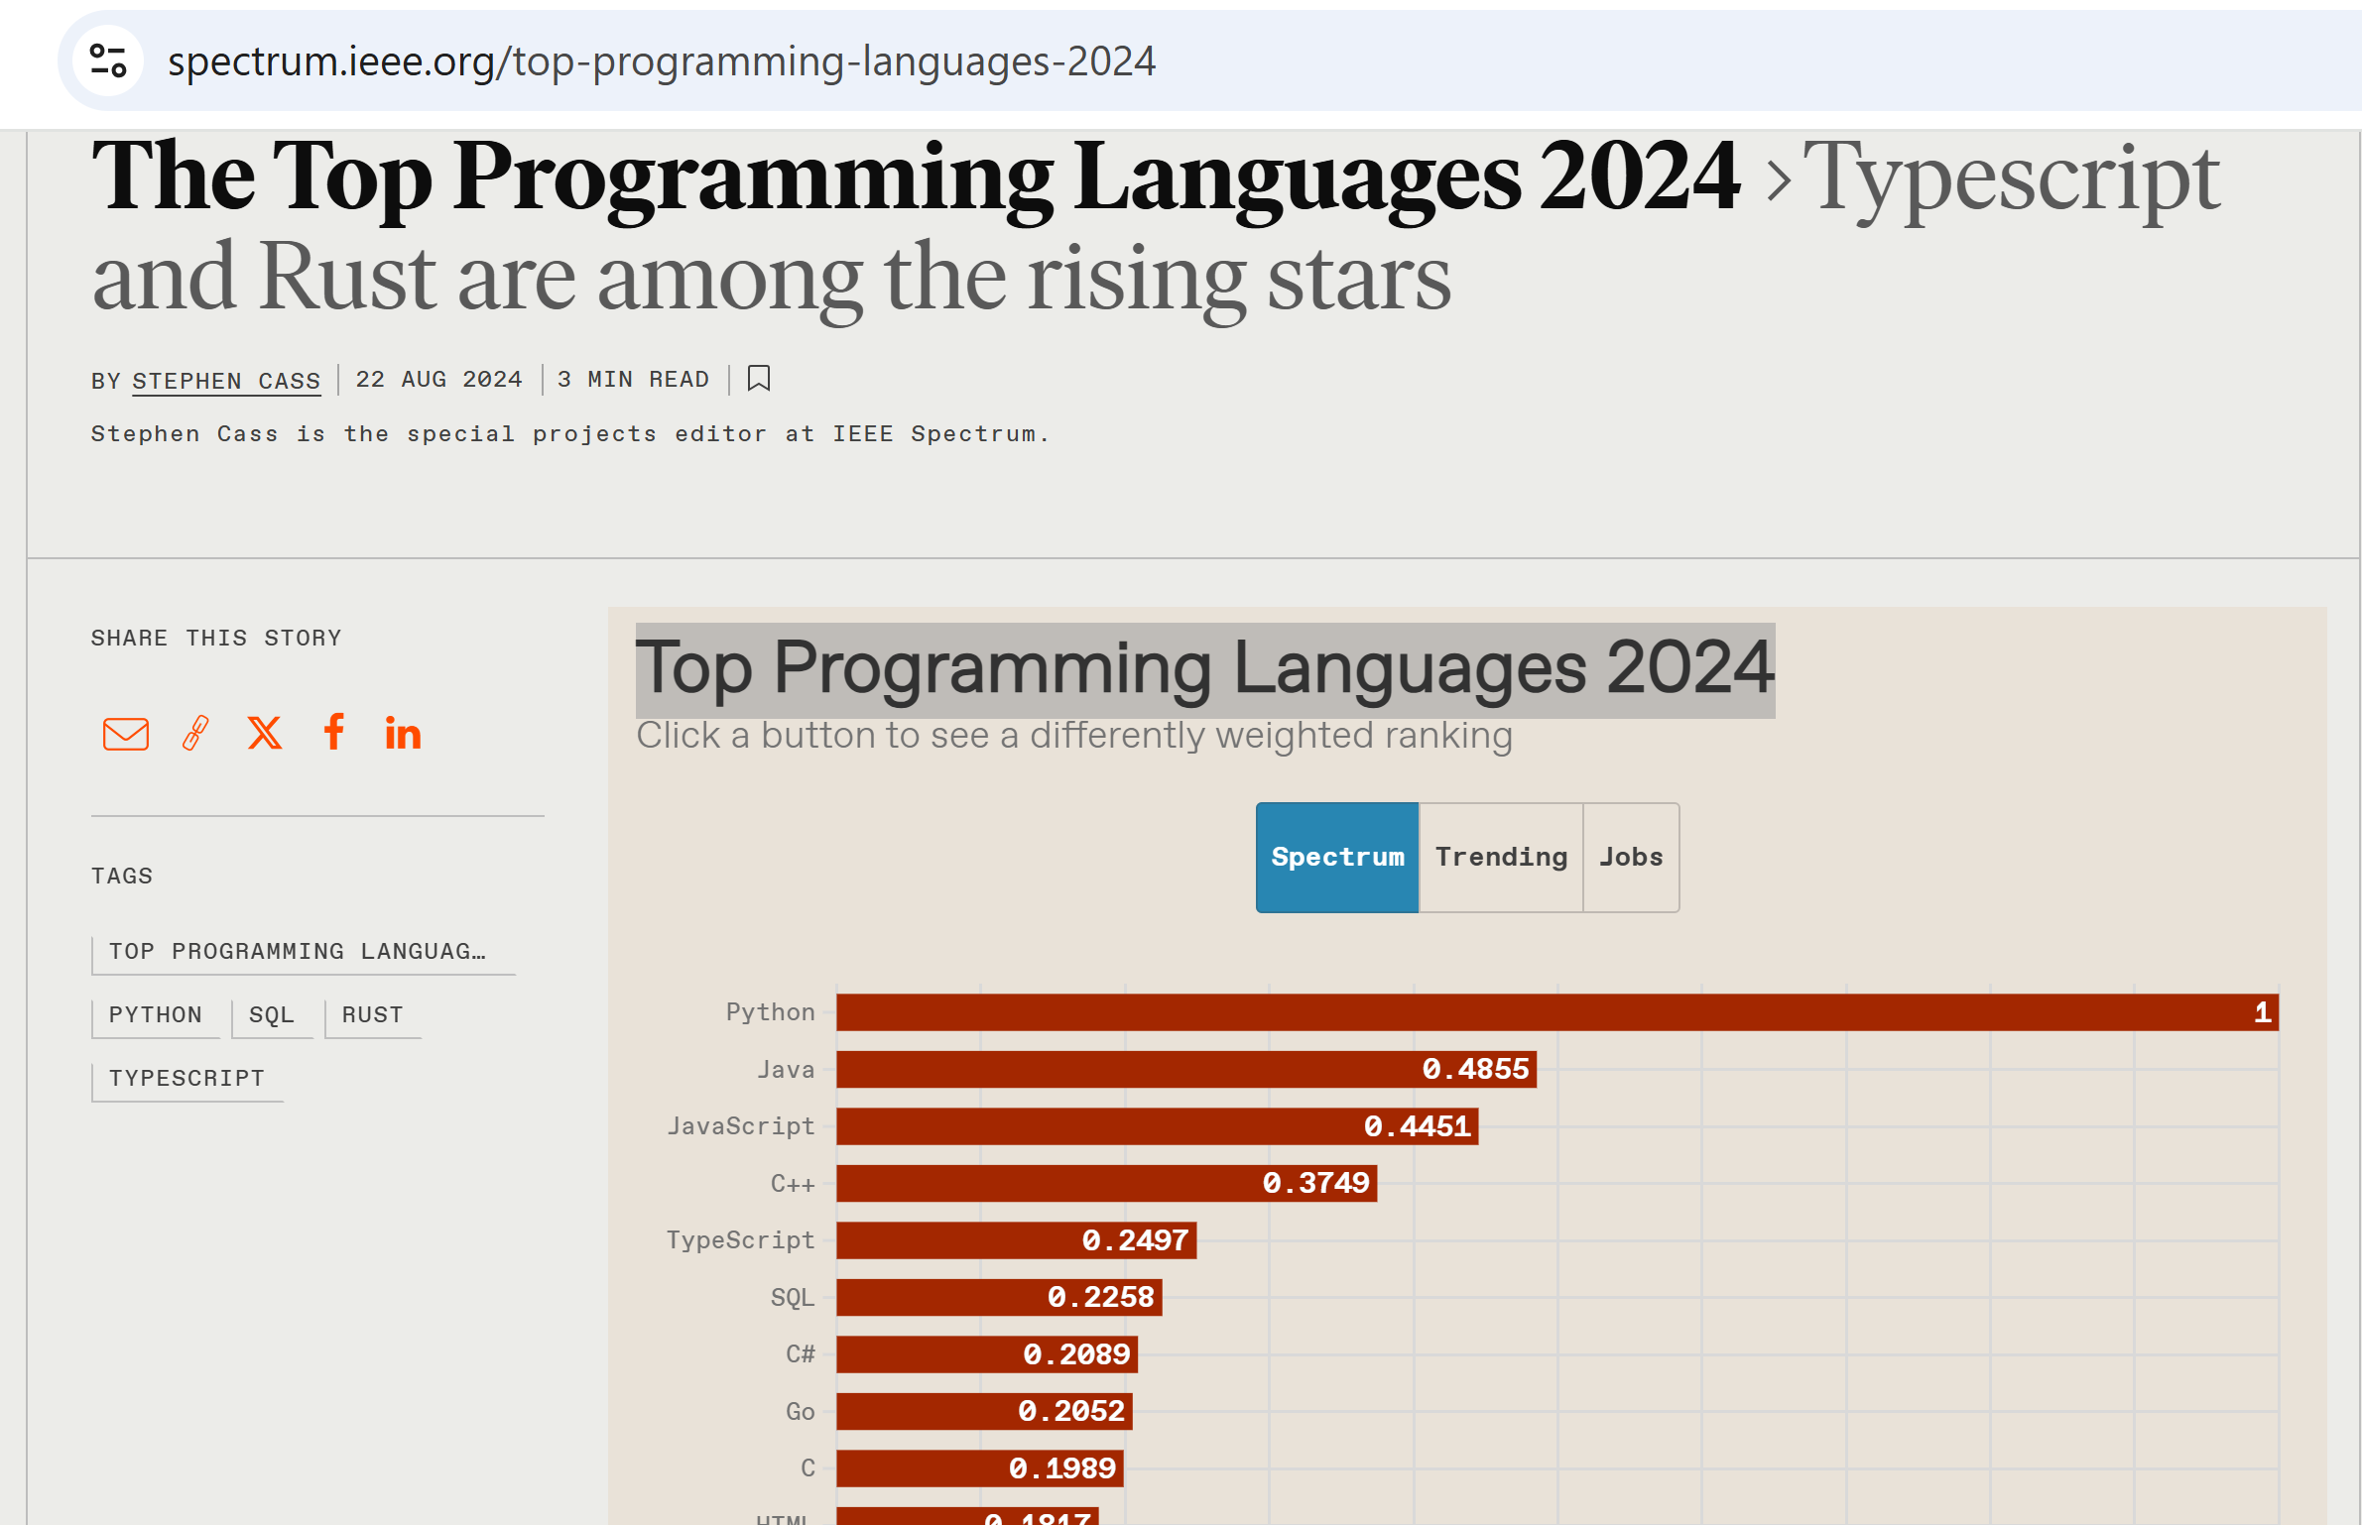
2.General Learning Suggestions
- Everyone is different and unique in learning.
- Engagement and learning by doing.
- Teaching is an excellent way of learning: help your classmates.
- Prepare your own notes: the best notes for you are written by yourself
- Consider crowd learning.
- Come to my office often, especially in groups.
- Please consider forming the habit of listening carefully and asking a lot of questions.
How do I learn? Try to optimize learning.
- I like visual learning: concrete examples, video (Youtube)
- Hands-on learning: doing by myself.

3. How to be successful in the course
General Professionalism:
- Attitude
- Be considerate.
- Be helpful and useful to others.
- Be a good listener.
- Be responsive.
- Hardworking
- Attention to details.
- Focus: uni-tasking

