CSCI 1470.3 Classroom Notes and Demonstrations
10/22/2025
Functions
CSCI 1470
by K. Yue
1. Functions: Introduction
1.1 Mathematical Functions
- A mathematical function is a rule that takes one or more inputs and produces or returns exactly one output.
Examples:
f(x) = 2 * x + 4
g(y) = y ** 2 + 1
h(x,y,z) = x + y + z
f(1) returns 6
f(3) returns 10
g(2) returns 5
g(4) returns 17
h(1,2,3) returns 6
h(f(1),g(2),f(3)+g(4)) returns 38
- In f(x) = 2 * x + 4:
  - "2 * x + 4" is the definition or rule that produces the single output.
  - x is the only formal parameter (or parameter, or formal argument) of the function f.
  - x is also called a dummy variable as one can use any name., e.g. f(num) = 2 * num + 1.
- In f(2), 2 is the actual argument (or argument, or actual parameter).
- Since a function returns one output value, the output can be used as the actual parameter, or a part of it, of another function. E.g., h(f(1),g(2),f(3)+g(4))
- Thus. functions can be nested.
- The domain of a function is the set of all possible input values.
- The range of a function is the set of all possible output values.
1.2 Python Functions
- Python functions have many similarities with mathematical functions.
  - A function has a definition to compute the return value.
  - Abstraction: To call a function, the user does not need to know how the function is implemented.
  - A function can have 0, 1, or more parameters.
  - A function returns a single value.
  - A function can be nested.
  - A function can be recursive: a function can call itself.
- Python functions also have many differences with mathematical functions. Examples:
  - Can produce different outputs for the same inputs (Python's fucntions can have states)
  - May have side effects other than the returned values (e.g., print something inside a function).
  - Parameters with default values
  - Varying number of parameters
  - ...
There are many advantages of using Python's functions. Some advantages include:
- Code Reuse: a function can be called multiple times by many programs.
- Decomposition and modularity: complex code can be decomposed into multiple functions.
- Simpler development: a function represents a single well-defined action.
- Reliability and error reduction: a function can be thoroughly tested before use.
- Improved organization and software architecture: functions can be organized into classes, modules and packages for efficient organization.
- Understandability: when there is no side effects, functions can be thoroughly understood by their return values.
- Encapsulation: functions encapsulate a specific set of operations, hiding the internal details from the callers.
2. User-defined Functions
- The format of a user-defined function:
def function_name(parameters):
function_body (indented)
- The return statement is used to exit a function and return a value to the caller.
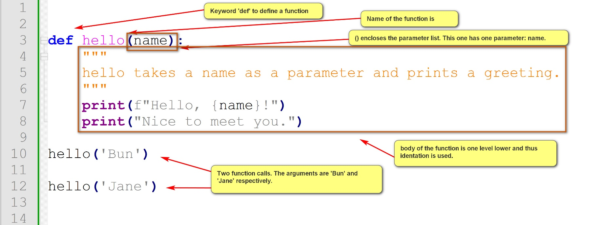
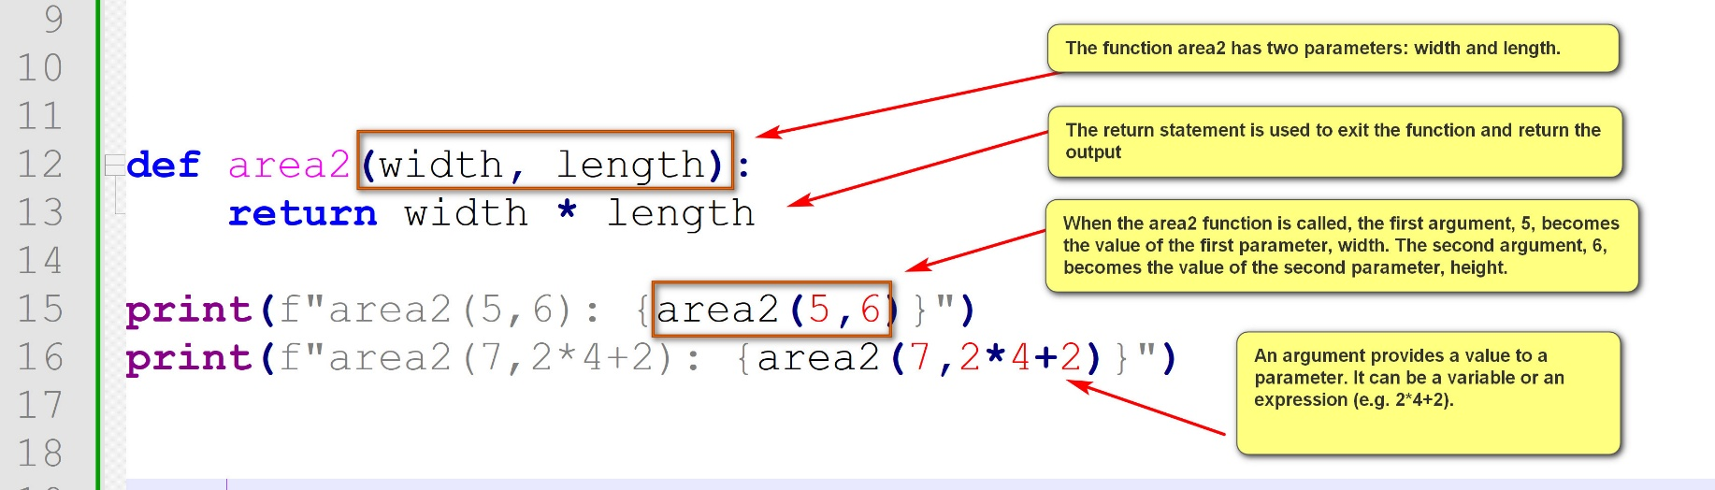
Example:
fun_basic_1.py
def area(width, length):
print(f"Area of a {width} * {length} rectangle: {width * length}")
# The print statement is an example of 'side effect': action other than the return value. Side effects should be avoided as much as possible.
area(5,6)
area(7,10)
# A better version: no side effect and use the return statement. It is also more general and useful.
def area2(width, length):
return width * length
print(f"area2(5,6): {area2(5,6)}")
print(f"area2(7,2*4+2): {area2(7,2*4+2)}")
width_1 = 5
length_1 = 6
print(f"Area of a {width_1} * {length_1} rectangle: {area2(width_1, length_1)}")
width_2 = 7
length_2 = 10
print(f"Sum of the areas of the two rectangles: {area2(width_1, length_1) + area2(width_2, length_2)}")
def hello(name):
"""
hello takes a name as a parameter and prints a greeting.
"""
print(f"Hello, {name}!")
print("Nice to meet you.")
hello('Bun')
hello('Jane')
The following example shows some advantages of functions.
Example:
Get the names and ages of three players and display greetings.
Without using function: player_greetings_no_fun.py
# Process player 1 input and display a welcome message.
player_1_name = input("Player 1: please enter your name: ")
player_1_age = int(input("Player 1: please enter your age: "))
if player_1_age >= 18:
print(f"Hello, {player_1_name}! You are an adult.")
else:
print(f"Hello, {player_1_name}! You are a minor.")
# Process player 2 input and display a welcome message.
player_2_name = input("Player 2: please enter your name: ")
player_2_age = int(input("Player 2: please enter your age: "))
if player_2_age >= 18:
print(f"Hello, {player_2_name}! You are an adult.")
else:
print(f"Hello, {player_2_name}! You are a minor.")
# Process player 3 input and display a welcome message.
player_3_name = input("Player 3: please enter your name: ")
player_3_age = int(input("Player 3: please enter your age: "))
if player_3_age >= 18:
print(f"Hello, {player_3_name}! You are an adult.")
else:
print(f"Hello, {player_3_name}! You are a minor.")
- Note the same code for getting input (the input statements) and displaying greetings (the if-then-else statement with print) are repeated three times.
Using two functions: player_greetings.py
def get_user_details(user):
name = input(f"{user}: please enter your name: ")
age = int(input(f"{user}: please your age: "))
return name, age
def display_greeting(name, age):
if age >= 18:
print(f"Hello, {name}! You are an adult.")
else:
print(f"Hello, {name}! You are a minor.")
# Main program
player_1_name, player_1_age = get_user_details("Player 1")
display_greeting(player_1_name, player_1_age)
player_2_name, player_2_age = get_user_details("Player 2")
display_greeting(player_2_name, player_2_age)
player_3_name, player_3_age = get_user_details("Player 3")
display_greeting(player_3_name, player_3_age)
If the way of getting input and displaying greetings are changed, and there are now four players:
player_greetings_v2.py
def get_user_details(user):
name = input(f"{user}: please enter your name: ")
age = int(input(f"{user}: and your age: "))
return name, age
def display_greeting(name, age):
if age >= 90:
print(f"Hello, {name}! Sure want to play? :-)")
else:
print(f"Hello, {name}! Let's roll.")
# Main program
player_1_name, player_1_age = get_user_details("Player 1")
display_greeting(player_1_name, player_1_age)
player_2_name, player_2_age = get_user_details("Player 2")
display_greeting(player_2_name, player_2_age)
player_3_name, player_3_age = get_user_details("Player 3")
display_greeting(player_3_name, player_3_age)
player_4_name, player_4_age = get_user_details("Player 4")
display_greeting(player_4_name, player_4_age)
General principle: avoid unnecessary redundancy.
2.1 Function parameters and arguments
- Parameters are placeholders defined within the parentheses of a function's def statement.
- They receive values from arguments when the function is called.
- Parameters can have default values. (not supported by many programming languages)
2.1.1 Positional and named parameters
- Positional arguments are assigned to parameters based on their order in the function call. The first argument is assigned to the first parameter, the second to the second, and so on. Some advantages:
  - Simplicity
  - Familiarity: many programming languages support only positional parameters.
  - Clarity and consistency: if there are natural orders.
  - Function evolution
- Named arguments (keyword arguments) are a way to pass values to a function by explicitly specifying the parameter name along with the value. Not supported by many other languages. Some advantages:
  - Clarify
  - Order independence
  - Ease of use with default values
Example:
param_1.py:
# positional parameters
def add_two(a,b):
return a+b
print("""
def add_two(a=1,b=0):
return a+b
""")
print(f"add_two(1,4): {add_two(1,4)}")
print(f"add_two(a=1,b=4): {add_two(a=1,b=4)}")
print(f"add_two(-1,40): {add_two(-1,40)}")
def add_two_with_default(a=1,b=2):
return a+b
print("""
def add_two_with_default(a=1,b=2):
return a+b
""")
print(f"add_two_with_default(1,4): {add_two_with_default(1,4)}")
print(f"add_two_with_default(a=1,b=4): {add_two_with_default(a=1,b=4)}")
print(f"add_two_with_default(-1,40): {add_two_with_default(-1,40)}")
print(f"add_two_with_default(8): {add_two_with_default(8)}")
print(f"add_two_with_default(b=1): {add_two_with_default(b=1)}")
print(f"add_two_with_default(): {add_two_with_default()}")
# Positional parameters and keyworded (named) parameters.
# A parameter has a position and a name.
def introduce(name, age):
print(f"My name is {name} and I am {age} years old.")
return 'done'
print("""
def introduce(name, age):
print(f"My name is {name} and I am {age} years old.")
return 'done'
""")
print(f"introduce('Jane', 19): {introduce('Jane', 19)}")
print(f"introduce(19,'Jane'): {introduce(19,'Jane')}")
print(f"introduce(name='Jane', age=19): {introduce(name='Jane', age=19)}")
print(f"introduce(age=19,name='Jane'): {introduce(age=19,name='Jane')}")
- Python functions support multiple (varying) arguments. (Not supported by many programming languages., e.g. Java)
  - *positional_parameter_name can be used to accept multiple number of positional arguments into the parameter positional_parameter_name.
  - * (by itself) signals the end of positional parameters. Parameters thereafter must be named parameters.
  - **named_parameter_name can be used to accept multiple numbers of named arguments into the parameter named_parameter_name.
Example:
param_2.py:
# arbitrary numbers of arguments.
def add(*args):
return sum(args)
print("""
def add(*args):
return sum(args)
""")
print(f"add(1,2,3,4,5): {add(1,2,3,4,5)}")
print(f"add(10,2,3,4,5,6,7): {add(10,2,3,4,5,6,7)}")
def multiplied_sum(*numbers, multiplier=1):
total_sum = sum(numbers)
return total_sum * multiplier
print("""
def multiplied_sum(*numbers, multiplier=1):
total_sum = sum(numbers)
return total_sum * multiplier
""")
print(f"multiplied_sum(1,2,3,4,multiplier=5): {multiplied_sum(1,2,3,4,multiplier=5)}")
print(f"multiplied_sum(1,2,3,4,5): {multiplied_sum(1,2,3,4,5)}")
def area(*, width, length):
return width * length
print("""
def area(*, width, length):
return width * length
""")
print(f"area(width=2,length=3): {area(width=2,length=3)}")
print(
"""
print(f"area(2,3): {area(2,3)}")
TypeError: area() takes 0 positional arguments but 2 were given
"""
)
2.2 Functions are objects
- Functions are first class objects. For examples, they can be assigned to a variable.
- Python's functions are callable objects: objects that can be called.
- This flexibility supports powerful use patterns for constructing solutions.
- In this course, we provide only simple examples behind the concept.
Example:
fun_obj_1.py: functions are callable objects.
def hello(name):
print(f"hello, {name}. Nice to see you.")
def bye(name):
print(f"Bye, {name}. See you next time.")
my_func = hello
my_func('Bun')
my_func = bye
my_func('Bun')
greetings = {
"hello": hello,
"bye": bye
}
greetings["hello"]("Jane")
greetings["bye"]("Jane")
3. Python built-in functions and imported functions
- Python built-in functions are standard functions that come with Python distribution.
- Imported functions are functions defined in Python modules. To use them, two steps are needed.
  - Install the module using pip.
  - Import the module in your program.
3.1 Built-in functions
To understand built-in functions:
- Consult the official Python documentation: https://docs.python.org/3/library/functions.html
- Use the help() function in Python
- Textbook, tutorials, courses, instructors, ...
Example:
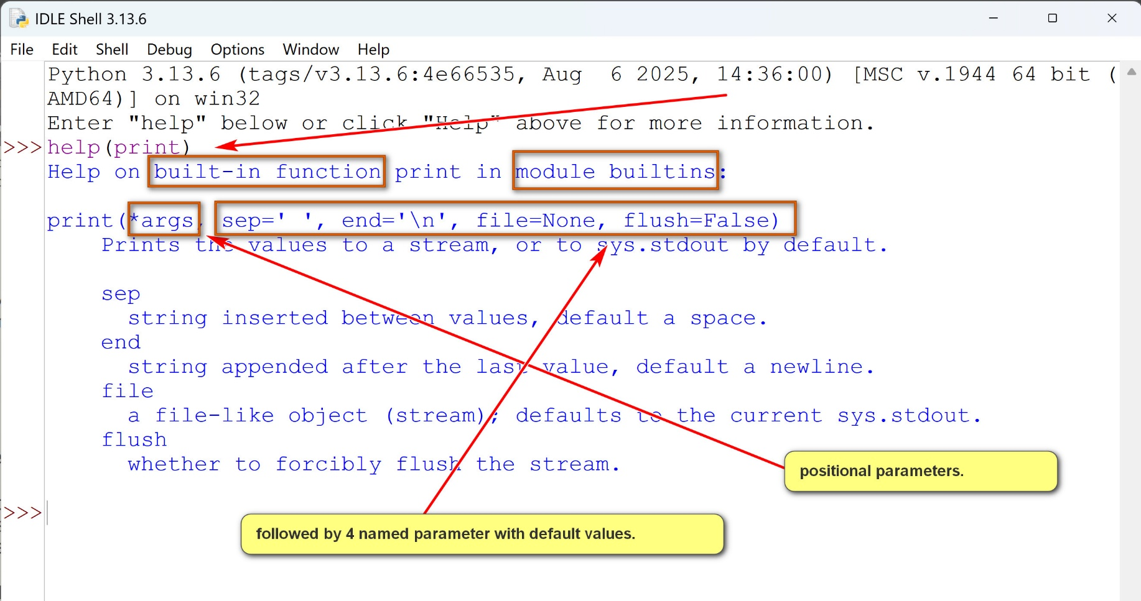
Some categories of built-in functions:
- Type conversions and creation: e.g., int(), float(), str(), list(), tuple(), ...
- Mathematical operations: e.g., max(), min(), sum(), pow(), ...
- Iteration and sequence operations: e.g., len(), range(), enumerate(), reversed(), sorted(), ...
- Object and attribute manipulation operations: e.g., id(), type(), hasattr(), ...
- Input/Output: e.g., input(), print(), open(), ...
- Code execution operations: e.g., eval(), exec(), ...
3.2 Imported functions
- Python modules can be imported by the import statement.
- Functions in the modules can then be called by their full names: module_name.function_name.
- Alternately, functions can be imported by using "from module_name import function_name, ..."
- The imported functions can then be used directly without the modules name: function_name.
Example:
built_in_fun_1.py:
import math
from random import randint
# imported functions of the math module are called by full names: e.g., math.sqrt()
# imported function randint of the random module is called directly.
print(f"math.sqrt(64): {math.sqrt(64)}")
print(f"math.pi: {math.pi}")
print(f"math.sin(1): {math.sin(1)}")
print(f"math.gcd(24,36,126): {math.gcd(24,36,126)}")
print(f"math.lcm(24,36,126): {math.lcm(24,36,126)}")
print(f"randint(1,10): {randint(1,10)}")
print(f"randint(1,10): {randint(1,10)}")
print(f"randint(1,10): {randint(1,10)}")
print(f"randint(1,10): {randint(1,10)}")
print(f"randint(1,10): {randint(1,10)}")

