CSCI 1470.3 Classroom Notes and Demonstrations
10/13/2025

Iteration Statements
CSCI 1470
by K. Yue

list_name[start:stop:step]
‘stop’ does not include list_name[stop]
list_name[start:stop}: list_name[start], list_name[start+1] … list_name[stop-1]
Debugger on test Q1.16
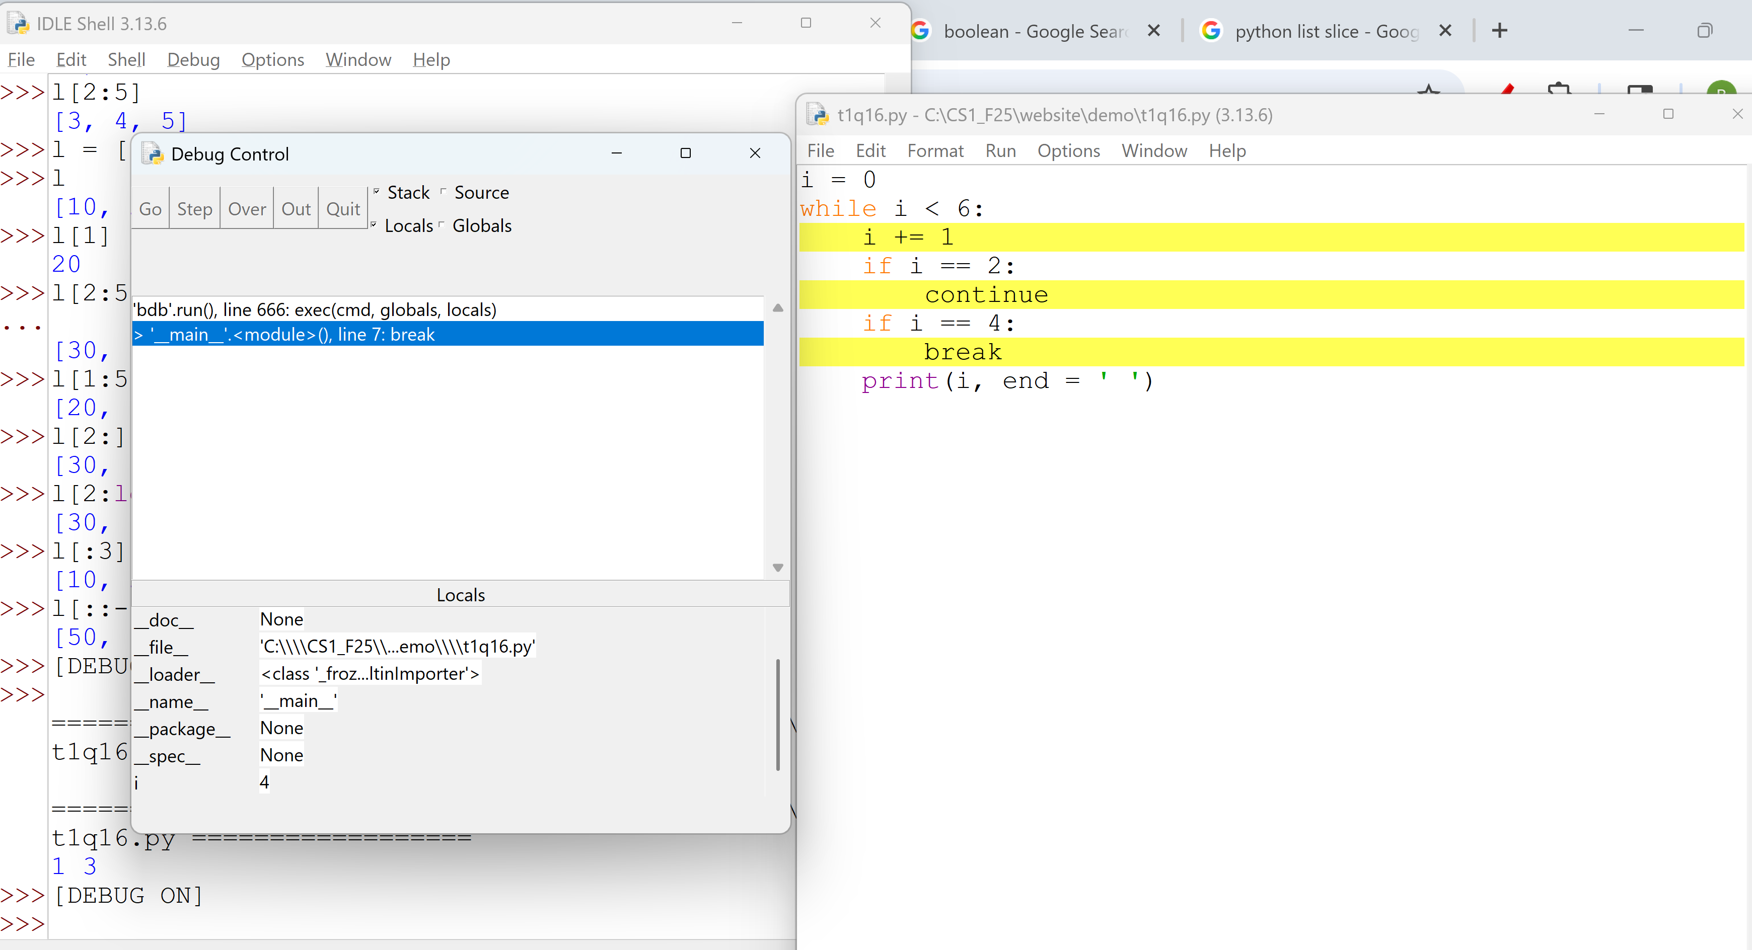
1. Iteration: for loop
- Python offers several iteration statements to repeatedly loop through and execute a block of code.
- The primary iteration statements in Python are for loops and while loops.
- A loop statement may have several components:
  - Initialization: preparatory logic before entering the loop. To be executed once.
  - Continuing condition: when the loop should be continued.
  - Iteration code: a block of code to be executed. To be executed as many times as the loop continues.
  - Update code: update the variables involved in the continuing condition to prepare whether the loop should continues.
- An iteration statement executes step [1] once, and steps [2] to [4] as many times as the continuing condition is evaluated to true.
- The for loop in Python is signficantly different in both syntax and meaning to the for loop in a Java/C/C#/C++.
Example in Java:
for (int i = 0; i < 10; i++) { // Iterates from 0 to 9
System.out.println(i);
}
- Initialization: int i = 0; Set the variable i = 0.
- Continuing condition: i < 10; so long as i is less than 10.
- Iteration code: what logic demands. E.g., System.out.println(i);
- Update code: i++ Increment i by 1
Example in Python:
for i in range(10): # Iterates from 0 to 9
print(i)
- Initialization: i is set to 0 implicitly. This is because the lower limit of range(10) is 0.
- Continuing condition: i < 10. This is because the lower limit of range(10) is 10.
- Iteration code: what logic demands. E.g., print(i);
- Update code: i is implicitly incremented by 1.
- A Python for loop is used for iterating over iterable objects:
  - a sequence data type (such as a list, tuple, string, dictionary, or range): the main focus of this course.
  - iterable objects returned by function calls: some of these functions will be covered in this course.
  - objects of user-defined iterable classes: may or may not be covered later in the course.
Tools:
bk.py:
This is a simple Python module that supports one function break_and_show(). When the function is called, it represents a break point. It shows the old and new values of all variables that have been changed. It contains many limitations.
To use the module, put bk.py in your working project directory and add the following line in your python program:
from bk import break_and_show
Format:
for iteration_variable in iterable_object:
# A block of iteration code to be executed.
# Indentation is required as the block is one level lower.
Examples:
Try the following three python programs on for loops.
for_1.py:
from bk import break_and_show
debug = False # set debug to False if you do not want to see breakpoints.
# Version 1: loop five times from 0 to 4.
for i in range(5): # range(stop): start assumes to be 0.
if debug: break_and_show()
print(f"square({i}): {i * i}")
# Version 2: loop five times from 1 to 5.
for i in range(1, 6): # range(start, stop)
if debug: break_and_show()
print(f"square({i}): {i * i}")
# Version 3: loop three times: 1, 3, 5.
for i in range(1, 6, 2): # range(start, stop, step)
if debug: break_and_show()
print(f"square({i}): {i * i}")
# summing a list:
list_1 = [3,4,1,7,8,3,6]
print(f"list_1: {list_1}")
print(f"len(list_1): {len(list_1)}")
list_sum = 0
for i in range(len(list_1)):
if debug: break_and_show()
list_sum += list_1[i]
print(f"sum of list_1: {list_sum}")
print(f"sum(list_1): {sum(list_1)}")
for_2.py:
from bk import break_and_show
debug = False # set debug to False if you do not want to see breakpoints.
data_points = [10, 25, 30, 15, 40]
for point in data_points:
if debug: break_and_show()
print(f"Data point: {point}")
my_string = "love"
for char in my_string:
if debug: break_and_show()
print(char)
numbers = [11, 22, 33, 44, 55]
total_sum = 0
for num in numbers:
total_sum += num
if debug: break_and_show()
print(f"Total sum: {total_sum}")
for_3.py:
from bk import break_and_show
debug = True # set debug to False if you do not want to see breakpoints.
raw_scores = [25, 82, 58, 98]
scaled_scores = []
i = 1
for score in raw_scores:
scaled_scores.append(score / 100)
i += 1
if debug: break_and_show()
print(f"Scaled scores: {scaled_scores}")
2. while loop
- In Python, a loop statement executes a block of code 0 or more times, as long as a specified condition remains evaluated to True.
Format:
while condition:
# Code to be executed repeatedly
# Indentation is required for the block.
- The while loop terminates when
  - the condition is evaluated to False, or
  - when a break statement is executed.
- The break statement can be used to exit a while loop immediately (without completing the current iteration).
- The continue statement skips the rest of the current iteration and proceeds to the next iteration of the loop (which starts by evaluating the condition).
Recall that there are four components of a loop statement.
- Initialization: preparatory logic before entering the loop. To be executed once.
- Continuing condition: when the loop should be exit.
- Iteration code: a block of code to be executed. To be executed as many times as the loop continues.
- Update code: update the variables involved in the continuing condition to prepare whether the loop should continues.
Thus, the general structure of a while loop:
# [1] initialization code
while condition: # [2] continuing condition.
# Code to be executed repeatedly: [3] Iteration code
# [4] Update code is usually at the end of the while block
- The for loop is used to iterate through sequences or iterable objects. The number of iterations is generally known before the loop starts.
- The while loop is used when the continue condition is determined during runtime and the number of iterations is generally not known before the loop starts.
Examples: loop five times from 1 to 5.
Using for loop:
# loop five times from 1 to 5 using for loop and range function
for i in range(1, 6): # range(start, stop)
if debug: break_and_show()
print(f"square({i}): {i * i}")
Using while loop: while_1.py
# loop five times from 1 to 5 using while loop
i = 1
while i < 6:
if debug: break_and_show()
print(f"square({i}): {i * i}")
i += 1
while_2.py: simple while loops and how to improve them.
from bk import break_and_show
debug = True # set debug to False if you do not want to see breakpoints.
# version #1
required_samples = 3
collected_samples = 0
data_points = []
while collected_samples < required_samples:
data_input = input(f"Enter data point {collected_samples + 1}/{required_samples}: ")
data_points.append(data_input)
collected_samples += 1
print(f"Data point '{data_input}' recorded.")
print("\nAll required data samples collected:")
for data in data_points:
print(f"Sample: {data}")
# version #2
required_samples = 3
data_points = []
while len(data_points) < required_samples:
data_input = input(f"Enter data point {len(data_points) + 1}/{required_samples}: ")
data_points.append(data_input)
print(f"Data point '{data_input}' recorded.")
# Also print sample #.
print("\nAll required data samples collected:")
i = 0
while i < len(data_points):
print(f"Sample #{i+1}: {data_points[i]}")
i += 1
# Alternate solution using enumerate
print("\nAll required data samples collected:")
for i, data in enumerate(data_points):
print(f"Sample {i+1}: {data}")
while_yes_no.py: a simple use case of getting a yes or no user input and why a function is defined.
def get_yes_no_input(prompt_message):
"""
Prompts the user for a yes/no input and returns True for yes, False for no.
Handles variations like 'y', 'yes', 'n', 'no' (case-insensitive).
"""
while True:
user_input = input(f"{prompt_message} (yes/no): ").lower().strip() # conver to lower case and remove trailing white spaces.
if user_input in ('yes', 'y'):
return True
elif user_input in ('no', 'n'):
return False
else:
print("Invalid input. Please enter 'yes' or 'no'.")
# Example usage:
if get_yes_no_input("Do you want to continue?"):
print("Good. Here is another question.")
else:
print("User chose to stop.")
answer = get_yes_no_input("Is life a box of chocolate?")
if answer:
print("Great!")
else:
print("Then, get pizza.")
Fibonacci numbers: 0,1,1,2,3,5,8,13,21,
fib(1) = 0
fib(2) = 1
fib(n) = fib(n-1) + fib(n-2)
for_ftb_1.py: print the first 20 Fibonacci numbers
- A for loop is used since we know the number of iterations.
- How do you improve on the code below?
# Initialize the first two Fibonacci numbers
a, b = 0, 1
# Print the first two numbers
print(a)
print(b)
# Loop to calculate and print the remaining 18 Fibonacci numbers
for _ in range(18): # We need 18 more numbers after the initial two
next_fib = a + b
print(next_fib)
a = b
b = next_fib
- Note the multiple assignment statement: a, b = 0, 1
- Note the use of _ in for _ in range(18). _ is an anonymous variable. It stores a value but the value is not used (referenced).
- The effect is the same as for i in range(18). In this case, since i is not used, it is better to be replaced by _ to improve brevity and simplicity.
- Clarity and simplicity are very important in computer science.
while_fib_1.py: print all Fibonacci numbers smaller than 50,000.
- Each iteration prints one Fibonacci number.
- Since we do not know how many Fibonacci numbers are smaller than 50,000, a while loop is used.
LIMIT = 50000
# Initialize the first two Fibonacci numbers
a, b = 0, 1
# Print the starting number 0, since it is less than the limit
print(a)
# Use a while loop to generate and print the sequence
while b < LIMIT:
print(b)
# Update the values for the next iteration
# The new 'a' becomes the old 'b', and the new 'b' is their sum
a, b = b, a + b
while_valid_number.py:
# input validation
while True:
try:
user_input = input("Please enter an integer: ")
number = int(user_input)
break # Exit the loop if input is a valid integer
except ValueError:
print(f"Not an integer: {user_input}. Pleas try again. ")
print(f"You entered the number: {number}")
- If the input is valid, the break statement is used to exit the while loop.
- Note the use of the try-except block for error handling. Error handling will be covered later with more details.
while_nested_1.py: what is the output of this code?
i = 1
while i <= 3:
j = 1
while j <= i:
print(f"Outer loop variable, i: {i}, Inner loop variable, j: {j}")
j += 1
i += 1

