DASC 5333 Database Systems for Data Science
CSCI 4333 Design of Database Systems
Fall 2023
Homework #3 Database Modeling

UML Modeling
Download and install the student version of Astah's UML Editor: http://astah.net/download. Astah provides it free for students. This is one of the best free UML editors available. It has some restrictions but should be more than sufficient for our class. Another good alternative is to use Visual Paradigm community version. This is free but will leave a watermark when you export your model diagram to images or PDF. Instead, you may just take a screenshot of the model.
The homework assignment is to model a drastically simplified toy Group World (GW) database to support Web-based groups.
Multiplicities for attributes and associations should be as specific as possible. Attribute and association documentation are optional, but they are encouraged when not trivial. For example, the roles or names of associations should be displayed when appropriate. Operations for classes are not necessary. You may use the stereotypes <<PK>> and <<unique>> for attributes when appropriate. Create suitable data types for SQL if needed, e.g., SQL:Date, SQL:Time, SQL:DateTime.
Save your files as <<last-name>>_<<student_id>>_h3_class.asta (Astah's file format) and <<last-name>>_<<student_id>>_h3_documentation.docx (optional; for additional information if needed). Examples: bajaj_0007007_h3_class.asta. Include a PDF versions of your class diagram: <<last-name>>_<<student_id>>_h3_class.pdf, especially if you are not using Astah.
Submit your homework through Blackboard, including .asta and/or .pdf files. If you are not using Astah, you must submit a PDF file.

GroupWord
Create a data model using an UML class diagram to support a portion of a drastically simplified Meetup-type social media network: Group World (GW). It only supports a very limited set of functions with drastic simplifications. Make additional reasonable assumptions.

GW allows members to form groups for gathering events. A GW Member must have a name and an email address to join GW. A unique member GWId is created automatically for a new member, and the join time is recorded.
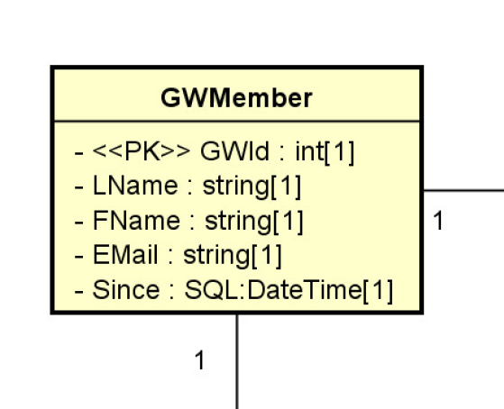
- Name: GWMember, not Member
- SQL:DateTime, user-defined data type: explicit, more accurate, more reusable, more control
- PK: an implementation level sterertype.
(group member) Members can form groups. (e.g. Bun, a GW Member, is a member of the group machine learning in Houston, a Group object; promoted to a class, GroupMembership. ) A group has a unique id and a unique name. There may be a description for a group. A group can set up any number of rules, which are numbered. These rules can be governing rules, bylaws, and anything the group want to record. They can possibly be displayed in the group's page.
Bun is a faculty member.
Bun takes the role of the faculty member at UHCL.
A group can recommend any number of other groups, (Example: Group A recommends, association, Group B, A recommends C, D, and E. Promote an association to a n associate class) A description may be stored for a recommendation. For example, the 'Clear Lake Flying Database Developers' group may recommend two other groups: 'Clear Lake Computer Science Faculty' and 'Houston Aviator." Only an admin of a group can add a recommendation from the group. The admin who adds a recommendation should be recorded in GW. When a group A recommends a group B, it can select whether a link to group B will be displayed in the page for group A or not.
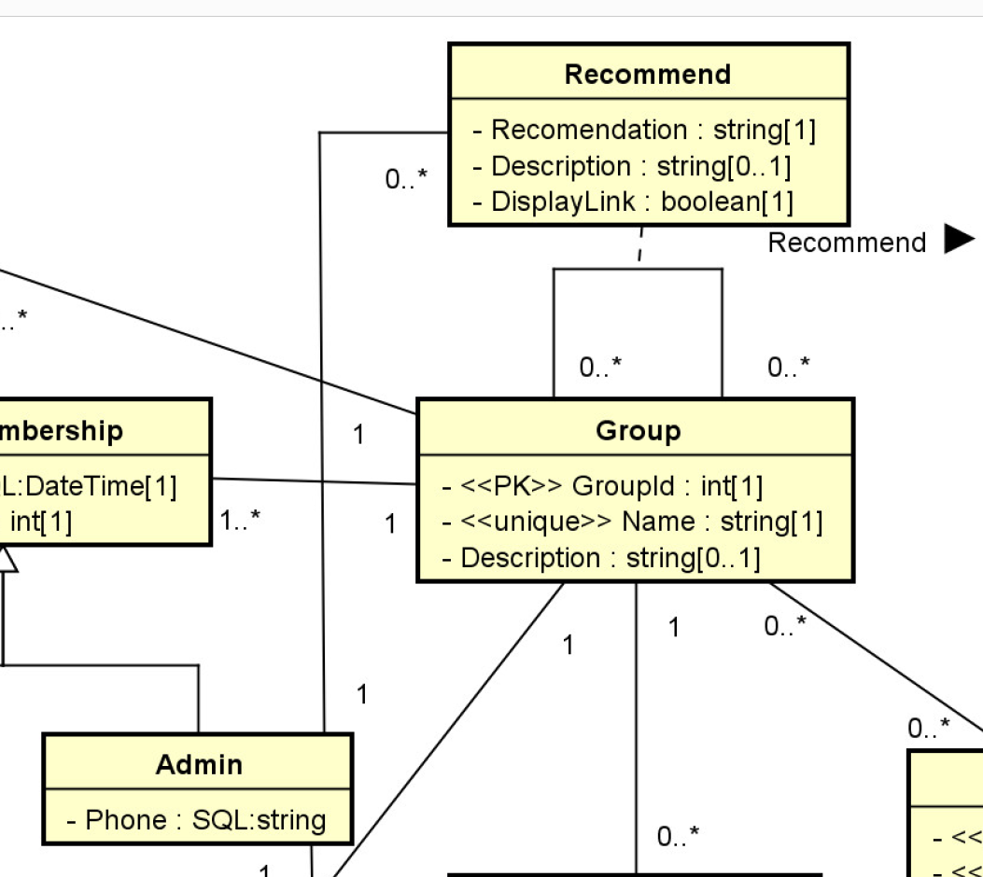
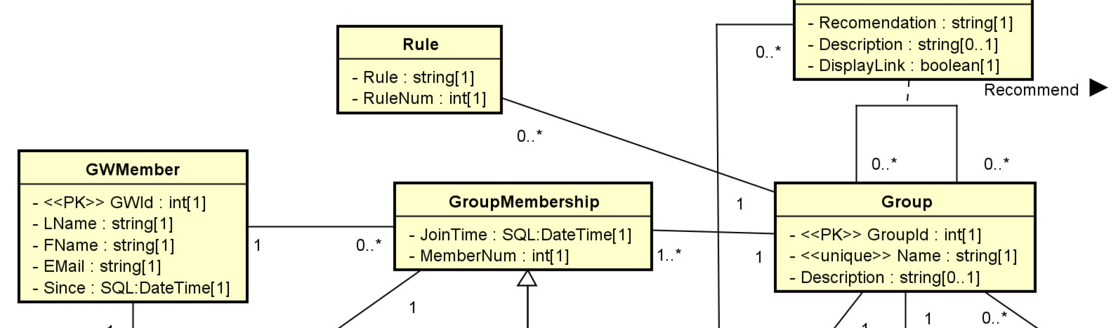
Notes:

GW members can be a regular member or an admin in a group. If a GW member is an admin, a phone number must be stored. Note that the phone number of an admin in a group may be different from the phone number of the same GW member serving as an admin in a different group. When a GW member joins a group, a member number is recorded. A GW member can join any number of groups.
A group may belong to multiple categories, such as 'dessert', 'sport' and 'computer science'. For example, the group 'Clear Lake Flying Database Developers' may belong to both 'sport' and 'computer science'. A category has a unique id, for examples, 101:'dessert', 87:'computer science', etc. A category may have a description.
A group can recommend any number of other groups, A description may be stored for a recommendation. For example, the 'Clear Lake Flying Database Developers' group may recommend two other groups: 'Clear Lake Computer Science Faculty' and 'Houston Aviator." Only an admin of a group can add a recommendation from the group. The admin who adds a recommendation should be recorded in GW. When a group A recommends a group B, it can select whether a link to group B will be displayed in the page for group A or not.
A group can set up any number of events. An event has a unique id, an event name, and meeting place, date, and time. There may be a description.
Group members can post in the group's web pages. A posting in the group's page must have a post time, subject, body, and priority. There are two kinds of postings. An event posting is associated with a specific event. Only a group administrator can add event postings. Event postings are displayed differently than regular postings in the group page as they are more important. A regular group member can add postings (called regular postings) to the group, but not event postings. An administrator can add both. A GW member that is not a member of a group cannot add a posting on the group. An event posting must have a posting type, selected from a predefined list, such as 'initial announcement', 'update', 'cancellation', 'completion', etc.
Any GW member can post a comment on any group's postings and comments. The time and text of the comments are displayed in the group web pages in some ways. A comment may be made on a posting, which is at the top level of the group's page, or it can be on another comment.

