School of

Science & Computer Engineering

Office of Academic Advising
Suite 3611 Bayou Building – (281) 283-3711
SCEAdvising@uhcl.edu
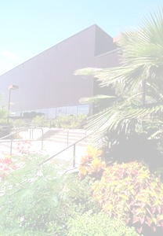

Undergraduate Degrees

Bachelor’s with a Teaching Certification Bachelor of Arts
BA Life Sciences w/ 4-8 Certification Biological Sciences
BA Life Sciences w/ 8-12 Certification Chemistry
BA Mathematical Science w/ 4-8 Certification Mathematical Science
BA Mathematical Science w/ 8-12 Certification
BS Mathematical Science w/ 8-12 Certification
BS Physical Sciences w/ 8-12 Certification

Bachelor of Science

Biological Sciences Environmental Science
-Cell/Molecular -Biology
-Physiology/Pre-Health -Chemistry
-Ecology/Microbiology -Geology
Chemistry -Industrial Hygiene & Safety
Computer Information Systems Mathematical Science
Computer Science Physical Sciences
Computer Systems Engineering

Graduate Degrees

Master of Science

Biological Sciences Environmental Science
Chemistry -Biology
Computer Engineering -Chemistry
Computer Information Systems -Geology
Computer Science -Industrial Hygiene & Safety
Mathematical Science Systems Engineering
Physics Statistics
Software Engineering

