- Questions and Short Answers
- (5 pts) When A receives a message from B, A needs to be sure that the message he has received is correct. This security service is called integrity. Explain the difference between data integrity and origin integrity.

- The following is a partial listing of an X.509 certificate.
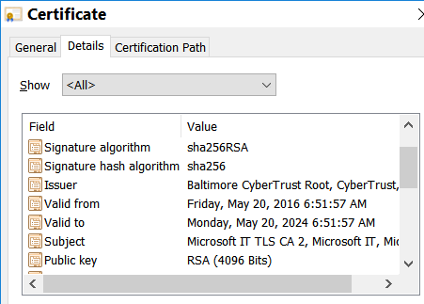
- (1 pts) Who is the certification authority of this certificate?
Answer:
- (1 pts) Who is the owner of this certificate?
Answer:
- (5 pts) Show how the signature on this certificate was generated? Hint: Show how the public key packet (pkp) is signed by the CA.

- (5 pts) (Continued from above) Explain how can this signature be verified? Clearly state the prerequisite of the verification.

- When browsing a web site, we see the following message.
There is a problem with this website’s security certificate.
The security certificate presented by this website was not issued by a trusted certificate authority.
- (5 pts) What does it mean that the certificate is not issued by a trusted CA?

- (5 pts) What is considered as a trusted CA?

