**CSCI 4333.2**

8/19/2024

**3. MySQL**

* The standard query language for RDBMS is Structured Query Language (SQL).
* We use MySQL (or MariaDB) in this class.

DBMS mostly uses a client-server architecture.

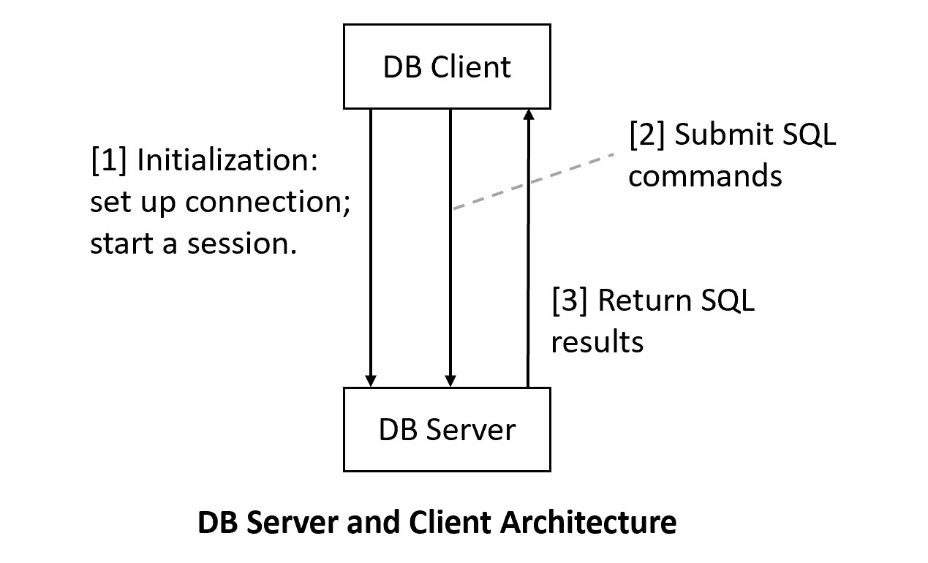

**3.1 MySQL Server Setup**

We will use MariaDB that is a part of XAMPP. Do not recommend installing standalone MySQL.

[1] Install XAMPP, which contains many server software configured to work together for development purposes. For XAMPP, we will use MySQL/Maria DB and Apache (Web server).

1. Recommended to install XAMPP in the*top* level: c:\xampp (likely the default).
2. Set up development accounts immediately using *phpMyAdmin* after installation.
3. Change the root password (optional but recommended): a secure step that requires tinkering.
4. To ensure that PHPMyAdmin will work on a new admin account (optional):
   1. Use PHPMyAdmin to create a new admin account, e.g., "frog_ad", with the password "a_new_prince" for both hostname '%' and 'localhost'
   2. PhpMyAdmin uses the default root account (with no initial password) via localhost.
   3. Thus, you will need to supply the new username and password to start up PhpMyAdmin by editing the file c:\xampp\phpMyAdmin\config.inc.php, search change the line to, for example:
      1. $cfg['Servers'][$i]['user'] = 'frog_ad';
      2. $cfg['Servers'][$i]['password'] = 'a_new_prince';

source createtoyu.sql

to create toyu.