DASC 5333 Database Systems for Data Science
CSCI 4333 Design of Database Systems
Fall 2024
Homework #2 UML Modeling
Download and install the student version of Astah's UML Editor: http://astah.net/download. Astah provides it free for students. This is one of the best free UML editors available. It has some restrictions but should be more than sufficient for our class. Another good alternative is to use Visual Paradigm community version. This is free but will leave a watermark when you export your model diagram to images or PDF. Instead, you may just take a screenshot of the model.
The homework assignment is to model a drastically simplified database application described below.
Multiplicities for attributes and associations should be as specific as possible. You do not need to explicitly specify the attribute multiplicity of 1..1 (or just 1), which is assumed to be the default. Attribute and association documentation are optional, but they are encouraged when not trivial. For example, the roles or names of associations may be displayed when appropriate. Operations for classes are not necessary.
Save your files as <<last-name>>_<<student_id>>_h2.asta (Astah's file format) and <<last-name>>_<<student_id>>_h2_documentation.docx (optional; for additional information if needed). Examples: bajaj_0007007_h2.asta. Include a PDF versions of your class diagram: <<last-name>>_<<student_id>>_h2.pdf, especially if you are not using Astah.
Submit your homework through Canvas, including .asta and/or .pdf files. If you are not using Astah, you must submit a PDF file.
LabPro
Create a data model by constructing an UML class diagram to support a portion of a drastically simplified laboratory database: LabPro. It only supports a very limited set of reduced functions. Make reasonable assumptions. You may use the stereotypes <<PK>> and <<unique>> for attributes when appropriate. You may also use the user-defined types: SQL:date, SQL:time, SQL:datetime, SQL:email, and SQL.phone.
Specification
LabPro allows customers to take medical laboratory tests, such as blood test, urine test, X-ray, MRI, etc. This portion of the assignment focuses on test items that have quantitative values, such as red blood cell count, cholesterol, creatinine, etc.

Customers (class) have last names, first names, date of birth (dob, optional), and addresses. Customers may provide optional phone number and email address.
- Class Person
- SQL:date: user-defined types are usually better.
- A person can take on 0..1 customer role.
- A customer role is the role of exactly one person.
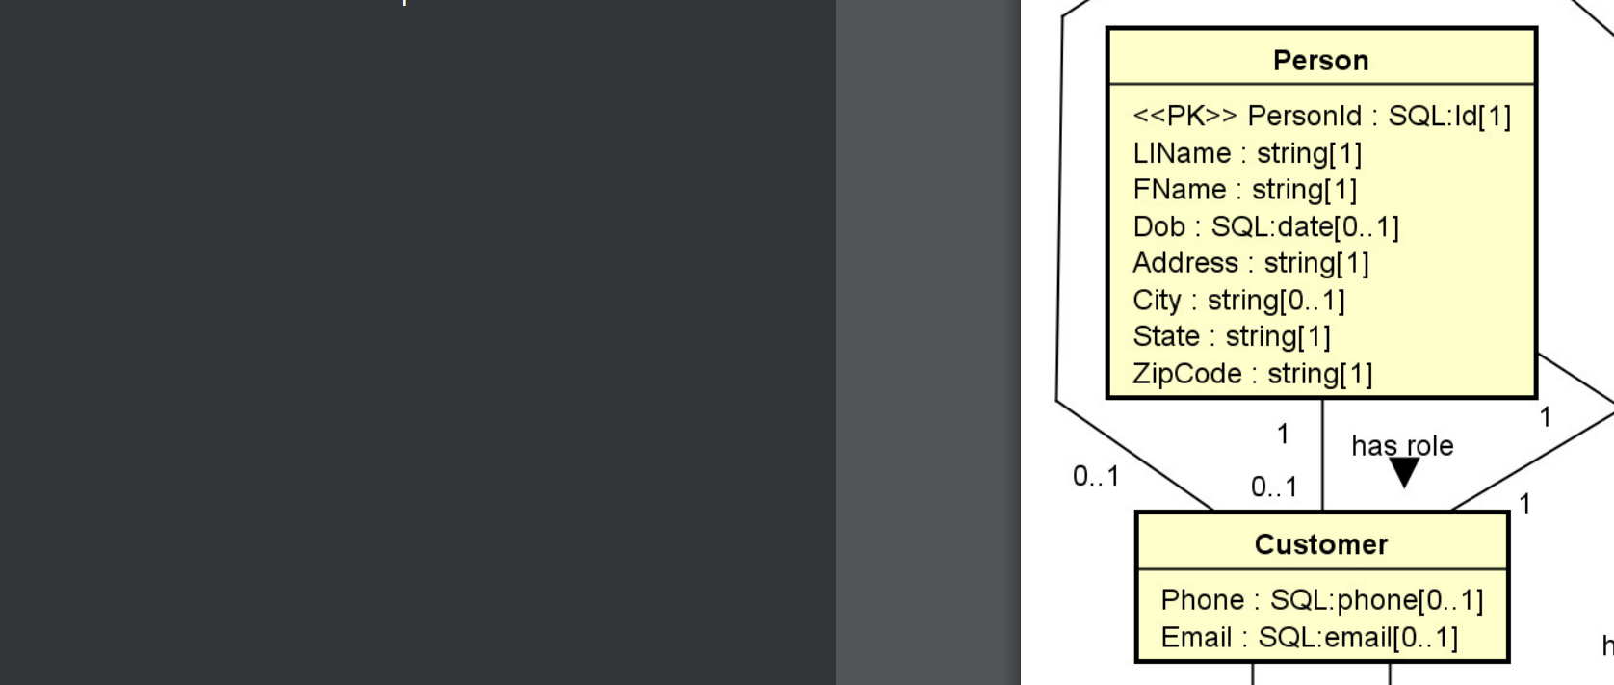

They (persons with customer roles) have accounts and passwords to access laboratory results through the Web. The creation times of all accounts should be recorded.
Note:
- Account [1] – owned by – customer [0..1]
- Account [1]: A customer must have an account

- customer [0..1]: an account belongs to 0 or 1 customer.
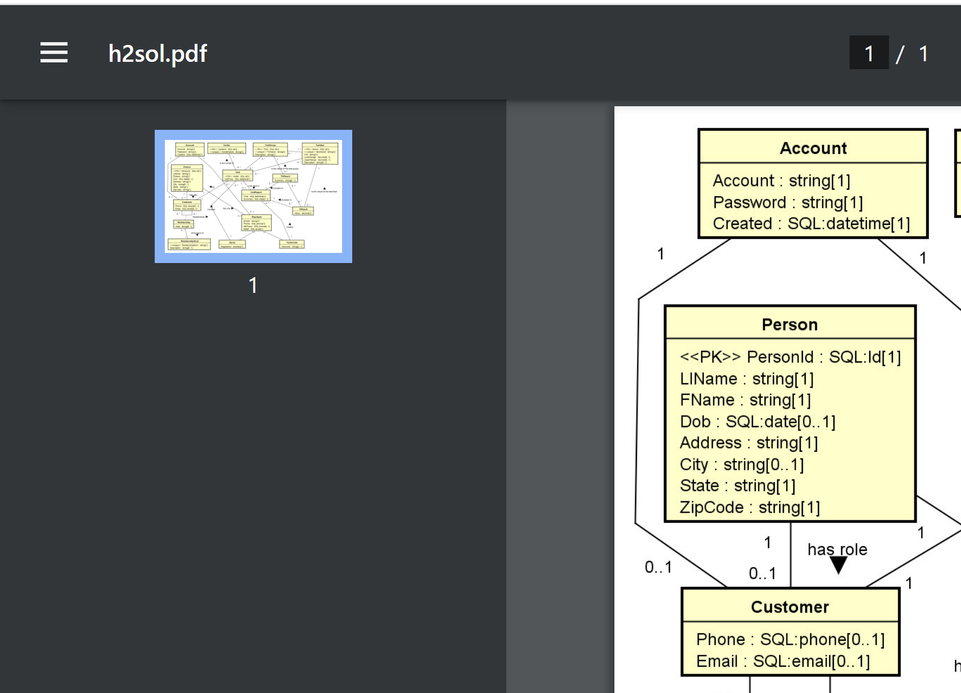

An address has an address line, city, state and zip code. The field city may not be available as some addresses do not lie within a city.
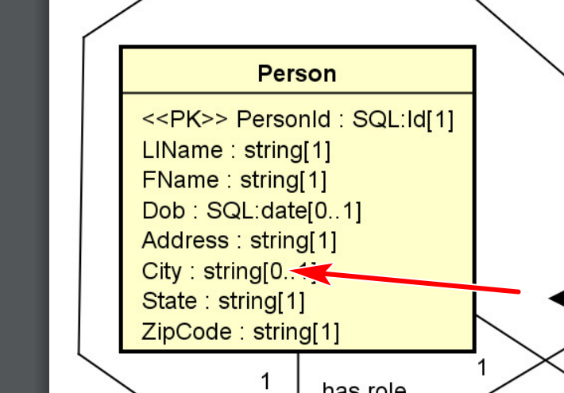

Two customers may have a relationship between them. For example, customer A may be the 'husband' of customer B and the 'father' of customer C. Customer C may be a 'sister' of customer D. The database stores a list of predefined relationship kinds (such as 'father', 'mother', etc.) and a description (e.g., the description for the relation kinds ‘bf’ may be ‘best friend’). LabPro may store a note on a relationship between two customers.
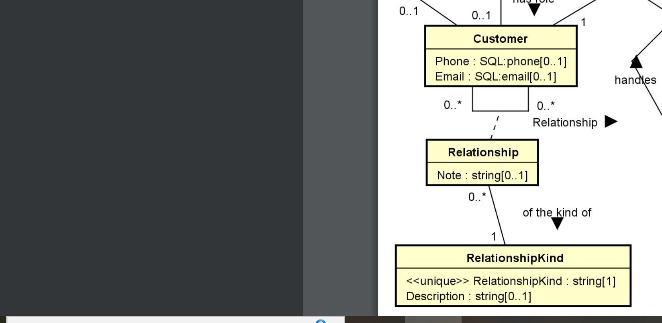
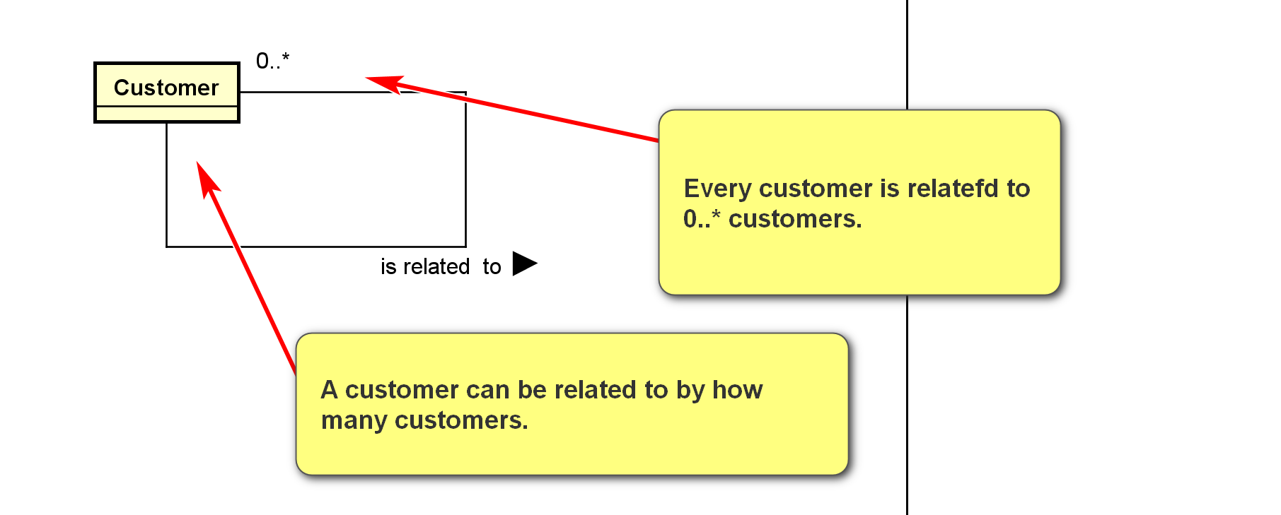
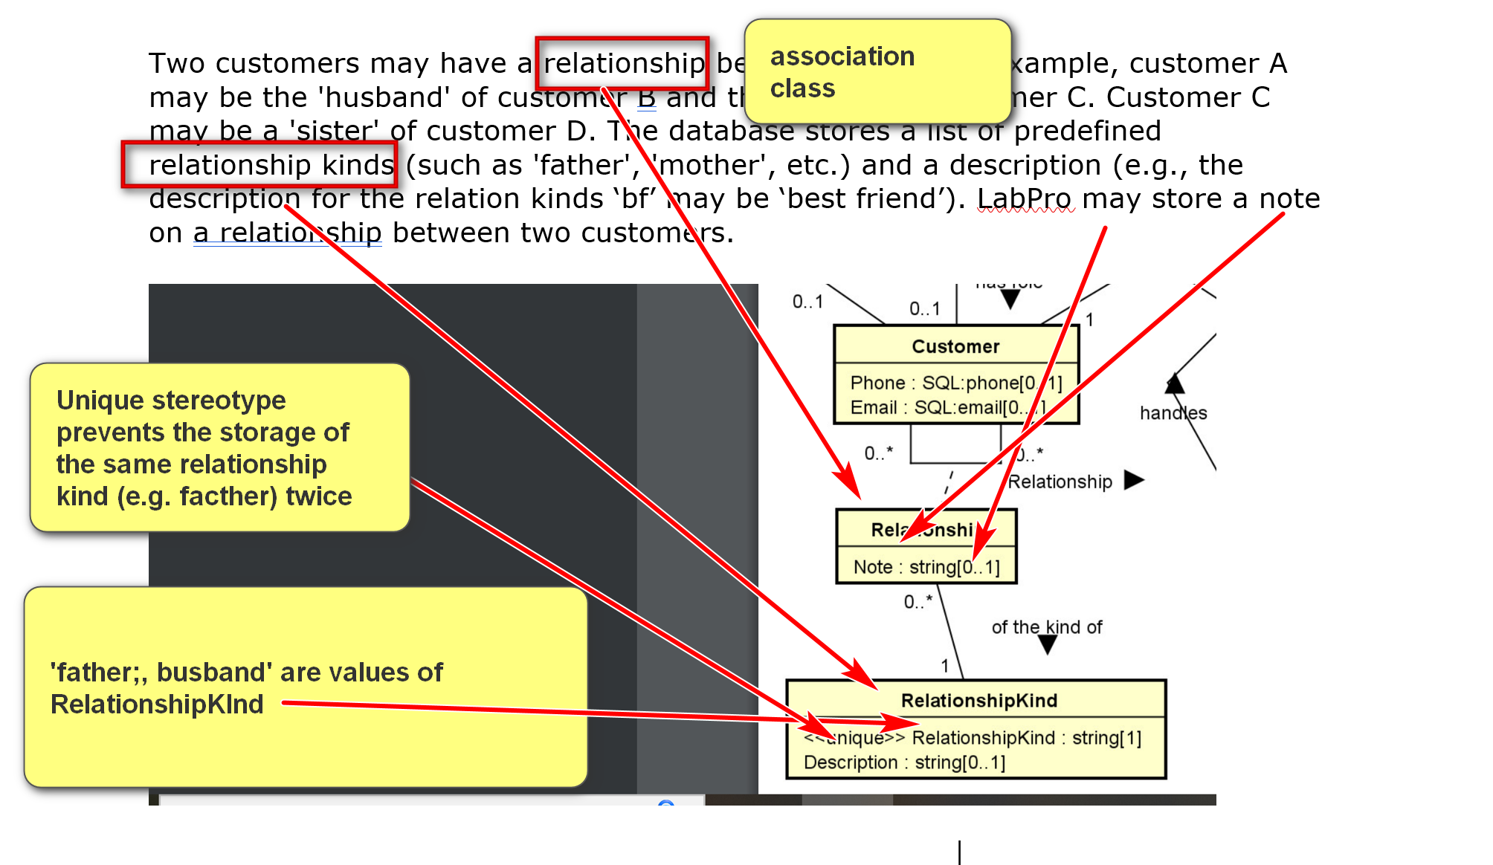
“relationship”: an association class, can have attributes and associations themselves.
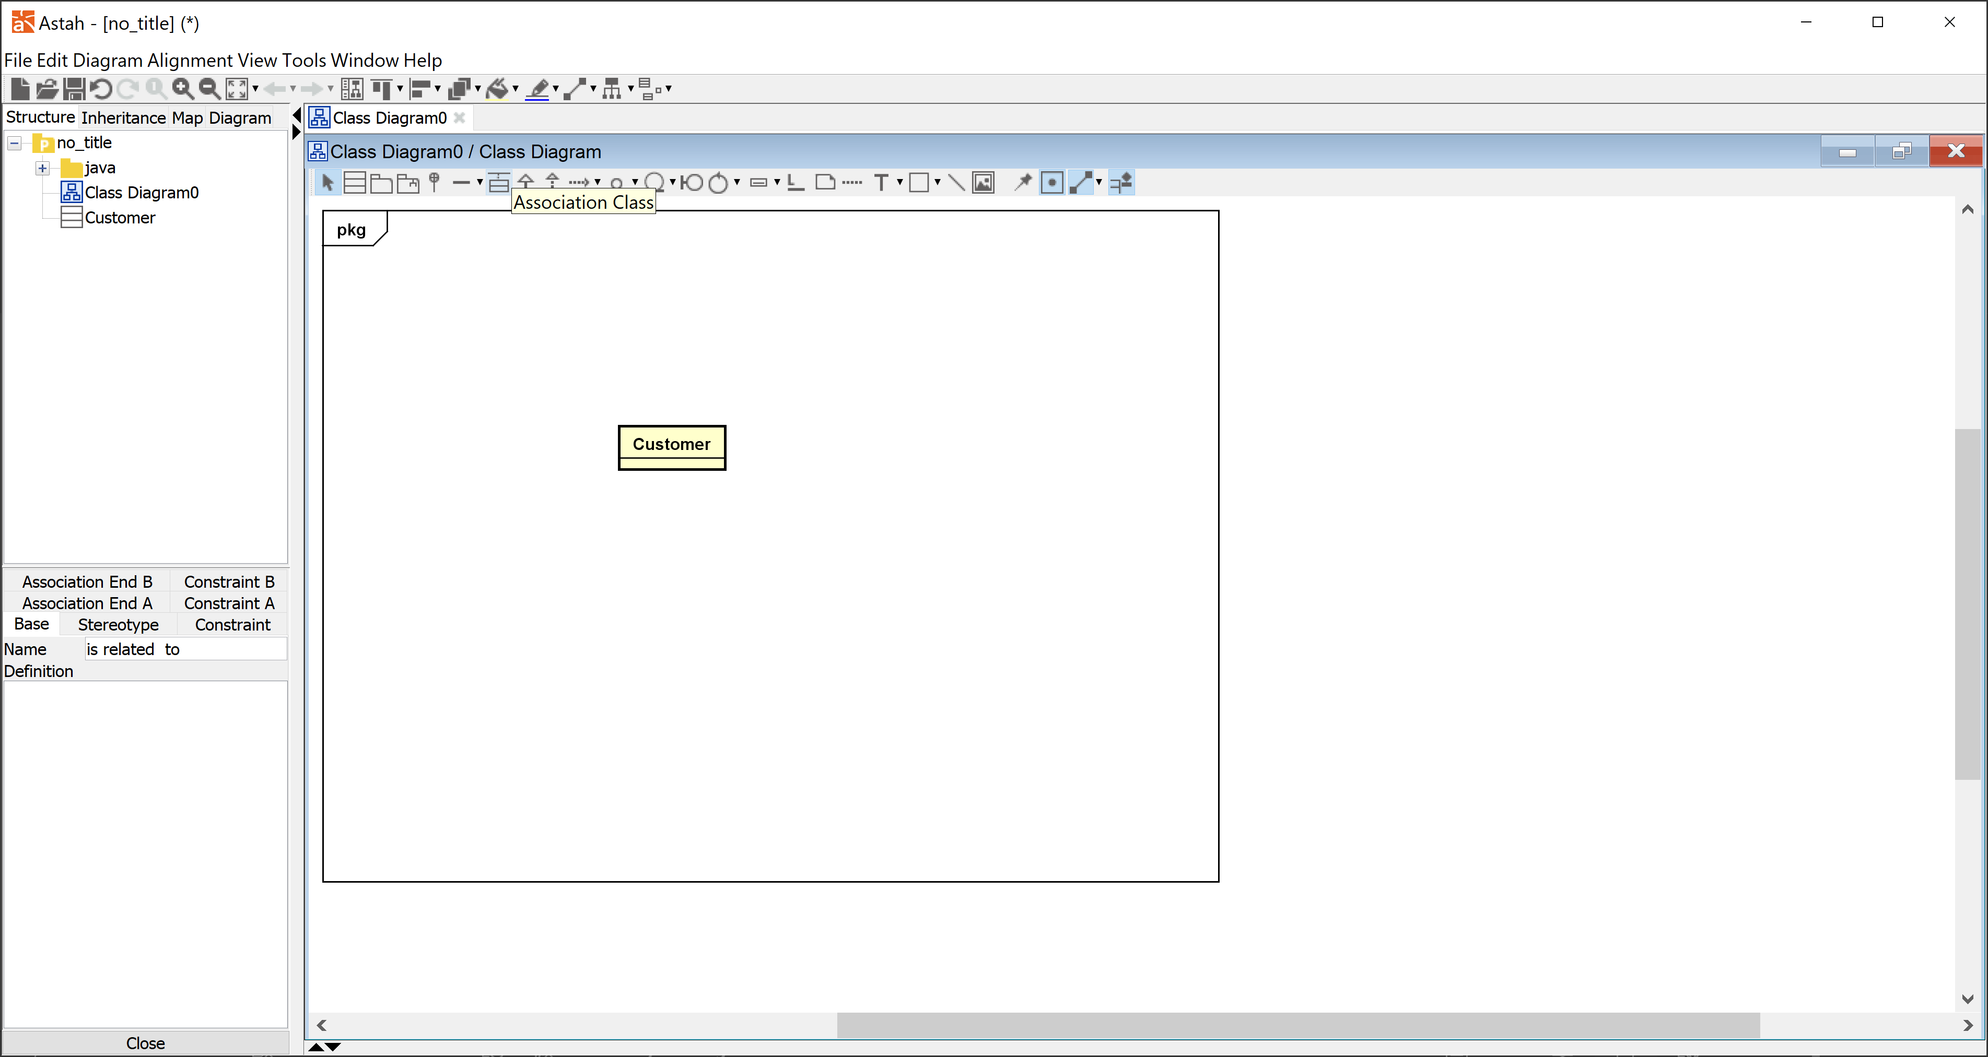
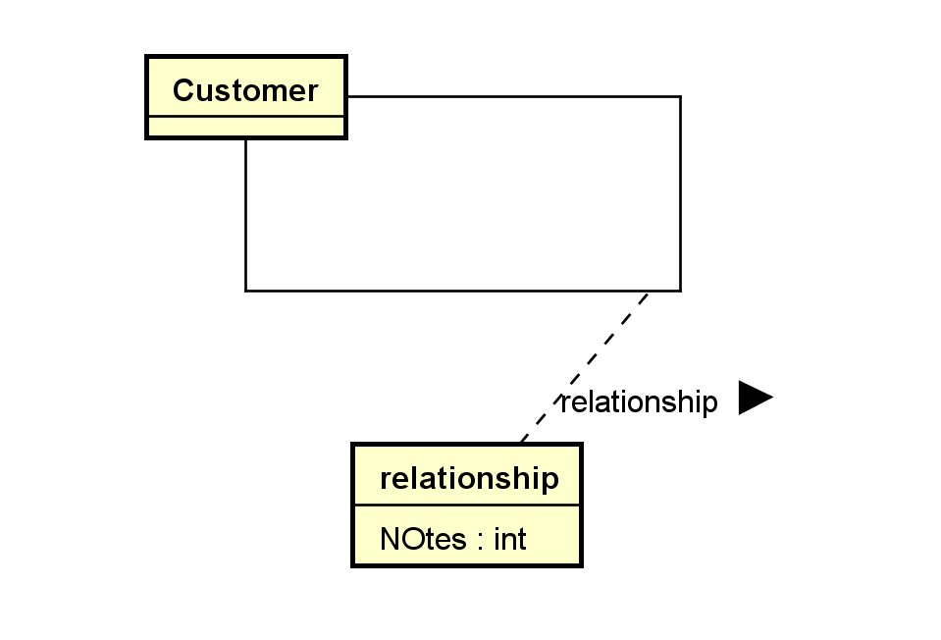
Customers visit laboratory centers to take tests. Customers may take any number of tests during a visit. The visits’ dates and times are recorded,
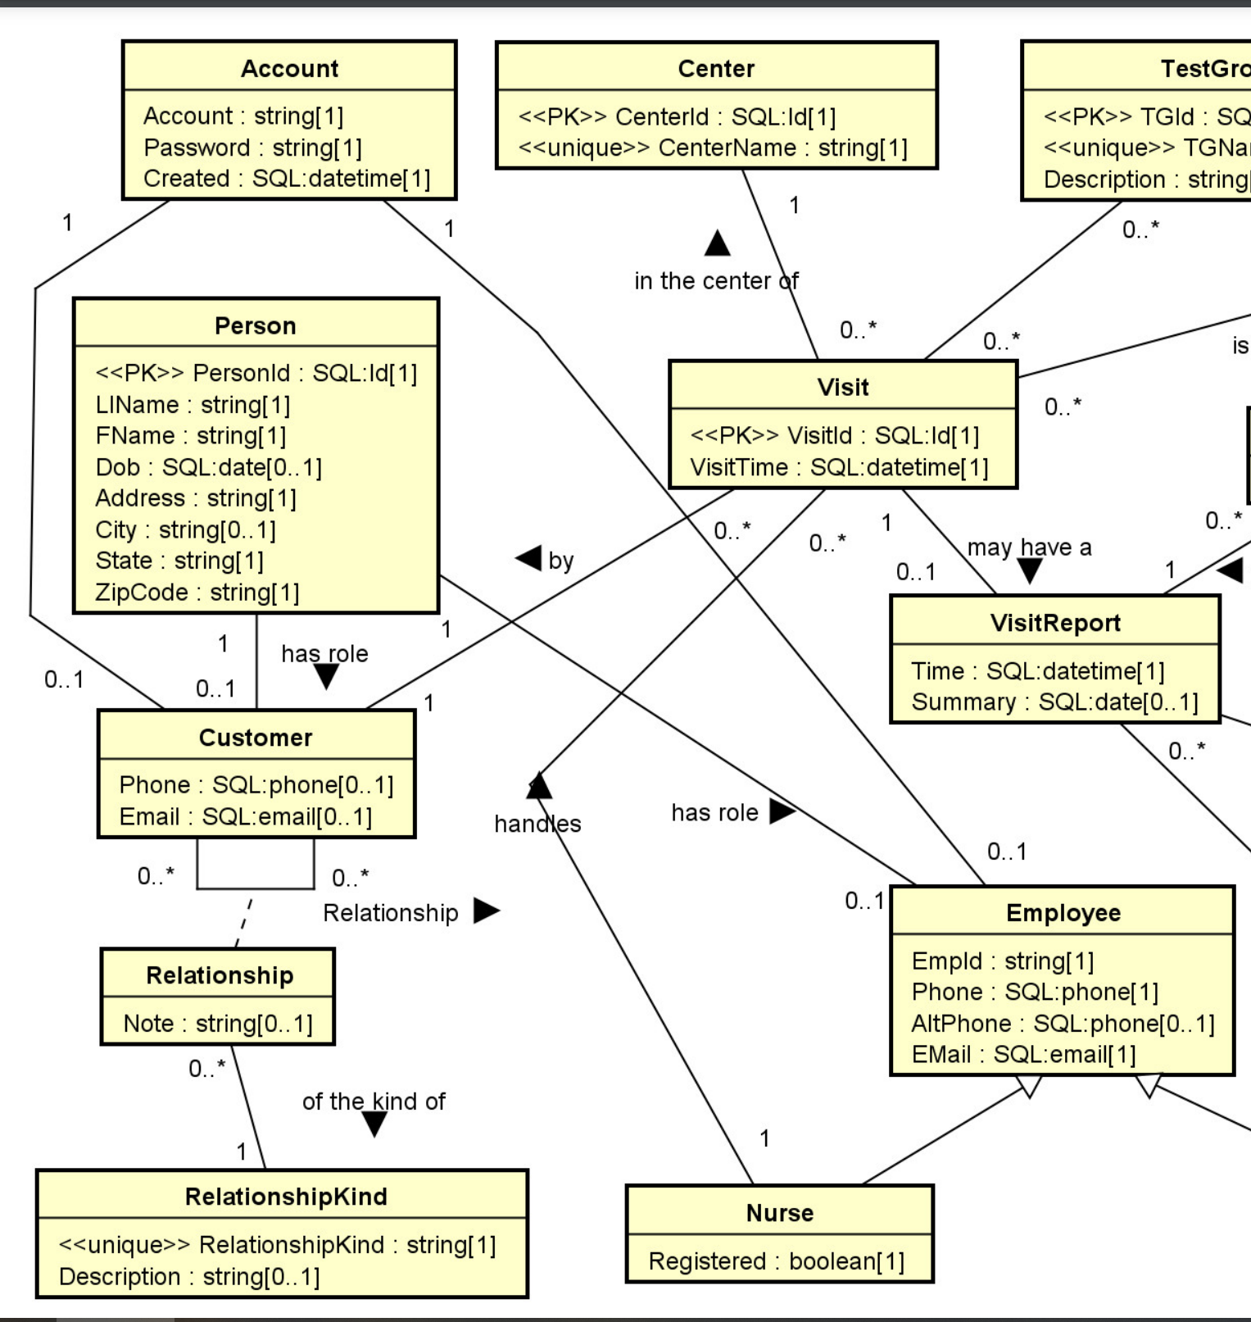
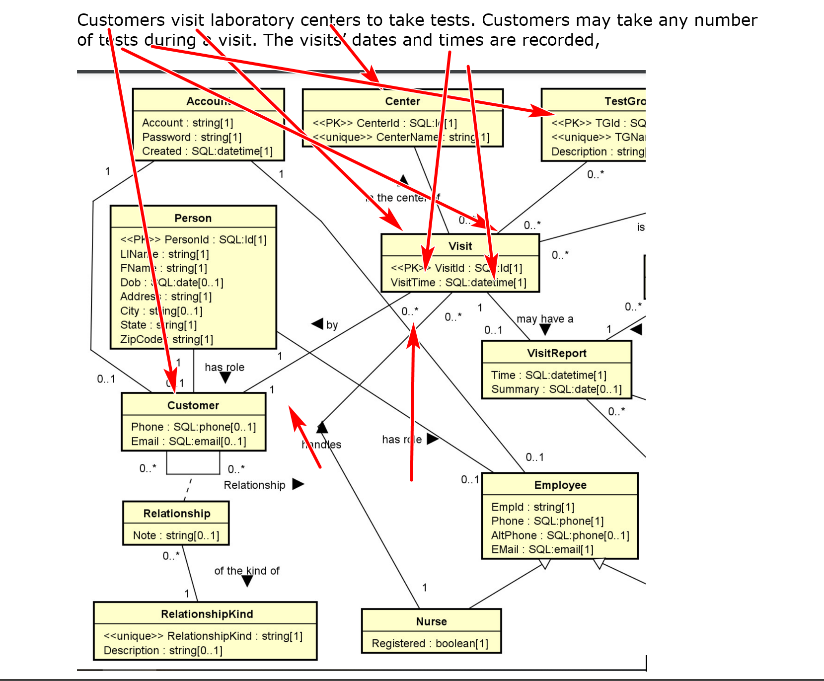

together with the nurses who performed the tests (such as by drawing blood and collecting urine). The handling nurse is an employee of LabA. A nurse may be registered or not. A center has a unique identifier, a name, plus other information not needed to be modeled in this assignment.
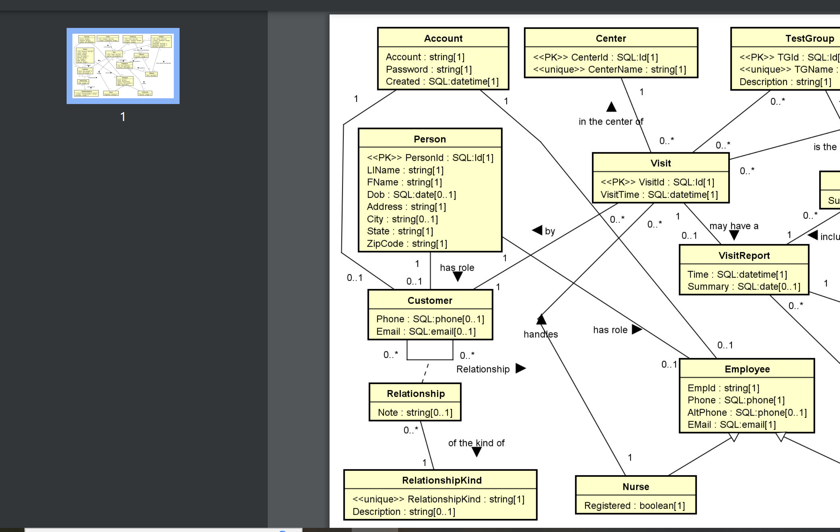

For every person in LabPro, names, dates of birth and addresses are recorded. An employee is a person taking on an employee role. The employee Id (EmpId), phones, and email addresses of all employees must also be recorded. Furthermore, an employee may have an additional alternate phone number. Besides nurse, the other kind of employee in this assignment is technician. Technicians conduct the actual tests using the samples provided by the nurses and create visit reports. Technicians may have different levels of certification. An employee also has an account to access the database (with more privileges than customers). Note that a person can be an employee and a customer at the same time. Thus, the person may have two accounts, one for her job as an employee and one for her role as a customer so she can access her own lab test results.
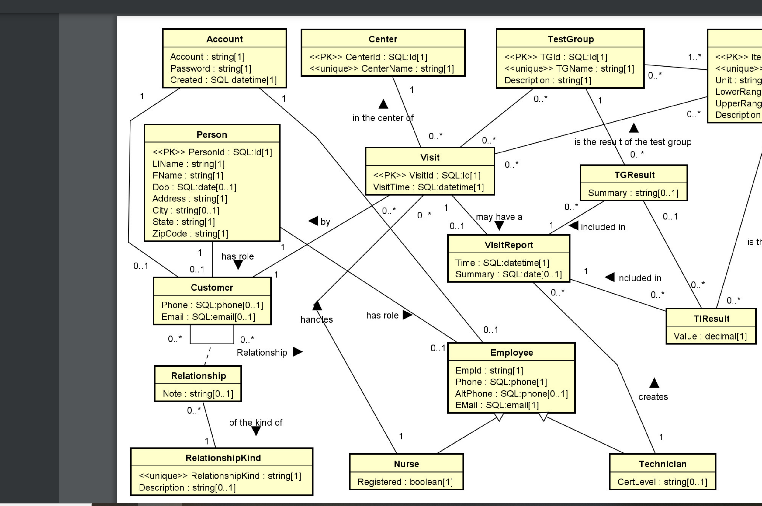

Each visit has a unique id and the visit time should be recorded. A visit report should have a report’s creation time and an optional summary.
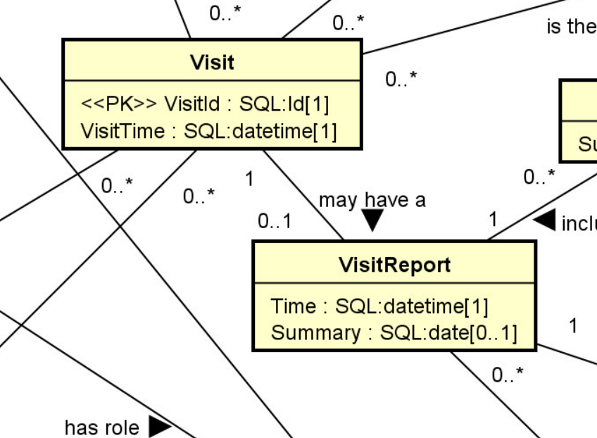
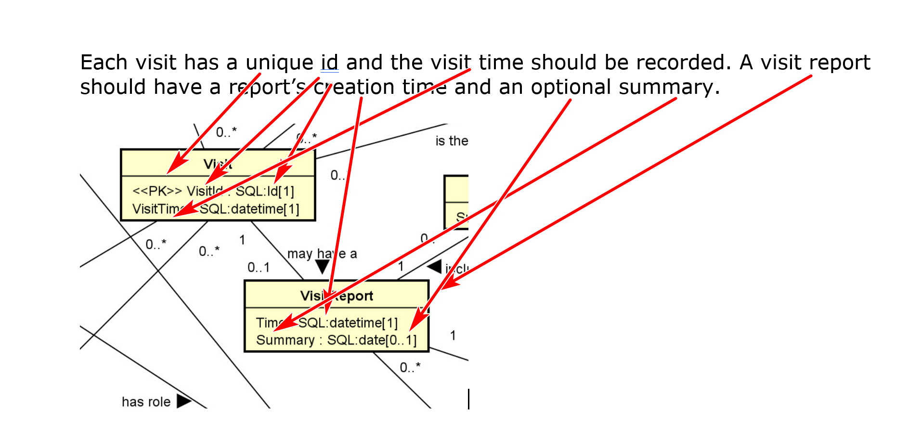

A customer can take many tests in a visit. A test item contains a unique id (as a key) and a unique name. It has a unit (such as ml, gm, etc.) for the test value (which is a decimal number). A test may have a normal range stored for reference purposes. For example, test '2101' may be for 'creatinine' which has a normal range of 0.5 mg/dL to 1.1 mg/dL. Customer A may have a creatinine value of 0.75 mg/dL in visit X on 3/12/2024, and a value of 2.1 mg/dL in visit Y on 8/17/2024.
A test group is defined as one or more related test items. For example, the test group G1 may contain test items 2101, 2112 and 2231. A test item may belong to more than one test group. A customer may have multiple test groups and test items conducted in a visit. For example, customer A may take test groups TG11, TG2, and test items 2101 and 2300 in visit X. There may be a summary of the result of a test group (but not an individual test item) in a laboratory visit report.
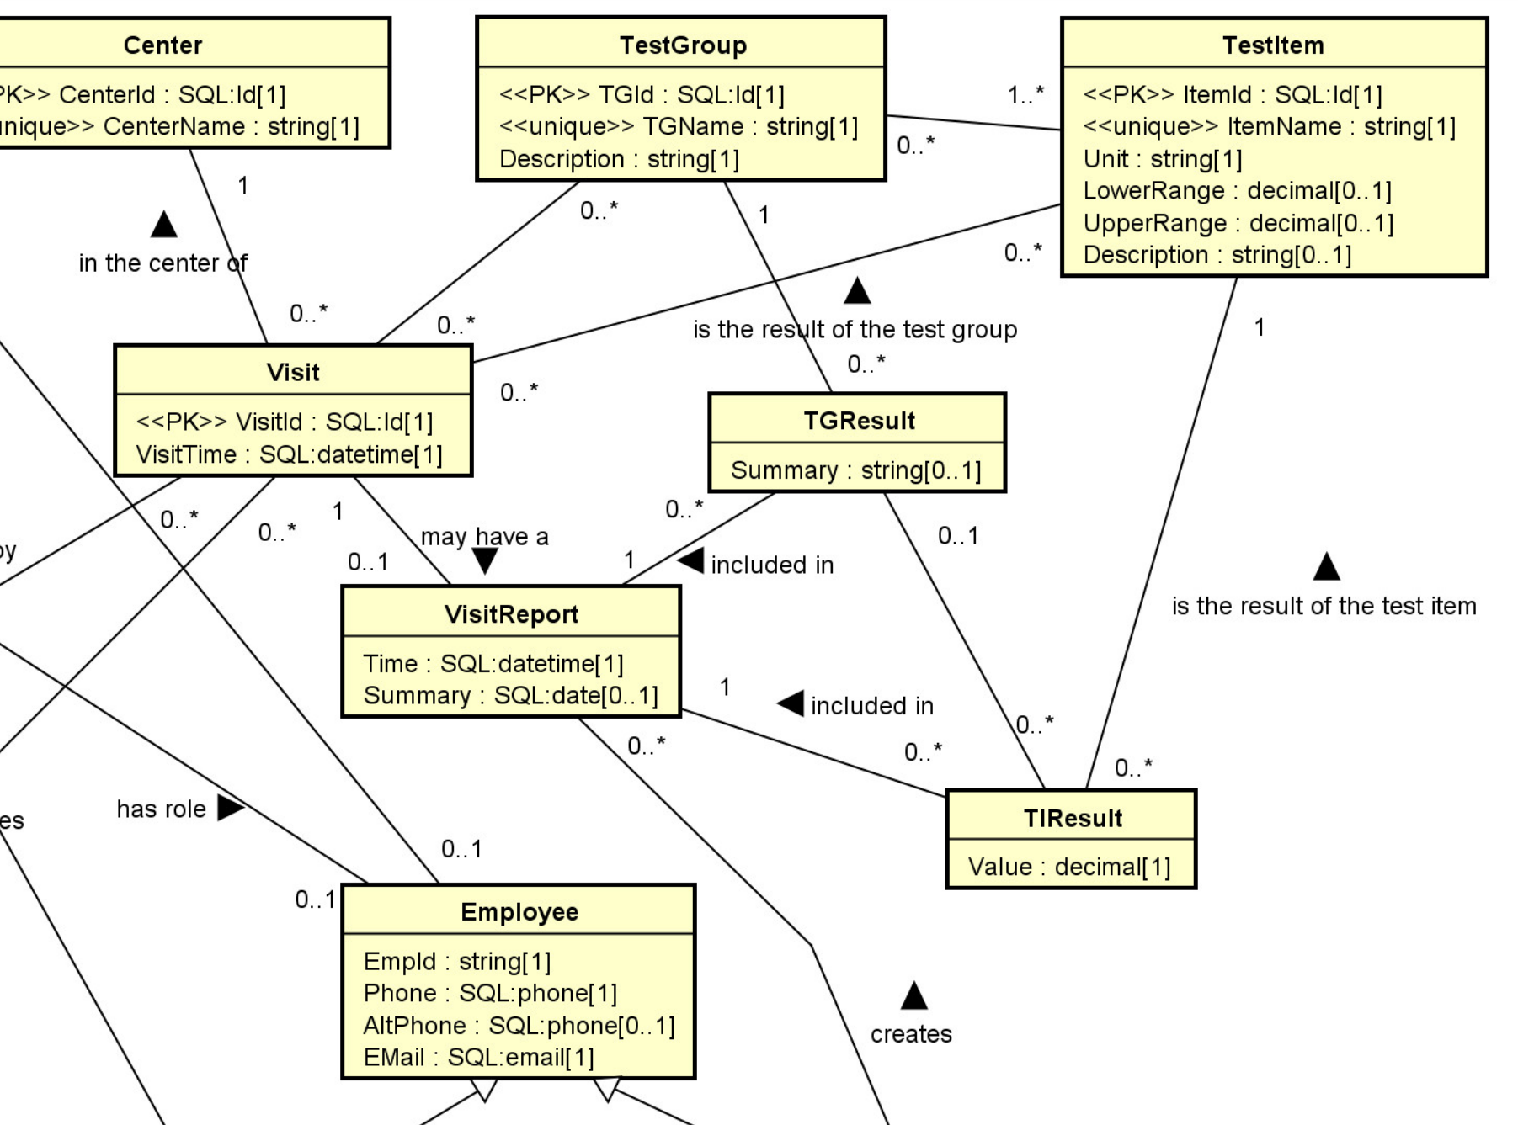

Here is an example of a Visit Report:
Visit Report
Id: 123972012
Report Time: 3/15/2024 3:37pm
Visit Time: 3/12/2024 1:05pm
Nurse: 8904783, Mary Page
Technician: 8902838, Jean Taylor
Customer:
Paul Law
1235231271
Summary:
No noticeable concern.
Test Results:
Test Group 1: TG11
Item: 2101, Creatinine: 0.75 mg/dL (normal range: 0.5 mg/dL to 1.1 mg/dL)
Item: 2121, BFK: 113 ppm (normal range: 50ppm to 250ppm)
Test Group 2: TG19
Item: 3631, AST: 7.75 UL (normal range: 0 UL to 40UL)
Item: 3633, ALT: 26 UL (normal range: 0UL to 33UL)
Individual Test Items:
Test Item 1: 8329: BSF: 17 ppm (normal range: 28ppm to 120ppm)
Test Item 2: 9323: RB Ratio: 22.5% (normal range: 10% to 35%)

