CSCI 4333
4/22/2025
Introduction to MongoDB
by K. Yue
1. Introduction
- NoSQL document model distributed database owned by MongoDB (NASDAQ: MDB).
- Documents are stored in JSON format.
- Three versions:
  - Community server: open source and version
  - Enterprise server: commercial version
  - Atlas: cloud version
1.1 Installation
For this class, install the followings.
- MongoDB community server: ensure that it includes Mongo Compass, a MongoDB client, https://www.mongodb.com/try/download/community
Server starts automatically.
- Mongo Shell:
  - mongosh.exe: a Javascript shell for interacting with MongoDB, https://www.mongodb.com/try/download/shell.
  - Do not use mongo.exe, the deprecated former shell.
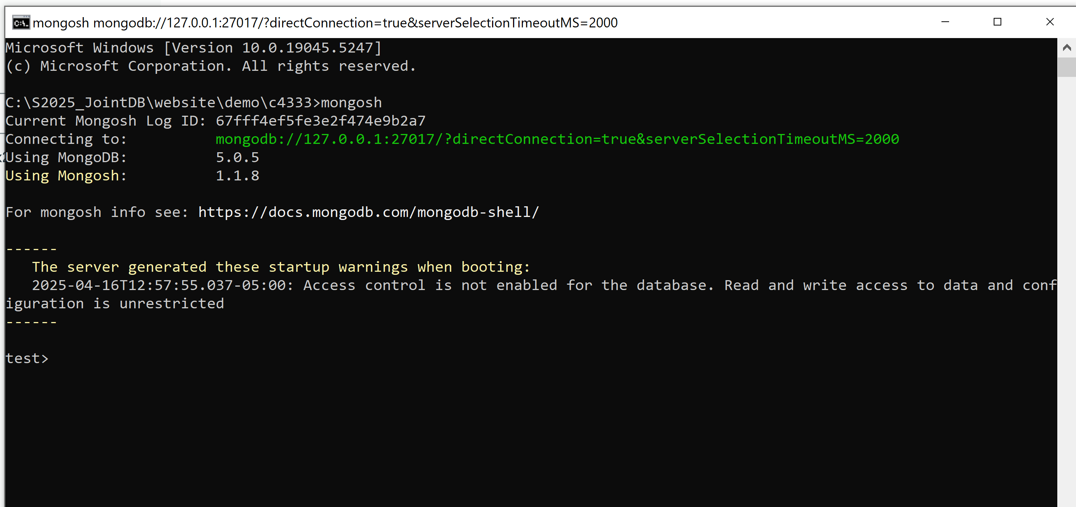
- Mongo Compass (client) includes a Mongosh.
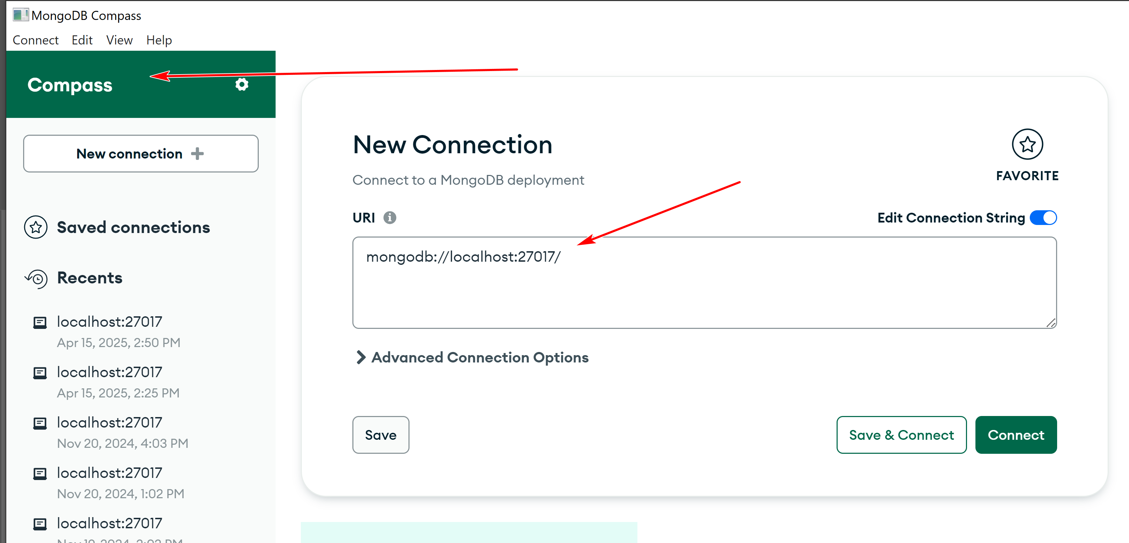
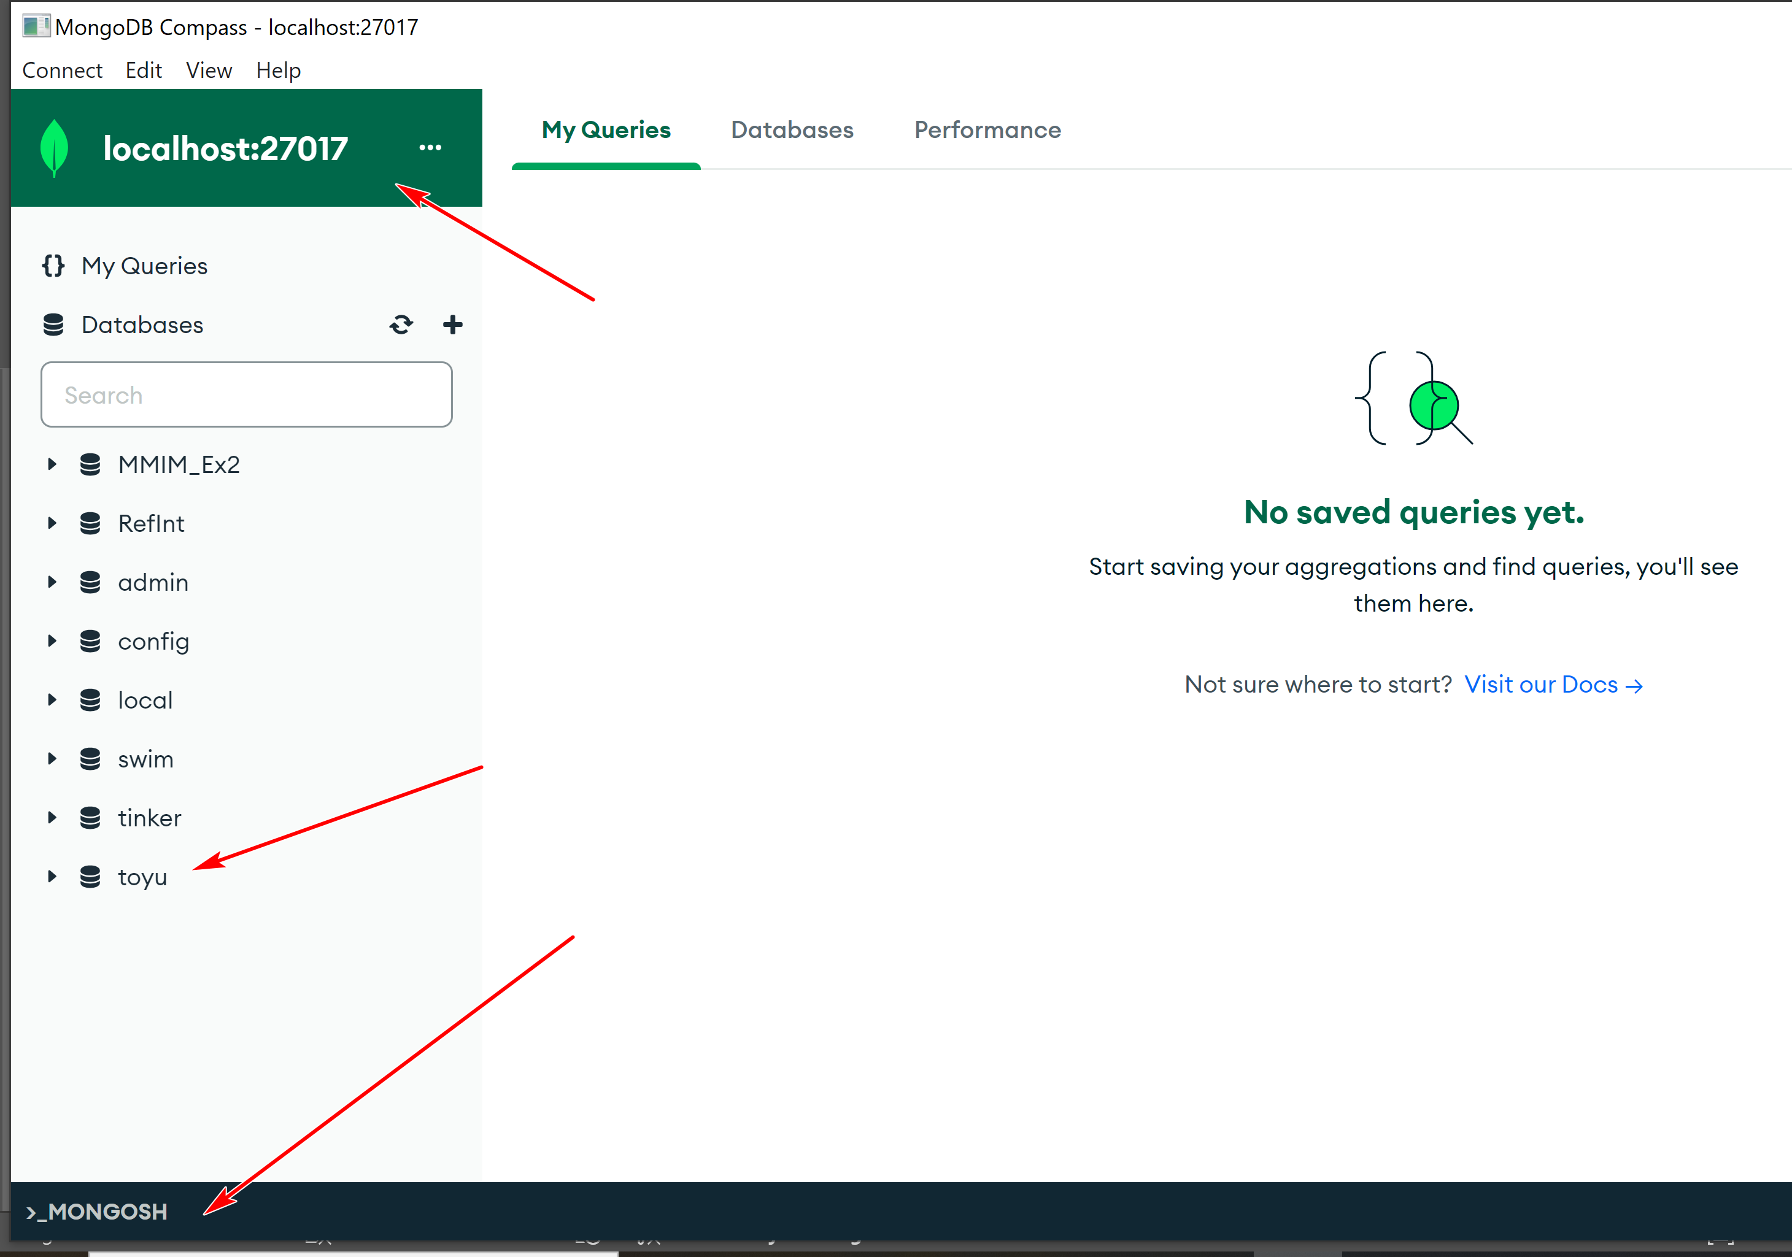
- MongoDB tools: command line utilities including import and export, https://www.mongodb.com/try/download/database-tools.
  - After unzipping, you may put mongosh and these utilities in the same location of the other mongoDB programs, e.g., C:\Program Files\MongoDB\Server\5.0\bin.
  - You may add the directory “C:\Program Files\MongoDB\Server\5.0\bin”, or similar, in the system PATH variable so these tools can be used anywhere.
- To be able to use MongoDB through Python, you will to install a driver: "pip install pymongo" in cmd.
1.2 Server-Client DBMS architecture
- Like many DBMS, MongoDB uses a client server model.
- Server:
  - In case the MongoDB server has not been started, run "mongod" in a command terminal.
  - To check whether mongod is running, execute 'tasklist /FI "IMAGENAME eq mongod.exe"' in Command CLI.
  - It listens to a port to accept and interpret commands and return results.
  - mongod's default port: 27017.
- Clients: send MongoDB commands and accept results. Clients used in this course:
  - Mongo Compass
  - mongosh
  - Python through pymongo (if Python is used.)
1.3 Resources
- MongoDB manual: https://docs.mongodb.com/manual/
2. MongoDB Structures
- MongoDB is structured as db -> collection -> document in a way similar to db -> table -> row in relational DB.
- Thus, documents are inserted into a collection of a db.
- db and collection do not need to exist before referencing them.
- In MongoDB's db, within mongosh:
  - 'use tinker' set the default db to tinker.
  - The keyword db refers to the default db.
  - If 'tinker' does not exist, it will be created.
2.1 Using mongo command CLI through mongosh
- Run 'mongosh' in command CLI in your working directory.
- Mongosh accept JavaScript commands in a mongo shell setting.
- For inserting documents, it supports two methods, insertOne and insertMany.
- See mongosh CRUD: https://docs.mongodb.com/mongodb-shell/crud/insert/.
3. Writing to Mongo
- See CRUD operation in Mongo Guide to begin with: https://docs.mongodb.com/guides/.
  - However, the guide uses the deprecated shell "mongo" instead of "mongosh".
  - Since mongosh should be used, be mindful of discrepancies.
Example:
In mongosh, execute the code:
use tinker
db.test1.insertOne(
{
"StudentId" :1,
"StudentName" : "Joseph Connor"
}
)
gives the following result:
test> use tinker
switched to db tinker
tinker> db.test1.insertOne (
... {
..... "StudentId" :1,
..... "StudentName" : "Joseph Connor"
..... }
... )
{
acknowledged: true,
insertedId: ObjectId("61e0d5f36753d9628bb4bfa1")
}
tinker> db.test1
tinker.test1
Note:
- In "db.test1.insertOne (", the '(' must not be put into the next line.
- If not, mongosh thinks that the current JavaScript statement has ended and you may get:
tinker> db.test1.insertOne
[Function: insertOne] AsyncFunction {
apiVersions: [ 1, Infinity ],
serverVersions: [ '3.2.0', '999.999.999' ],
returnsPromise: true,
topologies: [ 'ReplSet', 'Sharded', 'LoadBalanced', 'Standalone' ],
returnType: { type: 'unknown', attributes: {} },
deprecated: false,
platforms: [ 0, 1, 2 ],
isDirectShellCommand: false,
acceptsRawInput: false,
shellCommandCompleter: undefined,
help: [Function (anonymous)] Help
}
tinker> (
... {
..... "StudentId" :1,
..... "StudentName" : "Joseph Connor"
..... }
... )
{ StudentId: 1, StudentName: 'Joseph Connor' }
In Windows, you may start Compass through the startup manual:

In Mongo Compass (you may enter nothing in the 'Paste your connection string' connect box):
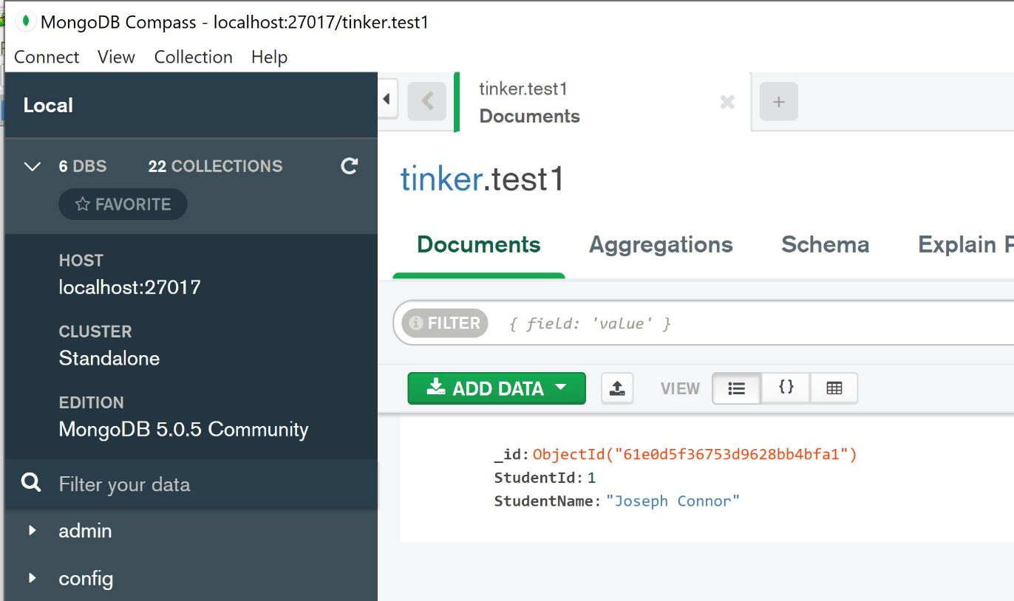
- Note that a field _id with a system generated object id is created. It is unique and can be served as an id.
If the code is executed one more time, Mongo Compass has:
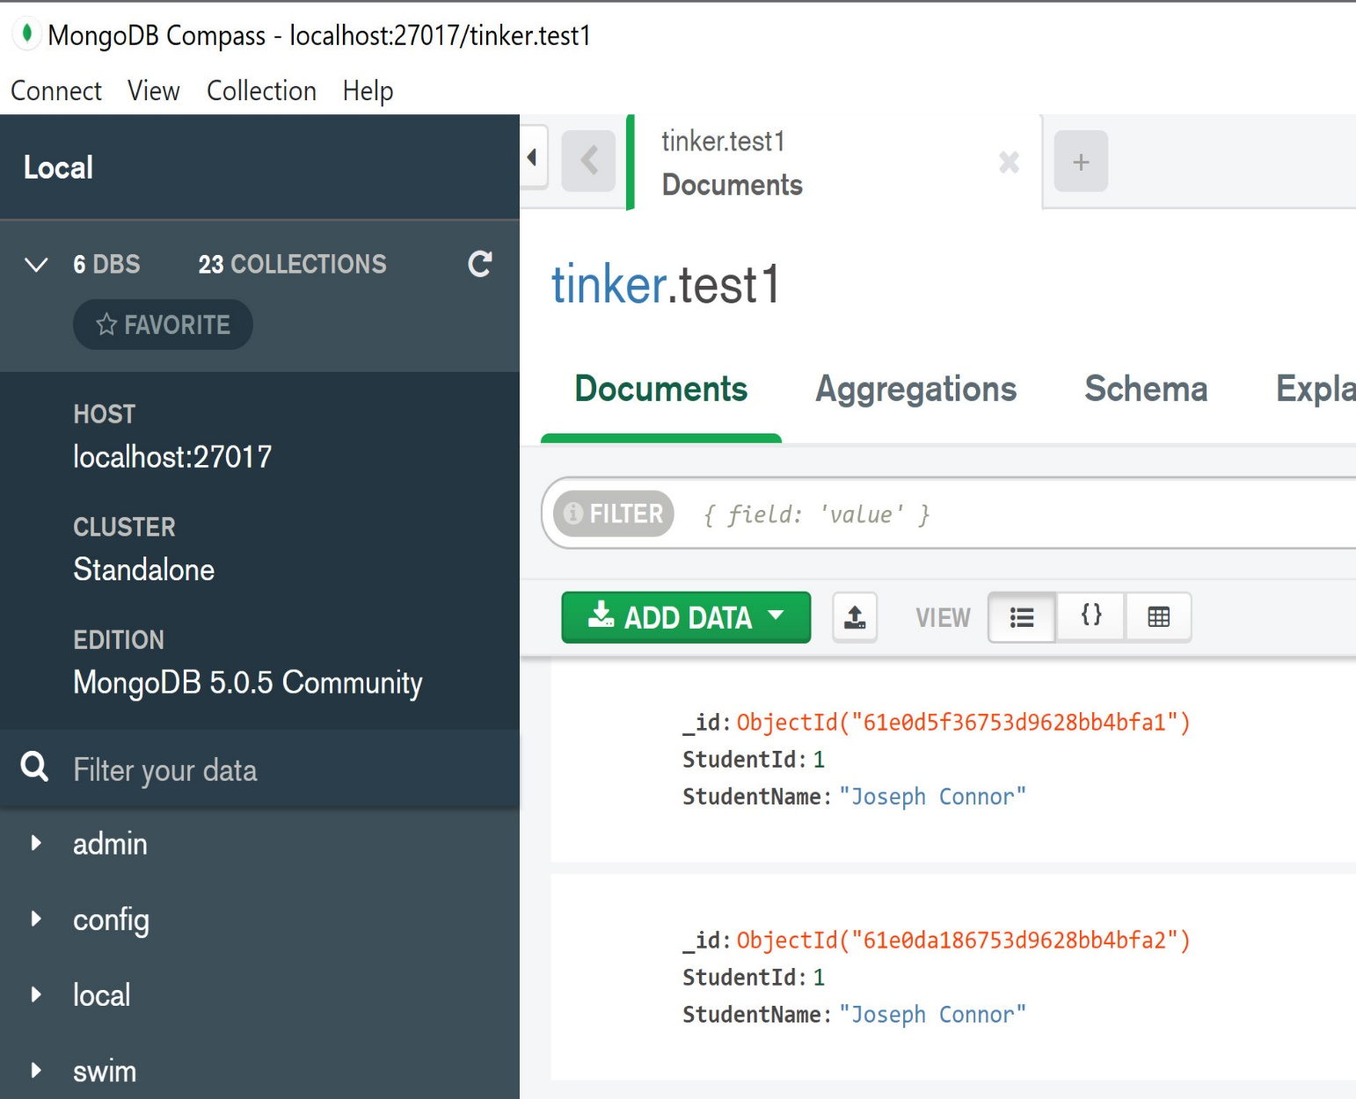
Note:
- There are now two Joseph Connor.
- StuId is not a 'primary key'.
- Document model is not set-theoretic. Relation model is set-theoretic.
To insert a document 'doc' only when it does not already exist, use something like:
if (db.test1.find(doc).count() == 0) { db.test1.insertOne(doc) }
Note:
- 'db.test1.find(doc)' finds the documents doc (one document in the example below). It returns a cursor, which is an iterator of the query result.
- cursor has a method count() to count the result.
The following session illustrates this concept.
Code:
show dbs
db.dropDatabase()
show dbs
// remove tinker
use tinker
db.test1.find()
doc = {
"StudentId" :1,
"StudentName" : "Joseph Connor"
}
doc
if (db.test1.find(doc).count() == 0) { db.test1.insertOne(doc) }
db.test1.find()
if (db.test1.find(doc).count() == 0) { db.test1.insertOne(doc) }
db.test1.find()
Session:
tinker> db.test1.find()
tinker> doc = {
... "StudentId" :1,
... "StudentName" : "Joseph Connor"
... }
{ StudentId: 1, StudentName: 'Joseph Connor' }
tinker> doc
{ StudentId: 1, StudentName: 'Joseph Connor' }
tinker> if (db.test1.find(doc).count() == 0) { db.test1.insertOne(doc) }
{
acknowledged: true,
insertedId: ObjectId("61e0e49e6753d9628bb4bfa5")
}
tinker> db.test1.find()
[
{
_id: ObjectId("61e0e49e6753d9628bb4bfa5"),
StudentId: 1,
StudentName: 'Joseph Connor'
}
]
tinker> if (db.test1.find(doc).count() == 0) { db.test1.insertOne(doc) }
tinker> db.test1.find()
[
{
_id: ObjectId("61e0e49e6753d9628bb4bfa5"),
StudentId: 1,
StudentName: 'Joseph Connor'
}
]
3.2 Unique Index
- A unique index can be used to ensure that all documents within the collection must have unique values on the fields.
- This can be used for use cases of inserting the document only if the unique index has an unique value.
- Thus, a unique index can serve as a candidate key (if it is not missing) for identifying document in the collection.
Example:
Code:
// remove tinker
show dbs
db.dropDatabase()
show dbs
// create index
db.test1.createIndex( { "StudentId": 1 }, { unique: true } )
doc = {
"StudentId" :1,
"StudentName" : "Joseph Connor"
}
doc
db.test1.insertOne(doc)
db.test1.insertOne(doc)
Session:
tinker> // create index
tinker> db.test1.createIndex( { "StudentId": 1 }, { unique: true } )
StudentId_1
tinker> doc = {
... "StudentId" :1,
... "StudentName" : "Joseph Connor"
... }
{ StudentId: 1, StudentName: 'Joseph Connor' }
tinker> doc
{ StudentId: 1, StudentName: 'Joseph Connor' }
tinker> db.test1.insertOne(doc)
{
acknowledged: true,
insertedId: ObjectId("6570fb99629ad72db73f7bcf")
}
tinker> db.test1.insertOne(doc)
MongoServerError: E11000 duplicate key error collection: tinker.test1 index: StudentId_1 dup key: { StudentId: 1 }
Note:
- In 'db.test1.createIndex( { "StudentId": 1 }, { unique: true } )', '"StudentId": 1' means the attribute is a part of the index. It does not mean the value of "StudentId" should be one. 1 stands for true here.
- In { unique: true }, the index is set to have the uniqueness property.
Example:
db.test1.insertMany([
{ "StudentId" :2,
"GPA": 3.72
},
{ "StudentId" :3,
"GPA": 1.69
},
{
"BCAssetId": "78c22fc6-5dec-11ec-bf63-0242ac130002",
"BCAssetType": "BCAssetTypeMetadata",
"BCAssetName": "BCAssetTypeMetadata: MBSEModel",
"ForBCAssetType": "MBSEModel",
"Version": {
"Version": "1.0",
"Subversion": null,
"StartTime": "2019-01-13T07:23:13+06:00"
}
}
])
db.test1.find()
Note:
- The method insertMany() inserts many documents.
- Documents may have no schema.
- Within a collection, there can be many kinds of documents.
- StudentId is a unique index, but it may not exist.
- Thus, a Mongo's unique index is not exactly the same as a candidate key (which cannot be null) of a table in the relational model.
4. Querying
- Basically use the find method.
- find as supported in Mongosh: https://docs.mongodb.com/manual/reference/method/db.collection.find/.
- Format: db.collection.find(query, projection).
4.1 Toyu
Create the ‘toyu’ database in MongoDB.
- Download the file: toyu-db.gz.
- Ensure that you have download MongoDB tools: command line utilities including import and export, https://www.mongodb.com/try/download/database-tools.
- Run the command:
mongorestore --archive="toyu-db.gz" --gzip --nsFrom='toyu.*' --nsTo='toyu.*'
Note that the design of toyu is not the typical way one would design a MongoDB. Instead, it is intended to look like the toyu MySQL database for ease of comparison.
Example:
[1] Show all students.
use toyu
db.student.find()
Getting rid of _id:
db.student.find({},
{ "_id": 0 }
)
[2] // Show all information of students majoring in 'CINF'.
db.student.find({"major": "CINF"},
{ "_id": 0 }
)
[3] Show all student names. Return an array of student objects.
db.student.find({},
{ "fname": 1, "lname":1, "_id": 0 }
)
[4] Show all student names in this format:
student #0: Tony Hawk
student #1: Mary Hawk
student #2: David Hawk
student #3: Catherine Lim
student #4: Larry Johnson
student #5: Linda Johnson
student #6: Lillian Johnson
student #7: Ben Zico
student #8: Bill Ching
student #9: Linda King
Solution:
db.collection.find(query, projection, options)
Selects documents in a collection or view and returns a cursor to the selected documents.
result = db.student.find({},
{ "fname": 1, "lname":1, "_id": 0 }
).toArray()
// May not always work as toArray() returns a promise,
// which may not be ready for use.
result.forEach((x,i) => console.log('student #' + String(i) + ': ' + x["fname"] + ' ' + x["lname"]))
[5] Show the names and credits (ach) of students majoring in 'CSCI' and having 40 or more credits.
db.student.find(
{ "major": "CSCI", "ach" : {$gte: 40} },
{ "fname": 1, "lname":1, "ach":1, "_id": 0 }
)
Notes:
- MongoDb's query and projection operators: https://docs.mongodb.com/manual/reference/operator/query/
[6] Show the first name and last name of students with a first name starting with a L or B, case insensitive.
db.student.find(
{ "fname": { $regex: /^[lb]/, $options: "i" } },
{ "fname": 1, "lname":1, "_id": 0 }
)
Notes:
- A regular expression is used: https://docs.mongodb.com/manual/reference/operator/query/regex/#mongodb-query-op.-regex.
- For regular expressions in general, see: https://en.wikipedia.org/wiki/Regular_expression
- Explanations:
  - ^: match the beginning of a string.
  - [lb]: a character class that matches 'l', 'b' (and also 'L' and 'B' since case insensitive matching is used.)
  - option a: case insensitive matching.
[7] Show the names and credits (ach) of students majoring in 'CSCI' and having 40 or more credits.
db.student.find(
{ "$and": [ { "major": "CSCI"}, { "ach": {"$gte": 40}} ] },
{ "fname": 1, "lname":1, "ach":1, "_id": 0 }
)
4.2 Aggregation
- "Aggregation operations process multiple documents and return computed results."
- See: https://docs.mongodb.com/manual/aggregation/.
- It can be used to replace map-reduce functionality. See: https://docs.mongodb.com/manual/reference/map-reduce-to-aggregation-pipeline/.
- There will not be programming questions on aggregation in the final examination.
[8] Show the number of faculty in each department.
In SQL:
SELECT DISTINCT deptCode, Count(facId)
FROM faculty
GROUP BY deptCode;
In MongoDB:
db.faculty.aggregate([
{"$group" : {_id:"$deptCode", "count":{$sum:1}}}
])
db.faculty.aggregate(
[
{ $group: { "_id": "$deptCode", "count": {$sum:1}} },
{ $project: { "deptCode": "$_id" , "num_faculty": "$count", "_id": 0}}
]
)
Notes:
- $group: form group.
- $sum: aggregate function.
[9] Show the names of students who have enrolled in 10000: joining two document.
This should have the similar effect of the SQL statement:
SELECT DISTINCT s.fname, s.lname
FROM student AS s, enroll AS e
WHERE s.stuId = e.stuId AND e.classId = 10000;
In MongoDB:
db.student.aggregate([
{$lookup:
{
from: "enroll",
let: {joinValue: '$stuId'},
pipeline: [
{ $match:
{ $expr:
{ $and:
[
{ $eq: [ "$stuId", "$$joinValue" ] },
{ $eq: [ "$classId", 10000 ] }
]
}
}
}
],
as: "enrollment" }},
{ $match: {"enrollment": { $ne: [] }}},
{ $project: { "fname": 1, "lname": 1, "_id": 0}}
])
Notes:
- An 'join' example.
- Joining is difficult in MongoDB than SQL as document database should not be designed like a relational database.
- In particular:
  - The relational model uses a flat structure with no embedment.
  - The document model uses a hierarchical structure encouraging embedment.
4.3 Running Javascript program not using mongosh
Try run tinker.js.txt (remove .txt when saving)
// run "npm i mongodb" in the working directory.
// To run this program: node tinker1.js
const mongo = require('mongodb');
var MongoClient = mongo.MongoClient;
var url = 'mongodb://localhost:27017';
MongoClient.connect(url, function(err, client) {
db = client.db("toyu");
console.log("hello");
var result = db.collection("faculty").find(
{ "rank": "Assistant Professor" },
{ "fname": 1, "lname": 1, "deptCode": 1, "_id": 0, }
).toArray()
result.then((docs) => {
console.log(docs);
}).catch((err) => {
console.log(err);
}).finally(() => {
client.close();
});
});

Introduction to concurrency control and transaction management
by K. Yue
1. Concepts of Concurrency Control
- Modern databases are multi-user, multi-tasking systems: many users access the system concurrently with many tasks.
- A task may not be completed in one continuous execution. It may be divided into many execution steps.
- There are many concurrent tasks.
- There are no guarantees of the relative orders of concurrent tasks in an execution schedule.
- Without proper concurrency control,
  - Read-write anomaly and write-write anomaly can occur.
  - Database may become inconsistent.
- Task schedules need to maintain data and transaction integrity.
Example:
Use case: transfer $200 from account 1000 to account 2000.
-- Task t1
-- Assumption: account 1000: $1,000, account 2000: $500
-- Initial consistent state: total of two accounts: $1,500
-- Step [1]:
UPDATE Account SET amount=amount-200 WHERE account_number=1000;
-- Between step [1] and step [2]:
-- Inconsistent state at this point; total of two accounts: $1,300
-- Step [2]:
UPDATE Account SET amount=amount+200 WHERE account_number=2000; -- step [2]
-- After completion of step [2]: consistent state again; total of two accounts: $1,500
Intended sequence #1 for task #1:
(1) Task t1 step [1]
(2) Task t1 step [2]

Sequence #2: read-write anomaly.
(1) Task t1: step [1]
(2) Task t2 reads the inconsistent state to produce an account report: account 1000: $800, account 2000: $500
(3) Task t1: step [2]
Sequence #3: system crash and recovery
(1) Task t1: step [1]
(2) System crashes; task t1 aborts after step [1]
Sequence #4: write-write anomaly.
(1) Task t1: step [1]
(2) Task t2 reads and account amounts, calculate interest and update accounts. Interests will be calculated based on account 1000: $800, account 2000: $500.
(3) Task t1: step [2]
1.1 ACID Properties
- Thus, to avoid accessing inconsistent states, concurrency control is necessary.
- Concurrency control is mainly done by transaction management.
- A transaction is a logical unit of database processing that is atomic: either the entire transaction is performed, or none of the transaction action is performed. This is the 'all or nothing' property.
- This refers to the famous ACID properties in DBMS: e.g. http://en.wikipedia.org/wiki/ACID
- ACID properties:
  - Atomicity: A transaction is an atomic unit of processing. It is either performed in its entirety or not performed at all. (all or nothing property)
  - Consistency preservation: A correct execution of a transaction must take the database from one physically consistent state to another. This is known as physical consistency.
  - Isolation: A transaction should not make its updates visible to other tasks and transactions until it is committed.
    - In the example above, isolation disallows task t2 to access the inconsistent states of accounts 1000 and 2000 within task t1.
    - This property, when enforced strictly, solves the temporary update problem and makes cascading rollbacks of transactions unnecessary.
  - Durability or permanency: Once a transaction changes the database and the changes are committed, these changes must never be lost because of subsequent failure.
- Implementing ACID can bring performance degradation. Thus, for example, some NoSQL DB provide only 'eventual consistency'.
- Many NoSQL databases support the BASE model instead: Basic Availability, Soft-State, Eventual Consistency.
- Many DBMS support ACID by means of locking or multi-versioning.
- Basically, in locking, a transaction may have the exclusive access to selected data until the transaction is terminated.
- SQL support of transaction management depends on the vendor. It usually includes:
  - The execution of a single SQL statement is atomic.
  - The commands START TRANSACTION (or similar) and END TRANSACTION (or similar) are available to specify the boundary of transactions.
  - COMMIT makes all data changes in the transaction to become permanent.
  - ROLLBACK undoes all data changes in the transaction (or since the last COMMIT or ROLLBACK).
Example:
Use case: transfer $200 from account 1 to account 2000.
START TRANSACTION;
UPDATE Account SET amount=amount-200 WHERE account_number=1000;
UPDATE Account SET amount=amount+200 WHERE account_number=2000;
IF ERRORS=0 COMMIT;
IF ERRORS<>0 ROLLBACK;
1.2 Application programmer's responsibility in terms of ACID
- Atomicity: the transaction is either fully committed, or fully rollback. The DB developer needs to define the scope and action of the transaction.
- Consistency: the execution of transaction should keep data consistent. It is the programmer's responsibility to ensure logical consistency: that the logic of the code is consistent with the problem requirements.
Example: The following transaction can be atomic but inconsistent.
START TRANSACTION;
UPDATE Account SET amount=amount-200 WHERE account_number=1000;
UPDATE Account SET amount=amount+400 WHERE account_number=2000;
IF ERRORS=0 COMMIT;
IF ERRORS<>0 ROLLBACK;
- Isolation: As a result, concurrent access will leave the database consistent. Usually not a concern for the application programmers.
- Durability: Once committed, the transaction is finalized. Usually no concern for the application programmers.
2. MySQL Transaction Management
- MySQL Manual on TM statements: https://dev.mysql.com/doc/refman/8.1/en/sql-transactional-statements.html
- Autocommit mode: after the execution of a SQL statement, the result is automatically committed.
- START TRANSACTION disables the autocommit mode.
- MySQL supports COMMIT and ROLLBACK.
- It also supports LOCK TABLES and UNLOCK TABLES.
Example:
This is not a realistic example but it shows you an example of transaction management.
Suppose we have an ActiveStudent table on top of the Student table in toyu. The column numCourses is the number of courses a student has enrolled in. It is a derived column obtained by counted the number of classId the student in the enroll table.
CREATE TABLE IF NOT EXISTS activeStudent(
stuId INT NOT NULL,
fname VARCHAR(30) NOT NULL,
lname VARCHAR(30) NOT NULL,
numCourses INTEGER(4) DEFAULT 0
);
SELECT * FROM activeStudent;
-- Populating activeStudent initially.
INSERT INTO activeStudent(stuId, fName, lName, numCourses)
SELECT s.stuId, s.fName, s.lName, COUNT(e.classId) as numCourses
FROM Student AS s LEFT JOIN Enroll AS e ON (s.stuId = e.stuId)
GROUP BY s.stuId, s.fName, s.lName;
SELECT * FROM activeStudent;
When we add the enrollment (100000, 10006, NULL, 0), we need to perform two tasks:
- insert the row (100000, 10006, NULL, 0) into enroll.
- increment numCourses for student 100000 by 1 in activeStudent
We can write a procedure to do so:
DROP PROCEDURE IF EXISTS enroll;
DELIMITER //
CREATE PROCEDURE enroll
(IN stuid VARCHAR(6),
IN classId VARCHAR(8),
IN grade VARCHAR(2),
IN n_alerts INT)
BEGIN
DECLARE EXIT HANDLER FOR SQLEXCEPTION
BEGIN
ROLLBACK;
RESIGNAL; -- pass on the error with no change.
END;
START TRANSACTION;
INSERT INTO enroll
VALUES (stuid, classId, grade, n_alerts);
UPDATE activestudent AS a
SET a.numCourses = a.numCourses + 1
WHERE a.stuid = stuid;
COMMIT;
END //
DELIMITER ;
SELECT * FROM Enroll;
SELECT * FROM ActiveStudent;
CALL enroll(100000, 10006, NULL, 0);
CALL enroll(100009, 10006, NULL, 0);
SELECT * FROM Enroll;
SELECT * FROM ActiveStudent;
DROP TABLE ActiveStudent;
DROP PROCEDURE enroll;
DELETE FROM enroll WHERE stuId = 100000 AND classId = 10006;
DELETE FROM enroll WHERE stuId = 100009 AND classId = 10006;
SELECT * FROM Enroll;

