**1/27/2025**

Self annotation/notes

*Install XAMPP:*

MySQL server:

SQL client:

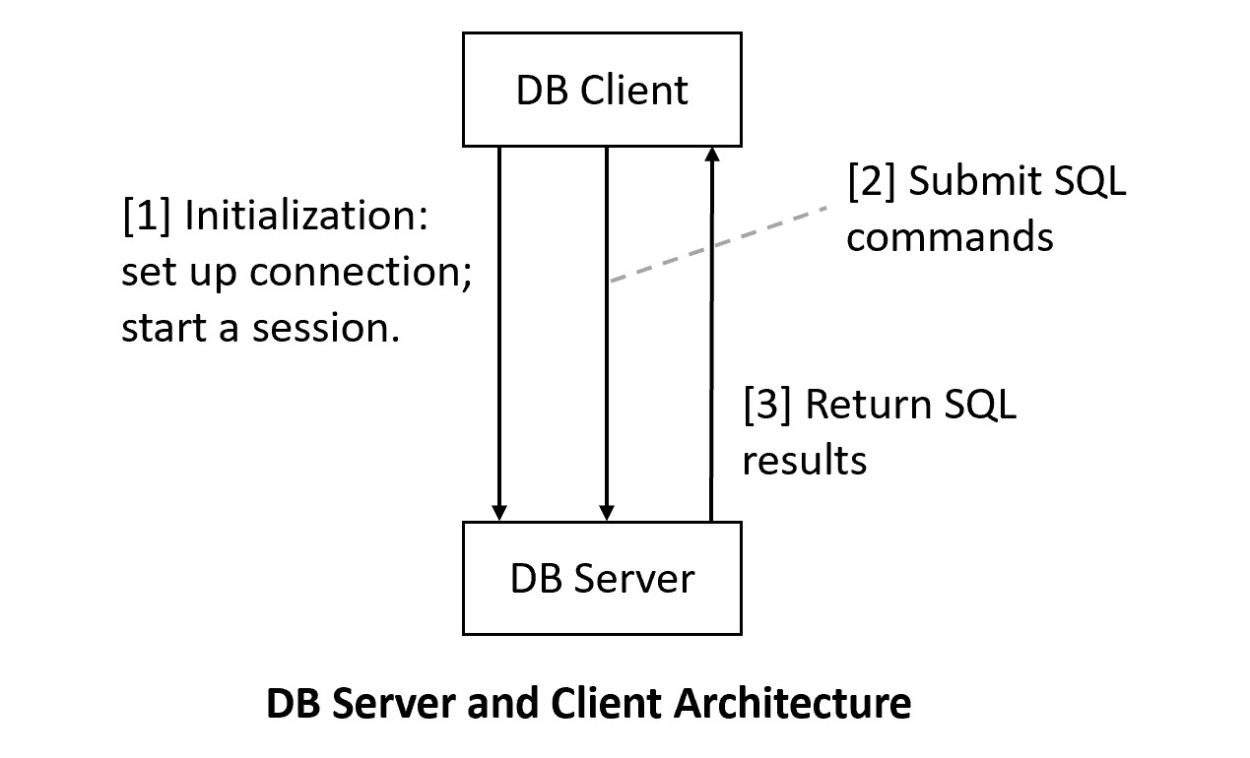

* DB are stored in the DBm server.

Working directory: e.g. C:\S2025_JointDB\website\demo\c4333

Terminal in working directory:

DB client (MySQL client)

mysql -u yue -p

may need to set PATH:

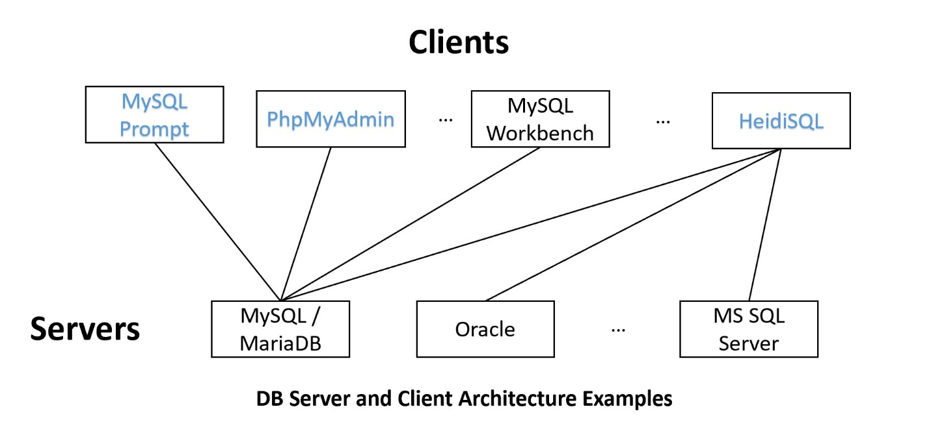

HeidiSQL: GUI client

