[1] Provide the name, surface area and population of all countries with a population more than 100,000,000.
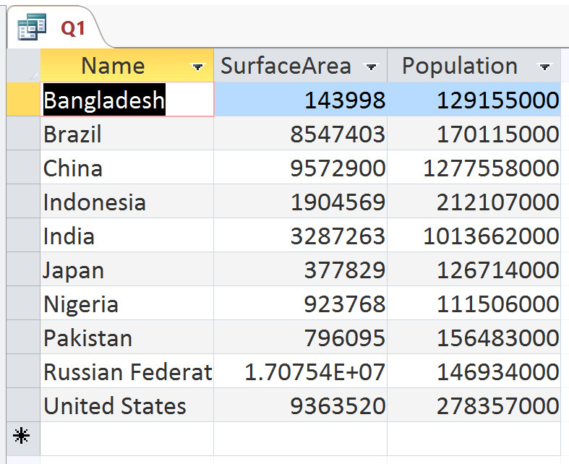
Columns in output: name, surface area and population of all countries
Source tables: country
Conditions: population > 100,000,000
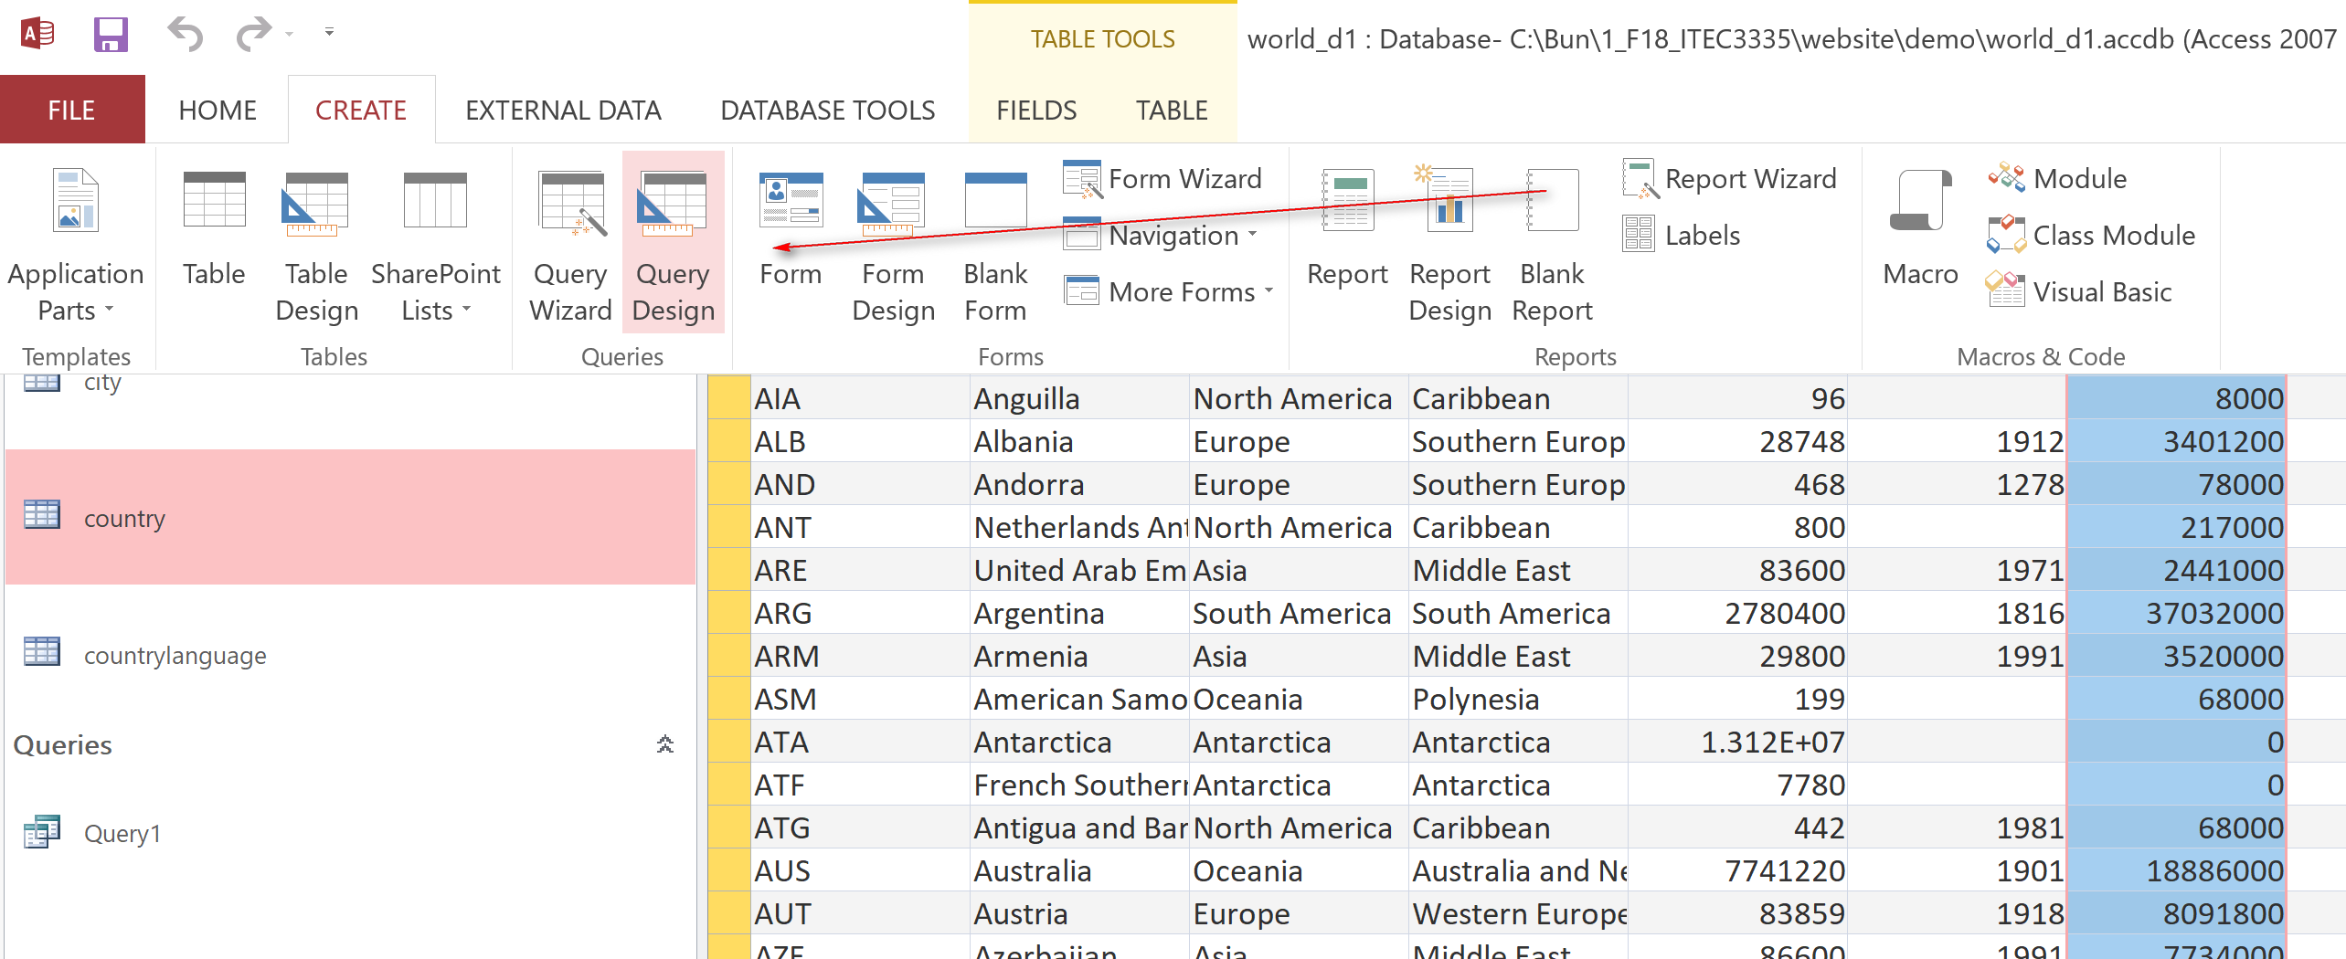

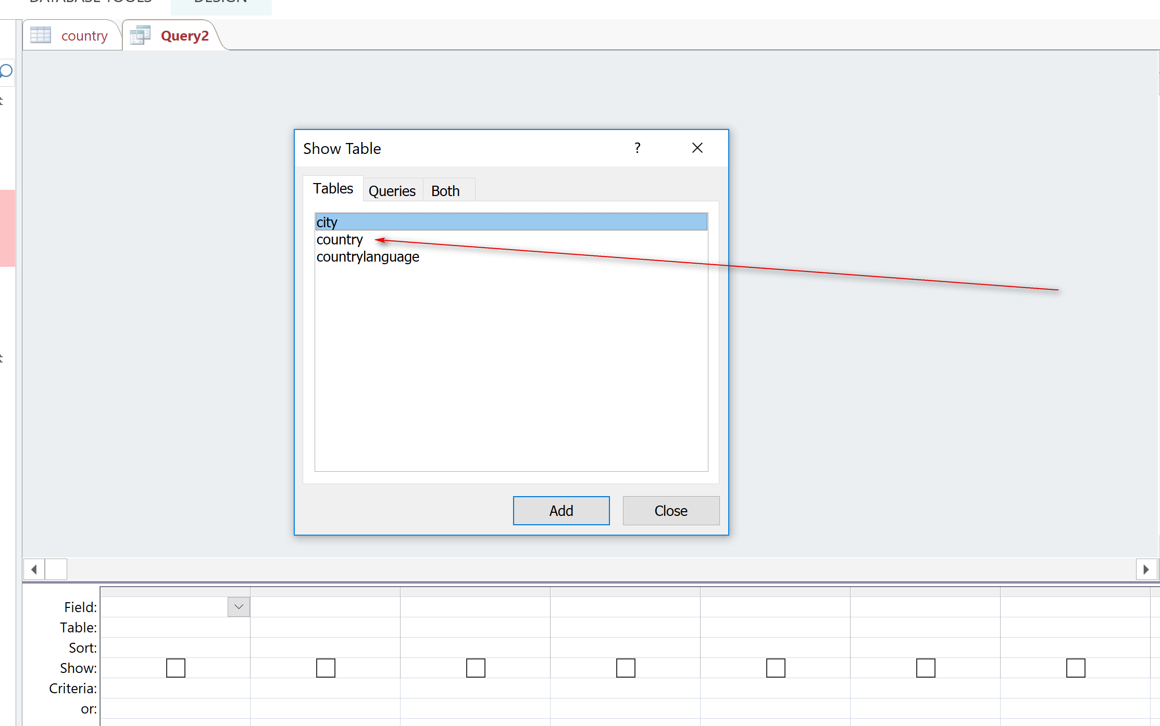
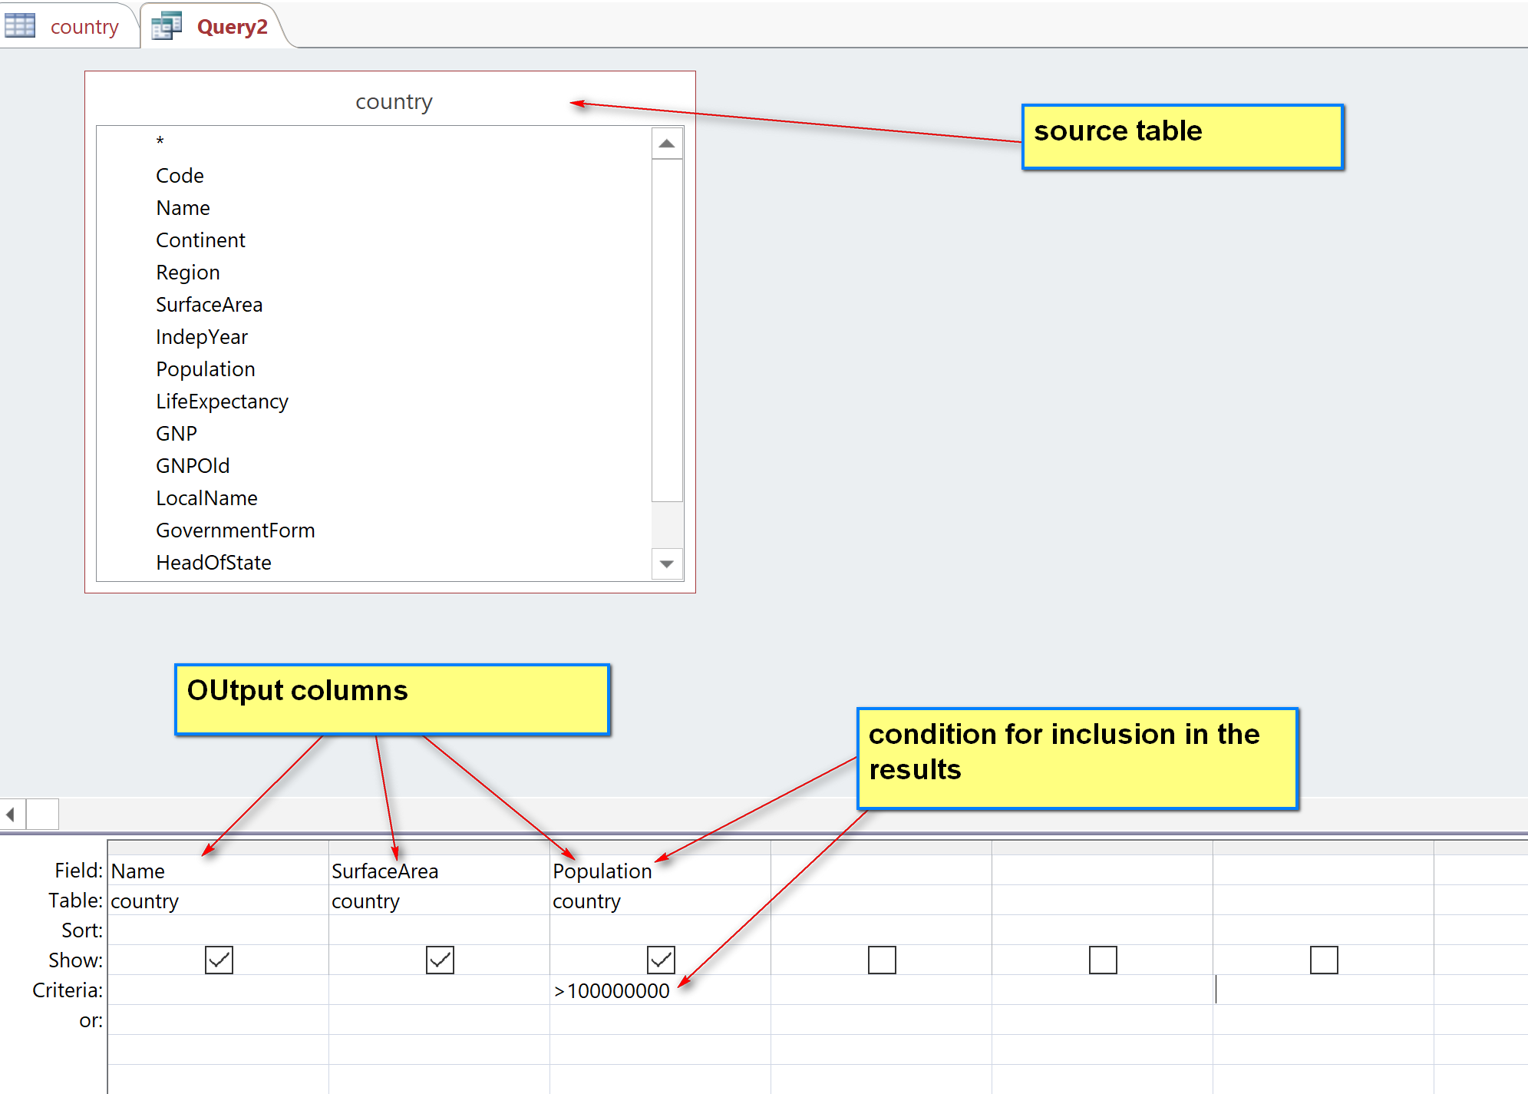

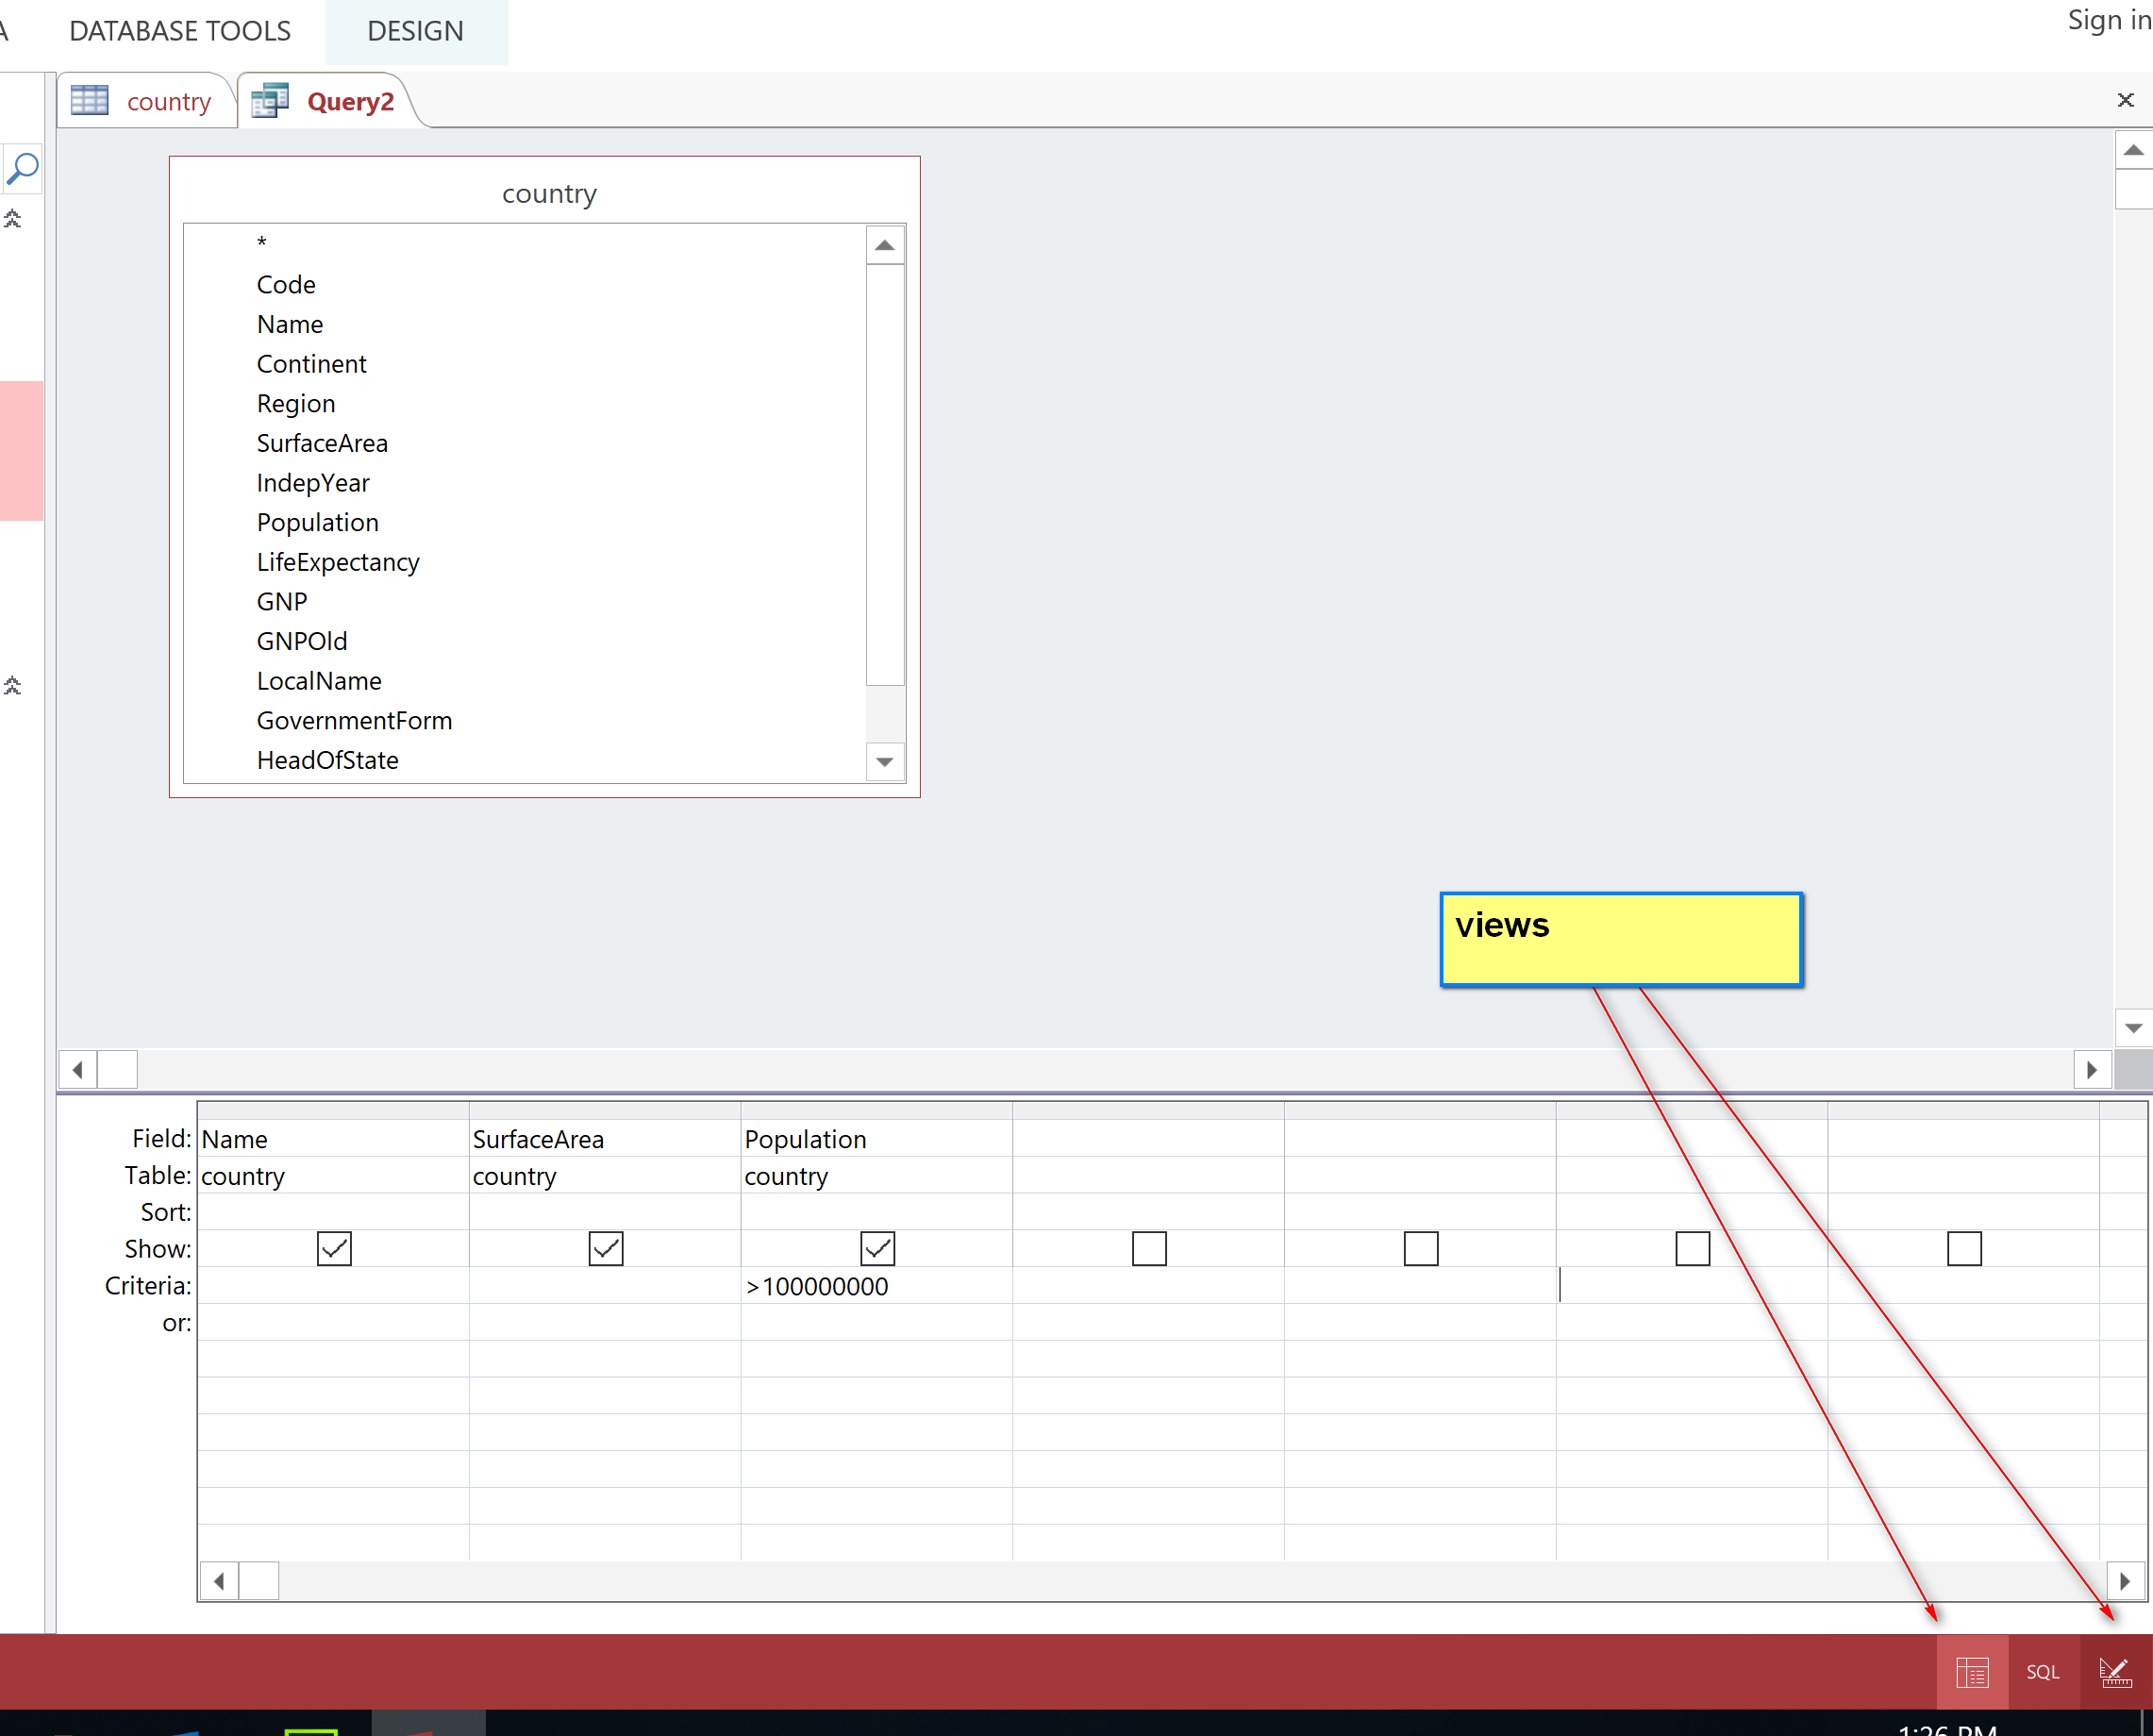

Click the datasheet view to get results:
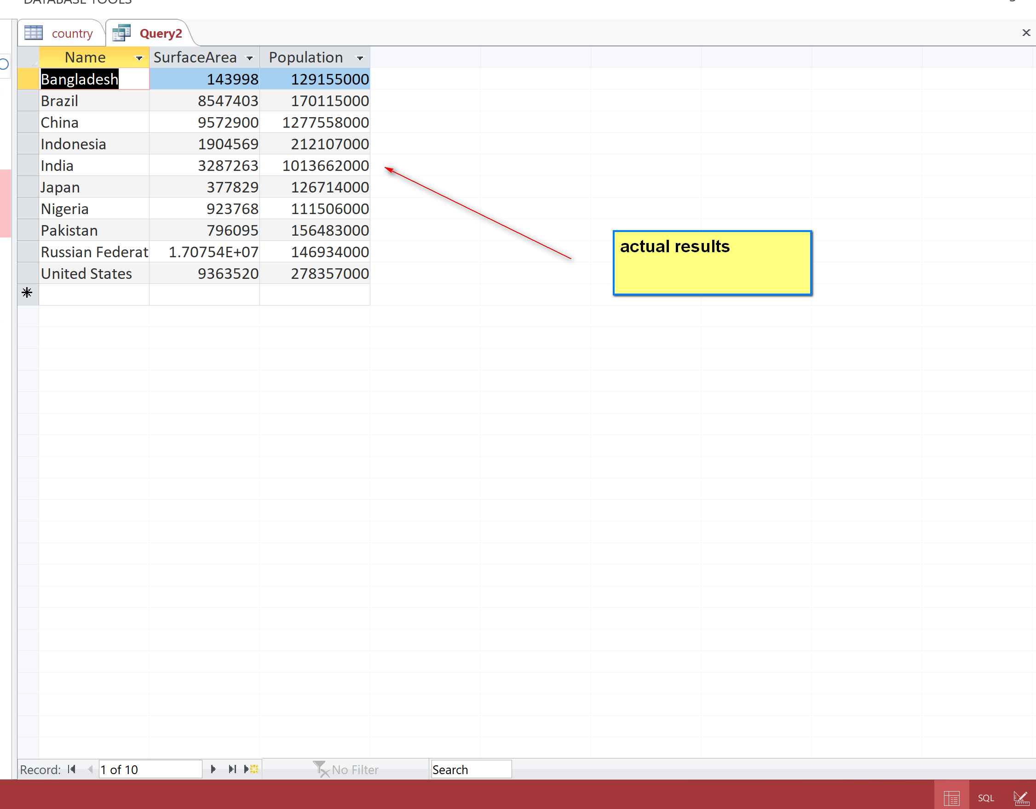
Actual results = expected result. OK

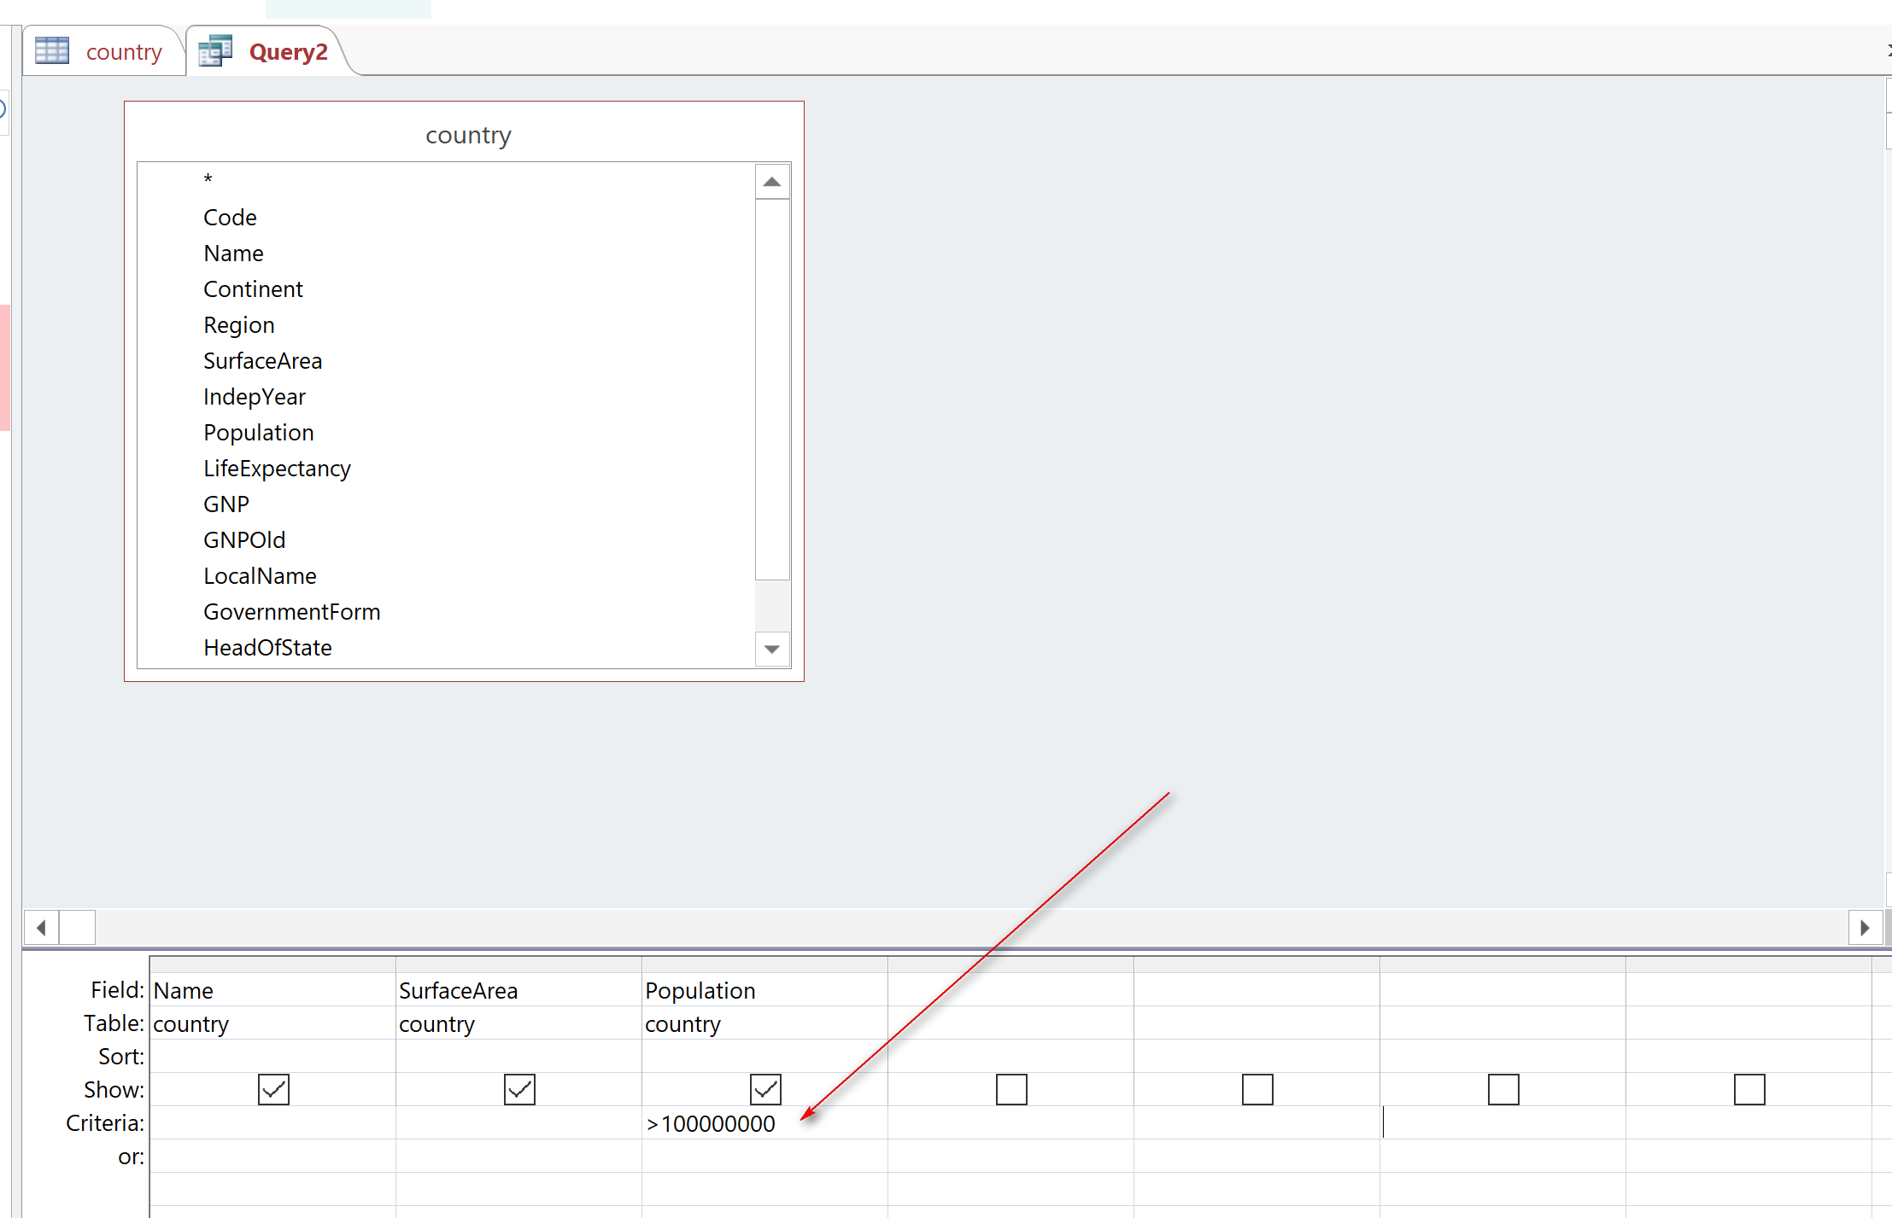

[2] Provide information of all countries in North America in the following format.
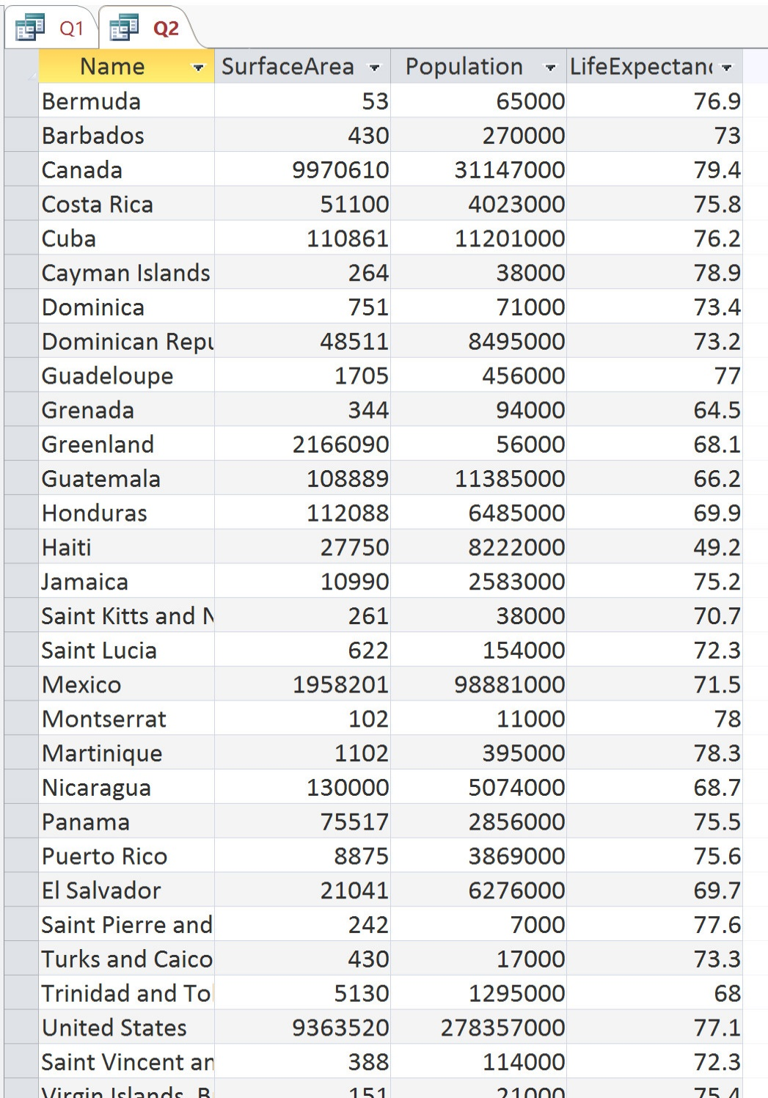
Output: name, surface area, population, life expectancy
Source: country
Condition: Continent = North America

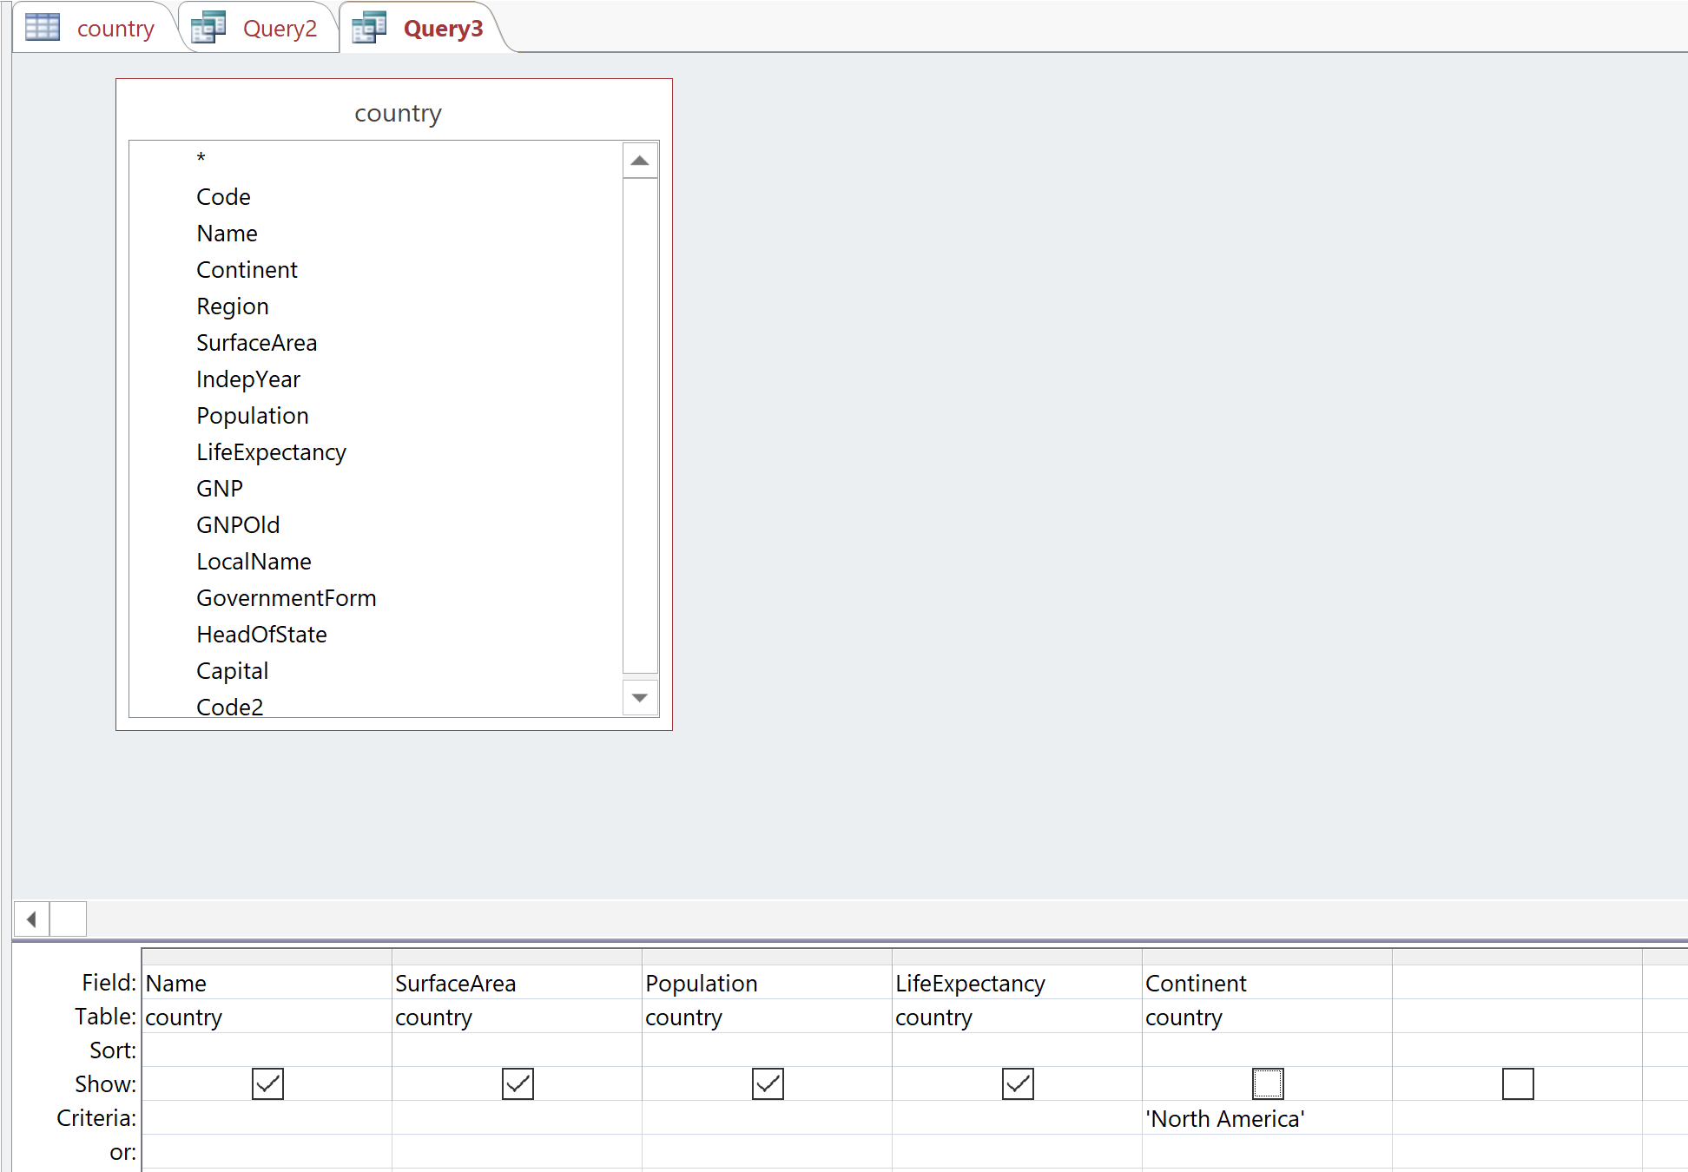

(3) List the names of the countries with English as a language, together with whether English is an official language, and the percentage of people with English as the primary language. List only those countries with a percentage of English as the primary language of 30% or above.
Output: name, IsOfficial, percentage
Source: countrylanguage: IsOfficial, percentage; country: name
Condition: language = English; percentage >= 30%
