9/26/18
(1) [30 points] The goal is to build a highly simplified toy prototype database to partially support storing of information about employees, departments and projects. Provide an ER diagram to capture and model the partial requirements below. You should list the entities, their attributes, and relationships (with names and cardinalities). Identify the primary keys of the entities when appropriate. Since this is only a highly simplified part of the application, model your design in a flexible way.
The company has many employees, each with a unique employee id.
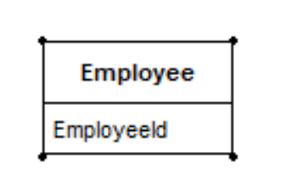
The company has many employees, each with a unique employee id.
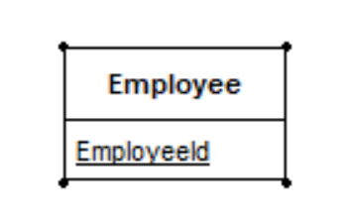
Concepts:
- Company: ?
- Has
- Employee:
  - Attribute: has value
  - Entity: properties (attributes), form relationships, exists by itself.
- Employee id (unique)
The last name, first name, office, and phone of an employee should be stored.
- last name, first name, office, and phone are properties of an employee -> attributes.
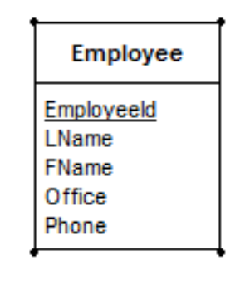
An employee works for a department, but she may also be without a department.
New concepts:
- department: entity
  - Attribute: has value
  - Entity: properties (attributes), form relationships, exists by itself.
- Work: relationship
  - Relationship is between two entity (instances). Subject – verb (relationship) – object.
An employee works for a department, but she may also be without a department.
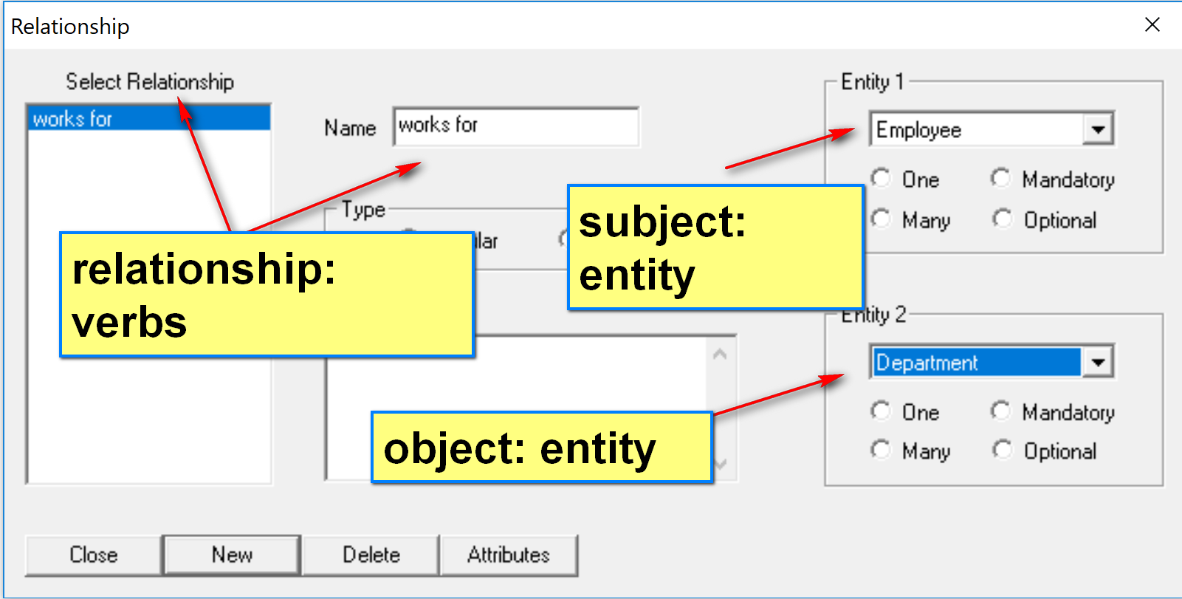
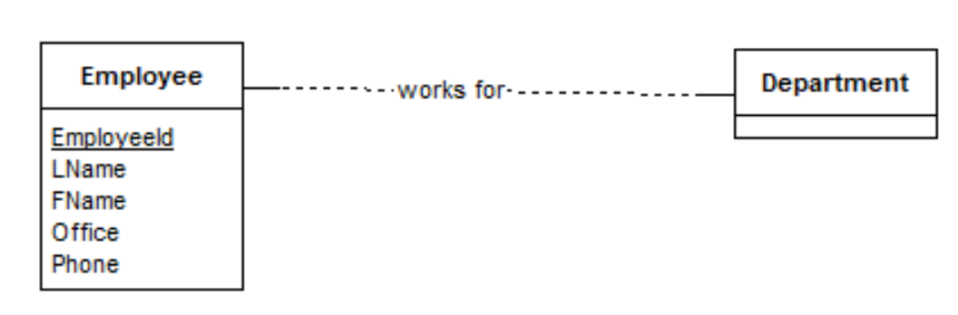
- with or without

An employee works for a department, but she may also be without a department.
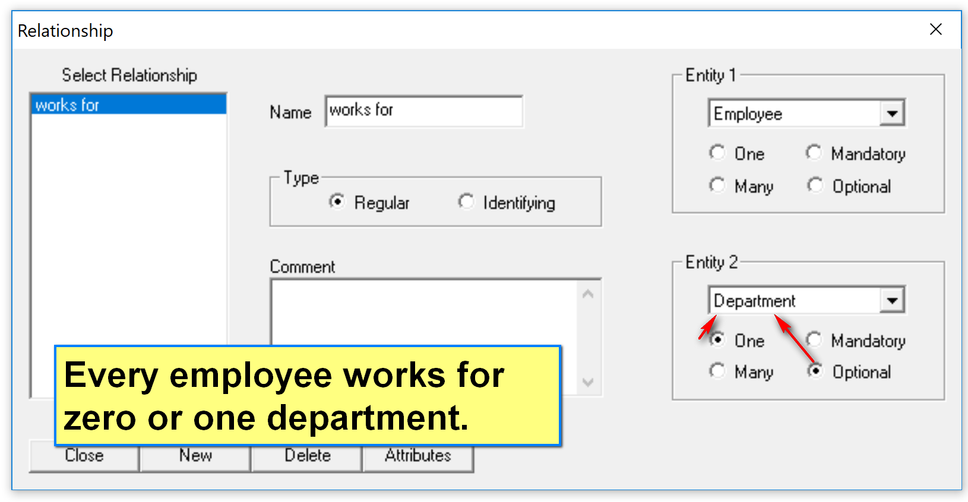
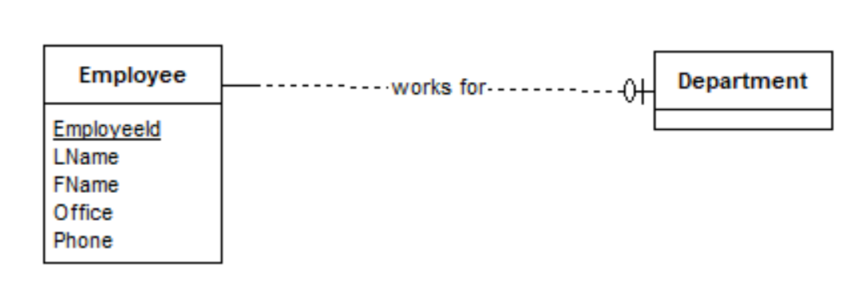
Assumption: a department may have 0 or more employees.
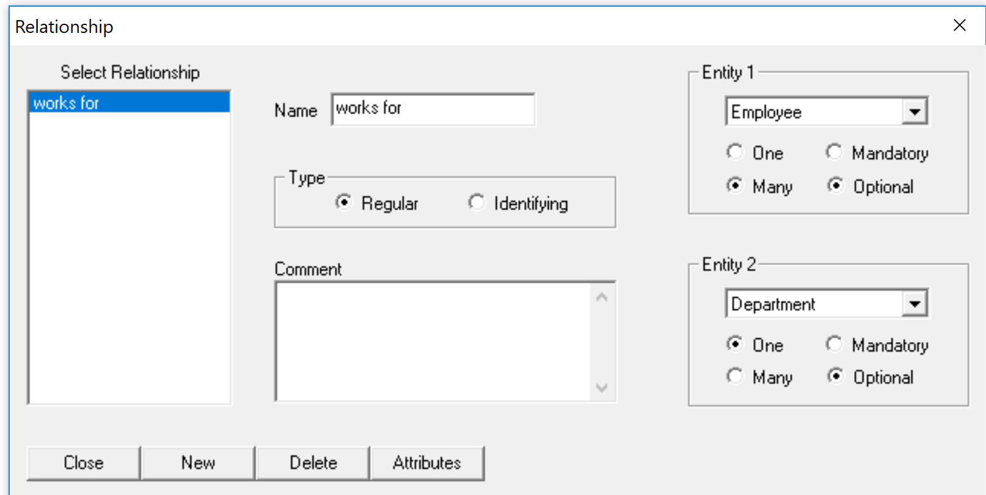
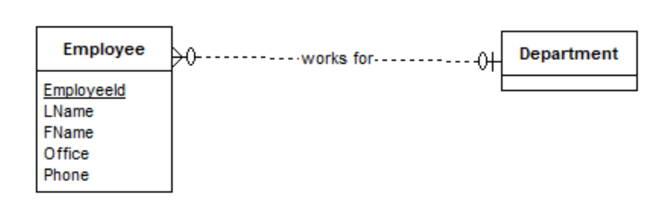
Each department may have a head, selected from the pool of employees.
New Concepts:
- Head: noun; role of an employee of a department.
Dr. Davari (entity instance) is the head of (relationship) the department of computing sciences (entity instance)
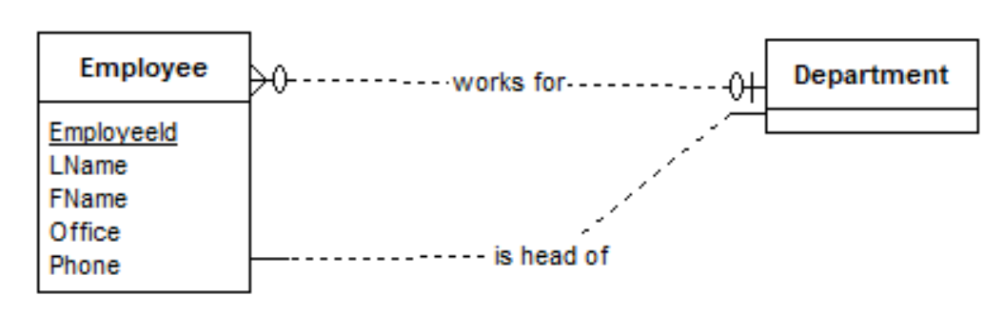
- May have
Each department may have a head, selected from the pool of employees.
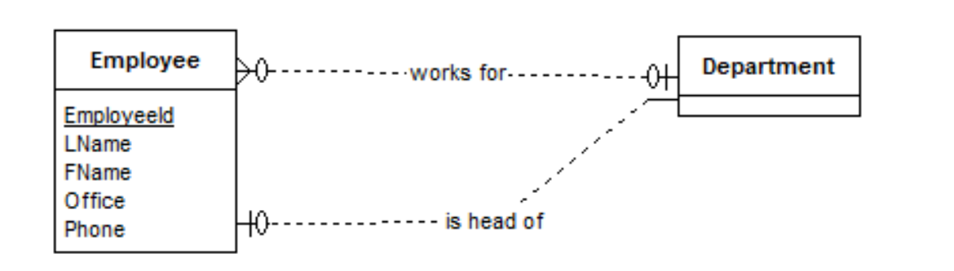
Although an employee usually is the head of only one department, sometimes she may head multiple departments.
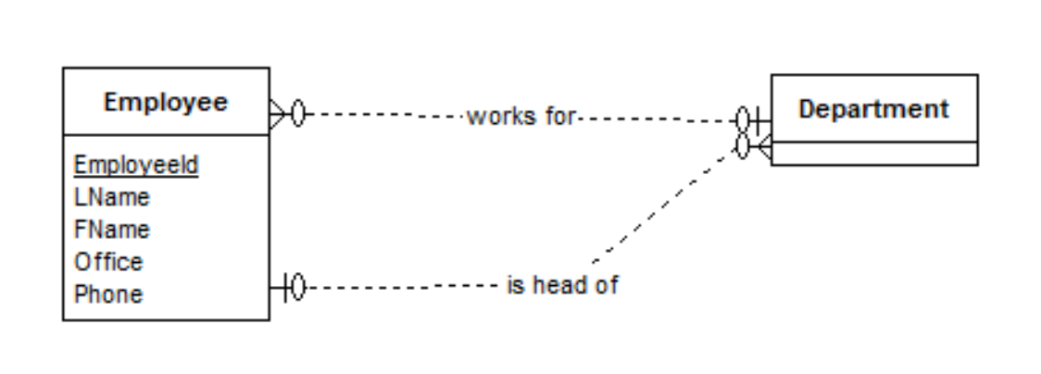
A department has a unique id and name. It also has an office.
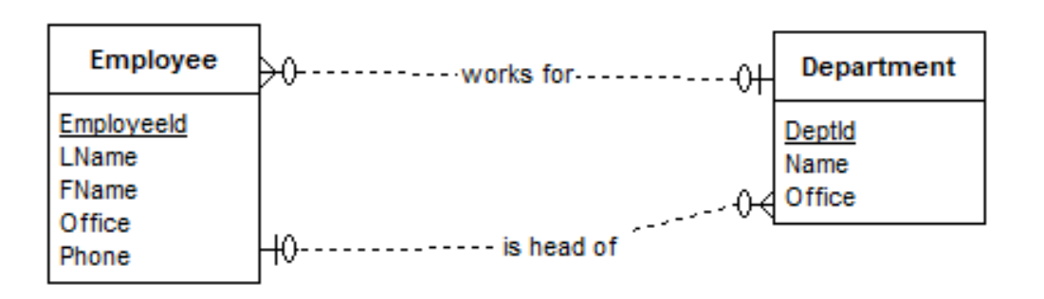

There are projects. The project name and an optional description must be recorded.
- Project: entity
- Name, description (optional): attribute
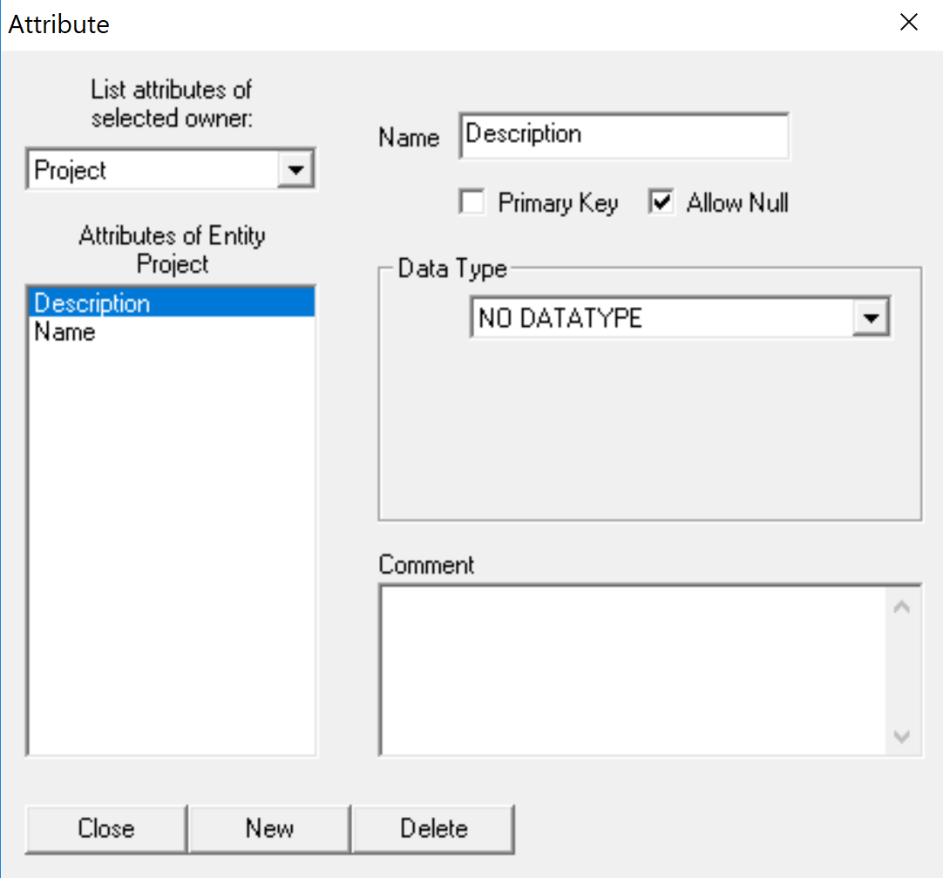
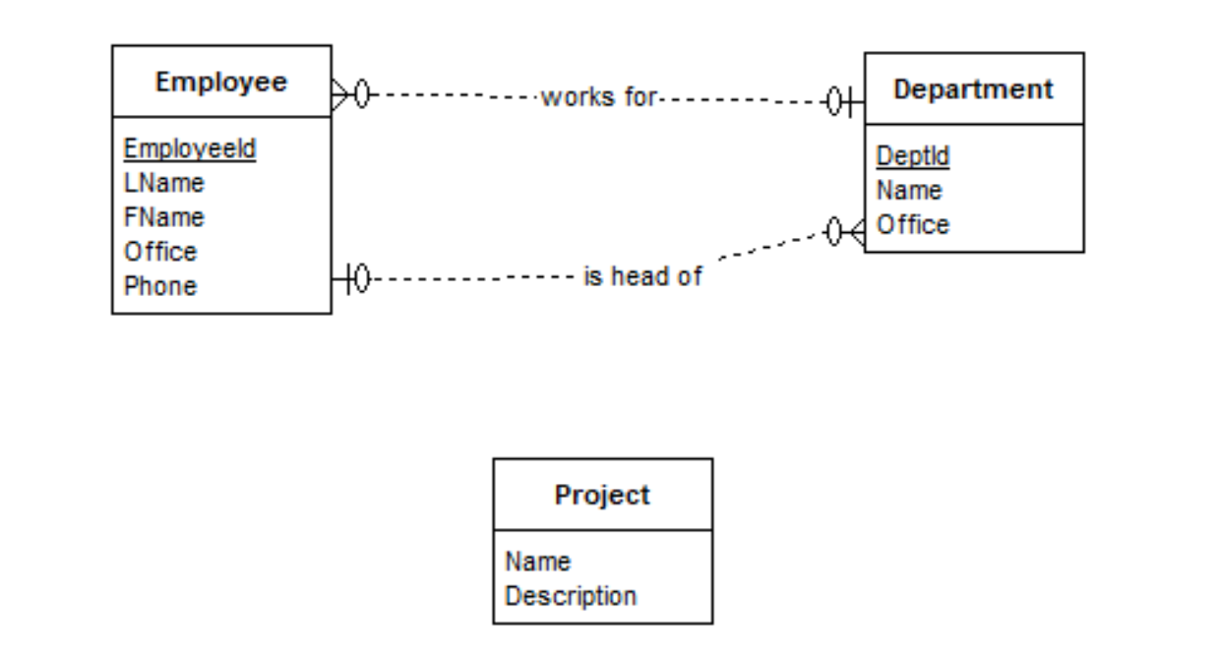
Many departments may work on a project but there is always one lead department.
Concepts:
- is always one lead
DCS is the lead department of the project Phoenix.
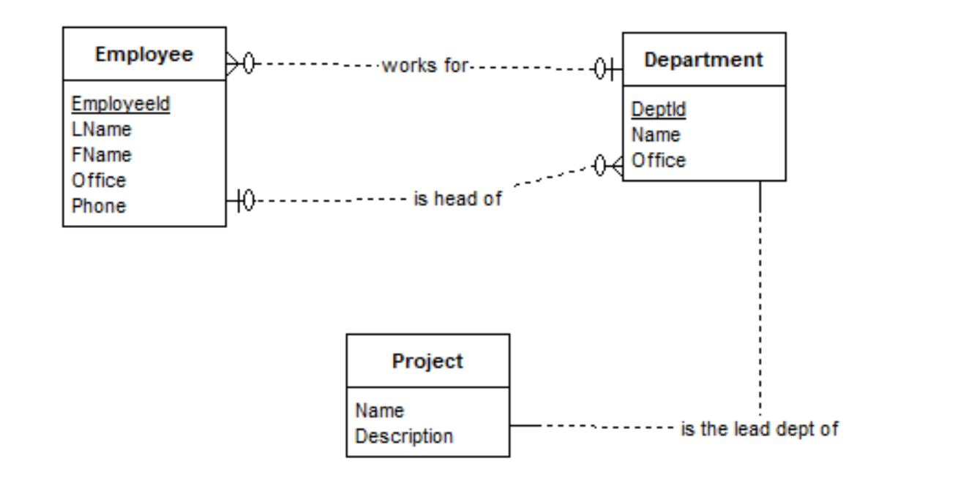
A project has one and only one lead department.

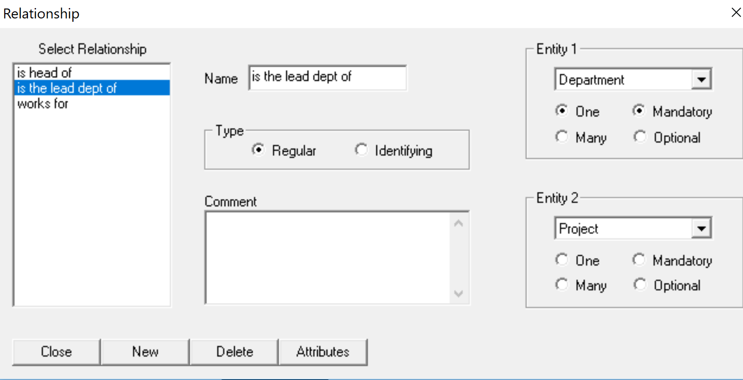
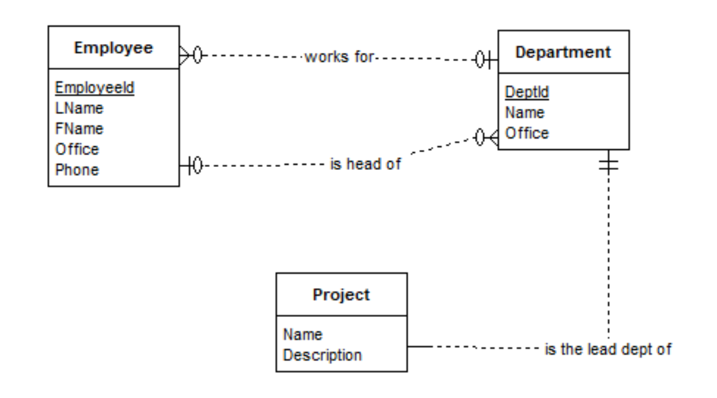
- may work
Many departments may work on a project but there is always one lead department.

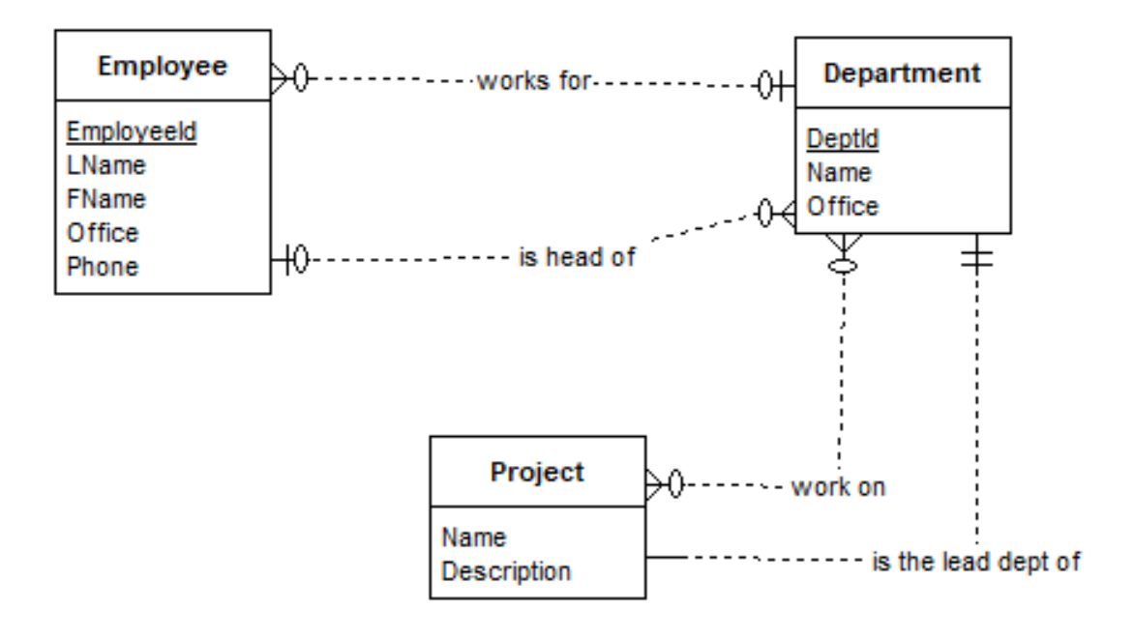

Employees are assigned to projects. The database should record the role of an employee in a project and her relevant skills for the project.

A1: Bun is assigned to Proj X with the role SA with skills windows/Linux (properties of the assignment).
A2: Lee is assigned to Proj X with the role programmer with skills Java (properties of the assignment).
A3: Bun is assigned to Proj Y with the role programmer with skills Python/SQL.
Model assignment as an entity
