9/19/18
Excel: table:
- no meta-data
- Table: 2 dimensional array (ordered collection of elements)
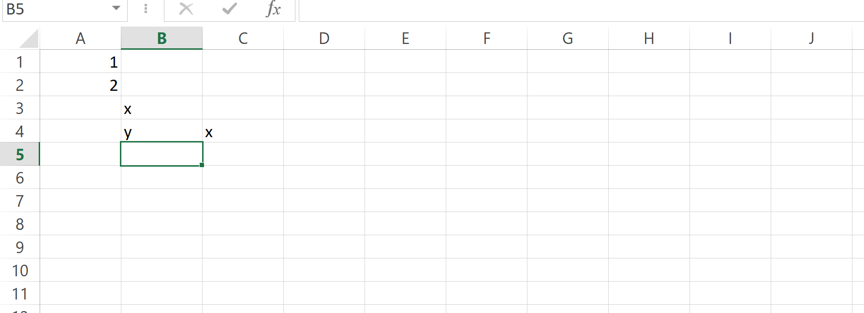
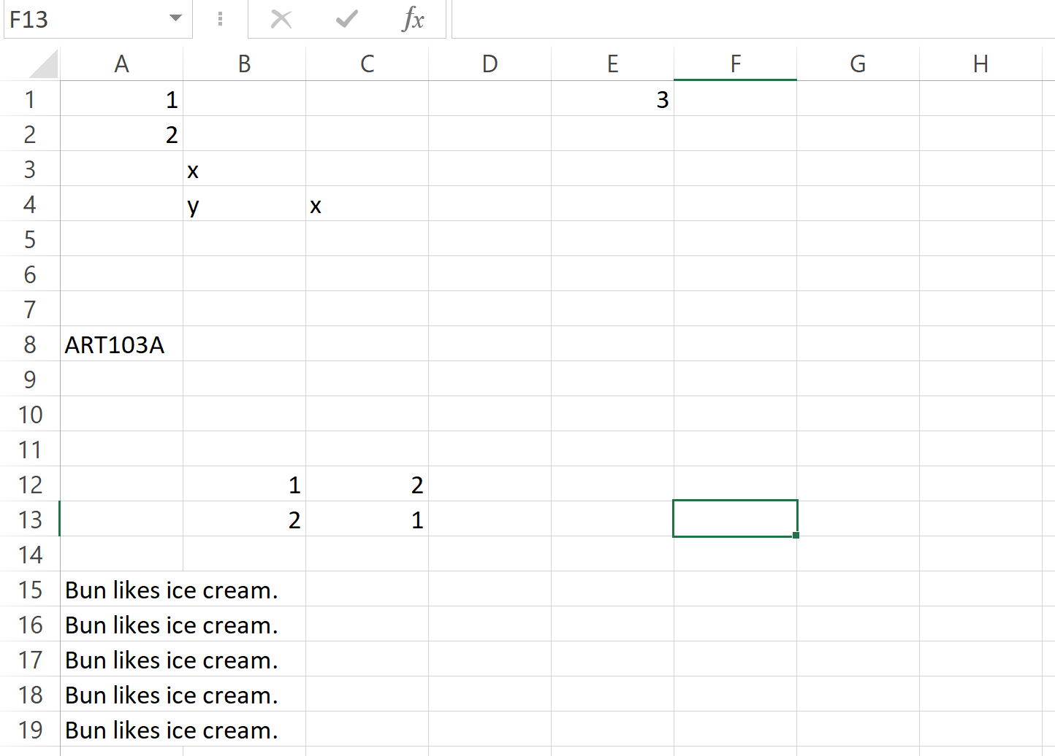
RDB: table:
- has meta-data
- has constraint
- Query using SQL
- Table: not ordered, no duplicate rows and columns.
- Relation: a set (unordered collection of non-duplicating elements) of rows.

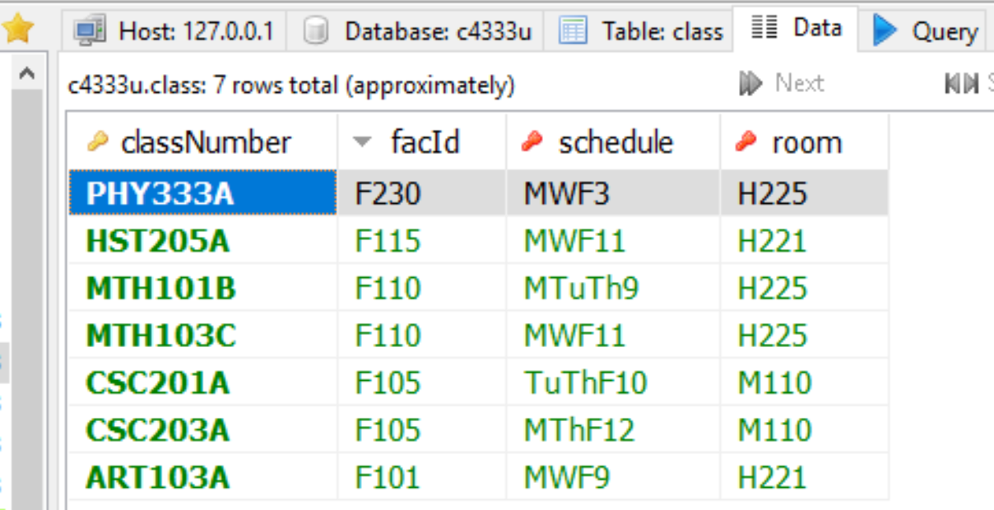

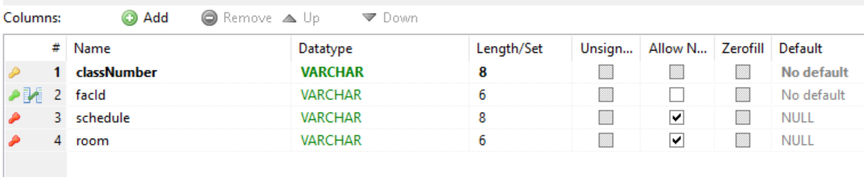

Domain: data type
Null:
-- find the student with no declared major.

-- output: all attributes in student
-- source: student
-- condition: major is null

-- * wildcard match
select distinct s.*
from student s
where s.major is null;

select distinct s.*
from student s
where s.major is not null;

