9/17/2018
(5) student:
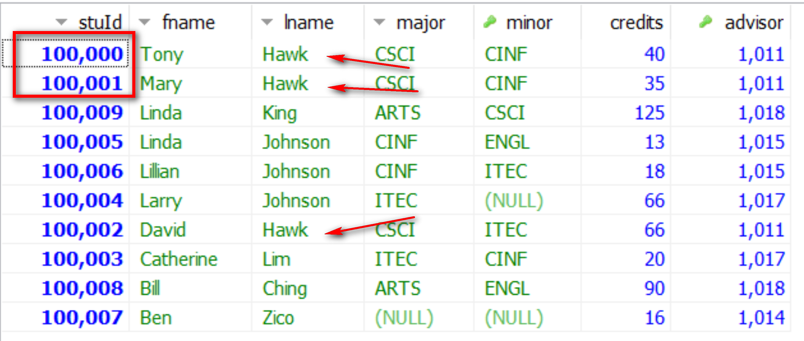
Class: courseId = 2000
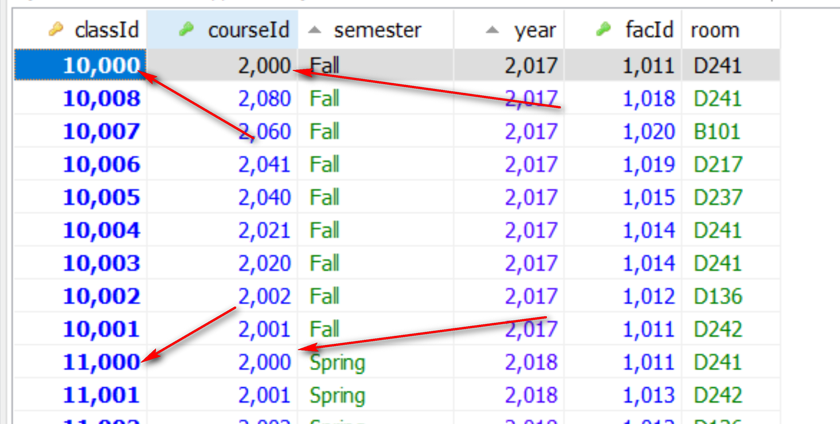
Enroll:

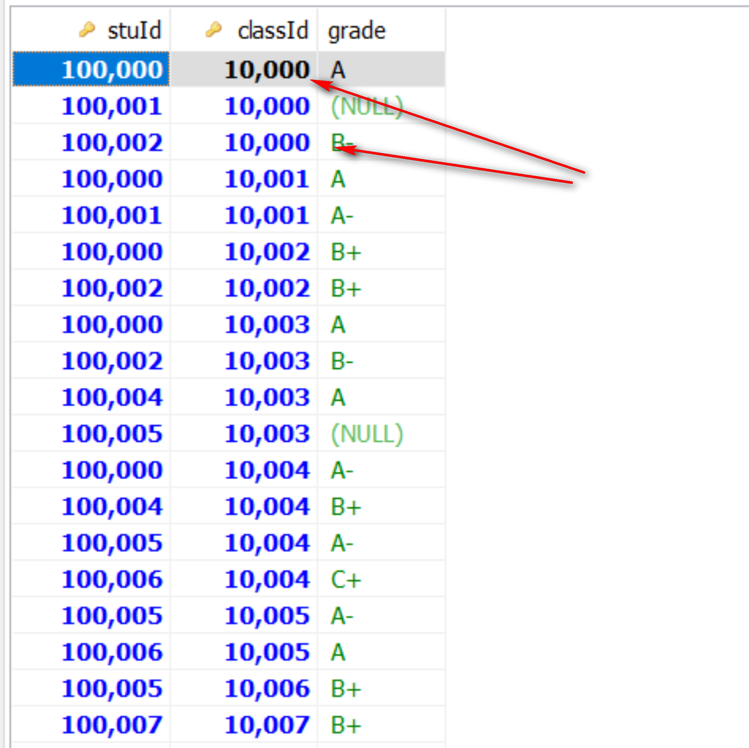

To link tables enroll and class -> enroll.classId = class.classId (‘common’ attribute)
TO link/join tables enroll and student -> enroll.stuId = Student.stuId

MariaDB [toyu]> select distinct s.stuId, s.fname, s.lname, c.semester
-> from student s, enroll e, class c -- aliases
-> where c.courseId = 2000
-> and e.classId = c.classId
-> and e.stuId = st.stuId;
ERROR 1054 (42S22): Unknown column 'st.stuId' in 'where clause'
MariaDB [toyu]>

