9/12/2018
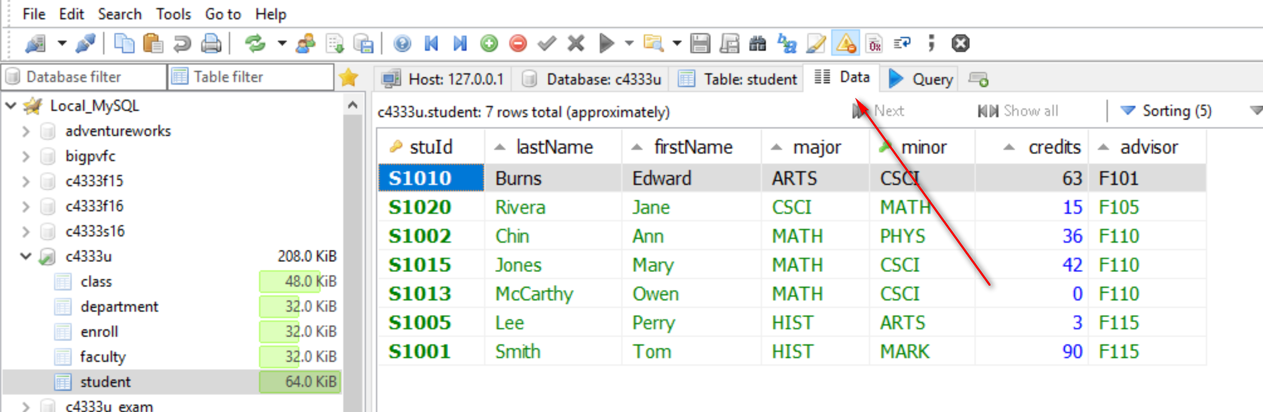
(a)
Output columns:
Source tables:
conditions:
- Output columns: fname, lname, minor, credits
- Source tables: student
- conditions: major = ‘ITEC’
Select -- 1
from -- 2
where -- 3
Select fname, lname, minor, credits
from student
where major = ‘ITEC’;
Use a text editor for development.
MariaDB [toyu]> Select fname, lname, minor, credits
-> from student
-> where major = 'ITEC';
+-----------+---------+-------+---------+
| fname | lname | minor | credits |
+-----------+---------+-------+---------+
| Catherine | Lim | CINF | 20 |
| Larry | Johnson | NULL | 66 |
+-----------+---------+-------+---------+
2 rows in set (0.00 sec)

How to change the SQL output column name? from lname to ‘Last Name’, eg.

Full sql script file:
source C:\<<your path>>\Createtoyu.sql.txt

