9/10/2018
MySQL 8.0 (client and server)

XAMPP: MariaDB = MySQL.
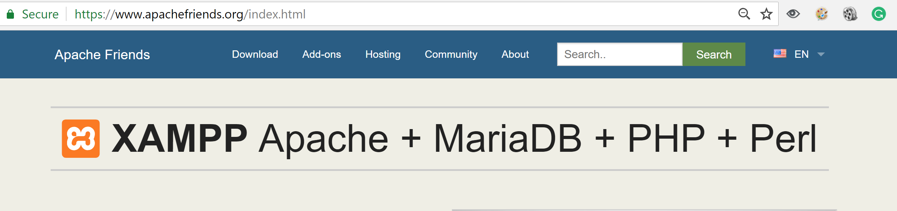

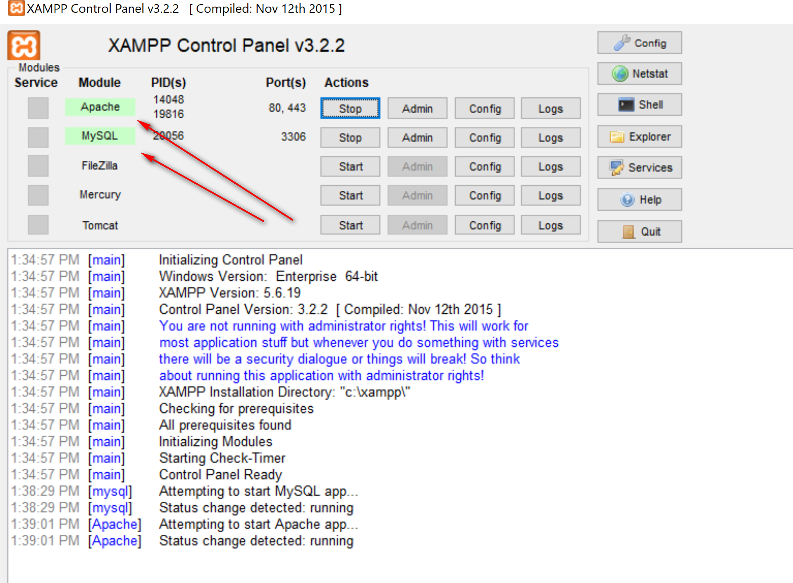
HeidiSQL; Graphical SQL client 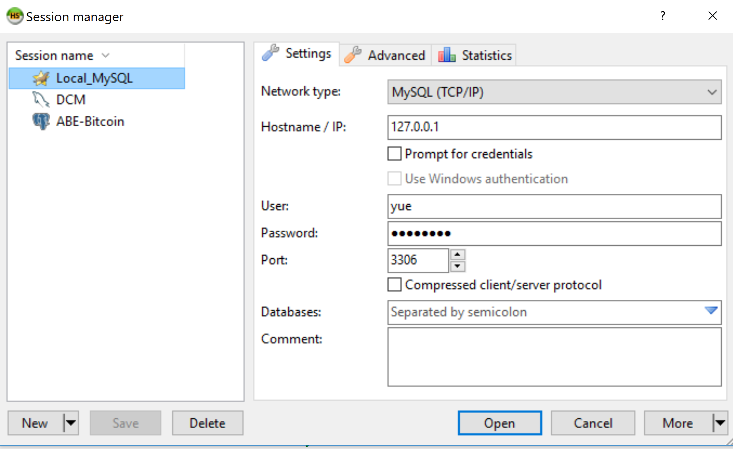

MySQL Client:
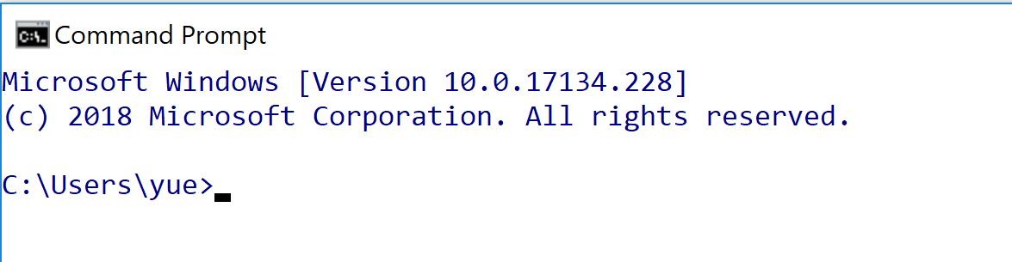

Mysql
Command option:
-u: user
-p: password
Mysql –u yue –p
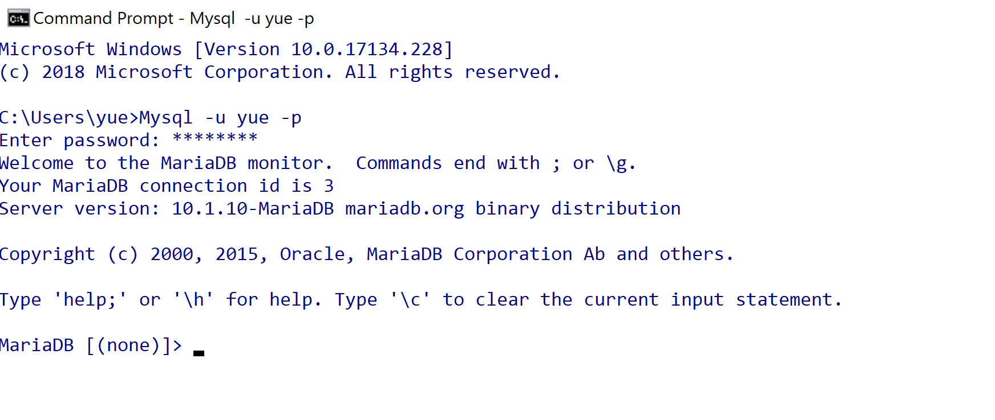

Show tables;
Creating toyu:
1. Open mysql in the directory that contains the sql source file.
Shift right-click -> open command windows here
2. Execute SQL file:
Source Createtoyu.sql.txt

Problem. Show me information about all students.
Analysis:
Output columns:
Source tables:
Conditions:
1. Output columns: all columns in students
2. Source tables: student
3. Conditions: no

Select – 1
from -- 2
where – 3

Select *
from student;

