-- Q2. ALl information of faculty in the department CSCI.

-- Expected output:

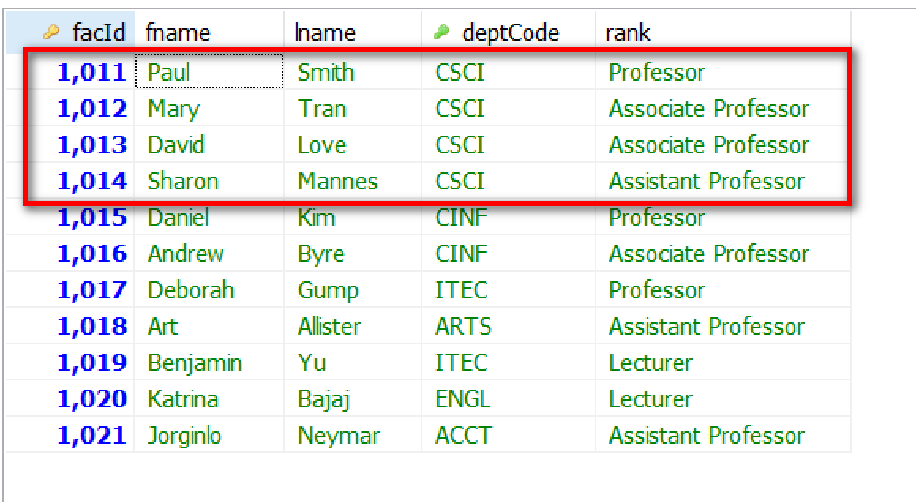

-- Q3.Faculty names ranks of the department 'Computer Science'

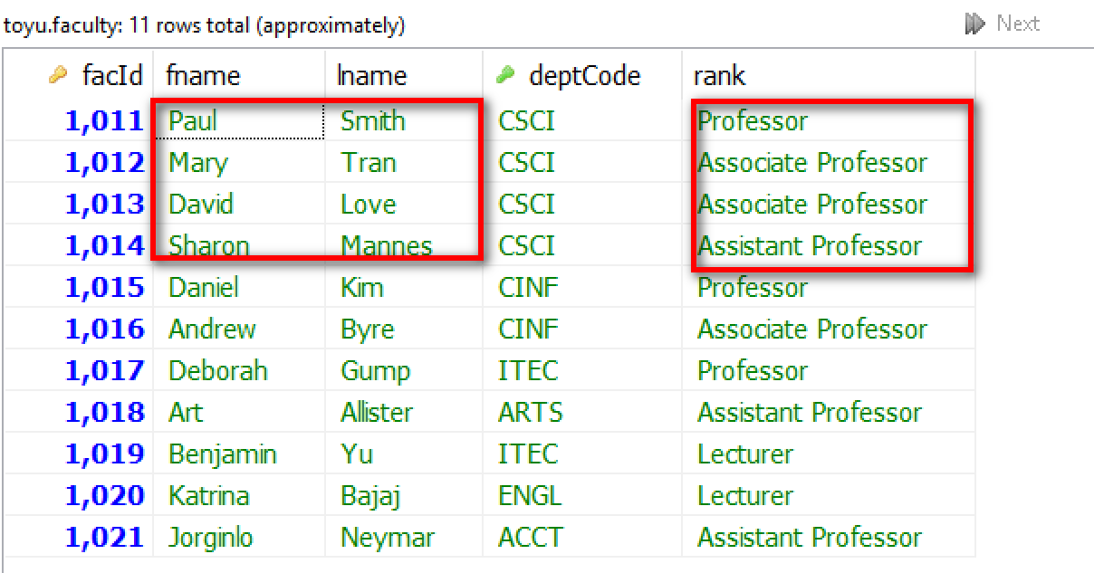

select distinct fname, lname, rank
from faculty, department -- department to look up the deptCode of 'Computer Science'
where deptName = 'Computer Science';

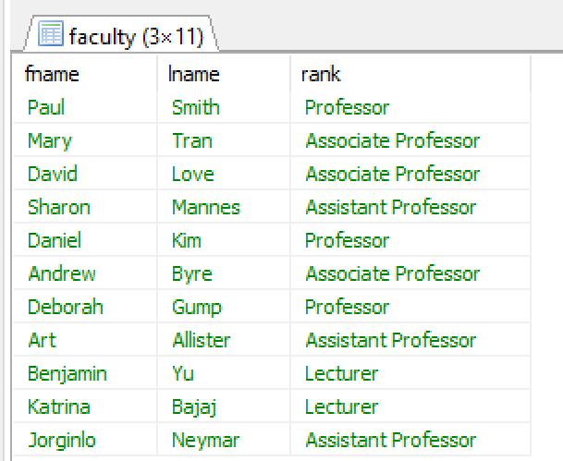

-- q4. student names that enroll in a class offered by Andrew Bryne.

Expected: Empty set.
Faculty -> facId of Andrew Bryne: 1016
Class -> classId by facID 1016: 11003
Enroll -> student taking 11003 -> null
Student -> student names.
-- q5. student names that enroll in a class offered by Sharon Mannes.

Expected: Empty set.
Faculty -> facId of Sharon Mannes: 1014
Class -> classId by facID 1014: 10003, 10004
Enroll -> students
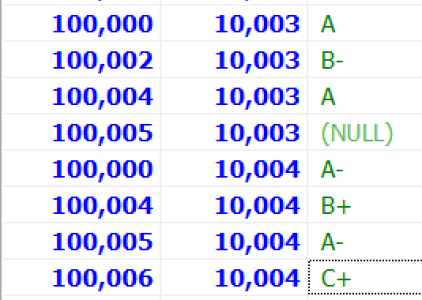
Student -> 5 student names
