(2) Using the MS Access file for the Pine Valley Furniture Company (PVFC) of the textbook, pvfc.mdb, create an Excel Spreadsheet, Customer_T.xlsx, that contains data of the customer_t table. It looks like this after the columns are formatted with width:
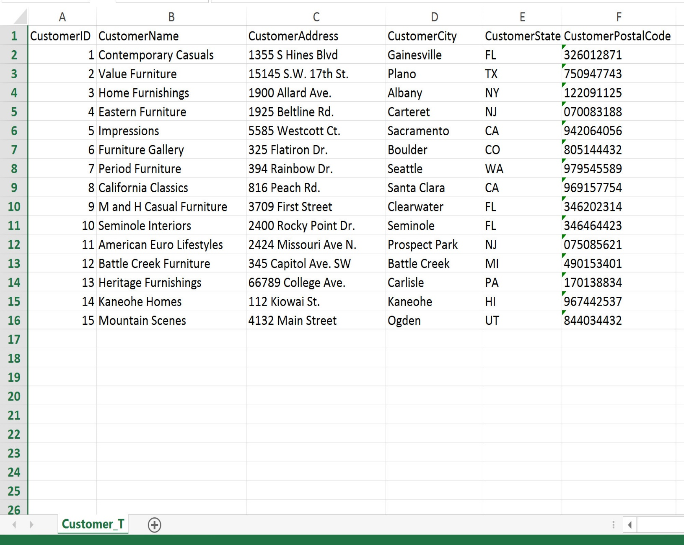
There are facilities in MS Access to do so. Your task is to figure out how. Turn in Customer_T.xlsx. Describe the steps that you used in layman's terms (what is layman?) with suitable screenshots. This is sort of like an introductory user guide for people who would like to convert Access tables to Excel.
- Investigate the options for Access to Excel conversion.

Connecting to DCM through HeidiSQL:

