SQL
MS Access: GUI -> SQL SQL Engine (DB Engine).

SQL:
- DDL: Data Definition Language -> define the relation schema (structure).
- DML: the relation instance
MySQL:
- MySQL
- XAMPP

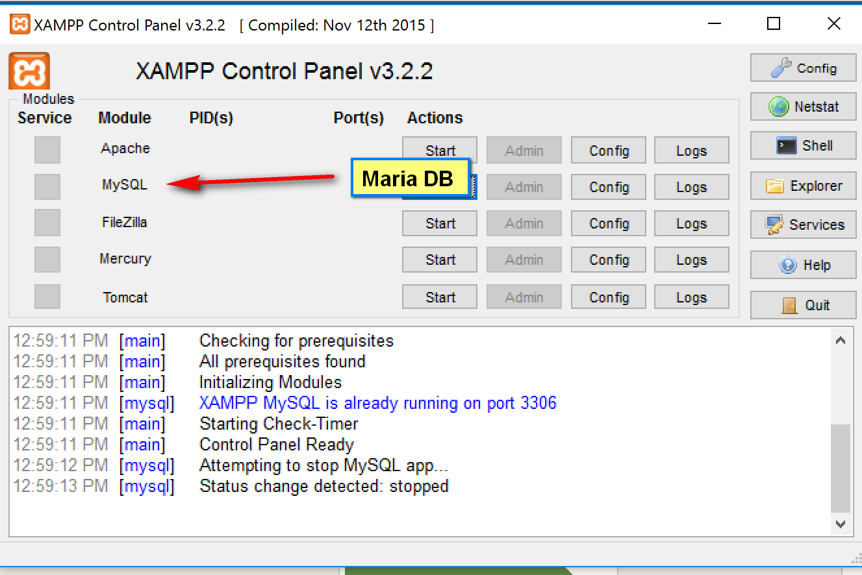

MySQL monitor:
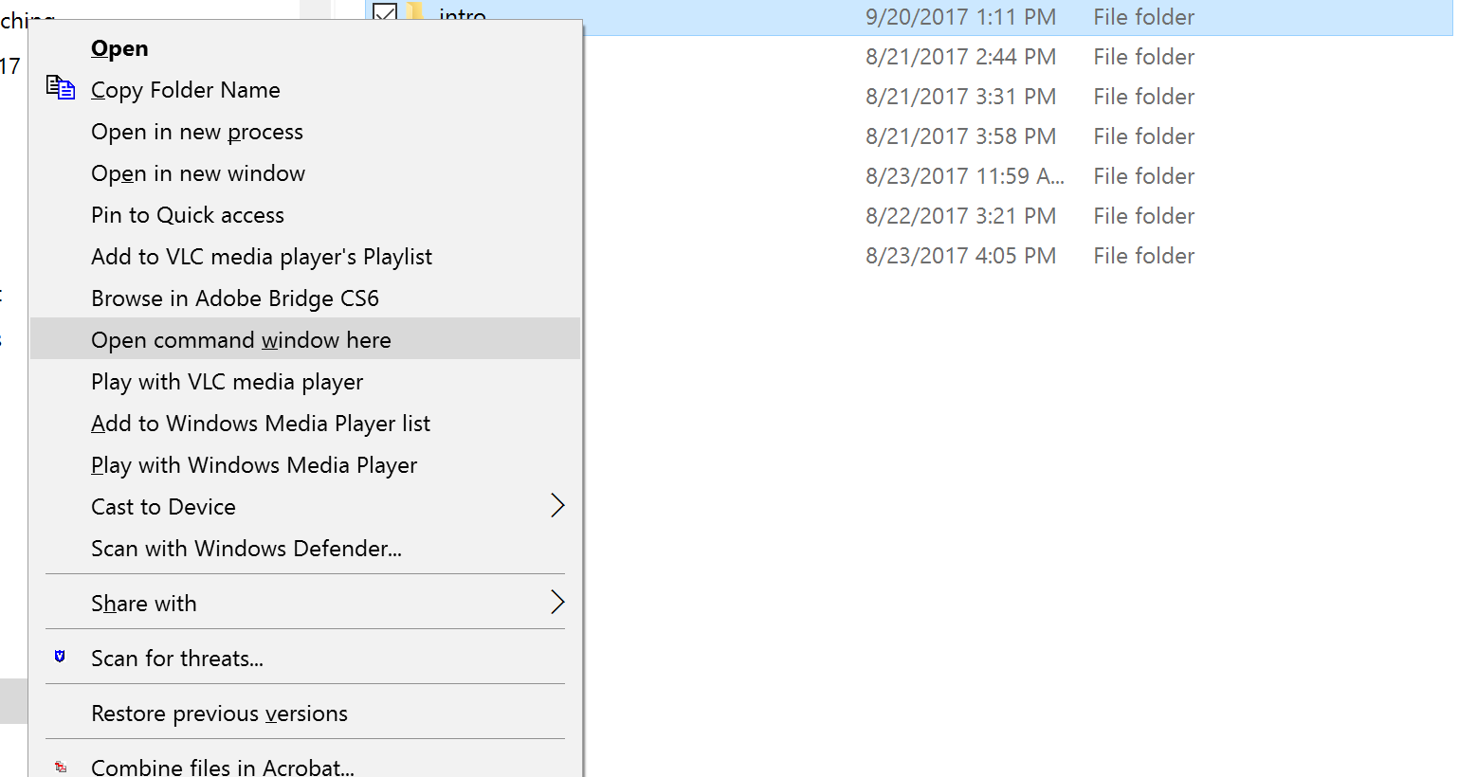

mysql –u yue –p

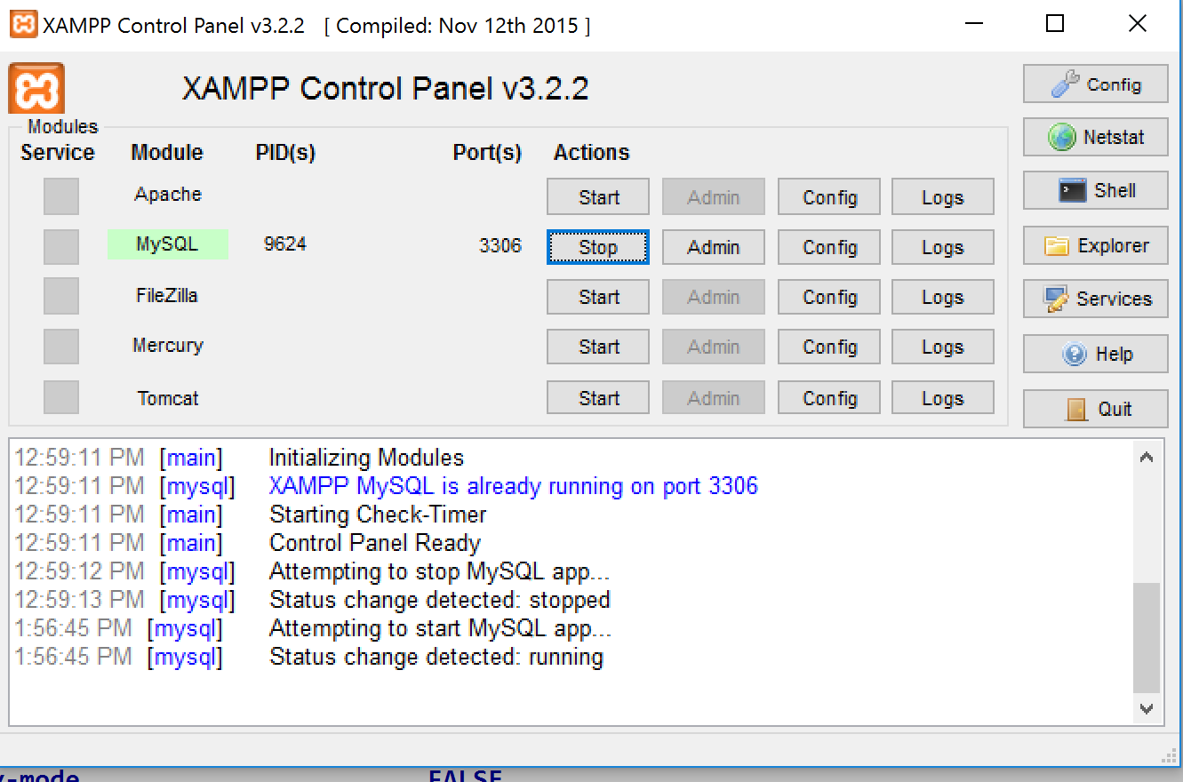

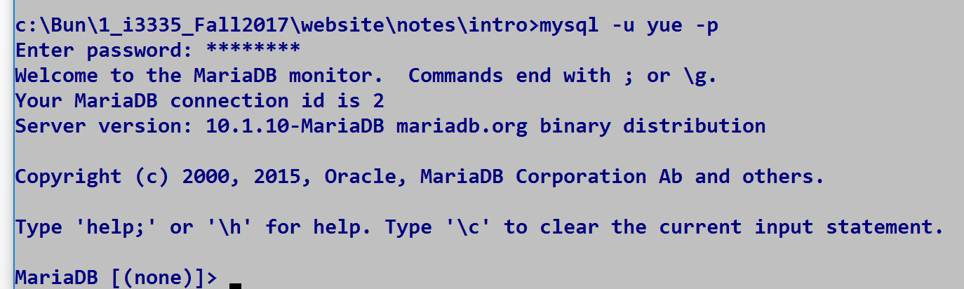

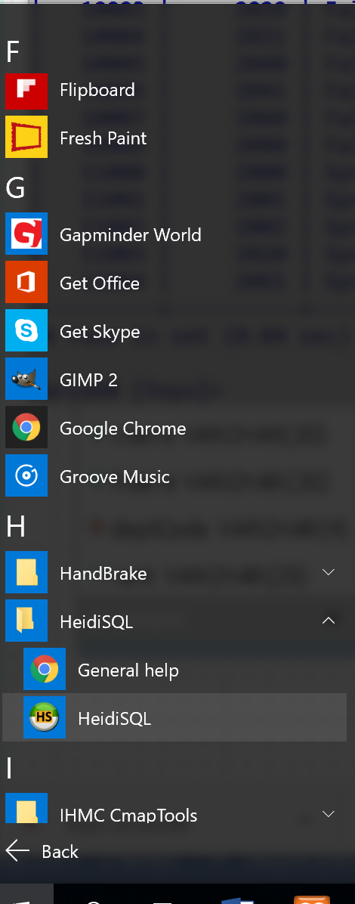
Relation schema of the table class:
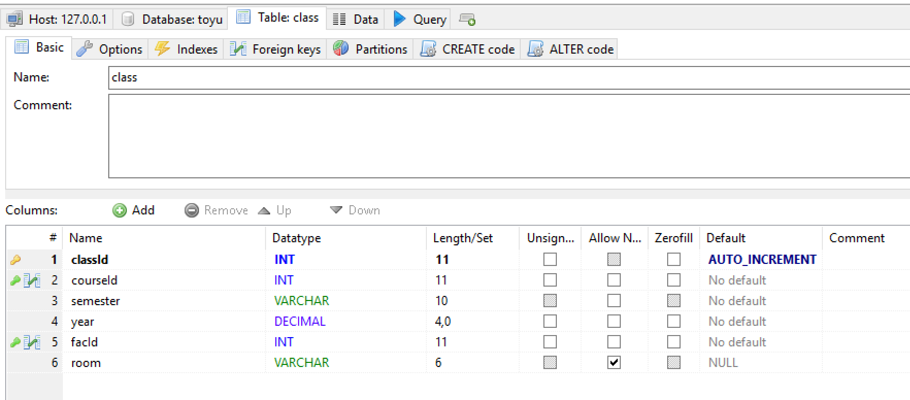

Relation instance of the table class:
