Converting world.accdb to Excel
[1] Open world.accdb: by double clicking the file.
[2] Select External Data -> Excel to export to Excel.
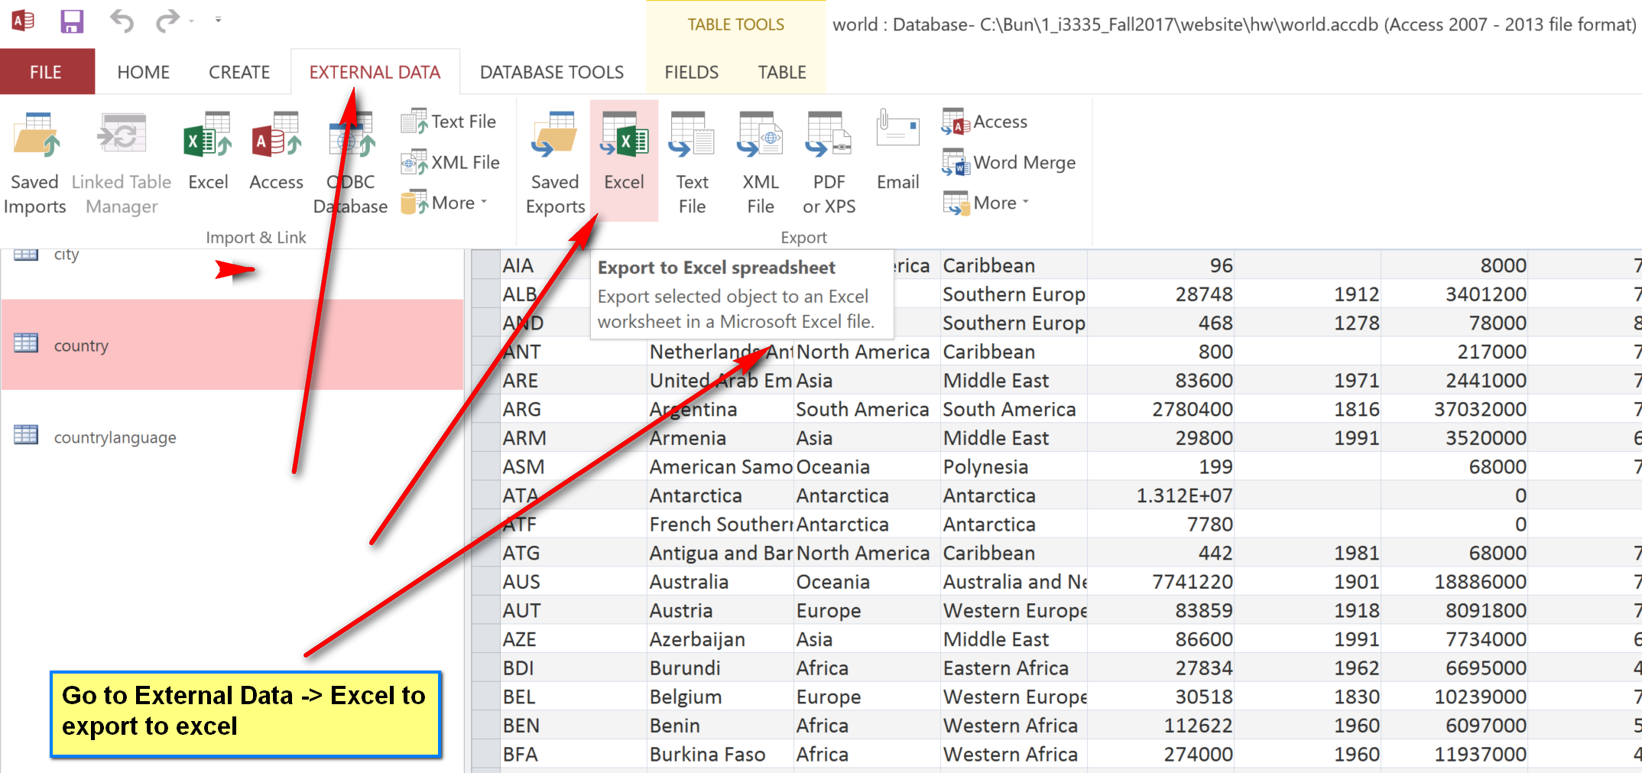
[3] In the popup export to Excel windows, enter the destination of the Excel file.
