Starting to run Java

(1) Checking JRE Version and Installation

1. Use the Website: http://www.java.com/en/download/installed.jsp

You can follow the site to install the newest version of JRE (Java Runtime Environment).

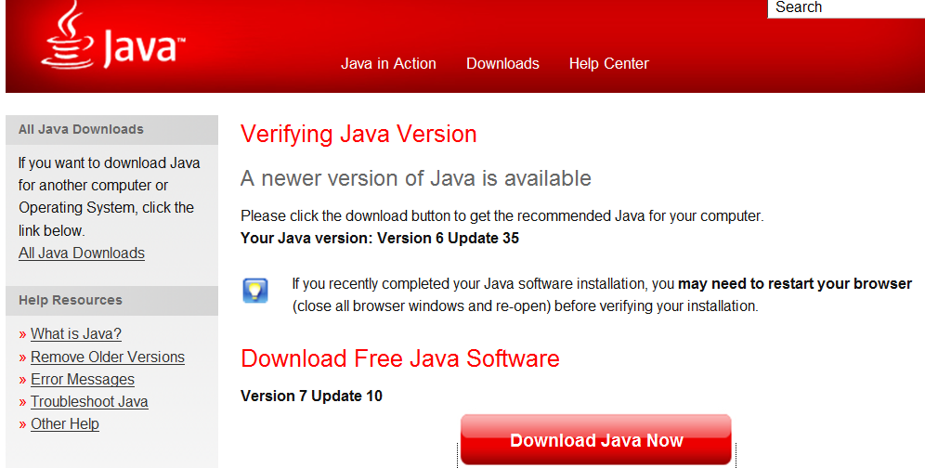

After installing a new version:

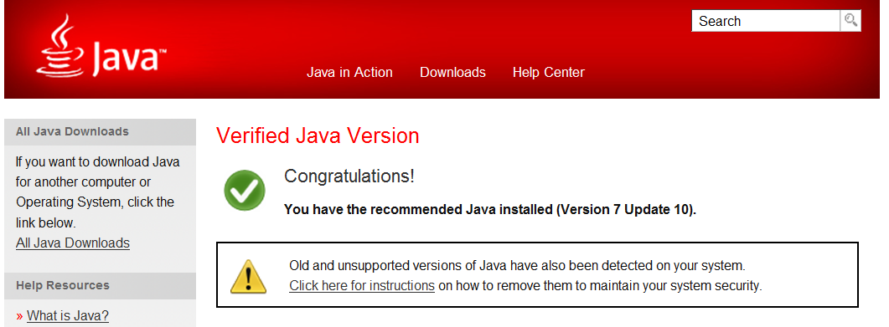

2. Command line: java –version

For example:

C:\Users\Yue>java -version
java version "1.6.0_06"
Java(TM) SE Runtime Environment (build 1.6.0_06-b02)
Java HotSpot(TM) Client VM (build 10.0-b22, mixed mode, sharing)

After installing a newer version:

C:\Users\Yue>java -version
java version "1.7.0_10"
Java(TM) SE Runtime Environment (build 1.7.0_10-b18)
Java HotSpot(TM) 64-Bit Server VM (build 23.6-b04, mixed mode)

(2) Installing JDK SE

To install JDK for Java development, go to http://java.sun.com/javase/downloads/index.jsp.

Download and install the latest stable JDK SE.

One potential problem in installation may be some applications running in Java is executing. In this case, close the application and re-install.

Another issue is the correct settings of the system variables of PATH, CLASSPATH and JAVA_HOME. Note that not every application uses these system variables. Use the set command to see its value, for example, to see the value of JAVA_HOME:

C:\Yue>set JAVA_HOME
JAVA_HOME=C:\Progra~1\Java\jdk1.7.0_10

You can set JAVA_HOME using the control panel of Windows.

Example of JAVA_HOME value C:\Program Files\Java\jdk1.7.0_10

See http://docs.oracle.com/javase/tutorial/essential/environment/paths.html for further information.

Also see the common problem section (http://java.sun.com/docs/books/tutorial/getStarted/problems/index.html) of the Sun’s Java tutorial (http://java.sun.com/docs/books/tutorial/index.html).

(3) Command Line Execution of Java Programs

To compile and Java program:

javac Mastermind.java

To run a Java program:

java Mastermind

The Sun’s Java SE documentation page (http://java.sun.com/javase/reference/api.jsp) has information on :

- JDK: http://docs.oracle.com/javase/7/docs/
- Core API: http://docs.oracle.com/javase/7/docs/api/
- Java’s tools : http://java.sun.com/javase/7/docs/technotes/tools/index.html#basic
- Java compilation options: http://docs.oracle.com/javase/7/docs/technotes/guides/javac/index.html
- Java runtime options: http://docs.oracle.com/javase/7/docs/technotes/tools/windows/java.html

(4) Useful Resources for Java Beginners

- Java Developer Network: http://java.sun.com/developer/onlineTraining/index.html
- Java SE tutorial: http://docs.oracle.com/javase/tutorial/

(5) Eclipse

Installation :

- Download : http://eclipse.org/downloads/
- Compare different Eclipse packages: http://www.eclipse.org/downloads/compare.php (The basic Java package is likely what you will need.)

